 | FENCE QOUTATION
 | For fences apparently high on value and low on drama
 |  |  | FENCE FREESTYLERS | QUOTE | WORK | WORK
 |  |  | 100 Border Street | DATE | START DATE | END DATE
 |  |  | Suite 12a | 05/05/2022 | 05/30/2022 | 06/05/2022
 |  |  | Gaston, NY 20016 | QUOTE | VALID | PAYMENT
 |  |  | (555) 000-00000 | NUMBER | UNTIL | DUE BY
 |  |  | info@fencefreestylerscomp.com | 10002525 | 05/20/2022 | 05/29/2022
 | CLIENT |  | MATERIAL | QTY | UNIT PRICE | TOTAL
 | Client Name |  | 3x3" Gate posts | 20.00 | $25.00 | $500.00
 | Company Name |  | 2x2" Posts for balance | 40.00 | $18.00 | $720.00
 | 000 Street Name |  | Wall mount brackets | 10.00 | $3.00 | $30.00
 | Additional Data |  | Nylon gate hinges | 30.00 | $5.00 | $150.00
 | Freetown, BS 22255 |  | Fence panels 20x10" | 20.00 | $105.00 | $2,100.00
 | (000) 000-00000
 | Email Address
 | FENCE DESIGN IMAGE
 | 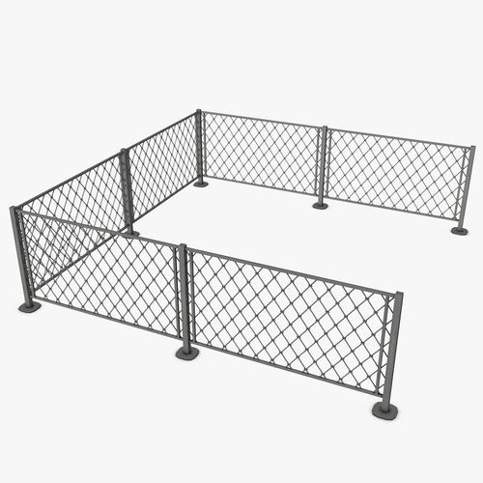
 |  |  |  | TOTAL MATERIALS |  | $3,500.00
 |  |  | INSTALLATION | HOURS | RATE | TOTAL
 |  |  | Installation supervisor | 8.00 | $30.00 | $240.00
 |  |  | Main installer | 16.00 | $25.00 | $400.00
 |  |  | Assistant | 16.00 | $10.00 | $160.00
 |  |  |  | TOTAL INSTALLATION |  | $800.00
 | DESCRIPTION OF WORK |  | MISCELLANEOUS CHARGES | HOURS / QTY | RATE / UNIT | TOTAL
 | Establish the layout and design of fences  Dig post holes and mix cement for installation  Install the main posts  Cut and install fence rails  Attach pickets or panels |  | Construction inspection fee | 1.00 | $350.00 | $350.00
 |  |  |  | TOTAL MISCELLANEOUS |  | $350.00
 |  |  |  |  | SUBTOTAL | $4,650.00
 |  |  | CUSTOMER SIGNATURE |  | DISCOUNT | $1,000.00
 |  |  |  | SUBTOTAL LESS DISCOUNT |  | $3,650.00
 |  |  |  |  | TAX RATE | 10%
 | TOTAL AMOUNT |  |  |  | TOTAL TAX | $365.00
 | $4,165.00 |  | AUTHORIZED SIGNATURE | SHIPPING/HANDLING |  | $150.00
 |  |  |  |  | OTHER | $0.00
 |  |  |  |  | TOTAL | $4,165.00
 | FOR ASSISTANCE CALL: 1-800-0000-00000
 | MON-SAT 8:00 AM to 5:00 PM CST
 |  |  |  |  | © TemplateLab.com

