 |  | RISK REGISTER |  |  |  |  | 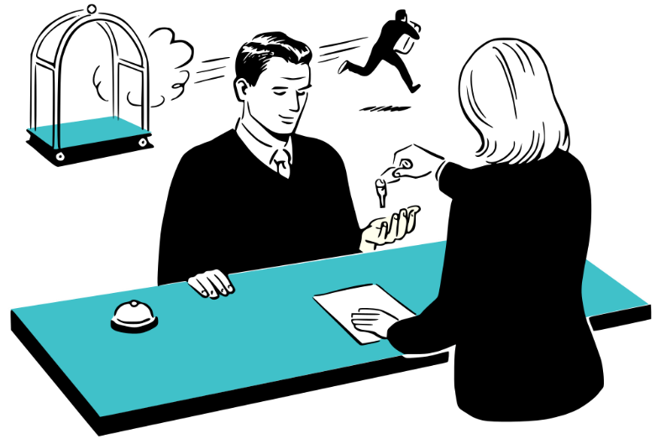
 |  | HAZARD | LIKELIHOOD | SEVERITY | RISK SCORE | MANAGEMENT
 |  | Risk of falling from balconies | 2 | 5 | 10 | Clear 'ground rules' will be set on expectations regarding behaviour and consumption of alcohol. Students must not climb between balconies.
 |  | Risk of theft inside the hotel | 4 | 1 | 4 | Access doors to the balconies should be kept locked and blinds drawn when not in the room or sleeping. Valuables should be left in the hotel safe.
 |  | Hotel |  | Risk Assessment by: |  | Date (Last Change):
 |  | CASINO ROYALE |  | JOHN DOE |  | 05/05/2022
 |  | 205 Best Avenue
 |  | 23250 New Hampshire
 |  | SEVERITY SCALE | 1 | 2 | 3 | 4 | 5
 |  | LIKELY INJURY | Minor non-immobilising injury or trauma not requiring hospital treatment | Non-immobilising injury or trauma but requiring hospital treatment | Immobilising injury or trauma requiring hospital treatment | Severe injury or trauma requiring urgent hospital treatment | Very severe life-threatening event
 |  | LIKELIHOOD SCALE | 1 | 2 | 3 | 4 | 5
 |  | HAZARD OCCURENCE | Highly unlikely | Unlikely | Possible | Likely | Very likely
 |  |  |  |  |  |  | © TemplateLab.com

