 |  | CONTRACT MANAGEMENT  RISK REGISTER |  |  | RISK ITEM  DESCRIPTION | RISK  CATEGORY | RISK  LIKELIHOOD | RISK  CONSEQUENCE | RISK  RATING
 |  | NEC (New Engineering Contract) risk register can be used to record any project risks |  |  | Conveyor speed can be changed | Design Information | Possible | Moderate | MEDIUM
 |  |  |  | RISK ID: R01
 |  |  |  | PROJECT ITEM: 3.12
 |  |  |  |  | Equipment from China delayed at customs | Delay | Likely | Minor | MEDIUM
 |  | COMPANY: |  | RISK ID: R02
 |  | Engineering Experts LLC |  | PROJECT ITEM: 4.02
 |  | CLIENT: |  |  | Calculation data access restricted | Access | Unlikely | Low | LOW
 |  | Best Consumers gmbh |  | RISK ID: R03
 |  |  |  | PROJECT ITEM: 5.11
 |  | PROJECT:
 |  | Big factory construction (#L235876-1123) |  |  | Not enough space for row materials to pass | Works Area | Possible | Major | HIGH
 |  |  |  | RISK ID: R04
 |  |  |  | PROJECT ITEM: 7.22
Project risk is defined as an uncertain event or condition which has either a negative or positive impact on a project.
The negative impact of a project risk item can be quantified by risk rating. The rating is determined by measuring the associated likelihood of occurrence and level of consequence. As shown in the table (which you can remove), a sample risk matrix can be used to determine the risk rating.
The scale of likelihood is standardised as almost certain, likely, possible, unlikely, and rare; the scale of consequence is standardised as serious, major, moderate, minor, and low; and the scale of risk rating is standardised as extreme, high, medium, low, and negligible.
 |  |  |  |  | Large number of unexperienced employees | Workmanship | Likely | Minor | MEDIUM
 |  |  |  | RISK ID: R05
 |  |  |  | PROJECT ITEM: 6.17
 |  |  |  |  | Inspection findings on safety equipment | Safety | Rare | Moderate | LOW
 |  |  |  | RISK ID: R06
 |  |  |  | PROJECT ITEM: 5.11
 |  |  |  |  |  |  | 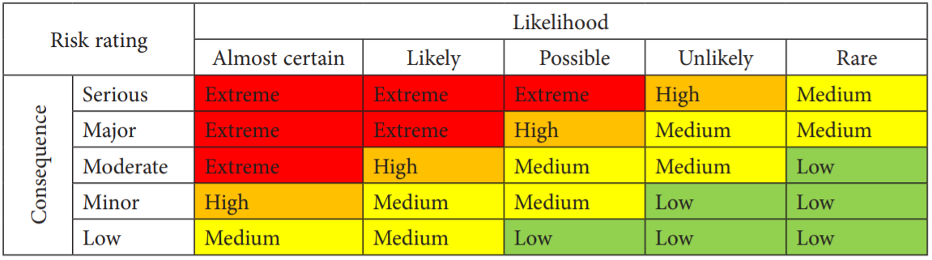
 |  |  |  |  |  |  | © TemplateLab.com

