 | BANK RISK REGISTER |  |  |  | 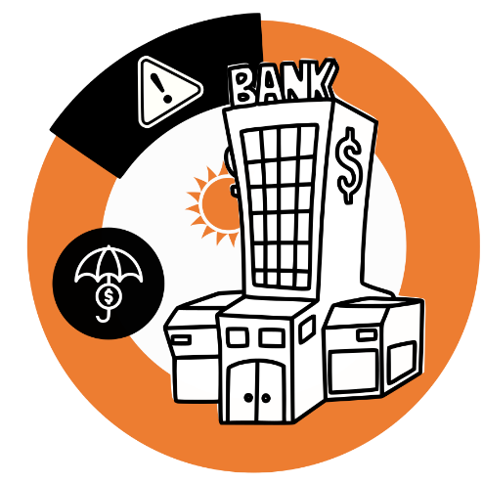
 | Bank |  | Risks registered by
 | National Bank of Fronland |  | Pamela Ruxton
 | Address |  | Last change date
 | 235 Banking Street, 25437 New York |  | 05/02/2022
 | RISK IDENTIFIED | PROBABILITY | IMPACT | RISK RATING | POTENTIAL  FINANCIAL LOSS | RESPONSIBLE
 | Interest rate risk. Possible occurrence of adverse effects on the bank’s financial result and capital on account of banking book items caused by changes in interest rates. | 3 | 2 | 6 | $3,600,000.00 | Garry Finch
 | Legal risk. Loss caused by penalties and sanctions originating from court disputes due to breach of contractual and legal obligations, and penalties and sanctions pronounced by a regulatory body. | 1 | 4 | 4 | $15,000,000.00 | John Doe
 |  |  |  |  |  | © TemplateLab.com

