

TRAVEL BROCHURE

+123-456-7890

123 Anywhere St., Any City, ST 12345

www.templatelab.com

Booklets are printed materials with four or more pages, containing details about a business, event, product, promotion, etc.

Let us

do the planning.

Just sit back and enjoy the wild ride.

WE TAKE YOU AT THE LOWEST RATES

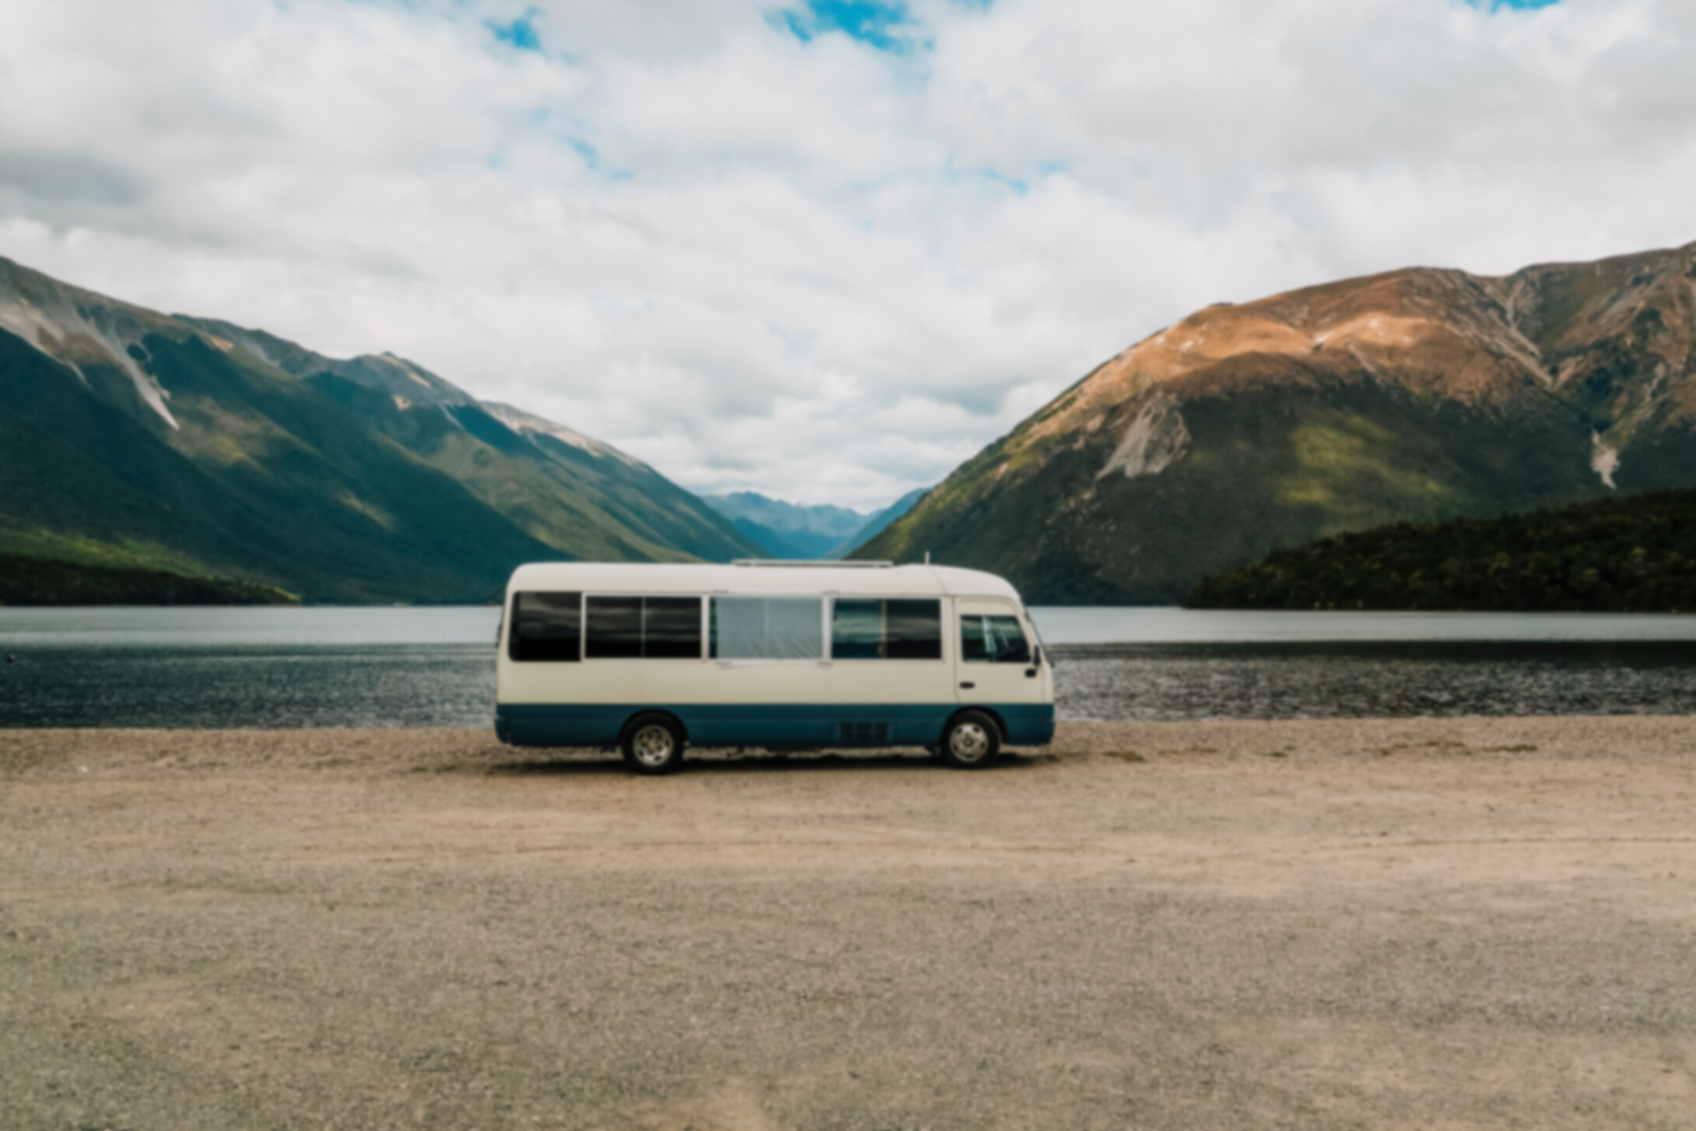

Booklets are printed materials with four or more pages, containing details about a business, event, product, promotion, etc. They are also known as catalogs or pamphlets and are usually created to communicate a message to audiences.

OUR SERVICES

PLAN YOUR NEXT

JOURNEY WITH US

Booklets are printed materials with four or more pages, containing details about a business, product, promotion, etc.

EXPLORE

the world

Booklets are printed materials with four or more pages, containing details about a business, event, product, promotion, etc.

They are also known as catalogs or pamphlets and are usually created to communicate a message to a wide

variety of audiences.

Seaside Tour

Make sure to feature your bestsellers or signature products or pieces.

Desert Trip

Make sure to feature your bestsellers or signature products or pieces.

CITY Trip

Make sure to feature your bestsellers or signature products or pieces.

Mountain TrIP

Make sure to feature your bestsellers or signature products or pieces.