Football Water Bottle Label
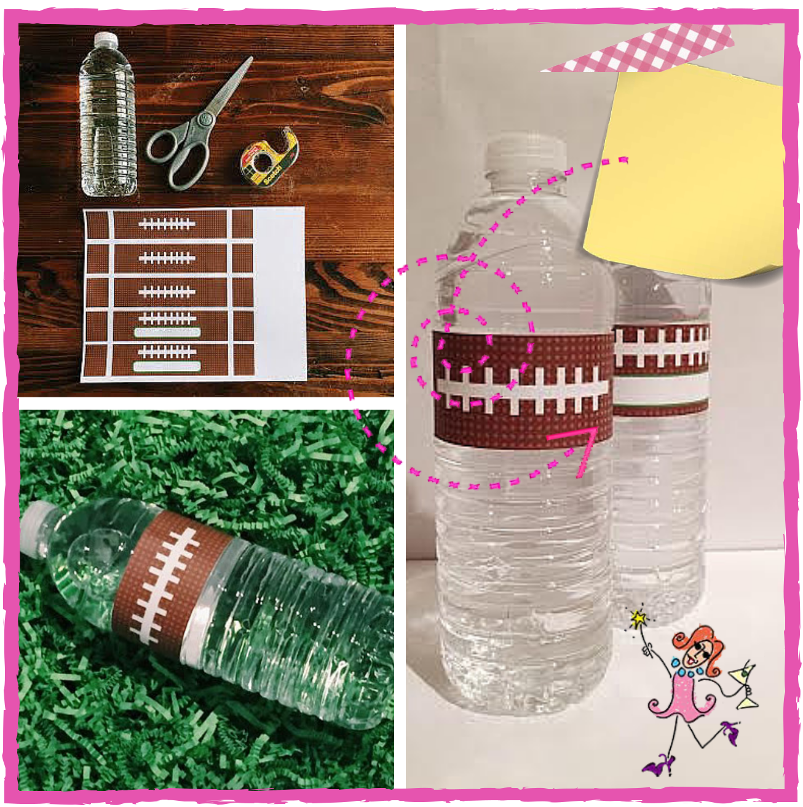

It's a |  | snap
with
 | our |  | FREE
printable |  |  | FREE
 |  | water
bottle la
 | b
 |  |  | els
 |  |  | !
 |  |  | ThePartyGoddess.com/sm

Free Printables ©The Party Goddess Inc. All rights reserved. PartyGoddessBlog.com

Football Water Bottle Label


The Party Goddess Inc. 2016©
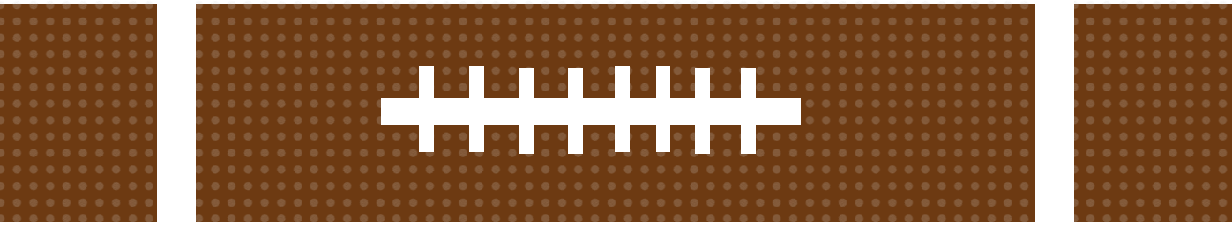

The Party Goddess Inc. 2016©


water bottle label

The Party Goddess Inc. 2016©


water bottle label

The Party Goddess Inc. 2016©

Free Printables ©The Party Goddess Inc. All rights reserved. PartyGoddessBlog.com

