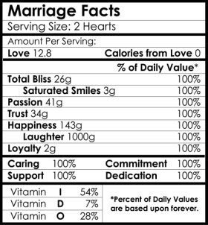 | 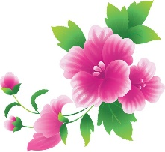  Jane and John  August 25th, 2020 | [Text] AND [Text]  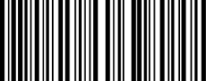  AUGUST 25th 2020
 | Jane and John  August 25th, 2020 | [Text] AND [Text]  AUGUST 25th 2020
 | Jane and John  August 25th, 2020 | [Text] AND [Text]  AUGUST 25th 2020
 | Jane and John  August 25th, 2020 | [Text] AND [Text]  AUGUST 25th 2020
 | Jane and John  August 25th, 2020 | [Text] AND [Text]  AUGUST 25th 2020
 | Jane and John  August 25th, 2020 | [Text] AND [Text]  AUGUST 25th 2020

Instructions:

Labels should print out 8.5x1.65 and will fit a standard water bottle.

To replace the images:
- Delete the image you wish to replace.
- Select Insert > Picture > From File.
- Select the image you’d like on your water bottle and choose ‘OK’.
- Select the newly imported image and scale it to the size you need.
- Double click on the image, choose the picture tab, and select the image that says ‘in front of text’.
- You can then move the image to where you need.
- Repeat the steps for other images.
- Copy and paste for the remaining labels.

Good Luck!

