

label guidelines

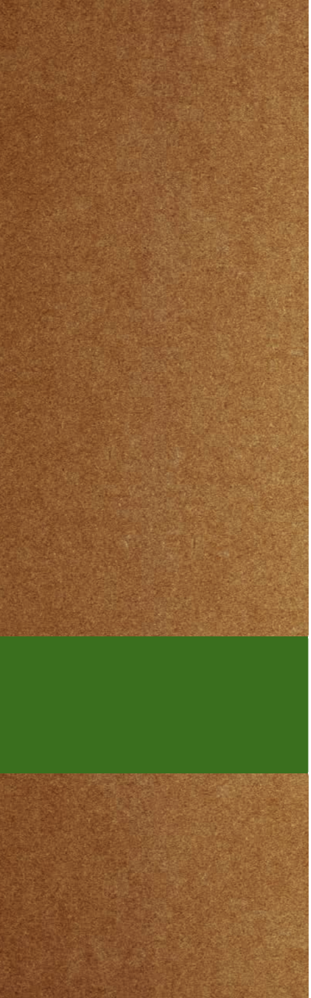

container

BRANDING
embossment
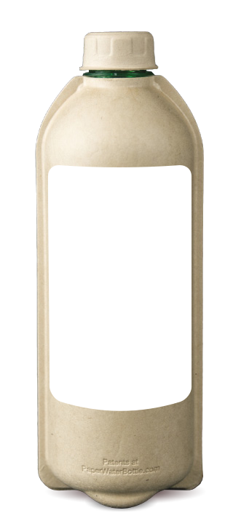

The phrase “Patents at PaperWaterBottle.com” is embossed on the lower portion of the bottle and shall not be altered or covered.

container label sizing

One or two labels may be applied to our stock container. The label size should be 3” wide x 4.625” high.

environmental marketing considerations

The information contained in this Label Guide is strictly limited to our bottle materials and is for informational purposes only. It is NOT meant to be a substitute for the advice provided by an attorney or regulatory advisor. The Paper Water Bottle client (Brand Owner) should consult applicable federal and state environmental regulations such as the Federal Trade Commission (FTC) Guides for the Use of Environmental Marketing Claims (known as “Green Guides”), State of California Public Resources Code (PRC) Sections 42355-42358.5 (Plastic Products), State of Maryland Code, Environment Sections 9-2102 and 9-2104, and other state regulations in your sales area. All label content is the responsibility of the Brand Owner who should determine compliance with all relevant federal and state regulations.

©2021 Paper Water Bottle | All Rights Reserved | Revised December 2021 PAPER WATER BOTTLE VISUAL BRAND GUIDE

2

container

BRANDING
qualified claims

Environmental claims for products are governed in the United States by the FTC “Green Guides”. The Guidelines recommend Marketers qualify general claims with specific environmental benefits. Paper Water Bottle and its suppliers have commissioned 3rd party testing performed by accredited labs to validate Paper Water Bottle’s claims and qualifiers. Based on that testing, the Paper Water Bottle ECO 1 GREEN™ bottle’s generally acceptable claim and required qualifications are:

Claim: 98% Landfill Biodegradable by Weight

Qualifier: ASTM D5526 shows up to 30.3% biodegradation in 391 days.

Qualifier Label Version: ASTM D5526 30%/391 Days

Please note the generally acceptable claim above may not be used on Paper Water Bottles sold into states where the term “biodegradable” or similar terms may not be applied to plastic container components.

California Sales: California law prohibits the sale of plastic packaging and plastic products that are labeled with the terms ‘biodegradable,’ ‘degradable,’ or ‘decomposable,’ or any form of those terms, or that imply in any way that the item will break down, biodegrade, or decompose in a landfill or other environment. These restrictions apply to all sales in or into the State of California, including such sales over the Internet. California law also strictly limits the sale of plastic packaging and plastic products with the term “compostable” or “marine degradable.” See calrecycle.ca.gov for full details.

Maryland Sales: Maryland law prohibits the sale of plastic products that are labeled with the terms ‘biodegradable,’ ‘degradable,’ or ‘decomposable,’ or with any other term to imply that the product will break down, fragment, biodegrade, or decompose in a landfill or any other environment. Maryland strictly limits the use of the terms “compostable” and “home compostable.” These restrictions apply to all sales in or into the State of Maryland, including such sales over the Internet. See Maryland Code, Environment Sections 9-2102 and 9-2104 for full details.

Use of the qualified claims above is voluntary.

marketing content

Other standard marketing content may be available from Paper Water Bottle such as Guilt-Free Disposability™.

Note the Federal Trade Commission Guides for the Use of Environmental Marketing Claims (known as Green Guides) prohibit the use of unqualified marketing terms such as “eco-friendly”, “environmentally friendly” and “green”.

©2021 Paper Water Bottle | All Rights Reserved | Revised December 2021 PAPER WATER BOTTLE VISUAL BRAND GUIDE

3

filled water bottles

Paper Water Bottle offers filled water bottles through our water bottler, Creekside Springs, LLC. Filled water bottle labels require the prior review of the water bottler to ensure all required water content regulatory information is included. Review of the label only pertains to the label’s water content information required by federal and state regulations. All other label information and formatting is the responsibility of the Brand Owner, per above.

Filled water bottle label proofs should be sent to sales@paperwaterbottle.com for forwarding to Creekside Springs, LLC for review. Typical turnaround time is 2-4 days.

water label

REQUIREMENTS

label requirements

Spring Water bottle labels must include:

Consumer Contact Phone or Web URL 16.9 FL OZ (500 mL)

Ingredients: Spring Water (*see note below)

Processed by: Filtration, UV Light and Ozonation Spring Water Sources: Columbiana County, OH 43945 PA DEP #5046493

NYSHD Cert. #637 (if distributed in NY)

NV #25569 (if distributed in NV)

 |  |  |  |  |  |  |  | Bottled By:
Nutrition |  | Amount/serving %DV |  |  |  |  |  | Bottled By:
Facts |  |  | Total Fat | 0g | 0%
 |  |  | Sodium 10mg |  | 0%
1 serving |  |  |  |  | 0%
 |  |  | Total Carb |  | 0%
per container |  |  | Total Carb | 0g | 0%
Serving size |  |  | Protein | 0g | 0% |  |  | Ambridge, PA 15003
16.9 oz (500mL) |  |  |  |  |  |  |  | Ambridge, PA 15003
 |  |  | Not a significant source of |  |  |  |  | Ambridge, PA 15003
 |  | cholesterol, dietary fiber, total
Calories
 |  | sugars, added sugars, Vitamin D,
per serving 0 |  | calcium, iron, and potassium.


Front-only labels can use linear display:
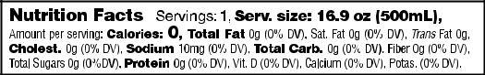

Alkaline Spring Water bottle labels must include:

Consumer Contact Phone or Web URL 16.9 FL OZ (500 mL)

Ingredients: Spring Water (*see note below)

Processed by: Filtration, UV Light, Ionization and Ozonation Spring Water Sources: Columbiana County, OH 43945 PA DEP #5046493

NYSHD Cert. #637 (if distributed in NY)

NV #25569 (if distributed in NV)

Bottled By:
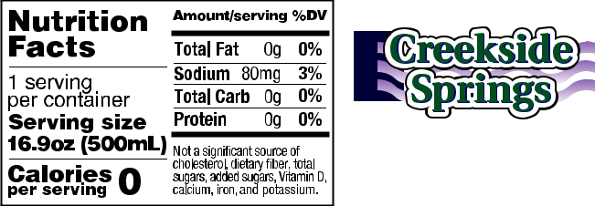

Ambridge, PA 15003

Front-only labels can use linear display:
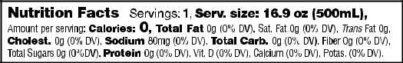

Download label resource files at paperwaterbottle.com/label-resources Nutrition Facts panels are provided for informational purposes only. See FDA requirements for Nutrition Facts Label formatting at www.fda.gov.

*Not required if the words “Spring Water” are included elsewhere to denote contents.

©2021 Paper Water Bottle | All Rights Reserved | Revised December 2021 PAPER WATER BOTTLE VISUAL BRAND GUIDE

4

9020 Beech Grove Road

Burlington, KY 41005 USA

859-534-PURE

www.PaperWaterBottle.com

