

Vaccine Temperature Log Book

Public Health Unit Contact Information

Public Health Unit:

Website:

Telephone:

Fax:

Always keep your vaccines refrigerated between +2˚C to +8˚C.

If the temperature is outside of +2˚C to +8˚C, contact your public health unit immediately.


This page has been intentionally left blank.
Protecting Ontario Vaccine Supply

- Always keep vaccines refrigerated between +2 °C to +8°C.

- Never leave vaccines out of the refrigerator.

- Monitor refrigerator temperatures and record twice daily in the Temperature Log Book.

- Reset the maximum-minimum thermometer after temperature recordings (if applicable).

- Store vaccines on the middle shelves of the refrigerator, never on the door or in the drawers.

- Check vaccine expiry dates regularly.

- Always use vaccines with the earlier expiry date first.

- Order no more than a one-month supply of vaccine at a time.

- Call your public health unit immediately to report vaccines that have been exposed to temperatures below +2 °C and/or above +8°C.

- NEVER administer or discard exposed vaccine until your public health unit has assessed the situation. Keep exposed vaccines in the refrigerator by placing these vaccines in a labelled container (or bag), marked with the date and time and “DO NOT USE.”

- Spoiled or expired vaccine should always be returned to your source of supply

(i.e., public health unit or Ontario Government Pharmaceutical and Medical Supply Service (OGPMSS)).

- Reorder Temperature Log Books:

  - Outside Toronto, through your public health unit.

  - Within Toronto, through OGPMSS at (416) 327-0837

 |  |  |  |  |  |  |  |  |  | January |  |  | 2019 |  |  |  | Office/Facility: |  |  |  |  |  |  |  | ABC Family Practice |  |  |  |  |  |  |  |  |  |  |  |  | 9
Month: |  |  |  |  |  |  |  |  |  |  |  |  |  |  |  |  |  |  |  |  |  |  |  |  | 6 |  | Fri |  | 7 |  | Sat |  | 8 | Sun |  |  |  | 9
 |  |  |  |  |  |  |  |  |  |  |  |  |  |  |  |  |  |  |  |  |  | 5 | Thurs |  | 6 |  | Fri |  | 7 |  | Sat |  | 8
 |  |  |  |  |  |  |  |  |  |  |  |  |  |  |  |  |  | 4 | Wed |  |  | 5 |  |  | 6 |  | Fri |  | 7 |  |  |  |  |  |  |  |  | PM
 |  |  |  |  |  |  |  |  |  |  |  |  |  |  |  |  |  | 4 |  |  |  | 5 |  |  | 6 |  |  |  |  |  |  |  | PM |  | AM |  |  | PM
 |  |  |  |  |  |  |  |  |  |  |  |  |  | 3 |  | Tue |  | 4 |  |  |  |  |  |  |  |  |  |  |  |  |  |  | PM |  |  |  |  | PM
 |  |  |  |  |  |  |  |  |  |  |  |  |  | 3 |  | Tue |  | 4 |  |  |  |  |  |  |  |  |  |  | PM |  | AM |  | PM
 |  |  |  |  |  |  |  |  |  |  |  | Mon |  | 3 |  | Tue |  | 4 |  |  |  |  |  |  |  |  |  |  | PM |  | AM |  | PM
 |  |  |  |  |  |  |  |  |  |  |  | Mon |  | 3 |  | Tue |  | 4 |  |  |  |  |  |  | PM |  | AM |  | PM |  | AM |  |  |  |  |  |  | 7
 |  |  |  |  |  |  |  |  |  |  |  |  |  |  |  |  |  |  |  |  |  |  |  |  | PM |  |  |  |  |  |  |  |  |  | 0 |  |  | 6.
 |  |  |  |  |  |  |  |  |  |  |  |  |  |  |  |  |  |  |  | AM |  |  |  |  |  |  |  |  |  |  |  |  |  |  | 0 |  |  | 6.
Week |  | 1 |  |  |  |  |  |  |  |  |  |  |  |  |  |  |  | PM |  |  |  | PM |  | AM |  |  |  |  |  |  |  |  | 5 |  |  |  |  | 6.
 |  |  |  |  |  |  |  |  |  |  |  |  |  |  |  | AM |  | PM |  |  |  |  |  |  |  |  |  |  |  |  | 0 |  | 6.
 |  |  |  |  |  |  |  |  |  |  |  |  |  | PM |  | AM |  |  |  |  |  |  |  |  |  |  |  |  | .2 |  | 7.
 |  |  |  |  |  |  |  |  |  |  |  | AM |  | PM |  |  |  |  |  |  |  |  |  |  |  |  | .3 |  | 5
 |  |  |  |  |  |  |  |  |  |  |  | AM |  |  |  |  |  |  |  |  |  |  |  | 2 | 5.3 |  | 5 |  |  |  |  |  |  |  |  |  |  | 5.5
 |  |  |  |  |  |  |  |  |  |  |  |  |  |  |  |  |  |  |  | .7 |  | 6. |  | 3. |  |  |  |  |  |  |  |  |  |  | 4.5 |  |  | 5.5
Time |  |  |  |  |  |  |  |  |  |  |  |  |  |  |  |  |  | .6 |  | 5 |  | 8 |  |  |  |  |  |  |  |  | 5.6 |  | 5.2
 |  |  |  |  |  |  |  |  |  |  |  |  |  |  |  | 4 |  | 5 |  |  |  |  |  |  |  |  |  |  | 6.4 |  | 5.6
 |  |  |  |  |  |  |  |  |  |  |  |  |  | 0 |  | 3. |  |  |  |  |  |  |  |  |  |  | 6.3 |  | 6.4
 |  |  |  |  |  |  | Temp |  |  |  |  | .8 |  | 7. |  |  |  |  |  |  |  |  |  | 10.4 | 6.9 |  | 6.3 |  |  |  |  |  |  |  |  |  |  | 7.8
Current |  |  |  |  |  |  |  |  |  |  |  | 5 |  |  |  |  |  | 6.8 |  | 6.7 |  | 7.1 |  | 10.4 | 6.9 |  |  |  |  |  | 7.0 |  | 7.5 |  | 6 |  |  | 7.8
 |  |  |  |  |  |  |  |  |  |  |  | 6.8 |  | 6.5 |  | 6.0 |  |  |  |  |  |  |  | 2.5 | 3.0 |  | -0.2 |  | 3.6 |  |  |  |  |  | .5
Max |  |  | Temp |  |  |  |  |  |  |  |  | 6.8 |  | 6.5 |  | 6.0 |  | 3.3 |  | 3.4 |  | .0 |  | 2.5 | 3.0 |  | -0.2 |  | 3.6 |  |  |  | AB |  | AB |  |  | AB
Max |  |  |  |  |  |  |  |  |  |  |  | 3.4 |  | 3.5 |  | 2.9 |  | 3.3 |  | 3.4 |  | 4 |  | AA | AA |  | AA |  | AA |  | AB |  | AB |  |  |  |  | AB
Min Temp |  |  |  |  |  |  |  |  |  |  |  | 3.4 |  | 3.5 |  | 2.9 |  | AA |  | AA |  | AA |  | AA | AA |  | AA |  | AA |  | AB |  |  |  | Sun
 |  |  |  |  |  |  |  |  |  |  |  | AB |  | AB |  | AA |  | AA |  | AA |  | AA |  | AA | AA |  | Fri |  |  |  | Sat
Initials |  |  |  |  |  |  |  |  |  |  |  | AB |  | AB |  | AA |  | AA |  |  |  |  |  | Thurs |  |  | Fri |  |  |  | Sat
 |  |  |  |  |  |  |  |  |  |  |  | AB |  | AB |  | AA |  |  |  |  |  |  |  | Thurs |  |  | Fri |  |  |  |  |  |  |  |  |  |  | PM
 |  |  |  |  |  |  |  |  |  |  |  | AB |  | AB |  |  |  |  |  | Wed |  |  |  | Thurs |  |  | Fri |  |  |  |  |  |  |  |  | AM
 |  |  |  |  |  |  |  |  |  |  |  | AB |  |  |  |  |  |  |  | Wed |  |  |  | Thurs |  |  |  |  |  |  |  |  | PM
 |  |  |  |  |  |  |  |  |  |  |  |  |  |  |  | Tue |  |  |  | Wed
 |  |  |  |  |  |  |  |  |  |  |  |  |  |  |  |  |  |  |  | Wed |  |  |  |  |  |  |  |  |  |  | AM
 |  |  |  |  |  |  |  |  |  |  |  | Mon |  |  |  |  |  |  |  |  |  |  |  |  |  |  |  |  | PM
 |  |  |  |  |  |  |  |  |  |  |  | Mon |  |  |  |  |  |  |  |  |  |  |  |  |  |  | AM
 |  |  |  |  |  |  |  |  |  |  |  |  | SAMPLE
Week |  |  |  |  | 2 |  |  |  |  |  |  |  |  |  |  |  |  |  |  |  |  | PM |  | AM |  | M
 |  |  |  |  |  |  |  |  |  |  |  |  |  |  |  |  |  | PM |  | AM
 |  |  |  |  |  |  |  |  |  |  |  |  |  |  |  | AM
 |  |  |  |  |  |  |  |  |  |  |  |  |  | PM
 |  |  |  |  |  |  |  |  |  |  |  | AM
Time
Current |  |  |  |  |  |  |  |  | Temp
Max Temp
Min |  |  |  | Temp |  |  |  |  |  |  |  |  |  |  |  |  |  |  |  |  |  |  |  |  |  |  |  |  |  |  | Sat |  |  |  |  | Sun
 |  |  |  |  |  |  |  |  |  |  |  |  |  |  |  |  |  |  |  |  |  |  |  |  |  |  | Fri
Initials |  |  |  |  |  |  |  |  |  |  |  |  |  |  |  |  |  |  |  |  |  |  |  | Thurs |  |  |  |  |  |  |  |  |  |  |  |  |  |  | PM
 |  |  |  |  |  |  |  |  |  |  |  |  |  |  |  |  |  |  |  | Wed |  |  |  |  |  |  |  |  |  |  |  |  |  | PM |  |  | AM |  | PM
 |  |  |  |  |  |  |  |  |  |  |  |  |  |  |  | Tue |  |  |  |  |  |  |  |  |  |  |  |  |  |  |  |  |  |  |  |  |  |  | PM
 |  |  |  |  |  |  |  |  |  |  |  |  |  |  |  |  |  |  |  |  |  |  |  |  |  |  |  |  |  |  |  | AM
 |  |  |  |  |  |  |  |  |  |  |  | Mon |  |  |  |  |  |  |  |  |  |  |  |  |  |  |  |  |  | PM
 |  |  |  |  |  |  |  | 3 |  |  |  |  |  |  |  |  |  |  |  |  |  |  |  |  |  | PM |  | AM
Week |  |  |  |  |  |  |  |  |  |  |  |  |  |  |  |  |  |  |  |  |  |  | PM |  | AM
 |  |  |  |  |  |  |  |  |  |  |  |  |  |  |  |  |  |  | PM |  | AM |  |  |  | AM
 |  |  |  |  |  |  |  |  |  |  |  |  |  |  |  |  | AM
 |  |  |  |  |  |  |  |  |  |  |  |  |  |  | PM
 |  |  |  |  |  |  |  |  |  |  |  |  | AM
Time
Current |  |  |  |  |  |  |  |  |  |  | Temp
 | Max Temp
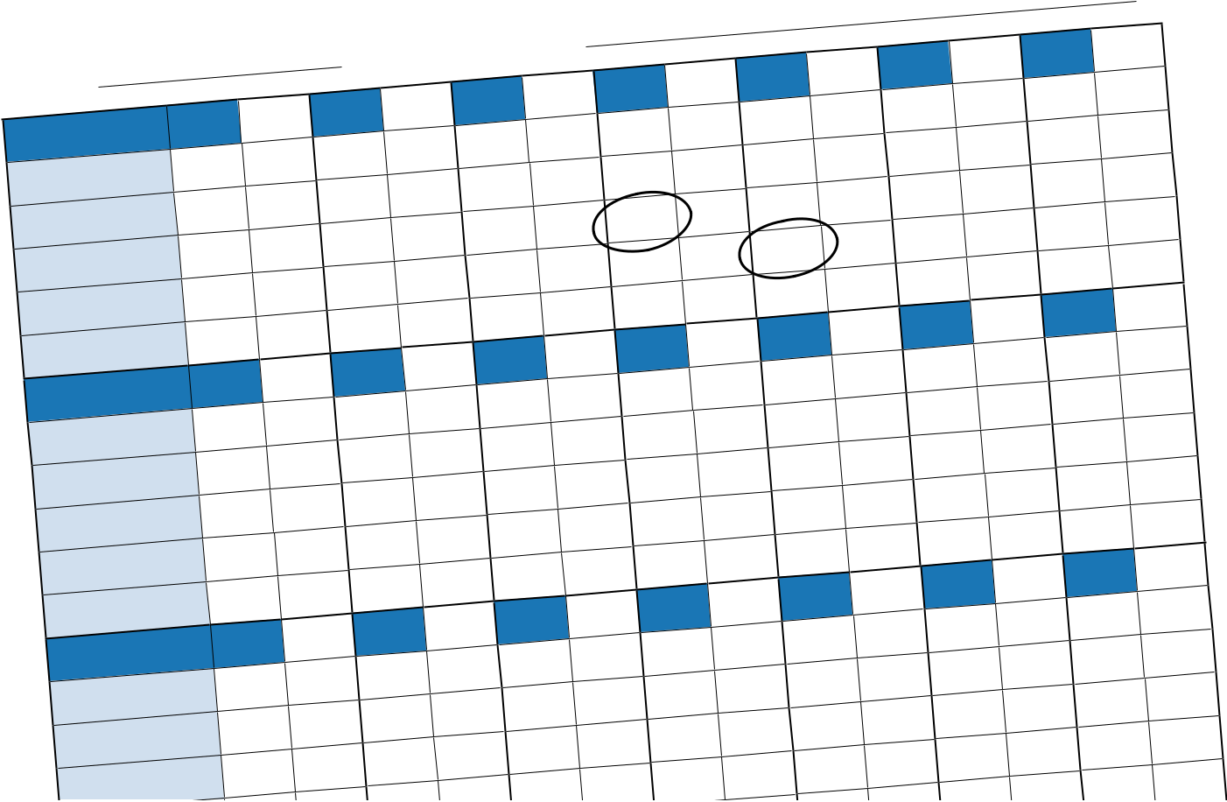
Month: |  | MM/YY |  |  |  |  | Office/Facility:
Week 1 |  | Mon |  |  | Tue |  |  | Wed |  |  | Thur |  | Fri |  | Sat |  | Sun
Time |  | AM |  | PM | AM |  | PM | AM | PM |  | AM | PM | AM | PM | AM | PM | AM | PM
Current Temp
Max Temp
Min Temp
Initials
Week 2 |  | Mon |  |  | Tue |  |  | Wed |  |  | Thur |  | Fri |  | Sat |  | Sun
Time |  | AM |  | PM | AM |  | PM | AM | PM |  | AM | PM | AM | PM | AM | PM | AM | PM
Current Temp
Max Temp
Min Temp
Initials
Week 3 |  | Mon |  |  | Tue |  |  | Wed |  |  | Thur |  | Fri |  | Sat |  | Sun
Time |  | AM |  | PM | AM |  | PM | AM | PM |  | AM | PM | AM | PM | AM | PM | AM | PM
Current Temp
Max Temp
Min Temp
Initials
Week 4 |  | Mon |  |  | Tue |  |  | Wed |  |  | Thur |  | Fri |  | Sat |  | Sun
Time |  | AM |  | PM | AM |  | PM | AM | PM |  | AM | PM | AM | PM | AM | PM | AM | PM
Current Temp
Max Temp
Min Temp
Initials
Week 5 |  | Mon |  |  | Tue |  |  | Wed |  |  | Thur |  | Fri |  | Sat |  | Sun
Time |  | AM |  | PM | AM |  | PM | AM | PM |  | AM | PM | AM | PM | AM | PM | AM | PM
Current Temp
Max Temp
Min Temp
Initials
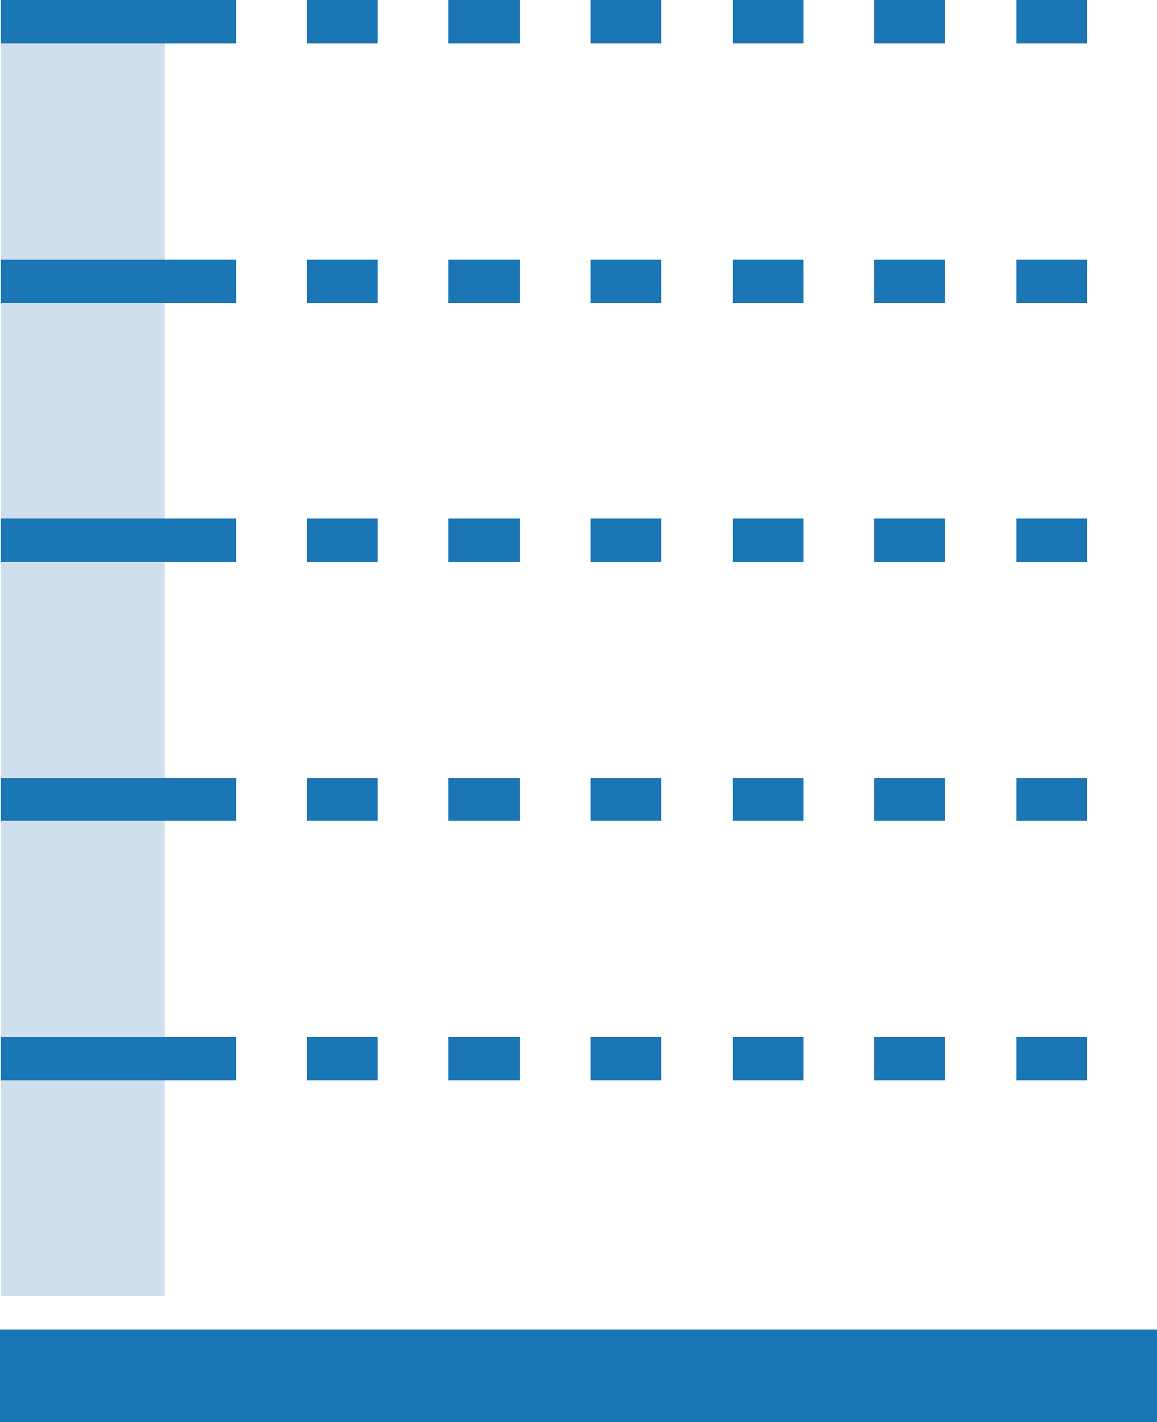

If the temperature is outside of +2˚C to +8˚C, contact your public health unit immediately.

Month: |  | MM/YY |  |  |  |  | Office/Facility:
Week 1 |  | Mon |  |  | Tue |  |  | Wed |  |  | Thur |  | Fri |  | Sat |  | Sun
Time |  | AM |  | PM | AM |  | PM | AM | PM |  | AM | PM | AM | PM | AM | PM | AM | PM
Current Temp
Max Temp
Min Temp
Initials
Week 2 |  | Mon |  |  | Tue |  |  | Wed |  |  | Thur |  | Fri |  | Sat |  | Sun
Time |  | AM |  | PM | AM |  | PM | AM | PM |  | AM | PM | AM | PM | AM | PM | AM | PM
Current Temp
Max Temp
Min Temp
Initials
Week 3 |  | Mon |  |  | Tue |  |  | Wed |  |  | Thur |  | Fri |  | Sat |  | Sun
Time |  | AM |  | PM | AM |  | PM | AM | PM |  | AM | PM | AM | PM | AM | PM | AM | PM
Current Temp
Max Temp
Min Temp
Initials
Week 4 |  | Mon |  |  | Tue |  |  | Wed |  |  | Thur |  | Fri |  | Sat |  | Sun
Time |  | AM |  | PM | AM |  | PM | AM | PM |  | AM | PM | AM | PM | AM | PM | AM | PM
Current Temp
Max Temp
Min Temp
Initials
Week 5 |  | Mon |  |  | Tue |  |  | Wed |  |  | Thur |  | Fri |  | Sat |  | Sun
Time |  | AM |  | PM | AM |  | PM | AM | PM |  | AM | PM | AM | PM | AM | PM | AM | PM
Current Temp
Max Temp
Min Temp
Initials
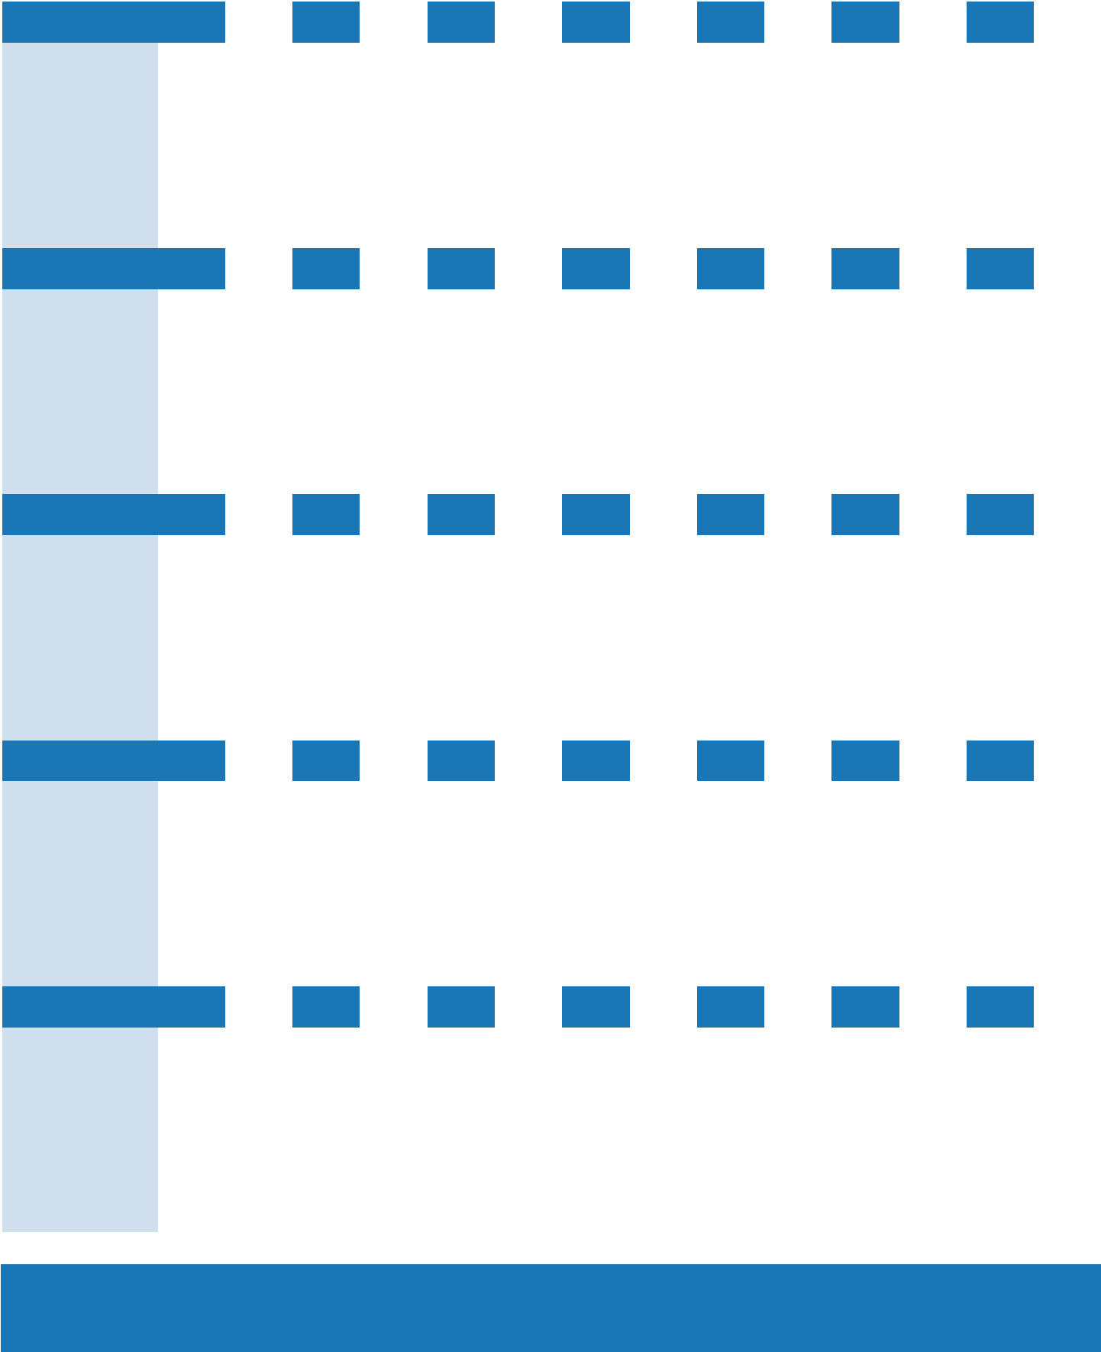

If the temperature is outside of +2˚C to +8˚C, contact your public health unit immediately.

Month: |  | MM/YY |  |  |  |  | Office/Facility:
Week 1 |  | Mon |  |  | Tue |  |  | Wed |  |  | Thur |  | Fri |  | Sat |  | Sun
Time |  | AM |  | PM | AM |  | PM | AM | PM |  | AM | PM | AM | PM | AM | PM | AM | PM
Current Temp
Max Temp
Min Temp
Initials
Week 2 |  | Mon |  |  | Tue |  |  | Wed |  |  | Thur |  | Fri |  | Sat |  | Sun
Time |  | AM |  | PM | AM |  | PM | AM | PM |  | AM | PM | AM | PM | AM | PM | AM | PM
Current Temp
Max Temp
Min Temp
Initials
Week 3 |  | Mon |  |  | Tue |  |  | Wed |  |  | Thur |  | Fri |  | Sat |  | Sun
Time |  | AM |  | PM | AM |  | PM | AM | PM |  | AM | PM | AM | PM | AM | PM | AM | PM
Current Temp
Max Temp
Min Temp
Initials
Week 4 |  | Mon |  |  | Tue |  |  | Wed |  |  | Thur |  | Fri |  | Sat |  | Sun
Time |  | AM |  | PM | AM |  | PM | AM | PM |  | AM | PM | AM | PM | AM | PM | AM | PM
Current Temp
Max Temp
Min Temp
Initials
Week 5 |  | Mon |  |  | Tue |  |  | Wed |  |  | Thur |  | Fri |  | Sat |  | Sun
Time |  | AM |  | PM | AM |  | PM | AM | PM |  | AM | PM | AM | PM | AM | PM | AM | PM
Current Temp
Max Temp
Min Temp
Initials

If the temperature is outside of +2˚C to +8˚C, contact your public health unit immediately.

Month: |  | MM/YY |  |  |  |  | Office/Facility:
Week 1 |  | Mon |  |  | Tue |  |  | Wed |  |  | Thur |  | Fri |  | Sat |  | Sun
Time |  | AM |  | PM | AM |  | PM | AM | PM |  | AM | PM | AM | PM | AM | PM | AM | PM
Current Temp
Max Temp
Min Temp
Initials
Week 2 |  | Mon |  |  | Tue |  |  | Wed |  |  | Thur |  | Fri |  | Sat |  | Sun
Time |  | AM |  | PM | AM |  | PM | AM | PM |  | AM | PM | AM | PM | AM | PM | AM | PM
Current Temp
Max Temp
Min Temp
Initials
Week 3 |  | Mon |  |  | Tue |  |  | Wed |  |  | Thur |  | Fri |  | Sat |  | Sun
Time |  | AM |  | PM | AM |  | PM | AM | PM |  | AM | PM | AM | PM | AM | PM | AM | PM
Current Temp
Max Temp
Min Temp
Initials
Week 4 |  | Mon |  |  | Tue |  |  | Wed |  |  | Thur |  | Fri |  | Sat |  | Sun
Time |  | AM |  | PM | AM |  | PM | AM | PM |  | AM | PM | AM | PM | AM | PM | AM | PM
Current Temp
Max Temp
Min Temp
Initials
Week 5 |  | Mon |  |  | Tue |  |  | Wed |  |  | Thur |  | Fri |  | Sat |  | Sun
Time |  | AM |  | PM | AM |  | PM | AM | PM |  | AM | PM | AM | PM | AM | PM | AM | PM
Current Temp
Max Temp
Min Temp
Initials

If the temperature is outside of +2˚C to +8˚C, contact your public health unit immediately.

Month: |  | MM/YY |  |  |  |  | Office/Facility:
Week 1 |  | Mon |  |  | Tue |  |  | Wed |  |  | Thur |  | Fri |  | Sat |  | Sun
Time |  | AM |  | PM | AM |  | PM | AM | PM |  | AM | PM | AM | PM | AM | PM | AM | PM
Current Temp
Max Temp
Min Temp
Initials
Week 2 |  | Mon |  |  | Tue |  |  | Wed |  |  | Thur |  | Fri |  | Sat |  | Sun
Time |  | AM |  | PM | AM |  | PM | AM | PM |  | AM | PM | AM | PM | AM | PM | AM | PM
Current Temp
Max Temp
Min Temp
Initials
Week 3 |  | Mon |  |  | Tue |  |  | Wed |  |  | Thur |  | Fri |  | Sat |  | Sun
Time |  | AM |  | PM | AM |  | PM | AM | PM |  | AM | PM | AM | PM | AM | PM | AM | PM
Current Temp
Max Temp
Min Temp
Initials
Week 4 |  | Mon |  |  | Tue |  |  | Wed |  |  | Thur |  | Fri |  | Sat |  | Sun
Time |  | AM |  | PM | AM |  | PM | AM | PM |  | AM | PM | AM | PM | AM | PM | AM | PM
Current Temp
Max Temp
Min Temp
Initials
Week 5 |  | Mon |  |  | Tue |  |  | Wed |  |  | Thur |  | Fri |  | Sat |  | Sun
Time |  | AM |  | PM | AM |  | PM | AM | PM |  | AM | PM | AM | PM | AM | PM | AM | PM
Current Temp
Max Temp
Min Temp
Initials

If the temperature is outside of +2˚C to +8˚C, contact your public health unit immediately.

Month: |  | MM/YY |  |  |  |  | Office/Facility:
Week 1 |  | Mon |  |  | Tue |  |  | Wed |  |  | Thur |  | Fri |  | Sat |  | Sun
Time |  | AM |  | PM | AM |  | PM | AM | PM |  | AM | PM | AM | PM | AM | PM | AM | PM
Current Temp
Max Temp
Min Temp
Initials
Week 2 |  | Mon |  |  | Tue |  |  | Wed |  |  | Thur |  | Fri |  | Sat |  | Sun
Time |  | AM |  | PM | AM |  | PM | AM | PM |  | AM | PM | AM | PM | AM | PM | AM | PM
Current Temp
Max Temp
Min Temp
Initials
Week 3 |  | Mon |  |  | Tue |  |  | Wed |  |  | Thur |  | Fri |  | Sat |  | Sun
Time |  | AM |  | PM | AM |  | PM | AM | PM |  | AM | PM | AM | PM | AM | PM | AM | PM
Current Temp
Max Temp
Min Temp
Initials
Week 4 |  | Mon |  |  | Tue |  |  | Wed |  |  | Thur |  | Fri |  | Sat |  | Sun
Time |  | AM |  | PM | AM |  | PM | AM | PM |  | AM | PM | AM | PM | AM | PM | AM | PM
Current Temp
Max Temp
Min Temp
Initials
Week 5 |  | Mon |  |  | Tue |  |  | Wed |  |  | Thur |  | Fri |  | Sat |  | Sun
Time |  | AM |  | PM | AM |  | PM | AM | PM |  | AM | PM | AM | PM | AM | PM | AM | PM
Current Temp
Max Temp
Min Temp
Initials

If the temperature is outside of +2˚C to +8˚C, contact your public health unit immediately.

Month: |  | MM/YY |  |  |  |  | Office/Facility:
Week 1 |  | Mon |  |  | Tue |  |  | Wed |  |  | Thur |  | Fri |  | Sat |  | Sun
Time |  | AM |  | PM | AM |  | PM | AM | PM |  | AM | PM | AM | PM | AM | PM | AM | PM
Current Temp
Max Temp
Min Temp
Initials
Week 2 |  | Mon |  |  | Tue |  |  | Wed |  |  | Thur |  | Fri |  | Sat |  | Sun
Time |  | AM |  | PM | AM |  | PM | AM | PM |  | AM | PM | AM | PM | AM | PM | AM | PM
Current Temp
Max Temp
Min Temp
Initials
Week 3 |  | Mon |  |  | Tue |  |  | Wed |  |  | Thur |  | Fri |  | Sat |  | Sun
Time |  | AM |  | PM | AM |  | PM | AM | PM |  | AM | PM | AM | PM | AM | PM | AM | PM
Current Temp
Max Temp
Min Temp
Initials
Week 4 |  | Mon |  |  | Tue |  |  | Wed |  |  | Thur |  | Fri |  | Sat |  | Sun
Time |  | AM |  | PM | AM |  | PM | AM | PM |  | AM | PM | AM | PM | AM | PM | AM | PM
Current Temp
Max Temp
Min Temp
Initials
Week 5 |  | Mon |  |  | Tue |  |  | Wed |  |  | Thur |  | Fri |  | Sat |  | Sun
Time |  | AM |  | PM | AM |  | PM | AM | PM |  | AM | PM | AM | PM | AM | PM | AM | PM
Current Temp
Max Temp
Min Temp
Initials

If the temperature is outside of +2˚C to +8˚C, contact your public health unit immediately.

Month: |  | MM/YY |  |  |  |  | Office/Facility:
Week 1 |  | Mon |  |  | Tue |  |  | Wed |  |  | Thur |  | Fri |  | Sat |  | Sun
Time |  | AM |  | PM | AM |  | PM | AM | PM |  | AM | PM | AM | PM | AM | PM | AM | PM
Current Temp
Max Temp
Min Temp
Initials
Week 2 |  | Mon |  |  | Tue |  |  | Wed |  |  | Thur |  | Fri |  | Sat |  | Sun
Time |  | AM |  | PM | AM |  | PM | AM | PM |  | AM | PM | AM | PM | AM | PM | AM | PM
Current Temp
Max Temp
Min Temp
Initials
Week 3 |  | Mon |  |  | Tue |  |  | Wed |  |  | Thur |  | Fri |  | Sat |  | Sun
Time |  | AM |  | PM | AM |  | PM | AM | PM |  | AM | PM | AM | PM | AM | PM | AM | PM
Current Temp
Max Temp
Min Temp
Initials
Week 4 |  | Mon |  |  | Tue |  |  | Wed |  |  | Thur |  | Fri |  | Sat |  | Sun
Time |  | AM |  | PM | AM |  | PM | AM | PM |  | AM | PM | AM | PM | AM | PM | AM | PM
Current Temp
Max Temp
Min Temp
Initials
Week 5 |  | Mon |  |  | Tue |  |  | Wed |  |  | Thur |  | Fri |  | Sat |  | Sun
Time |  | AM |  | PM | AM |  | PM | AM | PM |  | AM | PM | AM | PM | AM | PM | AM | PM
Current Temp
Max Temp
Min Temp
Initials

If the temperature is outside of +2˚C to +8˚C, contact your public health unit immediately.

Month: |  | MM/YY |  |  |  |  | Office/Facility:
Week 1 |  | Mon |  |  | Tue |  |  | Wed |  |  | Thur |  | Fri |  | Sat |  | Sun
Time |  | AM |  | PM | AM |  | PM | AM | PM |  | AM | PM | AM | PM | AM | PM | AM | PM
Current Temp
Max Temp
Min Temp
Initials
Week 2 |  | Mon |  |  | Tue |  |  | Wed |  |  | Thur |  | Fri |  | Sat |  | Sun
Time |  | AM |  | PM | AM |  | PM | AM | PM |  | AM | PM | AM | PM | AM | PM | AM | PM
Current Temp
Max Temp
Min Temp
Initials
Week 3 |  | Mon |  |  | Tue |  |  | Wed |  |  | Thur |  | Fri |  | Sat |  | Sun
Time |  | AM |  | PM | AM |  | PM | AM | PM |  | AM | PM | AM | PM | AM | PM | AM | PM
Current Temp
Max Temp
Min Temp
Initials
Week 4 |  | Mon |  |  | Tue |  |  | Wed |  |  | Thur |  | Fri |  | Sat |  | Sun
Time |  | AM |  | PM | AM |  | PM | AM | PM |  | AM | PM | AM | PM | AM | PM | AM | PM
Current Temp
Max Temp
Min Temp
Initials
Week 5 |  | Mon |  |  | Tue |  |  | Wed |  |  | Thur |  | Fri |  | Sat |  | Sun
Time |  | AM |  | PM | AM |  | PM | AM | PM |  | AM | PM | AM | PM | AM | PM | AM | PM
Current Temp
Max Temp
Min Temp
Initials

If the temperature is outside of +2˚C to +8˚C, contact your public health unit immediately.

Month: |  | MM/YY |  |  |  |  | Office/Facility:
Week 1 |  | Mon |  |  | Tue |  |  | Wed |  |  | Thur |  | Fri |  | Sat |  | Sun
Time |  | AM |  | PM | AM |  | PM | AM | PM |  | AM | PM | AM | PM | AM | PM | AM | PM
Current Temp
Max Temp
Min Temp
Initials
Week 2 |  | Mon |  |  | Tue |  |  | Wed |  |  | Thur |  | Fri |  | Sat |  | Sun
Time |  | AM |  | PM | AM |  | PM | AM | PM |  | AM | PM | AM | PM | AM | PM | AM | PM
Current Temp
Max Temp
Min Temp
Initials
Week 3 |  | Mon |  |  | Tue |  |  | Wed |  |  | Thur |  | Fri |  | Sat |  | Sun
Time |  | AM |  | PM | AM |  | PM | AM | PM |  | AM | PM | AM | PM | AM | PM | AM | PM
Current Temp
Max Temp
Min Temp
Initials
Week 4 |  | Mon |  |  | Tue |  |  | Wed |  |  | Thur |  | Fri |  | Sat |  | Sun
Time |  | AM |  | PM | AM |  | PM | AM | PM |  | AM | PM | AM | PM | AM | PM | AM | PM
Current Temp
Max Temp
Min Temp
Initials
Week 5 |  | Mon |  |  | Tue |  |  | Wed |  |  | Thur |  | Fri |  | Sat |  | Sun
Time |  | AM |  | PM | AM |  | PM | AM | PM |  | AM | PM | AM | PM | AM | PM | AM | PM
Current Temp
Max Temp
Min Temp
Initials

If the temperature is outside of +2˚C to +8˚C, contact your public health unit immediately.

Month: |  | MM/YY |  |  |  |  | Office/Facility:
Week 1 |  | Mon |  |  | Tue |  |  | Wed |  |  | Thur |  | Fri |  | Sat |  | Sun
Time |  | AM |  | PM | AM |  | PM | AM | PM |  | AM | PM | AM | PM | AM | PM | AM | PM
Current Temp
Max Temp
Min Temp
Initials
Week 2 |  | Mon |  |  | Tue |  |  | Wed |  |  | Thur |  | Fri |  | Sat |  | Sun
Time |  | AM |  | PM | AM |  | PM | AM | PM |  | AM | PM | AM | PM | AM | PM | AM | PM
Current Temp
Max Temp
Min Temp
Initials
Week 3 |  | Mon |  |  | Tue |  |  | Wed |  |  | Thur |  | Fri |  | Sat |  | Sun
Time |  | AM |  | PM | AM |  | PM | AM | PM |  | AM | PM | AM | PM | AM | PM | AM | PM
Current Temp
Max Temp
Min Temp
Initials
Week 4 |  | Mon |  |  | Tue |  |  | Wed |  |  | Thur |  | Fri |  | Sat |  | Sun
Time |  | AM |  | PM | AM |  | PM | AM | PM |  | AM | PM | AM | PM | AM | PM | AM | PM
Current Temp
Max Temp
Min Temp
Initials
Week 5 |  | Mon |  |  | Tue |  |  | Wed |  |  | Thur |  | Fri |  | Sat |  | Sun
Time |  | AM |  | PM | AM |  | PM | AM | PM |  | AM | PM | AM | PM | AM | PM | AM | PM
Current Temp
Max Temp
Min Temp
Initials

If the temperature is outside of +2˚C to +8˚C, contact your public health unit immediately.

Month: |  | MM/YY |  |  |  |  | Office/Facility:
Week 1 |  | Mon |  |  | Tue |  |  | Wed |  |  | Thur |  | Fri |  | Sat |  | Sun
Time |  | AM |  | PM | AM |  | PM | AM | PM |  | AM | PM | AM | PM | AM | PM | AM | PM
Current Temp
Max Temp
Min Temp
Initials
Week 2 |  | Mon |  |  | Tue |  |  | Wed |  |  | Thur |  | Fri |  | Sat |  | Sun
Time |  | AM |  | PM | AM |  | PM | AM | PM |  | AM | PM | AM | PM | AM | PM | AM | PM
Current Temp
Max Temp
Min Temp
Initials
Week 3 |  | Mon |  |  | Tue |  |  | Wed |  |  | Thur |  | Fri |  | Sat |  | Sun
Time |  | AM |  | PM | AM |  | PM | AM | PM |  | AM | PM | AM | PM | AM | PM | AM | PM
Current Temp
Max Temp
Min Temp
Initials
Week 4 |  | Mon |  |  | Tue |  |  | Wed |  |  | Thur |  | Fri |  | Sat |  | Sun
Time |  | AM |  | PM | AM |  | PM | AM | PM |  | AM | PM | AM | PM | AM | PM | AM | PM
Current Temp
Max Temp
Min Temp
Initials
Week 5 |  | Mon |  |  | Tue |  |  | Wed |  |  | Thur |  | Fri |  | Sat |  | Sun
Time |  | AM |  | PM | AM |  | PM | AM | PM |  | AM | PM | AM | PM | AM | PM | AM | PM
Current Temp
Max Temp
Min Temp
Initials

If the temperature is outside of +2˚C to +8˚C, contact your public health unit immediately.

Month: |  | MM/YY |  |  |  |  | Office/Facility:
Week 1 |  | Mon |  |  | Tue |  |  | Wed |  |  | Thur |  | Fri |  | Sat |  | Sun
Time |  | AM |  | PM | AM |  | PM | AM | PM |  | AM | PM | AM | PM | AM | PM | AM | PM
Current Temp
Max Temp
Min Temp
Initials
Week 2 |  | Mon |  |  | Tue |  |  | Wed |  |  | Thur |  | Fri |  | Sat |  | Sun
Time |  | AM |  | PM | AM |  | PM | AM | PM |  | AM | PM | AM | PM | AM | PM | AM | PM
Current Temp
Max Temp
Min Temp
Initials
Week 3 |  | Mon |  |  | Tue |  |  | Wed |  |  | Thur |  | Fri |  | Sat |  | Sun
Time |  | AM |  | PM | AM |  | PM | AM | PM |  | AM | PM | AM | PM | AM | PM | AM | PM
Current Temp
Max Temp
Min Temp
Initials
Week 4 |  | Mon |  |  | Tue |  |  | Wed |  |  | Thur |  | Fri |  | Sat |  | Sun
Time |  | AM |  | PM | AM |  | PM | AM | PM |  | AM | PM | AM | PM | AM | PM | AM | PM
Current Temp
Max Temp
Min Temp
Initials
Week 5 |  | Mon |  |  | Tue |  |  | Wed |  |  | Thur |  | Fri |  | Sat |  | Sun
Time |  | AM |  | PM | AM |  | PM | AM | PM |  | AM | PM | AM | PM | AM | PM | AM | PM
Current Temp
Max Temp
Min Temp
Initials
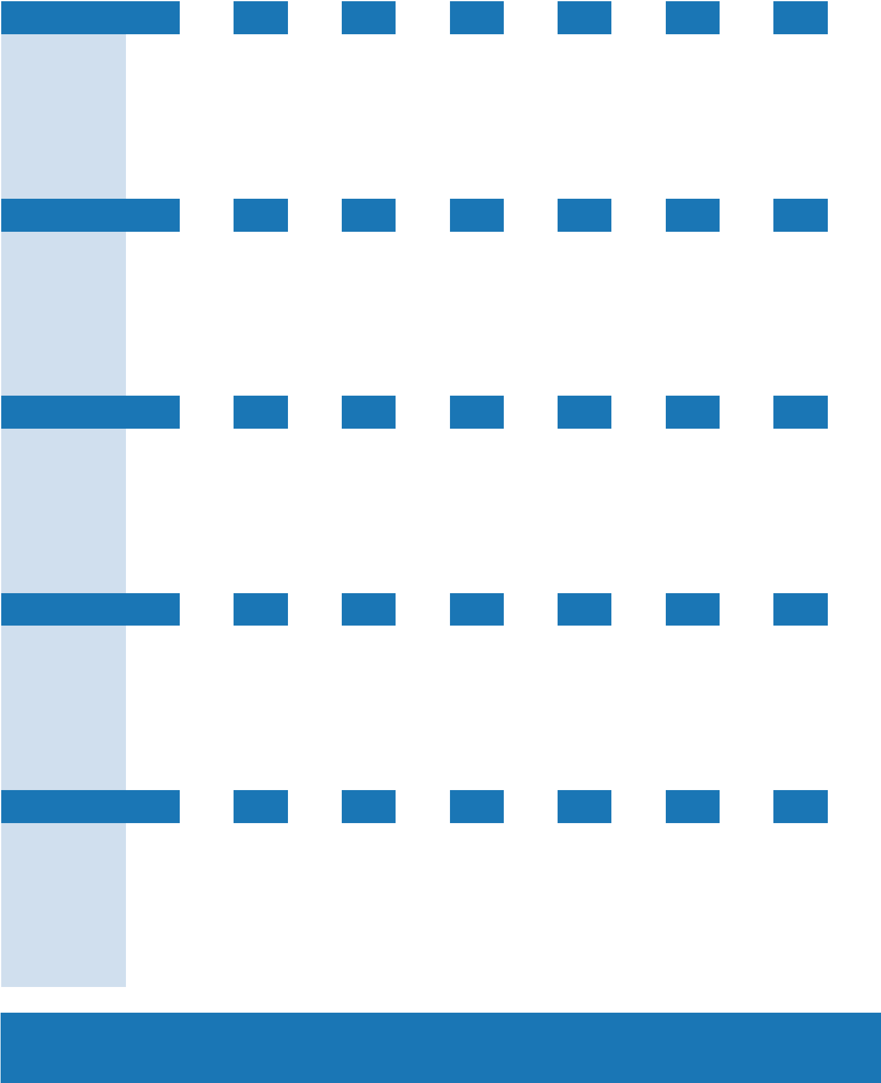

If the temperature is outside of +2˚C to +8˚C, contact your public health unit immediately.

Vaccine Storage Troubleshooting Record


Date

Time

Temperature
at Time of

Discovery

Problem

Action Taken

(If applicable, indicate

name of health unit staff

who provided assistance)

Results

Initials

Vaccine Storage Troubleshooting Record

Date

Time

Temperature
at Time of

Discovery

Problem

Action Taken

(If applicable, indicate

name of health unit staff

who provided assistance)

Results

Initials

Vaccine Storage Troubleshooting Record


Date

Time

Temperature
at Time of

Discovery

Problem

Action Taken

(If applicable, indicate

name of health unit staff

who provided assistance)

Results

Initials

Product No. 761019080 40,000 March 2021 © Queen’s Printer for Ontario 2021

