Interior Jan 16-17
Design 2020
Show Toronto

IDS Contract

Metro Toronto Convention Centre South Building

IDS Contract brings people together to experience the Power of Design.
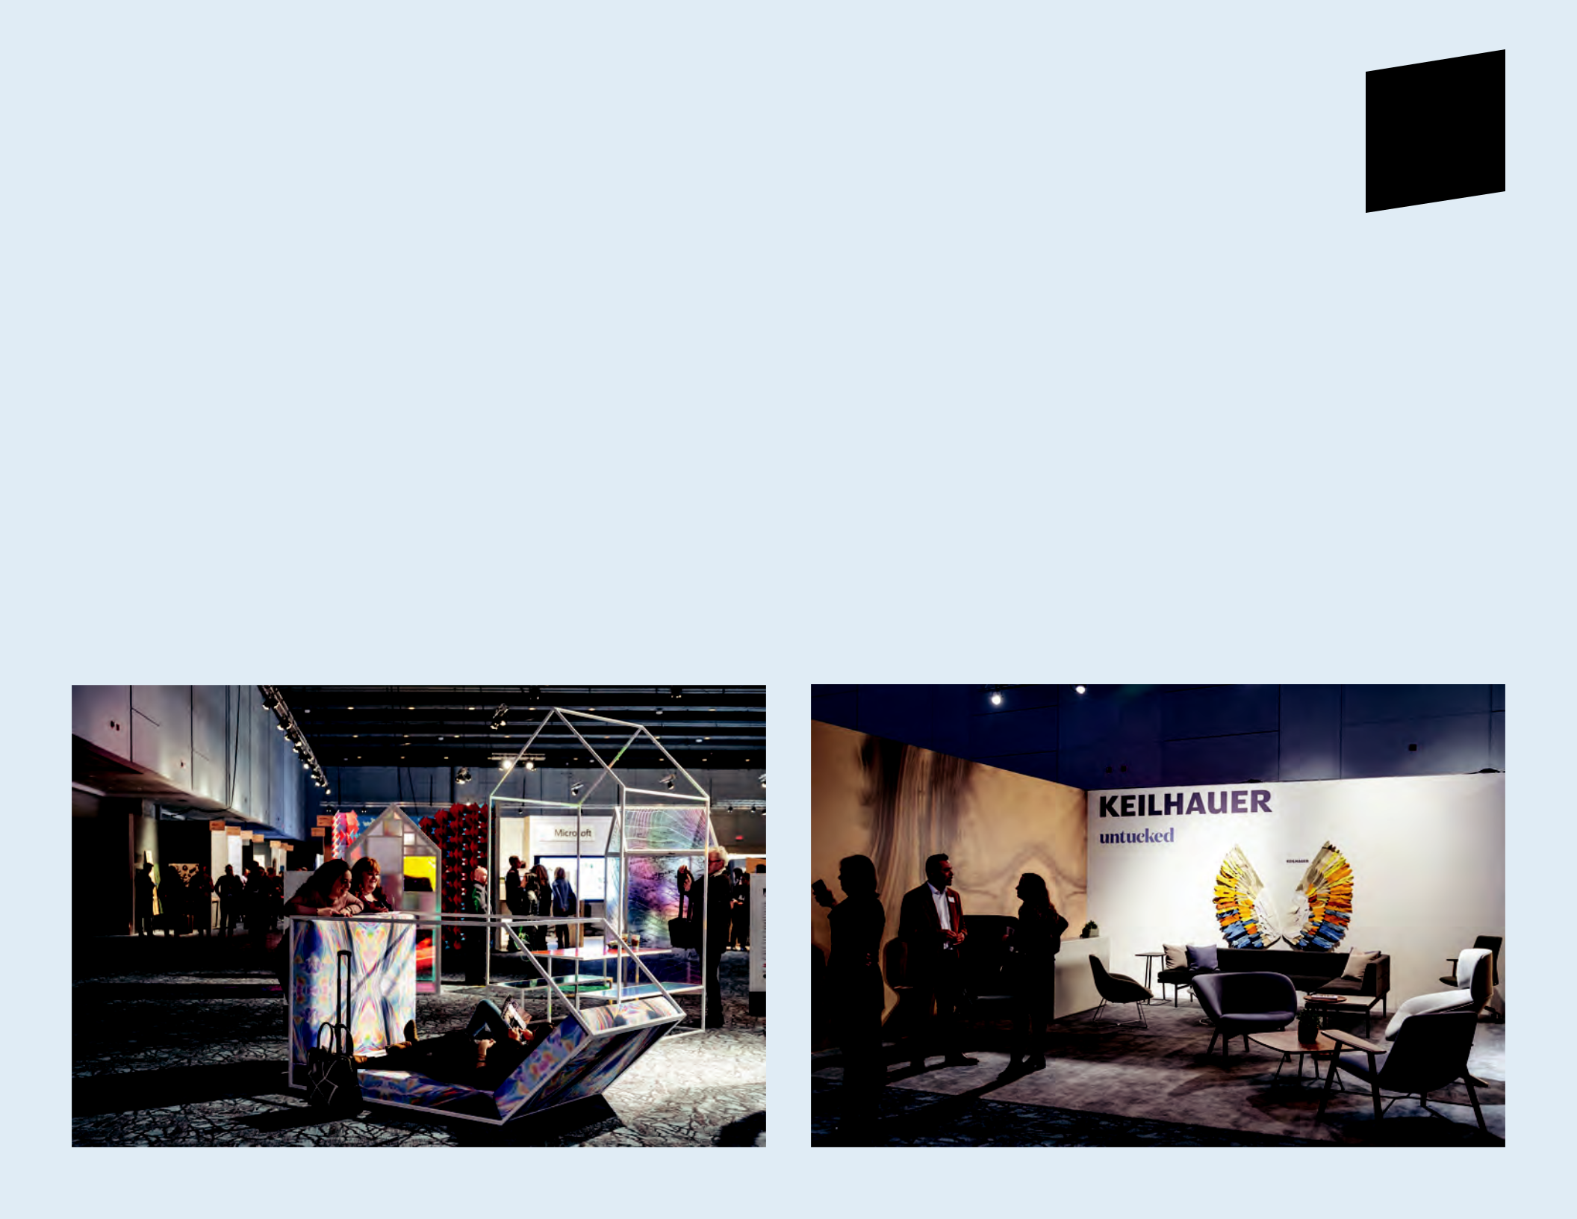

A hyper-curated B2B trade-only exposition and conference for the architecture and interior design professional.

Astley Gilbert Experiential Hub Keilhauer

Why IDS Contract?

14K+

over 14,000 trade

1st

Toronto is home to the

2020 Rates

Turnkey Booth Fee:

Reach a Targeted Audience & Generate Leads

IDS Contract is exclusive to the trade and brings industry together with architects, interior designers, facility managers, property managers, real estate executives and

professionals from across Canada and 26 other countries attended in 2019.

90%

of trade attendees are key

largest design industry in Canada – 3rd largest in North America. It currently has the highest crane count in North America with 191 commercial and residential high-rise and

5' x 10' inline 10' x 10' inline 20' x 10' inline 5' x 20' inline 10' x 10' corner 20' x 10' corner

- $3,939 CAD + HST

- $6,556 CAD + HST

- $11,445 CAD + HST

- $6,871 CAD + HST

- $6,276 CAD + HST

- $11,166 CAD + HST

builders/developers.

Increase Brand Awareness Enhance Customer Experience

Partnering with IDS is not simply a branding exercise, we work with our partners to create compelling content that is integrated within the framework of the show and allows companies to connect directly with A&D customers in new and exciting ways.

Align with Creative Minds & Industry Leaders

IDS Contract includes a robust conference program comprising of roundtables, master classes, seminars, tours and keynotes. From thought leadership, to creating unique experiences for your potential clients, we help you connect with the brands, firms and design professionals.
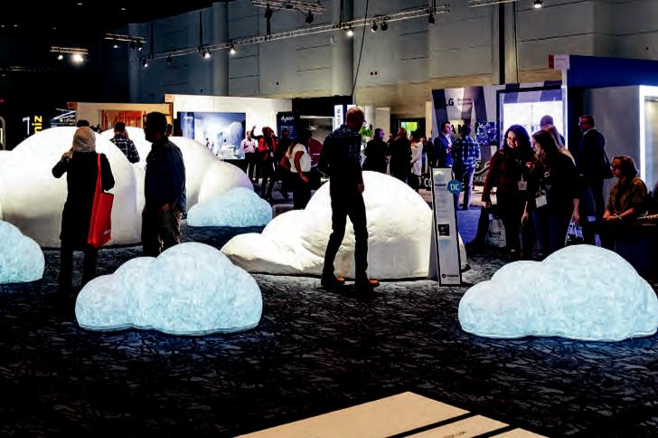

decision-makers who visit the show to specify for an existing project.

346 Million

will be spent on projects this year.

200+

over 200 brands featuring their new product launches,
- CEU-accredited seminars, 6 world-class keynote speakers, groundbreaking features, networking lounges and opening night party.

mid-rise projects under construction. It also has an additional 400+ high-rise projects proposed.

400+

over 400 media representatives attended IDS in 2019, resulting

in 220 million media impressions globally.
Includes:

- 10' High White Hard Walls

- Electricity 1500 Watt 110 Volt

- Floor Covering

- Lighting

- Standardized Booth Signage

Large Turnkey Booth Fee:

20' x 20' inline = $18,457+HST

20' x 20' corner = $17,518+HST

Includes:

- 10' High White Hard Walls

- Standardized Booth Signage

For additional information about IDS Contract, visit InteriorDesignShow.com

To apply, please contact Maria Ropotyn at 416 960 4520 / maria.ropotyn@informa.com
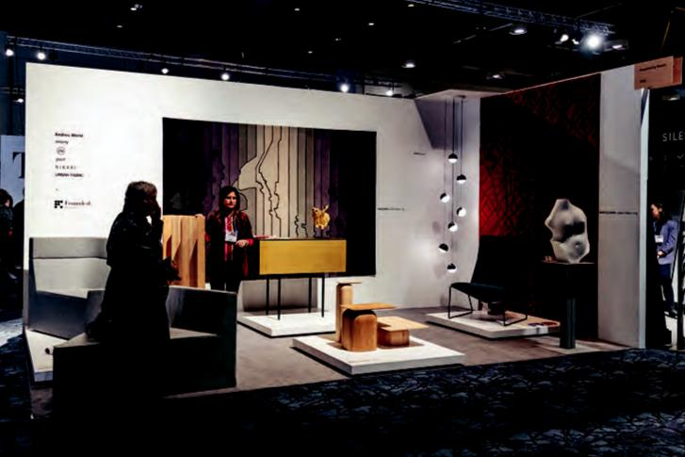

Haven Founded by Garcia


Interior Jan 16-17
Design 2020
Show Toronto

DS20 Contract Application
Hall F & G

Exhibitor Information

Company Name:

Exhibitor Listing Name:

Address:

City: Province/State: Postal/Zip Code:

Telephone:

Website:

Contact Name:

Contact Email: Telephone:

Booth Design Firm:

Booth Fee

Turnkey Booth:

□ 5' x 10' inline = $3,939 CAD + HST

□ 5' x 20' inline = $6,871 CAD + HST

□ 10' x 10' inline = $6,556 CAD + HST

□ 10' x 10' corner = $6,276 CAD + HST

□ 20' x 10' inline = $11,445 CAD + HST

□ 20' x 10' corner = $11,166 CAD + HST

All Exhibit Space is Turnkey* and includes the following:

- 10' High Hard Walls

- Electricity 1500 Watt 110 Volt

- Floor Covering

- Lighting

- Standardized Booth Signage

Large Turnkey Booths:

- 20' x 20' inline = $18,457 CAD + HST

- 20' x 20' corner = $17,518 CAD + HST

Includes:
• 10' High White Hard Walls • Standardized Booth Signage

- Island spaces:

401 sq.ft. and larger

Raw Space at $36/sq.ft.

Corner Charge at $380/corner

- Other Options: We are interested in one or more
of the following; larger exhibit space, sponsorship opportunities, advertising.

Booth Design Criteria

As a design fair, it is expected that attention be given to the booth design and presentation of product. Items to consider (but not limited to): overall design aesthetic, merchandising and original design. Priority and preference will be given to exhibitors who are showcasing new and innovative product. The name of the design firm should be included with the proposed design.

Submission Guidelines: To be considered for IDS Contract, please submit your application, images and information for the product(s) and/or service(s) you will be showcasing and a booth design for how you will be showcasing in your exhibit space. No pop up displays or retractable banners permitted. No overhead trade banners are permitted. Suspended installations and lighting are welcome, please send to management for approval. Painting may be ordered through Show Management for an additional cost.

1

Interior Jan 16-17
Design 2020
Show Toronto

Payment

By providing your credit card information below and signing this application, you hereby request and authorize Show Management to automatically charge the credit card set forth below in the amounts and on the dates listed in page 2 of this application. You hereby agree and acknowledge that all such charges are valid and accurate. You agree you will not dispute any such charges with your credit card company and hereby release Show Management from any and all claims in respect thereof. If, any time, your credit card is declined for any reason whatsoever you agree upon our notification to promptly provide an alternative form of acceptable payment. Failure to do so could result in late fees and/or penalties. All pages must be signed and sent by fax to 416-927-0862.

A deposit of 20% is required. If the deposit is not attached, the application will not be processed.

- My cheque is enclosed (made payable to “Informa Canada Inc.”)

- I will be paying the balance of my invoice via cheques (made payable to “Informa Canada Inc.”)

- Please debit Visa / Amex / MasterCard: (Credit charges will appear as “Informa Canada Inc.”)

Card Number: | Expiry Date:
Name on Card: | Signature:

Read Carefully

Applicants are hereby notified that Show Management is under no obligation to assign any space rental, but reserves the right to determine the location of any space rental and to assign a different location from the space occupied by the applicant in any previous show. Show Management shall not be held responsible for any damage, loss of business or inconvenience suffered by any applicant due to assignment or non-assignment of rental space. Should this application be accepted, Show Management shall send the applicant a booth confirmation clearly indicating the location of the space rental.

I understand that a signed contract along with your 20% deposit must reach our office within 10 business days of my application being accepted or my space will be released. By signing this application, I agree that you must pay 50% 30 days after being accepted into the show and full payment must be made 60 days after acceptance. I understand that my deposit is non-refundable. I also understand that the deposit will be applied toward my total booth fee.

I agree to comply with Ontario’s Occupational Health & Safety Act and its applicable Regulations and to ensure that all staff and third party contractors are equipped with steel toed boots/shoes (and other appropriate Personal Protective Equipment as needed), which must be worn on the show floor during move-in and move-out.

CANCELLATION & RELOCATION POLICY: Management shall in no event be required to make any rebate or refund to the exhibitor in connection with any cancellation of this application. Management reserves the right to relocate exhibitor in space other than specified herein. A change in location shall not relieve the exhibitor of their obligations hereunder.

Communication

- I agree to allow the Interior Design Show to contact me by email regarding information as it pertains to the event which may include the following: contracting, general information about exhibiting, exhibitor information and event newsletter.

- I agree to allow the Interior Design Show to share my contact information with exclusive show suppliers as it pertains setting up for the event. These suppliers provide services such as but not limited to: Material Handling, Lighting & Electrical, Parking passes, Show Guide Publishing, etc.

For more information or to unsubscribe from receiving any further commercial electronic communications from Informa Canada Inc., please contact a representative at 20 Eglinton Ave. West, suite 1200, Toronto, M4R 1K8 c/o Interior Design Show Toronto or by email at Laura.Bennett@Informa.com

Authorized Signature:

Print Name: Date:

2


Interior Jan 16-17
Design 2020
Show Toronto

Additional Exhibitor Marketing Opportunites

In addition to an exhibitor listing on our website and floor plan

handout there are several additional marketing opportunities available.

Please contact Show Management for more information.

- IDS Website Advertising

- IDS Newsletter Advertising

- Social Media Advertising

- IDS Show Guide Advertising

- Sponsorship

Exhibitor Categories Selection

Please select the category/categories that best describe your business

(maximum 4 allowed):

- Architects & Designers

- Carpet & Flooring

- Furniture

- Magazines

- Materials

- Accessibility

- Wallcovering

- Accessories

- Kitchen & Bath

- Workplace

- Textiles

- Healthcare

- Education

- Commercial Interiors

- Lighting

- Outdoor/Landscape

- Sustainable/Wellness

- Hospitality

- Senior Living

- International Trade Commissions

- Windows & Doors

- Technology/Innovation

The exhibitor listing is a valuable resource to our audience therefore

show management reserves the right to edit the exhibitor listed categories.

3

