TERMS AND CONDITIONS

For the delivery of Handyman Services 2015 (AVHD 2015)
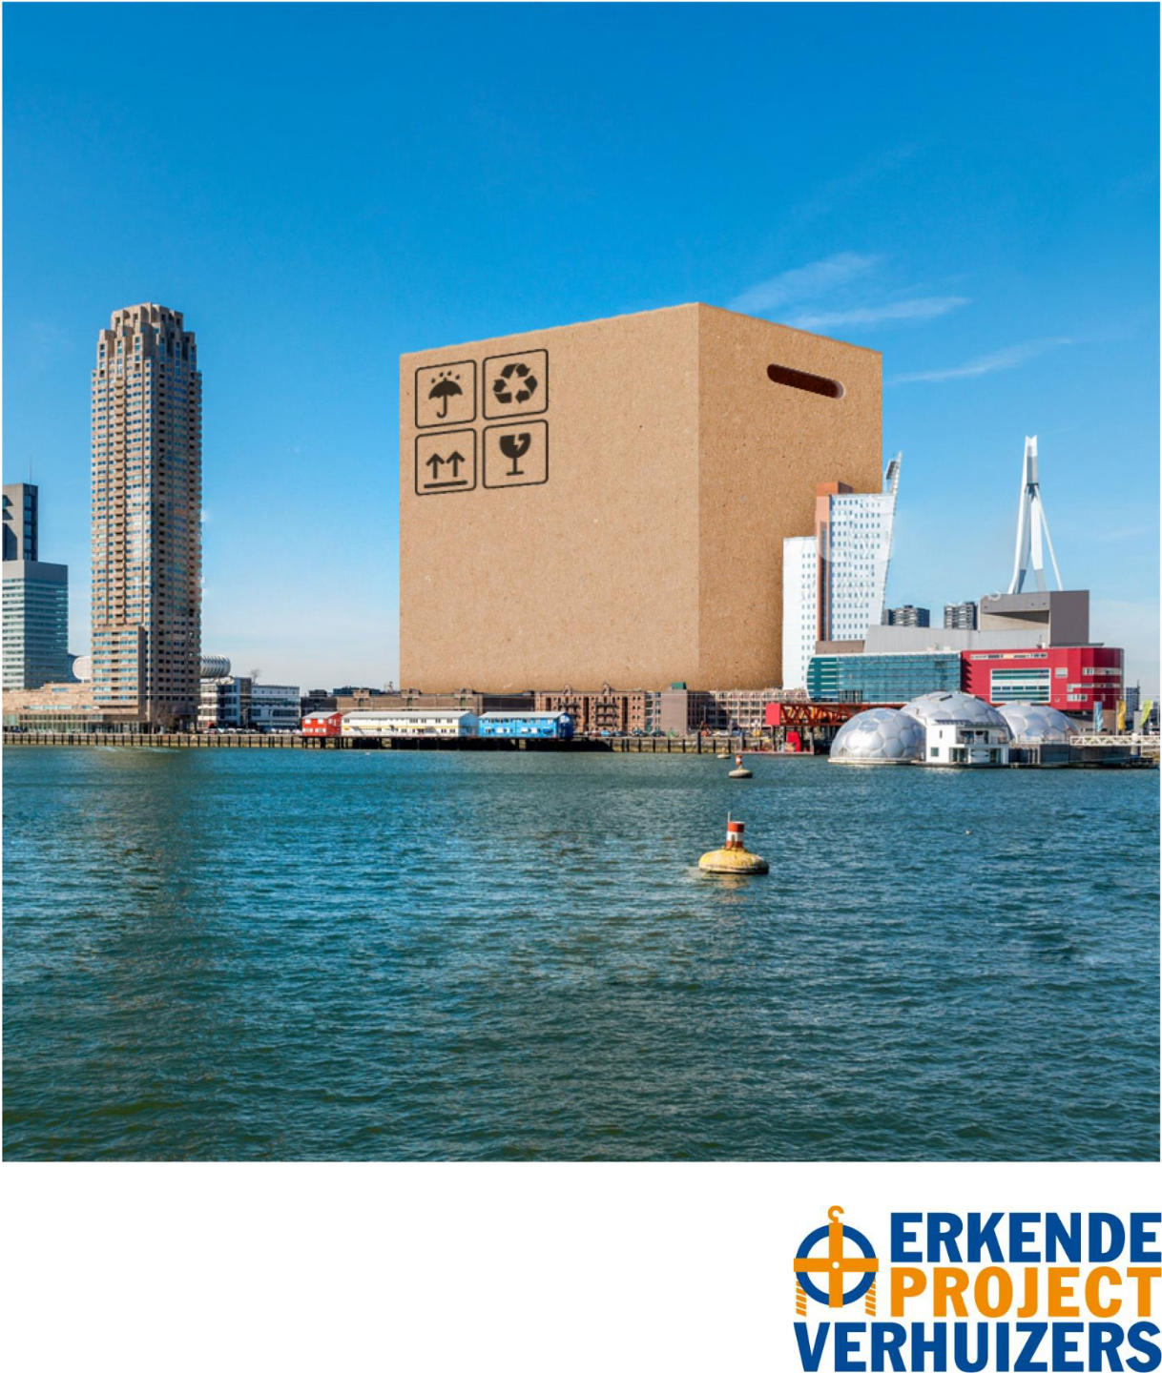

© 2015, Organisatie of Recognised Removers

No part of this publication may be reproduced, stored in a retrieval system or transmitted in any form or by any means, electronic, mechanical, photocopying, recording, or otherwise, without the prior written permission of the Publishers.

Terms and Conditions for the delivery of Handyman services 2015 (AVHD 2015)
Edition: Organisation of Recognised Removers
Bredewater 26, 2715 CA Zoetermeer

T: 070-3401788
- info@erkendeverhuizers.nl
www.erkendeverhuizers.nl

AVHD 2015 © Organisation of Recognised Removers Page 2 of 8

INDEX

TERMS AND CONDITIONS FOR THE DELIVERY OF HANDYMAN SERVICES 2015 (AVHD 2015)

ARTICLE 1 - Definitions |  |  | 4
ARTICLE 2 - Scope |  |  | 4
ARTICLE 3 - Conclusion of the Agreement |  |  | 4
ARTICLE 4 - Obligations of the Recognised Remover |  |  | 5
ARTICLE 5 - Obligations of the Client |  |  | 5
ARTICLE 6 | - Changes to the contract |  | 5
ARTICLE 7 | - Unforeseen complications |  | 5
ARTICLE 8 | - Delivery |  | 6
ARTICLE 9 | - Payment in instalments |  | 6
ARTICLE 10 - Final account |  |  | 6
ARTICLE 11 - Deferment of the payment |  |  | 6
ARTICLE 12 - Failure to fulfil the payment obligation |  |  | 6
ARTICLE 13 - Guarantee |  |  | 7
ARTICLE 14 |  | - Disputes | 7
ARTICLE 15 |  | - Binding recommendations compliance guarantee | 7
ARTICLE 16 |  | - Amendments to the General Terms and Conditions | 8
ARTICLE 17 |  | - Short title | 8

AVHD 2015 © Organisation of Recognised Removers Page 3 of 8

TERMS AND CONDITIONS FOR THE DELIVERY OF HANDYMAN SERVICES 2015 (AVHD 2015)

ARTICLE 1 - DEFINITIONS

In these Terms and Conditions, the following terms are understood to mean:

- Client: the contracting authority acting as a consumer or acting in the performance of his duties or the operation of a business;

- Consumer: a natural person acting for purposes that are not contained in the scope of his duties or business operations;

- Recognised Remover: the contractor (Erkende Verhuizer) recognised by the Dutch Organisation of Recognised Removers who provides consumers with professional removal services and who provides Handyman odd-job services in a commercial capacity;

- Handyman Agreement: the contract for odd jobs in which the Recognised Remover undertakes to execute odd jobs for the Client;

- Contract Extras and Reductions: additions to and reductions of the agreed work requested by the Client that lead to additional charges to or deductions from, the arranged price;

- Disputes Committee: the Disputes Committee for Removal Services of the Dutch Foundation forConsumer Complaints Boards (Geschillencommissie Verhuizen van de Stichting Geschillencommissies voor Consumentenzaken) (P.O. Box 90600, 2509 LP The Hague, the Netherlands, www.sgc.nl).

ARTICLE 2 - SCOPE

These General Terms and Conditions – hereafter called Handyman Terms and Conditions – apply to all offers and contracts between the Client and the Recognised Remover.

ARTICLE 3 - CONCLUSION OF THE AGREEMENT

- The Recognised Remover shall ensure that every contract is in principle recorded in writing in a Contract Form for Handyman Services. A contract comprises a clear description of the work that is to be done, including:

  - a record of the time at which the work can be started and an indication of the duration of the work;

  - the price of the work;
  - the method of payment.

- The Client and the Recognised Remover may make arrangements on the basis of one of two methods of pricing:

  - - a fixed price;
  - - a cost-plus contract.

- Departures from a fixed price in the final account are only possible on the grounds of a provision in these Handyman Terms and Conditions. For a cost-plus contract, the Client and the Recognised Remover agree that the costs incurred by the Recognised Remover shall be reimbursed; the hourly rate, and if possible, the other costs, are fixed in advance; the Recognised Remover draws up a breakdown of the hours worked and all other costs, including the costs of the materials used for the contract,for each account. If preferred, a guide price may be given for a cost-plus contract. A guide price should be an estimate of the ultimate overall price owed that is as accurate as possible; that estimate pertains to the number of hours to be worked and/or the materials to be used and/or the other costs. It is also possible to usea combination of these two methods of pricing (part fixed price, part cost-plus contract).

- If the Client is a consumer, all prices stated shall include VAT.

- The Recognised Remover shall ensure that the Client receives these Handyman Terms and Conditions in due time, but no later than the conclusion of the Agreement.

AVHD 2015 © Organisation of Recognised Removers Page 4 of 8

ARTICLE 4 - OBLIGATIONS OF THE RECOGNISED REMOVER

The Recognised Remover guarantees that the work will be well and thoroughly delivered in accordance with the provisions of the Agreement and that he will use sound methods and materials.

- When preparing and executing the contract, the Recognised Remover will take the Client’s wishes into consideration and make adjustments to accommodate the Client’s wishes, insofar as possible.

- During the execution of the work, the Recognised Remover will observe the applicable rules and regulations as they are effective or will be effective at the time the work is executed.

- The Recognised Remover is obliged to point out to the Client:

  - errors in the commissioned work, insofar as the Recognised Remover is aware of them or could reasonably be expected to be aware of them;

  - errors in the constructions and methods requested by the Client;
  - apparent faults in the (im)moveable good on which the work is to be executed;

  - faults in or inappropriateness of materials or equipment that have been furnished by the Client;

insofar these matters are apparent to the Recognised Remover prior to, or during, the execution of the work and the Recognised Remover should be deemed to be an expert of the matter.

- If the Recognised Remover fails to perform one or more agreements, or the performance is overdue or not adequate, he is obliged to pay compensation for the damage that could reasonably be considered to be related to that failure.

ARTICLE 5 - THE CLIENT’S OBLIGATIONS

- The Client guarantees the soundness and the appropriateness of the materials and equipment he has furnished or which he has given instructions to use and for the accuracy of the details he has provided.

- The Client should ensure that the Recognised Remover can execute the work timely and thoroughly.

- If the Client fails to perform one or more agreements, or the performance is overdue or not adequate, he is obliged to pay compensation for the damage that could reasonably be considered to be related to that failure.

- The Client bears the risk of damage caused by:
  - errors in the commissioned work;
  - errors in the constructions and methods requested by the Client;
  - apparent fault in the (im)moveable good on which the work is executed;

  - faults in or inappropriateness of materials or equipment furnished by the Client. This is does not detract from the Recognised Remover’s duty to warn the Client pursuant to Article 4, paragraph 4.

ARTICLE 6 - CHANGES TO THE CONTRACT

Parties may agree on Contract Extras and Reductions, which the Recognised Remover shall ensure that the changes are recorded in writing on a contract form as specified in Article 3 and which shall include the Client’s approval.

ARTICLE 7 - UNFORESEEN COMPLICATIONS

- If unforeseen complications arise, the Recognised Remover should notify the Client of them as soon as possible.

- If the Recognised Remover cannot contact the Client, the Recognised Remover should interrupt the work, except if the unforeseen complication necessitates immediate action.
- Any additional costs that the Recognised Remover must incur as a result of immediate action and that are necessary to limit the damage shall be reimbursed by the Client unless the damage is attributable to the Recognised Remover.

AVHD 2015 © Organisation of Recognised Removers Page 5 of 8

ARTICLE 8 - DELIVERY

- On completion of the work, the Recognised Remover shall invite the Client to inspect the delivery of the executed work. The Client should respond within a reasonable term and may accept the work, provisionally or otherwise, or reject the work, stating the faults.

- If faults are identified that should be restored by the Recognised Remover, the Recognised Remover will restore the faults as soon as possible, but no later than within two weeks of the delivery date, unless that is impossible due to circumstances that are beyond the Recognised Remover’s control.

ARTICLE 9 - PAYMENT IN INSTALMENTS

- If parties have agreed on payment in instalments, the payment should be made proportionately to the progress. The payment should be made no later than two weeks following the receipt of the bill.

- If payment in instalments has been agreed and the Recognised Remover fails in the performance of his obligations related to the progress of the work, the Client has the authority to defer the payment.

- If the Client fails to perform his obligations regarding the payments, the Recognised Remover has the authority to defer the progress of the work.

ARTICLE 10 - FINAL ACCOUNT

- The Recognised Remover shall hand the final account to the Client on delivery of the work or arrange to send it to the Client as soon as possible following the delivery of the work.

- If the Agreement is based on a cost-plus contract (in combination with a guide price or otherwise), the final account should contain a breakdown of the hours worked, supplied materials and other costs (such as the hire of tools, parking costs, municipal tax on encroachments in, on or above public land, etc.).

- If the Agreement is based on a fixed price, the final account should contain a breakdown of the fixed price, any “contract extras or reductions” and any additional costs on the grounds of unforeseen complications.

- The final account should also contain a breakdown of the sums, if any, already paid by the Client and the remaining balance.

- All payments should be made within two weeks of receipt of the bill, unless parties have agreed on a different term.

ARTICLE 11 - DEFERMENT OF THE PAYMENT

- If the delivered work does not meet the requirements of the Agreement, the Client is entitled to defer the payment on the condition that the deferred amount is in reasonable proportion to the identified fault.

- If the deferred amount is not reasonably proportionate to the identified fault, the Recognised Remover is entitled to charge the statutory interest rate on the excess of the deferred payment.

ARTICLE 12 - FAILURE TO FULFIL THE PAYMENT OBLIGATIONS

- If the Client’s payment is overdue, he will be deemed in default by law without requiring any notice of default. Nonetheless, the Recognised Remover will send one reminder of payment after the payment term (as specified in Article 9, paragraph 1, and Article 10, paragraph 5) has expired, in which the Recognised Remover calls the Client’s attention to the failure to pay and grants the Client the opportunity to pay the reminder as yet, within two weeks of the receipt of the reminder of payment.

- The Recognised Remover may charge interest on overdue payment as of the expiry date of the payment term (as specified in Article 10, paragraph 5) until the day the amount due is paid. The rate of that interest equals the statutory interest rate.

AVHD 2015 © Organisation of Recognised Removers Page 6 of 8

- After the term mentioned in paragraph 1 has expired, the Recognised Remover is entitled to arrange the collection of the amount due to the Recognised Remover without further notice of default.

ARTICLE 13 - GUARANTEE

- The Recognised Remover guarantees that any faults that emerge after the delivery will be restored without charge during a twelve-month term, unless he demonstrates that the fault is not a consequence of the work. If parties have agreed on a longer term, that term should be recorded on the contract form. The above is without prejudice to the fact that the Recognised Remover may still be liable for any faults after that term pursuant to the law.

- The fault specified in paragraph 1 are faults that could not have been recognised by the Consumer than at the time of their discovery and of which the contractor has been notified by the Consumer in writing within the competent period. If the contractor is not notified of complaints in due time, the Client could lose his rights in that matter.

ARTICLE 14 - DISPUTES

- Both the Consumer and the Recognised Remover may bring disputes between the Consumer and the Recognised Remover related to the formation of agreements pertaining to the work delivered by the Recognised Remover before the Disputes Committee.

- A dispute will only be heard by the Disputes Committee if the Consumer has first submitted his complaint to the Recognised Remover.

- After the complaint has been submitted to the Recognised Remover, the dispute should be brought before the Disputes Committee no later than within three months of the time the dispute arose.

- If the Consumer brings a dispute before the Disputes Committee, the Recognised Remover is bound to that decision. If the contractor wants to bring a dispute before the Committee, the contractor must request the Consumer to decide whether the Consumer agrees to that decision within five weeks. The contractor should announce that, after that term has expired, he shall feel at liberty to bring the dispute before the court.

- The Disputes Committee pronounces a decision with due observance of the provisions of the regulations that apply to the Committee. The Disputes Committee’s regulations are available on request.

The decisions of the Disputes Committee are pronounced by means of a binding recommendation. A fee is owed for hearing a dispute.

- The court and the aforementioned Disputes Committee have sole competence to hear disputes.

ARTICLE 15 - BINDING RECOMMENDATIONS COMPLIANCE GUARANTEE

- The Organisation of Recognised Removers guarantees the performance of the binding recommendations by its members, unless the member decides to submit it to the court for review within two months of the announcement of the binding recommendation. That guarantee will be revived if the binding recommendation is upheld after review by the court and the decision from which that emerges becomes final. In the event of a sum not exceeding EUR 10,000 per binding recommendation, that sum will be paid out to the Consumer by the Organisation of Recognised Removers. In the event of sums larger than EUR 10,000 per binding recommendation, the consumer will be paid a sum of EUR 10,000. With respect to the excess of that sum, the Organisation of Recognised Removers has a best efforts obligation to ensure that the member complies with the binding recommendation. That best efforts obligation means that the Consumer will be given the opportunity to transfer his claim to the Organisation of Recognised Removers, after which the Organisation of Recognised Removers will, under its own name, bear the expenses for applying for the payment of that claim in court to pay the Consumer.

AVHD 2015 © Organisation of Recognised Removers Page 7 of 8

- The Organisation of Recognised Removers will not provide a performance bond if, prior to meeting the formal intake requirements (payment of complaint-filing fee, return of completed and signed questionnaire and deposit) for hearing the dispute on behalf of the Consumer, one of the following situations arises or has arisen:

  - the member has been granted a moratorium;
  - the member has been declared bankrupt;

  - the business operations have been effectively terminated. A determining factor for that situation is the date on which the business discontinuation is registered in the Trade Register or an earlier date of which the Organisation of Recognised Removers can convincingly argue that the business operations were effectively terminated.

- The Recognised Remover has taken out an additional insurance policy for the Consumer. That insurance policy covers the liability of the Recognised Remover to the Client to a sum of EUR 1,000,000 per claim; a sum of EUR 10,000 applies to material damage to the work, to the materials intended for the work and a sum of EUR 250,000 applies to the Client’s current possessions. A bankruptcy coverage to a sum of EUR 10,000 per decision applies to the performance of the decisions by the Disputes Committee. That insurance policy has been taken out as a group insurance by the Organisation for Recognised Removers for its affiliated members.

ARTICLE 16 - AMENDMENTS TOTHE GENERAL TERMS AND CONDITIONS

Amendments to these Terms and Conditions may only be implemented in agreement with the Dutch Consumer Association, whose legal Dutch name is Consumentenbond, if and insofar the amendments arise from the amendments to legislation and regulations with respect to the execution of the work to which these Terms and Conditions pertain. In the event of such amendments, those amendments only shall become effective as of one month after the amendments have been published. The Organisation of Recognised Removers assumes the duty to publish established amendments.

ARTICLE 17 - SHORT TITLE

The General Terms and Conditions, whose official Dutch language title is Algemene Voorwaarden, may be quoted as AVHD 2015.

AVHD 2015 © Organisation of Recognised Removers Page 8 of 8

