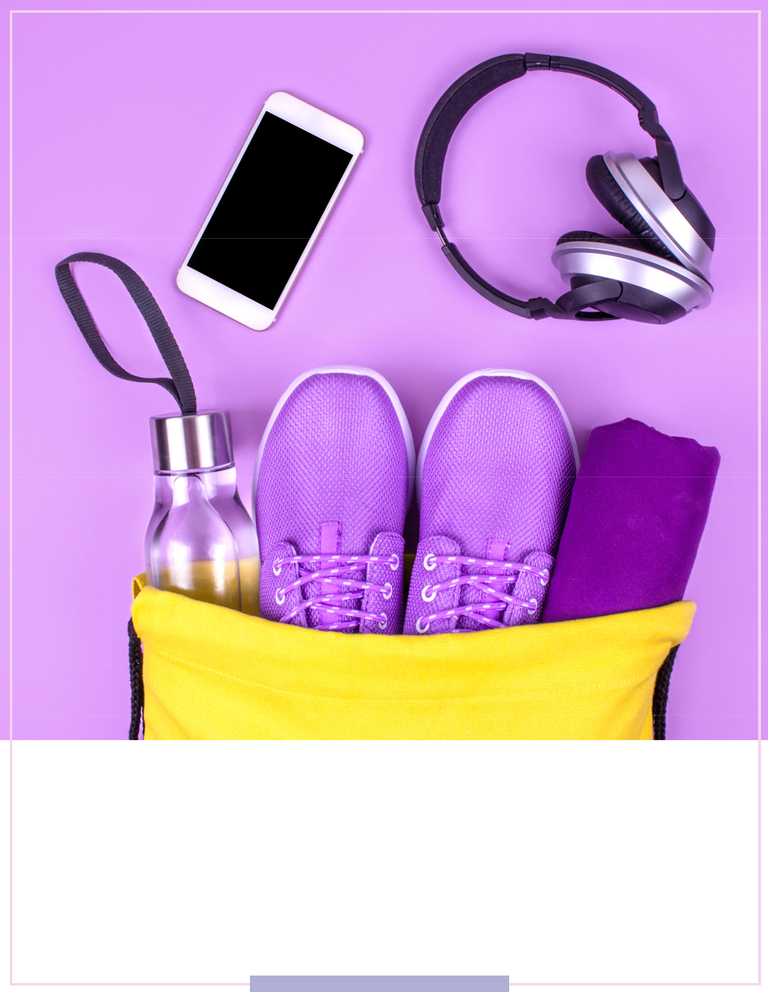

The 21-Day

Health Habit Tracker

WWW.MYMACROMENTOR.COM

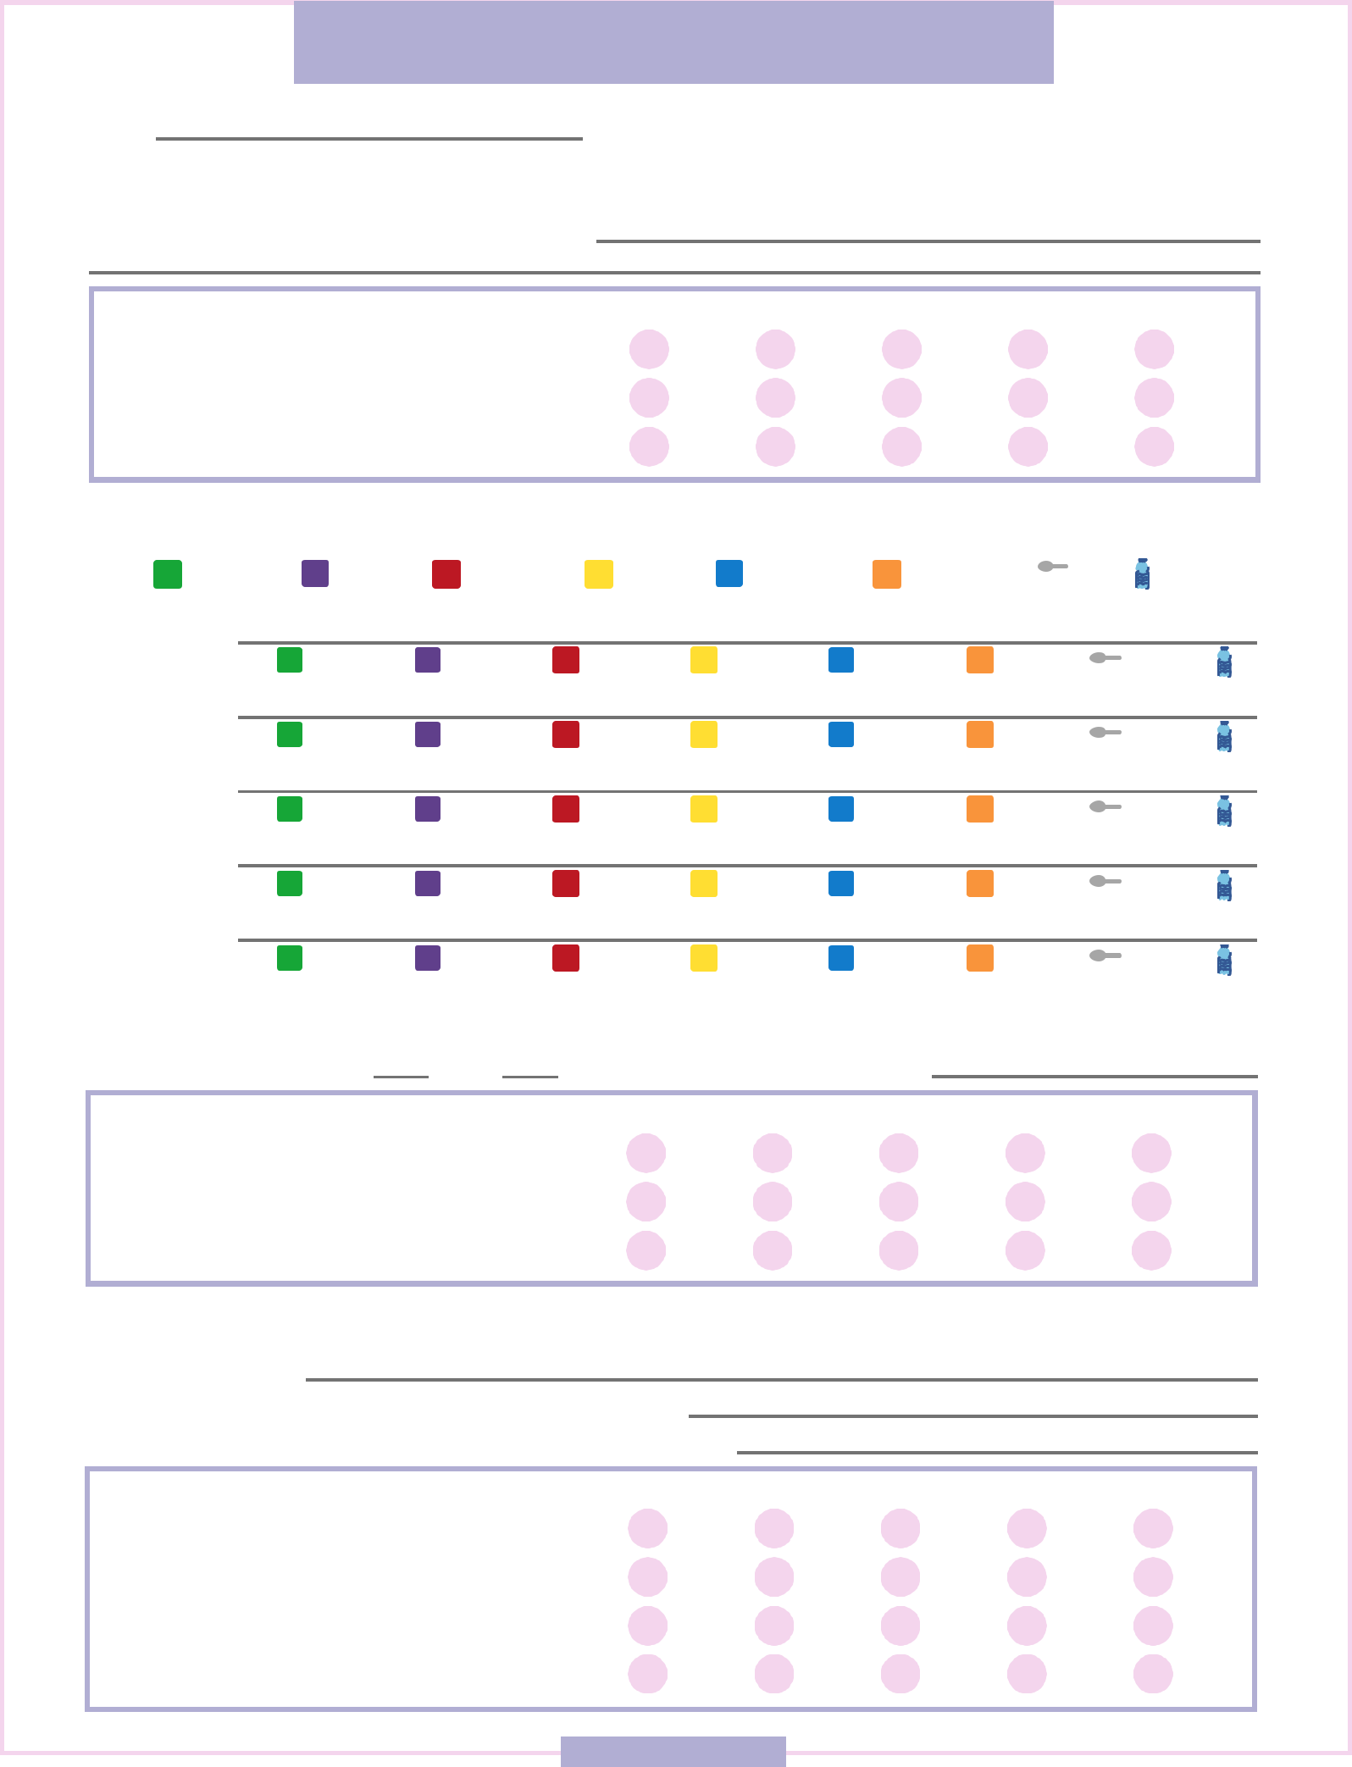
WEEK 1 DAY 1

DATE M T W T F S S

BEGIN WITH MINDFULNESS

What are your today's goals and intentions?

Rate when you wake up:
SLEEP | 1 | 2 | 3 | 4 | 5
MOOD | 1 | 2 | 3 | 4 | 5
ENERGY | 1 | 2 | 3 | 4 | 5

BEING HEALTHY

VEGGIES | FRUITS | PROTEIN | CARBS | HEALTHY | SEEDS & | TEASPOON | WATER
 |  |  |  | FATS | NUTS | TEASPOON | WATER

BREAKFAST

SNACK

LUNCH

SNACK

DINNER

BEING FIT

Did you work out today? | YES | NO | For how long?
Rate your attitude about:
BODY |  | 1 | 2 | 3 | 4 | 5
NUTRITION |  | 1 | 2 | 3 | 4 | 5
ENERGY |  | 1 | 2 | 3 | 4 | 5

END WITH REFLECTION

What went today?

What's one thing you can improve on for tomorrow?

What emotions did you feel when eating or after eating?

Rate the day:
ENERGY | 1 | 2 | 3 | 4 | 5
MOOD | 1 | 2 | 3 | 4 | 5
DIGESTION | 1 | 2 | 3 | 4 | 5
BOWEL MOVEMENT | 1 | 2 | 3 | 4 | 5

WEEKWEEK1| 1DAY|DAY1 1

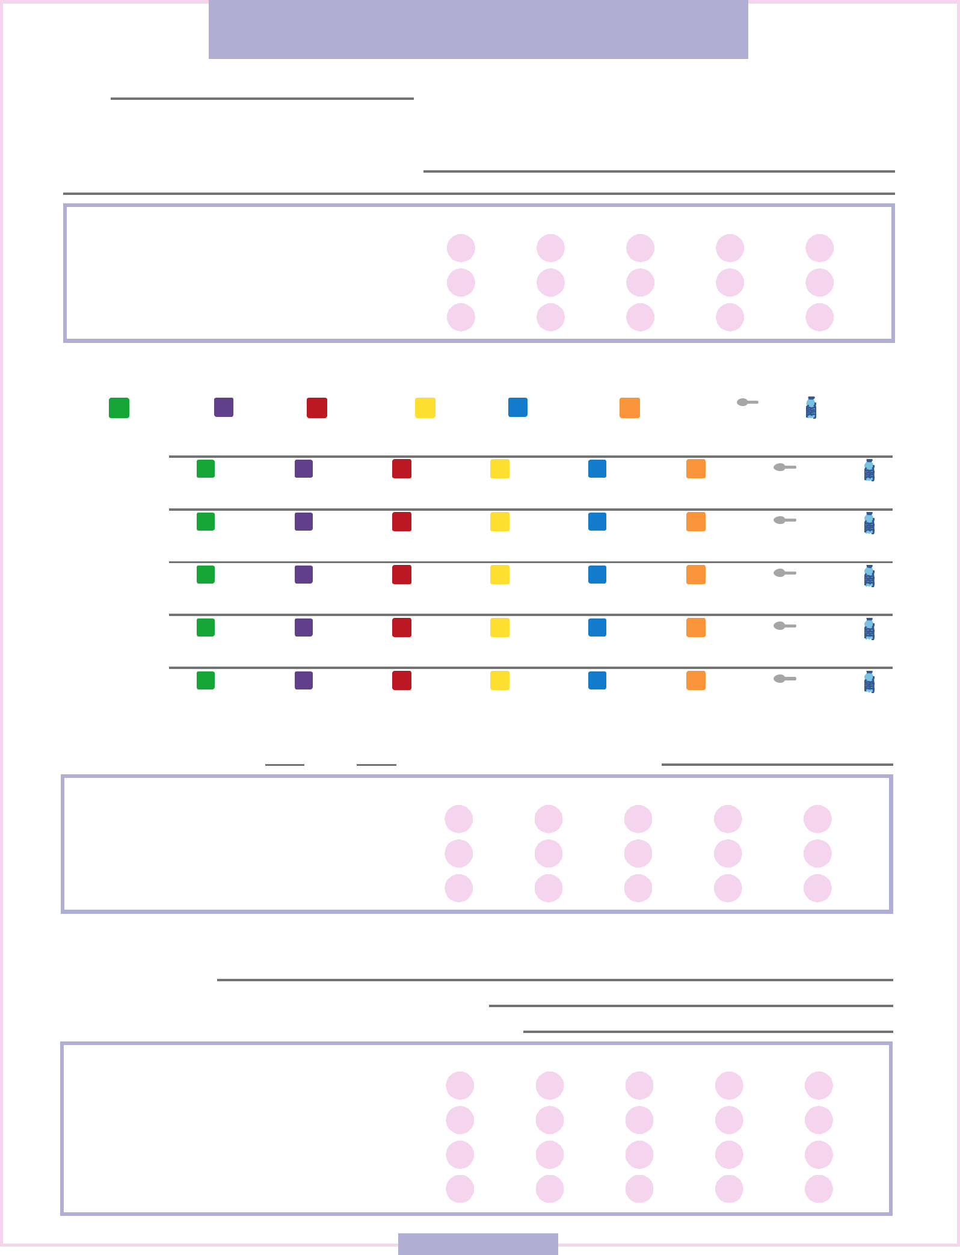
WEEK 1 DAY 2

DATE M T W T F S S

BEGIN WITH MINDFULNESS

What are your today's goals and intentions?

Rate when you wake up:
SLEEP | 1 | 2 | 3 | 4 | 5
MOOD | 1 | 2 | 3 | 4 | 5
ENERGY | 1 | 2 | 3 | 4 | 5

BEING HEALTHY

VEGGIES | FRUITS | PROTEIN | CARBS | HEALTHY | SEEDS & | TEASPOON | WATER
 |  |  |  | FATS | NUTS | TEASPOON | WATER

BREAKFAST

SNACK

LUNCH

SNACK

DINNER

BEING FIT

Did you work out today? | YES | NO | For how long?
Rate your attitude about:
BODY |  | 1 | 2 | 3 | 4 | 5
NUTRITION |  | 1 | 2 | 3 | 4 | 5
ENERGY |  | 1 | 2 | 3 | 4 | 5

END WITH REFLECTION

What went today?

What's one thing you can improve on for tomorrow?

What emotions did you feel when eating or after eating?

Rate the day:
ENERGY | 1 | 2 | 3 | 4 | 5
MOOD | 1 | 2 | 3 | 4 | 5
DIGESTION | 1 | 2 | 3 | 4 | 5
BOWEL MOVEMENT | 1 | 2 | 3 | 4 | 5

WEEK 1 | DAY 2

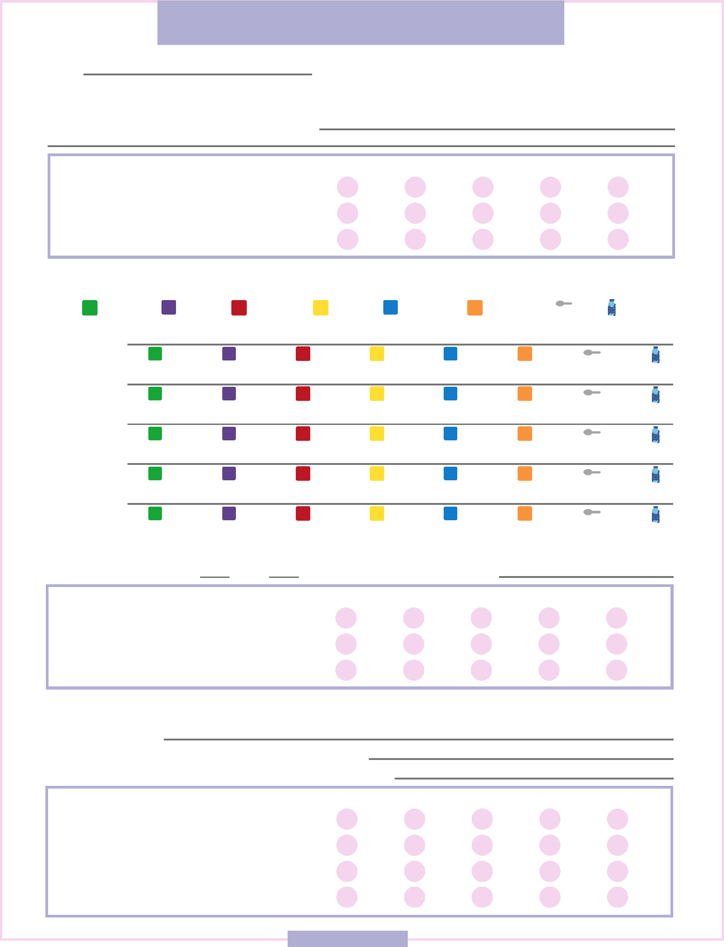
WEEK 1 DAY 3

DATE M T W T F S S

BEGIN WITH MINDFULNESS

What are your today's goals and intentions?

Rate when you wake up:
SLEEP | 1 | 2 | 3 | 4 | 5
MOOD | 1 | 2 | 3 | 4 | 5
ENERGY | 1 | 2 | 3 | 4 | 5

BEING HEALTHY

VEGGIES | FRUITS | PROTEIN | CARBS | HEALTHY | SEEDS & | TEASPOON | WATER
 |  |  |  | FATS | NUTS | TEASPOON | WATER

BREAKFAST

SNACK

LUNCH

SNACK

DINNER

BEING FIT

Did you work out today? | YES | NO | For how long?
Rate your attitude about:
BODY |  | 1 | 2 | 3 | 4 | 5
NUTRITION |  | 1 | 2 | 3 | 4 | 5
ENERGY |  | 1 | 2 | 3 | 4 | 5

END WITH REFLECTION

What went today?

What's one thing you can improve on for tomorrow?

What emotions did you feel when eating or after eating?

Rate the day:
ENERGY | 1 | 2 | 3 | 4 | 5
MOOD | 1 | 2 | 3 | 4 | 5
DIGESTION | 1 | 2 | 3 | 4 | 5
BOWEL MOVEMENT | 1 | 2 | 3 | 4 | 5

WEEK 1 | DAY 3

WEEK 1 DAY 4

DATE M T W T F S S

BEGIN WITH MINDFULNESS

What are your today's goals and intentions?

Rate when you wake up:
SLEEP | 1 | 2 | 3 | 4 | 5
MOOD | 1 | 2 | 3 | 4 | 5
ENERGY | 1 | 2 | 3 | 4 | 5

BEING HEALTHY

VEGGIES | FRUITS | PROTEIN | CARBS | HEALTHY | SEEDS & | TEASPOON | WATER
 |  |  |  | FATS | NUTS | TEASPOON | WATER

BREAKFAST

SNACK

LUNCH

SNACK

DINNER

BEING FIT

Did you work out today? | YES | NO | For how long?
Rate your attitude about:
BODY |  | 1 | 2 | 3 | 4 | 5
NUTRITION |  | 1 | 2 | 3 | 4 | 5
ENERGY |  | 1 | 2 | 3 | 4 | 5

END WITH REFLECTION

What went today?

What's one thing you can improve on for tomorrow?

What emotions did you feel when eating or after eating?

Rate the day:
ENERGY | 1 | 2 | 3 | 4 | 5
MOOD | 1 | 2 | 3 | 4 | 5
DIGESTION | 1 | 2 | 3 | 4 | 5
BOWEL MOVEMENT | 1 | 2 | 3 | 4 | 5

WEEK PAGE1|DAY44

WEEK 1 DAY 5

DATE M T W T F S S

BEGIN WITH MINDFULNESS

What are your today's goals and intentions?

Rate when you wake up:
SLEEP | 1 | 2 | 3 | 4 | 5
MOOD | 1 | 2 | 3 | 4 | 5
ENERGY | 1 | 2 | 3 | 4 | 5

BEING HEALTHY

VEGGIES | FRUITS | PROTEIN | CARBS | HEALTHY | SEEDS & | TEASPOON | WATER
 |  |  |  | FATS | NUTS | TEASPOON | WATER

BREAKFAST

SNACK

LUNCH

SNACK

DINNER

BEING FIT

Did you work out today? | YES | NO | For how long?
Rate your attitude about:
BODY |  | 1 | 2 | 3 | 4 | 5
NUTRITION |  | 1 | 2 | 3 | 4 | 5
ENERGY |  | 1 | 2 | 3 | 4 | 5

END WITH REFLECTION

What went today?

What's one thing you can improve on for tomorrow?

What emotions did you feel when eating or after eating?

Rate the day:
ENERGY | 1 | 2 | 3 | 4 | 5
MOOD | 1 | 2 | 3 | 4 | 5
DIGESTION | 1 | 2 | 3 | 4 | 5
BOWEL MOVEMENT | 1 | 2 | 3 | 4 | 5

WEEK 1 | DAY 5

WEEK 1 DAY 6

DATE M T W T F S S

BEGIN WITH MINDFULNESS

What are your today's goals and intentions?

Rate when you wake up:
SLEEP | 1 | 2 | 3 | 4 | 5
MOOD | 1 | 2 | 3 | 4 | 5
ENERGY | 1 | 2 | 3 | 4 | 5

BEING HEALTHY

VEGGIES | FRUITS | PROTEIN | CARBS | HEALTHY | SEEDS & | TEASPOON | WATER
 |  |  |  | FATS | NUTS | TEASPOON | WATER

BREAKFAST

SNACK

LUNCH

SNACK

DINNER

BEING FIT

Did you work out today? | YES | NO | For how long?
Rate your attitude about:
BODY |  | 1 | 2 | 3 | 4 | 5
NUTRITION |  | 1 | 2 | 3 | 4 | 5
ENERGY |  | 1 | 2 | 3 | 4 | 5

END WITH REFLECTION

What went today?

What's one thing you can improve on for tomorrow?

What emotions did you feel when eating or after eating?

Rate the day:
ENERGY | 1 | 2 | 3 | 4 | 5
MOOD | 1 | 2 | 3 | 4 | 5
DIGESTION | 1 | 2 | 3 | 4 | 5
BOWEL MOVEMENT | 1 | 2 | 3 | 4 | 5

WEEK 1 | DAY 6

WEEK 1 DAY 7

DATE M T W T F S S

BEGIN WITH MINDFULNESS

What are your today's goals and intentions?

Rate when you wake up:
SLEEP | 1 | 2 | 3 | 4 | 5
MOOD | 1 | 2 | 3 | 4 | 5
ENERGY | 1 | 2 | 3 | 4 | 5

BEING HEALTHY

VEGGIES | FRUITS | PROTEIN | CARBS | HEALTHY | SEEDS & | TEASPOON | WATER
 |  |  |  | FATS | NUTS | TEASPOON | WATER

BREAKFAST

SNACK

LUNCH

SNACK

DINNER

BEING FIT

Did you work out today? | YES | NO | For how long?
Rate your attitude about:
BODY |  | 1 | 2 | 3 | 4 | 5
NUTRITION |  | 1 | 2 | 3 | 4 | 5
ENERGY |  | 1 | 2 | 3 | 4 | 5

END WITH REFLECTION

What went today?

What's one thing you can improve on for tomorrow?

What emotions did you feel when eating or after eating?

Rate the day:
ENERGY | 1 | 2 | 3 | 4 | 5
MOOD | 1 | 2 | 3 | 4 | 5
DIGESTION | 1 | 2 | 3 | 4 | 5
BOWEL MOVEMENT | 1 | 2 | 3 | 4 | 5

WEEK 1 | DAY 7

WEEK 2 DAY 1

DATE M T W T F S S

BEGIN WITH MINDFULNESS

What are your today's goals and intentions?

Rate when you wake up:
SLEEP | 1 | 2 | 3 | 4 | 5
MOOD | 1 | 2 | 3 | 4 | 5
ENERGY | 1 | 2 | 3 | 4 | 5

BEING HEALTHY

VEGGIES | FRUITS | PROTEIN | CARBS | HEALTHY | SEEDS & | TEASPOON | WATER
 |  |  |  | FATS | NUTS | TEASPOON | WATER

BREAKFAST

SNACK

LUNCH

SNACK

DINNER

BEING FIT

Did you work out today? | YES | NO | For how long?
Rate your attitude about:
BODY |  | 1 | 2 | 3 | 4 | 5
NUTRITION |  | 1 | 2 | 3 | 4 | 5
ENERGY |  | 1 | 2 | 3 | 4 | 5

END WITH REFLECTION

What went today?

What's one thing you can improve on for tomorrow?

What emotions did you feel when eating or after eating?

Rate the day:
ENERGY | 1 | 2 | 3 | 4 | 5
MOOD | 1 | 2 | 3 | 4 | 5
DIGESTION | 1 | 2 | 3 | 4 | 5
BOWEL MOVEMENT | 1 | 2 | 3 | 4 | 5

WEEK 2 | DAY 1

WEEK 2 DAY 2

DATE M T W T F S S

BEGIN WITH MINDFULNESS

What are your today's goals and intentions?

Rate when you wake up:
SLEEP | 1 | 2 | 3 | 4 | 5
MOOD | 1 | 2 | 3 | 4 | 5
ENERGY | 1 | 2 | 3 | 4 | 5

BEING HEALTHY

VEGGIES | FRUITS | PROTEIN | CARBS | HEALTHY | SEEDS & | TEASPOON | WATER
 |  |  |  | FATS | NUTS | TEASPOON | WATER

BREAKFAST

SNACK

LUNCH

SNACK

DINNER

BEING FIT

Did you work out today? | YES | NO | For how long?
Rate your attitude about:
BODY |  | 1 | 2 | 3 | 4 | 5
NUTRITION |  | 1 | 2 | 3 | 4 | 5
ENERGY |  | 1 | 2 | 3 | 4 | 5

END WITH REFLECTION

What went today?

What's one thing you can improve on for tomorrow?

What emotions did you feel when eating or after eating?

Rate the day:
ENERGY | 1 | 2 | 3 | 4 | 5
MOOD | 1 | 2 | 3 | 4 | 5
DIGESTION | 1 | 2 | 3 | 4 | 5
BOWEL MOVEMENT | 1 | 2 | 3 | 4 | 5

WEEK 2 | DAY 2

WEEK 2 DAY 3

DATE M T W T F S S

BEGIN WITH MINDFULNESS

What are your today's goals and intentions?

Rate when you wake up:
SLEEP | 1 | 2 | 3 | 4 | 5
MOOD | 1 | 2 | 3 | 4 | 5
ENERGY | 1 | 2 | 3 | 4 | 5

BEING HEALTHY

VEGGIES | FRUITS | PROTEIN | CARBS | HEALTHY | SEEDS & | TEASPOON | WATER
 |  |  |  | FATS | NUTS | TEASPOON | WATER

BREAKFAST

SNACK

LUNCH

SNACK

DINNER

BEING FIT

Did you work out today? | YES | NO | For how long?
Rate your attitude about:
BODY |  | 1 | 2 | 3 | 4 | 5
NUTRITION |  | 1 | 2 | 3 | 4 | 5
ENERGY |  | 1 | 2 | 3 | 4 | 5

END WITH REFLECTION

What went today?

What's one thing you can improve on for tomorrow?

What emotions did you feel when eating or after eating?

Rate the day:
ENERGY | 1 | 2 | 3 | 4 | 5
MOOD | 1 | 2 | 3 | 4 | 5
DIGESTION | 1 | 2 | 3 | 4 | 5
BOWEL MOVEMENT | 1 | 2 | 3 | 4 | 5

WEEK 2 | DAY 3

WEEK 2 DAY 4

DATE M T W T F S S

BEGIN WITH MINDFULNESS

What are your today's goals and intentions?

Rate when you wake up:
SLEEP | 1 | 2 | 3 | 4 | 5
MOOD | 1 | 2 | 3 | 4 | 5
ENERGY | 1 | 2 | 3 | 4 | 5

BEING HEALTHY

VEGGIES | FRUITS | PROTEIN | CARBS | HEALTHY | SEEDS & | TEASPOON | WATER
 |  |  |  | FATS | NUTS | TEASPOON | WATER

BREAKFAST

SNACK

LUNCH

SNACK

DINNER

BEING FIT

Did you work out today? | YES | NO | For how long?
Rate your attitude about:
BODY |  | 1 | 2 | 3 | 4 | 5
NUTRITION |  | 1 | 2 | 3 | 4 | 5
ENERGY |  | 1 | 2 | 3 | 4 | 5

END WITH REFLECTION

What went today?

What's one thing you can improve on for tomorrow?

What emotions did you feel when eating or after eating?

Rate the day:
ENERGY | 1 | 2 | 3 | 4 | 5
MOOD | 1 | 2 | 3 | 4 | 5
DIGESTION | 1 | 2 | 3 | 4 | 5
BOWEL MOVEMENT | 1 | 2 | 3 | 4 | 5

WEEK 2 | DAY 4

WEEK 2 DAY 5

DATE M T W T F S S

BEGIN WITH MINDFULNESS

What are your today's goals and intentions?

Rate when you wake up:
SLEEP | 1 | 2 | 3 | 4 | 5
MOOD | 1 | 2 | 3 | 4 | 5
ENERGY | 1 | 2 | 3 | 4 | 5

BEING HEALTHY

VEGGIES | FRUITS | PROTEIN | CARBS | HEALTHY | SEEDS & | TEASPOON | WATER
 |  |  |  | FATS | NUTS | TEASPOON | WATER

BREAKFAST

SNACK

LUNCH

SNACK

DINNER

BEING FIT

Did you work out today? | YES | NO | For how long?
Rate your attitude about:
BODY |  | 1 | 2 | 3 | 4 | 5
NUTRITION |  | 1 | 2 | 3 | 4 | 5
ENERGY |  | 1 | 2 | 3 | 4 | 5

END WITH REFLECTION

What went today?

What's one thing you can improve on for tomorrow?

What emotions did you feel when eating or after eating?

Rate the day:
ENERGY | 1 | 2 | 3 | 4 | 5
MOOD | 1 | 2 | 3 | 4 | 5
DIGESTION | 1 | 2 | 3 | 4 | 5
BOWEL MOVEMENT | 1 | 2 | 3 | 4 | 5

WEEK 2 | DAY 5

WEEK 2 DAY 6

DATE M T W T F S S

BEGIN WITH MINDFULNESS

What are your today's goals and intentions?

Rate when you wake up:
SLEEP | 1 | 2 | 3 | 4 | 5
MOOD | 1 | 2 | 3 | 4 | 5
ENERGY | 1 | 2 | 3 | 4 | 5

BEING HEALTHY

VEGGIES | FRUITS | PROTEIN | CARBS | HEALTHY | SEEDS & | TEASPOON | WATER
 |  |  |  | FATS | NUTS | TEASPOON | WATER

BREAKFAST

SNACK

LUNCH

SNACK

DINNER

BEING FIT

Did you work out today? | YES | NO | For how long?
Rate your attitude about:
BODY |  | 1 | 2 | 3 | 4 | 5
NUTRITION |  | 1 | 2 | 3 | 4 | 5
ENERGY |  | 1 | 2 | 3 | 4 | 5

END WITH REFLECTION

What went today?

What's one thing you can improve on for tomorrow?

What emotions did you feel when eating or after eating?

Rate the day:
ENERGY | 1 | 2 | 3 | 4 | 5
MOOD | 1 | 2 | 3 | 4 | 5
DIGESTION | 1 | 2 | 3 | 4 | 5
BOWEL MOVEMENT | 1 | 2 | 3 | 4 | 5

WEEK 2 | DAY 6

WEEK 2 DAY 7

DATE M T W T F S S

BEGIN WITH MINDFULNESS

What are your today's goals and intentions?

Rate when you wake up:
SLEEP | 1 | 2 | 3 | 4 | 5
MOOD | 1 | 2 | 3 | 4 | 5
ENERGY | 1 | 2 | 3 | 4 | 5

BEING HEALTHY

VEGGIES | FRUITS | PROTEIN | CARBS | HEALTHY | SEEDS & | TEASPOON | WATER
 |  |  |  | FATS | NUTS | TEASPOON | WATER

BREAKFAST

SNACK

LUNCH

SNACK

DINNER

BEING FIT

Did you work out today? | YES | NO | For how long?
Rate your attitude about:
BODY |  | 1 | 2 | 3 | 4 | 5
NUTRITION |  | 1 | 2 | 3 | 4 | 5
ENERGY |  | 1 | 2 | 3 | 4 | 5

END WITH REFLECTION

What went today?

What's one thing you can improve on for tomorrow?

What emotions did you feel when eating or after eating?

Rate the day:
ENERGY | 1 | 2 | 3 | 4 | 5
MOOD | 1 | 2 | 3 | 4 | 5
DIGESTION | 1 | 2 | 3 | 4 | 5
BOWEL MOVEMENT | 1 | 2 | 3 | 4 | 5

WEEK 2 | DAY 7

WEEK 3 DAY 1

DATE M T W T F S S

BEGIN WITH MINDFULNESS

What are your today's goals and intentions?

Rate when you wake up:
SLEEP | 1 | 2 | 3 | 4 | 5
MOOD | 1 | 2 | 3 | 4 | 5
ENERGY | 1 | 2 | 3 | 4 | 5

BEING HEALTHY

VEGGIES | FRUITS | PROTEIN | CARBS | HEALTHY | SEEDS & | TEASPOON | WATER
 |  |  |  | FATS | NUTS | TEASPOON | WATER

BREAKFAST

SNACK

LUNCH

SNACK

DINNER

BEING FIT

Did you work out today? | YES | NO | For how long?
Rate your attitude about:
BODY |  | 1 | 2 | 3 | 4 | 5
NUTRITION |  | 1 | 2 | 3 | 4 | 5
ENERGY |  | 1 | 2 | 3 | 4 | 5

END WITH REFLECTION

What went today?

What's one thing you can improve on for tomorrow?

What emotions did you feel when eating or after eating?

Rate the day:
ENERGY | 1 | 2 | 3 | 4 | 5
MOOD | 1 | 2 | 3 | 4 | 5
DIGESTION | 1 | 2 | 3 | 4 | 5
BOWEL MOVEMENT | 1 | 2 | 3 | 4 | 5

WEEK 3 | DAY 1

WEEK 3 DAY 2

DATE M T W T F S S

BEGIN WITH MINDFULNESS

What are your today's goals and intentions?

Rate when you wake up:
SLEEP | 1 | 2 | 3 | 4 | 5
MOOD | 1 | 2 | 3 | 4 | 5
ENERGY | 1 | 2 | 3 | 4 | 5

BEING HEALTHY

VEGGIES | FRUITS | PROTEIN | CARBS | HEALTHY | SEEDS & | TEASPOON | WATER
 |  |  |  | FATS | NUTS | TEASPOON | WATER

BREAKFAST

SNACK

LUNCH

SNACK

DINNER

BEING FIT

Did you work out today? | YES | NO | For how long?
Rate your attitude about:
BODY |  | 1 | 2 | 3 | 4 | 5
NUTRITION |  | 1 | 2 | 3 | 4 | 5
ENERGY |  | 1 | 2 | 3 | 4 | 5

END WITH REFLECTION

What went today?

What's one thing you can improve on for tomorrow?

What emotions did you feel when eating or after eating?

Rate the day:
ENERGY | 1 | 2 | 3 | 4 | 5
MOOD | 1 | 2 | 3 | 4 | 5
DIGESTION | 1 | 2 | 3 | 4 | 5
BOWEL MOVEMENT | 1 | 2 | 3 | 4 | 5

WEEK 3 | DAY 2

WEEK 3 DAY 3

DATE M T W T F S S

BEGIN WITH MINDFULNESS

What are your today's goals and intentions?

Rate when you wake up:
SLEEP | 1 | 2 | 3 | 4 | 5
MOOD | 1 | 2 | 3 | 4 | 5
ENERGY | 1 | 2 | 3 | 4 | 5

BEING HEALTHY

VEGGIES | FRUITS | PROTEIN | CARBS | HEALTHY | SEEDS & | TEASPOON | WATER
 |  |  |  | FATS | NUTS | TEASPOON | WATER

BREAKFAST

SNACK

LUNCH

SNACK

DINNER

BEING FIT

Did you work out today? | YES | NO | For how long?
Rate your attitude about:
BODY |  | 1 | 2 | 3 | 4 | 5
NUTRITION |  | 1 | 2 | 3 | 4 | 5
ENERGY |  | 1 | 2 | 3 | 4 | 5

END WITH REFLECTION

What went today?

What's one thing you can improve on for tomorrow?

What emotions did you feel when eating or after eating?

Rate the day:
ENERGY | 1 | 2 | 3 | 4 | 5
MOOD | 1 | 2 | 3 | 4 | 5
DIGESTION | 1 | 2 | 3 | 4 | 5
BOWEL MOVEMENT | 1 | 2 | 3 | 4 | 5

WEEK 3 | DAY 3

WEEK 3 DAY 4

DATE M T W T F S S

BEGIN WITH MINDFULNESS

What are your today's goals and intentions?

Rate when you wake up:
SLEEP | 1 | 2 | 3 | 4 | 5
MOOD | 1 | 2 | 3 | 4 | 5
ENERGY | 1 | 2 | 3 | 4 | 5

BEING HEALTHY

VEGGIES | FRUITS | PROTEIN | CARBS | HEALTHY | SEEDS & | TEASPOON | WATER
 |  |  |  | FATS | NUTS | TEASPOON | WATER

BREAKFAST

SNACK

LUNCH

SNACK

DINNER

BEING FIT

Did you work out today? | YES | NO | For how long?
Rate your attitude about:
BODY |  | 1 | 2 | 3 | 4 | 5
NUTRITION |  | 1 | 2 | 3 | 4 | 5
ENERGY |  | 1 | 2 | 3 | 4 | 5

END WITH REFLECTION

What went today?

What's one thing you can improve on for tomorrow?

What emotions did you feel when eating or after eating?

Rate the day:
ENERGY | 1 | 2 | 3 | 4 | 5
MOOD | 1 | 2 | 3 | 4 | 5
DIGESTION | 1 | 2 | 3 | 4 | 5
BOWEL MOVEMENT | 1 | 2 | 3 | 4 | 5

WEEK 3 | DAY 4

WEEK 3 DAY 5

DATE M T W T F S S

BEGIN WITH MINDFULNESS

What are your today's goals and intentions?

Rate when you wake up:
SLEEP | 1 | 2 | 3 | 4 | 5
MOOD | 1 | 2 | 3 | 4 | 5
ENERGY | 1 | 2 | 3 | 4 | 5

BEING HEALTHY

VEGGIES | FRUITS | PROTEIN | CARBS | HEALTHY | SEEDS & | TEASPOON | WATER
 |  |  |  | FATS | NUTS | TEASPOON | WATER

BREAKFAST

SNACK

LUNCH

SNACK

DINNER

BEING FIT

Did you work out today? | YES | NO | For how long?
Rate your attitude about:
BODY |  | 1 | 2 | 3 | 4 | 5
NUTRITION |  | 1 | 2 | 3 | 4 | 5
ENERGY |  | 1 | 2 | 3 | 4 | 5

END WITH REFLECTION

What went today?

What's one thing you can improve on for tomorrow?

What emotions did you feel when eating or after eating?

Rate the day:
ENERGY | 1 | 2 | 3 | 4 | 5
MOOD | 1 | 2 | 3 | 4 | 5
DIGESTION | 1 | 2 | 3 | 4 | 5
BOWEL MOVEMENT | 1 | 2 | 3 | 4 | 5

WEEK 3 | DAY 5

WEEK 3 DAY 6

DATE M T W T F S S

BEGIN WITH MINDFULNESS

What are your today's goals and intentions?

Rate when you wake up:
SLEEP | 1 | 2 | 3 | 4 | 5
MOOD | 1 | 2 | 3 | 4 | 5
ENERGY | 1 | 2 | 3 | 4 | 5

BEING HEALTHY

VEGGIES | FRUITS | PROTEIN | CARBS | HEALTHY | SEEDS & | TEASPOON | WATER
 |  |  |  | FATS | NUTS | TEASPOON | WATER

BREAKFAST

SNACK

LUNCH

SNACK

DINNER

BEING FIT

Did you work out today? | YES | NO | For how long?
Rate your attitude about:
BODY |  | 1 | 2 | 3 | 4 | 5
NUTRITION |  | 1 | 2 | 3 | 4 | 5
ENERGY |  | 1 | 2 | 3 | 4 | 5

END WITH REFLECTION

What went today?

What's one thing you can improve on for tomorrow?

What emotions did you feel when eating or after eating?

Rate the day:
ENERGY | 1 | 2 | 3 | 4 | 5
MOOD | 1 | 2 | 3 | 4 | 5
DIGESTION | 1 | 2 | 3 | 4 | 5
BOWEL MOVEMENT | 1 | 2 | 3 | 4 | 5

WEEK 3 | DAY 6

WEEK 3 DAY 7

DATE M T W T F S S

BEGIN WITH MINDFULNESS

What are your today's goals and intentions?

Rate when you wake up:
SLEEP | 1 | 2 | 3 | 4 | 5
MOOD | 1 | 2 | 3 | 4 | 5
ENERGY | 1 | 2 | 3 | 4 | 5

BEING HEALTHY

VEGGIES | FRUITS | PROTEIN | CARBS | HEALTHY | SEEDS & | TEASPOON | WATER
 |  |  |  | FATS | NUTS | TEASPOON | WATER

BREAKFAST

SNACK

LUNCH

SNACK

DINNER

BEING FIT

Did you work out today? | YES | NO | For how long?
Rate your attitude about:
BODY |  | 1 | 2 | 3 | 4 | 5
NUTRITION |  | 1 | 2 | 3 | 4 | 5
ENERGY |  | 1 | 2 | 3 | 4 | 5

END WITH REFLECTION

What went today?

What's one thing you can improve on for tomorrow?

What emotions did you feel when eating or after eating?

Rate the day:
ENERGY | 1 | 2 | 3 | 4 | 5
MOOD | 1 | 2 | 3 | 4 | 5
DIGESTION | 1 | 2 | 3 | 4 | 5
BOWEL MOVEMENT | 1 | 2 | 3 | 4 | 5

WEEK 3 | DAY 7

