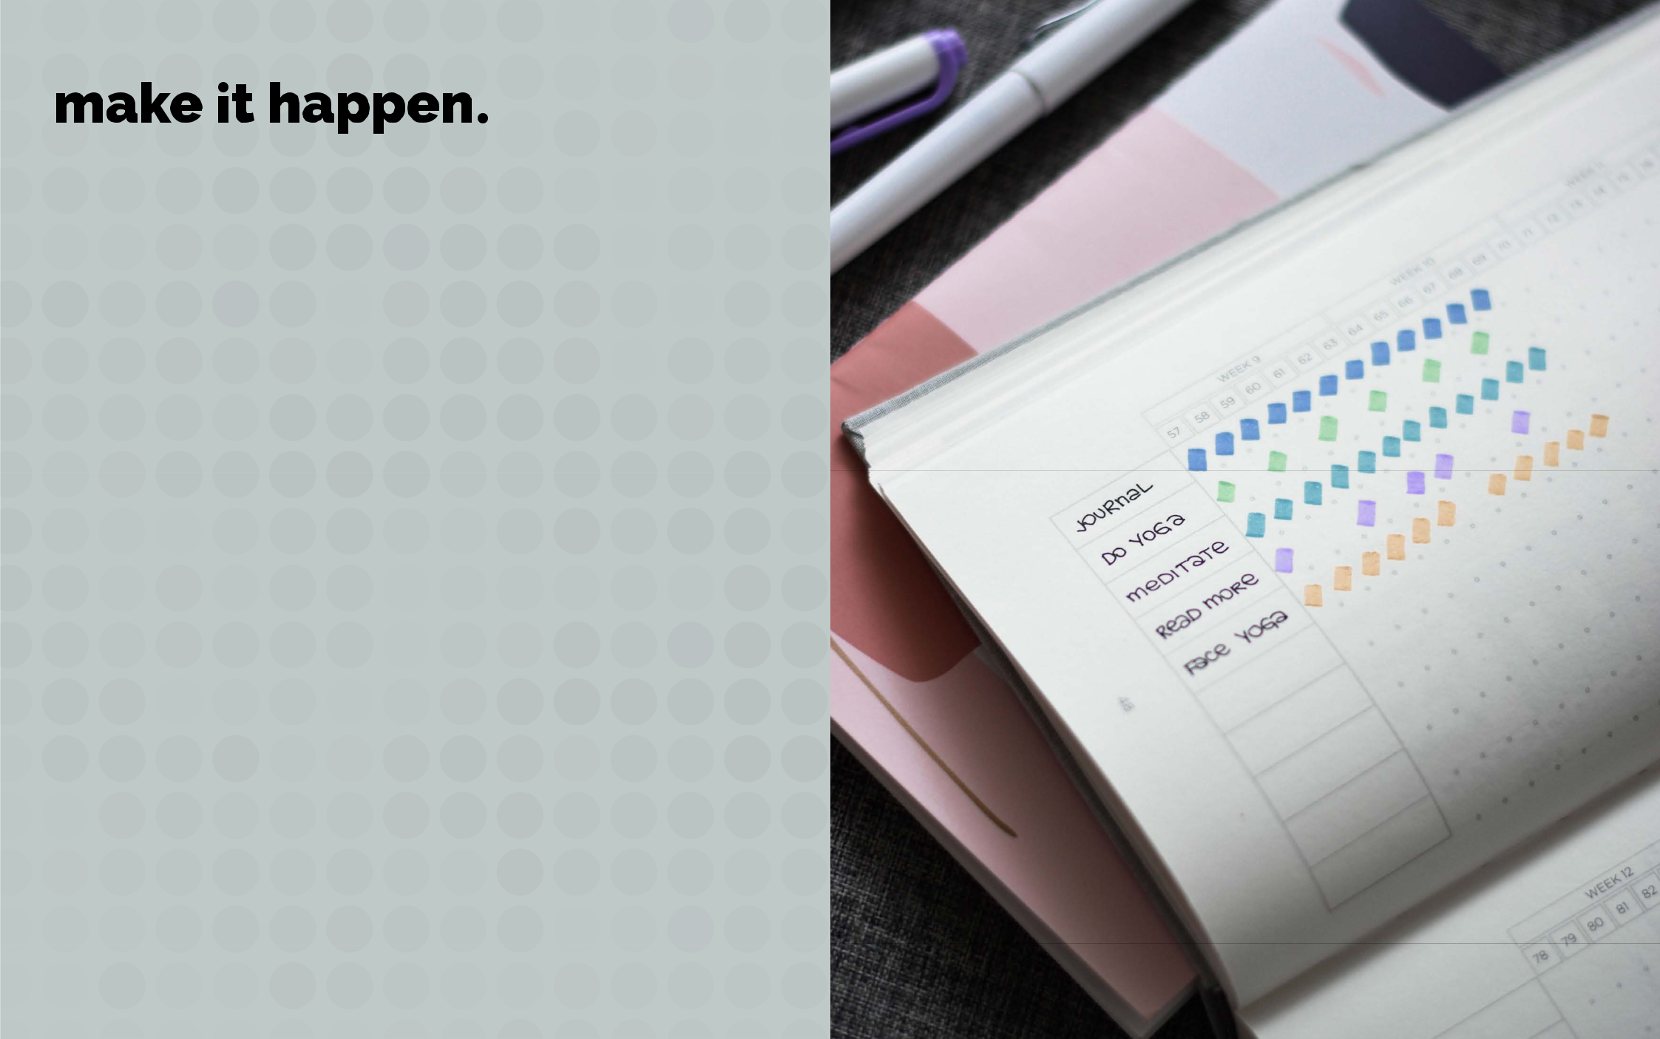

the habit tracker.

the habit tracker: what it is and how it works.

Instructions

The habit tracker is a simple way to measure whether you did a habit.

To make this process as easy as possible, I created the habit tracker.

What do you need to do?

All you have to do choose whether you want to use the habit by month or the habit by week version, add your habit, set how often you want to do it and start crossing off the days.

The most basic format is to get a calendar and cross off each day you stick with your routine.

For example, if you meditate on Monday, Wednesday, and Friday, each of those dates gets an X. As time rolls by, the calendar becomes a record of your habit streak.

Placing an X on each day is the classic look. You might prefer something a little more design-oriented, like shading in the cells on your habit tracker. You could also use ticks or fill your habit tracker with dots.

Where to keep it

Keep your Habit Tracker somewhere you will see it multiple times a say day such as on the fridge, your desk at work, on your wardrobe. This enables your habit tracker to become a trigger to remind you to do your habit should you forget.


the habit tracker.

No matter what design you choose, the key point is your habit tracker provides immediate evidence that you completed your habit. It’s a signal that you are making progress. Of course, that’s not all it does…

Using the habit tracker is powerful for three reasons.

- It creates a visual cue that can remind you to act.

- It is motivating to see the progress you are making.

- You don’t want to break your streak. It feels satisfying to record your success in the moment.

Common habits you could track:

- journaling

- reading X pages

- meditating for X minutes

- doing X minutes exercise

- stretching for X minutes

- write 10 things I’m grateful for

- making your bed

- wake up by X time

- go to bed by X time

- take a cold shower

- take vitamins/supplements

- play [instrument] for X minutes

- set and prioritise must-do list

- walk the dog
the habit tracker. |  |  |  | habit by month.
Habit: |  | Frequency: Daily /

01 | 02 | 03 | 04 | 05 | 06 | 07
08 | 09 | 10 | 11 | 12 | 13 | 14
15 | 16 | 17 | 18 | 19 | 20 | 21
22 | 23 | 24 | 25 | 26 | 27 | 28
29 | 30 | 31

the habit tracker. |  |  |  | habit by week.
Habit: |  | Frequency: Daily /

monday

tuesday

wednesday

thursday


friday

saturday

sunday

