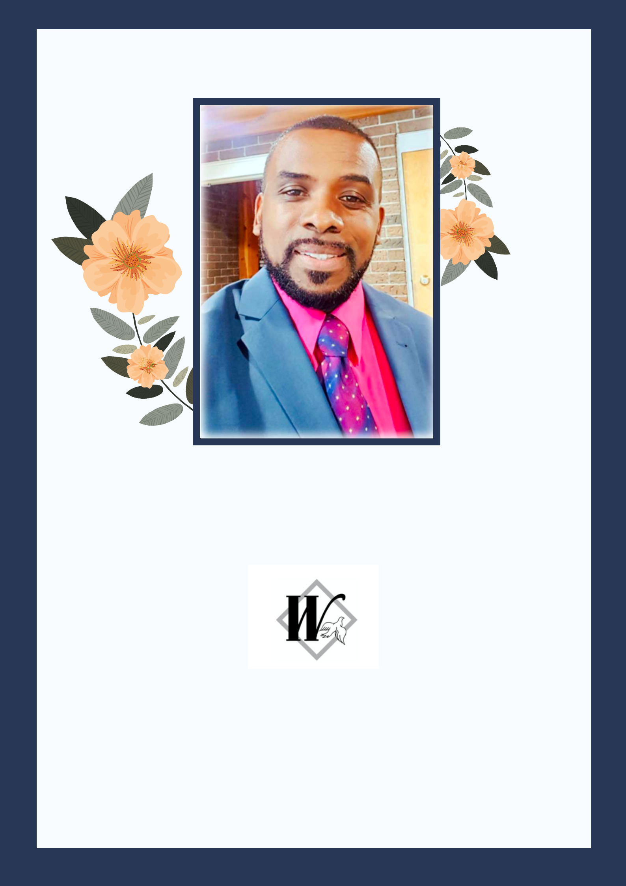

IN LOVING MEMORY

William Delano Gentles

June 17, 1966 - May 3, 2021

Service held at:

Henry Walser Funeral Home

Thursday, May 13, 2021

10:30 A.M.

Officiating: Pastor Christopher Johnson

Program Schedule

Opening Remarks

Prayer

Scripture Reading

Special Song

1 Thess 4:13-18

Pr. Christopher Johnson

Pr. Christopher Johnson

Kerone Brown (Niece)

Trishannah Gallinger (Niece)

Tributes - Elders
Special Song |  | Assure Group (Jamaica)
Tributes - Friends
Scripture Reading 1 Cor 15:50-55, 58 |  | Nordia Gentles & Schenell David (Nieces)
Special Song |  | Dimitar Kolev
Tributes - Hall Family
Special Song |  | Men of Faith
Live Tributes |  | Brother and Sisters
Tributes - Gentles Family

Eulogy |  | Avonae & Delano Gentles (Children)
Song of Meditation | #516 | All the Way My Savior Leads Me
Homily |  | Pr. Christopher Johnson
Prayer of Comfort |  | Pr. Titmus Morgan
Master Guide Flag Folding |  | KW AGAPE Masterguide Club
Recessional |  | Ariel Petruk and Micheal Pappoe

Revelations 21: 4, 5

4 And God will wipe away every tear from their eyes; there shall be no more death, nor sorrow, nor crying. There shall be no more pain, for the former things have passed away.

5 Then He who sat on the throne said, “Behold, I make all things new.”

And He said to me, “Write, for these words are true and faithful.”


Obituary

William Delano Gentles

June 17, 1966 - May 3, 2021

William (Dilly) Gentles passed away peacefully on May 3, 2021, at his home surrounded by his loving family at the age of 54. Beloved husband of Zenova of 30 years. Loving father of Avonae & Delano (Rojae) and niece Shaun-pierre (Candy). Dear son of Maud Gentles and the late Dormant Gentles. Cherished brother of Yvonne, Norma (Trevor), Alman, Diana (Patrick), Jennifer, Albert (Denise) and Anneta. He will be missed by countless nieces and nephews in addition to numerous family, friends and other relatives in Jamaica, the US and England. Dilly was an active elder in the Roosevelt Avenue (Stadium Community Church - Jamaica) before he immigrated to Canada where he continued to serve as an elder at the Kitchener-Waterloo Seventh Day Adventist Church, in addition to many other offices.

Dilly's family invites you to join the funeral via livestream at

https://www.henrywalser.com/live-streaming

on

Thursday, May 13th, 2021

at

10:30am (EDT) or 9:30 am (EST)

Interment will be at the Parkview Cemetery. Follow on zoom at

https://us02web.zoom.us/j/4116561977pwd=Q2lrVUM2dnJnbUF2YjllMDU3b1duUT09

Meeting ID: 411 656 1977

Passcode: DILLY

Thank You


The Gentles & KW Adventist Church family would like to formally thank you for joining us in the celebration of life for our beloved William (Dilly) Gentles. May our Father God grant you peace and comfort in the blessed hope of Jesus' return and resurrection of the righteous.

