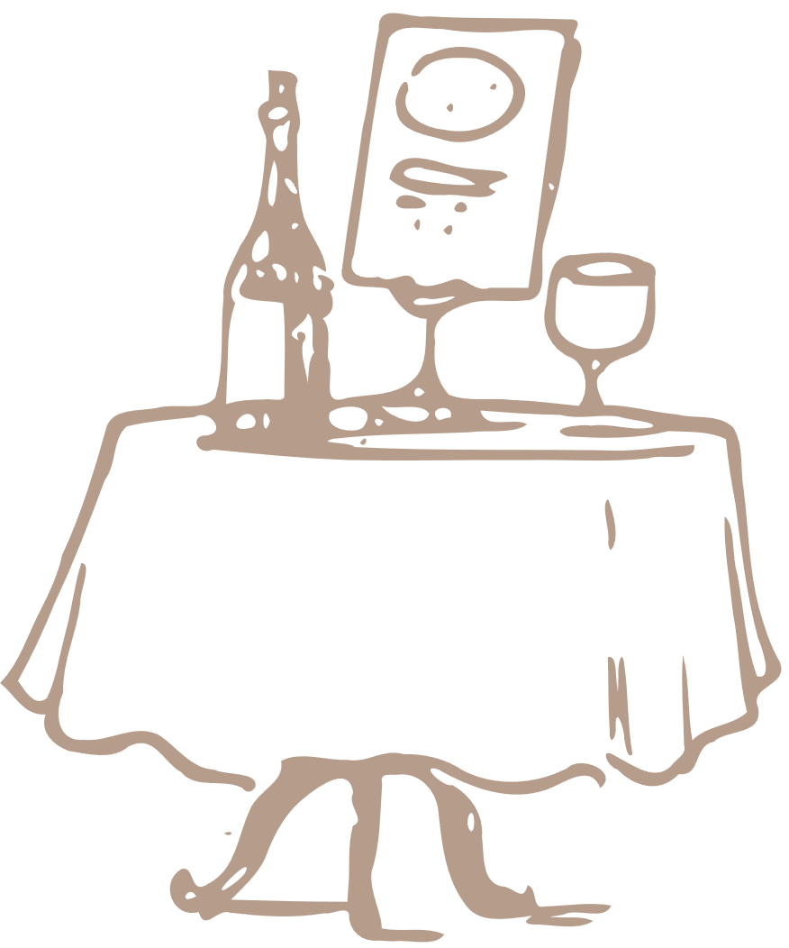

Restaurant

To Do List

No.

To Do

Yes/No

Notes

