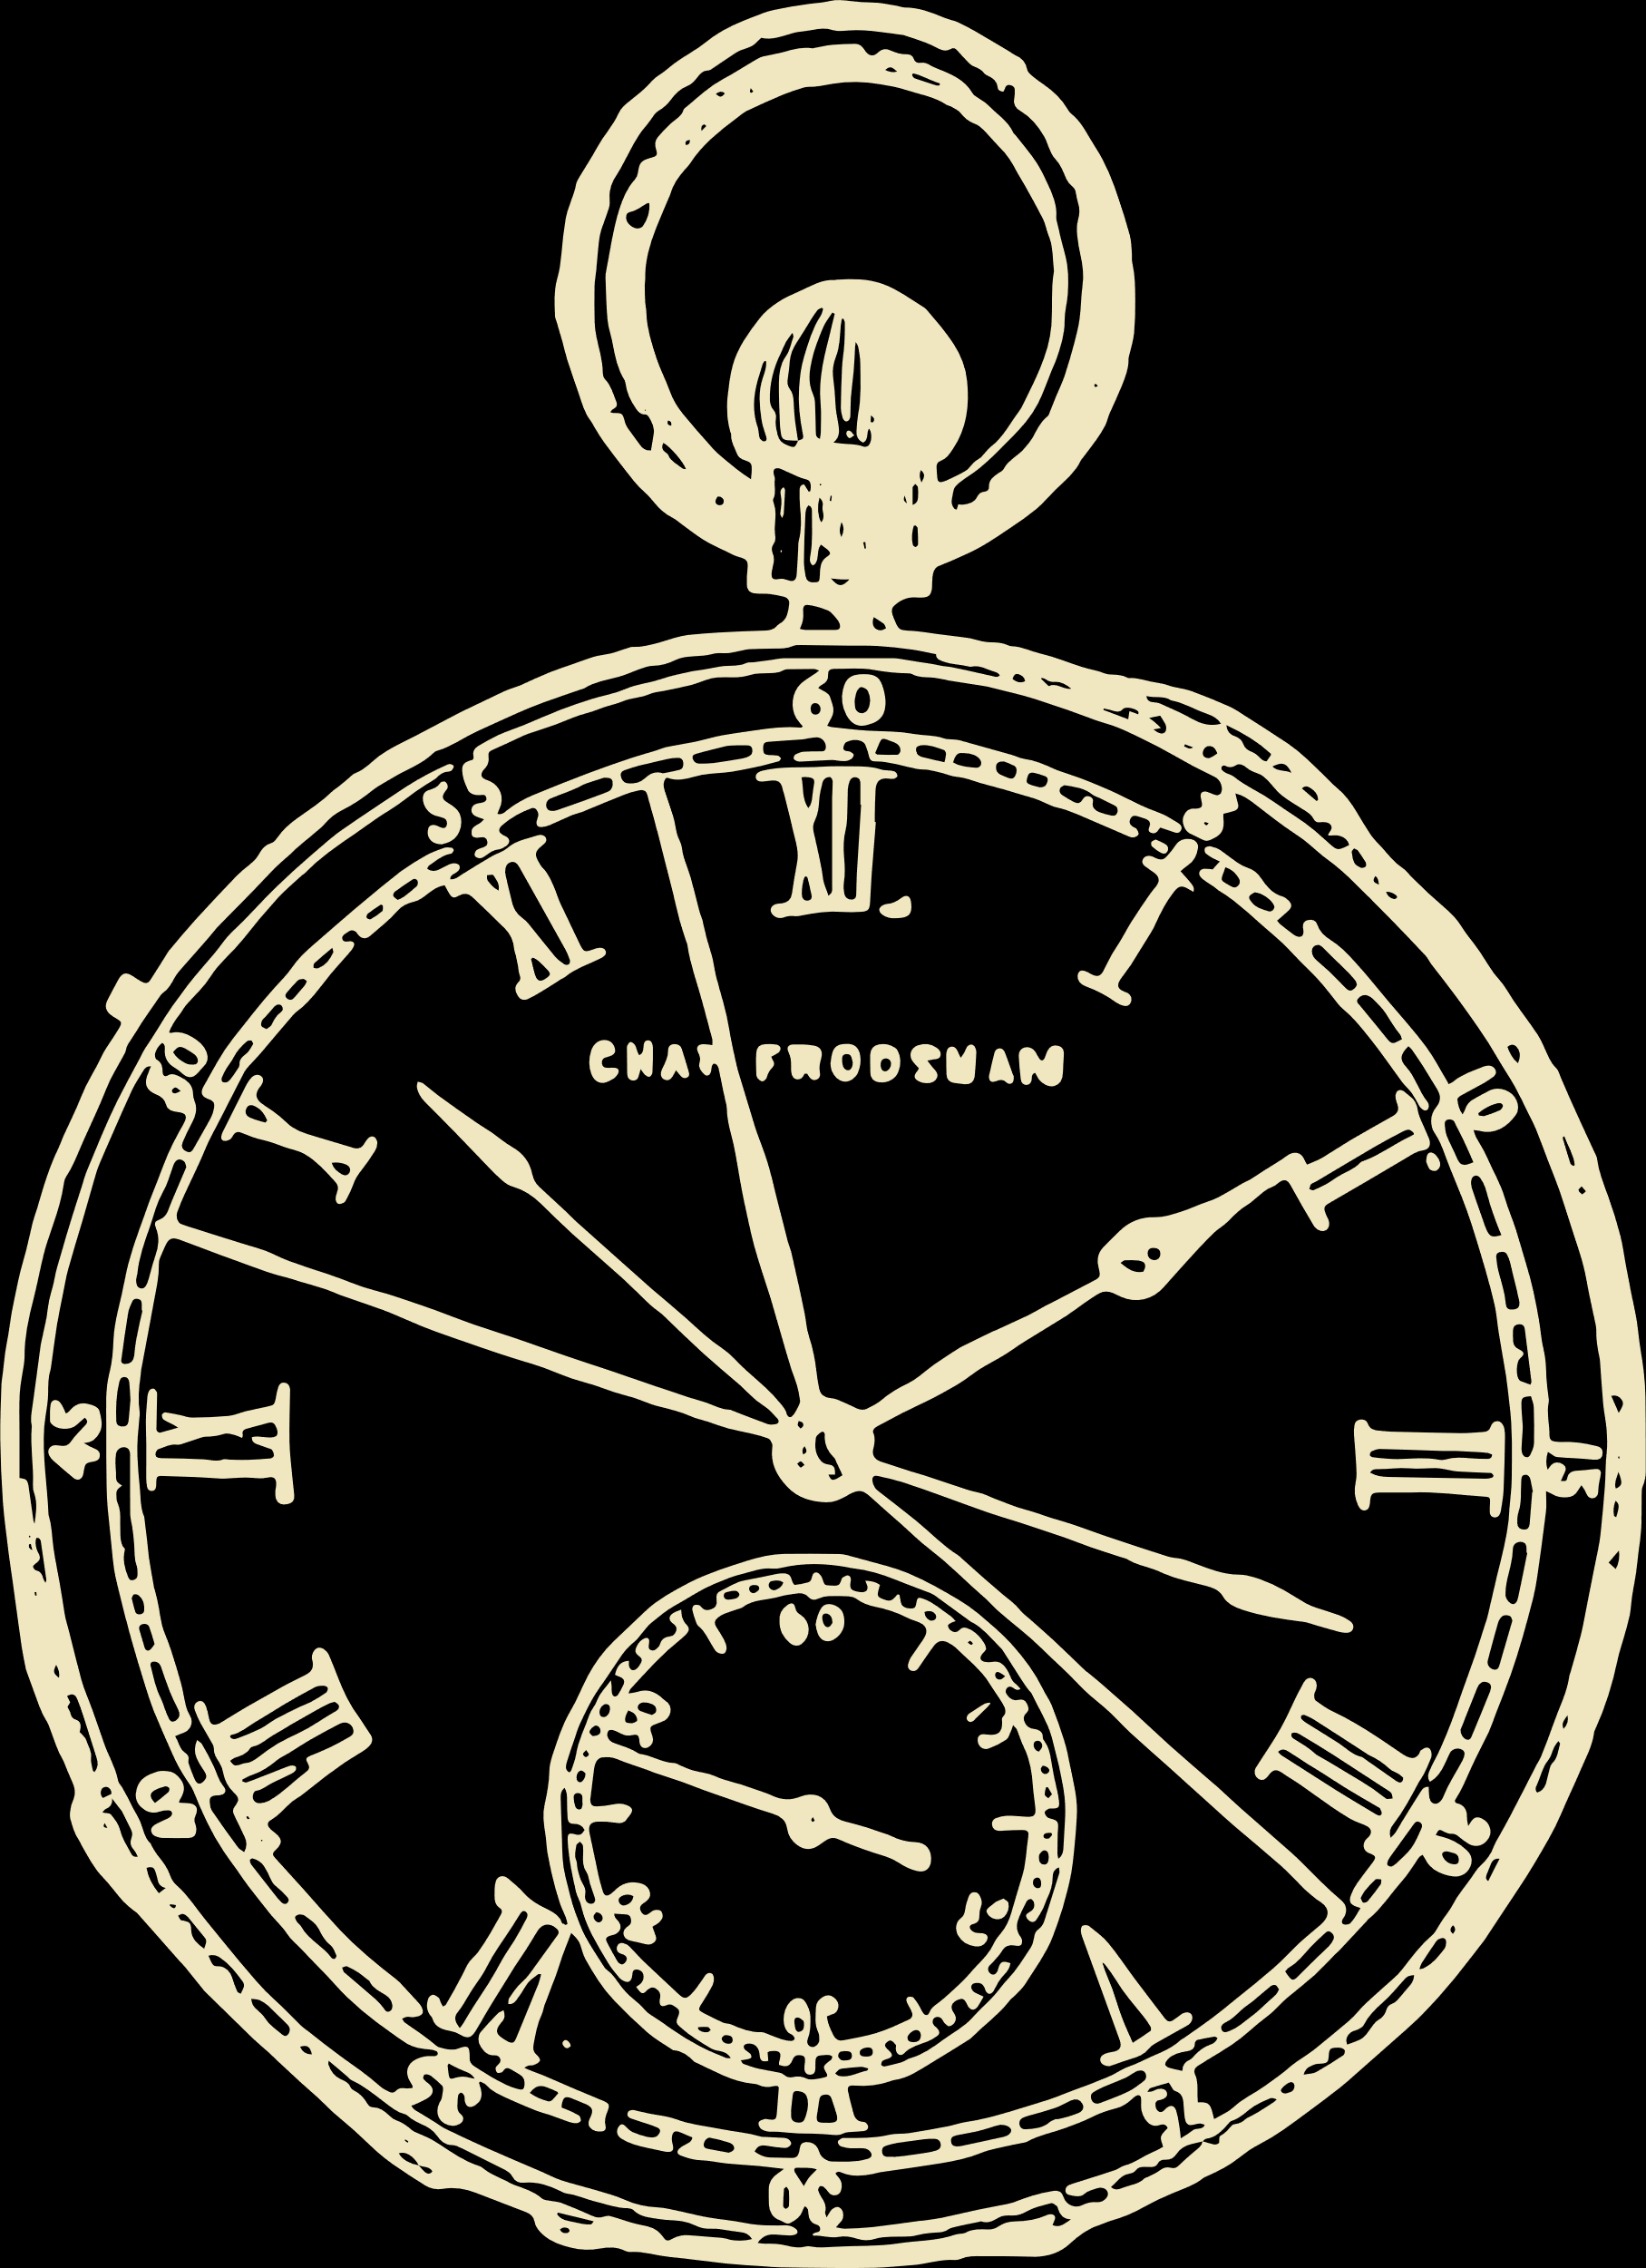

Belle Steele

• SEAT 34 •