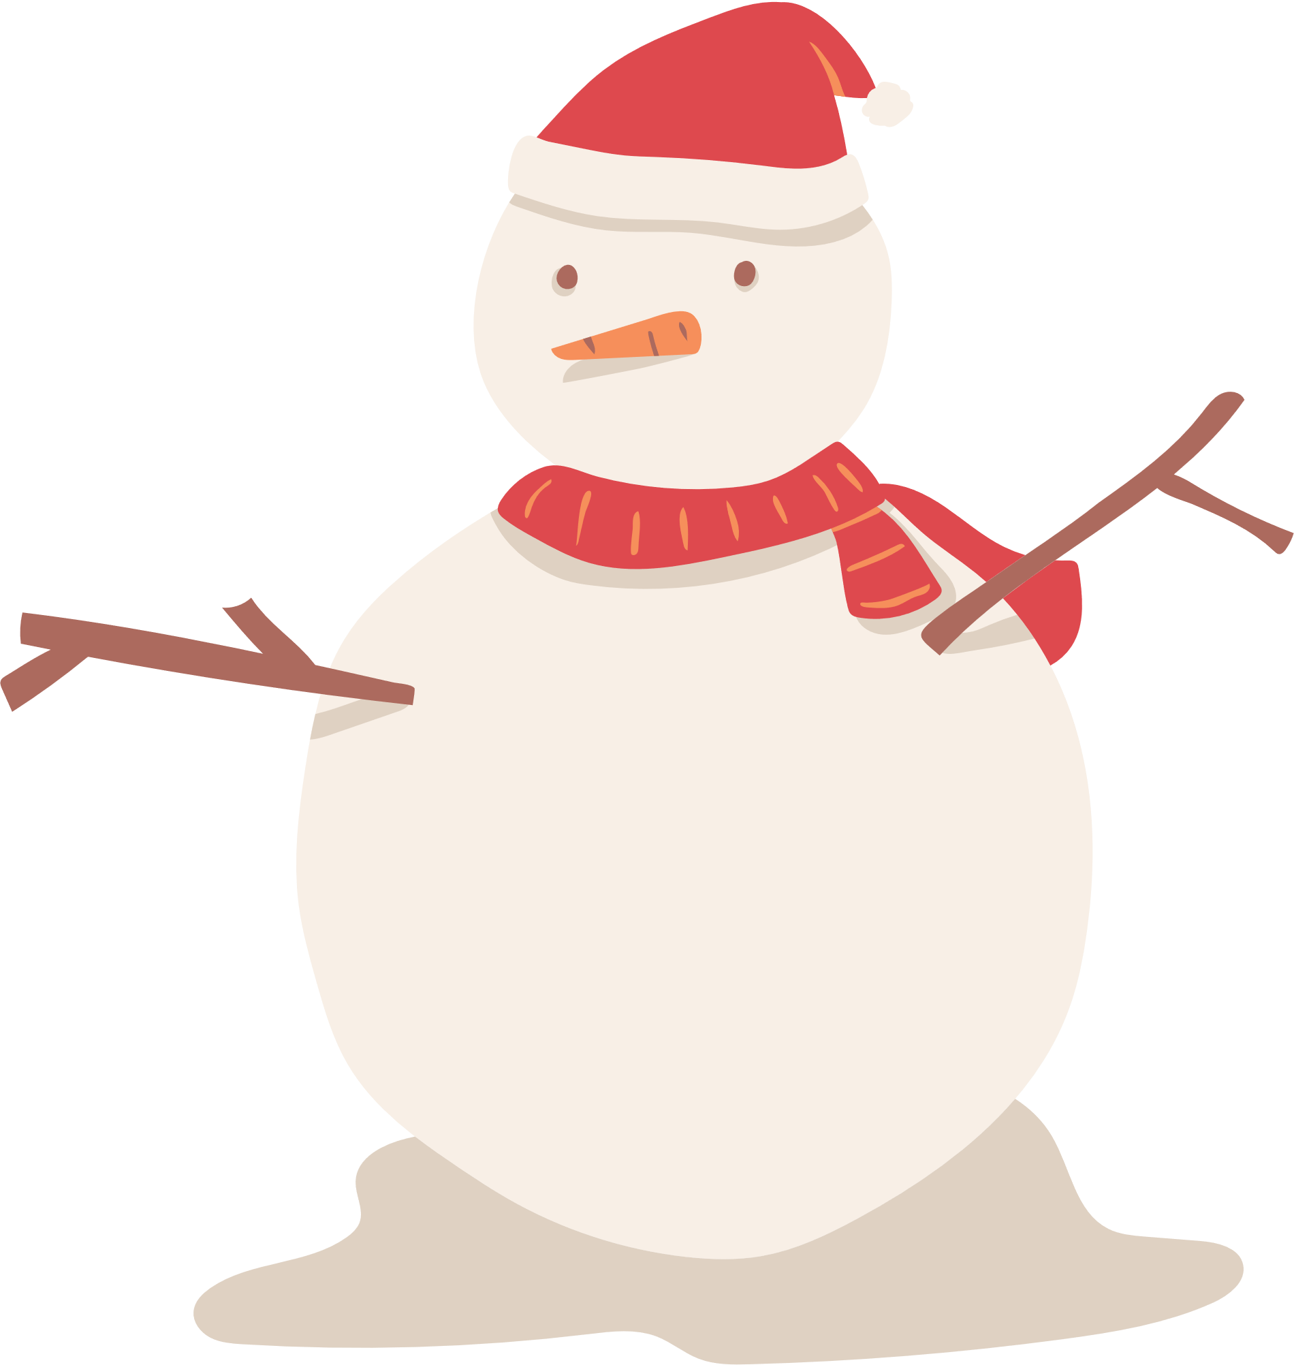

MERRY CHRISTMAS

COUSIN CHARLES

