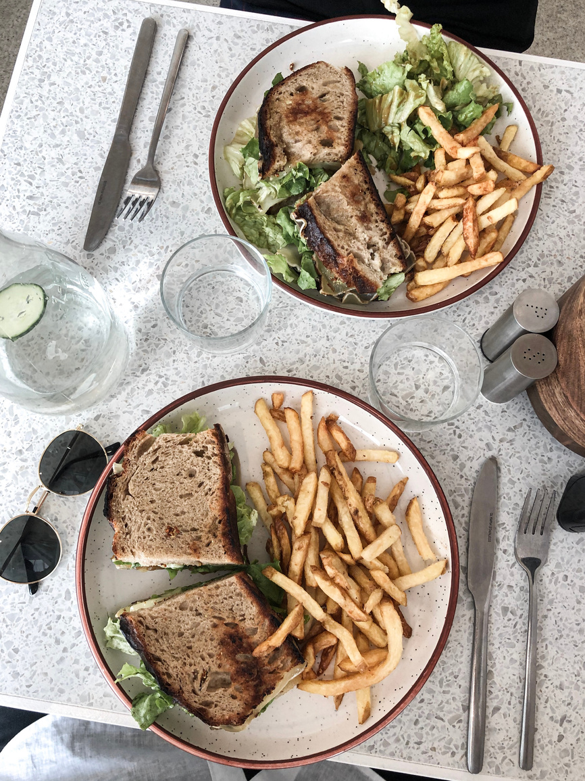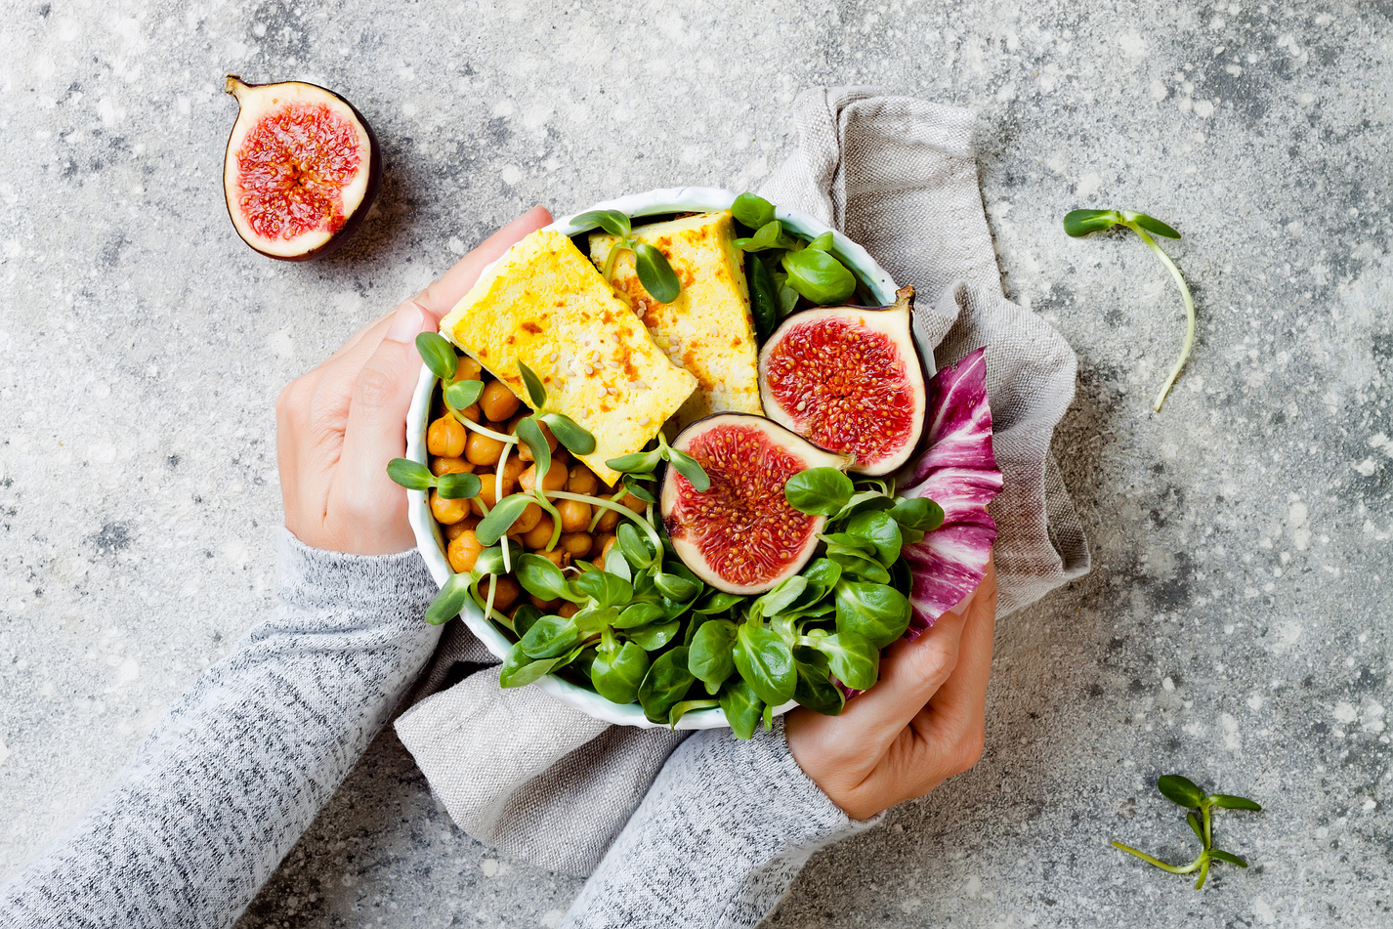

COOKBOOK

Appetizers

*02*

Pastas

*14*

Main courses

*14*

Seafood

*30*

Desserts

*40*

Easter

*55*

Valentine day

*60*

Halloween

*65*

Thanksgiving

*70*

Christmas

*80*

*TABLE OF CONTENTS*

