

A Celebrationof life



Scripture

Acknowledgments

Lorem ipsum dolor sit amet, consectetur adipiscing elit, sed do eiusmod tempor incididunt ut labore et dolore magna aliqua. Ut enim ad minim veniam, quis nostrud exercitation ullamco laboris nisi ut aliquip ex ea commodo consequat. Duis aute irure dolor in reprehenderit in voluptate velit esse cillum dolore eu fugiat nulla pariatur. Excepteur sint occaecat cupidatat non proident, sunt in culpa qui officia deserunt mollit anim id est laborum.Lorem ipsum dolor sit amet, consectetur adipiscing elit, sed do eiusmod tempor incididunt ut labore et dolore magna aliqua. Ut enim ad minim veniam, quis nostrud exercitation ullamco laboris nisi ut aliquip ex ea commodo consequat. Duis aute irure dolor in reprehenderit in voluptate velit esse cillum dolore eu fugiat nulla pariatur. Excepteur sint occaecat.

Jane Doe

Name of Service Location123 Street City, StateTime: 8:00 PMPastor John Smith

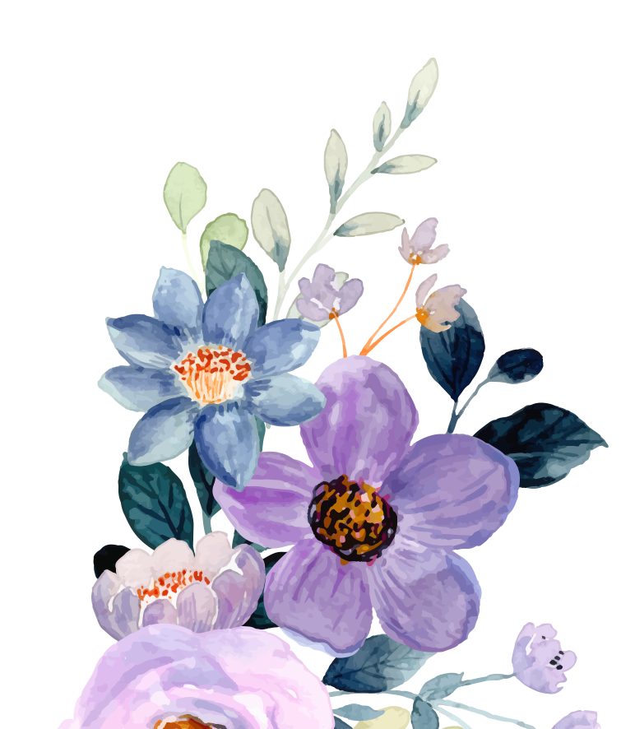

For since death came through a man, the resurrection of the dead comes also through a man. For as in Adam all die, so in Christ all will be made alive." "My flesh and my heart may fail, but God is the strength of my heart and my portion forever.So we are always confident, because we know that while we are living in the body, we are away from our home with the Lord. We live by faith and not by sight. We are confident, and we would prefer to leave the body and to be at home with the Lord.”

— 2 Corinthians 5:6-8v

January 4 1970 - March 6 2020



Remember by Christina Rosettii

Obituary

Lorem ipsum dolor sit amet, consectetur adipiscing elit, sed do eiusmod tempor incididunt ut labore et dolore magna aliqua. Ut enim ad minim veniam, quis nostrud exercitation ullamco laboris nisi ut aliquip ex ea commodo consequat. Duis aute irure dolor in reprehenderit in voluptate velit esse cillum dolore eu fugiat nulla pariatur. Excepteur sint occaecat cupidatat non proident, sunt in culpa qui officia deserunt mollit anim id est laborum.Sed ut perspiciatis unde omnis iste natus error sit voluptatem accusantium doloremque laudantium, totam rem aperiam, eaque ipsa quae ab illo inventore veritatis et quasi architecto beatae vitae dicta sunt explicabo. Nemo enim ipsam voluptatem quia voluptas sit aspernatur aut odit aut fugit, sed quia consequuntur magni dolores eos qui ratione voluptatem sequi nesciunt. Neque porro quisquam est, qui dolorem ipsum quia dolor sit amet, consectetur, adipisci velit, sed quia non numquam eius modi tempora incid.

Order of Services

Musical prelude...................

Processional........................

Musical Selection................

Prayer..................................

Scripture..............................

Solo.....................................

Hymn...................................

Obituary...............................

Eulogy..................................

Words of comfort.................

Name of song

John Doe

Name of song

Title

Lorem Ipsum

Mary Doe

Name

Stacey Smith

Jack Wilson

John Doe

Michael Scott

Johann Doe

Max Wilson

Manuel Miranda

Jake Doe

Anne Scott

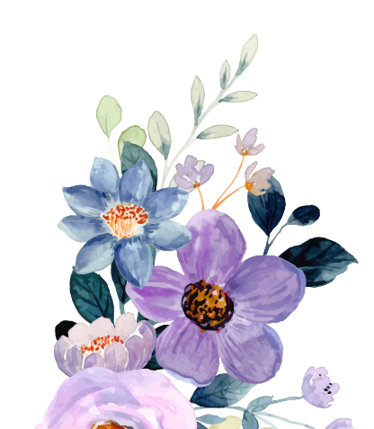



Pallbearers

Remember me when I am gone away, Gone far away into the silent land; When you can no more hold me by the hand, Nor I half turn to go yet turning stay. Remember me when no more day by day You tell me of our future that you plann'd: Only remember me; you understand It will be late to counsel then or pray. Yet if you should forget me for a while. And afterwards remember, do not grieve: For if the darkness and corruption leave. A vestige of the thoughts that once I had, Better by far you should forget and smile.Than that you should remember and be sad.Sed ut perspiciatis unde omnis iste natus error sit voluptatem accusantium doloremque laudantium, totam rem aperiam, eaque ipsa quae ab illo inventore veritatis et quasi architecto beatae vitae dicta sunt explicabo. Nemo enim ipsam.