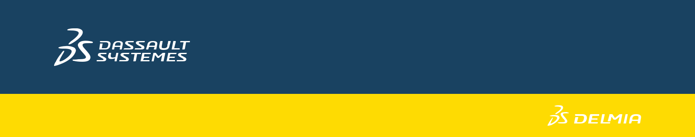

MANUFACTURING WORK INSTRUCTIONS

Whitepaper
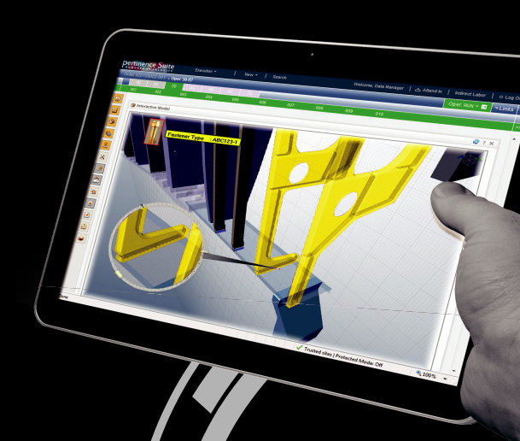

CONTENTS

- Work Instruction Challenge

- Manage Efficiency

- Build Integrity & Deliver Efficiency

- 3DS Configured 3D Work Instruction Solution

Manufacturing Work Instructions for Aerospace Whitepaper 2 © 2012 Dassault Systèmes

Manufacturing Work Instructions help create and manage assembly work instructions, condition of supply illustrations, and maintenance manuals from a configured 3D definition for the aerospace industry.

To be in compliance with FAA regulations or government program office requirements, aerospace companies have to ensure that the shop floor—or the supplier—has manufactured and assembled each product as design intended. As-Designed intent must be reconciled to the shop floor’s As-Planned work instructions as a foundation for an accurate As-Built result.

The business drivers for this are lower shop-floor costs and better reliability, which result from reducing the time spent creating and consuming accurate, comprehensive work instructions for each unit, while accommodating late changes as fast as possible.

Aerospace companies recognize that there is great value in increasing productivity in the authoring phase of work instruction. But they also recognize that the ultimate payoff for an end-to-end solution is the value-add that it brings to shop-floor installation and quality inspection.

WORK INSTRUCTION CHALLENGE

Companies spend much time and effort implementing rich 3D solutions that enable great product and process design, but there remains a wall between Engineering and Documentation. Documentation users can’t use the 3D data effectively, so they resort to creating their own sketches and illustrations, or to taking digital photos of completed products.

In some aerospace companies, documentation users go to engineering designers and ask them to create screenshot after screenshot of CAD data—wasting time and taking engineers away from important design activities.

Other companies place a predefined digital mockup directly on the shop floor, using CAD models that are often too heavy.

The problem with these manual methods is that they’re disconnected from the engineering systems. As the product changes, these manually-created deliverables don’t stay current with modifications, and are difficult and costly to update. These documents must be revisited individually for each plan, with a greater potential for error or overlooked data. This creates a redo situation that pushes out the release-to-market time — impacting market share and eroding profitability.


Value Positions

Deliver 3D model-based work instructions

to the shop floor, based on validated and reconciled planning data in the 3DS DELMIA Manufacturing Hub.

Minimize effort required to incorporate design- or manufacturing-driven changes into work instructions.

Deploy an intuitive, easy -to-use interface for authoring and illustrating 3D work instructions.

Reuse common work instructions across different configurations.

Use a similar methodology for maintenance manual creation and Condition of Supply illustration.

Manufacturing Work Instructions for Aerospace Whitepaper 3 © 2012 Dassault Systèmes

How many different formats do you use for your shop floor work instructions? Which parts of your current instructions are reusable?

MANAGE EFFICIENCY

Model-based design practices are intended to provide a single source of design authority. Designers electronically define the As-Designed flyaway condition of the aircraft in a consistent manner, using components of 3D with catalogs supplemented by annotations and callouts that incorporate intelligence into the dataset. The key benefit is consistency, which enables the data to be used automatically downstream. As the data is enriched along the way, Manufacturing can automatically incorporate the changes into their flexible planning system and adapt. The model-based approach is not always a 3D definition, but rather

- single-source, model-based architecture that enables efficient design and planning evolution.

Designers have refined their model-based architecture to “one part = one model” for efficient change and configuration management. In the same way, planners have refined their model-based architecture to adapt: instead
of being embedded into a flat-file document or production visual aid, manufacturing plans are exposed in the database at a change-and -configuration-managed granular level to maximize reuse and provide visibility into changes. This information can be used to analyze several variations of the plans; planners can apply simulation and analysis to select the best plans, just as designers do for engineering.

The resulting validated model-based plans can be reused and distributed downstream as accurate work instructions. A key benefit of this approach is the ability to incorporate and validate late design changes quickly. The net effect on the shop floor is assurance that work instructions are accurate and up to date.

Product information is usually delivered late, so planners define textual work instructions separately from any graphics, knowing the text will have to be reworked when the final graphics are available. The downstream impact of inaccurate work instructions is that design issues have to be resolved on the shop floor, where the cost of change is high. This affects the production schedule by increasing the number of non-conformances and the number of corrective actions that have to be taken.

Using configured work instructions from Dassault Systèmes (DS), planners can create detailed 3D work instruction with half the effort in half the time. Model-based design and planning enables efficient reuse of intellectual property for work instruction authoring. In addition, standard text libraries enable quick descriptions that can be directly associated with this 3D definition.

The efficient reuse of upstream engineering and planning information delivers clear, accurate, and comprehensive 3D work instructions for use on the shop floor.
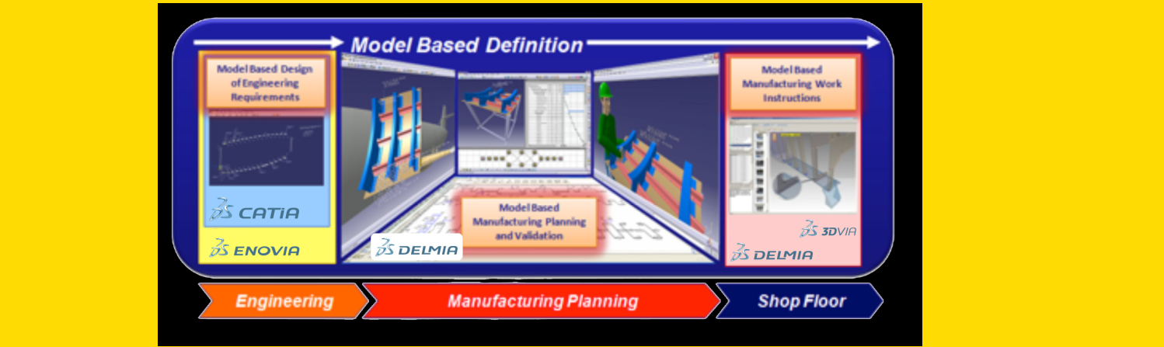

Model-based design and planning enables efficient reuse of intellectual property for work instruction authoring.

Manufacturing Work Instructions for Aerospace Whitepaper 4 © 2012 Dassault Systèmes

BUILD INTEGRITY

The impact of engineering change challenges the integrity of shop-floor work instructions. Design changes are requested for many reasons, such as customer and market requests, performance requirements, and shop-floor unbuildable conditions. A seemingly simple part redesign can result in thousands of downstream work instruction updates.

The result on the shop floor is that extra time is spent getting clarification on the work instruction, which takes time away from building the aircraft, and the possibility of work stoppage. In most cases, incorporating a change request on the shop floor results in many additional follow-on change requests because downstream processes were not considered.

All of this can be avoided by using a Product

Process and Resource data model to analyze the impact of any given change on work instructions. Shop floor workers then receive accurate instructions and limited change notifications where necessary. The result is increased worker touch time, faster turnaround time for completing change requests, and improved product quality.

DELIVER CONSISTENCY

Because manufacturing plans are authored according to aircraft Tail Number or Unit Number, the job that a worker must perform can deviate from plane to plane depending on the configuration and set of parts to be installed. This high level of variability means more work re-creating work instructions.

3DS PPR Model


The 3DS Product, Process and Resource (PPR) model enables a direct association between design, manufacturing planning, and shop floor deliverables for automatic changes

Making a change within the PPR model has a virtual downstream impact just as change does on the shop floor, enabling:

- Upfront change impact analysis

- Fast re-planning and validation of all affected plans and work instructions, in context

- Incorporation of ALL shop floor changes required to maintain production & quality

Because work instructions are re- created and duplicated, a single operation can be described in multiple ways. Shop floor workers need extra time to understand their procedures, and the potential for unnecessary non-conformances rises. The solution: eliminate re-creating any work instructions that are common from unit to unit by authoring them under configuration control. This also ensures consistent documentation of already-validated procedures.

Reuse and validation means that shop floor workers deal with less variability. Whenever possible, they’re looking at the exact same job, and are only notified when the job is changed.
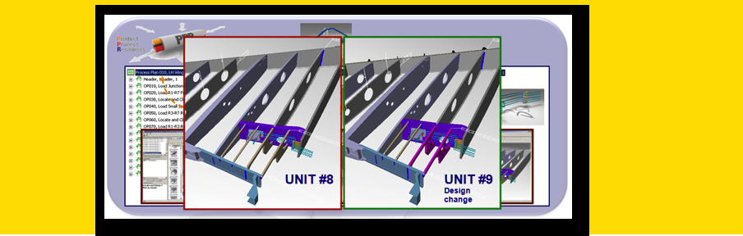

Manufacturing Work Instructions for Aerospace Whitepaper 5 © 2012 Dassault Systèmes

What if you could deliver common work instructions for multiple configurations to the right people at the right time?

3DS CONFIGURED
3D WORK INSTRUCTION SOLUTION

3DS Manufacturing Work Instructions for Aerospace enables a solution with efficiency, integrity, and consistency. Work Instruction authors use their time more efficiently by reusing model-based definition and standard instructions wherever possible. Shop floor deliverables become much more accurate and reliable because the PPR data model streamlines change management. The practice of creating common instructions across configurations dramatically increases a worker’s understanding of the work content—demonstrating the value of authoring configured work instructions and quickly delivering the right instructions to the shop floor.

This 3DS solution is scalable within your enterprise, and is flexible in terms of instruction authoring, with ZeroD, 2D and 3D functionality. ZeroD authoring provides for rich textual content, including the use of standard instruction libraries. 2D authoring amends the use of drawings, images, spreadsheets and other material as attachments to a plan. The key is that the 3DS solution allows your company to apply the correct functionality to the discipline or to the needs of the target product program. It puts the full breadth of functionality in the hands of the end users, giving them the power to deliver appropriate content (ZeroD, 2D or 3D) to any task.

3DS Solution: Key Applications

CATIA – Digital product experience and innovation

DELMIA Process Engineer – Structured process planning and Bill of Material management

Work Instruction Composer – Create and manage model-based work instructions from a configured 3D definition

3DVIA – Repurpose existing 3D data to create high-quality interactive technical 3D experiences

DELMIA Operations Velocity – Real-time Manufacturing Operations Management supporting shop floor execution and non-conformance management

The 3DS Work Instruction end-to-end solution relies on the model-based definition from As-Designed to As-Planned to As-Built, applying tools from CATIA, DELMIA Process Engineer, DELMIA Work Instruction Composer, and DELMIA Operations Velocity. The end-to-end solution supports multiCAX import, providing model-based definitions that originate from many sources.

DELMIA Work Instruction Composer (WKC) embeds

3DS 3DVIA lightweight geometry and extensive publishing technology on top of its built-in configuration-managed
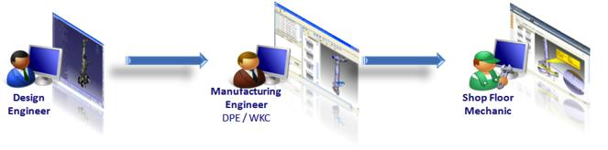

Manufacturing Work Instructions for Aerospace Whitepaper 6 © 2012 Dassault Systèmes

foundation. Work instructions with lightweight 3D content, created with WKC in maximum configuration states, are filtered by a Shop Order Release for specific line or unit numbers and delivered to the 3DS MES solution (DELMIA Operations Velocity) for execution. Shop floor execution, using Velocity, provides manufacturing technicians with full 3D product views with annotation, measurement functionality, buyoff and signoff. Velocity also has complete non-conformance management functionality, rounding out the 3DS solution with business-matching capability for the aerospace enterprise.
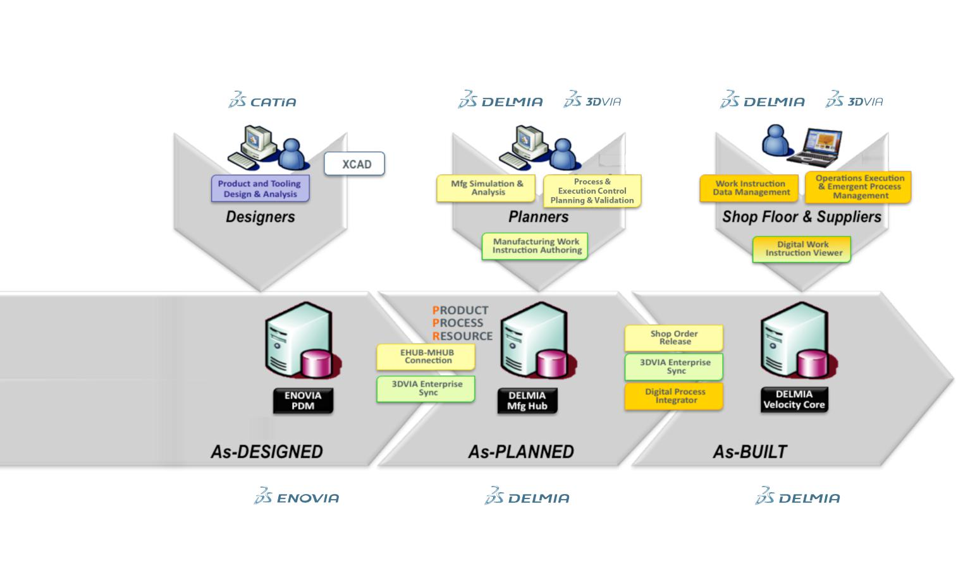

At the center of the 3DS Solution for 3D authoring, the DELMIA Work Instruction Composer

add-on provides fast, intuitive functionality for manufacturing engineers, including views of:

- Operations Sequence

- Standards Links

- Parts and Tools lists

- Text Instructions

- Product and Tools, as well as markup visual aids

3DS PLM Solution for Manufacturing PLANNING and EXECUTION

Manufacturing Work Instructions for Aerospace Whitepaper 7 © 2012 Dassault Systèmes

Below is a view of WKC used by manufacturing engineers for 3D instruction authoring.

Velocity, the DELMIA Operations Manufacturing Execution Solution, delivers world-class capability to shop-floor assembly and quality personnel. It gives them interactive use of:

- Orders

- Operations Sequence

- Standards Links

- Parts and Tools lists

- Text Instructions

- 3D Product and Tools, as well as markup visual aids

- Non-conformance item management
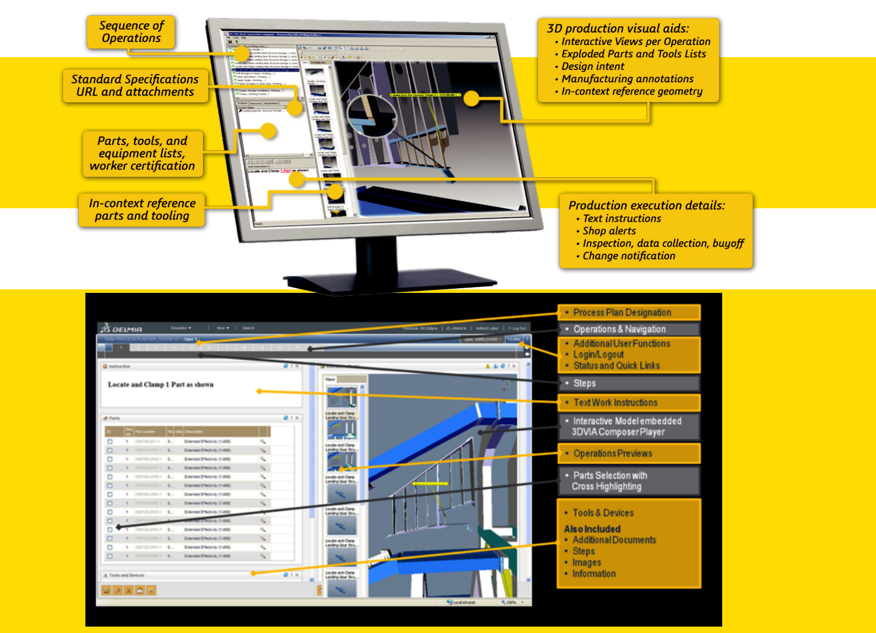

Here is a view of DELMIA Operations used by manufacturing and quality technicians.

Manufacturing Work Instructions for Aerospace Whitepaper 8 © 2012 Dassault Systèmes



Delivering Best-in-Class Products



Virtual Product Design | Information Intelligence
3D for Professionals | Dashboard Intelligence
Realistic Simulation | Social Innovation
Virtual Production | Online 3D Lifelike Experiences
Global Collaborative Lifecycle Management
About Dassault Systèmes








Dassault Systèmes, the 3DEXPERIENCE Company, provides business and people with virtual universes to imagine sustainable innovations. Its world-leading solutions transform the way products are designed, produced, and supported. Dassault Systèmes’ collaborative solutions foster social innovation, expanding possibilities for the virtual world to improve the real world. The group brings value to over 150,000 customers of all sizes, in all industries, in more than 80 countries. For more information, visit www.3ds.com.

The 3DS logo, CATIA, SOLIDWORKS, SIMULIA, DELMIA, ENOVIA, GEOVIA, EXALEAD, NETVIBES, 3DSWYM and 3DVIA are either trademarks or registered trademarks of Dassault Systèmes or its subsidiaries in the US and/or other countries.

Europe/Middle East/Africa | Asia-Pacific | Americas
Dassault Systèmes | Dassault Systèmes | Dassault Systèmes
10, rue Marcel Dassault | Pier City Shibaura Bldg 10F | 175 Wyman Street
CS 40501 | 3-18-1 Kaigan, Minato-Ku | Waltham, Massachusetts
78946 Vélizy-Villacoublay Cedex | Tokyo 108-002 | 02451-1223
France | Japan | USA

Visit us at
3DS.COM/DELMIA


Item: 3DS.WP.TRI.2012x.0417

