
Management System Document | Work Instruction

Title: Instructions for handling Corona virus at the yards in Topside & Facilities

Doc. No.: 01-W-HES100E

Business Process: HSSE

Owned by: SVP Performance & Transformation, Topside and Facilities

Checked by: Torstein Leth Approved by: Arve Kleppe

Revision Date


22 11-03-2021

Description


Changed regime regarding travel to the yards – new chapter 8 Some structural changes of chapters

Clarification in chapter 9 regarding private travels / visits Removed Appendix for application from ring 1 and 2 municipalities

Validity: Governed by Metadata

Purpose

Decide actions to limit spread of infection and at the same time maintain our business activities

Doc no.: 01-W-HES100N Rev.: 21 Page 1 of 24

Internal © 2020 Aker Solutions. No part of this document or the information it contains may be reproduced or transmitted in any form or by any means without the permission of Aker Solutions. This document is no longer controlled once downloaded.

Management System Document | Work Instruction

Table of Contents

1 Situation 3

2 Purpose 3

3 Definitions and contact number 3

4 Hygiene and distance 4

- In case of respiratory infection, suspected infection and confirmed COVID-19 disease and close

contact 4

6 Quarantine and registration of quarantine 5

7 Office 5

8 Travel to yard 6

8.1 General 6

8.2 Personnel arriving Norway 7

8.3 Personnel travelling from A, B and C municipalities in Norway 9

8.4 Personnel travelling from other municipalities in Norway 12

8.5 Visitors 12

9 Other transports and travels 12

Transport to/from/at office/workplace 12

Business travels 12

Commuter travel 13

Private travel 13

10 Conference and meeting 13

11 Welfare activities 14

12 Cyber security 14

13 Instructions for deliveries from outside Norway to our locations 14

14 To Managers – Continuity Planning 15

Appendix I: Close contacts 16

Appendix II: Risk group 17

Appendix III Notification 19

APPENDIX IV RISK ASSESSMENT OF VARIOUS FORMS OF MEETINGS 21

Appendix V Template for “Extra security check” 24

Doc no.: 01-W-HES100N Rev.: 21 Page 2 of 24

Internal © 2020 Aker Solutions. No part of this document or the information it contains may be reproduced or transmitted in any form or by any means without the permission of Aker Solutions. This document is no longer controlled once downloaded.
Management System Document | Work Instruction

1 Situation

The Corona virus is now spreading both nationally and internationally. The Norwegian health authorities have a strategy to deal with the situation in a way that it is avoided to get many seriously ill at the same time. Consequently, the health authorities have introduced several restrictions to limit and prevent the transmission/ spread of infection. Among these measures are quarantine and isolation.

We are preparing for different scenarios. Our highest priority is to minimize the damage to people, society and operations.

2 Purpose

The purpose of this document is to provide instructions on actions we take to safeguard our employees, corporate social responsibility to limit the spread of infection and to maintain our business activities in the current situation where the infection spreads.

This document deals with our business the yards in Topside & Facilities where we are the principal enterprise. Where the client is the principal enterprise, we follow their guidelines.

We adheres to guidelines from Aker Solutions, the Directorate of Health and the Institute of Public Health, but may in some cases have stricter internal guidelines.

Local emergency response plans must ensure operationalisation of the requirements in this instruction. The revision number and the validity date of the instruction are updated when the content of the instruction changes.

3 Definitions and contact number

Close contact

Primary business interest

Se appendix I

Is to maintain production, avoid significant cost effects,

significant delays in projects or loss of business development

opportunities.

Contact number

It is created contact number to the occupational health services on the following locations:

Location Stord / Verdal:

Occupational Health Service: +47 53 41 89 01 for questions related to Corona infection. The line is serviced by health professionals and is open weekdays between 07:00 - 15:00.

Location Egersund / Sandnessjøen

Occupational Health Service: + 47 514 69 116 or +47 992 34 709. The line is serviced by health professionals and is open weekdays between 07:00 - 15:00.

Doc no.: 01-W-HES100N Rev.: 21 Page 3 of 24

Internal © 2020 Aker Solutions. No part of this document or the information it contains may be reproduced or transmitted in any form or by any means without the permission of Aker Solutions. This document is no longer controlled once downloaded.

Management System Document | Work Instruction

4 Hygiene and distance

The three basic pillars to slowing the spread of infection are:

- Be home if you are sick Se chapter 5.

- Good hand hygiene, good cough etiquette and enhanced cleaning

All employees should exhibit good hand hygiene and coughing etiquette according to information from the

FHI and the Directorate of Health.

There must be an increased cleaning on all locations during this period. Cleaning of possible contamination points such as eating area door handles, water / coffee machines, control panel in elevators, handrails in internal stairs, etc. is performed daily. If dining breaks are at different time, cleaning of tables must be performed between each group.

In case of infection spreading close down of parts of offices / areas for disinfection may be necessary.

3. Social distancing

Reduced contact between people and sufficient distance will:

prevent the spread of infection

reduce the number of close contacts (less than 2 meters distance in more than 15 minutes) in case of suspected or confirmed infection

The following distance rules applies:

- Minimum 1 meter at all time *

- Minimize your movements outside your own work area and in general be around as few as possible

- Persons belonging to the risk groups shall also ensure at least one meter away from others, but may keep a greater distance if possible. They should continue to follow the advice on how to protect themselves extra, including by limiting the number of people you have close contact with.

  - Do not touch other persons. Ban on greeting and hugging each other. Show each other joy without touching each other

* If minimum 1m distance is impossible in certain tasks, P3 masks shall be used by all involved. Ordinary face masks shall not be used in production areas. Face masks shall be used at public transport and other public places where keeping minimum 1m distance is impossible.

5 In case of respiratory infection, suspected infection and confirmed COVID-19 disease and close contact

Suspected infection and confirmed COVID-19 disease

We adheres to guidelines from the Directorate of Health and the Institute of Public Health.

Stay home if you feel sick e.g. cold, fever, cough, sore throat, heavy breathing (also mild symptoms) or lost sense of taste and smell. Guidelines at FHI.no

Employees who develop symptoms of COVID-19 while at work must immediately distance themselves from others and return home immediately.

Doc no.: 01-W-HES100N Rev.: 21 Page 4 of 24

Internal © 2020 Aker Solutions. No part of this document or the information it contains may be reproduced or transmitted in any form or by any means without the permission of Aker Solutions. This document is no longer controlled once downloaded.
Management System Document | Work Instruction

Close contact

Employees who are defined as close contact to a person who has been confirmed sick with COVID-19 shall be quarantined (ref appendix I).

You must inform your manager if you are covered by the points above. The manager notifies then according to notification matrix (see appendix III)

6 Quarantine and registration of quarantine

Rules related quarantine and isolation are listed up at https://www.fhi.no/nettpub/coronavirus/testing-og-oppfolging-av-smittede/definisjoner-av-mistenkte-og-bekreftede-tilfeller-med-koronavirus-coronavir/ and https://www.fhi.no/nettpub/coronavirus/fakta/avstand-karantene-og-isolering/?term=&h=1
If you are in quarantine and are not sick, you shall work from home if you have the opportunity.

Registration of quarantine Stord / Verdal:

The quarantine or confirmed infection must be registered on the following link by the individual. If you do not

have the opportunity, ask your manager to assist.

https://forms.office.com/Pages/ResponsePage.aspx?id=9km3JnKM40S73q494HtCBlWd-

ixwWMRGg_dojweIj4dUNTJFV1o0NUs5S0tPREc3MkxENk9LMlQ3MS4u

Registration of quarantine Egersund / Sandnessjøen

Registration of employees’ testing/positive/close-contact and quarantine is done on own link administrated by HSSE.

7 Office

Due to the infection situation, there may be different guidelines at the different locations according to local risk assessment. The following applies to the locations:

Egersund:

Working from home office is still the main rule. Personnel / functions that have major challenges related to home office may make agreement with personal leader and leader in project to work at office full or part time if rules of keeping distance can be followed. Consult OHS when needed.

Sandnessjøen:

Working from home office is still the main rule. Personnel / functions that have major challenges related to home office may make agreement with personal leader and leader in project to work at office full or part time if rules of keeping distance can be followed. Consult OHS when needed.

Stord:

Working from home office is still the main rule. Personnel / functions that have major challenges related to home office may make agreement with personal leader and leader in project to work at office full or part time if rules of keeping distance can be followed. Consult OHS when needed.

Verdal:

Working from home office is still the main rule. Personnel / functions that have major challenges related to home office may make agreement with personal leader and leader in project to work at office full or part time if rules of keeping distance can be followed. Consult OHS when needed.

Doc no.: 01-W-HES100N Rev.: 21 Page 5 of 24

Internal © 2020 Aker Solutions. No part of this document or the information it contains may be reproduced or transmitted in any form or by any means without the permission of Aker Solutions. This document is no longer controlled once downloaded.
Management System Document | Work Instruction

8 Travel to yard

8.1 General

All travel to the yards, beyond ordinary daily commuting of internal / external resources that have their daily work at the yard, shall be pre-approved. A given approval is valid for one travel.

The table below provides an overview of groups, examples of types of personnel within each group, the application process and barriers that must be in place. The barriers are described in more details in the following chapters.

Group | Category | Type of personnel | Barrierers | To be approved by
1 | Foreign personnel* | Foreign workers, hired-in | Test / quarantine / | Yard Director (in
 |  | resources | security check list | accordance with yard risk
 |  |  |  | assessment)
2 | Foreign personnel | Specialists / individuals | Test / quarantine / | BCP in T&F, after
 | subject to government | considered strictly | security check list | recommendation from
 | application | necessary to uphold |  | local HSSE Manager**
 |  | activity in Norwegian
 |  | companies
3 | Personnel from | External / internal | Test / leisure time | BCP in T&F, after
 | municipalities with | business critical resources | quarantine / security | recommendation from
 | increased restrictions |  | check list | local HSSE Manager
 | (ABC municipalities)
4 | Personnel from other | Internal / external | Security check list . | Infection rate > 150 /
 | municipalities | travelling personnel | BCP can implement | 100.000: BCP in T&F,
 |  |  | measures deemed | after recommendation
 |  |  | necessary based on | from local HSSE Manager
 |  |  | high infection rate in a | Infection rate < 150 /
 |  |  | municipality. | 100.000: Yard Director, in
 |  |  |  | cooperation with local
 |  |  |  | HSSE Manager
5 | Visitors | Company visits, customer | Security check list. | Yard Director, in
 |  | visits, audits, school visits, | BCP can implement | cooperation with local
 |  | media, politicians, | measures deemed | HSSE Manager
 |  | pensioners etc (not work- | necessary based on
 |  | related visits) | high infection rate in a
 |  |  | municipality.


- Currently, the borders are in principle closed, and as a main rule only foreigners with Norwegian residency, as well as Norwegian citizens, may travel to Norway.

**To be approved by BCP before an application is submitted to the authorities (The Norwegian Maritime Directorate)

For all groups, except from group 1, the following from shall be used for application of getting in personnel to the yards:

APPLICATION FORM

For application of 10 or more, the form “Massesøknad for tilreisende personell” can be used and uploaded in this application form

Doc no.: 01-W-HES100N Rev.: 21 Page 6 of 24

Internal © 2020 Aker Solutions. No part of this document or the information it contains may be reproduced or transmitted in any form or by any means without the permission of Aker Solutions. This document is no longer controlled once downloaded.
Management System Document | Work Instruction

The need of personnel travelling to the yard shall be compiled in one application per project and shall include all internal / external resources including client. The personnel being applied for must be assessed and considered strictly necessary and done in co-operation with project manager.

The application must be filed within Wednesday at 12:00 for the following week. The applications will upon nomination from HSSE at the yards be decided by the Business Continuity Planning team (BCP) or yard director respectively.

Contact your local HSSE manager if you have questions regarding this.

Persons that are living in other areas, but have not been home last 10 days is not considered to be under the regulations described in chapter 8.

Flowchart for the application process:
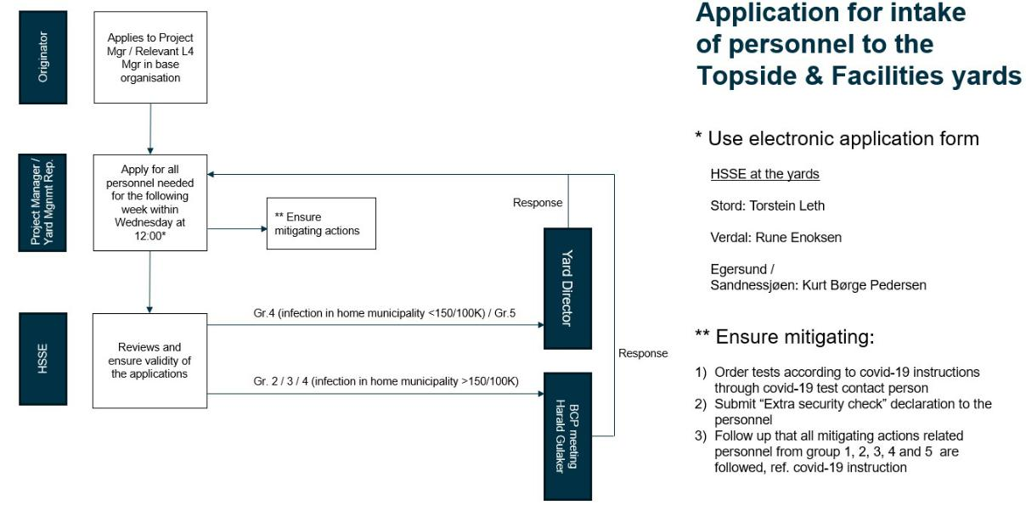

8.2 Personnel arriving Norway

The borders are for the time being closed with a very few exceptions. This means that as for now hired in personnel from abroad cannot be mobilised, but the authorities are continuously assessing a gradually re-opening again.

If need of mobilising specialists from abroad (group 2), the internal application process must be followed. If approved by BCP, the process of applying for the personnel through the Norwegian Maritime Authority can start, see their website.

The covid-19-regulation apply with the following rules for personnel arriving Norway through the exception rules:

Registration obligation for travel to Norway

Persons arriving Norway from an area with quarantine obligation pursuant to Appendix A of the Covid-19-regulations, shall prior to the travel register necessary information according to §5b in the Covid-19-regulations

Doc no.: 01-W-HES100N Rev.: 21 Page 7 of 24

Internal © 2020 Aker Solutions. No part of this document or the information it contains may be reproduced or transmitted in any form or by any means without the permission of Aker Solutions. This document is no longer controlled once downloaded.
Management System Document | Work Instruction

For more details see Forskrift om smitteverntiltak mv. ved koronautbruddet (covid-19-forskriften).

Negative test for SARS-CoV-2 required upon arrival to Norway

Persons arriving Norway from an area that requires quarantine as described in Appendix A in the Covid-19 regulations, shall upon arrival present a certificate of negative test of SARS-CoV-2. PCR or antigen speed test are valid test methods. The test shall not have been taken later than 24 hours prior to arrival to Norway. For personnel arriving by plane, the test may be taken during the last 24 hours prior to scheduled continuous flight to Norway including transit on other airports. The certificate must be in Norwegian, Swedish, Danish, English, French or German.

The required negative test upon arrival to Norway does not apply for Norwegians, foreigners who live in Norway holding a residence permit, foreigners who frequently arrive Norway from Sweden or Finland to work, and foreigners who perform commercial transport of goods and personnel, etc. For complete list, see the Covid-19-regulation §4a.

Testing required of personnel who have stayed in countries with high occurrence of mutant viruses Persons who have stayed in Great Britain, South Africa, Ireland, Netherland, Austria, Portugal or Brazil during last 10 days prior to arrival to Norway, and arrive Norway, shall do a PCR test for SARS-CoV-2 at the Norwegian border.

Testing required of personnel who have stayed in an area with a quarantine obligation

Persons who have stayed in an area with quarantine obligation pursuant to Appendix A of the Covid-19-regulations during the last 14 days prior to arrival to Norway, shall do a SARS-CoV-2 test at the Norwegian border. The test shall be antigen speed test or PCR test. In case of positive antigen speed test, a PCR re-test is required within 24 hours after arrival.

This does not apply to i.e.:

- Persons with quarantine exemption according to §6a

- Persons who more than one time during a period of 15 days arrive Norway from areas in Sweden or Finland with quarantine obligation according to Appendix A in the Covid-19-regulations as part of travel between work place and home, and are being tested according to §6b
- Professional drivers of long-distance transport according to §6b

Ref. §4d in the Covid-19-regulations.

Travel Quarantine

Persons arriving Norway from an area with quarantine obligation pursuant to Appendix A of the Covid-19-regulations, shall in 10 days of quarantine. This includes also for stopover in areas pursuant to in Attachment A. If a person is arriving via an area without quarantine obligation, the quarantine period is reduced corresponding to the time the person has stayed in the area without quarantine obligation. If the country or area are no longer subject to quarantine obligation pursuant to Appendix A of the Covid-19-regulations, the quarantine obligation is repealed, ref. §4 first part letter a in the Covid-19-regulations.

The travel quarantine can be reduced if the person documents negative test result from PCR test during the quarantine, taken at the earliest 7 days after the arrival, ref. §4c in the Covid-19-regulations.

Persons arriving Norway more than one time during a period of 15 days from areas in Sweden or Finland with quarantine obligation pursuant to Appendix A of the Covid-19-regulations as travel between work place

Doc no.: 01-W-HES100N Rev.: 21 Page 8 of 24

Internal © 2020 Aker Solutions. No part of this document or the information it contains may be reproduced or transmitted in any form or by any means without the permission of Aker Solutions. This document is no longer controlled once downloaded.
Management System Document | Work Instruction

and home, are exempted from quarantine during work time if they are tested for SARS-CoV-2 at least every 7 days, or arrival day and then every 7 days if it is more than 7 days since last test

Requirements for staying in travel quarantine

We have arranged suitable rooms for quarantine stay according to §5 second part, letter c during the quarantine period for our hired-in personnel.

Individuals (i.e. ATS, client, etc.) arriving Norway where quarantine and testing are not administrated through us shall document that the quarantine and testing requirements according to Covid-19-regulations are adhered to.

Stord/Verdal:

It will be possible for testing / drop-in at our supplier for own cost. Call Aktimed +47 97 40 99 10.

The manager / contact person must log the presented documentation in the quarantine form: https://forms.office.com/Pages/ResponsePage.aspx?id=9km3JnKM40S73q494HtCBlWd-ixwWMRGg_dojweIj4dUNTJFV1o0NUs5S0tPREc3MkxENk9LMlQ3MS4u

Egersund:

Own test regime established via OHS (Aker Care)

Sandnessjøen:

Own test regime established by Alstadhaug Municipality

If a positive test, the person must be in isolation, and infection tracing is done according to the routines at the yards.

If people arrive from the area that is green (ie except for quarantine duty) according to the updated FHI map, they can go directly to work without quarantine or testing.

Karanteneregler når du kommer til Norge fra utlandet.

Information on infection prevention measures must be available in the relevant language at the workplace. Self-declaration forms are used before mobilization to confirm that you are not in risk group, suspected infection, confirmed COVID -19 disease or in close contact with anybody infected.

8.3 Personnel travelling from A, B and C municipalities in Norway

The Covid-19-Regulations Chapter 5 defines the municipalities at all time with increased restriction level, and the type of level:

- Very high (A)

- High (B)

- Somewhat high (C)

Main rule

No personnel that during the last 10 days have stayed more than 1 day or had close contact with other persons in a municipality that according to the Covid-19-Regulation chapter 5 has a grade of high restriction level (A-D) shall have access to the yard if not the following is in place

1) Pre-approval as critical personnel stated in the following instructions

Doc no.: 01-W-HES100N Rev.: 21 Page 9 of 24

Internal © 2020 Aker Solutions. No part of this document or the information it contains may be reproduced or transmitted in any form or by any means without the permission of Aker Solutions. This document is no longer controlled once downloaded.
Management System Document | Work Instruction

- Approval from the yard director (and HSSE manager) to use the “fast-track” alternative in acute safety critical situation where critical personnel must be immediately mobilised.

Definition of critical personnel

Persons that are doing work that the yard deem strictly necessary to uphold critical operations, deliveries or support and will have significant schedule and/or cost consequences to hold back.

Process for pre-approval of critical personnel from municipalities with increased restriction level There must be a good description in the application form with arguments for why personnel from this kind of municipality is business critical, i.e. it must have severe consequences. HSSE manager nominate for approval or refusal in cooperation with yard manager and forward the applications to BCP.

Protocol for planned mobilisation of critical personnel for > 1 day

Timeline | Process | Mitigating Actions
Day 0 | Home before departure | Self-declaration (see Appendix VI) that confirm:
 |  | a. | No symptoms last 24 hours
 |  | b. | No close contact with confirmed case or close contact to defined close contacts
 |  | c. | Followed all infection control advice for the municipality
 |  | Negative PCR test taken less than 48 hours prior to departure (exemption may be given by HSSE/OHS)
Day 1 | Travel to work place | Alone in own car without stopping if possible (exemption may e given by local HSSE mgr)
 |  | Keep minimum 2m distance plus face mask if in contact with others
 | Arrival at yard | PCR test (PCR speed test when available)
 |  | Quarantine while waiting test result that is verified by HSSE or OHS
 | At work | Keep 2m distance in all situations where possible
 |  | Work with <2m distance to be risk assessed with actions like P3 masks, strict cohort regulations, etc.
 |  | Limit contact with persons outside cohort
 |  | Follow all internal covid-19 regulations
 |  | Stay in leisure quarantine outside work hours according to FHI rules at designated area
Day 2-10 | Work | As described above
 | Leisure time | Quarantine at designated area
 | If ill/symptoms | Notify immediately leader who consult OHS. To be sent to municipal health.
 | If work related injuries | OHS to assess whether to do treatment with mitigating actions or to send to municipal health
 |  | PCR test to be taken at day 7
Day 10 | Leisure time | Quarantine period stops
 |  | Covid-19 precautions as for others


Doc no.: 01-W-HES100N Rev.: 21 Page 10 of 24

Internal © 2020 Aker Solutions. No part of this document or the information it contains may be reproduced or transmitted in any form or by any means without the permission of Aker Solutions. This document is no longer controlled once downloaded.
Management System Document | Work Instruction

Process for mobilising critical personnel without pre-approval from municipalities with increased restriction level

In case personnel needs access to the yard as an immediate action to uphold vital functions, responsible leader shall confer with yard director and HSSE manager to get exemption from the required pre-approval.

Protocol for immediate mobilisation of critical personnel for > 1 day

Timeline | Process | Mitigating Actions
Day 1 | Travel to work place | Alone in own car without stopping if possible (exemption may e given by local HSSE mgr)
 |  | Keep minimum 2m distance plus face mask if in contact with others
 | Arrival at yard | Self-declaration (see Appendix VI) that confirm:
 |  | a. | No symptoms last 24 hours
 | At work | b. | No close contact with confirmed case or close contact to defined close contacts
 |  | c. | Followed all infection control advice for the municipality
 |  | PCR speed test when available. To be verified by HSSE or OHS
 |  | Keep 2m distance in all situations where possible
 |  | Work with <2m distance to be risk assessed with actions like P3 masks, strict cohort regulations, etc.
 |  | Limit contact with persons outside cohort
 |  | Follow all internal covid-19 regulations
 |  | Stay in leisure quarantine outside work hours according to FHI rules at designated area
Day 2-10 | Work | As described above
 | Leisure time | Quarantine at designated area
 | If ill/symptoms | Notify immediately leader who consult OHS. To be sent to municipal health.
 | If work related injuries | OHS to assess whether to do treatment with mitigating actions or to send to municipal health
 |  | PCR test to be taken at day 7
Day 10 | Leisure time | Quarantine period stops
 |  | Covid-19 precautions as for others


Protocol for short term work at the yard (7,5 hours or less)

Applies for delivery of goods or acute repair work, maintenance, etc.

- Person must answer the following question at the gate before being let in:

  - Have you during the last 24 hours been ill / had symptoms? (answer no)

  - Have you had contact with a Covid-19 positive person or been in close contact with an infected person during the last 10 days? (answer no)

  - Have you adhered to the infection control advice in the municipality you are coming from? (answer yes)

- Required to keep minimum 2m distance to other persons at all time

- Required to use face mask delivered by the gate security guard

- Avoid change of paper and signing – to be done by the driver himself or use gloves

- Goods to be handled fully by the driver or fully by own personnel – no interaction / close contact

- Gate security guard calls receiver to be extra careful

- To be accompanied with 2m distance by own personnel during the stay (for maintenance / repairs)

- Frequent suppliers shall send their routines for infection control for verification by HSSE

- Person shall not use canteen or other common areas

Doc no.: 01-W-HES100N Rev.: 21 Page 11 of 24

Internal © 2020 Aker Solutions. No part of this document or the information it contains may be reproduced or transmitted in any form or by any means without the permission of Aker Solutions. This document is no longer controlled once downloaded.
Management System Document | Work Instruction

8.4 Personnel travelling from other municipalities in Norway

Travels shall as main rule be limited to a absolute minimum. All travels to the yard shall be applied for and approved in advance with argumentation for why the travel is needed. Travel from municipalities with high infection rate (>100/100K) shall be approved by BCP. Travels from municipalities with lower infection rate (<150/100K) shall be approved by yard director.

A self-declaration (Appendix VI Extra security check) must be filled out and sent to responsible leader prior to arrival to get access to the yard.

8.5 Visitors

Visitors are externals that are coming to the yard not doing work regulated by contracts with AKSO, i.e.

company visits, client visits, audits, school visits, journalists, politician, pensioners, etc.

Visits shall be applied for and approved in advance by yard directors:

Jan Ertresvåg (Egersund / Sandnessjøen)

Jarle Henriksrud (Stord)

Erik Stiklestad (Verdal)

Visitors shall fill out a self-declaration (Appendix VI Extra security check) at the main gate upon arrival.

- Other transports and travels

Transport to/from/at office/workplace

- When travelling to and from work, you must limit your use of public transportation. Use your own car, motorcycle, bicycle or walk if possible.

- Avoid crowded public transportation. If you need to use public transport, follow current recommendations on distancing and other protective measures, including face masks.
III. Having two people in one vehicle/taxi is permitted

IV. Main rule is to use only one single seating/ free middle seat in transportation. For air transport we follow the Aviation guidelines for infection control: https://www.fhi.no/nettpub/coronavirus/rad-og-informasjon-til-andre-sektorer-og-yrkesgrupper/smittevern_i_luftfarten/

V. Avoid visiting places where many people congregate and avoid areas where queues could form.

Business travels

- Follow requirements from Norwegian government/ Ministry of Foreign Affairs' travel advisories

- International travels must be approved by Arve Kleppe. See also separate instructions for preparation of international travels. https://ksite.sharepoint.com/:w:/r/sites/GovDoc/_layouts/15/Doc.aspx?sourcedoc=%7B32D273F0-CC4D-4378-AF9A-1AC27F6F428E%7D&file=01-W-HES099N.docx&action=default&mobileredirect=true

Doc no.: 01-W-HES100N Rev.: 21 Page 12 of 24

Internal © 2020 Aker Solutions. No part of this document or the information it contains may be reproduced or transmitted in any form or by any means without the permission of Aker Solutions. This document is no longer controlled once downloaded.
Management System Document | Work Instruction

  - After traveling to yellow countries, you shall have 10 days with home office and not meet physically at work. The number of days can be reduced if COVID-19 tests are performed (ref. test regimen described in chapter 7).

  - After traveling to red countries the following quarantine rules applies: https://www.fhi.no/nettpub/coronavirus/fakta/reiserad-knyttet-til-nytt-koronavirus-coronavirus/?term=&h=1

- Domestic travel should be reduced to an absolute minimum and approved by Project Director in dialogue with base manager. For base functions the yard manager must approve

Commuter travel

The same applies to commuter trips as for business trips. If you commute between two locations, for example between Stord and Oslo, you must work from the office location closest to your place of residence and participate in meetings and work via video conferencing and interaction platforms. See also chapter 8 for municipalities with increased restriction levels.

Persons who have to commute to perform their work are not included in the section above. Section about Hygiene and distance shall be pursued. Hired operators for the yards are handled by the rotation office.

Private travel

We refers to the prevailing official travel advisories and restrictions at any given time. These are published on the FHI website, "Infection control advice for holidays and travel as regards coronavirus (COVID-19)".

As regards foreign travel, we refer to the Ministry of Foreign Affairs' travel advisories. Please note that foreign travel could involve a mandatory quarantine requirement when you return to Norway. You can read more about this on the FHI website, "Quarantine for people entering Norway from abroad". In such instances, any quarantine period must be complete by the agreed reporting time at your workplace.

We do not have the right to impose restrictions on employees for leisure travel. However, we have a clear expectation that employees show responsibility in terms of destinations, and that they do not expose themselves to unnecessary exposure.

You have a duty to inform your manager about your planned and completed trips abroad.

Persons that have to perform strictly needed travel to A, B and C municipalities with increased restriction level (funeral, doctor visits, etc.):

- Are recommended to seek advice at OHS prior to the travel

- Shall have discuss with OHS at site after the travel before coming to work

Persons that have had close contact with other persons in an A, B and C municipality (i.e. travel to or visit from) must in addition fill out the self-declaration “Extra security check” and send to responsible leader prior to come to work.

10 Conference and meeting

As of today, the infection situation is considered to be long-lasting, and all forms of business activities must be adapted to the situation we are in with effective infection control measures.

All gatherings are put on hold and physical meetings are only allowed when it is absolutely necessary, with a limit of maximum 20 persons independent of the size of the meeting room. See Appendix IV for more details. For all types of gatherings and meetings, it is an unavoidable requirement that the infection control described in this instruction must be followed at all times.

Doc no.: 01-W-HES100N Rev.: 21 Page 13 of 24

Internal © 2020 Aker Solutions. No part of this document or the information it contains may be reproduced or transmitted in any form or by any means without the permission of Aker Solutions. This document is no longer controlled once downloaded.
Management System Document | Work Instruction

Meetings should be conducted digitally

Larger meetings and meetings beyond ordinary meeting rooms, as well as participation in conferences and seminars, must be risk assessed and approved by the local HSSE leader
Social events or gatherings as teambuilding etc. should not be held

11 Welfare activities

Welfare activities (under the direction of employer) are cancelled. Training activities are also cancelled; both joint workouts in the gym, gym facilities and other activities.

12 Cyber security

Please note that cybersecurity will be extra important in the situation we now find ourselves in:

- Be careful clicking external links in e-mails - Corona-related topics will be used as clickbait - stop and consider whether this is real before clicking a link. Do you know the sender or were you expecting
this e-mail? Is there anything suspicious about the content or text?

- Distinguish between private use of data and use of data for work: Avoid installing and using private programs on work PCs. Employer’s information must only be stored and processed in our IT systems.

13 Instructions for deliveries from outside Norway to our locations

Professional drivers of long-distance transport arriving Norway from areas with quarantine obligation pursuant to Appendix A of the Covid-19-regulations, are exempted from quarantine when crossing Norwegian borders during work hours. Quarantine regulations apply for leisure time.

Driver must answer no on the following question at the gate before being let in:

- Have you during the last 24 hours been ill / had symptoms?

- Have you had contact with a Covid-19 positive person or been in close contact with an infected person during the last 10 days? (answer no)

In addition the following requirements apply:

- Required to keep minimum 2m distance to other persons at all time

- Required to use face mask delivered by the gate security guard

- Avoid change of paper and signing – to be done by the driver himself or use gloves

- Goods to be handled fully by the driver or fully by own personnel – no interaction / close contact

- Gate security guard calls receiver to be extra careful

- To be accompanied with 2m distance by own personnel during the stay (for maintenance / repairs)

- Frequent suppliers shall send their routines for infection control for verification by HSSE

- Person shall not use canteen or other common areas

Doc no.: 01-W-HES100N Rev.: 21 Page 14 of 24

Internal © 2020 Aker Solutions. No part of this document or the information it contains may be reproduced or transmitted in any form or by any means without the permission of Aker Solutions. This document is no longer controlled once downloaded.
Management System Document | Work Instruction

14 To Managers – Continuity Planning

It is mandatory for all managers to comply with the instructions contained in this document and ensure that this is communicated to their employees

Furthermore, all managers must plan for employees to be away from work, either in isolation due to symptoms - or that they are healthy and workable but in quarantine.

For you as a leader, when planning to maintain continuity in the work you are responsible for, consider the following:

Identify critical roles and tasks - do you have people who can cover a critical role if the person who now fills it becomes inaccessible?

How will you inform and keep your organization updated through this situation?

Follow up employees at home office

Employees in the risk group should work as usual. The manager must inform employees about preventive measures (see Appendix II regarding who is at risk and preventative measures). The employee also has a responsibility to inform his / her manager of special needs and / or needs for work arrangements.

How will the interaction routines be if the majority of those working in your department / project have to work from home? Access to files, systems etc.

What activities must be prioritized over others? Which are important and which can or must wait?

What to do if you become inaccessible yourself - who takes your role if you get ill? (Also clarify with your manager)

Identify work operations where it is a challenge to maintain adequate distance / infection control measures

Make it clear that it is a personal responsibility to keep up to date and comply with the requirements for infection control

Doc no.: 01-W-HES100N Rev.: 21 Page 15 of 24

Internal © 2020 Aker Solutions. No part of this document or the information it contains may be reproduced or transmitted in any form or by any means without the permission of Aker Solutions. This document is no longer controlled once downloaded.
Management System Document | Work Instruction

Appendix I: Close contacts

You are considered to be a "close contact" if

you have been in contact with a person with confirmed COVID-19 disease less than 48 hours before they developed their first symptoms onset (for people without symptoms: see chapter about Smittesporing) AND

the contact has been

- less than two metres away for more than 15 minutes OR

- in direct physical contact OR

- in direct contact with secretions.

This does not apply when recommended personal protective equipment is used in the healthcare service.

Anyone who can document that they have had COVID-19 disease using an approved method during the last six months, are exempt from quarantine duty.

The most exposed close contacts are "household members and equivalent close contacts". This usually means those who:

Live in the same household.

Have had similar close physical contact as in a household (for example, boyfriend/girlfriend, colleagues who sit near each other in an open plan office).

Have cared for a person with confirmed COVID-19 disease or had similar close physical contact, without having used recommended protective equipment.

https://www.fhi.no/en/op/novel-coronavirus-facts-advice/testing-and-follow-up/definitions-of-probable-and-confirmed-cases-of-coronavirus-COVID-19-and-con/

Doc no.: 01-W-HES100N Rev.: 21 Page 16 of 24

Internal © 2020 Aker Solutions. No part of this document or the information it contains may be reproduced or transmitted in any form or by any means without the permission of Aker Solutions. This document is no longer controlled once downloaded.
Management System Document | Work Instruction

Appendix II: Risk group

Groups with slightly increased risk:

- Age 66–80 years

- Age 50–65 years with one of the following chronic diseases:

- cardiovascular disease (other than well-regulated high blood pressure)

- morbid obesity (BMI ≥ 30 kg/m2) in combination with weight-related diseases, or BMI ≥ 40 kg/m2)

- diabetes

- chronic kidney disease and kidney failure

- chronic lung disease (other than well-regulated asthma)

- chronic liver disease

- immunosuppressive therapy such as chemotherapy, radiation therapy and immunosuppressive
therapy in autoimmune diseases

People under 50 years of age have a lower risk of developing severe COVID-19 disease. However, some people with poorly-regulated chronic conditions or a combination of several chronic diseases might be at increased risk.

Groups with moderate / high risk

- Residents of nursing homes

- Over 80 years of age

- Age 66–80 years with one of the following chronic diseases, OR age 50–65 years with two or more of the following chronic diseases:

o cardiovascular disease (other than well-regulated high blood pressure)
o morbid obesity (BMI ≥ 30 kg/m2 in combination with weight-related diseases or BMI ≥ 40 kg/m2)

o diabetes
o chronic kidney disease and kidney failure
o chronic lung disease (other than well-regulated asthma) o chronic liver disease

o immunosuppressive therapy such as chemotherapy, radiation therapy and immunosuppressive therapy in autoimmune diseases
- Severe health condition, regardless of age *:

- people with active cancer, ongoing or recently discontinued treatment for cancer (especially immunosuppressive therapy, radiation therapy to the lungs or chemotherapy).

- neurological or muscular disease with impaired coughing strength or lung function (e.g. ALS)

- congenital immunodeficiency in an unstable phase that carries the risk of severe respiratory tract infections
- blood diseases that impair the immune system

- organ transplant

- HIV infection with low CD4 counts

- significant renal impairment or significantly impaired liver function

- other, assessed by a doctor

*We have included some serious health conditions in this list of a precautionary principle, although at present there are no studies indicating a higher risk of severe progression for the diseases.

https://www.fhi.no/nettpub/coronavirus/fakta/risikogrupper/

Doc no.: 01-W-HES100N Rev.: 21 Page 17 of 24

Internal © 2020 Aker Solutions. No part of this document or the information it contains may be reproduced or transmitted in any form or by any means without the permission of Aker Solutions. This document is no longer controlled once downloaded.
Management System Document | Work Instruction
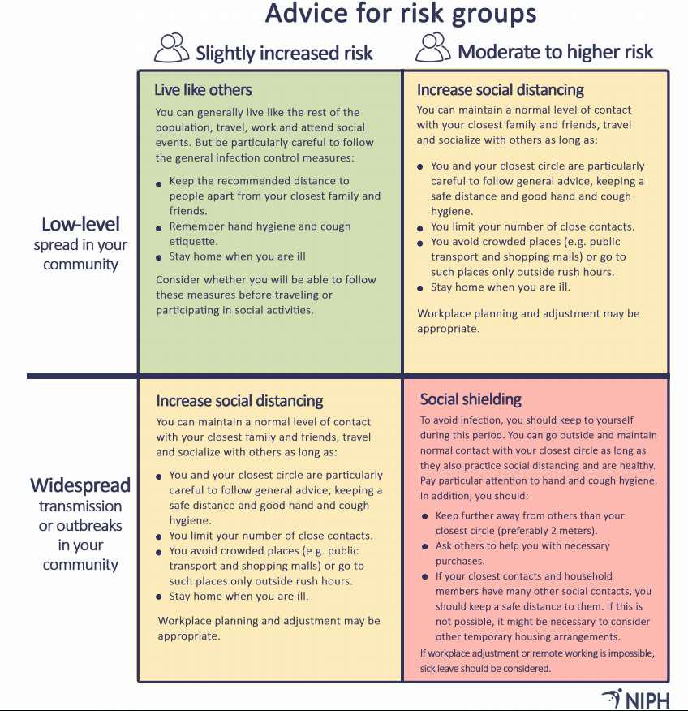

Doc no.: 01-W-HES100N Rev.: 21 Page 18 of 24

Internal © 2020 Aker Solutions. No part of this document or the information it contains may be reproduced or transmitted in any form or by any means without the permission of Aker Solutions. This document is no longer controlled once downloaded.
Management System Document | Work Instruction

Appendix III Notification
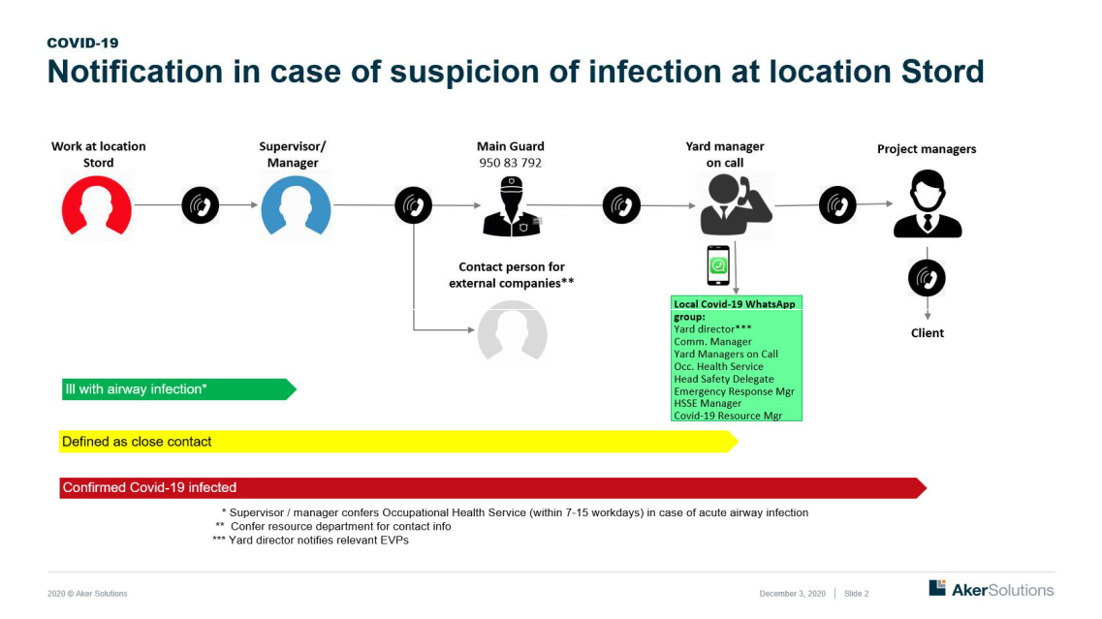
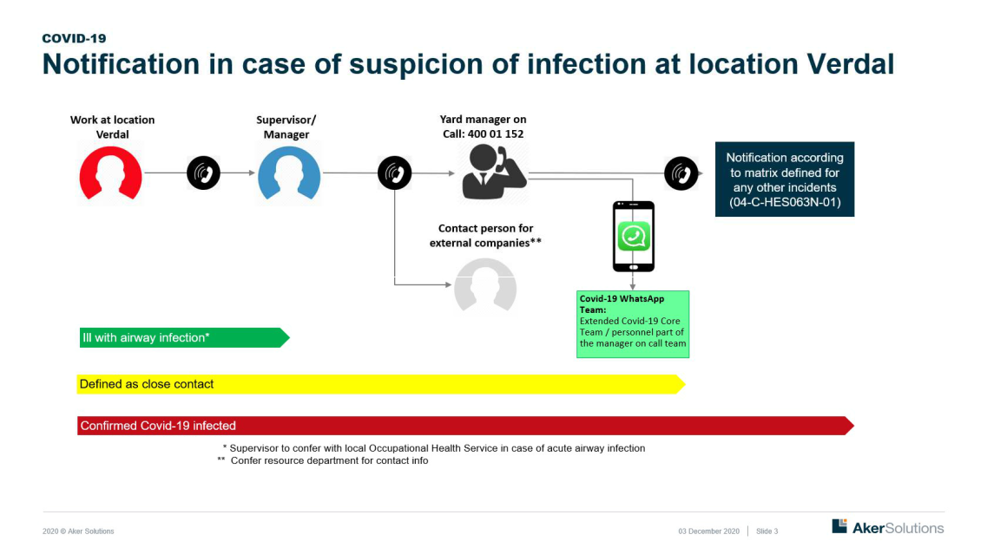

Doc no.: 01-W-HES100N Rev.: 21 Page 19 of 24

Internal © 2020 Aker Solutions. No part of this document or the information it contains may be reproduced or transmitted in any form or by any means without the permission of Aker Solutions. This document is no longer controlled once downloaded.
Management System Document | Work Instruction
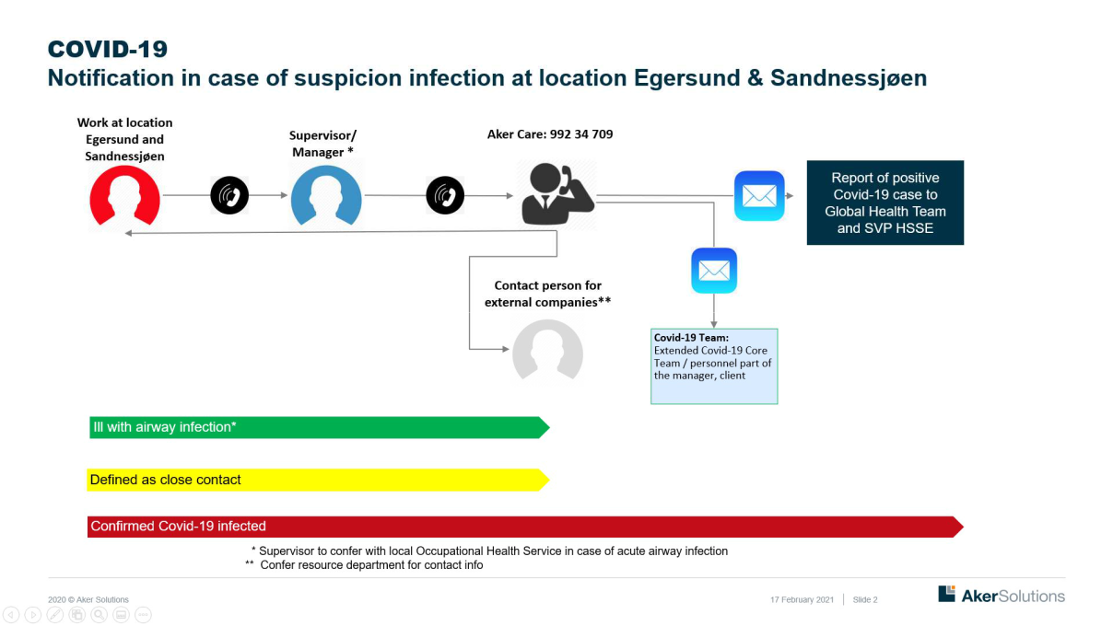

Doc no.: 01-W-HES100N Rev.: 21 Page 20 of 24

Internal © 2020 Aker Solutions. No part of this document or the information it contains may be reproduced or transmitted in any form or by any means without the permission of Aker Solutions. This document is no longer controlled once downloaded.
Management System Document | Work Instruction

APPENDIX IV RISK ASSESSMENT OF VARIOUS FORMS OF MEETINGS

The risk assessment will be updated in the event of a change in the infection situation and the risk status for the region. The following meetings have been approved, if the following requirements are met:
Types | Risk | Requirements |  | Responsible | Status
Ordinary | Spread of |  | Physical meetings shall be | Meeting
meetings in | infection. |  | limited to the absolutely | responsible
the office | Crowded |  | necessary
 | meeting |  | To widest extent use Teams
 | rooms. |  | Minimum 1m distance
 |  |  | (shoulder to shoulder)
 |  |  | between each meeting
 |  |  | participant in the meeting
 |  |  | room
 |  |  | Register participants who
 |  |  | are physically present in the
 |  |  | meeting room
 |  |  | Maximum 20 person
 |  |  | present in a meeting room
Town hall | Spread of |  | Max 50 | Yard director | ON HOLD
 | infection. |  | Rigged with chairs with a | (for | Application for
 | Unclear |  | minimum distance of 2m (to | operation/basis) | deviation to be
 | close |  | avoid close contact | Project Manager | sent to local
 | contacts |  | challenge). In Verdal, these | (for project) | HSSE manager
 |  |  | types of meetings are held
 |  |  | standing in the Module Hall.
 |  |  | 1 m distance because
 |  |  | «hall» is defined as outdoor
 |  |  | area.
 |  | Guards at entrance / exit to
 |  |  | avoid collection and
 |  |  | clogged queues
 |  | Before and after cleaning is
 |  |  | agreed with Facility
 |  |  | Management
 |  | Start the meeting with
 |  |  | information about escape
 |  |  | routes and infection control
 |  |  | rules
Meetings with | Spread of |  | Minimum 1m distance | Meeting | ON HOLD
food / | infection. |  | (shoulder to shoulder) | responsible | Application for
celebrations | Crowded |  | between each meeting |  | deviation to be
at the | meeting |  | participant in the meeting |  | sent to local
company | rooms / |  | room |  | HSSE manager
 | rooms. |  | Register participants who
 |  |  | were physically present
 |  | Food is ordered by the
 |  |  | canteen (which delivers
 |  |  | according to the infection
 |  |  | control rules)
 |  |  | Arrange cleaning with
 |  |  | Facility Management when
 |  |  | using canteens / lunch
 |  |  | rooms
Doc no.: 01-W-HES100N |  |  | Rev.: 21 |  | Page 21 of 24


Internal © 2020 Aker Solutions. No part of this document or the information it contains may be reproduced or transmitted in any form or by any means without the permission of Aker Solutions. This document is no longer controlled once downloaded.
Management System Document | Work Instruction


Courses at Spread of
the office infection.

Crowded
meeting
rooms.


Business Spread of

related infection.

gatherings by Unclear
AKSO but close
outside own contacts.
facilities Lack of

routines.

Strive for personnel who work together on a daily basis (cohort) to sit together (minimum 1m distance)

Seating to be documented / or take a picture of the «table set», in order to reduce the risk of having unnecessarily many close contacts defined

It is specified in the notice that you must stay at home if you are ill (symptom of respiratory infection, etc.)

Minimum 1m distance (shoulder to shoulder) between each meeting participant in the meeting room

Register participants daily Any food is ordered by the canteen (which delivers according to the infection
control rules)

The instructor is responsible for ensuring that distance rules are also complied during breaks

Strive for personnel who work together on a daily basis (cohort) to sit together (minimum 1m distance)

Seating to be documented / or take a picture of the «table set», in order to reduce the risk of having unnecessarily many close contacts defined

Start the course with information about escape routes and infection control rules

Max 20 persons present It is specified in the notice

that you must stay at home if you are ill (symptom of respiratory infection, etc.)

Location must be approved by the HSSE responsible
Travel must be limited to what is strictly necessary The current location must

submit the current infection control rules for the site to the responsible HSSE, and


Meeting

responsible

Arranger

To be run digital if possible


ON HOLD Application for deviation to be sent to local HSSE manager

Doc no.: 01-W-HES100N Rev.: 21 Page 22 of 24

Internal © 2020 Aker Solutions. No part of this document or the information it contains may be reproduced or transmitted in any form or by any means without the permission of Aker Solutions. This document is no longer controlled once downloaded.

Management System Document | Work Instruction


External Spread of


professional infection.

gatherings Unclear
outside AKSO close

contacts.
Lack of

routines.

may be subject to
verification

Minimum 1m distance (shoulder to shoulder) between each participant in the room

Registration of participants The organizer is
responsible for ensuring that distance rules are also complied during breaks

Start the meeting with information about escape routes and infection control rules

Strive for personnel who work together on a daily basis (cohort) to sit together (minimum 1m distance)

If you document / take a picture of the «table set», you can reduce the risk of having unnecessarily many close contacts defined

If a gathering ends with dinner, a maximum of 2 alcohol units is allowed.

Approved by local HSSE leader (Stord: Torstein Leth, Verdal: Arve Kleppe, Egersund/Sandnessjøen: Kurt Børge Pedersen) in advance


ON HOLD

Application for

deviation to be
sent to local

HSSE manager

Doc no.: 01-W-HES100N Rev.: 21 Page 23 of 24

Internal © 2020 Aker Solutions. No part of this document or the information it contains may be reproduced or transmitted in any form or by any means without the permission of Aker Solutions. This document is no longer controlled once downloaded.

Management System Document | Work Instruction

Appendix V Template for “Extra security check”
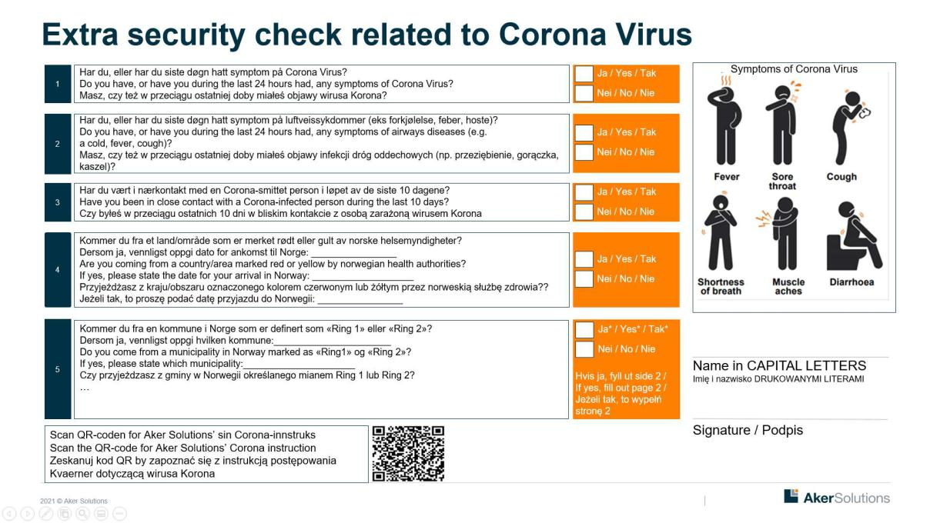

The response at question 1-3 at page 1 must be “no”.
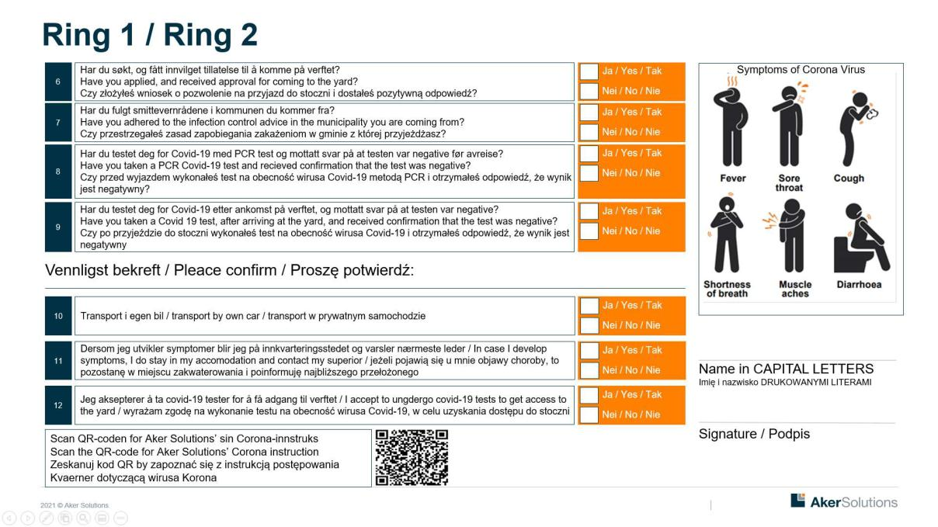

The response at question 6, 7, 9, 11 and 12 at page 2 must be “yes” to get access to the yard.

In case of «no» at question 8 and 10 contact HSSE manager at the yard.

Doc no.: 01-W-HES100N Rev.: 21 Page 24 of 24

Internal © 2020 Aker Solutions. No part of this document or the information it contains may be reproduced or transmitted in any form or by any means without the permission of Aker Solutions. This document is no longer controlled once downloaded.

