 | Quality Assurance Work |  | CDRL A003
 | Instruction
Approved: |  | Date: 1 November 2003
Title: LO&SC Quality System Plan |  | REV |  | Page 1 of 19
 |  | D |  | Page 1 of 19
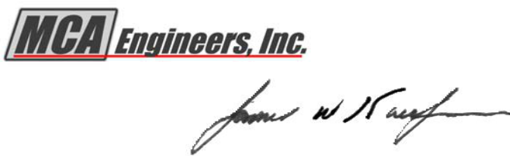

1.0 POLICY/PURPOSE

MCA Quality Policy

(As found in the MCA Quality Manual)

“ MCA Engineers, Inc., is absolutely committed to the delivery of products and services

that are consistent with the highest quality standards established by our customers,

industry, and internal requirements. Further, we will exceed the highest expectations of our customers and strive to continuously improve the quality of our products based upon customer feedback and self analysis of our processes and procedures. “

The purpose of this Quality System Plan (QSP) is to fully implement the MCA Quality Policy for the Launch Operations and Support Contract (LO&SC), Vandenberg AFB, CA. This QSP fully integrates the requirements of the MCA Quality Manual and the various MCA ISO procedures that implement ISO 9001 elements. (NOTE: In addition to ISO 9001: 1994 requirements, this plan implements ISO 9001: 2000 requirements.) (NOTE: MCA Engineers is now a subdivision of SBAR, Inc.; however, all existing MCA Quality Management System policies, procedures, and work instructions remain in affect.)

2.0 SCOPE

This Quality System Plan (QSP) defines the LO&SC Quality Management System (QMS).

It is applicable to all LO&SC functional areas including work performed by subcontractors.

3.0 REFERENCES AND DEFINITIONS

3.1 References

ISO 9001: Quality Management Systems-Requirements, Third Edition (2000-12-15).

ISO 9000: Quality Management Systems-Fundamentals and Vocabulary, Second Edition.

ISO 9004: Quality Management Systems-Guidelines for Performance Improvement, Second Edition.

Pande, Peter S. et al, (2000), The Six Sigma Way, McGraw-Hill.

American National Standard, ANSI/ISO/ASQC Q9001-1994: Quality Systems – Model for Quality Assurance in Design, Development, Production, Installation and Servicing

Copyright © This document is the property of MCA Engineers, Inc. It shall not be copied without the prior written approval of MCA Engineers, Inc.
 | Quality Assurance Work |  | CDRL A003
 | Instruction
Approved: |  | Date: 1 November 2003
Title: LO&SC Quality System Plan |  | REV |  | Page 2 of 19
 |  | D |  | Page 2 of 19

Guideline for Auditing Quality Systems, ANSI/ASQC Q10011-1-1994, Q10011-2-1994, and Q10011-3-1994

MCA Engineers, Inc. Documentation

- MCA Quality Manual (QAP 0002)

- MCA and Government Services Division (GSD) procedures implementing ISO 9001 elements

Statement of Work for Launch Operations & Support Contract (LO&SC) (FO4684-98-C-0014)

3.2 Definitions

Contractor Computerized Management System (CCMS): “CCMS is the contractor acquired computer software and equipment databases contained facility data with the capability of being accessed by the GPM. It shall store and process data for maintenance management functions….”

Customer: Recipient of a product provided by the supplier. A customer may be a commercial firm, an individual, or a government agency. MCA is the supplier.

Data Management Central Library (DMCL): The focal point for all quality records associated with the LO&SC contract. The DMCL is located in Bldg. 861.

Environmental Health and Safety Specialist (EH&SS): LO&SC staff member responsible for the administration of the contract environmental and safety programs.

Functional Area Manager (FAM): A senior supervisory individual who is responsible for the leadership, direction, and overall success of an area of MCA, such as O&M, contracts, logistics, quality, safety, engineering, financial, task orders, etc.

Metrics: Meaningful measures. For a measure to be meaningful, it must present data that encompasses the right action. In the context of the Statement of Work, metrics refers to management and performance measures.

Process Action Report (PAR): An electronic form used to report and document nonconformances, preventive actions, or process improvement actions. The PAR system is located in the PAR Database maintained at the MCA web site. (NOTE: The PAR is the only form authorized for recording and documenting nonconformances, preventive actions, and process improvement actions unless otherwise authorized by the Quality Manager.)

Copyright © This document is the property of MCA Engineers, Inc. It shall not be copied without the prior written approval of MCA Engineers, Inc.
 | Quality Assurance Work |  | CDRL A003
 | Instruction
Approved: |  | Date: 1 November 2003
Title: LO&SC Quality System Plan |  | REV |  | Page 3 of 19
 |  | D |  | Page 3 of 19

Procedure: Corporate/division level, written direction that defines the specific strategy that MCA employs in performing a task, e.g., quality, and human resources, financial. Procedures give general guidance, and, where applicable, apply throughout all levels of the corporation.

Quality: Totality of characteristics that bear on the ability to satisfy stated and implied needs.

Quality Assurance Office/Officer (QAO): The LO&SC agency that is responsible for the overall management of the LO&SC’s quality program. For the purposes of this QSP, the LO&SC Product Assurance (PA) Office is the QAO.

Quality Hold: An order issued to cease operations because the desired level of quality is either not being achieved or the quality of the product or service is in question.

Quality Assurance Guide (QA Guide): A directive, prepared by the LO&SC PA Manager and approved by the LO&SC MCA Program Manager, that gives interim guidance on policies and procedures affecting the LO&SC. These guides are temporary in nature and do not conflict with corporate or division policies and procedures. Further, these guides are either incorporated into a LO&SC work instruction or are rescinded when they are no longer needed.

Quality Management: All activities of the overall management function that determine the quality policy objectives and responsibilities and implement them through quality planning, quality control, quality assurance, and quality improvement within the quality system. Quality management is the responsibility of all levels of management in all functions within an organization. Its implementation involves all members of the organization.

Quality Management System (QMS): MCA’s coordinated activities to direct and control the LO&SC quality program. Direction and control includes the establishment of the quality policy and quality objectives, quality planning, quality control, quality assurance, and quality improvement. Quality management is the responsibility of all levels of management in all functions within MCA, to include the LO&SC. Its implementation involves all MCA employees.

Quality Objective: Something sought or aimed for and is generally based upon MCA’s Quality Policy. Quality objectives are normally identified for specific functions/organizations within MCA. (NOTE: For the LO&SC, contract metrics are quality objectives.)

Quality Steering Committee (QSC): Organization of LO&SC senior managers who review the LO&SC QMS to ensure its continuing suitability and effectiveness in satisfying the ISO 9001

Copyright © This document is the property of MCA Engineers, Inc. It shall not be copied without the prior written approval of MCA Engineers, Inc.
 | Quality Assurance Work |  | CDRL A003
 | Instruction
Approved: |  | Date: 1 November 2003
Title: LO&SC Quality System Plan |  | REV |  | Page 4 of 19
 |  | D |  | Page 4 of 19

requirements, fulfilling MCA’s quality policy, and meeting the needs of our customers. (NOTE:

The LO&SC holds a weekly QSC as part of its staff meeting.)

Quality System Plan (QSP): Written direction/guidance to establish and maintain an ISO 9001 compliant and/or equivalent quality system IAW the LO&SC Statement of Work. The QSP implements the Quality Management System.

Statement of Work (SOW): Contract number FO6484-98-C-0014 that is the written agreement with the Government for the administration of the Launch Operations and Support Contract at Vandenberg AFB, CA.

“Voice of the Customer:” A strategy and system developed by Pande, Nueman, and Cavanaugh (Pande, Peter S. et al, (2000), The Six Sigma Way, McGraw-Hill) that continually tracks and updates customer requirements, competitor activities, market changes, etc.

Work Control Center (WCC): The LO&SC agency that is the customer service function for the contract. The WCC receives, processes, schedules, tracks, and provides status on all work requirements within the contract.

Work Instruction (WI) : Written details that, when appropriate, state what shall be done and by whom; when, where and how it shall be done; what materials, equipment and documents shall be used; and how it shall be controlled and recorded. WIs will normally be used to implement corporate procedures and/or specific contractual requirements.

4.0 RESPONSIBILITIES

4.1 Product Assurance (PA) Manager

The PA Manager is responsible for the Quality System Plan.

4.2 Quality System Responsibilities

WHO | RESPONSIBILITY AND AUTHORITY
 | • Maintain the Quality Management System (QMS)
Program Manager | • Develop and implement plans for improving the
Program Manager | quality management system
 | • Communicateand ensure the visibility and
 | understanding of MCA’s quality policy throughout the

Copyright © This document is the property of MCA Engineers, Inc. It shall not be copied without the prior written approval of MCA Engineers, Inc.
 |  | Quality Assurance Work |  |  |  | CDRL A003
 |  |  |  | Instruction
Approved: |  |  |  |  |  | Date: 1 November 2003
Title: LO&SC Quality System Plan |  |  |  |  |  | REV |  | Page 5 of 19
 |  |  |  |  |  | D |  | Page 5 of 19
 |  |  | company
 |  |  | • | Chair/attend QSC meetings
 |  |  | • | Ensure customer requirements are identified and
 |  |  | achieved to enhance customer satisfaction
 |  |  | • | Establish communication processes to ensure that there
 |  |  | is feedback regarding the effectiveness of the QMS
 |  |  | • | When appropriate, issue QA Guides for the LO&SC
 |  |  | • | Ensure that the QMS is established, implemented, and
 |  |  | maintained in accordance with ISO standards throughout
 |  |  | LO&SC
 |  |  | • ReportQMS performance to the Program
Product Assurance (PA) Manager |  |  | Manager/QSC and make recommendations for
 |  |  | improvement
 |  |  | • | Ensure the promotion of customer requirements
 |  |  | throughout LO&SC
 |  |  | • | Obtain and communicate customer requirements to the
Functional Area Managers (FAMs) |  |  | appropriate management level
and supervisory personnel |  |  | • | Ensure that qualified, skilled, and trained personnel, as
 |  |  | well as other resources, are used to implement the QMS
 |  |  | • Ensure that products and services satisfy customer
 |  |  | requirements, including quality, safety, cost, timeliness,
 |  |  | performance, reliability, durability, accuracy, and
 |  |  | maintainability
 |  |  | • | Comply with applicable standards, specifications, and
All Employees |  |  | documented procedures/work instructions
 |  |  | • | Demonstrate understanding of the quality process
 |  |  | • | Perform quality work
 |  |  | • | Comply with corporate procedures and WIs.
 |  |  | • Stop work in-progress and notify the FAM when
 |  |  | quality is in doubt or compromised

Copyright © This document is the property of MCA Engineers, Inc. It shall not be copied without the prior written approval of MCA Engineers, Inc.
 | Quality Assurance Work |  | CDRL A003
 | Instruction
Approved: |  | Date: 1 November 2003
Title: LO&SC Quality System Plan |  | REV |  | Page 6 of 19
 |  | D |  | Page 6 of 19

5.0 REQUIREMENTS/PROCEDURES

Figure 1 – Responsibilities for LO&SC SOW Requirements

Program Manager

(3.1.1 Program Management)
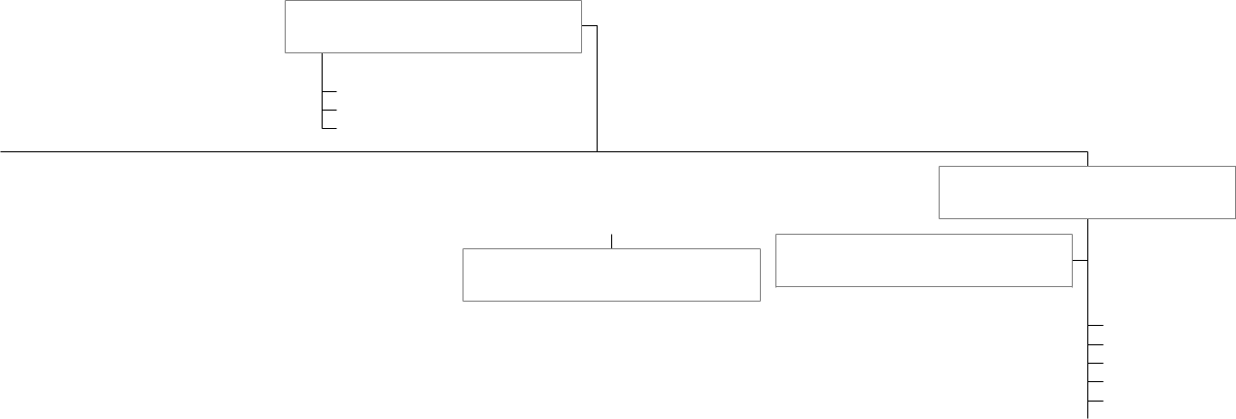

Product Assurance (PA) Manager

1.4 Quality Assurance

1.5 Security

3.1.4 Data Management

Resource Manager |  |  |  | Technical Services Manager
 |  |  |  | (3.5.1 Sustaining Engineering)

Contracts/Procurement Manager

1.7 Energy Conservation
1.7 Energy Conservation | Operations and Maintenance Manager
1.8 Environmental Controls
1.9 Safety
3.1.2.1 Customer Service/Trouble Desk
3.1.2.3 Work Classification |  |  | 3.1.2.2 Planning and Estimating
3.1.2.4 Environmental Hazards
3.1.2.4 Environmental Hazards |  |  | 3.2.1 Operations
3.1.2.5 Work Site Access
3.1.2.5 Work Site Access |  |  | 3.2.2 South Vandenberg Power Plant
3.1.2.6 Outages & Work Clearance
3.1.2.6 Outages & Work Clearance |  |  | 3.3.1 Recurring Work Program
3.1.2.7 Daily Problem Summary Report
 |  |  | 3.3.2 Corrective Maintenance
3.1.2.8 Completed Work
3.1.2.8 Completed Work |  |  | 3.3.3 Facilities (Appendix A)
3.1.3 Financial Managment
3.1.3 Financial Managment |  |  | 3.3.4 Cranes & Hoists (Appendix B)
3.10 Contractor Employees
3.10 Contractor Employees |  |  | 3.3.7 Towers (Appendix E)
 |  |  | 3.3.8 Diesel Electric Units
 |  |  | 3.3.10 Test Weight Moves
 |  |  | 3.3.11 Lifelines (Bldg 1819)
 |  |  | 3.5.1.4 Construction Management
 |  |  | 3.5.2 Plant Engineering
 |  |  | 3.6 Repair
 |  |  | 3.7 Work Request
 |  |  | (SOW Development)
 |  |  | 3.8 Task Assignments
 |  |  | (SOW Development)

SLC-3/SLC-4 Manager

3.1.1.2 Space Launch Complex

Corrosion Control Manager

(3.4.1 Corrosion Control)

1.3.1.1 Benchstock

1.3.1.2 Integrated Logistics Support

1.3.1.3 Supply

1.3.2 Contractor Furnished Property

3.3.5 Elevators

3.11 Reimbursables

Copyright © This document is the property of MCA Engineers, Inc. It shall not be copied without the prior written approval of MCA Engineers, Inc.

 | Quality Assurance Work |  | CDRL A003
 | Instruction
Approved: |  | Date: 1 November 2003
Title: LO&SC Quality System Plan |  | REV |  | Page 7 of 19
 |  | D |  | Page 7 of 19

Figure 2 -- Structure of Quality Management System Documentation

 |  |  |  |  |  |  |  | MCA
 |  |  |  |  |  |  |  | Quality
 |  |  |  |  |  |  |  | Policy
 |  |  |  |  |  |  |  | Statement
 |  |  |  |  |  |  |  |  |  |  | Philosophies and
 |  |  | Why |  |  |  | MCA Quality Manual
 |  |  |  |  |  |  |  |  |  |  | Policies
What, When, |  |  |  |  |  | Corporate/Division Procedures |  |  |  |  | Principles and
 |  |  |  |  |  | and Additional Documents/Data
Where, and Who |  |  |  |  |  |  |  |  |  |  | Strategies
 |  |  |  |  |  |  |  | (Records)
 |  |  |  |  |  | Division, Branch, and Contract
How |  |  |  |  |  |  | Specific Work Instructions |  |  |  |  |  | Current
How |  |  |  |  |  | and Additional Documents/Data |  |  |  |  |  |  | Practices
 |  |  |  |  |  |  |  | (Records)
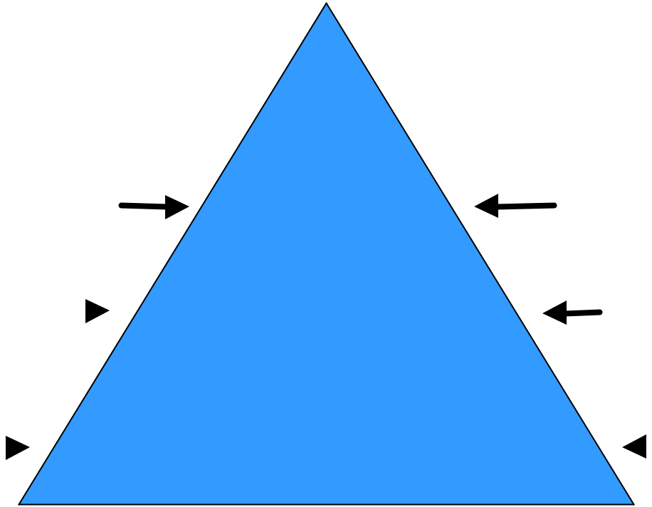

Copyright © This document is the property of MCA Engineers, Inc. It shall not be copied without the prior written approval of MCA Engineers, Inc.
 | Quality Assurance Work |  | CDRL A003
 | Instruction
Approved: |  | Date: 1 November 2003
Title: LO&SC Quality System Plan |  | REV |  | Page 8 of 19
 |  | D |  | Page 8 of 19

5.1 General

The Launch Operations and Support Contract (LO&SC) provides mission essential support for ground systems associated with launch operations and ensures continuing timely, responsive, and technical excellence in mission and test support by the 30 Space Wing (30 SW) to the space, ballistic missile, and related programs operating at Vandenberg AFB, CA. MCA Engineers, Inc. is teamed with EG&G and General Physics Corporation and are the nucleus of the LO&SC. As the LO&SC team, we are responsible for providing and managing a skilled work-force capable of providing services in the following areas:

- Planning, Programming, and Cost Estimating

- Design

- Studies and Analysis

- Installation

- Fabrication

- Project Coordination/Scheduling

- Repairs, Modification, and Refurbishment

- Quality Control, Testing, and Inspection

- Drafting and Documentation

- Documentation Updating and Maintenance

- Surveillance

Copyright © This document is the property of MCA Engineers, Inc. It shall not be copied without the prior written approval of MCA Engineers, Inc.
 | Quality Assurance Work |  | CDRL A003
 | Instruction
Approved: |  | Date: 1 November 2003
Title: LO&SC Quality System Plan |  | REV |  | Page 9 of 19
 |  | D |  | Page 9 of 19

- Operations and Maintenance

- Corrosion Control

5.2 Quality Management System (QMS)

LO&SC has established and documented a QMS specifically designed for LO&SC that ensures compliance with contract SOW requirements, applicable elements of ANSI/ASQC 9001-1994 (ISO 9001), ISO 9001: Quality Management Systems-Requirements, Third Edition (2000-12-15), the MCA Quality Manual, MCA procedures, and GSD procedures. This QSP establishes quality policy, plans, and procedures for implementing the QMS. Detailed work process instructions and procedures implement our quality system at all levels of the organization. There are no exclusions to the 1994 or 2000 version of ISO 9001.

5.3 Organization and Management

Figure 1 is the assignment of SOW responsibilities to specific LO&SC functional areas/FAMs. The responsibility for quality begins with the LO&SC Program Manager, assisted by the Quality Assurance Manager (PA Manager), and flows through FAMs, lead technicians/foremen, and onto technicians and painters. This is intended to be a dynamic process with the flow of information going up, down, and across the organization.

5.4 Continuous Quality Improvement

LO&SC utilizes a process-oriented quality management system designed in consonance with ISO 9001 series standards, with built-in mechanisms to ensure continuous quality improvement. Through employee involvement, we strive to build quality into our work processes and procedures and reduce the need for quality control inspections after the work has been completed. This results in reduced costs associated with re-work and the correction of non-conforming work. Elements of our QMS that emphasize and facilitate continuous quality improvement include:

Work Instruction (WI) Development and Updates: User input collected during simulated or “first runs” of WIs provides valuable information and data for improving detailed processes.

Corrective and Preventive Actions: Eliminating causes of actual and potential defects in product or performance and verifying the effectiveness of actions taken promotes continuous improvement.

Copyright © This document is the property of MCA Engineers, Inc. It shall not be copied without the prior written approval of MCA Engineers, Inc.
 | Quality Assurance Work |  | CDRL A003
 | Instruction
Approved: |  | Date: 1 November 2003
Title: LO&SC Quality System Plan |  | REV |  | Page 10 of 19
 |  | D |  | Page 10 of 19

Internal Quality Audits: Trained auditors provide an independent assessment of QMS elements and results of processes to discover defects and opportunities for improvement.

Management Review: Program management reviews of QMS elements provide an overview of performance that identifies trends, weaknesses, and opportunities for improvement. These are conducted during regularly scheduled QSC meetings.

Nonconformance Reporting: Disposition and closure for nonconformances include consideration for corrective actions.

Employee Suggestions/Involvement: Every employee is encouraged to share ideas for improvement and every suggestion is thoroughly evaluated. This is one of our most valuable sources of innovation and improvement ideas.

Customer Feedback/the Voice of the Customer: Increased customer satisfaction results when customer concerns are promptly addressed and positive steps taken to remedy concerns. In addition to frequent face-to-face meetings with customers, the LO&SC Customer Survey Form and customer visits are used to identify potential problem areas.

Quality Hold: When warranted, LO&SC personnel and subcontractors are authorized to impose an immediate “Quality Hold” on work in-process, impounding nonconforming products, withholding acceptance until quality is assured, etc. Quality Holds are promptly reported to the appropriate FAM/supervisor for action as required.

5.5 Quality System Required Elements

5.5.1 Management Responsibility

The Program Manager has executive responsibility for the QMS and the PA Manager has the authority to establish, implement, and maintain the QMS. Further, the PA Manager reports the status of the QMS to the Program Manager on a recurring basis.

5.5.2 Quality System

The Program Manager chairs a weekly staff meeting of senior LO&SC managers that oversees the successful implementation and continuation of the company’s quality program. Portions of this staff meeting are dedicated to quality issues in the form of a Quality Steering Committee (QSC) Meeting. These meetings address the status of open PARs and when appropriate, the Program Manager appoints Action Teams to resolve problem areas, prevent problems from occurring, and implement specific quality improvement programs. In addition to addressing the status of PARs, these meetings are used to address specific quality issues that require additional support from the LO&SC staff. In addition to the Program Manager, the QSC is composed of, as a minimum, the PA Manager, Technical Services Manager,

Copyright © This document is the property of MCA Engineers, Inc. It shall not be copied without the prior written approval of MCA Engineers, Inc.
 | Quality Assurance Work |  | CDRL A003
 | Instruction
Approved: |  | Date: 1 November 2003
Title: LO&SC Quality System Plan |  | REV |  | Page 11 of 19
 |  | D |  | Page 11 of 19

Contracts/Procurement Manager, and the Resource Manager. Further, the PA Manager maintains a suspense list that, amongst other things, documents the status of all open PARs.

5.5.3 Contract Review

The Contracts/Procurement Manager maintains documentation for review of contract requirements and Statement of Work (SOW) changes, proposal processing, and contract amendments. Affected FAMs review contract scope changes to ensure requirements are adequately defined and the capabilities exist to meet those requirements.

5.5.4 Design and Development Control

The Contracts/Procurement Manager employs design and development control services that verify that LO&SC design and development activities meet ISO 9001, MCA, and customer requirements. LO&SC design and development activities are planned, controlled, verified, and validated; requirements for designs are documented; design reviews are held, as appropriate; and design changes are made in accordance with documented procedures/WIs.

5.5.5 Document and Data Control

The MCA structure for documenting the Quality Management System is depicted in Figure 2. To the maximum extent practical, corporate and division procedures are written with sufficient detail so they can be used at the contract level. When more details are needed, the LO&SC has written contract specific WIs to further ensure the quality of our products and services.

MCA and the LO&SC have established and maintain procedures and WIs to control all documents and data that relate to the requirements of the LO&SC. Requirements are established for review and approval of WIs prior to use; maintenance of a master listing of controlled documents identifying the current revision status; and controls to prevent the use of obsolete or invalid documents and data. Changes to internal documents and data are reviewed and approved by the same organizations or functions that performed the original review or approval. Table A is the Quality System Plan Relational Matrix that defines the procedures, WIs, etc. that are required per this Quality System Plan.

Copyright © This document is the property of MCA Engineers, Inc. It shall not be copied without the prior written approval of MCA Engineers, Inc.
 | Quality Assurance Work |  |  | CDRL A003
 | Instruction
Approved: |  |  |  | Date: 1 November 2003
Title: LO&SC Quality System Plan |  |  |  | REV |  | Page 12 of 19
 |  |  |  | D |  | Page 12 of 19
Table A – Quality System Relational Matrix
 | OPR | ISO
DOCUMENT NAME |  | ELEMENT | SUSPENSE |  |  | COMPLETED
 |  | (1994)
MCA & GSD PROCEDURES
(Latest Revision Located MCA
Web Site & LO&SC Server)
MCA Quality Manual | MCA QA | 4.1 to 4.20 |  | N/A |  | 16 Aug 03
GSD Contract Review | MCA QA | 4.3 |  | N/A |  | 27 Nov 02
MCA Design& Development | MCA QA | 4.4 |  | N/A |  | 11 Jan 02
Control
MCA Document & Data Control | MCA QA | 4.5 |  | N/A |  | 7 Feb 03
GSD Purchasing | MCA QA | 4.6 |  | N/A |  | 22 Feb 02
MCA Customer Property | MCA QA | 4.7 |  | N/A |  | 24 Jan 03
MCA Product ID and Traceability | MCA QA | 4.8 |  | N/A |  | 15 Feb 02
MCA Process Control | MCA QA | 4.9 |  | N/A |  | 6 Feb 02
MCA Inspection and Testing | MCA QA | 4.10 |  | N/A |  | 1 Mar 02
MCA Control of IMTE | MCA QA | 4.11 |  | N/A |  | 25 Feb 02
MCA Inspection and Test Status | MCA QA | 4.12 |  | N/A |  | 24 May 02
MCA Control of Nonconforming | MCA QA | 4.13/4.14 |  | N/A |  | 27 Feb 03
Product/Corrective and Preventive
Action
MCA Handling, Storage, | MCA QA | 4.15 |  | N/A |  | 7 May 02
Packaging, Preservation, and
Delivery
MCA Control of Quality Records | MCA QA | 4.16 |  | N/A |  | 27 May 02
MCA Internal Audits | MCA QA | 4.17 |  | N/A |  | 1 Apr 02
MCA Training | MCA QA | 4.18 |  | N/A |  | 10 May 02
MCA Servicing | MCA QA | 4.19 |  | N/A |  | 1 May 03
MCA Measurement and Analysis | MCA QA | 4.20 |  | N/A |  | 29 Apr 02
LO&SC WIs
(Latest Revision Located
LO&SC Server)
Quality System Plan | PA | 4.1 to 4.20 |  | N/A |  | 25 Oct 02
LO&SC Design and Development | PA | 4.4 |  | N/A |  | 19 Sep 02
Control
LO&SC Government Property | Contracts/ | 4.7 |  | N/A |  | 10 Nov 02

Copyright © This document is the property of MCA Engineers, Inc. It shall not be copied without the prior written approval of MCA Engineers, Inc.
 | Quality Assurance Work |  |  |  | CDRL A003
 | Instruction
Approved: |  |  |  |  | Date: 1 November 2003
Title: LO&SC Quality System Plan |  |  |  |  | REV |  | Page 13 of 19
 |  |  |  |  | D |  | Page 13 of 19
 | Procurement
Work Control | Tech Services | 4.9 |  |  | N/A |  | 6 Jun 02
Environmental Program | EH&SS | 4.9 |  |  | N/A |  | 11 Feb 03
Administration
EPA specific environmental | EH&SS | 4.9 |  |  | N/A |  | Various
programs
OSHA specific safety programs | MCA QA, | 4.9 |  |  | N/A |  | Various
 | EH&SS
Preventive Maintenance WIs | PA | 4.9 |  |  | N/A |  | Various
Crane & Hoist Insp./Main. | Tech Services | 4.9 |  |  | N/A |  | 22 Mar 03
Crane Rated Load/Proof Load | Tech Services | 4.9 |  |  | N/A |  | 19 Mar 03
Service Guide Main. Checklist for
Alimak Elevators | Tech Services | 4.9 |  |  | N/A |  | 1 May 99
Service Guide Main. Checklist for
Hydraulic Elevators | Tech Services | 4.9 |  |  | N/A |  | 1 May 99
Service Guide Maintenance
Checklist for Traction Elevators | Tech Services | 4.9 |  |  | N/A |  | 1 May 99
Miscellaneous
(Located MCA Web Site)
CWBS Dictionary | Financial | 4.1 |  |  | N/A |  | 21 Oct 03
Cost Performance Report | Financial | 4.1 |  | Monthly |  |  | Monthly Update
Elevator Work Schedule | Tech Services | 4.9 |  |  | Annual |  | Annual Update
Facility Inspection Schedule | Tech Services | 4.9 |  |  | Annual |  | Annual Update
Power Generator Status Report | Tech Services | 4.9 |  | Monthly |  |  | Monthly Update
Meter Readings | Tech Services | 4.9 |  | Monthly |  |  | Monthly Update
Facility Corrosion Control Plan | Corrosion | 4.9 |  |  | Annual |  | Annual Update
Contract Funds Status Report
(JOCAS) | Financial | 4.9 |  | Monthly |  |  | Monthly Update
Contractor’s Upload Format | Financial | 4.9 |  | Monthly |  |  | Monthly Update
Power Plant Monthly Ops. | Tech Services | 4.9 |  | Monthly |  |  | Monthly Update
Waste Water Discharge Report | Tech Services | 4.9 | Semi-Annual |  |  |  | Semi-Annual
 |  |  |  |  |  |  | Update
Fugitive Hydrocarbons Report | Tech Services | 4.9 |  | Quarterly/ |  |  | Quarterly/
 |  |  |  |  | Annual |  | Annual Update

Copyright © This document is the property of MCA Engineers, Inc. It shall not be copied without the prior written approval of MCA Engineers, Inc.
 | Quality Assurance Work |  | CDRL A003
 | Instruction
Approved: |  | Date: 1 November 2003
Title: LO&SC Quality System Plan |  | REV |  | Page 14 of 19
 |  | D |  | Page 14 of 19

5.5.6 Purchasing

LO&SC maintains documented procedures to ensure products and services are obtained from approved suppliers and meet defined requirements for quality, cost, and schedule. Procedures include methods for evaluating and selecting qualified vendors and subcontractors; preparing purchasing documents that clearly define requirements; verifying products and services meet requirements; and provisions for source acceptance of supplier’s product. Purchase decisions are based on obtaining the best quality products, at the best cost, in time to support customer schedule requirements.

Receiving inspection is performed to ensure incoming materials have undergone a review for conformity. When a source inspection or independent testing is indicated, the requirement is specified in the purchase document and acceptance records included with shipping documents.

Suppliers must guarantee LO&SC access to facilities to conduct source inspection and surveillance, or to expedite product delivery or processing when needed. Nonconforming products are rejected.

5.5.7 Control Of Customer-Supplied Product

Accountability for Government Furnished Property is assigned to the LO&SC user and verified by routine daily operator inspections and periodic property audits as appropriate. Methods for controlling and managing materials and equipment are incorporated into our control of government property plan. The Contracts/Procurement Department maintains property records and an electronic inventory listing of all equipment and property and warranties are maintained in our Contractor Computerized Management System (CCMS).

5.5.8 Product Identification And Traceabilty

The scope of ISO 9001 element 4.8 is limited to identification of operators and workers who perform detail processes for LO&SC. Our CMMS and process work instructions provide this element.

5.5.9 Process Control

The LO&SC QMS ensures all work is prescribed in clear and complete work process instructions that provide criteria for performing operations and acceptance of completed work. Each functional area contributes to the development and maintenance of work processes. LO&SC process control includes:

- Documented MCA procedures and LO&SC specific Work Instructions.

Copyright © This document is the property of MCA Engineers, Inc. It shall not be copied without the prior written approval of MCA Engineers, Inc.
 | Quality Assurance Work |  | CDRL A003
 | Instruction
Approved: |  | Date: 1 November 2003
Title: LO&SC Quality System Plan |  | REV |  | Page 15 of 19
 |  | D |  | Page 15 of 19

- Control, use, and operation of equipment.

- Suitable working environment.

- Compliance with standards, codes, and regulations.

- Approval of process, procedures, and equipment.

- Criteria for workmanship.

- Maintenance of equipment to ensure continued capability and operation.

FAMs are assigned for each process and this assignment is documented in the applicable WI.

5.5.10 Inspection and Testing

Required inspection and testing, performed by designated individuals, and the records to be established, are detailed in various WIs needed to perform LO&SC tasks. Inspection mechanisms involve a combination of checkpoints utilizing self-inspections and technical verification by designated personnel at identified quality inspection points.

5.5.11 Inspection, Measuring, and Test Equipment (IMTE)

The MCA has established procedures for handling, calibrating, and controlling any inspection, measurement, and test equipment used to verify conformance to established quality requirements and specifications. Calibration and periodic maintenance of inspection, measurement, and test equipment are controlled and documented by the LO&SC automated calibration and maintenance recall system. All measurement and test equipment will be available for use by the Government when needed to verify conformance with contract requirements. The Vandenberg AFB Precision Measurement Equipment Laboratory (PMEL) calibrates IMTE.

5.5.12 Inspection and Test Status

Inspections are conducted by designated individuals who indicate acceptance by signature or stamp and date or by electronic means on the appropriate documentation. A serviceable (yellow) or unserviceable (red) material/equipment tag is used to indicate material or equipment status.

Copyright © This document is the property of MCA Engineers, Inc. It shall not be copied without the prior written approval of MCA Engineers, Inc.
 | Quality Assurance Work |  | CDRL A003
 | Instruction
Approved: |  | Date: 1 November 2003
Title: LO&SC Quality System Plan |  | REV |  | Page 16 of 19
 |  | D |  | Page 16 of 19

5.5.13/14 Control of Nonconforming Product/Corrective and Preventive Action

Each functional area initiates and maintains procedures with appropriate records to ensure nonconforming products or services are not used or delivered to the customer. These procedures ensure proper identification, documentation, evaluation, segregation, corrective actions, preventive actions, disposition, and notification of nonconforming products or services. The documentation system is available to the customer for use in reporting defects as well as for determining status of reported nonconformances. When nonconformity is detected, a Process Action Report (PAR) documents recovery and corrective actions.

Nonconformances are identified by LO&SC employees as part of their daily work. It is their responsibility to document the nonconformance, and report it to their supervisor and the QAO (Product Assurance). The QAO ensures nonconformances are properly documented, tracked, and that the proper LO&SC and Government personnel have been notified. Nonconforming product and/or material is controlled until the nonconformance is resolved. Recovery actions; including system restoration, retest, and corrective actions, are documented in the PAR system.

Sustaining Engineering provides N/CAR dispositions when an engineering solution is needed; the nonconformance affects form, fit, or function; a change is required to the system configuration; or the nonconformance is against a critical system. Otherwise, lead technicians/foremen provide dispositions. LO&SC technicians implement all approved recovery instructions. When appropriate, Government concurrence is obtained for nonconformance dispositions.

PARs are also used when there is a problem or the possibility of a nonconformance. The QAO ensures preventive actions are properly documented, tracked, and that the proper LO&SC and Government personnel have been notified. These reports remain open until the problem is solved or sufficient preventive actions are implemented to prevent a nonconformance.

The QAO is responsible for monitoring all PARs (including process improvement) to ensure proper identification, control, isolation, and disposition of nonconformances and preventive actions. FAMs ensure that cost-effective and positive corrective and preventive actions are taken to preclude or reduce the rate of nonconformances. See MCA N/CAR Procedure for details.

Copyright © This document is the property of MCA Engineers, Inc. It shall not be copied without the prior written approval of MCA Engineers, Inc.
 | Quality Assurance Work |  | CDRL A003
 | Instruction
Approved: |  | Date: 1 November 2003
Title: LO&SC Quality System Plan |  | REV |  | Page 17 of 19
 |  | D |  | Page 17 of 19

5.5.15 Handling, Storage, Packing, Preservation, and Delivery

Warehouse shelf -life is the major concern in this area and the LO&SC Government Property Procedure WI contains applicable provisions.

5.5.16 Control of Quality Records

All LO&SC quality records including supplier, subcontractor, and installation and servicing records are maintained by the QAO in the Data Management Central Library. The Product Assurance Manager has overall responsibility for the retention and maintenance of LO&SC quality records. The Quality Steering Committee is responsible for specifying what records are needed to document conformance to the quality system. Functional Area Managers ensure that quality records are available and maintained IAW MCA Control of Quality Records Procedure.

5.5.17 Internal Quality Audits

The QAO establishes and maintains documented procedures for planning and implementing internal quality audits of LO&SC operations. The audits compare actual practices to the documented procedures and instructions maintained by the organizations. All functional areas are audited to assess the degree of compliance and effectiveness of the quality program. These audits are conducted according to an audit plan, provided to Air Force Quality, based on the importance of the operations to the quality program and are performed by individuals independent of those operations being audited. Further, Air Force Quality is encouraged to accompany MCA’s internal auditors during their audits.

Trained auditors conduct internal audits with each ISO Element audited at least every 12 months. Audit results are recorded and nonconformances, preventive actions, and process improvement opportunities result in the generation of PARs, as appropriate. FAMs, supervisors, lead technicians, foremen, as appropriate, take timely action to remedy the audit finding.

5.5.18 Training

LO&SC employees receive the necessary training to attain and retain task proficiency and remain current with changes in techniques, equipment, facilities, and procedures that affect their work. All personnel who successfully complete required training receive a certificate of completion and a copy is maintained in their personnel file. Training and skill requirements are defined in job descriptions and skill/development plans are developed for every employee annually.

Copyright © This document is the property of MCA Engineers, Inc. It shall not be copied without the prior written approval of MCA Engineers, Inc.
 | Quality Assurance Work |  | CDRL A003
 | Instruction
Approved: |  | Date: 1 November 2003
Title: LO&SC Quality System Plan |  | REV |  | Page 18 of 19
 |  | D |  | Page 18 of 19

5.5.19 Servicing

The WCC is the focal point for the LO&SC customer service function. The center receives, processes, schedules, tracks, provides status, and closes all LO&SC work requirements. All LO&SC customer service requirements are centralized within the WCC to ensure fast and effective support, to include post-delivery actions (as required). Additionally, FAMs maintain a dialogue with their Government counterparts to further ensure the Government’s needs are met.

Additionally, in order to “hear” the Voice of the Customer, MCA employs the following programs:

- Normal, day-to-day meetings and correspondence with senior Government representatives.

- Program Management Reviews.

- Customer Survey Forms (target audience is facility mangers, field operations and maintenance activities, etc.)

- Customer visits between senior LO&SC managers and senior Government leadership.

- Award Fee Program.

Further, the LO&SC’s continuous improvement program is documented IAW MCA Servicing Procedure. Additionally, when appropriate, a continuous improvement PAR is initiated.

5.5.20 Statistical Techniques

The Resource Manager collects and tracks contract metrics, i.e., quality objectives, and Customer Survey Results that are provided to the MCA Program Manager for review and analysis. Additionally, this information is provided to the Government during Program Management Review Meetings. Finally, when appropriate, preventive and corrective actions are instituted to ensure there is no adverse impact on the quality of our service.

Copyright © This document is the property of MCA Engineers, Inc. It shall not be copied without the prior written approval of MCA Engineers, Inc.
 | Quality Assurance Work |  | CDRL A003
 |  | Instruction
Approved: |  |  | Date: 1 November 2003
Title: LO&SC Quality System Plan |  |  | REV |  | Page 19 of 19
 |  |  | D |  | Page 19 of 19
PREPARATION, REVIEW, AND APPROVAL OFFICIALS
Prepared By: |  | Reviewed By:
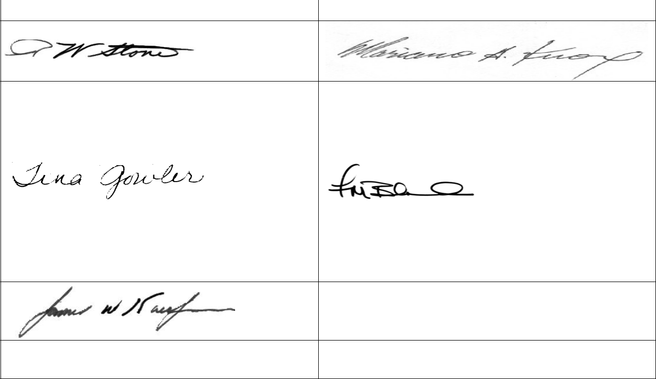

R. W. Stone | Mariano A. Knox
Product Assurance Manager | Contracts/Procurement Manager
Reviewed By: | Reviewed By:
Tina Gowler | Frank Bland
Resource Manager | Technical Services Manager
Approved By:

James W. Kaufmann

Program Manager

CONTROLLED DISTRIBUTION LIST

Copy No.

Master (Electronic)

Copies

Electronic

Electronic

Copy Custodian

PA Manager

MCA Web Site/LO&SC Server

30 RMS/RMO

30 RMS/RMQS

Copyright © This document is the property of MCA Engineers, Inc. It shall not be copied without the prior written approval of MCA Engineers, Inc.

