COMMERCIAL IN CONFIDENCE


Works Instruction for SOL8SDR-C

WI0267 v7

12-07-2018

Domo Tactical Communications (DTC) Limited

Fusion 2, 1100 Parkway, Whiteley, Fareham, Hampshire PO15 7AB, UK T: +44 (0)1489 566750 F: +44 (0)1489 880 538

© Domo Tactical Communications (DTC) Limited own the copyright of this document and it is supplied in confidence. It must not be used for any purpose other than for which it is supplied and must not be reproduced without permission in writing from the owners.

Whilst every effort is made to ensure the accuracy of the information contained in this document, no responsibility can be accepted for any errors or omissions.

COMMERCIAL IN CONFIDENCE
Page 1 of 15 (Template 6,240,023, Revision: 5.0)

COMMERCIAL IN CONFIDENCE

Change History

 | Version |  | Change Summary + |  |  | Author |  | ME / Prod |  | Eng Approval |  | Date
 | Version |  |  | QUAL/ECN ref |  | Author |  | Approval |  | Eng Approval |  | Date
 | v1 |  | Initial Release (converted |  |  | NP |  | N/A |  | N/A |  | 04/02/2016
 | v1 |  | from supplier documentation) |  |  | NP |  | N/A |  | N/A |  | 04/02/2016
 | v2 |  | QUAL-8852/ECN-3516 |  |  | RGH |  | IV |  | RL |  | 21/06/2016
 | v3 |  |  | ECN-3873 |  | NP |  | IV |  | JH |  | 28/11/2016
 | V4 |  | Added UHF variant. |  |  | NP |  | IV |  | JH |  | 20/02/2017
 | V4 |  | Removed SOL8NET |  |  | NP |  | IV |  | JH |  | 20/02/2017
 |  |  | Changed D1800 reference to
 | V5 |  | SA4130, changed SD card |  |  | NP |  | IV |  | RL |  | 25/07/2017
 |  |  |  | section.
 |  |  | - | Add reference to
 |  |  |  | environmental testing
 | V6 |  | - | Add SA4060 on |  | MJE |  | IV |  | JH |  | 22/06/2018
 | V6 |  |  | variants table |  | MJE |  | IV |  | JH |  | 22/06/2018
 |  |  | - | Add new metalwork
 |  |  | - Add new coin cell
 | V7 |  | Change 1.5mm gap pad to |  |  | MJE |  | AS |  | CT |  | 12/07/2018
 | V7 |  |  | 1.0mm |  | MJE |  | AS |  | CT |  | 12/07/2018

Related Documents


Index

[1]

File |  | Title


http://tcs-

dcms/Ops/Documents/Torq 6,240,003 Torque Standards ue%20Standards.pptx

[2]

COMMERCIAL IN CONFIDENCE

WI0267 v7
Page 2 of 15 (Template: 6,240,023, Revision: 5.0)

COMMERCIAL IN CONFIDENCE

Table of Contents

Change History |  | 2
Related Documents |  | 2
1 | Scope | 4
2 | Variants Table | 4
3 | Works Instructions | 5
3.1 | Assembly | 5
3.2 | Labelling | 10

COMMERCIAL IN CONFIDENCE

WI0267 v7
Page 3 of 15 (Template: 6,240,023, Revision: 5.0)

COMMERCIAL IN CONFIDENCE

1 Scope

This work instruction outlines the process to be followed to assemble: SOL8SDR-C-XXXXXX variants and SOL8NET-C.

2 |  | Variants Table
 | SA Number |  | Description
 |  | SA3578 | SOL8SDR-C Transceiver (OEM) 1.78~2.3GHz, Telemetry 902-
 |  |  | 928MHz Top Level Assembly
 |  | SA3652 | SOL8SDR-C Transceiver (OEM) 1.14~1.50GHz, Telemetry 433.05-
 |  |  | 434.79MHz Top Level Assembly
 |  | SA3763 | SOL8SDR-C Transceiver (OEM) 1.67~2.35GHz, Telemetry 433.05-
 |  |  | 434.79MHz Top Level Assembly
 |  | SA3768 | SOL8SDR-C Transceiver (OEM) 4.40~5.00GHz, Telemetry 902-
 |  |  | 928MHz Top Level Assembly
 |  | SA3811 | SOL8SDR-C Transceiver (OEM) 1.98~2.7GHz, Telemetry 433.05-
 |  |  | 434.79MHz Top Level Assembly
 |  | SA3813 | SOL8SDR-C Transceiver (OEM) 1.98~2.7GHz, Telemetry 902-
 |  |  | 928MHz Top Level Assembly
 |  | SA3815 | SOL8SDR-C Transceiver (OEM) 4.40~5.00GHz, Telemetry 433.05-
 |  |  | 434.79MHz Top Level Assembly
 |  | SA3967 | SOL8SDR-C Transceiver (OEM) 320~470MHz, Telemetry 902-
 |  |  | 928MHz Top Level Assembly
 |  | SA4060 | SOL8SDR-C Transceiver (OEM) 5.50~6.00GHz, Telemetry 902-928M

PCB


D1816_0915


D1815_0433


D1816_0433

D1823_0915

D1817_0433

D1817_0915

D1823_0433


D1812_0915


D1825_0915

COMMERCIAL IN CONFIDENCE

WI0267 v7
Page 4 of 15 (Template: 6,240,023, Revision: 5.0)

COMMERCIAL IN CONFIDENCE

- Works Instructions

3.1 Assembly

- For SA3967:

a. Fit gasket foam (MW2862) to the housing lid (MW3406).
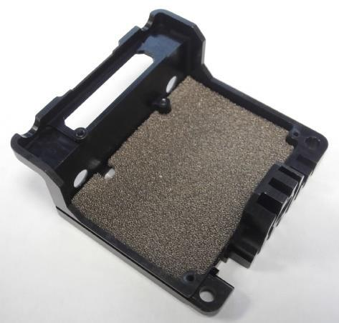

2) For all remaining SAs. Fit gasket foam (MW3764) to the housing lid (MW3763).
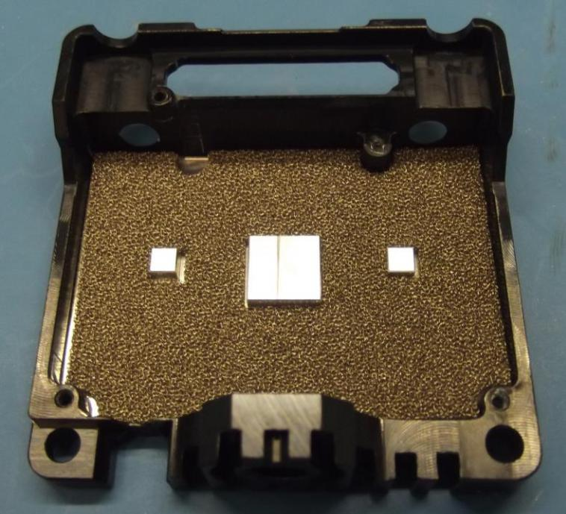

COMMERCIAL IN CONFIDENCE

WI0267 v7
Page 5 of 15 (Template: 6,240,023, Revision: 5.0)

COMMERCIAL IN CONFIDENCE

- For the following SAs fit both 1.0mm and 3mm gap pad:

  - SA3578

  - SA3652

  - SA3763

  - SA3811

  - SA3813

Obtain and cut 2 x (3mm x 3mm) 3mm gap pad (AP007557). Place on the left and right hand side pillar.

Obtain and cut (8mm x 8mm) 1.0mm gap pad (AP008986). Place on the centre pillar
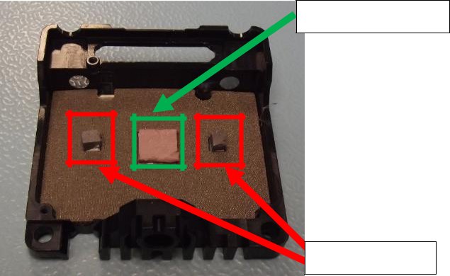

- For the following SAs fit 1.0mm ONLY

  - SA3768

  - SA3815

  - SA4060

1.0mm Gap Pad

3mm Gap Pad
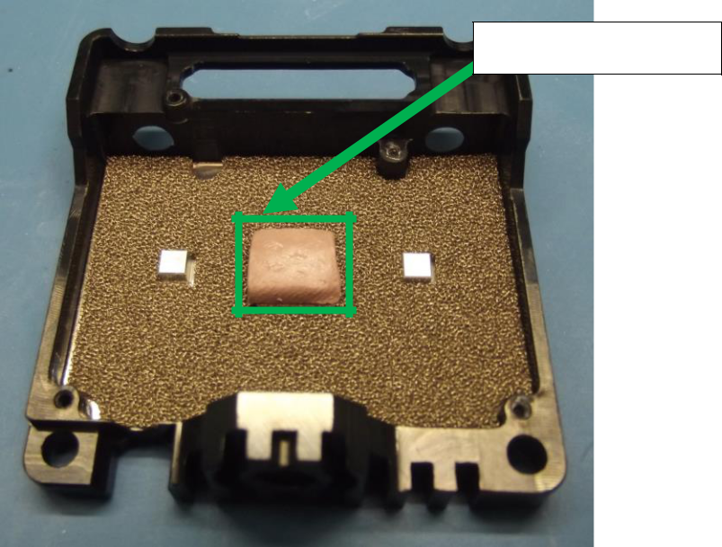

1.0mm Gap Pad

COMMERCIAL IN CONFIDENCE

WI0267 v7
Page 6 of 15 (Template: 6,240,023, Revision: 5.0)

COMMERCIAL IN CONFIDENCE

- Measure the voltage of the coin cell battery (AP009568), it should read ≥3.10v, if not use correct disposal method and replace. Take D18xx RF PCBA (dependant on variant) or D1809 Non-RF PCBA and fit battery (AP009568) into battery holder. Finish operation by affixing a small amount of Kapton tape to the top of the battery holder, ensuring the entire face of the battery holder is covered.
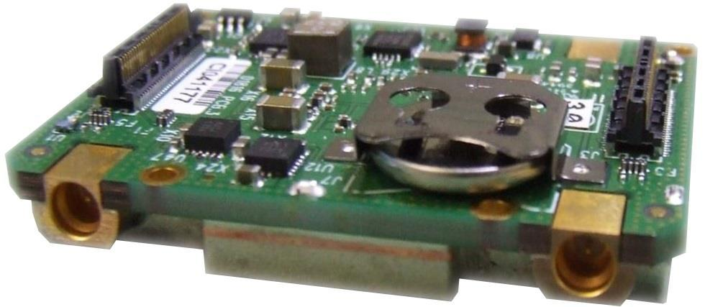

COMMERCIAL IN CONFIDENCE

WI0267 v7
Page 7 of 15 (Template: 6,240,023, Revision: 5.0)

COMMERCIAL IN CONFIDENCE
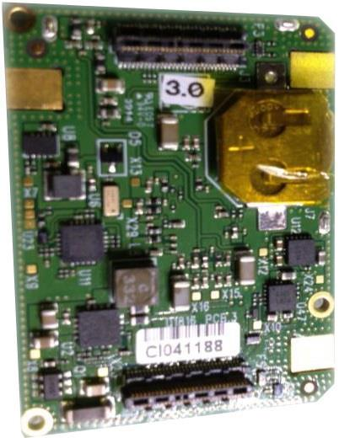

COMMERCIAL IN CONFIDENCE

WI0267 v7

Page 8 of 15

(Template: 6,240,023,

Revision: 5.0)

COMMERCIAL IN CONFIDENCE

- Offer the D18xx PCBA into the housing lid using x1pc M1.6x5 Cap Head Screw (AP009099) and
x2pcs Tx Spacers (MW2750). Torque screw to 15cNM and spacers to 13cNM.
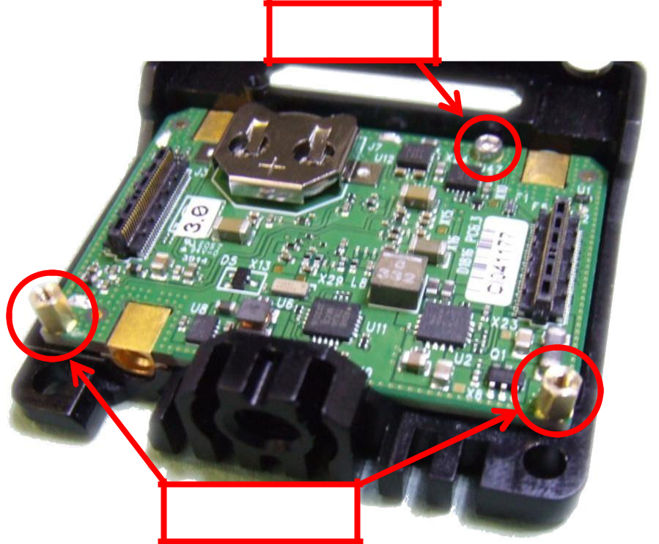

M1.6x5

MW2750

7) UHF ONLY: Take the Isolation PCB (D1896) and fit the D1812 RF Absorber (MW3432) as shown.
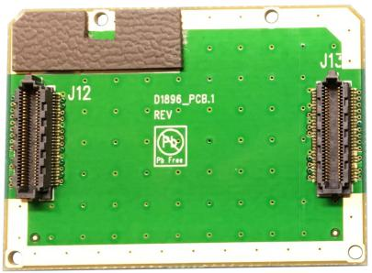

COMMERCIAL IN CONFIDENCE

WI0267 v7
Page 9 of 15 (Template: 6,240,023, Revision: 5.0)

COMMERCIAL IN CONFIDENCE

8) UHF ONLY: Now fit to the RF card. Secure in place using x2pcs Tx Spacers (MW2750).
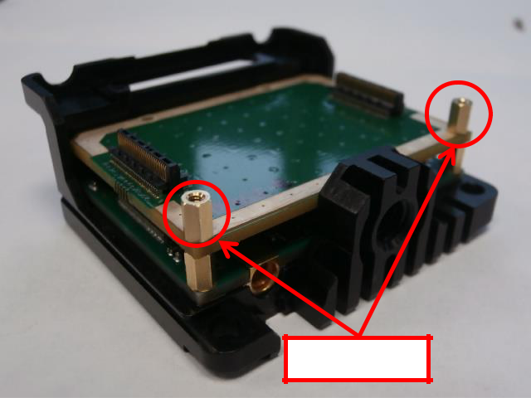

MW2750

9) Take SA4130 PCBA (D1800), ensure the SD Card is already fitted and the board is tested

COMMERCIAL IN CONFIDENCE

WI0267 v7
Page 10 of 15 (Template: 6,240,023, Revision: 5.0)

COMMERCIAL IN CONFIDENCE
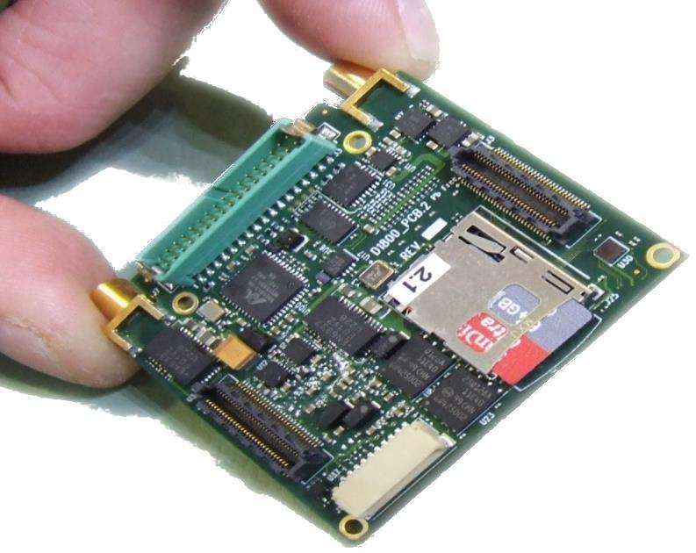

- Connect the SA4130 to the D18xx or D1896 PCBA. Carefully align to the pillars and pressure evenly.
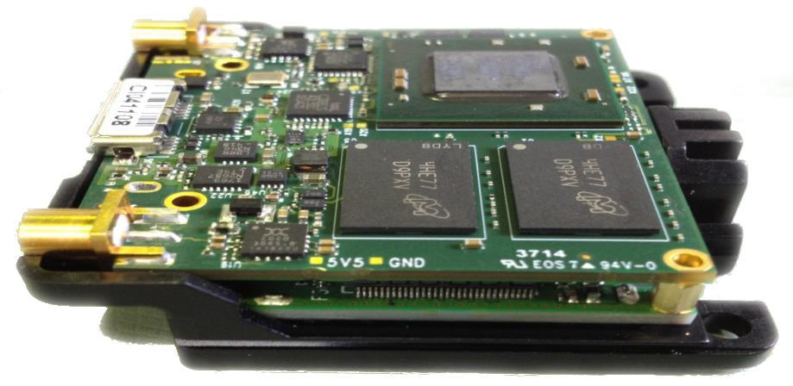

COMMERCIAL IN CONFIDENCE

WI0267 v7
Page 11 of 15 (Template: 6,240,023, Revision: 5.0)

COMMERCIAL IN CONFIDENCE

11) Apply thermal paste (AP007525) to U1, U2 and U5.
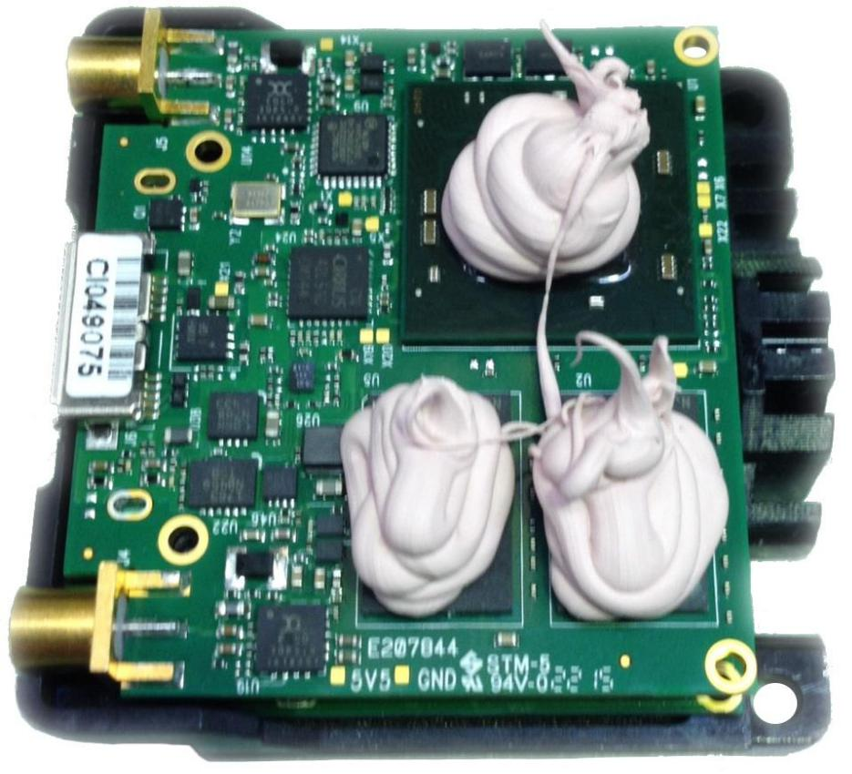

COMMERCIAL IN CONFIDENCE

WI0267 v7
Page 12 of 15 (Template: 6,240,023, Revision: 5.0)

COMMERCIAL IN CONFIDENCE

- Offer the housing base (MW2824, MW3405) to the assembly and fasten together using x3pcs
M1.6x8mm TX5 CSK Screws (AP008002). Torque to 15cNM.
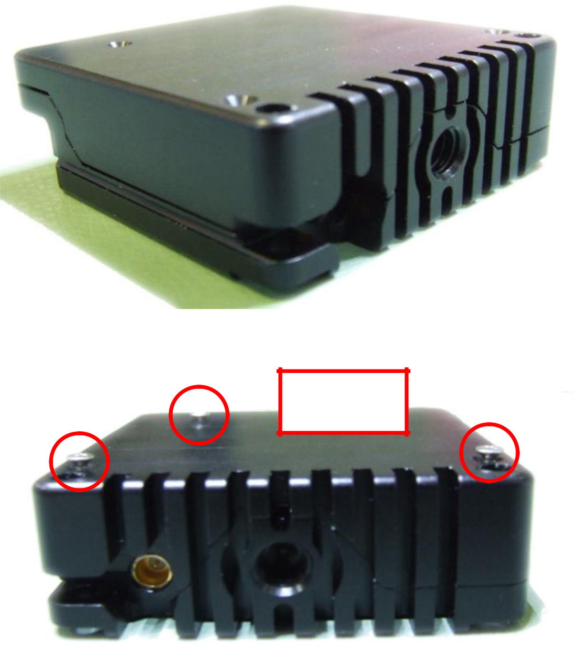

X3pcs
M1.6x8

COMMERCIAL IN CONFIDENCE

WI0267 v7
Page 13 of 15 (Template: 6,240,023, Revision: 5.0)

COMMERCIAL IN CONFIDENCE

3.2 Labelling

- Apply serial number label (AP000270) to the side of the unit (grooved) as shown:-
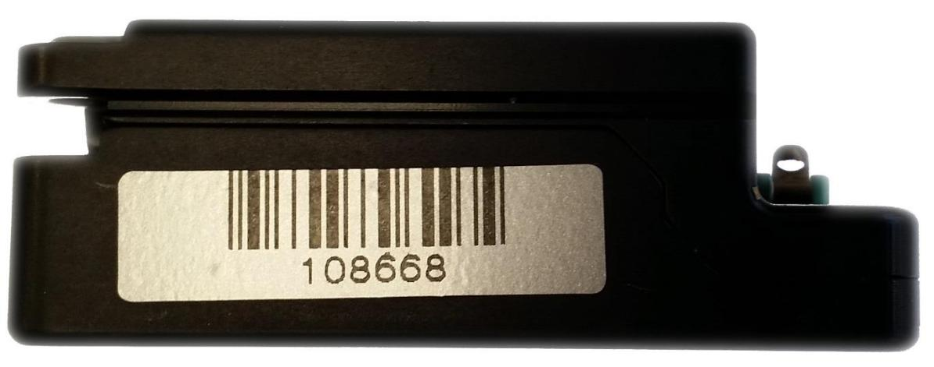

2) Apply the correct type product label centrally to the side of the unit (non-grooved) as shown:-
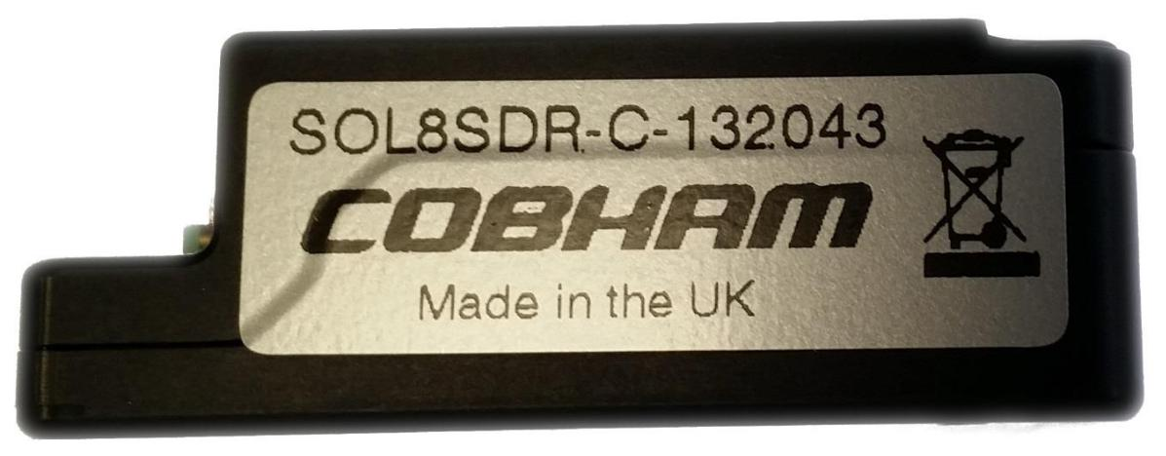

Please not that this label is an old branding. It will now read DTC

COMMERCIAL IN CONFIDENCE

WI0267 v7
Page 14 of 15 (Template: 6,240,023, Revision: 5.0)

COMMERCIAL IN CONFIDENCE

3) Affix ‘Caution Replace Label with Heatsink’ label (AP008529) in position as shown:-
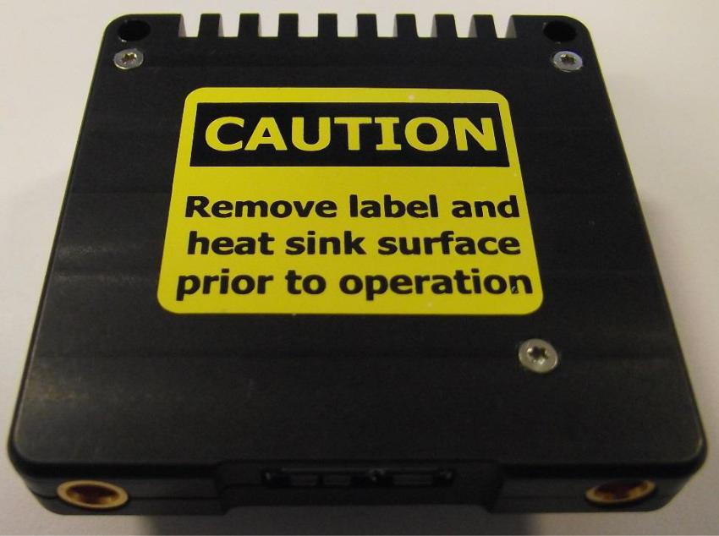

4 Environmental Cycle

After assembly past to environmental test.

The cycle should be as follows:
- Start at +20°C
- Ramp down to -20°C (-10°C/min)
- Dwell at -20°C for 1 hour
- Ramp up to +60°C (+10°C/min)
- Dwell at +60°C for 1 hour
- Ramp down to -20°C (-10°C/min)
- Repeat steps 3-6 two more times
- Dwell at -20°C for 1 hour
- Ramp up to +60°C within 20 mins (+10°C/min)
- Dwell at +60°C for 1 hour
- Ramp down to +20°C within 10 mins (-10°C/min) End of test

4 cycles required

COMMERCIAL IN CONFIDENCE

WI0267 v7
Page 15 of 15 (Template: 6,240,023, Revision: 5.0)

