Music Vision Statement Examples

Are the following statements - taken from real school websites - actual ‘vision statements’? Do they show these schools are ambitious for their music provision and pupils’ achievements in music? Do they paint an exciting picture of where the school is headed in its music provision? Or are they ‘mission statements’? (i.e. describing what the schools currently do now) Or ‘policy statements’? (i.e. guidance as to how music is taught in school and how the school delivers the music National Curriculum) Or are they something in between? You decide!

Music Vision Statement, Example 1
Music is an essential part of life; integral in the development of the whole person. We believe that the opportunity to engage in musical experiences is crucial for the development of the whole child. Learning music develops all aspects of a child’s learning, from the physical action of using an instrument to the mathematical skills needed to keep a pulse. These abilities are directly transferable to other areas of the curriculum, allowing them to flourish, and will be invaluable in their future life. At our school, children have access to music through regular classroom activities and formal music lessons, as well as extra opportunities such as peripatetic music lessons, after school clubs and wider performance opportunities with other schools and in the local community.
Through playing, singing, creating and performing, children will develop confidence, communication, thinking and creative skills and improve their emotional well-being. In addition, as these activities utilise both sides of the brain, it will foster connections which will improve memory and coordination. The skills involved in playing and listening to music will also help learners develop the self-esteem, self-discipline, cooperation, creativity, and self-motivation necessary for success. Children will find that music is enjoyable and relaxing which will help reduce stress. All children will be able to experience a sense of achievement and pride. The different cultures within the school will be celebrated as the children learn songs in different languages. Through our link with the Bexley Music Service, every child will have the opportunity to learn to play a musical instrument (other than voice) before leaving School, and all children in KS2 will be offered further peripatetic lessons in a variety of instruments. It is our vision that every child adopts an understanding and love of music which they can carry with them for the rest of their lives.

Music Vision Statement, Example 2
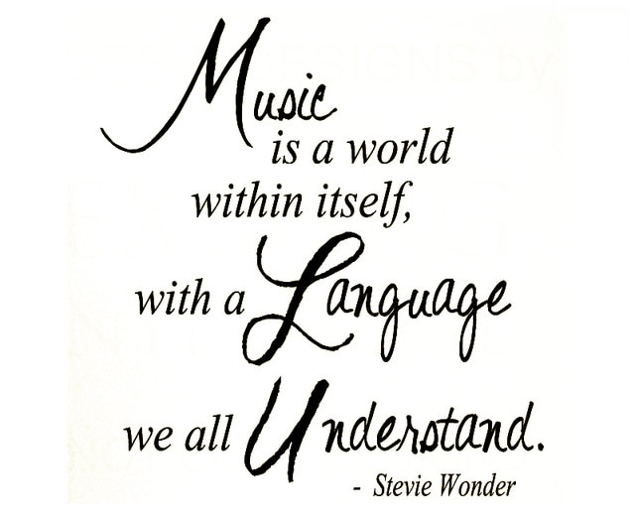
The vision of music at Example Primary School 2 is that Music is fully embedded in every aspect of school life and our aspiration is that every child adopts a lifelong love of music.
Through playing, singing, creating and performing, children will develop confidence, communication skills, thinking and creative skills and improve their emotional well-being. Children will find that music is enjoyable and relaxing which reinforces our whole school Mindmate ethos. Children will build on skills such as ‘determination, resilience, hard-work and bravery’ when performing to an audience.
Music lessons are lively and interactive and aim to foster a passion for music in children of all abilities. Bespoke planning is linked to our Example School 2 Novel/Topic Planning and incorporates aspects of the Charanga Music resource. Examples of this are: Listening to and composing Traditional Scottish music linked to Katie Morag Stories in Year 1, an appreciation of Tribal music in Year 3 linked to the Mayans and battle sounds being incorporated into learning linked to Ancient Rome and WWII in Year 6.
The children participate in singing, tuned and untuned percussion work, composition, and listening to live and recorded music. All children are taught the skills to be able to compose using musical instruments. When the children are in Year 3 and 4, musical notation is taught through the learning and playing of recorders and children across school are taught correct musical terminology e.g. rhythm, melody, pitch, dynamics.
Singing is a highly important part of our music curriculum. Weekly singing assemblies take place to teach children how to sing with a sense of pitch and melody. They are taught how to warm up their voices, sing in rounds and harmony, and build up a repertoire of songs. We have a school choir which meet each week and perform as a large choir at the Young Voices concert annually. Children also have opportunities to perform at events across the year such as Morley Elderly Action events and whole school church services.

Music Vision Statement, Example 3
We are delighted to announce that we have been recognised as a 2020/21 Music Mark School. Surrey Music Hub have recognised the value we place on music.
Our music curriculum aims to provide all pupils with a high-quality music education which engages and inspires children to develop a life-long love of music, increases their self-confidence, creativity and imagination, provides opportunities for self-expression and a sense of personal achievement and ensures that every child fulfils their musical potential. Children participate in a wide range of activities to develop their talents in all aspects of music including rhythm work, instrumental skills, composition, singing and appreciation.
We believe that opportunities for children to play in small groups or ensemble also helps to foster essential life skills such as co-operation, mutual support, self-discipline and commitment.
Music plays an important role in helping children to feel part of a community. We organise and collaborate in projects to enable children to share their musical skills at different events both inside and outside of school.
At Example Primary School 3, we believe that music is a unique and powerful form of communication that can change the way pupils feel, think and act. Furthermore, we feel there is great value in combining creativity with emotion that enables personal expression, reflection and development - a life opportunity that can reap dividends in the future.

Music Vision Statement, Example 4
At Example Primary School 4, we believe that music is a unique and powerful form of communication that can change the way pupils feel, think and act. Furthermore, we feel there is great value in combining creativity with emotion that enables personal expression, reflection and development - a life opportunity that can reap dividends in the future.
Our Vision & Aims
- That children will develop an ability to listen to, and appreciate a wide variety of music, including that which has a specific purpose.
- That children will have opportunities to explore and express ideas and feelings about music, in a variety of ways, for example through dance.
- That children will explore a range of musical elements, for example: pitch, tempo and dynamics.
- That we will encourage active involvement in creating and developing musical ideas using voices and instruments - both tuned and un-tuned.
- That we will develop a sense of group identity and togetherness through composing, rehearsing and performing music with others, to an audience.
- That we will help the children develop self-discipline and creativity, aesthetic sensitivity and fulfilment.

“There is no such thing as an unmusical person.”
Hans Werner Henze

“Music can change the world, because it can change people.”
Paul David Hewson

Music Vision Statement, Example 5
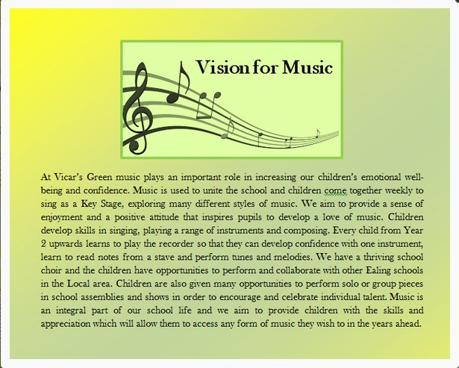

Music Vision Statement, Example 6
“Children singing everywhere,
Children with musical confidence,
Free to explore, imagine, create,
We support, applaud and respect success.
Children playing, participating,
Dedicated and motivated,
Musical stars discovered and shine,
The musicians of Example School”

So, are these good vision statements for music? Answers on a postcard please, as they used to say! Could you do better?

