Co-Teaching Vision Statement Template

Create your co-teaching vision statement using the guiding questions below.
What is the need for change in our school? | Who is on the team for implementing and supporting co-teaching? | What do our inclusive practices currently look like? | Where would we like to be?
Draw a picture that depicts your vision. |  | Jot down some descriptive words or phrases that represent your vision.
Vision Statement:

Example: Inclusive Vision Statement
What is the need for change in our school? | Who is on the team for inclusive practices? | What do our inclusive practices currently look like? | Where would we like to be?
All students can learn.  Everyone has sense of belonging, everyone is valued, and students are growing in knowledge. | 9th grade teachers, teachers (gen ed and special ed.), principal, paras, SLP | Co-teaching in English 10 only | The most inclusive school in Illinois
Draw a picture that depicts your vision.  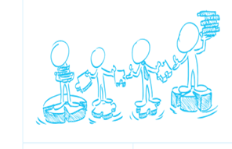 |  | Jot down some descriptive words or phrases that represent your vision.  Commitment of ALL staff  Shared beliefs  ALL students matter.  ALL students can learn.  ALL students need opportunities.
Vision Statement:

We, the staff at Hidden Valley High School, are committed to a vision in which our school is the best place to learn, play, grow for ALL students in their academic journey. We will establish a safe and supportive environment that will maximize the potential of all students, and provide differentiated learning experiences through authentic, engaging, and challenging instructional practices based on individual learning styles.

