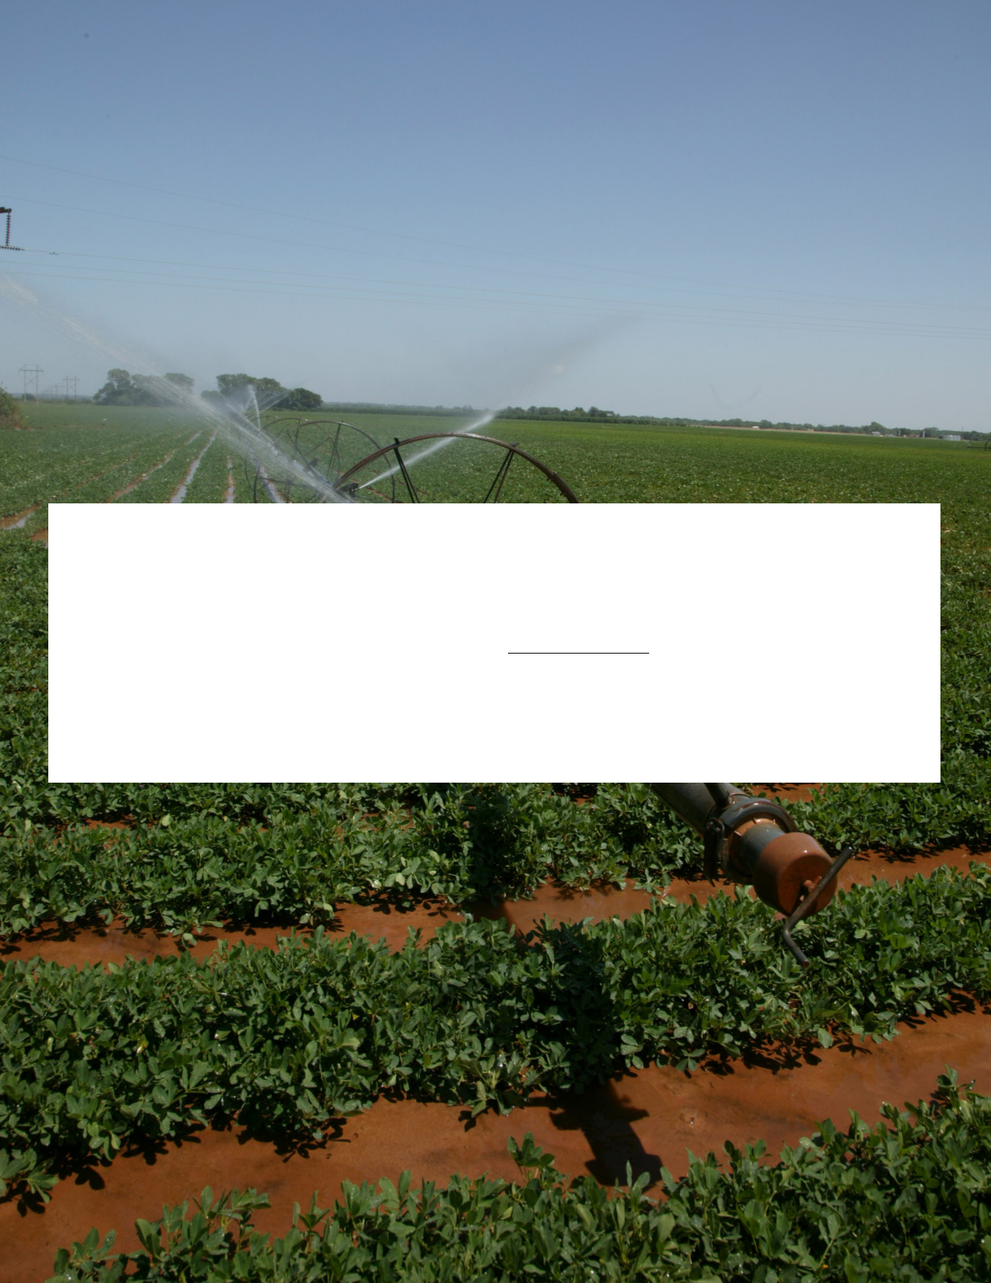

FARM TRANSITIONS

Chapter 1

Table of Contents

CHAPTER 1: FIRST STEPS

1.1. Examining the “Core Values” to determine what matters most 3

1.2. Where do you stand financially? 5

1.3. Evaluating financial feasibility 11

1.4. Developing a Farm Game Plan 16

1.5. Wants, Needs, Expectations, and Fears Exercise 19

1.6. Internal and External Factors 20

1.7. Selecting and Engaging Your Professional Team 21

1.8. Conclusion 23

1 – 2

First Steps

Arguably, the hardest part of the transition planning process is figuring out where to start. One place to start is to simply create an inventory of what you have to work with in creating a transition plan for your farm. Thus, you can begin by rounding up information not only about the property that makes up your farm, but also

the people and intangible assets that contribute to your operation. To help you with this process, consult the Transition Planning Inventory included in the references and tools portion of this section.

1.1. Examining the “Core Values” to determine what matters most

Our “value” system (our character, if you will) has been developed based on experiences and exposures over our entire lives. The list of influencing factors includes all of our long history of experiences, education, family upbringing, friends, and religious beliefs or training. In addition, various contemporary influences such as media of all types, books we read, and even our government can influence our values. Our core (strongly held) values influence our beliefs, our attitudes, and ultimately our behaviors, which is why it is important to start the transition thought process by reflecting on not only your own individual values, but how your values mesh with those of the rest of your family business stakeholder team.

Reflecting on values is a difficult exercise. It is often suggested that you begin by thinking about other people that you really respect or admire (your true heroes). Why do you look up to them? Looking inwardly to yourself, what is your proudest accomplishment? What characteristics do you see when you imagine “your best self?” Taking time for various members of your stakeholder team to ponder such questions can begin the process of sorting out what is really important to your team from a big picture, very long-term perspective.

Core values of the team help guide the transition planning process. Some common categories of strongly held beliefs that may need to be considered include:

- How do the stakeholders feel about various ownership and operational models for the future of the family business, and the process to get to a potential new model? For example, is it important that the business continue after the current management generation retires, and is it important that it remain completely within family ownership and/or management?

- How important is family consensus regarding the future of the farm, and how important is shared input and decision making?

- What roles will various stakeholders take in managing the business, and how will they be compensated?

- What are the perceptions of fairness vs equality as business assets transition to the next generation? How does everyone feel about providing additional assistance to younger generation members who will be actively involved in the family business?

- Do stakeholders feel strongly about particular products, services, production practices, or social and environmental responsibilities? These are simply examples of categories to think about when reflecting on core values. Business stakeholder teams may add to the list and come up with other categories of issues that are important to them.

It is important to remember that while reflecting on core values will likely begin as an exercise for each individual stakeholder in the business, ultimately agreement will need to be reached on the core values that reflect the consensus of the business stakeholders. These values will guide the rest of the planning process as an overall vision and mission are solidified into more concrete objectives and goals, and ultimately into specific

1 – 3

strategies and tactics for implementation. The questions need to evolve from the individual perspectives, to the “business” perspective, as illustrated in the following table, a process that can be difficult when the business is not used to having multiple stakeholders with significant roles.

Example of how “core values” need to evolve from individual perspectives to the overall business perspective.

Individual Perspective “Core Values” Questions | Stakeholder Team (The Business) Perspective
to Ponder | “Core Values” Questions to Ponder
What is important to me? | What is important to our business?
What would I like to be? | What would we like to be?
Who am I? | Who are we?
What do I want to do? | What do we want to do?
How will I measure activity? | How will we measure activity?
What is my plan? | What is our plan?
How do I implement the plan? | How do we implement the plan?

The “Zeroing in on Core Values” planning tool is included here to help stimulate thought. Individual business stakeholders can jot down thoughts regarding what is very important to them in the various categories listed, or add appropriate categories that capture what is important to them. Two columns are provided to reflect that fact that there may be a recognition that values might need to evolve over time as the business thinks about the long-term. These thoughts from individuals can then be discussed and combined into a set of over-arching core values that reflect the consensus of what is important to the entire stakeholder team as it pertains to the business.

Zeroing in on Core Values

Category | Now | Future
 | (Mission Statement) | (Vision Statement)
How is the business is managed, owned, and
organized?
How are decisions made?
Who does the work, how are they compensated,
how will that change over a transition period?
Fairness vs. equality in transferring the asset base
to the next generation: how will business operating
heirs be treated relative to non-operating heirs?
What products or services are produced; which
production practices and marketing practices are
used?
Social - environmental concerns / responsibilities
Work – family balance issues
Other issues:

1 – 4

1.2. Where do you stand financially?

A detailed financial assessment of the existing business is a critical component of any successful business transition plan. The assessment will address such issues as whether the business has adequate resources, whether the business can pay obligations, and whether the business is the type of profitable and efficient enterprise that you would want to pass on to heirs or successors. This will help determine if the existing business can achieve the objectives and goals that the various stakeholders have in mind, or if changes will need to be made before the transition process can begin. OCES publication AGEC-790 provides more detail and examples regarding the evaluation of financial performance and position.

The financial position and performance of a farm business needs to be evaluated based on the following criteria:

- solvency,

- liquidity,

- profitability,

- financial efficiency, and

- repayment capacity.

Solvency measures the ability of the business to pay all debts if the business were to be sold. In general, if the market value of the total assets (things of value owned by or owed to the business) of the business exceeds the amount of debt (financial obligations) owed by the business, then the business is solvent. Common solvency measures assess the “degree” of solvency. Examples include the absolute level of net-worth (equity), the debt-to-asset ratio, and related measures such as the equity-to-asset ratio and the debt-to-equity ratio.

Liquidity is a measure of the ability of the business to pay bills in a timely fashion in the short run. For agricultural businesses it is common to measure liquidity based expected sources of cash over the next year relative to bills and financial obligations over the next year. Liquidity is typically measured by either the absolute level of working capital, or by the ratio of current assets to current liabilities (current ratio). Profitability means the level of income the business generates after paying all expenses.

Profitability is typically measured over an accounting period (usually a year). Common measures include absolute level of net farm income, rate of return on assets, rate of return on equity, and operating profit margin ratio. Financial efficiency measures the ability to convert inputs to saleable output, or how good the business is at utilizing the inputs and resources it has available.

Financial efficiency is directly related to profitability, though it is not the sole driver of all profitability measures. Numerous measures are utilized to relate physical output to various physical and financial inputs. The most commonly utilized measures that can be applied to a wide variety of agricultural businesses include the asset turnover ratio, the operating expense ratio, the depreciation expense ratio, and the interest expense ratio.

Repayment capacity is closely related to liquidity, but more specifically provides an indication of the ability of the business to meet debt payment commitments. The absolute measure (known as the capital replacement and term debt repayment margin) and the relative measure (known as the term debt and capital lease coverage ratio) are the most commonly utilized indicators of repayment capacity.

So, what do we do with all this information regarding financial position and performance? By examining trends in measures over time or comparing measures to benchmarks, problems can be identified, mistakes can be corrected or avoided, and strengths can be identified so that opportunities can be pursued. Looking at the trend in key measures over time reveals important information such as whether or not the equity position of

1 – 5

the business is improving over time, whether a liquidity or debt repayment problem is developing, and how consistently profitable and efficient the business has been historically. The farm financial trends worksheet from OCES publication AGEC-238 is included as a starting point for evaluating trends in financial performance. Recent measures can also be compared to benchmarks that have either been established by the business as internal targets, or have been drawn from external sources such as comparative farms or industry standards. Numerous farm management benchmarking data sets are maintained across the U.S., and general industry standards have been established for many of the most common financial measures. An example resource is OCES publication AGEC-237. We have included the benchmark page from that resource in this manual.

The information needed to obtain the aforementioned position and performance measures comes from the two most basic financial statements, the balance sheet (also known as the net-worth statement), and the accrual income statement (also known as the profitability statement). The balance sheet is a systematic organization of everything owned and owed by the business at a single point in time, so it is a “snapshot” of the financial position of the business at that point in time. Assets values are presented from “most liquid” to “least liquid,” and similarly the corresponding liabilities are arranged based on when they are due. Assets that are cash equivalents or are expected to be converted to cash within one year (like grain produced to be sold, for example), and debts that are payable within one year (like an operating note, for example) are classified as current

assets and liabilities respectively. Assets that would not typically be sold within a year (breeding livestock, for example), and debts that are not payable with a year (the non-current portion of a land loan, for example), are classified as non-current assets and liabilities respectively. Some agricultural balance sheets also include an intermediate (1 to 7 year) category for both assets and liabilities. This “term-structure” breakdown allows the balance sheet to reveal information about liquidity. The basic accounting identity that is revealed by the balance sheet is that the total value of the assets is equal to the sum of the creditor’s claims (liabilities) plus the owner’s claims (equity), assuring that the balance sheet will reveal information about profitability.

The balance sheet can be prepared based on a market-basis valuation of the assets (fair market value minus selling costs), or based on a cost-basis valuation of the assets (original cost adjusted for depreciation). Each method has advantages and disadvantages. As a general rule, the market-based method is considered most useful for credit analysis and estimating true owner equity, while the cost-based method is considered most useful for evaluating true financial progress resulting from business management decisions over time. It is important that sequential balance sheets be prepared at the same time each subsequent year, and that the same valuation method be used for consistency. A typical farm looks a lot different in June than it does in December, so comparing snapshots over multiple years is most useful if they are prepared at the same time. Accurate inventories of everything owned and owed by the business are essential. An example balance sheet template extracted from OCES publication AGEC-752 is included in this workbook.

The income statement is a summary of revenues and expenses over an accounting time period (typically a year), and as such it reveals profitability. A critical point to remember is that accrual revenues and expenses are not the same as simple cash inflows and outflows. Accrual revenue represents the true value of anything produced during the accounting period, so it typically includes receipts from commodity sales adjusted for inventory changes that need to be accounted for in determining that true value of production. Accrual expenses represent the true costs of doing business, to it includes operating expenses (including non-cash expenses such as depreciation) adjusted for relevant expense inventory changes. Accrual net income (profit) is the difference between revenues and expenses. An example income statement template extracted from OCES publication AGEC-753 is included in this workbook.

Financial efficiency, repayment capacity, and some other financial indicators, typically combine information from both the balance sheet and the income statement. It is good business practice to develop and evaluate measures at least annually, but this is especially critical when working through the business transition planning process. Be consistent in how information is tracked and evaluated, and utilize the information to improve the business and to facilitate a smooth transition. Be sure to note and discuss reasons for unusual

1 – 6

measures (such as drought, etc.) and discuss ways to work through unusual times. It is important that all stakeholders be involved in the financial evaluation part of the transition process. Here is an example of a tool to monitor financial position and performance trends (taken from OSU Fact Sheet AGEC-238).
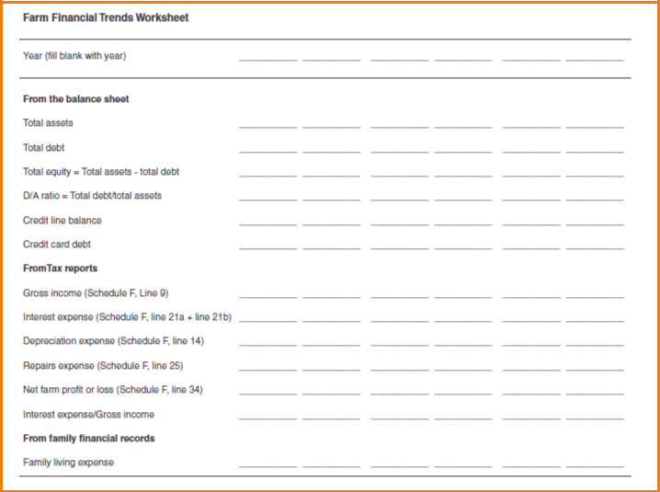

1 – 7

The following benchmarks for important financial position and performance measures were taken from OSU Extension Fact Sheet AGEC-237.
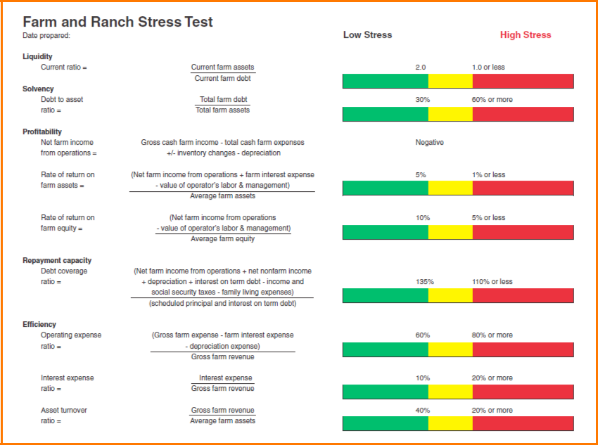

1 – 8

The following example balance sheet is adapted from the Kansas State AgManager.info publication MF-291 and its accompanying Excel template.
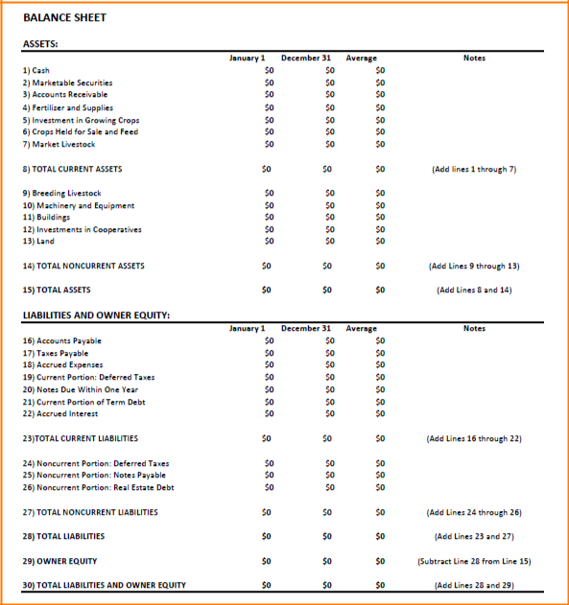

The following income statement example is taken from OSU Extension Fact Sheet AGEC-753.
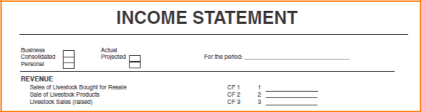

1 – 9

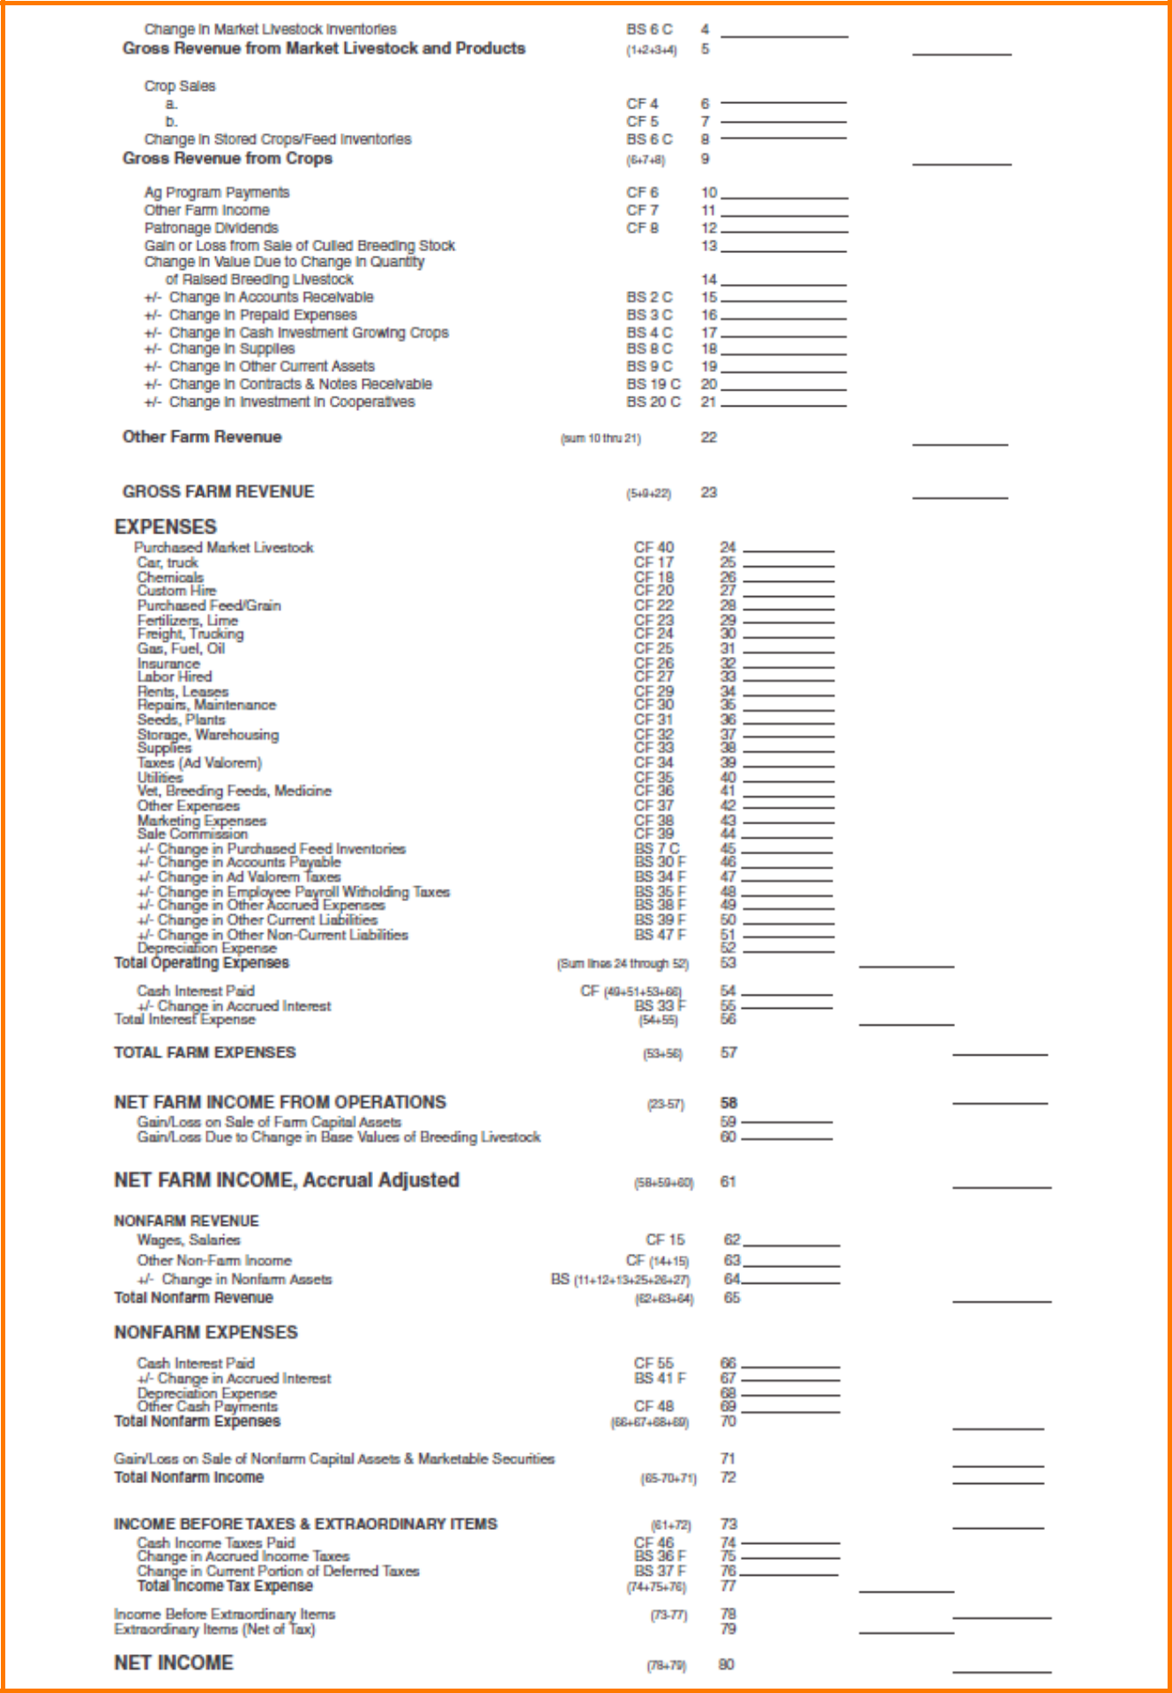

1–10
1.3. Evaluating financial feasibility

The previous section provided a discussion regarding evaluating financial position and performance. The other important financial aspect that must be addressed is financial feasibility, or “can we make this happen?” The fundamental difference between the concepts of “are we profitable and in a solid financial position?” and the concept of “can we make this happen?” is an important one that is often overlooked and misunderstood. It is definitely a mistake to assume that just because a business has been historically profitable that it can successfully navigate all of the complex financial obstacles associated with a major change, such as an ownership and/or management transition. The business must also look at several issues of financial feasibility.

The first feasibility concept is one of business size. In this context we are not referring to the obvious issues related to economies of scale and business efficiency, as those issues would show up in the performance indicators discussed in the previous section. Here we are simply examining the level of net income needed from the business to support family living needs and to facilitate needed growth for the future. In many agricultural businesses it is the residual that is left over after paying all the operating expenses, paying the outside investors, and reinvesting some earnings back into the business for growth and expansion that is used to support the primary operators on the farm.

Therefore, the level of net income needed becomes a question of “how many people can the business support?” This often becomes an issue when planning a family business transition because the fact of the matter is that people come in whole units of one, rather than in fractions. For example, if there is a desire for a family from the younger generation to return to the farm in an active role while the more senior generation is not yet ready to fully retire, there is a time period when the business will need to grapple with the issue of how to provide income for another whole person or an entire additional family. There always seems to be plenty of work to do around a farm, which often leads to the assumption that another person can easily be added. From a financial perspective that may not be the case.

For most of our modern commercial agricultural enterprises using modern technology, one person can and certainly needs to generate a lot of productivity. In order to do that, a significant amount of assets are needed. When faced with this issue, questions regarding how much income will be needed and how much of that will come from the farm or ranch business need to be addressed. This becomes the issue of business size. A simple evaluation that utilizes some of the financial performance measures discussed in the previous section can be conducted using the mathematical process imbedded in the following worksheets. Worksheets 1 and 2 help to identify the total net income that the business will need to generate to accommodate the sum of family living needs and equity growth. Worksheet 3 provides the calculations to compute the performance measures needed to plug into worksheet 4. Information to compute these measures is derived from the balance sheet and income statements. Worksheet 4 provides the calculations to estimate the size of the business that will be needed in terms of gross farm revenue, and in terms of the value of the asset base needed to achieve the target level of net income from the business.

1–11

Worksheet 1

Spendable Income Plus Growth That The Business
Is Expected To Generate

 | Family Living Expenses |  |  |  |  |  | $
 | Non-Farm Savings |  |  | + |  |  | $
 | Other Wants or Needs |  |  | + |  |  | $
 | Capital Needed for Farm Growth (from Worksheet 2) |  |  | + |  |  | $
 | Less Non-Farm Income |  |  | - |  |  | $
 | Income Needed From Business |  |  | =
 |  |  |  | = |  |  | $
 |  | Worksheet 2
 |  | Growth Worksheet
 | (A) | Current Farm Equity |  | $
 | Real Growth Rate Needed |  |  |  |  |  |  |  |  | %
 | Projected Inflation Rate |  |  | + |  |  |  |  |  | %
 | (B) | Nominal Growth Rate |  | = |  |  | %
 | Projected Capital Needed For Growth |  | (A*B)
 |  |  | (A*B) |  | $

Worksheet 3

Ratios Needed For The Evaluation

Net Farm Income From Operations

Net Farm Income
Gross Farm Revenues | ÷
NFIFO Ratio | =
Asset Turnover Ratio
Gross Farm Revenues
Average Farm Assets | ÷
Asset Turnover Ratio (ATR) | =

$

$

$

$

1–12

 | Worksheet 4
 | Business Size Evaluator
 | Gross Farm Income Needed
 | Income Needed From Business (Worksheet 1) |  |  | $
 | NFIFO Ratio (Worksheet 3) | ÷
 | Gross Farm Revenue Target | =
 | Gross Farm Revenue Target | = |  | $
 | Assets Required To Generate Desired Revenue
 | Gross Farm Revenue Target |  |  | $
 | Asset Turnover Ratio (ATR) (from Worksheet 3) | ÷
 | Asset Base Needed To Achieve Goals | =
 | Asset Base Needed To Achieve Goals | = |  | $

For illustration, assume that a farm has generated an average of about $50,000 in net income to cover the current operator’s family living plus grow the business investment a little bit each year. Also assume that this net income has been generated from an average gross income of about $250,000 per year utilizing an asset base valued at about $715,000. These historical facts result in a net farm income from operations ratio of 0.2, and an asset turnover ratio of 0.35. Now assume hypothetically that a transition is being considered where the current operator will semi-retire and live on only a $20,000 family living draw from the farm, to make way for a young family that will manage the operation for family living draw from the farm of $50,000, and an additional $10,000 is assumed to be needed for continued growth resulting in a total $80,000 net income requirement. Using worksheet 4 and the relevant historical ratios from this business, the new gross farm income target for this farm will need to be $400,000 per year, and the asset base needed to generate that level of gross income will need to be close to $1.15 million. Can the business make a one-time jump in size to accommodate these new realities? If this growth is not planned for and the higher levels of family living withdrawals occur anyway, then equity levels are quickly drained from the business to support family living. What if growth cannot occur that quickly? Then other models that include a slower transition, perhaps including more off-farm income may need to be considered. In any case these issues are much easier to grapple with if they are addressed in the planning stages of the transition, rather than in the later stages.

Another feasibility issue is whether or not the proposed enterprises of the farm or ranch will actually make money. Enterprise budgets can be used to answer this question. Enterprise budgets are an organization of revenue projections, expense projections, and profit projections for a single enterprise of the farm. Therefore, the enterprise budget can be thought of as an enterprise specific “income statement” projection, useful for identifying the most profitable enterprises to be included in the whole farm plan and for identifying bottlenecks to overall profitability. Alternatives can be explored and compared before significant resources are committed to the production process. Separate enterprise budgets can be constructed and evaluated for each different crop type and land tenure arrangement, and for each type of livestock enterprise being considered. The format is similar no matter what the enterprise, with the primary difference being that cropping budgets are typically done on a per-acre basis, while livestock budgets are typically done on a per-head basis (though it does not have to be done that way). All cash and non-cash revenues are projected, followed by operating or variable costs, then ownership or fixed costs. Finally, projected profits are calculated as the net return to all resources that were not charged in the budget (usually management and unpaid operator labor). Example budgets and budget

1–13

templates are available from a number of different sources, including most Land-Grant-University Extension Services. If the particular budget examples you are utilizing are not already in a spreadsheet template, it is highly recommended that users convert them to a spreadsheet format. This is to simplify the ability to conduct “sensitivity” analysis, or examining best and worst case production or price assumptions through a series of “what if” calculations.

The following is an example generated by the OSU Enterprise Budget Software.
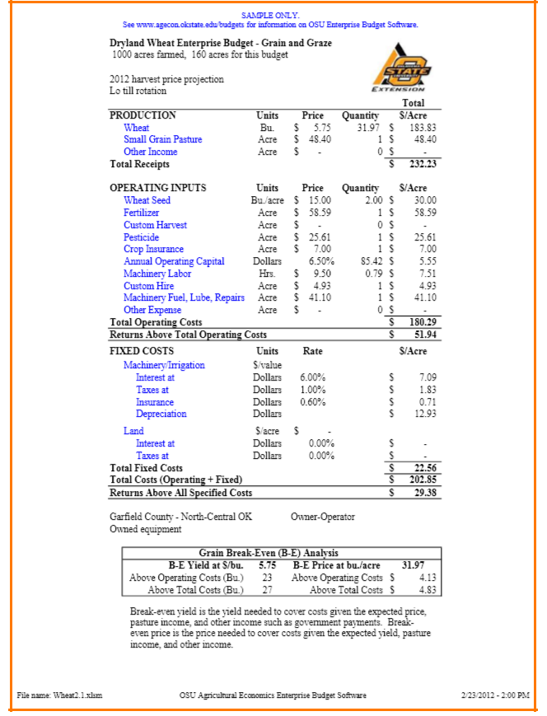

1–14

It is also useful to summarize all of the cash inflow and outflow projections into a cash flow budget projection. The cash flow projection is useful for examining the timing of cash flow sources and needs, so it is typically broken down into smaller time intervals, such as months, or at least quarterly. For each time period potential sources of cash include the beginning cash balance for the period, product sales, capital sales, new borrowing, government payments, and non-business cash inflows. Uses of cash include operating expenses, capital purchases, loan payments, and non-business expenses such as family living withdrawals. The cash flow plan helps answer the question “can the business actually make this work?” By examining the timing of cash inflows and outflows, the management team can project the timing and amount of new borrowing that will be needed during the year, and when loans can be projected to be paid down. Purchases, production plans, and non-business expenses can be planned to minimize the need for borrowing, etc. The following example is extracted from OCES publication number AGEC-751, “Developing a Cash Flow Plan.”
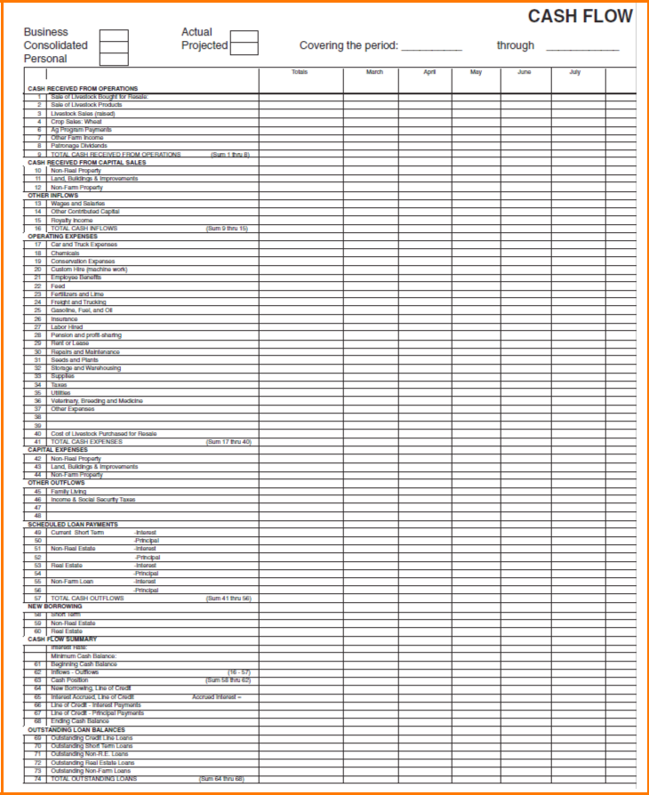
A partial budget is another feasibility tool that is often used to fine tune the operation on a day-to-day basis by examining smaller questions. Examples might include “should we harvest our own crops or hire a custom operator?” or “should we sell our calves at weaning or hold onto them for a while in a growing program?” The standard partial budgeting format provides a formal and consistent method for examining the expected profit impacts from proposed alternatives. Only changes in expected revenues and costs are considered in a very organized approach so that the chances of overlooking something or counting an item more than once are minimized. Typically, a proposed alternative way of doing something is compared to the existing way of doing it. Positive financial effects of the proposed alternative are listed on one side of a “T” accounting page as either added receipts or reduced expenses. Negative financial effects of the proposed alternative are then listed on the other side of the tee account as either added expenses or reduced receipts if the alternative were pursued rather than the existing plan. The net expected financial impact is simply the total positive effects minus the total negative effects.

For really significant changes to the business, stakeholders may want to consider developing whole-farm pro-forma financial statement projections, perhaps for multiple years into the future in order to help develop plans to most efficiently utilize the resources available. Budgeting is an important component of planning for smooth farm operations, and is an important component of the development of sound marketing plans as well.

Example Partial Budget Form

Column 1 |  | Column 2
Additonal costs | ________ | Additional returns | ________
Reduced returns | ________ | Reduced costs | ________
A. Total additional |  | B. Total additional
costs and reduced | ________ | returns and reduced | ________
returns |  | costs
Net change in
income (B minus A)

1.4. Developing a Farm Game Plan

Strategic planning involves thinking about where the farm or ranch business needs to be positioned in the future. It involves considering what the various stakeholders want to see happen to the business as a whole. It also involves evaluating what skills and resources the business and business participants bring to the table, and subsequently where efforts and resources need to be focused in order for the business to remain competitive into the future.

Historically, for many farms and ranches this planning for the future of the business has been done in a very informal manner. The thought process starts with a consideration of the resource base. Activities and enterprises are then selected to “fit” with the resource base. In many cases, vague objectives and goals remain in the minds of the individual managers or owners. As businesses, including farms, become larger, more complex, and involve more stakeholders there is benefit in replacing this traditional management style with a more strategic and participatory management style. The flow of the thought process for a “strategic” management style is dramatically different. The significance of this difference cannot be over-emphasized, as it dramatically opens

1–16

up the scope of possibilities available to the organization. The stakeholders begin with an overarching vision of where they want the business or entity to go. The vision is then focused down to a more concrete mission, which is made workable through well thought out and documented long-term objectives and short-term goals. A strategy is formulated, selecting enterprises and activities that lead to accomplishment and fulfillment of goals and objectives. Specific tasks and tactics are spelled out, and a resource base is assembled (beginning of course with the existing resource base) to implement the plan.

Vision and/or mission statements form the foundation of a strategic management system. Vision is a long-term concept, focusing on where the business hopes to be in the future, and providing guidance for the organization over the long-term. Knowledge and broad acceptance of what it is that the organization needs to accomplish always makes the path more clear. Vision statements often directly reflect deeply held core values such as honesty, integrity, passion for rural lifestyle, concern for the environment, etc. They focus on what is really important, emphasize the future, and can be a unity building instrument to facilitate the planning process. More specific characteristics such as business size and scope, composition and quality of products or services, target markets, and work force composition may also be reflected in the vision statement, or these specifics may be relegated to the mission statement.

The mission statement embodies the broader vision, but is much more specific and focused on the present, rather than the future. A well written mission statement outlines the basic purpose of the business and summarizes what is done, who it is done for, and how the organization conducts itself. The mission statement reflects the true strengths of the overall business. Therefore, in formulating a mission statement it is important to focus attention on the guiding values, principles, and primary roles of the organization to provide direction when making major decisions.

To illustrate the flow from an overarching “vision” to a more focused “mission,” a ranch could have a vision of producing the highest quality beef products possible. More concrete attributes like genetic characteristics, environmental responsibilities, commitment to the community, employee friendly workplace, etc., then need to be incorporated into the mission statement. The process of developing vision and mission statements is as important as the product. Getting input from every stakeholder, drafting statements, getting feedback, revising, and re-writing gets the communication flowing regarding things that really matter. However, due to the abstract nature of the activity, developing vision and mission statements can be one of the more difficult tasks for the farm business management team. Those who expend the time and effort to base their planning activities on a vision and a more specific mission for their organization will find that they provide a solid foundation for the business and provide guidance for day-to-day activities.

Individuals and organizations approach the visioning process differently, however, and a few general guidelines should be kept in mind. Relegate long-term planning activities (visioning) to non-crisis time periods so that attention can be focused on long-term issues. It is critical to discover the expectations of all family stakeholders during the visioning process. This reduces the risk of incorrect assumptions, increases cooperation in creating the plan, and helps to reduce conflict, ultimately resulting in a more effective plan. One danger of written vision and mission statements (and the most common criticism) is that they can quickly become too abstract and all encompassing, making them essentially useless for directing day-to-day management. The most effective way to avoid this pitfall is for the stakeholder team to keep this danger in mind as the statements are being drafted. Keep the purpose and intent of the visioning activity in mind throughout the process: to inspire and direct you and others in the business, not to impress outsiders. In their final form both the vision statement and the mission statement should be relatively brief (a rule of thumb for the mission statement is 100 words or less). There are many ways to begin pulling various stakeholder thoughts and expectations into vision and mission statements. Refer to the points various stakeholders made during the core-values exercise to help formulate vision and/or mission statements, perhaps utilizing generic templates like the following to illustrate and stimulate the thought process regarding “why the business exists,” and “what the business needs to look like in the future.”

1–17

Vision Statement Template: In ten years our business will be providing _____. We will be recognized for our ability to

____. We are pursuing these activities because _____.

Mission Statement Template: The mission of ___________ is to operate a _________.... This endeavor will provide

__________. (desired financial results, desired product results, desired family and living environment, desired business

transition results, recognition within industry, community, etc.)

Finally, realize that developing vision and mission statements that are appropriate for your farm or ranch will require a significant amount of time and effort. Spread that effort over numerous family and stakeholder discussions (family meetings).

The next step in the strategic planning thought process (goal setting) helps formalize informal “dreams” into concrete short-term goals and longer-term objectives that support the over-riding vision and mission of the organization. As with the visioning process, the goal setting process is often challenging for agricultural business managers because many have not tried to formalize their abstract ambitions. However, clearly defined written objectives and goals are essential for developing a serious business strategy, as they provide a solid framework for achieving the mission and vision of the organization.

When taken seriously, the goal setting process takes time, a precious commodity for everyone. Goal setting requires creative thinking, discussion and compromise among family and business partners (communication is critical throughout the strategic planning process). It is critical that the objectives and goals build on what is important and flow seamlessly from the over-riding vision and mission of the organization. Well-expressed objectives and goals provide management direction and consistency, and add precision to the decision making process so that resources can be allocated more effectively. Under the terminology convention adopted for this publication (certainly not universal), objectives are more general, have a longer (or undefined) time horizon, and provide overall direction. They reflect what the organization hopes to accomplish over

the long-run. They should flow directly from the mission statement, translating it into motion. A widely used acronym for long-term objectives is DRIVE (Directional, Reasonable, Inspiring, Visible, and Eventual). Examples for a farm or ranch business might include:

Increase gross income per acre by an amount of X Reduce work load by a number of Y man-hours per year Transfer the family business to the next generation within Z years

Goals, on the other hand, should be specific statements that set a timetable and provide benchmarks for measuring success. Goals translate general objectives into specific action statements. They work on the principles of focusing attention, mobilizing energy, increasing persistence, and developing work habits. The commonly used acronym for short-term goals is SMART (Specific, Measurable, Attainable, Rewarding, and Timed). Examples that directly relate to the previously illustrated example objective might include:

Increase average wheat yield to 42 bushels per acre next year

Contract with a custom operator to put up alfalfa crop beginning this year Schedule succession planning family meetings each month this year

Goals that are too general and vague provide little direction for the management team. Remember, specific strategies and tactics (production, marketing, financing, and transition plans) need to flow easily from the objectives and goals. To implement the objective and goal setting process, some businesses may find it useful to have each stakeholder or business partner fill out a goal setting matrix like the one illustrated here.

1–18

 | Category | Longer - Term | Short – Term
 |  | (Objectives – 1, 2,...) | (Goals – a, b, ....)
 | The overall business | 1. | 1a.
 | production enterprises, |  | 1b. ...etc.
 | activities, and production | 2. | 2a.
 | practices |  | 2b. ... etc.
 | Marketing products, | 1. | 1a.
 | services, and our business |  | 1b. ...etc.
 |  | 2. | 2a.
 |  |  | 2b. ... etc.
 | Financial position, | 1. | 1a.
 | size, structure |  | 1b. ...etc.
 |  | 2. | 2a.
 |  |  | 2b. ... etc.
 | Environmental, | 1. | 1a.
 | community, and |  | 1b. ...etc.
 | resource stewardship | 2. | 2a.
 |  |  | 2b. ... etc.
 | Personal / family | 1. | 1a.
 | family - business interaction |  | 1b. ...etc.
 | family communication | 2. | 2a.
 |  |  | 2b. ... etc.

The broad array of objectives and goals that various stakeholders bring to the table from this exercise can then be “thinned out” and prioritized, in order to reduce the demands on limited resources, reduce conflicts between business and family activities, and ensure consistency between objectives and goals, and with the overall mission and vision of the organization. Begin by developing a list of long-term objectives that are agreed upon by all stakeholders. Start with the objectives because typically the list of long-term objectives is shorter (and less controversial) than the list of short-term goals presented by various stakeholders. With the list of agreed upon objectives in front of the planning team, separately create a master list combining each stakeholders’ list of short-term goals. Consider the primary resource requirements (money, labor hours, etc.) for each goal. In addition, consider how well each individual goal matches up with other goals, and with other long-term objectives (complementary or conflicting). Numerous meeting and conversations involving all stakeholders will be needed over time to develop a more manageable list of the most important commonly agreed upon objectives and goals for the organization. The goal setting process is iterative. After contemplating prioritizing short-term goals, the management team may find that there is a need to go back and re-visit long-term objectives, or even revise the mission and/or vision statements of the organization.

1.5. Wants, Needs, Expectations, and Fears Exercise

Farm and ranch families often find it difficult to express all of their concerns when a successor plans to return to the farm family business. It is often most difficult for individual family members to discuss their concerns with other family members. This exercise is designed to help families explore their deepest feelings regarding the transition process. Every stakeholder, including fathers, mothers, successors and their spouses, and siblings or others who may have either an emotional or a financial stake in the family business needs to answer the following questions:

1–19

- What do we want to have happen when our successor returns to the farm family business?

- What do we need to have happen when our successor returns to the farm family business?

- What do we expect to have happen when our successor returns to the farm family business?

- What do we fear will happen when our successor returns to the farm family business?

After each individual stakeholder answers all four questions, the stakeholders need to openly discuss the individual desires and concerns openly.

1.6. Internal and External Factors

Large businesses often engage in a strategic planning exercise that has long been advocated by business schools and management consultants known as a “SWOT” analysis, or an examination of the Strengths, Weaknesses, Opportunities, and Threats of the business. You may not consider yourself a large business; however, conducting a SWOT analysis is an important step to keep a business competitive, and is especially useful when the business is facing significant change.

Strengths and weaknesses are associated with the internal workings of your farm, and are things that are generally within the control of the business. Skill set, machinery compliment, and how the business is financially structured are just a few examples that would be considered “internal factors,” things the business can control that might put them in a better or worse competitive position than others in the industry. Opportunities and threats are associated with external forces that can impact the business. External factors are important

to consider so that strategies can be considered that will manage the impacts on the business. Things beyond your control that are happening in your community (zoning regulations, for example), your geographic area (persistent drought, for example), or around the world (expanding markets, for example) are sources of opportunities and/or threats. Businesses planning for any type of a transition would be well served to engage in some form of a SWOT exercise. Facilitating discussions regarding the following questions, and perhaps incorporating the results of those discussions into a SWOT matrix is one way to begin this thought process.

- Identify two internal strengths (what the business does well). How important are these strengths to the overall competitive advantage of the business, and what (if anything) is the business doing to maintain this advantage?

- Identify two internal weaknesses (what the business does not do well). How important are these weaknesses to the overall competitive advantage of the business, and what (if anything) is the business doing to improve on these weaknesses?

- Identify one external opportunity that the business might consider taking advantage of. How important is this opportunity to the future of your business, and what (if anything) is the business doing to take advantage of this opportunity?

- Identify one external threat that the business might face in the future. How important is this threat to the future of your business, and what (if anything) is the business doing to respond to this threat?

In each quadrant of the following SWOT matrix, stakeholders can develop strategies and responses to deal with strengths, weaknesses, opportunities, and threats as they intersect.

1–20

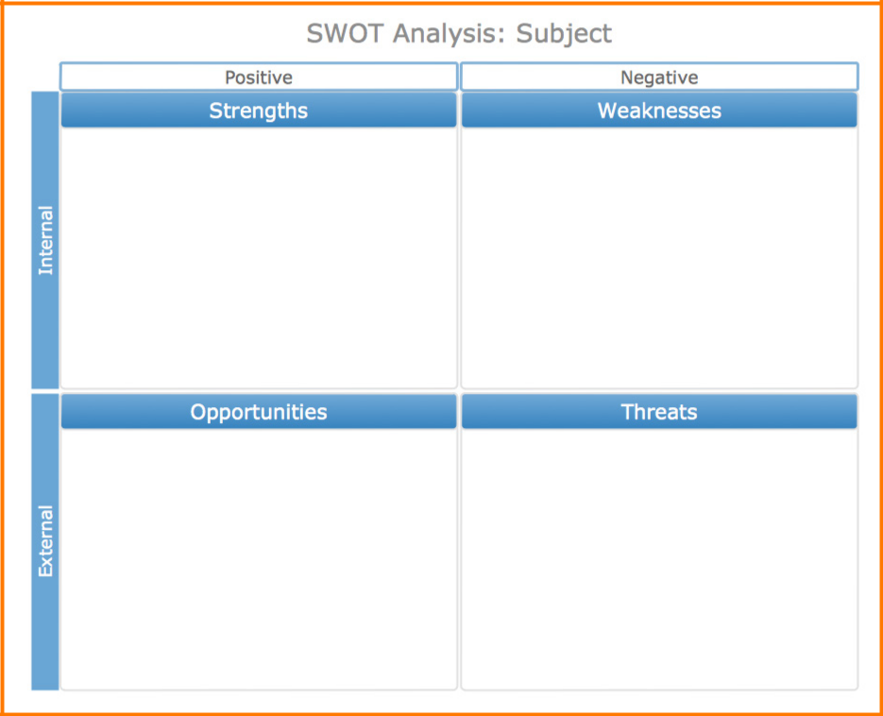

1.7. Selecting and Engaging Your Professional Team

As you have no doubt gathered from this section (and as you likely will from the sections to follow), the transition process can be complicated, even intimidating. That is why creating a team of knowledgeable professionals will be crucial to succeeding in the process – it is simply not possible to know everything one needs to know to navigate the process by yourself. Writing this workbook required a team of experts, and you need one too.

As you begin the transition planning process, consider adding the following professionals to your transition team:

1–21

 | Professional | Emphasis Area
 | Accounting professional | Determining farm’s current financial performance; evaluating feasibility of alternative
 |  | business arrangements/enterprises to implement transition plan
 | Tax professional | (If different from accounting professional) Evaluate income and estate taxation implications of
 |  | transition plan alternatives; suggest transaction structures to minimize tax liabilities incurred
 |  | by transition plan chosen.
 | Attorney | Suggest transactions and entity structures needed to accomplish transition objectives; draft
 |  | legal documentation needed to implement transition plan
 | Production consultants | Aid in evaluation of transition plan alternatives and feasibility of alternative operational
 |  | structures
 | Investment advisor | Aid in formation of retirement investment goals and selection of appropriate investment
 |  | vehicles to accomplish goals; aid in crafting of benefit plans for employees if needed
 | Human resources | Aid in development of position descriptions for all involved in farm operation, both currently
 | advisor | and after implementation of transition plan; consult on training programs and other actions
 |  | needed to acclimate stakeholders to new roles
 | Mediator / family | Facilitate transition meeting discussions; aid in gathering stakeholder input for transition
 | communication | process; provide continuing support in discussions to implement selected transition plan
 | specialist

This list is just a beginning. You may find other professionals in addition to these are needed. Do not be afraid to engage whatever professional assistance is needed. The transition process is one of the most important things you will ever do for your farm, so secure all the assistance you and your family need to make the best possible decision.

What if you have identified the need for a professional, but don’t know how to select one? While it is impossible to ensure you have always found “the best” professional, there are a number of steps you can take to help you find a good fit.

- Ask around: Seek out others who have gone through the transition process and ask for their experience with the type of professional you seek. Their encounters with similar professionals may suggest who to seek, and perhaps also who to avoid.

- Use professional association directories: Almost all professional associations maintain directories of their members, and may even provide search features on their websites that allow you to select a professional based on their areas of specialization (such as agriculture) and their location (such as a specific county or city).

- Interview the professional: Once you have narrowed your search to handful of professionals, schedule a meeting or telephone call to interview them. You would insist on an interview for someone working for you on the farm – this person will be working for you as well, just in a different capacity. Prepare a list of questions for the professional, such as their amount of experience in the specific area you need, and don’t settle for vague answers. “Oh yes, we do estate planning work for farmers and ranchers” is not enough. What proportion of your practice is in that area? Have you provided presentations or written on that topic? What training have you received in this area? Have you worked with professionals in other disciplines (this is important as the best professional team will work well with all other members of the professional team)? The point of your questions is to reveal how well equipped the professional is to address your specific needs.

- Ask for references, and follow up: During your interview, be sure to ask for reference clients you can contact to determine how the professional performed with real clients. Of course, the professional will only provide reference clients he or she feels would provide a good reference (although you may be surprised); don’t be afraid to ask those clients for the names of other clients you can contact (or “indirect references”).

1–22

This may be the most important information-gathering step in the process.

- Check professional credentials: Most professionals are subject to a board, association, or other organization that accredits and/or licenses the professional and maintains records of any disciplinary actions taken against its members. For example, attorneys are regulated by state bar associations, accountants are regulated by state accountancy boards, financial planners may be governed by the Securities and Exchange Commission or the Certified Financial Planners® Board (depending on their specific advising activities), and so on. Ask your professional for their governing board information, and contact the board to determine if the professional’s license or other credentials are in good standing, and if there is any pending or past disciplinary action regarding the professional.

- Ask for a written engagement agreement: “Get it in writing” is something you’ll see multiple times in this workbook, and it holds true here as well. When you think you have narrowed your search to the professional that fits your needs, ask them for a written engagement agreement that spells out the following details:

  - Who is the client: in transition work, multiple family members may be involved with the professional. Clearly spell out who is “the client” – in other words, for whom is the professional working? You, or the business as a whole? This can be a critical point, specifically with attorneys and accountants, as they have very specific ethical obligations with respect to their clients that can affect their ability to work with and disclose information to other stakeholders.

  - The scope of work – what specific tasks will the professional perform for you?

  - Deliverables – what specific products will the professional provide to you (such as a financial analysis report, a will, a set of corporate documents, etc.)?

  - Confidentiality – what will the professional do to protect the confidentiality of the information you provide to them? Will a “non-disclosure agreement” or other confidentiality document be needed to protect trade secret information or other information that should not be disclosed to other parties?

  - Payment terms – how will you be billed for the services provided by the professional? Will a “retainer” or other advance payment be required? Will you have an opportunity to review bills as the process goes on? Will you be billed on an hourly basis, according to a fee schedule, or on some other basis?

- Involve other stakeholders where appropriate: Some professionals may be working specifically for you, and in such cases you are certainly within your rights to select the professional by yourself. If the professional will be working extensively with other stakeholders, though, you may want to seek their input. The best professional team will be able to interact well with all your stakeholders.

1.8. Conclusion

As you complete this section of the workbook, you’ve seen a number of the fundamental questions you have to ask about your operation as it is today before you start planning for its future. Hopefully, these questions will not only jump-start your transition process; they will also help you focus your thought about how your operation runs and help you engage all your stakeholders. And speaking of engaging stakeholders, that will be the focus of Section 2!

1–23

