Metropolitan Washington Airports Authority | 1-16-C078

CONTRACT SNOW REMOVAL SERVICES

FOR THE

METROPOLITAN WASHINGTON AIRPORTS AUTHORITY

AT

WASHINGTON DULLES INTERNATIONAL AIRPORT

AND

RONALD REAGAN WASHINGTON NATIONAL AIRPORT

Attachment 01 Statement of Work – Page 1

Metropolitan Washington Airports Authority | 1-16-C078

- INTRODUCTION

The Metropolitan Washington Airports Authority (Airports Authority) is responsible for the operation and maintenance of Washington Dulles International Airport (Dulles International) and Ronald Reagan Washington National Airport (Reagan National). The Authority seeks qualified Contractor(s) to provide snow removal services in airport employee parking lots as well as other designated areas located at Dulles International and Reagan National airports.

The Contractor shall provide all supervision, labor, equipment, vehicles, fuel, tools, equipment maintenance, and transportation required to perform the services as described in this SOW.

Snow removal services shall consist of:

i

i

i

i

The removal of snow.

Hauling snow to Airports Authority-designated areas as needed.

Application of Airports Authority -supplied deicing or abrasive materials to mitigate snow, ice and sleet onto paved surfaces such as roadways and parking lots.

Application of Contractor supplied anti-icing solution on paved surfaces.

Snow removal services shall be performed on paved areas as shown in Appendix A at Dulles International and Appendix E and H for Reagan National . The Airports Authority reserves the right to increase or decrease the number of areas requiring snow/ice removal at its discretion if the need occurs.

- DEFINITIONS

ACCEPTANCE – The act of an authorized representative of the Airports Authority by which the Airports Authority approves partial or complete performance of the contract.

AOA - Aircraft Operation Area - The portion of the airport used or intended to be used for landing, takeoff, or surface maneuvering of aircraft. This is a security area requiring security badging. Workers in this area are required to obtain and display an AOA photo ID credential. Drivers in this area are required to obtain an Aerodrome Vehicle Operator's Permit.

AIRPORTS AUTHORITY - The Metropolitan Washington Airports Authority, to include Washington Dulles International Airport (Dulles International) and Ronald Reagan Washington National Airport (Reagan National).

CONTRACTING OFFICER (CO) - An Airports Authority employee with specific written authority to enter into, administer, and terminate contracts.

CONTRACTING OFFICER'S TECHNICAL REPRESENTATIVE (COTR) - A person with delegated authority from the Contracting Officer to assist in carrying out the CO's responsibilities at the project site.

CONTRACTOR'S EMPLOYEES - For the purpose of this contract, the Contractor’s employees shall include but not limited to equipment operators, supervisors, managers, and administrators who are employed on the job site to fulfill the requirements of the Statement of Work by the Contractor and/or any of its subcontractors.

CORRECTION - The elimination of a deficiency.

Attachment 01 Statement of Work – Page 2

Metropolitan Washington Airports Authority | 1-16-C078

FEDERAL AVIATION ADMINISTRATION (FAA) - The Federal Government agency responsible for the regulations and procedures related to air transportation.

FULL PERFORMANCE TIME - The Airports Authority identified timeframe when the Contractor’s equipment and personnel are in a working mode performing snow removal services as required by this SOW.

IDLE-TIME – The Airports Authority identified timeframe when the Contractor’s equipment and personnel are on-site in an “idle-time” or non-working mode. Contractor reimbursement is at a 50% reduced rate from Full Performance Time. See Stand-By Time.

MA-120 - Engineering and Maintenance Department, Reagan National Airport.

MA-226 –Engineering and Maintenance Department, Maintenance Engineering Division, Dulles International Airport.

MSDS - Material Safety Data Sheet

METROPOLITAN WASHINGTON AIRPORTS AUTHORITY (the Airports Authority) - The public body responsible for the operation and management of both Reagan National and Dulles International Airports.

OPERATORS – Personnel to operate various machinery defined in the contract, to include loaders, snow blowers, 4x4 vehicles, tandem dump trucks, etc. See Appendix C for complete listing for IAD.

OSHA - U. S. Occupational Safety and Health Administration. The Federal Government agency responsible for providing the rules and regulations on safety and health requirements in the work place.

QUALITY CONTROL - A method used by the Contractor to assure that quality services are provided to satisfy the requirements of the contract.

QUALITY ASSURANCE - A means by which the Airports Authority is able to confirm that the quantity and quality of services received conform to contract requirements. These methods/procedures are not intended to aid the Contractor in the performance of the contract requirements and shall not be a substitute for contract quality control.

SERVICES - Includes work performed, workmanship, and material furnished or utilized in the performance of services.

SOUTH SIDE AIRPORT SERVICES – South Side is defined as all areas south of the Aircraft Operations Area (AOA). Areas include Gates 313 and 317, Shop 2, Airports Authority Pistol Range, etc. at IAD. See Appendix A, Snow Contract Map.

SOW - Statement of Work

STAND-BY (Levels 1 through 5)- Airports Authority-defined manpower requirements to respond to all snow, ice, sleet, and/or freezing rain events requiring less than full mobilization of Airports Authority personnel and contractors.

STAND-BY TIME - The Airports Authority identified timeframe when the Contractor’s equipment and personnel are on-site in a “stand -by”, idle, or non-working mode. Contractor reimbursement is at a 50% reduced rate from Full Performance Time. See Idle-Time.

Attachment 01 Statement of Work – Page 3

Metropolitan Washington Airports Authority | 1-16-C078

SUPERVISOR - Contractor’s employee responsible for supervising individual and/or groups/teams of the Contractor’s employees/subcontractors with the authority to make decisions on behalf of the Contractor, to include hiring, firing, ordering additional equipment, removing equipment and in general be able to adhere to contract requirements.

WORKING SUPERVISOR – Personnel with authority to make decisions on behalf of the Contractor but shall also be expected to work alongside subordinates

- BASE SERVICES (REAGAN NATIONAL AND DULLES INTERNATIONAL)

- REAGAN NATIONAL PERFORMANCE REQUIREMENTS:

Snow removal services are required on an as needed basis at Reagan National in accordance with the following:

  - All rates for Reagan National are at the full performance rate. Standby rates are not applicable for any winter event at Reagan National.

  - Contractor shall provide tandem axle dump trucks with operators to perform snow removal/hauling tasks on the airfield operation area (AOA) of Reagan National under the direct supervision of the Authority’s snow removal director. The Airports Authority shall provide 2-way walkie-talkies for the contractor’s vehicles while operating in that area or under the Authority’s supervision. The contractor will be primarily tasked to haul snow from taxiways.

  - Work may also include snow loading on the AOA and/or removal hauling tasks for the street side of the terminals on an as needed basis over the winter period from November 1 through April 15.

  - The contractor shall be on site and available within four (4) hours of notification from the contracting officer’s representative.

  - The equipment provided must be equipped at a minimum with a checkered flag. The Airports Authority preference is for flashing yellow roof mounted lights.

  - Equipment operation will be under the direct supervision of the Metropolitan Washington Airports Authority snow removal director.

  - The contractor must have the ability to provide a minimum of 20 tandem axle dump trucks with operators within one week of award.

  - All equipment and truck traffic assigned to Reagan National shall use the cargo terminal gate or Gate A for staging areas located at the south end of the airport. (See Appendix E)

- REAGAN NATIONAL AUTHORIZED REPRESENTATIVES

The representatives authorized to place calls against this contract for Reagan National will be identified at contract award.

Attachment 01 Statement of Work – Page 4

Metropolitan Washington Airports Authority | 1-16-C078

- GENERAL PERFORMANCE REQUIREMENTS

  - The Contractor shall provide fully loaded rates for all supervision, labor, equipment, vehicles, fuel, tools, equipment maintenance, and transportation required to perform snow/ice removal services at Dulles International and Reagan National airports. The Contractor shall perform the services on designated roadways, aircraft taxi lanes, runways and employee parking lots (see Appendix A for diagram of IAD and Appendix E for diagram of DCA). Contract snow removal services shall include, but not be limited to, employee parking lots, air cargo parking lots, roadways, bus drive lanes, entrances, exits, slip ramps, and parking spaces.

  - The contractor shall be paid for events requiring snow removal, and/or ice control in accordance with the Price Schedule. Pricing for Snow removal base services and supplemental services is based upon specific hourly rates for snow removal equipment from November 1 through April 30 of each contract year.

  - The Airports Authority reserves the right to increase or decrease the number of service areas at its discretion.

  - Upon arrival to the site, the Contractor’s employees shall immediately sign in utilizing an Event Time Tracking Log (ETTL) to be maintained by the Contractor’s assigned Project Manager for each event (Appendix B for IAD and Appendix F for DCA). The Contractor’s employees shall provide their name, the date and time the employee arrived on-site, the equipment type, identification and license plate number of the piece of equipment the employee will be operating. At the end of each event, the Contractor shall submit the ETTL to the COTR. The Airports Authority reserves the right to audit the ETTL at any time during the snow event or snow season for any event that occurred. The Contractor shall maintain this log throughout the defined snow season.

  - The Contractor shall provide equipment that is in good operating condition. Prior to commencement of each event, the Contractor shall ensure each piece of equipment is functioning properly. The Airports Authority reserves the right to evaluate the operational condition of each piece of equipment. The Contractor shall provide a replacement in good operating condition for any and all equipment the Airports Authority deems unacceptable. Personnel that are in a Full Performance mode shall not assist or perform repairs to equipment.

  - Snow/Ice removal services shall commence at the direction of the COTR. Until such time, the Contractor will be placed on Idle Time, or half-rate of the pricing as set forth in the Price Schedule (see III. IAD Tab). Idle time is not applicable at Reagan National.

  - The Contractor shall apply deicing and/or abrasive materials as directed by the Airports Authority on the paved surfaces to ensure non-slippery conditions.

  - Snow removal services shall continue until snow accumulations have been cleared to the satisfaction of the Airports Authority. Paved areas shall be non-slippery and safe for vehicular and/or pedestrian traffic. Snow accumulations caused by drifting snow or snow piled by others from pedestrian walkways and bus stops shall also be cleared from the paved areas.

  - The Contractor shall plow snow away from parked vehicles to eliminate windrows directly behind the parked vehicles.

  - The Contractor shall not leave snow piled in vehicle drive lanes.

Attachment 01 Statement of Work – Page 5

Metropolitan Washington Airports Authority | 1-16-C078

  - Unless otherwise directed by the COTR, the Contractor shall remove, place, and pile snow at areas of the parking lots designated by the COTR.

  - In the event of a significant accumulation of snow, the Contractor shall remove and haul snow away from parking lots and other areas upon direction from the Airports Authority. Snow shall be hauled away and piled to an on-site location designated by the COTR.

  - Taxi Cab Parking Lot, Employee Parking main Bus Lanes, and Commercial Vehicle Drive are of the highest priority. These roadways shall be clear of snow and/or ice and shall be open and accessible for vehicular and pedestrian traffic at all times.

  - The Contractor will be released upon inspection and acceptance from the COTR at the conclusion of each snow, ice, and/or rain event

  - If, at any time during the contract period, the COTR determines that the work is deficient and/or not being performed in a timely manner and in accordance with the SOW, the Contractor shall correct these deficiencies at no additional cost to the Airports Authority.

  - The Contractor shall remove snow between parked vehicles where three or more vacant parking spaces exist.

  - The Contractor shall coordinate snow removal operations with the Sidewalk Snow Removal Contractor to ensure areas under its direction are kept clear of snow. Contractor will ensure that snow is not, blocking sidewalks or crosswalks, particularly Americans with Disabilities Act (ADA) designated areas.

  - Vehicle or equipment breakdowns shall be removed from the equipment list for the duration of the down time for payment purposes. The vehicle or piece of equipment may be added once the Contractor provides a visually verified substitute vehicle or piece of equipment.

  - The Airports Authority shall inspect base equipment set prior to the contract award date.

  - The Contractor shall consult with the COTR prior to mobilizing staff and equipment from a stand-by or idle-time mode to full performance for snow removal activities at IAD.

  - The COTR retains the right to inspect the equipment set listed in any given call order and reject marginal or non-operational equipment for each event.

  - Defined areas of coverage requiring supervision at IAD are: North Airport Service areas, Revenue Parking areas, South Airport Service Areas, and the DAAH 495 Ramps.

- STAFFING REQUIREMENTS AT REAGAN NATIONAL AND DULLES INTERNATIONAL

  - The Contractor shall ensure adequate staffing levels to maintain a continuous operation with rest periods. Staff shall not exceed a 12 hour consecutive work shift that must be followed by a minimum six hour rest period.

  - The Contractor shall provide, at a minimum, one supervisor or working supervisor for all snow events requiring a set amount of equipment to perform the requirements of the SOW for all Dulles International paid parking and employee parking lots, cargo areas, Reagan National airside snow hauling operations, and other defined areas in accordance with the call out and Appendix C for IAD and Appendix G for DCA.

Attachment 01 Statement of Work – Page 6

Metropolitan Washington Airports Authority | 1-16-C078

  - The Airports Authority shall determine the number of supervisors required for each event based upon weather forecast and required equipment set.

  - The Contractor’s supervisor shall be able to clearly communicate (both verbally and in writing) in the English language with the Airports Authority. The supervisor shall also be able to communicate verbally and in writing with all of the Contractor's employees and subcontractors. The Airports Authority reserves the right to require the Contractor to replace a supervisor who does not meet the communication requirement. .

  - Based on each storm event and operational needs, the Dulles Airport COTR may determine it necessary to supplement the supervisory personnel to monitor and manage the IAD south area roads requirement as defined in Appendix A. This position is considered a working supervisor and shall be required to assist in all areas of snow removal. Areas include Cabin Road, Gates 313 and 317, Air Traffic Control Tower (ATCT), Vehicle Maintenance Facility (VMF), Police Pistol Range, Shop 2 area and Fire Station 302. All main roads shall be plowed and treated by Airports Authority vehicles, but it is expected that the Contractor will provide backup. The supervisor shall have the authority to add or delete equipment as needed in coordination with the COTR.

  - A supervisor shall continuously monitor all areas and equipment covered by the SOW and shall direct the snow/ice removal operation in an effective, safe manner. The supervisor shall prioritize areas requiring snow/ice removal based upon guidelines provided by the Airports Authority and shall dispatch equipment to areas where needed.

  - The supervisor shall perform plowing operations only as required by an emergency and as approved by the Airports Authority.

  - Operators of motorized vehicles shall be properly trained. Commercial Driver Licenses (CDL) shall be obtained for all personnel operating vehicles required by the Virginia Department of Transportation (VDOT). Operators shall possess a minimum of two years’ experience operating the equipment they are assigned.

  - All supervisors and personnel assigned to the South Area Roads at Dulles Airport shall obtain a Dulles International security badge with approved driving and escort privileges.

  - The Contractor shall have a sign in sheet, Appendix B for IAD and Appendix F for DCA, providing names, tag numbers of vehicles, and associated Contractor signage. One hour after the Contractor has arrived on site, a copy of the sign-in sheet must be presented to the COTR for distribution.

  - For Dulles Airport, the 495 Overpass located on the Dulles Access Highway is maintained by the Airports Authority. This location requires a working supervisor regardless of the number of vehicles assigned, eliminating the need for a site-wide supervisor when only the 495 Overpass is called out.

- EQUIPMENT REQUIREMENTS

The Base Equipment Set is a defined list of equipment and pricing the Contractor shall supply to respond to any inclement weather event. The equipment set defined in Section III, Price Schedule is

based on forecasted accumulations of 1 - 3 inches of snow. The Airports Authority does not guarantee that the full base equipment set will be needed for all snow/ice weather events. All or a portion of the

Attachment 01 Statement of Work – Page 7

Metropolitan Washington Airports Authority | 1-16-C078

base equipment set may be used during a winter event. The equipment set shall be determined prior to arriving on site in coordination with the COTRs.

- The Dulles International Contract Base Equipment Set shall consist of:

  - Refer to Appendix C, Snow Equipment Matrix, for a guideline of estimated equipment requirements based on forecasted precipitation totals. The Airports Authority reserves the right to define equipment set totals for each event based on precipitation forecasts.

- The Reagan National Contract Base Equipment Set shall consist of:

  - Refer to Appendix G, Snow Equipment Matrix, for a guideline of estimated equipment requirements based on forecasted precipitation totals. The Airports Authority reserves the right to define equipment set totals for each event based on precipitation forecasts.

- The Airports Authority reserves the right to increase or decrease the quantity of the base equipment set and operators prior to and/or during snow removal operations. Cost adjustments due to an increase or decrease in the quantity of equipment and operators shall be in accordance with the Price Schedule.

- All equipment performing services under this contract shall be outfitted with appropriate safety devices to ensure safe operations. These devices shall include, but not be limited to flags, an amber (yellow) dome-type flashing strobe mounted on top of the vehicle, front and back lights, back-up horn, warning signage attached to spreaders, and other safety devices as deemed necessary by the Airports Authority.

- All equipment shall have Airports Authority-approved vehicle identification decals displayed on the left and right sides of each vehicle. For all 4WD vehicles, tandem trucks, and dump trucks vehicle marking shall be placed on the roof. Each piece of equipment shall be identified in a manner that indicates both the Contractor’s name as well as the individual piece of equipment (i.e., ABC-1, ABC-2, etc.). Equipment not displaying the required identification decals shall be removed from service until the deficiency has been corrected. The Contractor shall not be compensated for the piece of equipment until the deficiency is corrected and the unit is placed back into service.

- The Contractor shall provide equipment that is in good operating condition. Prior to commencement of each event, the Contractor shall ensure that each piece of equipment is functioning properly. The Airports Authority reserves the right to evaluate the operational condition of each piece of equipment. The Contractor shall provide a fully functioning replacement for any piece of equipment the Airports Authority deems unacceptable. The Contractor shall ensure that all personnel that are in a Full Performance mode perform functions in accordance with the SOW. The Contractor shall not be compensated for work outside the scope of work such as having personnel perform repairs to equipment.

- The Contractor shall immediately notify the Airports Authority of any equipment failures. The malfunctioning piece of equipment and its operator shall be taken off the clock until either the deficiency is corrected or a replacement is provided. The Contractor is required to return the equipment to operating condition within one hour or provide a replacement in good operating condition.

- All material applying equipment (i.e., spreaders) shall be calibrated in accordance with standard industry spreader calibration procedures. See Appendix D. The Contractor shall demonstrate

Attachment 01 Statement of Work – Page 8

Metropolitan Washington Airports Authority | 1-16-C078

to the Airports Authority’s satisfaction that each piece of equipment is calibrated prior to each snow event and upon request from the Airports Authority.

  - The Contractor shall be responsible for maintaining its staging area in a clean and safe condition at all times, free of debris, fire hazards, and other potentially dangerous situations. The Contractor shall be responsible for maintaining the security of its staging area and equipment. The Contractor shall be responsible for providing all utilities for its use, at no cost to the Airports Authority.

  - All equipment provided by the Contractor to fulfill the requirements of this SOW shall be rubber-tired with the exception of skid steer loaders.

  - Prior to contract award, the base equipment set shall be inspected and approved by Airports Authority personnel. All equipment licensed to drive on state highways must pass the Virginia State Inspection requirements. The Airports Authority reserves the right to inspect any/all base equipment, and shall provide the Contractor in writing, the number of pieces to be inspected within 48 hours of the scheduled inspection.

- AIRPORTS AUTHORITY-FURNISHED MATERIALS, EQUIPMENT, PERSONNEL, FACILITIES

  - The Airports Authority will furnish the following types of deicing and abrasive materials for the Contractor’s use at Dulles International and Reagan National Airports:

  - Salt.

  - Sodium Acetate.

  - Sand.

  - The Contractor shall apply authorized materials as directed by the Airports Authority.

  - Dulles International furnished deicing materials will be available in the Salt/Sand Storage Facility for the Contractor’s loading and use. Location of the Dulles facility is indicated on the drawing located in Appendix A. The Reagan National facility is located at: Chemical/Sand Shed, Thomas Avenue (south), Arlington, Virginia.

  - Water is not available at Reagan National. Water shall be made available at specific locations around Dulles Airport only. Each location at Dulles is referred to as “hot boxes” and requires the Contractor to have the capability to hook a 2-inch water line with 2-inch male couplings at each location. Two specific areas are:

- North end of Cargo 6.

- 2315 Glide Slope Drive, Dulles VA 20166 (in front of Landscape Contractor’s Lot).

- Three (3) trailers are provided for the use of the Contractor at Dulles International. The Contractor shall make all reasonable attempts to maintain the trailers. When problems occur that require services, the Contractor shall call the Work Order Desk on 703-572-2813 and request assistance to resolve problems. If it is deemed the problem is a result of the Contractor’s negligence, the Contractor shall resolve the problem at its own cost.

Attachment 01 Statement of Work – Page 9

Metropolitan Washington Airports Authority | 1-16-C078

- A Staging Area shall be provided at Dulles International and shall be referred to as Snow Contractor Lot. The tentative staging areas at Reagan National are depicted and highlighted in green in Appendix E.

- Obstructions and pavement edges will be identified by markers, supplied and placed by Metropolitan Washington Airports Authority personnel.

- Electrical power shall be made available for Airports Authority supplied trailers at Dulles (see Price Schedule) and for the making of brine solutions.

- The Airports Authority shall provide 2-way walkie-talkies for the Reagan National contractor’s vehicles while operating in the AOA or under the Authority’s direct supervision.

- The Airports Authority shall provide escorts as needed at Reagan National.

IV. SUPPLEMENTAL/AS NEEDED SERVICES (REAGAN NATIONAL AND DULLES INTERNATIONAL)

- During events where a significant accumulation of snow is experienced, the Airports Authority may require the Contractor to provide supplemental equipment and operators for Dulles International and Reagan National (as needed services only) during the term of this contract. Supplemental services for Dulles International shall be performed in accordance with the terms of the contract documents. The Contractor shall be reimbursed by the Airports Authority for supplemental services in accordance with the unit prices specified in the Price Schedule. The Contractor’s unit prices shall be fully loaded rates. The Contractor shall, upon direction from the Airports Authority, provide supplemental equipment and operators no later than four (4) hours from the time requested and authorized by the Airports Authority. The Airports Authority reserves the right to request the supplemental equipment and operators in any quantities it deems necessary during the snow/ice removal events.

- Supplemental/on/call services for Dulles International and Reagan National Airports:

Refer to Appendix C (IAD) and Appendix G (DCA), Snow Equipment Matrix, for estimated equipment requirements based on forecasted precipitation totals. The Airports Authority reserves the right to define equipment set totals for each event based on precipitation forecasts.

- Anti-icing/De-icing Material Applications

  - Highway anti-icing is the prevention of snow and ice bonding to roadways with timely applications of a chemical freezing-point depressant. It provides the Airports Authority with two major capabilities: Maintaining roads in the best conditions possible during a winter storm efficiently and providing the benefit of increased traffic safety at a lower cost.

  - The Airports Authority has adopted a systematic approach to snow and ice control consistent with the objective of preventing the formation or development of bonded snow and ice to various roadways and parking lots by utilizing a blended low cost mixture of water, salt and an anti-corrosive inhibitor (anti-icing).

  - Anti-Icing Ratios

    - Brine, a mixture of salt and water, works best when the ratio is a 23.3% salt to water solution. The Contractor shall utilize a hydrometer to ensure brine being

Attachment 01 Statement of Work – Page 10

Metropolitan Washington Airports Authority | 1-16-C078

provided to the Airports Authority within 5% of the desired 23.3% salinity quotient (22.14% - 24.4%). At this ratio, brine will melt snow and ice with pavement temperatures as cold as 15 degrees Fahrenheit. Contractor shall develop and maintain a salinity log. The salinity log shall be provided to the COTR.

  - The brine solution shall contain a corrosion inhibitor additive. Typical anti-corrosive inhibitors additives are beet juice, potato juice, or a manufactured brand. The corrosion inhibitor to brine ratio shall be: 85% brine, 15% anti-corrosive inhibitor for each load. Contractor shall have the capability to test and maintain a log detailing the liquid anti-corrosive mixture provided.

  - The Contractor shall supply a brine mixer with automated mixing capability and printout capability. The Contractor shall be able to conclusively demonstrate amount of mixture provided to the Airports Authority and provide printouts of gallons provided. A log shall be maintained by the contractor with dates and number of gallons stored.

- Liquid Anti-icing Equipment

  - The contractor shall provide speed sensor equipment units capable of applying liquid anti-icing solutions on roadways between 40 and 60 gallons per lane mile, consistently at varying speeds.

  - The COTR shall dictate the application rate prior to application.

  - The contractor shall certify the anti-icing equipment calibration once for every three call orders or upon request.

  - Contractor shall supply trucks capable of holding a minimum of one thousand (1,000) gallons of liquid anti-icing mixtures. Each truck shall have a fully automatic 3-lane boom with speed control sensors.

- Treatment Areas for Dulles International

The Airports Authority reserves the right to increase or decrease areas. The Contractor shall apply anti-icing mixture on the following areas:

  - DIAAH, Route 267 from the East/West flyover ramp to the West Falls Church Metro exit and return.

  - Route 7 flyover ramp.

  - Route 28 flyover ramps.

  - Commercial Vehicle Lane.

  - North Employee bus lanes and North Employee bus parking.

  - East Employee entrance, main lane, and exit.

  - Rudder Road.

Attachment 01 Statement of Work – Page 11

Metropolitan Washington Airports Authority | 1-16-C078

    - Autopilot Drive.

    - Aviation Drive.

    - Garage 1 and 2 bus lanes.

    - Blue Lot bus lanes.

    - Green Lot bus lanes.

    - Gold Lot bus lanes.

    - Purple Lot bus lanes.

- Anti-Icing Standards for Brine Application guidelines from November 1 through April 15 weather forecasts shall be monitored daily.

  - Application of brine will be based on the received Meteorlogix weather report using a 48-hour weather forecast when the following conditions occur:

    - Low temperatures shall achieve 36 degrees Fahrenheit or less within a 48-hour (2-days) forecast;

    - Precipitation shall be forecast at 30% or greater within a 48-hour forecast;
    - Winter weather (snow, ice, freezing rain) shall dictate how often call orders shall be generated.

    - When precipitation and temperatures dictate, a call order shall be generated to initiate the brine application 24 to 48 hours prior to the forecasted inclement weather event.

- The Airports Authority reserves the right to add or subtract treatment areas, or increase/decrease the application of liquid anti-icing frequencies. Written notification from the COTR(s) to increase/decrease treatment areas or applications will be provide to the contractor.

- Payment for brining shall be in accordance with the amount of liquid anti-icing mixture that is applied and related unit cost as stated in Section III – Price Schedule.

- Provide Anti-icing Brine

  - The contractor agrees to provide anti-icing brine, in accordance with the ratios listed above in IV.3.c, to the Airports Authority for use by Airports Authority winter operations. Pricing will be in accordance with Section III – Price Schedule.

  - Deliverables

    - Automatic brine mixing calibration at startup and upon request by the COTR.

    - Anti-icing salinity log.

    - Anti-corrosive inhibitor log.

    - Equipment calibration certification at the beginning of each winter season.

Attachment 01 Statement of Work – Page 12

Metropolitan Washington Airports Authority | 1-16-C078

      - Printout of anti-icing mixture in gallons provide, per event.

V.GENERAL REQUIREMENTS

  - Guaranteed Minimums

    - The Contractor shall be given a minimum of four hours’ notice for all events when services are requested.

    - Cancelled Events: The Contractor shall be guaranteed a minimum of four hours pay for all Contractor equipment responding to cancelled precipitation events requiring on-site presence in accordance with the Price Schedule.

  - Communications

    - The Contractor shall provide its supervisory personnel with cell phones.

    - The Contractor shall provide e-mail addresses, facsimile, telephone, and pager numbers by which the Airports Authority can contact individuals who have the responsibility and authority for implementing all the requirements of the contract.

    - The Contractor shall be responsible for ensuring each of its equipment operators are outfitted with a means to immediately contact the Contractor’s supervisor in the event of an equipment malfunction or accident.

    - Contractor shall submit a comprehensive communications plan (internal/external).

  - Work Hours

The Contractor shall be available to perform snow removal services continuously on a 24-hour/seven day per week basis as required during the snow season. Typical snow seasons are defined as the period from November 1 through April 15.

  - Reporting

    - The Contractor shall generate and submit a Snow Removal Activity Report to the COTR for each Airport via e-mail no later than 24 hours after the termination of each event. This report will summarize the Contractor’s work performance and shall include, but not be limited the event start date and time, the event termination date and time, stand-by and full performance times per equipment, equipment identification, total materials utilized, equipment malfunctions, a time line delineation of work performed, and all applicable special condition or activities.

    - The Contractor shall supply a list of equipment and personnel assigned to equipment within two (2) hours of each event. Equipment shall have unique identification markings and shall prominently display Contractors name or assigned Airports Authority airfield markings. As an example, ABC-1, ABC-2, ABC-3, etc.

  - Coordination Meetings

Attachment 01 Statement of Work – Page 13

Metropolitan Washington Airports Authority | 1-16-C078

The Contractor’s representative(s) shall attend meetings as required by the Airports Authority to coordinate, evaluate, discuss or critique snow/ice removal issues and the performance of work under this contract.

- Staging areas

  - The Airports Authority shall provide a staging area at Dulles with three (3) Airports Authority-owned trailers to the Contractor to store and stage its field office, equipment, and other support facilities. The staging area will be located on Dulles International property as designated by the COTR for such purposes. The tentative staging area location at Reagan National is located along the fence line between Lots Q and U. No trailers will be provided at Reagan National. The COTRs and Contractor shall make a joint site visits to document the condition of the staging areas prior to the Contractor’s use.

  - The Contractor shall be responsible for maintaining its designated area in a clean and safe condition at all times, free of debris, odors, fire hazards and other potentially dangerous situations. The Contractor shall be responsible for establishing and maintaining the security of its staging area, facilities, and equipment.

- Contractor Facilities

  - The Contractor shall provide the necessary storage sheds, sanitary facilities, and other support facilities. If applicable and requested, a site plan indicating the layout of the Contractor facilities shall be submitted to the COTR for review and approval. A list of the types, sizes and other pertinent information concerning the Contractor facilities shall be submitted to the COTR for review and approval no later than two (2) weeks prior to the contract start date. The exterior facade of the Contractor’s field office, storage sheds and other permanent structures shall match the “Dulles Grey” color finish equivalent to Pittsburgh Paints (PPG) Warm Dark Gray K-48. Reagan National does not require a specific color scheme.

  - The Contractor may optionally acquire, at no cost to the Airports Authority, temporary utilities including temporary electric power and telephone service as necessary. All work associated with utilities owned by the Airports Authority including connection to existing service shall be performed by the Contractor as approved by the Airports Authority.

  - The Contractor facilities shall comply with the Airports Authority Design Manual, and all applicable laws and regulations of authorities having jurisdiction, including but not limited to:

    - Building code requirements.

    - Health and safety regulations.

    - Utility company regulations.

    - Police, Fire Department and Rescue Squad rules.

    - Environmental protection regulations.

Attachment 01 Statement of Work – Page 14

Metropolitan Washington Airports Authority | 1-16-C078

  - The Contractor shall obtain a construction permit from the Airports Authority’s Engineering Department prior to the installation and use of temporary facilities.

  - The Contractor shall comply with all federal, state and local laws and regulations concerning storage and disposal of hazardous materials used by the Contractor.

  - Temporary office facilities, toilets, storage sheds, and other construction of a temporary nature shall be removed from the site at the conclusion of the contract. The Contractor shall properly restore the site to an equal to or greater condition than received.

- Safety and Protection

  - The Contractor shall be responsible for researching, understanding, administering, and practicing environmental protection, safety and health provisions of the latest additions of the Airports Authority Construction Safety Manual, Occupational Safety and Health Administration (OSHA), and all other applicable federal, state and local standards.

  - The Contractor shall assume responsibility on the job site for the actions of all its personnel and subcontractor(s) who are associated with performance on this contract. The Contractor shall take adequate measures to prevent personal injury and property damage. The Contractor shall be responsible for initiating, maintaining and supervising all safety precautions and programs in connection with the performance of the contract.

  - The Contractor shall immediately notify the Airports Authority of all damage to vehicles or property caused by or involving the Contractor’s equipment or personnel. The Contractor shall immediately notify Airports Authority police and shall submit a written report to the COTR of any such incident. Damage caused by the Contractor to any vehicle or property shall be repaired or replaced to the satisfaction of the Airports Authority at the expense of the Contractor. The Airports Authority, at its sole discretion, may elect to repair or replace the damaged property and deduct such costs from monies due the Contractor.

  - The Airports Authority shall have the right to inspect all areas and equipment for safety violations at its discretion, direct the Contractor to make immediate improvement of conditions and/or procedures, and/or stop the work if other hazards are deemed to exist. Notwithstanding any provision to the contrary, the Airports Authority shall not be obligated to make an equitable adjustment for any work stoppage that results from safety hazards created by the Contractor.

  - The Contractor shall develop and provide to the COTR the Contractor's Safety Plan. The Plan shall be submitted to the COTR no later than two (2) weeks prior to the contract start date.

  - The Contractor shall require that all drivers assigned to the Airports Authority Roads and Highway crew wear OSHA-approved reflective safety vests. All personnel who exit their vehicles in and around the Salt/Sand facilities shall wear reflective safety vests.

- Security Requirements

    - The Contractor, its subcontractors, and all its employees shall be subject to, and shall at all times conform with, all rules, regulations, policies and procedures pertaining to

Attachment 01 Statement of Work – Page 15

Metropolitan Washington Airports Authority | 1-16-C078

security at Dulles International and Reagan National. Any violations or disregard of the rules, regulations, policies and procedures may be cause for immediate termination.

  - The Contractor shall not pile snow against AOA fences.

- Quality Control

The Contractor shall implement a comprehensive quality control program that covers both airports and ensures fulfillment of all the requirements contained in the Statement of Work

VI. DELIVERABLES

The Contractor shall provide to the COTR:

- Ten (10) days prior to contract award, Contractor shall allow inspection of base equipment set at both Reagan National and Dulles International airports.

  - All vehicles capable of driving on Virginia roadways shall show evidence of a valid Virginia State Inspection (VSI).

  - All snow equipment (loaders, skids, dump trucks, etc.) shall be in good working order, with no leaks, and capable of performing in accordance with the Statement of Work.

  - The COTR may elect to inspect all or a percentage of listed base equipment prior to contract award (base equipment set is defined in Appendix C (IAD) and Appendix G (DCA).

- No later than two (2) weeks prior to the contract start date:

  - The names and résumés of all supervisors who will be on the job site to fulfill the requirements of this SOW.

  - The Contractor’s e-mail address, telephone, cell phone, fax and pager numbers.

  - The Contractor’s proposed Facility Plan (Dulles International).

  - The Contractor’s Safety Plan (Dulles International and Reagan National Airports).

- No later than four (4) hours after each event: Event Time Tracking Log

- No later than 24 hours after each event: Snow Removal Activity Report

- At each event:

  - All personnel assigned to the 495 highway ramps or the Airports Authority Roads and Highway team shall don OSHA-approved reflective vests. (IAD Only)

  - All 4WD vehicles shall have the Contractor’s ID displayed on three sides of each vehicle (top, driver’s side, passenger side)

Attachment 01 Statement of Work – Page 16

Metropolitan Washington Airports Authority | 1-16-C078

- All other vehicles (skids, wheel loaders, etc.) shall have the Contractor’s ID displayed on two sides (passenger/driver sides)

- All South Side assigned personnel and equipment shall be stationed on the south area roads within the first hour of arriving on site.

- A sign-in sheet shall be provided to the COTR one-hour after reporting on site for each event.

VII FUEL COST ADJUSTMENT

In the event the cost of fuel utilized by this Contract increases or decrease during the term of this Contract, a fuel adjustment shall be determined as set forth below. This adjustment shall be determined at the start of each snow season on November 1st utilizing the U.S. Energy Information Administration Petroleum Publication for U.S. East Coast Diesel Fuel at http://tonto.eia.doe.gov/oog/info/gdu/gasdiesel.asp to determine the average daily fuel price. The cost for this agency or service is free through the internet.

The contractor shall be entitled to a price increase/decrease based on the cost of a gallon of fuel originally determined on the day the solicitation is released to the public as provided in Section III – Price Schedule. This is called the “Fuel Cost Adjustment-Seasonal Level”.

As used in this clause, for sake of clarity, in determining the “Fuel Cost Adjustment-Seasonal Level”, the following algorithm shall apply:

- (Fuel Adjustment Factor) = ((Fuel Pricing for Contract Year) / (Fuel Pricing Basis)) - 1

- (Fuel Rate Adjustment Per Vehicle) = (Contractor's Hourly Fuel Rate Per Vehicle) * (Fuel Adjustment Factor)
- (Hourly Rate Per Vehicle) = (Hourly Rate Per Vehicle, Excluding Fuel) + (Con-tractor's Hourly Fuel Rate Per Vehicle) + (Fuel Rate Adjustment Per Vehicle)

Attachment 01 Statement of Work – Page 17

Metropolitan Washington Airports Authority | 1-16-C078

APPENDIX A

DULLES AIRPORT SNOW REMOVAL AREAS

Attachment 01 Statement of Work – Appendices

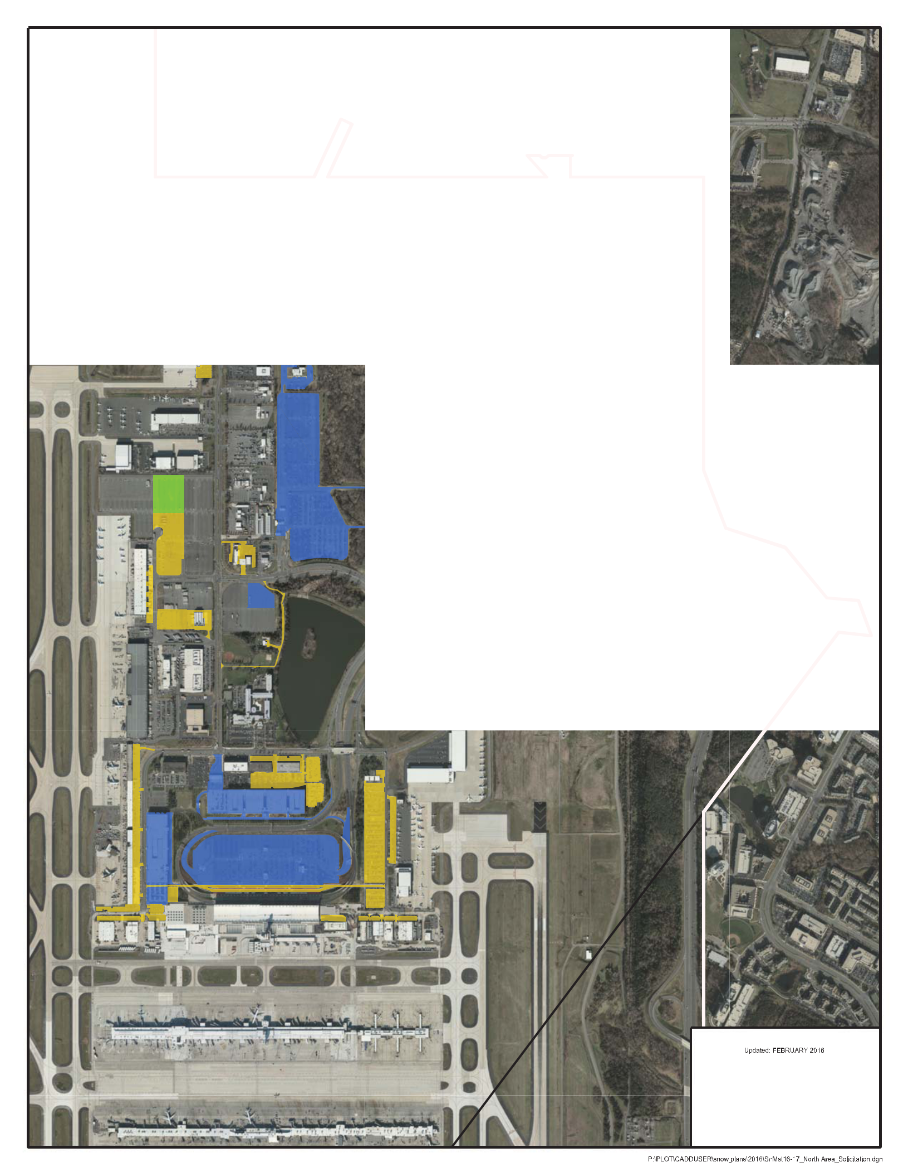


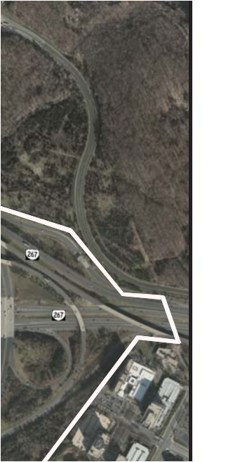


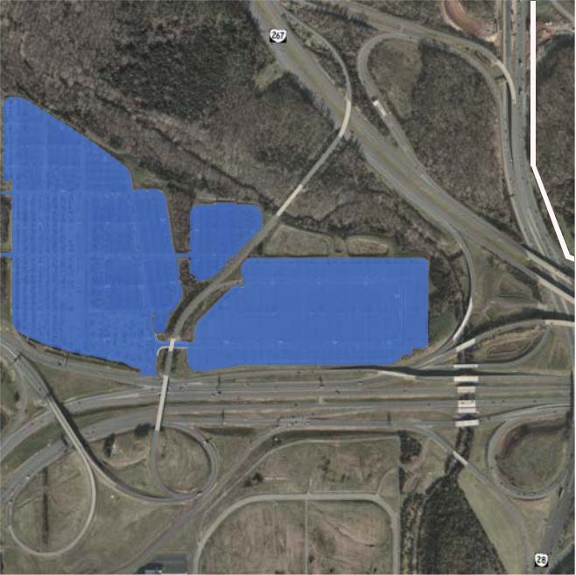

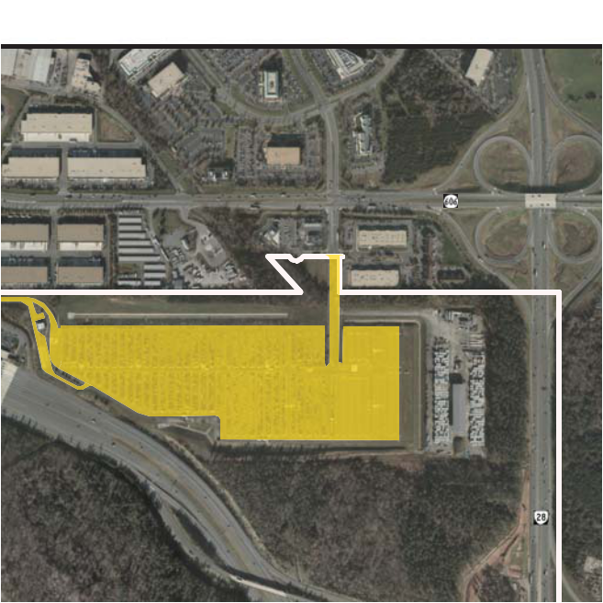

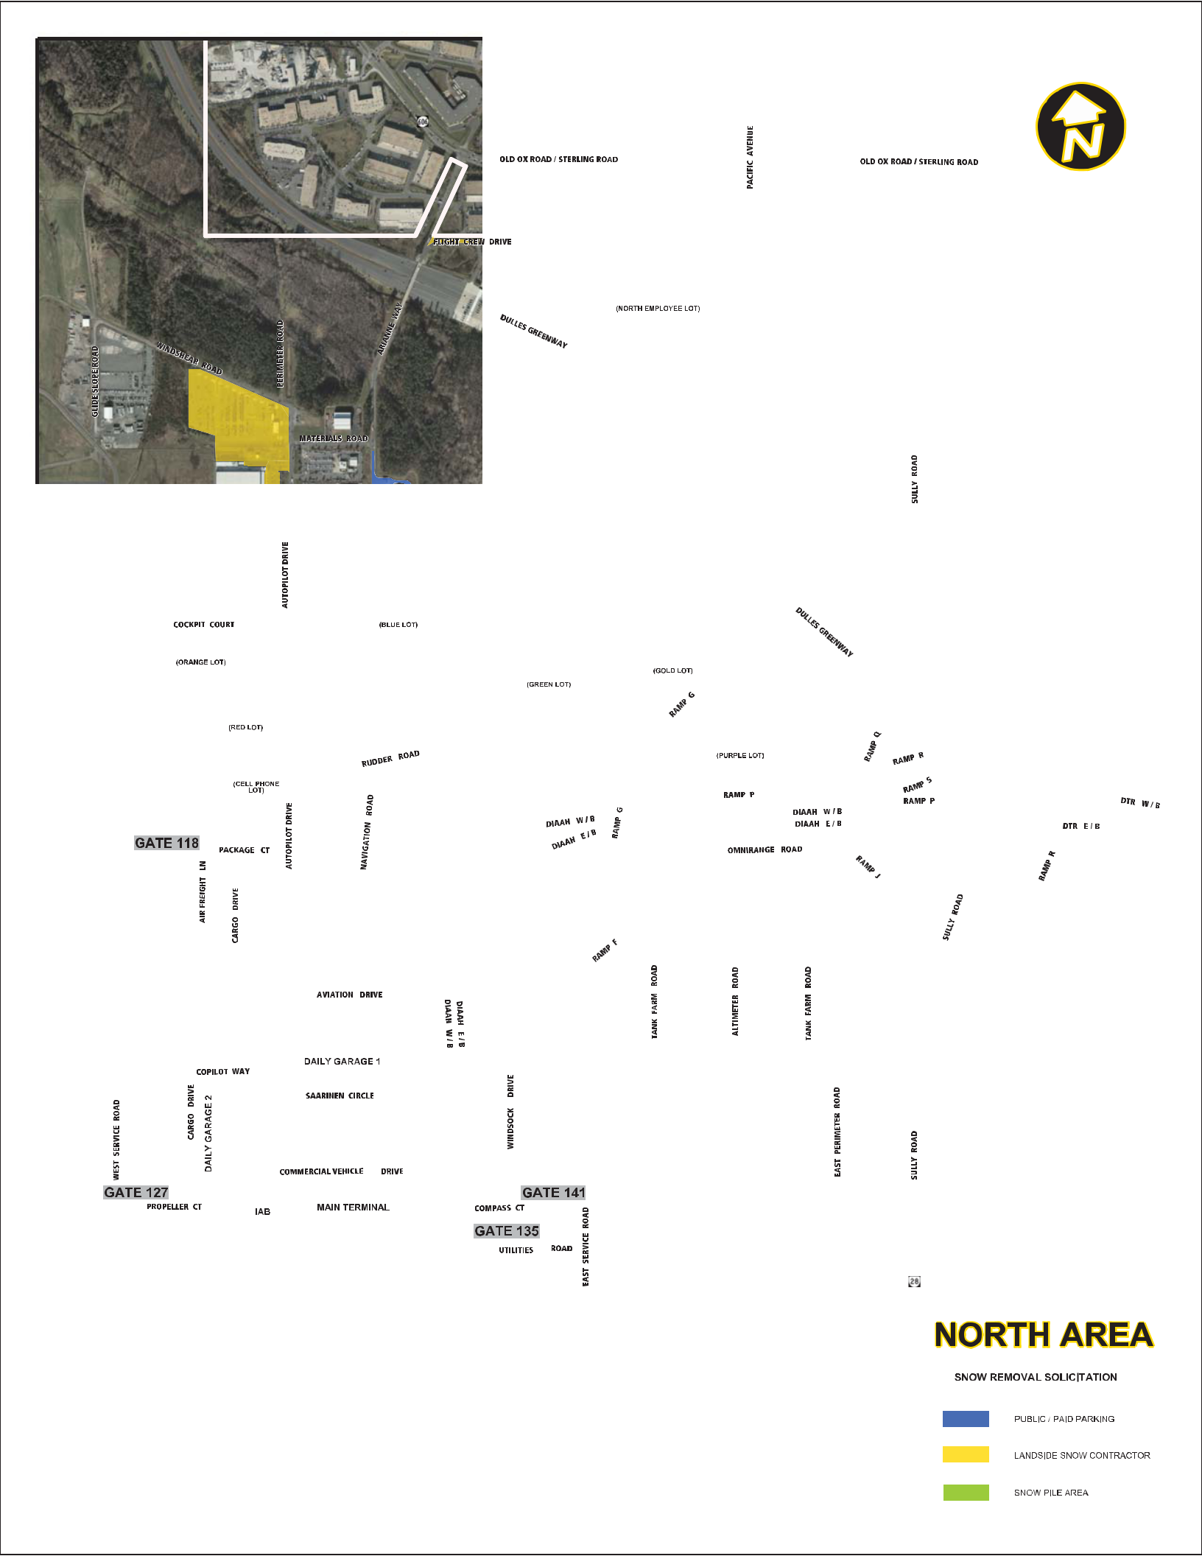
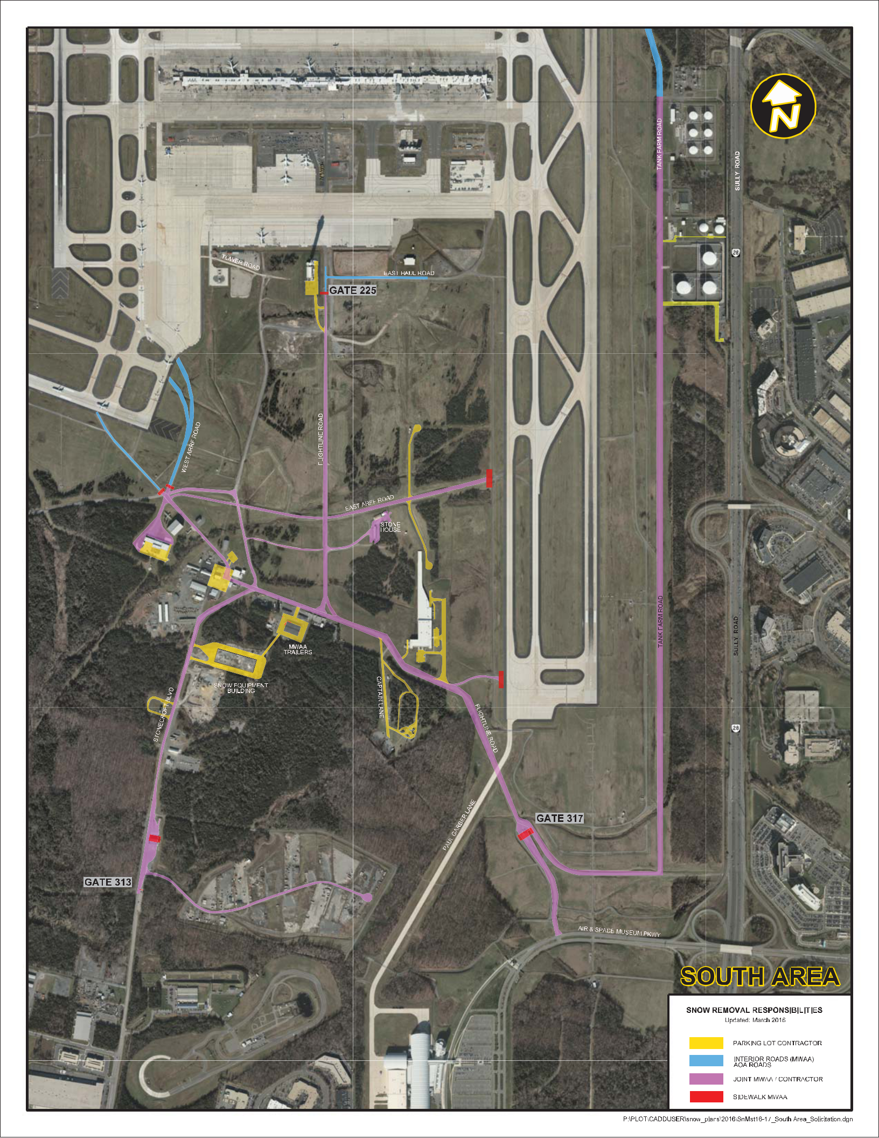
Metropolitan Washington Airports Authority | 1-16-C078

APPENDIX B

DULLES AIRPORT EVENT TRACKING LOG

Attachment 01 Statement of Work – Appendices

Washington Dulles International Airport

Employee Parking Lot Snow Removal Contract

Base Equipment Event Time Tracking Log

CONTRACT LINE ITEM

EQUIPMENT TYPE

EMPLOYEE NAME

EQUIPMENT ID | IDLE TIME START

IDLE TIME END

FULL PERFORMANCE | FULL PERFORMANCE
START TIME | END TIME

A.1.0 | Supervisor's 4WD
A.2.0 | Working Supervisor's 4WD
A.2.0 | w/ snow plow
 | Truck, 4WD, w/snow plow,
A.3.0 | minimum 2 yd. spreader
A.3.0 | and operator
 | Truck, 4WD, w/snow plow,
A.3.0 | minimum 2 yd. spreader
A.3.0 | and operator
 | Truck, 4WD, w/snow plow,
A.3.0 | minimum 2 yd. spreader
A.3.0 | and operator
 | Truck, 4WD, w/snow plow,
A.3.0 | minimum 2 yd. spreader
A.3.0 | and operator
 | Truck, 4WD, w/snow plow,
A.3.0 | minimum 2 yd. spreader
A.3.0 | and operator
 | Truck, 4WD, w/snow plow,
A.3.0 | minimum 2 yd. spreader
A.3.0 | and operator
 | Truck, 4WD, w/snow plow,
A.3.0 | minimum 2 yd. spreader
A.3.0 | and operator
 | Truck, 4WD, w/snow plow,
A.3.0 | minimum 2 yd. spreader
A.3.0 | and operator
A.4.0 | Skid Loader/Bobcat
A.4.0 | Loader and Operator
 | Skid Loader/Bobcat
A.4.0 | Loader and Operator
A.4.0 | Skid Loader/Bobcat
A.4.0 | Loader and Operator
A.4.0 | Skid Loader/Bobcat
A.4.0 | Loader and Operator
A.4.0 | Skid Loader/Bobcat
A.4.0 | Loader and Operator
A.4.0 | Skid Loader/Bobcat
A.4.0 | Loader and Operator
A.4.0 | Skid Loader/Bobcat
A.4.0 | Loader and Operator
 | Skid Loader/Bobcat
A.4.0 | Loader and Operator

Appendix B - Event Time Tracking Log

Washington Dulles International Airport

Employee Parking Lot Snow Removal Contract

Base Equipment Event Time Tracking Log

CONTRACT LINE ITEM

EQUIPMENT TYPE

EMPLOYEE NAME

EQUIPMENT ID | IDLE TIME START

IDLE TIME END

FULL PERFORMANCE | FULL PERFORMANCE
START TIME | END TIME

 | Dump Truck w/plow,
A.5.0 | spreader and Operator
 | Dump Truck w/plow,
A.5.0 | spreader and Operator
A.5.0 | Dump Truck w/plow,
A.5.0 | spreader and Operator
A.5.0 | Dump Truck w/plow,
A.5.0 | spreader and Operator
A.5.0 | Dump Truck w/plow,
A.5.0 | spreader and Operator
 | Dump Truck w/plow,
A.5.0 | spreader and Operator
 | Dump Truck w/plow,
A.5.0 | spreader and Operator
A.5.0 | Dump Truck w/plow,
A.5.0 | spreader and Operator
A.5.0 | Dump Truck w/plow,
A.5.0 | spreader and Operator
 | Front-End Loader w/snow
A.6.0 | basket or Push Box w/
A.6.0 | Operator
 | Front End Loader w/snow
 | basket or Push Box w/
A.6.0 | Operator
 | Front End Loader w/snow
A.6.0 | basket or Push Box w/
A.6.0 | Operator
 | Front End Loader w/snow
A.6.0 | basket or Push Box w/
A.6.0 | Operator
 | Front End Loader w/snow
A.6.0 | basket or Push Box w/
A.6.0 | Operator
 | Front End Loader w/snow
A.6.0 | basket or Push Box w/
A.6.0 | Operator
 | Front End Loader w/snow
A.6.0 | basket or Push Box w/
A.6.0 | Operator
 | Front End Loader w/snow
A.6.0 | basket or Push Box w/
A.6.0 | Operator

Appendix B - Event Time Tracking Log

Metropolitan Washington Airports Authority | 1-16-C078

APPENDIX C

DULLES AIRPORT EQUIPMENT SET ESTIMATES

Attachment 01 Statement of Work – Appendices

APPENDIX C

Washington Dulles International Airport Equipment Set Estimates

 | ESTIMATED EQUIPMENT SET ¹ |  | FORECASTED SNOWFALL |  |  |  |  |  | ICE /
 | ESTIMATED EQUIPMENT SET ¹ |  |  |  |  |  |  |  | FREEZING
 |  |  | 1/4" - 1” | 1”–3” | 3”–5” |  | 5”-8” | 8” + | RAIN
 | North Area Roads, |  | Parking Lots, and Cargo Areas
 | Supervisor w/4-Wheel Drive (4WD) |  | 1 | 1 | 1 |  | 1 | 1 | 1
 | Working Supervisor w/4WD and minimum 7.5 ft.
 | plow. |  | 0 | 0 | 0 |  | 1 | 2 | 0
 | Trucks w/operator, 4WD, 2 yd. spreader (or
 | greater), and min. 7.5 ft. plow. |  | 4 | 4 | 6 |  | 9 | 9 | 6
 | Skid Steers/Bobcat loader w/ operator, minimum
 | ½ yard bucket with quick disconnect capability
 | from a 60 in. high capacity bucket, or 8 ft. push
 | box.
 |  |  | 0 | 4 | 8 |  | 12 | 15 | 4
 | Dump Truck w/plow, operator, 10 ft. bed and 5
 | yd. spreader, 10 ft blade. |  | 0 | 4 | 6 |  | 6 | 6 | 4
 | Front-end Loader, 80HP or greater with operator,
 | quick-disconnect capability from utilizing a push
 | box or 1.5 yd. standard material handling bucket
 | with bolt on cutting edge (minimum 21,000 lb.
 | operating weight). Minimum 12 ft push box. |  | 0 | 4 | 8 |  | 12 | 15 | 0
 | Tandem Axle Dump truck with/11-ft. articulating
 | power angle plow, min. 10 yd. spreader and
 | operator. ²
 |  |  | 0 | 0 | 0 |  | 2 | 2 | 0
 | Tandem Dump Truck with operator, 14 yd. bed
 | minimum. |  | 0 | 0 | 0 |  | 10 | 20 | 0
 | Backhoe w/ min. 18ft. Reach from swivel and
 | operator. |  | 0 | 0 | 0 |  | 1 | 1 | 0
 | Snow Blower (3,000 tons or more per/hour) with
 | operator. |  | 0 | 0 | 0 |  | 0 | 1 | 0
 |  |  | Paid Parking
 | Supervisor |  | 1 | 1 | 1 |  | 1 | 1 | 1
 | Working Supervisor w/4WD and minimum 7.5 ft.
 | plow. |  | 0 | 0 | 0 |  | 1 | 2 | 0
 | Trucks w/operator, 4WD, 2 yd. spreader (or
 | greater), and min. 7.5 ft. plow. |  | 4 | 4 | 6 |  | 10 | 10 | 6
 | Skid Steers/Bobcat loader w/ operator, minimum
 | ½ yard bucket with quick disconnect capability
 | from a 60 in. high capacity bucket, or 8 ft. push
 | box. |  | 0 | 4 | 8 |  | 10 | 10 | 4
 | Dump Truck w/plow, operator, 10 ft. bed and 5
 | yd. spreader, 10 ft blade. |  | 0 | 4 | 6 |  | 4 | 4 | 4
 | Front-end Loader, 80HP or greater with operator,
 | quick-disconnect capability from utilizing a push
 | box or 1.5 yd. standard material handling bucket
 | with bolt on cutting edge (minimum 21,000 lb.
 | operating weight). Minimum 12 ft push box. |  | 0 | 4 | 8 |  | 10 | 10 | 0
 | Tandem Dump Truck with operator, 14 yd. bed
 | minimum |  | 0 | 0 | 0 |  | 10 | 20 | 0
 | Backhoe w/ min. 18ft. Reach from swivel and
 | operator |  | 0 | 0 | 0 |  | 1 | 1 | 0
 | Snow Blower (3,000 tons or more per/hour) |  | 0 | 0 | 0 |  | 0 | 1 | 0
 |  |  | South Side | Areas
 | Working Supervisor w/minimum 7.5 ft. plow |  | 0 | 0 | 1 |  | 1 | 1 | 1
 | Skid Steers/Bobcat loader w/ operator, minimum
 | ½ yard bucket with quick disconnect capability
 | from a 60 in. high capacity bucket, or 8 ft. push
 | box. |  | 0 | 0 | 2 |  | 2 | 2 | 4
 | Dump Truck w/plow, operator, 10 ft. bed and 5 |  | 0 | 0 | 1 |  | 3 | 3 | 4
 | yd. spreader, 10 ft blade. |  | 0 | 0 | 1 |  | 3 | 3 | 4
 | Dulles International Airport Access Highway (DIAAH) 495 Ramps
 | Dump Truck w/plow, operator, 10 ft. bed and 5
 | yd. spreader, min. 10 ft blade. |  | 1 | 1 | 1 |  | 1 | 1 | 1
 | Dump Truck w/plow, 10 ft. bed and 5 yd. |  | 0 | 1 | 2 |  | 3 | 3 | 2
 | spreader, min. 10 ft blade. |  | 0 | 1 | 2 |  | 3 | 3 | 2
 | ESTIMATED TOTALS for FORECASTED PRECIPITATION EVENTS ACCUMULATIONS
 |  |  |  |  |  |  |  |  | ICE /
 |  |  | 1/4" - 1” | 1”–3” | 3”–5” |  | 5”-8” | 8” + | FREEZING
 |  |  | 1/4" - 1” | 1”–3” | 3”–5” |  | 5”-8” | 8” + | RAIN >
 |  |  |  |  |  |  |  |  | 1/4"
 |  |  | 11 | 36 | 65 |  | 111 | 141 | 42
¹ The Airports Authority reserves the right to define equipment set totals for each event based on precipitation forecasts.

² Specialized Equipment: Tandem or Tri-Axle Dump truck (14 yd. minimum) w/spreader, 11-ft. power angle plow and operator. Operators will work directly with Airports Authority personnel. Spreading material will be supplied. This equipment set is designated solely to the Dulles International Airport Access Highway (DIAAH) road team and will operate independently from the Parking Lot Contractor Team under the jurisdiction of the Airports Authority DAAH team leader.

Metropolitan Washington Airports Authority | 1-16-C078

APPENDIX D

SPREADER CALIBRATION CHART

Attachment 01 Statement of Work – Appendices

 |  |  |  |  | CALIBRATION CHART
Truck No: |  |  |  |  | Spreader No:
Date: |  |  |  |  | By:
Gate Opening |  |  | (Inches) |  |  | POUNDS DISCHARGED PER MILE
 | (Hopper Type Spreaders)
 | A | B | C |  |  | MINUTES TO TRAVEL ONE MILE
Control | Shaft RPM | Discharge Per | Discharge | 5 mph | 10 mph | 15 mph | 20 mph | 25 mph | 30 mph | 35 mph | 40 mph | 45 mph
Control | (Loaded) | Revolution | Rate | x 12.00 | x 6.00 | x 4.00 | x 3.00 | x 2.40 | x 2.00 | x 1.71 | x 1.5 | x 1.33
Setting |  | (Pounds) | (Lbs/Min)
1 |  |  | - | - | - | - | - | - | - | - | - | -
2 |  |  | - | - | - | - | - | - | - | - | - | -
3 |  |  | - | - | - | - | - | - | - | - | - | -
4 |  |  | - | - | - | - | - | - | - | - | - | -
5 |  |  | - | - | - | - | - | - | - | - | - | -
6 |  |  | - | - | - | - | - | - | - | - | - | -
7 |  |  | - | - | - | - | - | - | - | - | - | -
8 |  |  | - | - | - | - | - | - | - | - | - | -
9 |  |  | - | - | - | - | - | - | - | - | - | -
10 |  |  | - | - | - | - | - | - | - | - | - | -
11 |  |  | - | - | - | - | - | - | - | - | - | -

SPREADER CALIBRATION PROCEDURE

Calibration is simply calculating the pounds per mile discharged at various truck speeds by first counting the number of auger or conveyor shaft revolutions per minute, measuring the salt discharged in one revolution, then multiplying the two and finally multiplying the discharge rate by the minutes it takes to travel one
mile. With hopper type or spreaders with adjustable discharge openings you must calibrate for specific gate openings. Measure from floor of conveyor to

edge of gate. Each spreader must be calibrated individually; even the same models may vary widely at the same control setting.

Equipment needed:

- Scale to weigh salt

- Salt collection device

- Marking device

- Watch with second hand

Calibration steps:

- Remove, by-pass or turn off spinner.

- Warm truck’s hydraulic oil to normal operating temperature with spreader system running.

- Put partial load of salt on truck.

- Mark shaft end of auger or conveyor.

- Dump salt on auger.

- Rev truck engine to operating RPM.

- Count number of shaft revolutions per minute at each spreader control setting, record.

- Collect salt for one revolution, weight, deducting weight of container. (For greater accuracy, collect salt for several revolutions and divide by this number of

turns to get weight for one revolution.)

- Multiply shaft RPM (Column A) by Discharge per Revolution (Column B) to get Discharge Rate in pounds per minute (Column C), then multiply Discharge Rate by Minutes to Travel One Mile at various truck speeds to get Pounds Discharged per Mile.*
*For example, at 20 MPH with 30 Shaft RPM and 7 lbs. Discharge – 30 x 7 = 210 x 3.00 = 630 lbs. Per mile.

CALIBRATION OF AUTOMATIC CONTROLS

Automatic controls may be calibrated using the following steps:

- Remove, by-pass or turn of spinner.

- Set control on given number.

- Tie sack or heavy canvas under spreader discharge area.

- Mark specific distance, such as 100 or 1,000 feet.

- Drive that distance with spreader operating.

- Weigh salt collected.

- Multiply weight of salt by 5.2 (in case of 1,000 feet) or 52.8 (in case of 100 feet).

Answer will be salt discharged per mile, which remains constant regardless of speed, but calibration must be done for each control setting. Some automatic control manufacturers have “simulators” which eliminate need for on-road operation for calibration.

Appendix D - Spreader Calibration

Metropolitan Washington Airports Authority | 1-16-C078

APPENDIX E

REAGAN NATIONAL STAGING AND HAULING AREA

Attachment 01 Statement of Work – Appendices

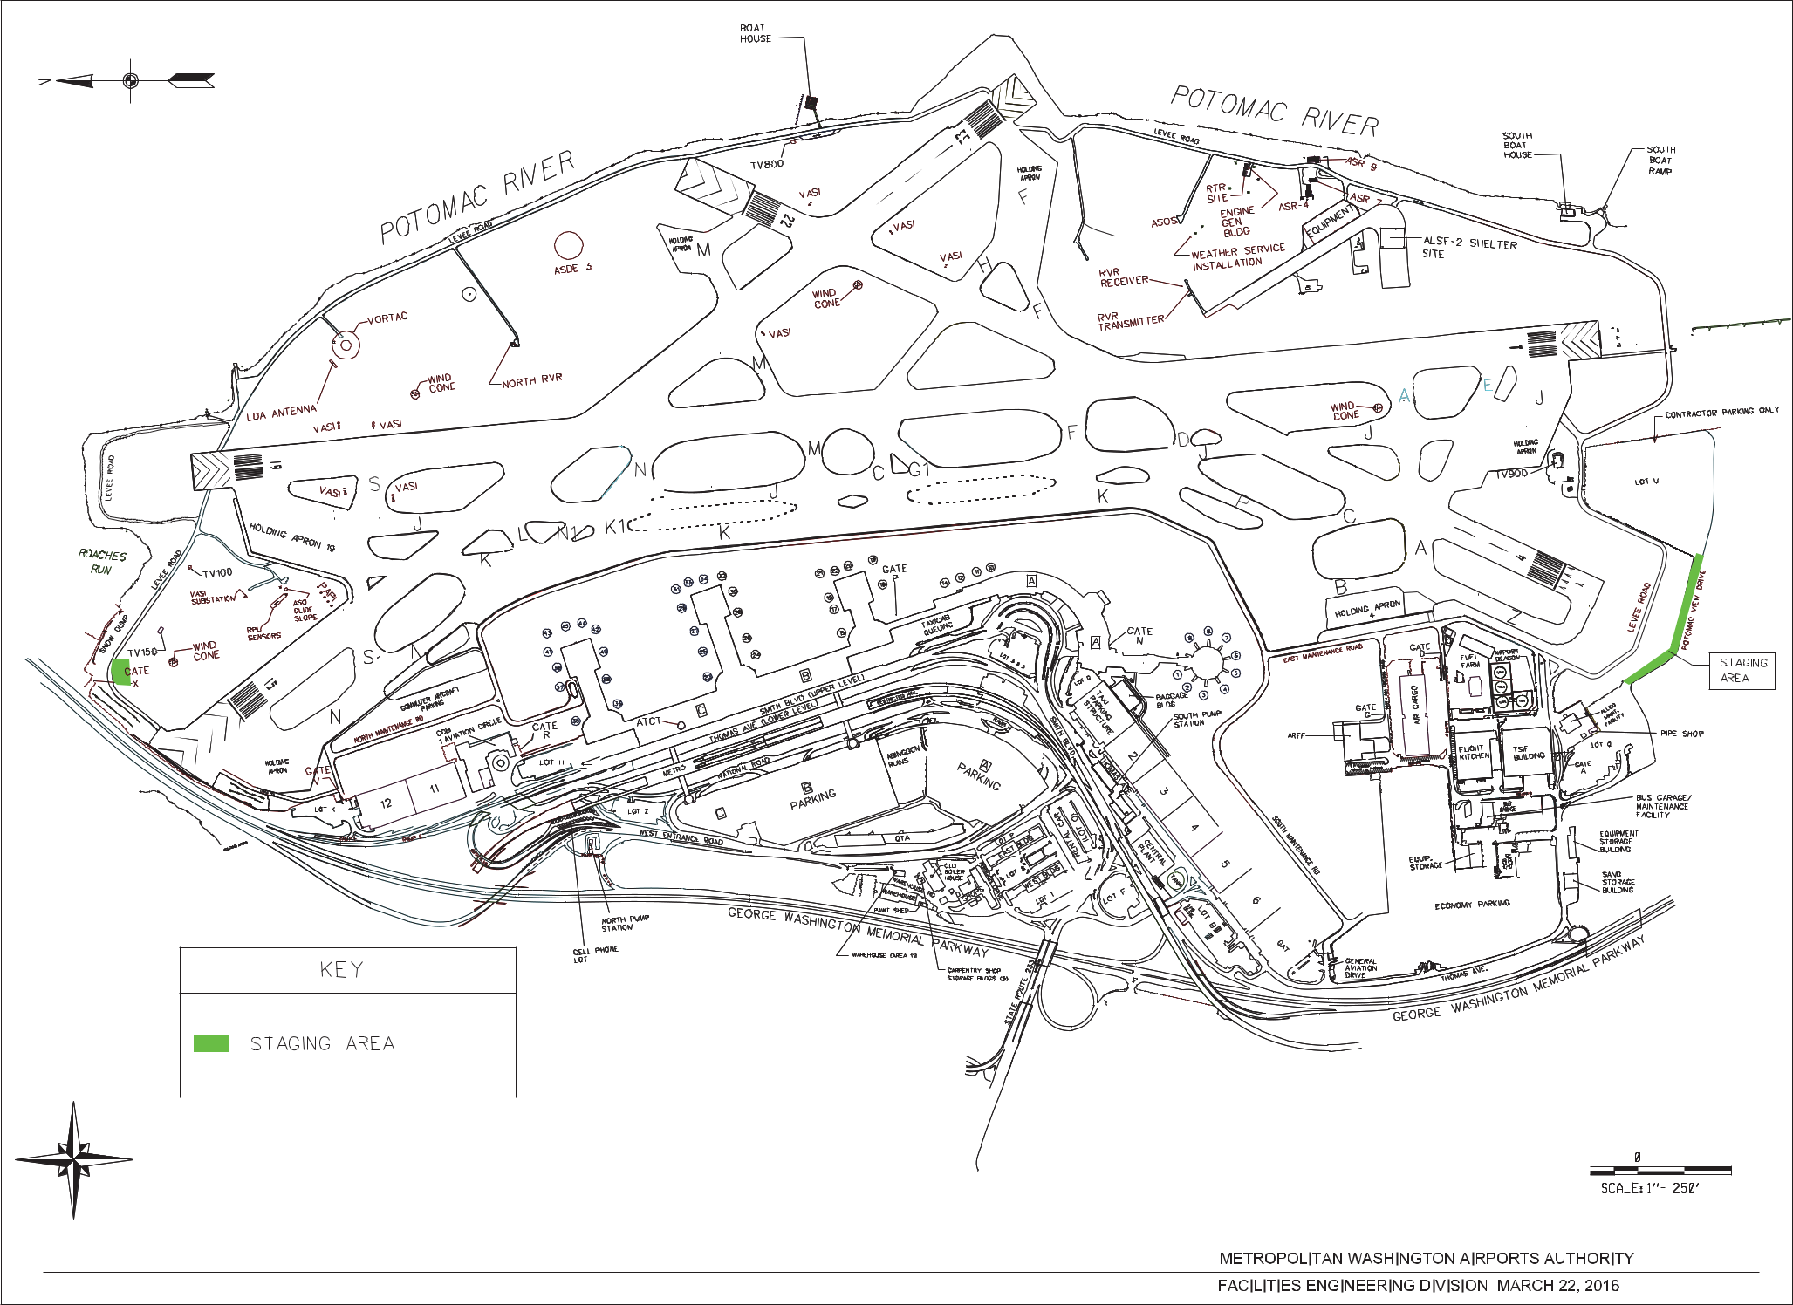
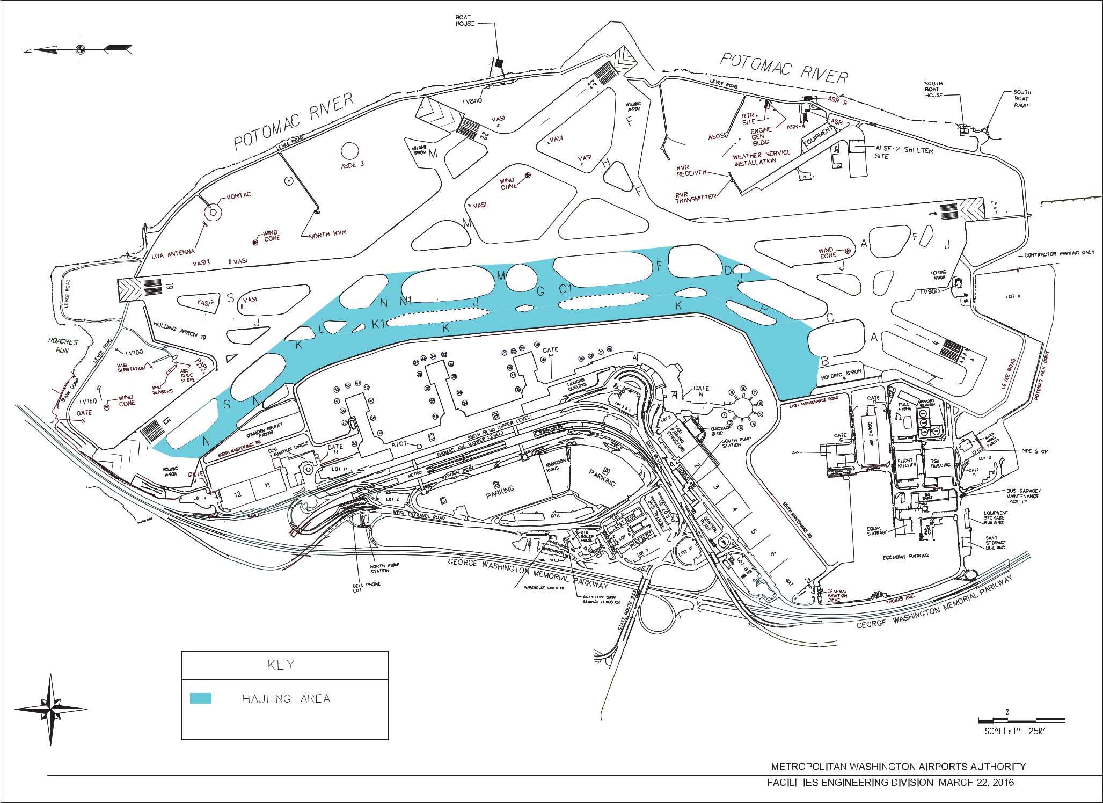
Metropolitan Washington Airports Authority | 1-16-C078

APPENDIX F

REAGAN NATIONAL EVENT TRACKING LOG

Attachment 01 Statement of Work – Appendices

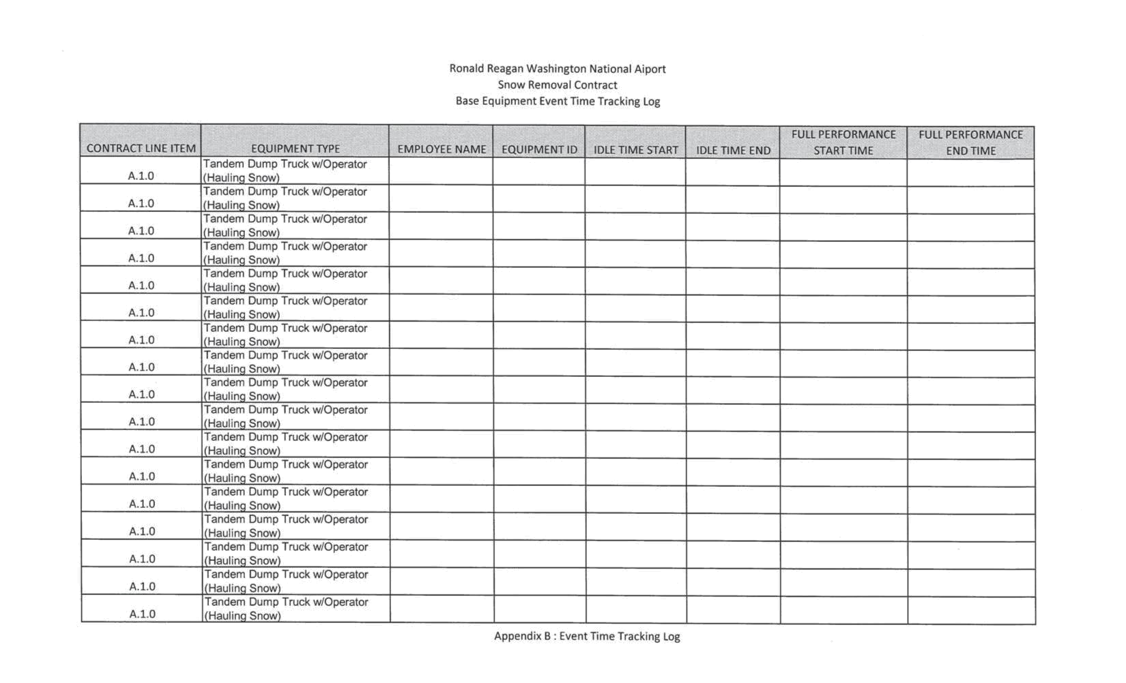
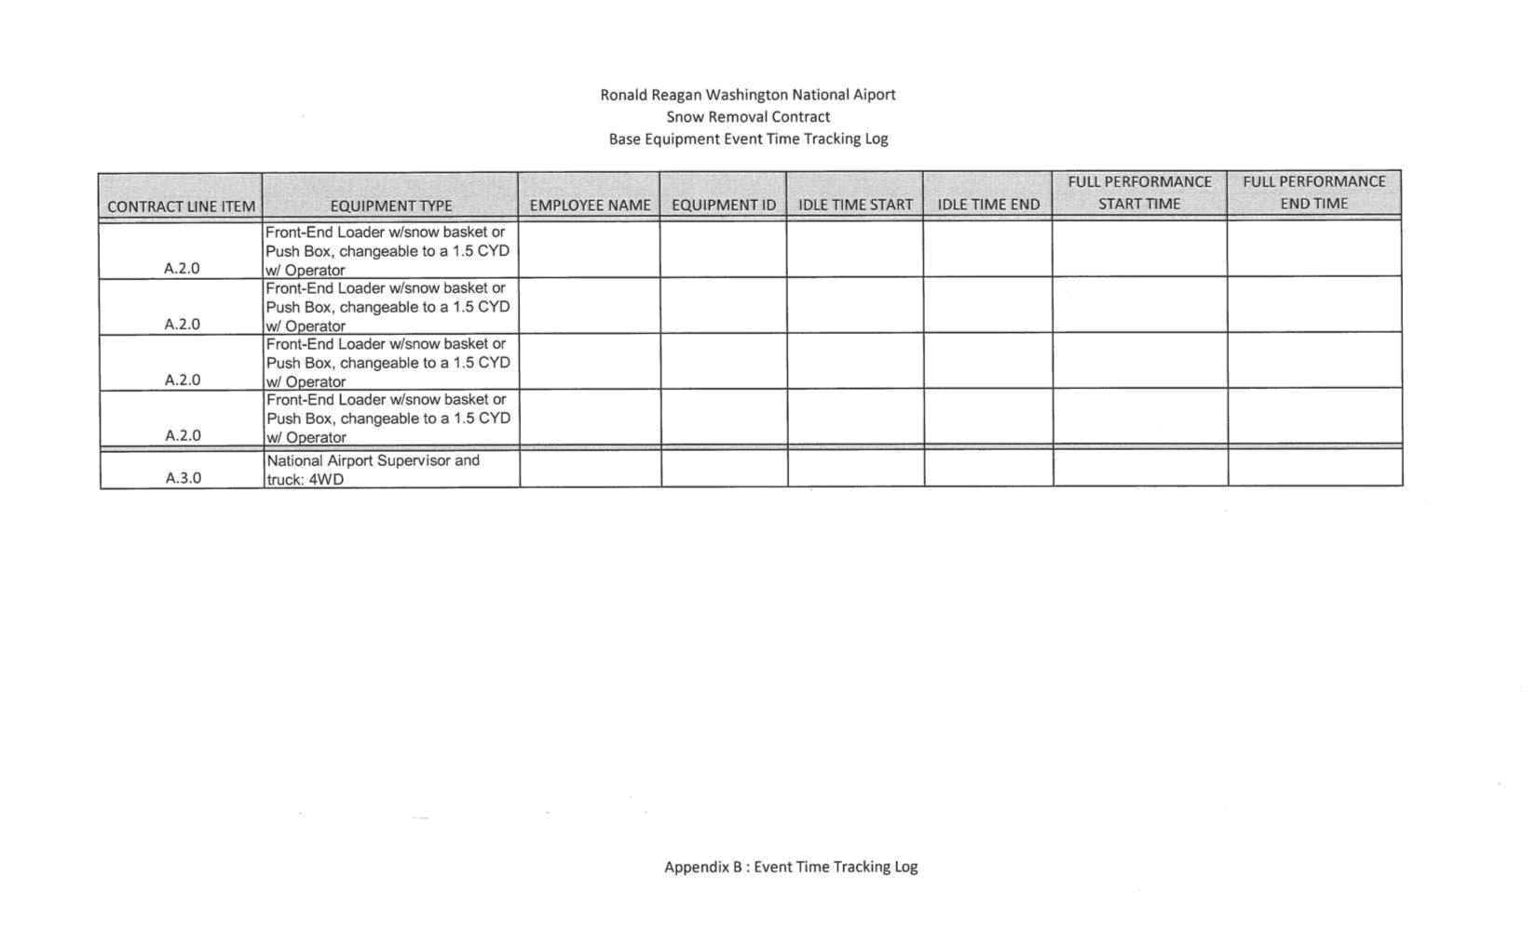
Metropolitan Washington Airports Authority | 1-16-C078

APPENDIX G

REAGAN NATIONAL EQUIPMENT SET ESTIMATES

Attachment 01 Statement of Work – Appendices



