
United States Department of Agriculture
Rural Development

Loan Approval Commitment Letter – Indenture – with Felony Certificate Example

Mr./Ms. First Name + Initial + Last Name

Title
Cooperative Name [May continue on the next line]
P.O. Box or Street Address

City, State [Do not abbreviate State and space twice before zip code]

Dear Mr./Ms. Last Name:

We are pleased to advise you that a loan guarantee commitment in the amount of $[Insert Amount of Loan] has been approved for [Insert Cooperative Name – May continue on the next line] [Insert Cooperative Short Name in parentheses], by the Rural Utilities Service (RUS). Under this commitment, RUS will guarantee a loan of $[Insert Amount of Loan] to [Insert Cooperative Short Name] from the Federal Financing Bank (FFB) under the terms and conditions set forth in the Note Purchase Commitment and Servicing Agreement dated as of January 1, 1992, as amended, between RUS and FFB. The proceeds of the guaranteed loan, designated “[Insert Loan Designation]”, are to be used by [Insert Cooperative Short Name] to finance only the system extensions and additions described in the RUS Form 740c, Cost Estimates and Loan Budget for Electric Borrowers, dated [Insert date the RUS Form 740 has been signed by Cooperative], enclosed and made a part hereof. Written approval by RUS must be obtained prior to the advancement of any loan proceeds for use for system extensions and additions that are not specifically listed on the enclosed RUS Form 740c.

The “[Insert Loan Designation]” loan contract and related documents, together with instructions, will be forwarded in the future for execution. The “[Insert Loan Designation]” loan is approved with the understanding that the loan documents will be authorized and executed by your organization and returned to us by the date set forth in the letter transmitting the documents.

Please note that this letter does not constitute an approval to advance the loan proceeds. Proceeds are eligible for advancement on the “[Insert Loan Designation]” loan after all conditions below have been met and the proper advance request documentation has been submitted to RUS:

- RUS has entered into a contract of guarantee with [Insert Cooperative Short Name], and the FFB has agreed, with RUS approval, to make [Insert Cooperative Short Name] a guaranteed loan of $[Insert Amount of Loan] to finance the system extensions and additions described on the enclosed RUS Form 740c;

- [Insert Cooperative Short Name] has submitted evidence, in form and substance satisfactory to the Administrator, that the conditions in the contract of guarantee have been satisfied to the extent and in the manner prescribed by the Administrator;

- [Insert Cooperative Short Name] has submitted evidence, in form and substance satisfactory to the Administrator, that [Insert Cooperative Short Name] has duly authorized, executed, and has delivered to the Administrator the FFB Note and the Reimbursement Note in the manner prescribed by the Administrator;

Committed to the future of rural communities.

“USDA is an equal opportunity provider, employer and lender.” To file a complaint of discrimination write USDA, Director, Office of Civil Rights, Room 326-W, Whitten Building, 1400 Independence Avenue, SW, Washington, DC 20250-9410 or call [202] 720-5964 [voice or TDD].
[Insert Cooperative and Loan Designations]

- [Insert Cooperative Short Name] has submitted evidence, in form and substance satisfactory to the Administrator, that the “[Insert Loan Designation]loan has been secured under the Indenture, or a supplement thereof, which is in form and substance satisfactory to the Administrator;

- [Insert Cooperative Short Name] has provided any and all certifications and any related documentation required under the Indenture to [Insert Name of Trustee] as Trustee. In addition, the [Insert Cooperative Short Name] has provided any and all certifications and any related documentation required under the RUS loan contract to RUS; and

- [Insert Cooperative Short Name] has submitted evidence, in form and substance satisfactory to the Administrator that [Insert Cooperative Short Name] has duly authorized, executed, and delivered to the Administrator a RUS loan contract in the manner prescribed by the Administrator.

[Add any and all additional conditions]

Please note that the approval of this loan guarantee commitment is an offer to [Insert Cooperative Short Name] of the “[Insert Loan Designation]” guaranteed loan. Your acknowledgement and acceptance of the “[Insert Loan Designation]” guaranteed loan is subject to the specified terms and conditions identified above.

This award is subject to the provisions contained in the Consolidated and Further Continuing Appropriations Act, 2015, P. L. 113-235, Division E, Title VII, Sections 744 and 745, as amended and/or subsequently enacted for USDA agencies and offices regarding corporate felony convictions and corporate federal tax delinquencies. Please see the attached certification for compliance with these requirements.

Your acknowledgement and acceptance must be received by RUS, by signature, within 14 calendar days from the date of this letter; otherwise, the commitment will be VOID. The Chairman or the Board President authorized by your organization to execute the loan documents must execute, date, and return this commitment and the attached Felony Form (AD-3031) via an email attachment to:

Zena Baldorado
Email Address: loancommitment@wdc.usda.gov

If email is not possible, the signed document can be faxed to 1-844-875-8076. The original executed and dated commitment will remain in your files.

Sincerely, |  | ACKNOWLEDGED AND ACCEPTED BY:
 |  | ______________________________________
 |  | [Name]
[Title-Loan Approver] |  | ______________________________________
 |  | [Title]
Enclosure – RUS Form 740c
 |  | ______________________________________
 |  | [Date]

[Insert Cooperative and Loan Designations]

- [Insert name of Manager of Cooperative and Title] NRUCFC [If appropriate]

CoBank [If appropriate]

Official File [Insert Cooperative & Loan Designations] // Reading File [Insert Cooperative] // GFR // DRCS [G. Belcher] // Financial Assistant

RUS: [Insert Division Short Name //Author // Typist // Date // File Name]

United States Department of Agriculture
Rural Development

Commitment Letter – Mortgage with Felony Certificate

(Date or date stamp)

Mr./Ms. First Name + Initial + Last Name
Title

Cooperative Name [May continue on the next line indented by 0.20 inch] P.O. Box or Street Address

City, State [Do not abbreviate State and space twice before zip code]

Dear Mr./Ms. Last Name:

We are pleased to advise you that a loan guarantee commitment in the amount of $[Insert Amount of Loan] has been approved for [Insert Cooperative Name – May continue on the next line] [Insert Cooperative Short Name in parentheses], by the Rural Utilities Service (RUS). Under this commitment, RUS will guarantee a loan of $[Insert Amount of Loan] to [Insert Cooperative Short Name] from the Federal Financing Bank (FFB)] under the terms and conditions set forth in the Note Purchase Commitment and Servicing Agreement dated as of January 1, 1992, as amended, between RUS and FFB. The proceeds of the guaranteed loan, designated “[Insert Loan Designation]”, are to be used by [Insert Cooperative Short Name] to finance only the system extensions and additions described in the RUS Form 740c, Cost Estimates and Loan Budget for Electric Borrowers, dated [Insert date the RUS Form 740 has been signed by Cooperative], enclosed and made a part hereof. Written approval by RUS must be obtained prior to the advancement of any loan proceeds for use for system extensions and additions that are not specifically listed on the enclosed RUS Form 740c.

The “[Insert Loan Designation]” loan contract and related documents, together with instructions, will be forwarded in the future for execution. The “[Insert Loan Designation]” loan is approved with the understanding that the loan documents will be authorized and executed by your organization and returned to us by the date set forth in the letter transmitting the documents.

Please note that this letter does not constitute an approval to advance the loan proceeds. Proceeds are eligible for advancement on the “[Insert Loan Designation]” after all conditions below have been met and the proper advance request documentation has been submitted to RUS:

- The RUS has entered into a contract of guarantee with [Insert Cooperative Short Name], and the FFB has agreed, with RUS approval, to make [Insert Cooperative Short Name] a guaranteed loan of $[Insert Amount of Loan] to finance the system extensions and additions described on the enclosed RUS Form 740c;

- [Insert Cooperative Short Name] has submitted evidence, in form and substance satisfactory to the Administrator, that the conditions in the contract of guarantee have been satisfied to the extent and in the manner prescribed by the Administrator;

Committed to the future of rural communities.

“USDA is an equal opportunity provider, employer and lender.” To file a complaint of discrimination write USDA, Director, Office of Civil Rights, Room 326-W, Whitten Building, 1400 Independence Avenue, SW, Washington, DC 20250-9410 or call [202] 720-5964 [voice or TDD].
[Insert Borrower & Loan Designation]

- [Insert Cooperative Short Name] has submitted evidence, in form and substance satisfactory to the Administrator, that [Insert Cooperative Short Name] has duly authorized, executed, and has delivered to the Administrator a RUS loan contract, the FFB Note and the Reimbursement Note in the manner prescribed by the Administrator; and,

- [Insert Cooperative Short Name] has submitted evidence, in form and substance satisfactory to the Administrator, that [Insert Cooperative Short Name] has duly authorized, executed, delivered, recorded, and filed a mortgage or other security instrument, if required, which is in form and substance satisfactory to the Administrator.

[Add any and all additional conditions]

Please note that the approval of this loan guarantee commitment is an offer to [Insert Cooperative Short Name] of the [Insert Loan Designation] guaranteed loan. Your acknowledgment and acceptance of the [Insert Loan Designation] guaranteed loan is subject to the specified terms and conditions identified above.

This award is subject to the provisions contained in the Consolidated and Further Continuing Appropriations Act, 2015, P. L. 113-235, Division E, Title VII, Sections 744 and 745, as amended and/or subsequently enacted for USDA agencies and offices regarding corporate felony convictions and corporate federal tax delinquencies. Please see the attached certification for compliance with these requirements.

Your acknowledgement and acceptance must be received by RUS, by signature, within 14 calendar days from the date of this letter; otherwise, the commitment will be VOID. The Chairman or the Board President authorized by your organization to execute the loan documents must execute, date, and return this commitment and the attached Felony Form (AD-3031) via an email attachment to:

Zena Baldorado
Email Address: loancommitment@wdc.usda.gov

If email is not possible, the signed document can be faxed to 1-844-875-8076. The original executed and dated commitment will remain in your files.

Sincerely,
ACKNOWLEDGED AND ACCEPTED BY:

Name: _________________________________

Title: __________________________________
[Title-Loan Approver]
Date: __________________________________
Enclosure – RUS Form 740c
[Insert Borrower & Loan Designation]

- [Insert name of Manager of Cooperative and Title] NRUCFC [If appropriate]
CoBank [If appropriate]

Official File [Insert Cooperative & Loan Designations] // Area File [Insert Cooperative & Loan Designations] Reading File [Insert Cooperative] // GFR // DRCS [G. Belcher] // Financial Assistant

RUS: [Insert Division Short Name //Author // Typist // Date // File Name]
Example Document

 |  |  |  |  |  |  |  |  |  |  |  |  |  |  |  |  |  |  |  |  |  |  |  |  |  |  |  |  |  |  |  |  |  |  | Form Approved
 |  |  |  |  |  |  |  |  |  |  |  |  |  | USDA-RUS |  |  |  |  |  |  |  |  |  |  |  |  |  |  |  |  |  |  |  |  | OMB No. 0572-0032
 |  |  |  | COST ESTIMATES AND LOAN BUDGET
 |  |  |  |  |  |  |  |  |  |  |  |  |  |  |  |  |  |  |  |  | BORROWER AND LOAN DESIGNATION
 |  |  |  |  |  |  |  |  |  |  |  |  |  |  |  |  |  |  |  |  | XYZ Company
 |  |  |  |  |  |  |  | FOR ELECTRIC BORROWERS
To: U.S. Dept. of Agriculture, RUS, Washington, D. C. 20250 |  |  |  |  |  |  |  |  |  |  |  |  |  |  |  |  |  |  |  |  | COST ESTIMATES AS OF:(Month, Year)
 |  |  |  |  |  |  |  |  |  |  |  |  |  |  |  |  |  |  |  |  | September 2011
INSTRUCTIONS |  |  | See tabs "Pg1 Instr" through "Pg4 Instr"
 |  |  |  | SECTION A. COST ESTIMATES |  |  |  |  |  |  |  |  |  |  |  |  |  |  |  |  |  |  |  |  |  |  |  |  |  |  |  |  |  |  |  | LOAN PERIOD 4 |  |  | YEARS
 |  |  |  |  |  |  |  |  |  |  |  |  |  |  |  |  |  |  |  |  |  |  |  |  |  |  |  |  |  |  |  |  |  |  |  | 2011-2015 CWP
 |  |  |  |  |  |  |  |  |  |  |  |  |  |  |  |  |  |  |  |  |  |  |  |  |  |  |  |  |  |  |  |  |  |  |  | BORROWER'S
1. DISTRIBUTION |  |  |  |  |  |  |  |  |  |  |  |  |  |  |  |  |  |  |  |  |  |  |  |  |  |  |  |  |  |  |  |  |  |  |  | COST ESTIMATES |  | RUS USE ONLY
100 |  | a. New Line: (Excluding Tie-Lines) |  |  |  |  |  |  |  |  |  |  |  |  |  |  |  |  |  |  |  |  |  |  |  |  |  |  |  |  |  |  |  |  |  | 284,480
Construction |  |  |  |  |  |  |  | Consumers |  |  |  |  |  |  |  |  |  |  |  |  |  |  | Miles
101 |  | Underground |  |  |  |  |  |  |  | 80 |  |  |  |  |  |  |  |  | 8.0
102 |  | Overhead |  |  |  |  |  |  |  | 320 |  |  |  |  |  |  | 32.00
 |  |  |  |  |  |  |  |  |  |  |  |  |  |  |  |  |  |  |  |  |  |  |  |  |  |  |  |  |  |  |  |  |  |  |  | 800,000
 |  | Total Consumers |  |  |  |  |  |  |  |  | . |  | 400 Total Miles |  |  |  |  | 40.00
 |  | . . |  |  |  |  |  | ....... | . . | . |  |  | ...................... |  |  |  |  |  |  |  |  |  |  |  |  |  |  |  |  |  |  |  |  |  |  | 484,480
 |  |  |  |  |  |  |  |  |  |  |  |  | Less Contributions . . . . . . . . . . . . . . . . . |  |  |  |  |  |  |  | . . | .... |  | . | . | . |  | .
 |  |  |  | . . . . . . . . . . . . . . . . . .Subtotal(NewLine-code100) |  |  |  |  |  |  |  |  |  |  |  |  | ........... | . |  |  | .... |  | ..... |  |  | . |  | . |  | . | . |  |  |  |  | 600,000
200 |  | b. New Tie-Lines
 |  |  |  | Line Designation |  |  |  |  |  |  |  |  |  |  |  |  |  |  |  |  |  |  | Miles
201 |  | Westbrook to Little Car single phase tie-line |  |  |  |  |  |  |  |  |  |  |  |  |  |  |  |  | 0.50
202
203
204
205
206
 |  | Subtotal | from page 1A |  |  |  |  |  |  |  |  |  |  |  | . Miles |  | ........0.50
 |  | Subtotal | ........ |  |  |  |  |  |  |  |  | ....... |  | ......
 |  | Subtotal (Includes subtotals from pages 1A) |  |  |  |  |  |  |  |  |  |  |  | . . . . . Miles |  |  | ........0.50
 |  |  |  |  |  |  |  |  |  |  |  |  |  |  |  |  |  |  |  |  |  |  |  |  |  |  |  |  |  |  |  |  |  |  |  | $12,500
300 |  | c. Conversion and Line Changes |  |  |  |  |  |  |  |  |  |  |  |  |  |  |  |  |  |  |  |  |  |  |  |  |  |  |  |  |  |  |  |  |  | $16,704
 |  |  |  | Line Designation |  |  |  |  |  |  |  |  |  |  |  |  |  |  |  |  |  |  | Miles
301 |  | Tie – Siding to Cold Ridge Ice/ Clearance Remediation |  |  |  |  |  |  |  |  |  |  |  |  |  |  |  |  |  |  |  |  |  |  |  |  |  |  |  |  |  |  | 6.90
302 |  | Highway 2B Three Phase Reconstruction |  |  |  |  |  |  |  |  |  |  |  |  |  |  |  |  |  |  |  |  |  |  |  |  |  |  |  |  | 20.00
 |  |  |  |  |  |  |  |  |  |  |  |  |  |  |  |  |  |  |  |  |  |  |  |  |  |  |  |  |  |  |  |  |  |  |  | 970,000
303 |  | Town Voltage Conversion |  |  |  |  |  |  |  |  |  |  |  |  |  |  |  |  | 36.60 |  |  |  |  |  |  |  |  |  |  |  |  |  |  |  |  | 444,380
304 |  | Bird Three Phase Extension to the Park |  |  |  |  |  |  |  |  |  |  |  |  |  |  |  |  | 10.00 |  |  |  |  |  |  |  |  |  |  |  |  |  |  |  |  | 430,000
305 |  | Bird – 7 Mile Distribution Extension |  |  |  |  |  |  |  |  |  |  |  |  |  |  |  |  | 0.20 |  |  |  |  |  |  |  |  |  |  |  |  |  |  |  |  | 8,600
306
307
308
309
310
 |  | Subtotal from page 1A |  |  |  |  |  |  |  |  |  |  |  |  | . . Miles
 |  | ................ . |  |  |  |  |  |  |  |  |  |  |  | ...... |  |  | .... ....... |  |  |  | .
 |  | Subtotal . (Includes subtotals from pages 1A) |  |  |  |  |  |  |  |  |  |  |  |  | Miles |  | 73.70
 |  |  |  |  |  |  |  |  |  |  |  |  |  | .... . |  |  |  |  |  |  |  |  |  |  |  |  |  |  |  |  |  |  |  |  |  | $1,869,684
400 |  | d. New Substations, Switching Stations, Metering Points, etc. |  |  |  |  |  |  |  |  |  |  |  |  |  |  |  |  |  |  |  |  |  |  |  |  |  |  |  |  |  |  |  |  |  | $2,500,000
 |  |  |  | Station Designation |  |  |  |  |  |  |  |  |  |  | kVA |  |  |  |  |  |  | kV to kV
401 |  | New Bird Substation |  |  |  |  |  |  |  |  |  |  |  | 10,000 |  |  | 115/24.9
402 |  | New Car Substation |  |  |  |  |  |  |  |  |  |  |  | 2,500 |  |  | 34.5/12.47
 |  |  |  |  |  |  |  |  |  |  |  |  |  |  |  |  |  |  |  |  |  |  |  |  |  |  |  |  |  |  |  |  |  |  |  | 820,000
403 |  | New Town Substation |  |  |  |  |  |  |  |  |  |  |  | 20,000 |  |  | 230/12.47 |  |  |  |  |  |  |  |  |  |  |  |  |  |  |  |  |  |  | 1,028,000
404
405
406


Subtotal . . . . . . . . . . . . . . . . . . . . . . . . . . . . . . . . . . . . . . . . . . . . . . . . . . . . . . . . . . . . . . . .

$4.348,000

RUS FORM 740c (Rev. 10-01, V2, 2/5/04) PAGE 1 OF 4 PAGES


  COST ESTIMATE AND LOAN BUDGET FOR ELECTRIC BORROWERS | BORROWER AND LOAN DESIGNATION

SECTION A. COST ESTIMATES (Page 1 Continuation Sheet | BORROWER'S | RUS USE ONLY
 | COST ESTIMATES

- b. New Tie-Lines (Continued)

 | Line Designation |  | Miles
207
208
209
210
211
212
213
214
215
216 | Miles . . . . . . . . . . . . . . . . . . . . .
 | Subtotal (transfers to page 1) . . . . . . . . . . . . . . . . . . | ...........
300
300 | c. Conversion and Line Changes(Continued)
 | Line Designation |  | Miles
311

312

313

314

315

316

317

318

319

320

321

322

323

324

325

326

327

328

329

330

331

332

333

334

335

336

337

338

339

340

341

342

343

344

345

346

347

348

349

350

351

352

353

354

Subtotal (transfers to page 1). . . . . . . . . . . . . . . . . . . . . Miles

RUS Form 740c (Rev. 10-01, V2, 2/5/04) Page 1A of 4

BORROWER AND LOAN DESIGNATION

 | SECTION A. COST ESTIMATES(cont.) |  |  |  |  |  |  | BORROWER'S | RUS USE ONLY
 |  |  |  |  |  |  |  | COST ESTIMATES
500e. Substation, Switching Station, Metering Point Changes
 | Station Designation |  |  |  | Description of Changes
501
502
503
504
505
506
507
508
509

 |  |  |  |  |  | Subtotal From Page 2A . . . . . . . . . . . . . . . . . . .
 |  |  |  |  |  | . . . . . . . . . . . . . . . . . . . . . . . . . . . . . . .Subtotal
600f. Miscellaneous Distribution Equipment
 |  |  |  |  |  |  |  |  |  |  |  |  |  |  |  |  |  |  |  |  |  |  |  |  |  | $494,400
601 | (1) Transformers and Meters
 | Construction |  |  |  |  |  |  | Transformers |  |  |  |  |  |  |  |  |  |  |  |  |  | Meters
 | Underground |  |  |  |  |  | 404 |  | $494,400
 | Overhead |  |  |  |  |  | 96 |  | $404,800 |  |  |  |  |  |  | 1716 $317,460
 |  |  |  |  |  |  |  |  |  |  |  |  |  |  |  |  |  |  |  |  |  |  |  |  |  | 722,260
 |  |  |  |  |  | Subtotal code 601(included in total of all 600 codes below)... |  |  |  |  |  |  |  |  |  |  |  |  |  |  |  |  |  |  |  |  | 1,216,660
 |  |  |  |  |  |  |  |  |  |  |  |  |  |  |  |  |  |  |  |  |  |  |  |  |  | 713,600
602 | (2) | Sets of Service Wires to increase Capacity |  |  |  |  |  |  |  |  |  |  |  |  |  | 464
603 | (3) | Sectionalizing Equipment |  |  |  |  |  |  |  |  |  |  |  |  |  | 41 |  |  |  |  |  |  |  |  |  |  | 706,520
604 | (4) | Regulators |  |  |  |  |  |  |  |  |  |  |  |  |  |  |  |  |  |  |  |  |  |  |  |  | 0
605 | (5) | Capacitors |  |  |  |  |  |  |  |  |  |  |  |  |  | 2 |  |  |  |  |  |  |  |  |  | 2,600
606 | (6) | Ordinary Replacements |  |  |  |  |  |  |  | 120 Anchors/Guys |  |  |  |  |  | 80 Crossarms |  |  |  |  |  |  |  |  |  | 64,000
 | (7) |  |  | 520 Poles, |  |  |  |  |  |  |  |  |  |  |  |  |  |  |  |  |  |  |  |  |  |  | 832,000
 | (8) |  |  | 80 Lightning Arrester; 80 Cutouts |  |  |  |  |  |  |  |  |  |  |  |  |  |  |  |  |  |  |  |  |  | 36,000
 | (9) |  |  |  |  |  |  |  |  |  |  |  |  |  |  |  |  |  |  |  |  |  |  |  |  |  | 1,500,000
 | (9) |  |  |  |  |  |  |  |  |  |  |  |  |  |  |  |  |  |  |  |  |  |  |  |  |  | 4,000
 | (10) |  |  |  |  |  |  |  |  |  |  |  |  |  |  |  |  |  |  |  |  |  |  |  |  |  | 4,000
 | (10) |  |  |  |  |  |  |  |  |  |  |  |  |  |  |  |  |  |  |  |  |  |  |  |  |  | 10,000
 | (11) |  |  |  |  |  |  |  |  |  |  |  |  |  |  |  |  |  |  |  |  |  |  |  |  |  | 10,000
 | (11) |  |  |  |  |  |  | Subtotal ALL 600 codes |  |  |  |  |  |  |  |  |  |  |  |  |  |  |  |  |  |  | $5,085,380
 |  |  |  |  |  |  |  |  |  |  |  |  |  |  |  | ........... |  |  | ........ |  |  | . . . |  |  |  |  | $5,085,380
700 | g. Other Distribution Items |  |  |  |  |  |  |  |  |  |  |  |  |  |  |  |  |  |  |  |  |  |  |  |  | $0
701 | (1) | Engineering Fees
701 | (1) |  |  |  |  |  |  |  |  |  |  |  |  |  |  |  |  |  |  |  |  |  |  |  |  |  | 48,000
702 | (2) | Security |  | Lights |  |  |  |  | 40 |  |  |  |  |  |  |  |  |  |  |  |  |  |  |  |  |  | 48,000
703 | (3) | Reimbursement of General Funds (see attached) |  |  |  |  |  |  |  |  |  |  |  |  |  | Consumers 60 Miles 10.70. |  |  |  |  |  |  |  |  |  |  | 668,052
704 | (4) SCADA |  |  |  |  |  |  |  |  |  |  |  |  |  |  |  |  |  |  |  |  |  |  |  |  |  | 26,000
 |  |  |  |  |  | Subtotal . . . . . . . . . . . . . . . . . . . . . . . . . . . . . . |  |  |  |  |  |  |  |  |  |  |  |  |  |  |  |  |  |  |  | $742,052
 |  |  |  |  |  |  |  |  |  |  |  |  |  |  |  |  |  |  |  | $12,657,616
 |  |  |  |  |  |  |  |  |  |  |  |  | TOTAL DISTRIBUTION. . . . . . . . .
8002. Transmission |  |  |  |  |  |  |  |  |  |  |  |  |  |  |  |  |  |  |  | $0
 | a. New Line
 | Line Designation |  |  |  |  |  |  |  |  |  | Voltage |  |  |  |  |  | Wire Size |  |  |  |  |  | Miles
801
802
803
804
805
806
807
808
809

810

Subtotal - Miles from Page 2A . . . . . . . . . .

Total Miles . . . . . . . . . . . . .
Subtotal From Page 2A . . . . . . . . . . . . . . . . . . . . . . . .

Subtotal . . . . . . . . . . . . . . . . . . . . . . . . . . . . . . .

RUS Form 740c (Rev. 10-01, V2, 2/5/04) PAGE 2 OF 4 PAGES


COST ESTIMATE AND LOAN BUDGET FOR ELECTRIC BORROWERS
BORROWER AND LOAN DESIGNATION

SECTION A. COST ESTIMATES (Page 2 Continuation Sheet BORROWER'S RUS USE ONLY

COST ESTIMATES

- e. Substation, Switch Stations, Metering Point Changes (Continued)

Station Designation kVA kV TO kV

510

511

512

513

514

515

516

517

518

519

520

521

522

523

524

525

526

527

528

529

530

531

532

533

534

535

536

537

538

539

540

541

542

543

544

545

546

547

548

549

550

551

552

553

554

Subtotal (transfers to page 2) . . . . . . . . . . . . . . . . . . . .

- a. New Line (Continued)

Line Designation Voltage Wire Size Miles

811

812

813

814

815

816

817

818

819

820

 | Subtotal - Miles(transfers to page 2). .
 | Subtotal (transfers to page 2). . . . . . . . . . . . . . . . . . . . .
RUS Form 740c | (Rev. 10-01, V2, 2/5/04) | Page 2A of 4

COST ESTIMATE AND LOAN BUDGET FOR ELECTRIC BORROWERS
BORROWER AND LOAN DESIGNATION
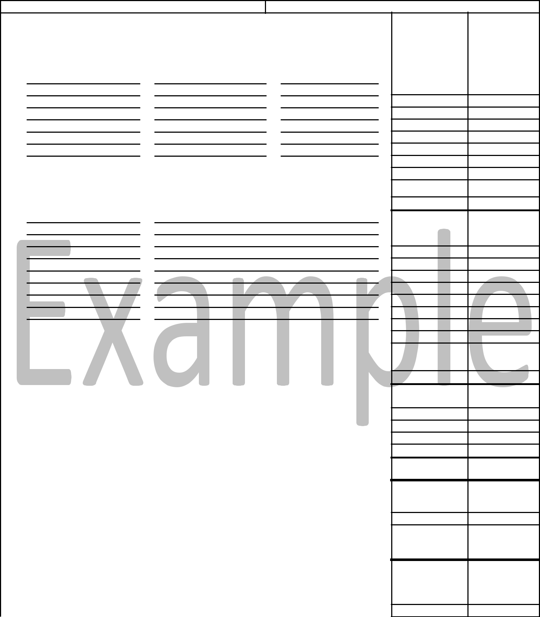

 | SECTION A. COST ESTIMATES |  |  |  | (cont.) |  |  | BORROWER'S | RUS USE ONLY
 |  |  |  |  |  |  |  | COST ESTIMATES
900 b. New Substation, Switching Station, etc.
 |  | Station Designation |  |  | kVA |  | kV TO kV

901

902

903

904

905

906

907

908

Subtotal From Page 3A . . . . . . . . . . . . . . . . . . . . . . . .

Subtotal . . . . . . . . . . . . . . . . . . . . . . . . . . . . . . . . . . . .

1000 c. Line and Station Changes

Line/Station Designation Description of Changes

1001

1002

1003

1004

1005

1006

1007

1008

1009

 |  |  |  | Subtotal From page 3A through 3C . . . |  |  | ...............
 |  |  |  | Subtotal . . . . . . . . . . . . . . . . . . . . . . . . |  |  | .................
1100 d. Other Transmission Items
1101 | (1) |  | R/W Procurement
1102 | (2) |  | Engineering Fees
1103 | (3)
1103 | (3) |  | Reimbursement of General Funds (see schedule)
1104 | (4)
 |  |  |  | Subtotal . . . . . . . . . . . . . . . . . . . . . . . . |  |  | ........
 |  |  |  |  | TOTAL TRANSMISSION. . . . . . . . . . . .
1200 3. |  | GENERATION (including Step-up Station at Plant)
1201 | a Fuel |  |  |  | Nameplate Rating |  |  | kW
1202 | b.

TOTALGENERATION..............

1300 4. HEADQUARTERS FACILITIES

1301 a. New or additional Facilities (Attach RUS Form 740g)

1302 b.

TOTAL HEADQUARTERS FACILITIES . . . . . . . . . . . . . . . .

RUS Form 740c (Rev. 10-01, V2, 2/5/04)


PAGE 3 OF 4 PAGES


  COST ESTIMATE AND LOAN BUDGET FOR ELECTRIC BORROWERS | BORROWER AND LOAN DESIGNATION

SECTION A. COST ESTIMATES (Page 3 Continuation Sheet) | BORROWER'S | RUS USE ONLY
 | COST ESTIMATES

- b. New Substation, Switching Station, etc.(Continued)

 | Station Designation |  | kVA |  | kV TO kV
909
910
911
912
913
914
915
916
917
918 |  |  | Subtotal (transfers to page 3)
 |  |  |  |  | ....................
1000
1000 | c. Line and Station Changes(Continued)
 | Line/Station Designation |  | Description of Changes
1010
1011
1012
1013
1014
1015
1016
1017
1018
1019
1020
1021
1022
1023
1024
1025
1026
1027
1028
1029
1030
1031
1032
1033
1034
1035
1036
1037
1038
1039
1040
1041
1042
1043
1044
1045
1046
1047
1048
1049
1050
1051
1052
 |  |  | . . . . . . . . . . . . . . . . .Subtotal(transferstopage3) |  |  | ....
 | RUS Form 740c | (Rev. 10-01, V2, 2/5/04) |  |  |  |  | Page 3A of 4

  COST ESTIMATE AND LOAN BUDGET FOR ELECTRIC BORROWERS | BORROWER AND LOAN DESIGNATION

 | SECTION A. COST ESTIMATES (Page 3 Continuation Sheet |  |  |  | BORROWER'S | RUS USE ONLY
 |  |  |  |  | COST ESTIMATES
1000 | c. Line and Station Changes(Continued)
 | Line/Station Designation |  |  | Description of Change
1053

1054

1055

1056

1057

1058

1059

1060

1061

1062

1063

1064

1065

1066

1067

1068

1069

1070

1071

1072

1073

1074

1075

1076

1077

1078

1079

1080

1081

1082

1083

1084

1085

1086

1087

1088

1089

1090

1091

1092

1093

1094

1095

1096

1097

1098

1099

1000.1

1000.2

1000.3

1000.4

1000.5

1000.5

1000.7

1000.8

1000.9

1001.1

1001.2

1001.3

1001.4

1001.5

1001.6

1001.7

Subtotal (transfers to page 3). . . . . . . . . . . . . . . . . . . . .

RUS Form 740c (Rev. 10-01, V2, 2/5/04) Page 3B of 4
COST ESTIMATE AND LOAN BUDGET FOR ELECTRIC BORROWERS | BORROWER AND LOAN DESIGNATION

 | SECTION A. COST ESTIMATES (Page 3 Continuation Sheet |  |  |  | BORROWER'S | RUS USE ONLY
 |  |  |  |  | COST ESTIMATES
1000 | c. Line and Station Changes(Continued)
 | Line/Station Designation |  |  | Description of Change
1001.8

1001.9

1002.1

1002.2

1002.3

1002.4

1002.5

1002.6

1002.7

1002.8

1002.9

1003.1

1003.2

1003.3

1003.4

1003.5

1003.6

1003.7

1003.8

1003.9

1004.1

1004.2

1004.5

1004.6

1004.7

1004.8

1004.9

1005.1

1005.2

1005.3

1005.4

1005.6

1005.7

1005.8

1005.9

1006.1

1006.2

1006.3

1006.4

1006.5

1006.6

1006.7

1006.8

1006.9

1007.1

1007.2

1007.3

1007.4

1007.5

1007.6

1007.7

1007.8

1007.9

1008.1

1008.2

1008.3

1008.4

1008.5

1008.6

1008.7

1008.8

1008.9

1009.1

Subtotal (transfers to page 3). . . . . . . . . . . . . . . . . . . . .

RUS Form 740c (Rev. 10-01, V2, 2/5/04) Page 3C of 4

COST ESTIMATE AND LOAN BUDGET FOR ELECTRIC BORROWER
BORROWER AND LOAN DESIGNATIO
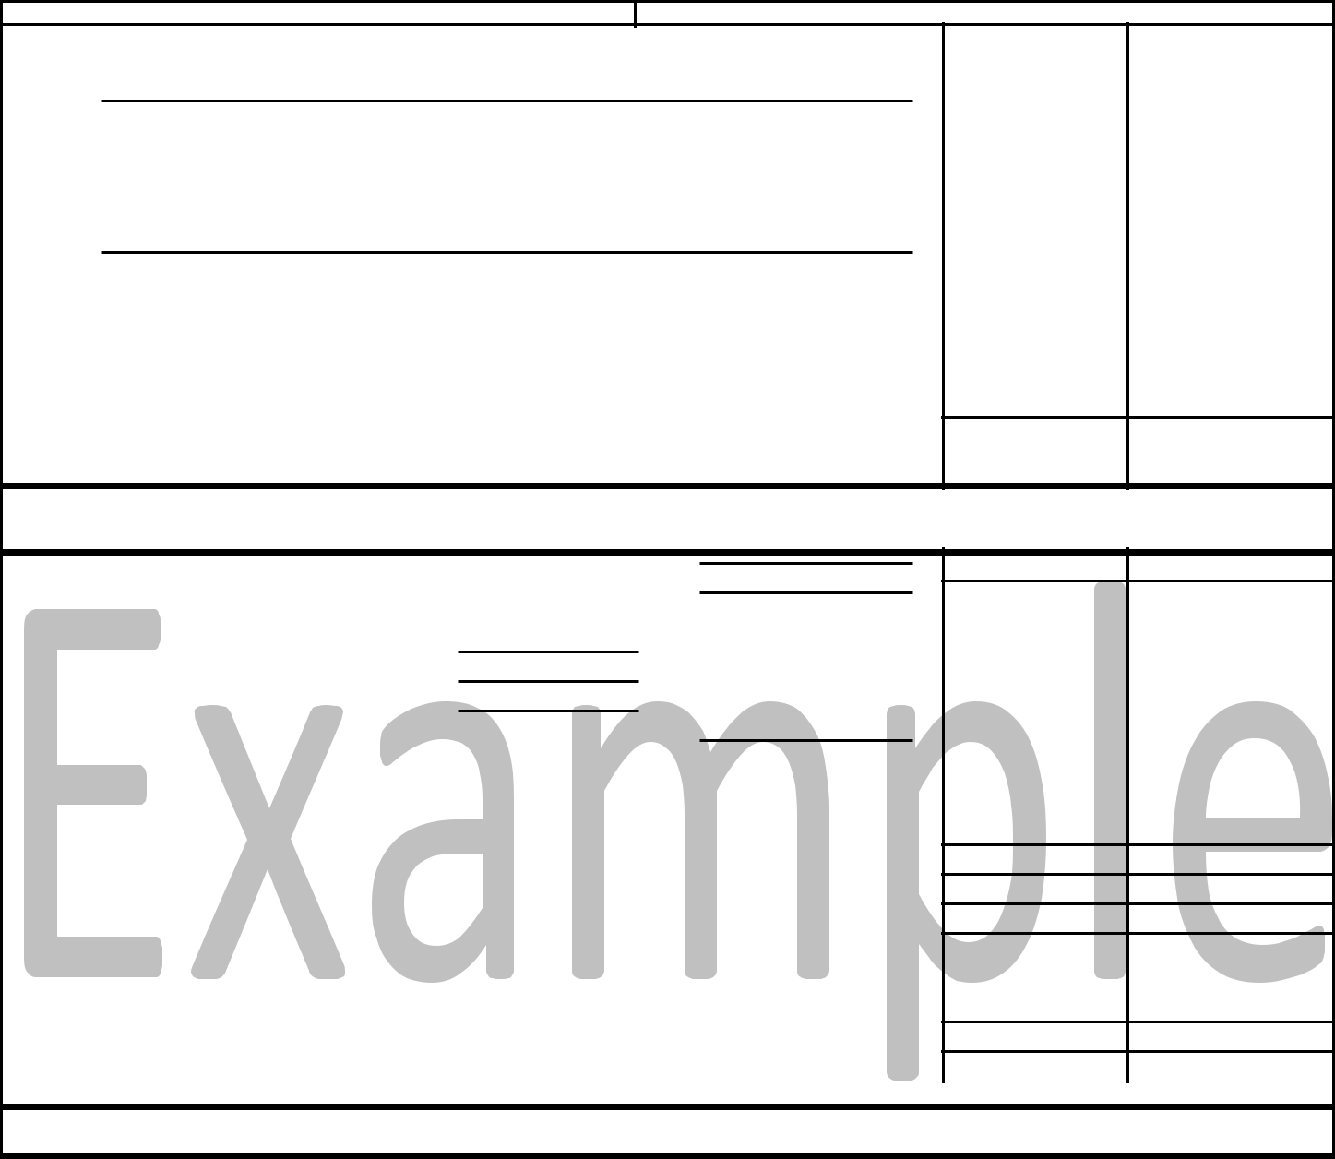

 | SECTION A. COST ESTIMATES |  |  | (cont.) |  |  |  | BORROWER'S | RUS USE ONLY
 |  |  |  |  |  |  |  | COST ESTIMATES
1400 | 5. | ACQUISITIONS
1401 | a. |  | Consumers |  | Miles
1402 | b.
 |  |  |  |  | TOTAL ACQUISITIONS. . . . . . . .
1500 | 6. | ALL OTHER
1501 | a.
1502 | b.
1503 | c.
1504 | d.
1505 | e.

TOTALALLOTHER...........

SECTION B. SUMMARY OF AMOUNTS AND SOURCES OF FINANCING

1.GRANDTOTAL-ALLCOSTS............................................

2. FUNDS AND MATERIALS AVAILABLE FOR FACILITIES

a. Loan Funds . . . . . . . . . . . . | ........... | ...................
b. Materials and Special Equipment . . . . . |  | ....................
c. General Funds . . . . . . . . . | Purpose 1 | $1,715,615

Purpose 2

$78,995

Purpose 3

Purpose 4

 | Total General Funds Applied . . . . . . . . . . . . . . . . |  | .$1,794,610 .
d. Total Available Funds and Materials . . . . . . . . . . . . . . . . . . . . . . . . . . . . . . . . . . . . .
3. NEW FINANCING REQUESTED FOR FACILITIES . . . . . . . . |  |  | ....................
4. RUS LOAN REQUESTED FOR FACILITIES. . . . . . . . . . . . . |  |  | ................100 |  | %
5. TOTAL SUPPLEMENTAL LOAN REQUESTED . . . . . . . . . |  |  | ................ |  |  | %
 | National Rural Utilities Cooperative Finance Corporation
 | Name of Supplemental Lender
6. CAPITAL TERM CERTIFICATE PURCHASES (CFC Loan only) . . . . . . . . . . . . |  |  |  |  | %
7. SUPPLEMENTAL LOAN REQUESTED FOR FACILITIES. . . . . . . . . . . . . . . . . . . . . . . . . |  |  |  |  | %
* Identify in section A by budget purpose and separate subtotals.

SECTION C. CERTIFICATION


We, the undersigned, certify that:

- Upon completion of the electrical facilities contained herein and any others uncompleted at this time but for which financing is available, the system will be capable of adequately and dependably serving the projected load for the loan period as contained in our current RUS approved Power Requirement Study and Construction Work Plan.

- Negotiations have been or will be initiated with our power supplier, where necessary, to obtain new delivery points and/or additional capacity at existing ones to adequately supply the projected load upon which this loan application is based.

- The data contained herein and all supporting documents have, to the best of my knowledge, been prepared correctly and in accordance with 7 CFR 1710.401(a)(3)

7/15/11___________________________
Date Signature of Borrower's Manager

7/15/11
Date | Signature of Borrower's President
 | Bruster Lee
 | XYZ Power & Light
 | Corporate Name of Borrower
 | GFR Initials

RUS Form 740c (Rev. 10-01, V2, 2/5/04)

PAGE 4 OF 4 PAGES

Attachment to 740c

Borrower and Loan Designation

STATEMENT

Statement certifying that at least 90% of the Loan funds are for facilities with a useful life of 33 years or longer as required by 7 CFR 1710.115.

To facilitate the determination of the final maturity for this RUS Loan,


does hereby certify that:


At least 90% of the Loan funds requested as part of this loan application and included on the RUS Form 740c (Cost Estimates and Loan Budget for Electric Borrowers) are for facilities with an anticipated useful life


of 33 years or longer.

Less than 90% of the Loan funds requested as part of this loan application and included on the RUS Form 740c (Cost Estimates and Loan Budget for Electric Borrowers) are for facilities with an anticipated useful life of 33 years or longer. A schedule has been attached to this statement listing the facilities with an anticipated useful life of less than 33 years, the anticipated useful life of those facilities and the associated cost estimates (see attached).

Date Title:

Useful Life Certification

INSTRUCTIONS FOR PREPARATION OF RUS FORM 740c (See 7 CFR 1710, Subpart I, for Additional Information)

If additional space is required for any item, attach continuation sheets as needed.

Prepare an original and one copy of this form for submission to RUS as part of the loan application.

Insert the borrower and loan designation, the date used for preparation of cost estimates, and the number of years the application is to cover.

SECTION A. COST ESTIMATES

The borrower should insert cost estimates only in the column titled "Borrower's Cost Estimates." RUS will complete the column headed "RUS Use Only" when the borrower's cost estimate varies from RUS's.

Estimates should be obtained from a current construction Work Plan which is in agreement with an approved long-range engineering study.

All estimates shown hereon should include material, labor and overhead costs, less any contributions in aid of construction (i.e., NET COST).

Where reimbursement of general funds for completed construction is requested, insert the amount under the appropriate budget purpose. On a separate sheet, itemize and describe the general fund expenditures to be reimbursed, showing applicable budget purpose and amount per item.


- DISTRIBUTION:

  - NEW LINE:

Insert number of consumers, number of miles, and total estimated cost including R/W clearing. (Estimates for underground and overhead construction should be shown separately.) Do not duplicate costs shown separately in items 1.f. and 1.g. Indicate the number of total new consumers to be served and total of new miles to be constructed. (Miles of secondary, services and underbuild should be included in the pole line miles shown.)

  - NEW TIE-LINES:

Show location by map reference and substation designation, line voltage (kV), conductor size and phasing, miles and estimated cost of each new tie-line. Also show whether the construction is overhead or underground. If there is insufficient space to itemize each tie-line, insert the

total miles and estimated cost and give a description of each tie-line on an attached sheet.

  - CONVERSION AND LINE CHANGES:

Show location by map reference and substation designation, indicate old and new conductor size and phasing, miles, and estimated cost. Also show whether the construction is overhead or under-ground. If there is insufficient space to itemize each conversion and line change, insert the

total estimated cost and give a detailed description of each conversion and line change on an attached sheet.

  - NEW SUBSTATIONS, SWITCHING STATIONS, METERING POINTS, ETC.:

For each new station, insert the station designation shown in the Construction Work Plan, the kVA rating, high and low side voltage classification, and estimated cost. (If procurement of station sites is to be financed with loan funds, the cost should be included in the estimate for the station.)

e. SUBSTATION, SWITCHING STATION AND METERING POINT CHANGES:

Identify each station by the designation shown in the Construction Work Plan and describe the changes to be made and the estimated cost.

- MISCELLANEOUS DISTRIBUTION EQUIPMENT:

  - Show the number and the total estimated installed cost of all transformers and meters used to serve new and existing consumers in this loan. Furnish separate estimates for under-ground and overhead construction.

  - Insert the number of sets of service wires and estimated cost in this loan application to increase the capacity of existing consumers.

  - - (5)

Insert the estimated cost of new sectionalizing equipment, line voltage regulators and capacitors.

- Insert the net cost of ordinary replacements (installed cost of new facility less original cost of facility being replaced).

- - (10)
Use these lines to show the estimated cost of other distribution equipment not listed above.


- OTHER DISTRIBUTION ITEMS:

  - Insert estimated cost of engineering fees (include details in the Construction Work Plan). Only those engineering costs associated with distribution facilities and not included in the cost estimates for items 1.a. through 1.f. should be included (i.e., long-range plans, sectionalizing studies, etc.).

  - Insert the estimated cost of security lights.

  - and (4)

Use these lines to show purpose, type, and estimated cost of other distribution items not listed above.

TOTAL DISTRIBUTION: Enter the sum of subtotals 1.a. through 1.g. above.

- TRANSMISSION: a. NEW LINE:

For each new line, insert the line designation (i.e., Westover to Shady Grove) as shown in the Construction Work Plan, line voltage (kV), wire size, miles, and total estimated cost including R/W clearing.
- NEW SUBSTATIONS, SWITCHING STATIONS, ETC.:

For each new station, insert the station designation as shown in the Construction Work Plan, kVA rating, high and low side voltage classification, and estimated cost. (New stations under this item should not be mistaken for new stations under Item 1 - Distribution. Any station not used for distribution purposes shall be considered a transmission station, except for the generating plant step-up substation which should be shown under Item 3.) If procurement of station sites

is to be financed with loan funds, this cost should be included in the estimate for the station.

- LINE AND STATION CHANGES:

For each conversion or line change, insert the line or station designation as shown in the Construction Work Plan, a description of changes, and the total estimated cost.

- OTHER TRANSMISSION ITEMS:

  - Insert all cost anticipated for the purchase, and/or procurement of transmission line right-of-way except attorney fees and clearing, which should be shown under Items 6 and 2.a., respectively.

  - Insert the estimated cost of engineering fees (including details in the Construction Work Plan). Only those engineering costs associated with transmission projects, and not already included in the line and station cost estimates of item 2.a., b. and c., should be shown (i.e., environmental reports, system studies, etc.).

  - - (6)

Use these lines to show purpose, type, and estimated cost of transmission items not listed above (i.e., transmission-related communications or control equipment, etc.).

TOTAL TRANSMISSION: Enter the sum of subtotals 2.a through 2.d. above.

- GENERATION (Including step-up station at plant):

  - Insert the kind of fuel to be used in the plant, the nameplate rating (kW), and the total esti-mated cost. (A detailed breakdown of each proposed generation project should be attached to this form, indicating the various items for which financing is requested. This breakdown should be in the form of, or supported by, an engineer's report.)

  - Use this line to show the estimated cost of generating facilities not included above.

TOTAL GENERATION: Enter the sum of items 3.a. and 3.b. above.

- HEADQUARTERS FACILITIES

  - NEW OR ADDITIONAL FACILITIES:

Insert total estimated cost. Complete and attach an original and one copy of RUS Form 740g for each project. (See instructions on reverse of RUS form 740g.)

  - Use this line to show the estimated cost of headquarters facilities not included above. TOTAL HEADQUARTERS FACILITIES: Enter the total of items 4.a. and 4.b. above.

- ACQUISITIONS:

  - Insert the number of consumers, miles or line to be acquired, and the total cost of the proposed acquisition. On a separate sheet, itemize: (1) the approximate purchase price of the acquisition; (Give breakdown and apportioned purchase price of distribution, transmission and/or generating plant facilities.) (2) a description and estimated costs of rehabilitation and integration;

(3) Engineering fees.
- Use this line to show the kinds and estimated cost of facilities to be acquired not included above.
TOTAL ACQUISITIONS: Enter the total of items 5.a. and 5.b. above.

- ALL OTHER: a. - e.

These lines are to be used for costs not listed above, such as legal fees, general plant equip-ment, etc. (Funds for general plant equipment generally will only be approved in initial loans.) All requests for funds under this budget purpose should be accompanied by a breakdown and justification for the requested funds.

TOTAL ALL OTHER: Enter the sum of items 6.a. through 6.d. above. SECTION B. SUMMARY OF AMOUNTS AND SOURCES OF FINANCING

Note: Items 1 and 3 below may require adjustment before entering in final form (see "ADJUSTMENT" below).

All other items may be entered in final form.

- GRAND TOTAL - ALL COSTS:

Insert the total of Budget Purposes 1 through 6 above.

- FUNDS AND MATERIALS AVAILABLE FOR FACILITIES:

  - LOAN FUNDS:

Insert the total amount of funds available from prior loans, as of the "Cut-Off" date, which are not required for original loan purposes. Attach RUS Form 602 and an explanation if necessary.

  - MATERIALS AND SPECIAL EQUIPMENT:

Insert the dollar value of materials and special equipment on hand which will be used for the proposed construction. Attach information identifying, by budget purpose, the kinds of materials or special equipment being applied to this loan and their dollar value. Do not include materials and special equipment needed for normal operation of the system.

  - GENERAL FUNDS:

Insert the total amount of general funds available for construction of the facilities listed

(i.e., general funds now available plus general funds to become available during the loan period.) For existing general funds, attach a statement indicating the need for any adjusted general funds in excess of RUS guidelines which will not be used for the proposed

construction (attach RUS Form 740a).

  - TOTAL AVAILABLE FUNDS FOR FACILITIES:

Insert the total of Items 2.a., b. and c. of this section and enter as Item 2.d.

- NEW FINANCING REQUESTED FOR FACILITIES: Subtract Item 2.d. from Item 1 and enter as Item 3.

- RUS LOAN REQUESTED FOR FACILITIES:

Insert the percentage of plant financing to be obtained from RUS (see 7 CFR 1710.110). Multiply Item 3 by the decimal equivalent of this percentage; round to the nearest thousand and enter as Item 4.

- TOTAL SUPPLEMENTAL LOAN REQUESTED:

Insert the percentage of plant financing to be obtained from a supplemental lender and the lender's corporate name. Multiply Item 3 by the decimal equivalent of this percentage and round to the nearest thousand.

Note: Where CFC is the supplemental lender, the result of the above calculation should be divided by 0.95 before rounding to the nearest thousand.

- CAPITAL TERM CERTIFICATE PURCHASES (CFC LOANS ONLY):

Multiply Item 5 by 0.05 and enter as Item 6. For loans made by supplemental lenders other than CFC, enter zero.

- SUPPLEMENTAL LOAN REQUESTED FOR FACILITIES: Subtract Item 6 from Item 5 and enter as Item 7.
ADJUSTMENT: After the above calculations have been completed, adjust Item 3 such that it equals Item 4
plus Item 7. Next adjust Item 1 and a cost estimate in Section A such that Item 2 plus Item 3 equals Item 1.

SECTION C. CERTIFICATION

Manager and board president must sign and date form (original and one copy). Insert borrower's corporate name.

