Date

 | PANEL LOAD CALCULATION AND SCHEDULE
Manufacturer's Serial Number |  | Panel
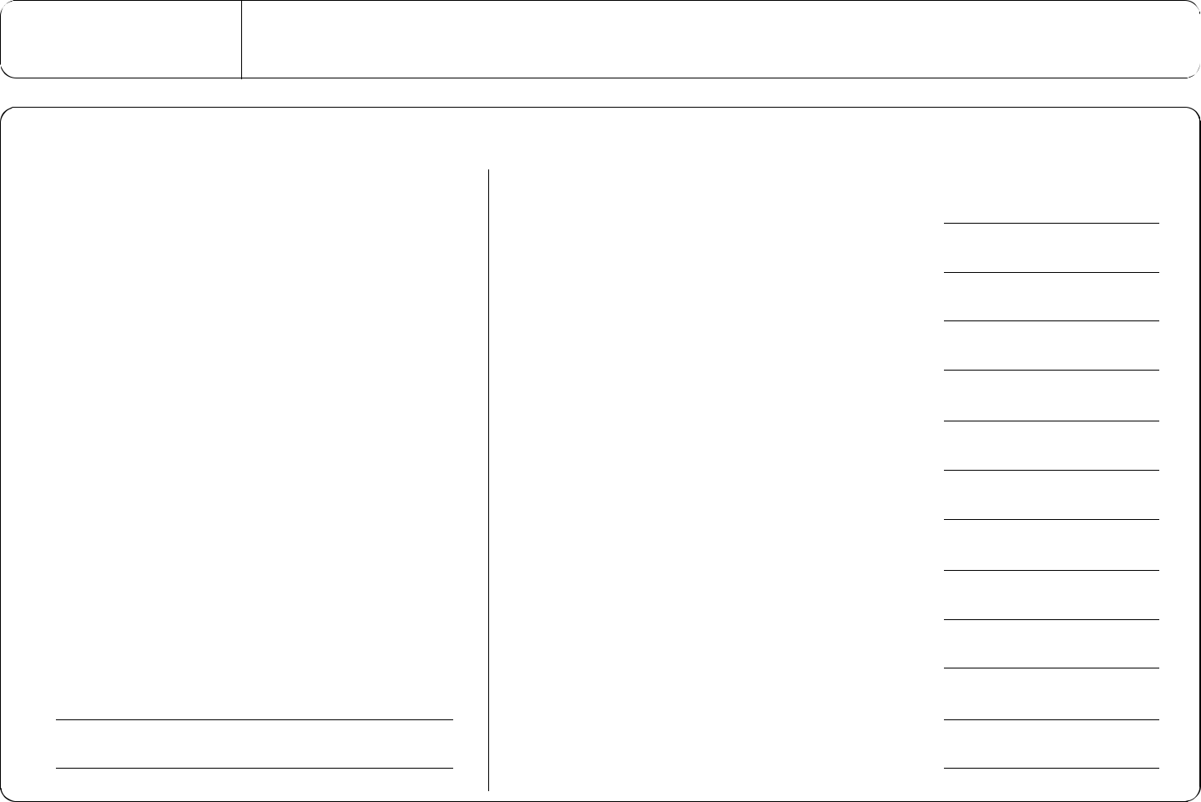

Load Type | Connected | Demand | Demand
Load Type | Load | Factor | Load

Lighting

Gen use receptacles <10 KVA

Gen use receptacles > 10 KVA

Motors & compressors

(Largest)

Computer receptacles

Mechanical & HVAC

Kitchen equipment

Miscellaneous

Miscellaneous

 |  | X 125% | =
 |  | X 100% | =
 |  | X 50% | =
 |  | X 100% | =
( | ) | X 25% | =
 |  | X 100% | =
 |  | X 100% | =
 |  | X ____% | =
 |  | X 100% | =
 |  | X_____% | =
 |  | X_____% | =
 |  | X_____% | =
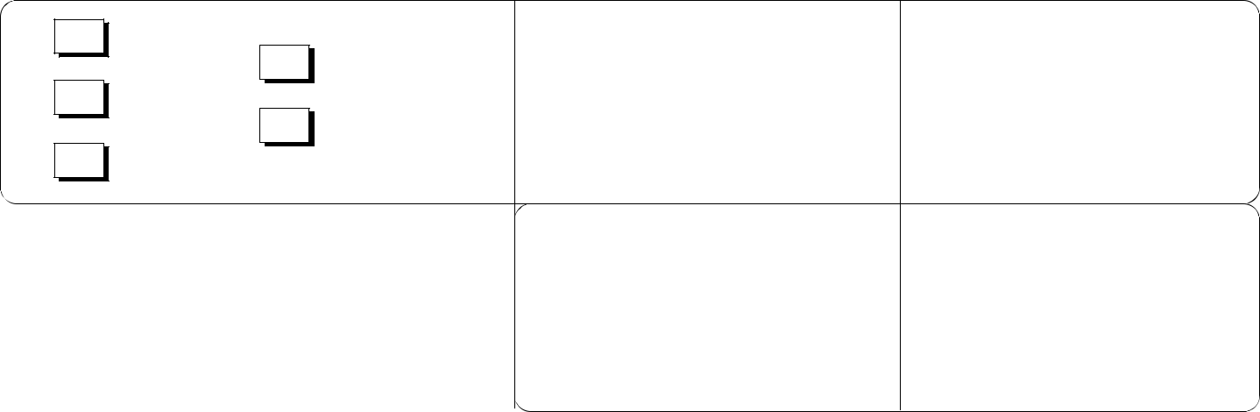

240/120

208/120

480/277

Definitions:

Connected load

Single phase

Three phase

Connected load

Connected amps

Demand load

Demand amps

- The nameplate rating of all appliances that are fastened in place, permanently connected to located to be on specific circuit. (Water heaters, space heaters, ranges, refrigerators, etc.)
- 180 VA for each general use receptacle
- Maximum VA of lighting fixtures
- Full load amps/KVA of all motors from Table 430-147, 148, 149 and 150 of the National Electric Code

Demand calculated load -

The connected load after any code required adjustment factor has been applied. Load calculations shall be submitted/expressed in KVA and converted to amps when sizing feeders and equipment.

F623-017-000 panel load calculation 8-98 (page 1 of 5)

. | 200A | . | SPARE
 | 200A | 3P
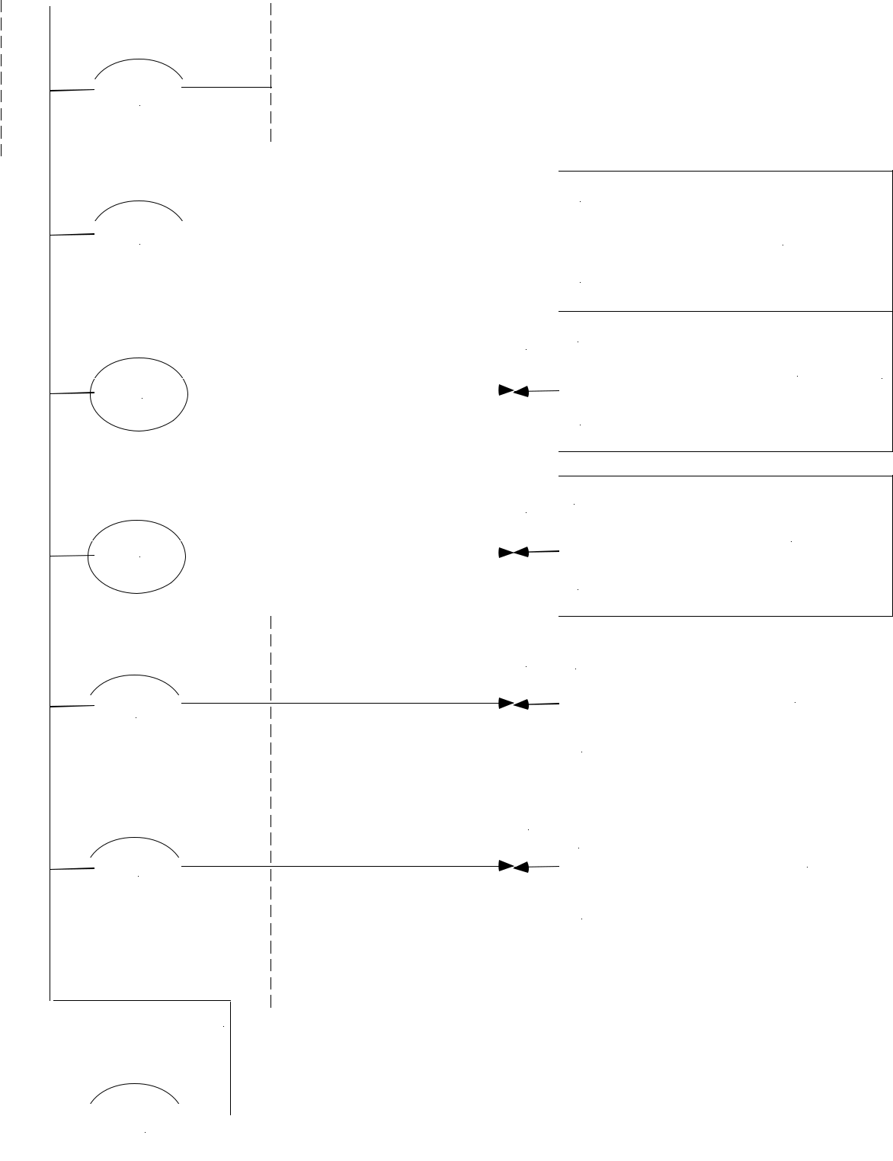

208/120V, 3 PHASE

 | . | 200A | 3P | . |  |  |  |  | SPARE |  |  |  |  | MLO
 |  |  |  |  |  |  |  |  | SPARE | <10000A |  |  |  | 400ABUS
 |  |  |  |  |  |  |  |  | (2) 2" GALV RIGID STEEL |  |  | SYM |  | MLO
 |  |  |  |  |  |  |  |  | OR (1) 3" GALV RIGID STEEL
 |  | 400A | 3P |  |  |  |  |  | OR (1) 3" GALV RIGID STEEL
 | . | 400A | 3P | . |  |  |  |  | 2 SETS (4) 3/0 THHN CU & #3 CU GND |  |  |  |  | 400ABUS
 |  |  |  |  |  |  |  |  |  | <10000A
 |  | 100A | 3P |  |  |  |  |  |  |  |  | SYM |  | 100ABUS
 |  |  |  |  |  |  |  |  | (1) 2" GALV RIGID STEEL |  |  |  |  | MLO
 | . |  |  | . |  |  |  |  | (1) 2" GALV RIGID STEEL
 | . |  |  |  |  |  |  |  | (4) 3/0 THHN CU & #8 CU GND

PANELK | SEC.2
PANELK | SEC.1 | -THRU LUGS
 |  | FEED
PANELC

UTILITY TRANSFORMER |  |  |  |  |  |  |  |  | DISTRIBUTION PANEL (MKP), 1200A,
 |  |  |  |  |  |  |  |  | MAIN
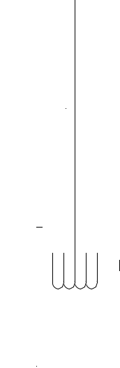

. | 200A | 3P | .
. | 200A | 3P | .

(1) 2" GALV RIGID STEEL

  - 3/0 THHN CU & #6 CU GND

- 2" GALV RIGID STEEL

  - 3/0 THHN CU & #6 CU GND

SYM <10000A

SYM <10000A

MLO |  | PANELB
225A | BUS
200AM.BKR |  | PANELA
225A | BUS

 |  | - (4) - 350 KCMIL CU |  |  |  | GALV RIGID STEEL |  |  |  |  |  |  | SERVICE POINT
 |  | SETS |  |  |  | (4) 3"
4

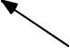

 |  |  |  |  |  |  |  |  |  |  |  |  |  |  |  |  |  |  |  |  |  |  |  |  |  |  |  |  |  |  |  |  |  | 1200ABUS
 |  |  |  |  |  |  |  |  |  |  |  |  | . |  |  |  |  |  | 1200A |  |  |  |  | .
 |  |  |  |  |  |  |  |  |  |  |  |  |  |  |  |  |  |  |  |  |  |  |  | 3P |  |  |  |  |  |  |  |  |  |  |  |  |  |  |  |  |  |  |  |  |  |  |  |  |  | x37650A
 | SECTION |  |  |  |  |  |  |  |  | )) |  |  |  |  |  |  |  |  |  |  |  |  |  |  |  |  |  |  |  |  |  |  |  |  |  |  |  |  |  |  |  |  |  |  |  |  |  |  |  | x37650A
 |  |  |  |  |  |  |  |  |  |  |  |  |  |  |  |  |  |  |  |  |  |  |  |  |  |  |  |  |  |  |  |  |  |  |  |  |  |  |  |  |  |  |  |  |  |  |  |  |  | SYM.
 | CT |  |  |  |  |  |  |  |  |  |  |  | M


SAMPLE
ONE - LINE

DIAGRAM

F623-017-000 sample one-line diagram 8-98 (page 2 of 5)

 | Panel
 |  |  |  |  |  |  |  |  |  |  |  |  |  |  |  |  |  |  |  | PANEL |  |  |  |  |  |  | Bus Rating |  |  | Single Phase |  |  | Voltage
 |  |  |  |  |  |  |  |  |  |  |  |  |  |  |  |  |  |  |  |  |  |  |  |  |  |  | ____________
 |  |  |  |  |  |  |  |  |  |  |  |  |  |  |  |  |  |  |  | SINGLE |  |  |  |  |  |  | ___________ |  |  |  | Iso, GND
 |  |  |  |  |  |  |  |  |  |  |  |  |  |  |  |  |  |  |  |  |  |  |  |  |  |  | Fed-thru lugs |  |  |  | Iso, GND
 | AIC |  |  |  | 10K |  |  | 14K |  |  | 18K |  |  | 22K |  |  | 25K |  |  |  |  |  |  |  |  |  |  |  |  |  | Iso, GND
 |  |  |  |  | 10K |  |  | 14K |  |  | 18K |  |  | 22K |  |  |  |  |  |  | PHASE
 |  |  |  |  | 42K |  |  | 65K |  |  | 100K |  |  | 150K |  |  | 200K |  |  |  |  |  |  |  |  |  | Double lugs
 |  |  |  |  | Circuit Description |  |  |  |  |  |  |  |  |  |  |  |  |  |  |  |  |  |  |  |  |  |  |  | Circuit Description
 |  |  |  |  |  |  |  |  |  |  |  |  |  |  |  |  |  |  |  |  | Bus |  | Code
 |  |  |  |  |  |  |  |  |  |  |  |  | Load (VA) |  |  | Code |  | Breaker |  |  | Bus | Breaker |  |  | Load (VA)
1 |  |  |  |  |  |  |  |  |  |  |  |  |  |  |  |  |  |  |  |  | A |  |  |  |  |  |  |  |  |  |  |  |  |  | 2
3 |  |  |  |  |  |  |  |  |  |  |  |  |  |  |  |  |  |  |  |  | B |  |  |  |  |  |  |  |  |  |  |  |  |  | 4
5 |  |  |  |  |  |  |  |  |  |  |  |  |  |  |  |  |  |  |  |  | A |  |  |  |  |  |  |  |  |  |  |  |  |  | 6
7 |  |  |  |  |  |  |  |  |  |  |  |  |  |  |  |  |  |  |  |  | B |  |  |  |  |  |  |  |  |  |  |  |  |  | 8
9 |  |  |  |  |  |  |  |  |  |  |  |  |  |  |  |  |  |  |  |  | A |  |  |  |  |  |  |  |  |  |  |  |  |  | 10
11 |  |  |  |  |  |  |  |  |  |  |  |  |  |  |  |  |  |  |  |  | B |  |  |  |  |  |  |  |  |  |  |  |  |  | 12
13 |  |  |  |  |  |  |  |  |  |  |  |  |  |  |  |  |  |  |  |  | A |  |  |  |  |  |  |  |  |  |  |  |  |  | 14
15 |  |  |  |  |  |  |  |  |  |  |  |  |  |  |  |  |  |  |  |  | B |  |  |  |  |  |  |  |  |  |  |  |  |  | 16
17 |  |  |  |  |  |  |  |  |  |  |  |  |  |  |  |  |  |  |  |  | A |  |  |  |  |  |  |  |  |  |  |  |  |  | 18
19 |  |  |  |  |  |  |  |  |  |  |  |  |  |  |  |  |  |  |  |  | B |  |  |  |  |  |  |  |  |  |  |  |  |  | 20
21 |  |  |  |  |  |  |  |  |  |  |  |  |  |  |  |  |  |  |  |  | A |  |  |  |  |  |  |  |  |  |  |  |  |  | 22
23 |  |  |  |  |  |  |  |  |  |  |  |  |  |  |  |  |  |  |  |  | B |  |  |  |  |  |  |  |  |  |  |  |  |  | 24
25 |  |  |  |  |  |  |  |  |  |  |  |  |  |  |  |  |  |  |  |  | A |  |  |  |  |  |  |  |  |  |  |  |  |  | 26
27 |  |  |  |  |  |  |  |  |  |  |  |  |  |  |  |  |  |  |  |  | B |  |  |  |  |  |  |  |  |  |  |  |  |  | 28
29 |  |  |  |  |  |  |  |  |  |  |  |  |  |  |  |  |  |  |  |  | A |  |  |  |  |  |  |  |  |  |  |  |  |  | 30
31 |  |  |  |  |  |  |  |  |  |  |  |  |  |  |  |  |  |  |  |  | B |  |  |  |  |  |  |  |  |  |  |  |  |  | 32
33 |  |  |  |  |  |  |  |  |  |  |  |  |  |  |  |  |  |  |  |  | A |  |  |  |  |  |  |  |  |  |  |  |  |  | 34
35 |  |  |  |  |  |  |  |  |  |  |  |  |  |  |  |  |  |  |  |  | B |  |  |  |  |  |  |  |  |  |  |  |  |  | 36
37 |  |  |  |  |  |  |  |  |  |  |  |  |  |  |  |  |  |  |  |  | A |  |  |  |  |  |  |  |  |  |  |  |  |  | 38
39 |  |  |  |  |  |  |  |  |  |  |  |  |  |  |  |  |  |  |  |  | B |  |  |  |  |  |  |  |  |  |  |  |  |  | 40
41 |  |  |  |  |  |  |  |  |  |  |  |  |  |  |  |  |  |  |  |  | A |  |  |  |  |  |  |  |  |  |  |  |  |  | 42
 | Code description |  |  |  |  |  | L = Lighting loads |  |  |  |  |  |  | M = Total |  |  |  | motor load |  |  |  |  |  | S = Dedicated receptacles |  |  |  |  | K = Kitchen equipment
 |  |  |  |  |  |  | R = General use receptacles |  |  |  |  |  |  | LM = Largest single motor |  |  |  |  |  |  |  |  |  | H = HVAC |  |  |  |  | Z = Miscellaneous or appliances
 | F623-017-000 |  |  | single phase panel |  |  | 8-98 (pg 3 of 5)


Fed

form

Location

SCHEDULE

Main Main

^{lugs} breaker

only

A A

3 4
- -
wire wire

208/120 240/120

 | Panel
 |  |  |  |  |  |  |  |  |  |  |  |  |  |  |  |  |  |  |  |  | PANEL |  |  |  |  |  |  | Bus Rating |  |  | Single Phase |  |  | Voltage
 |  |  |  |  |  |  |  |  |  |  |  |  |  |  |  |  |  |  |  |  |  |  |  |  |  |  |  | ____________
 |  |  |  |  |  |  |  |  |  |  |  |  |  |  |  |  |  |  |  |  | THREE |  |  |  |  |  |  | ___________ |  |  |  | Iso, GND |  | 208/120
 |  |  |  |  |  |  |  |  |  |  |  |  |  |  |  |  |  |  |  |  |  |  |  |  |  |  |  | Fed-thru lugs |  |  |  | Iso, GND
 | AIC |  |  |  | 10K |  |  | 14K |  |  | 18K |  |  |  | 22K |  |  | 25K |  |  |  |  |  |  |  |  |  |  |  |  |  | Iso, GND
 |  |  |  |  | 10K |  |  | 14K |  |  | 18K |  |  |  | 22K |  |  |  |  |  |  | PHASE
 |  |  |  |  | 42K |  |  | 65K |  |  | 100K |  |  |  | 150K |  |  | 200K |  |  |  |  |  |  |  |  |  | Double lugs
 |  |  |  |  | Circuit Description |  |  |  |  |  |  |  |  |  |  |  |  |  |  |  |  |  |  |  |  |  |  |  |  | Circuit Description
 |  |  |  |  |  |  |  |  |  |  |  |  |  |  |  |  |  |  |  |  |  | Bus |  | Code
 |  |  |  |  |  |  |  |  |  |  |  |  |  | Load (VA) |  |  | Code |  | Breaker |  |  | Bus | Breaker |  |  | Load (VA)
1 |  |  |  |  |  |  |  |  |  |  |  |  |  |  |  |  |  |  |  |  |  | A |  |  |  |  |  |  |  |  |  |  |  |  |  | 2
3 |  |  |  |  |  |  |  |  |  |  |  |  |  |  |  |  |  |  |  |  |  | B |  |  |  |  |  |  |  |  |  |  |  |  |  | 4
5 |  |  |  |  |  |  |  |  |  |  |  |  |  |  |  |  |  |  |  |  |  | A |  |  |  |  |  |  |  |  |  |  |  |  |  | 6
7 |  |  |  |  |  |  |  |  |  |  |  |  |  |  |  |  |  |  |  |  |  | B |  |  |  |  |  |  |  |  |  |  |  |  |  | 8
9 |  |  |  |  |  |  |  |  |  |  |  |  |  |  |  |  |  |  |  |  |  | A |  |  |  |  |  |  |  |  |  |  |  |  |  | 10
11 |  |  |  |  |  |  |  |  |  |  |  |  |  |  |  |  |  |  |  |  |  | B |  |  |  |  |  |  |  |  |  |  |  |  |  | 12
13 |  |  |  |  |  |  |  |  |  |  |  |  |  |  |  |  |  |  |  |  |  | A |  |  |  |  |  |  |  |  |  |  |  |  |  | 14
15 |  |  |  |  |  |  |  |  |  |  |  |  |  |  |  |  |  |  |  |  |  | B |  |  |  |  |  |  |  |  |  |  |  |  |  | 16
17 |  |  |  |  |  |  |  |  |  |  |  |  |  |  |  |  |  |  |  |  |  | A |  |  |  |  |  |  |  |  |  |  |  |  |  | 18
19 |  |  |  |  |  |  |  |  |  |  |  |  |  |  |  |  |  |  |  |  |  | B |  |  |  |  |  |  |  |  |  |  |  |  |  | 20
21 |  |  |  |  |  |  |  |  |  |  |  |  |  |  |  |  |  |  |  |  |  | A |  |  |  |  |  |  |  |  |  |  |  |  |  | 22
23 |  |  |  |  |  |  |  |  |  |  |  |  |  |  |  |  |  |  |  |  |  | B |  |  |  |  |  |  |  |  |  |  |  |  |  | 24
25 |  |  |  |  |  |  |  |  |  |  |  |  |  |  |  |  |  |  |  |  |  | A |  |  |  |  |  |  |  |  |  |  |  |  |  | 26
27 |  |  |  |  |  |  |  |  |  |  |  |  |  |  |  |  |  |  |  |  |  | B |  |  |  |  |  |  |  |  |  |  |  |  |  | 28
29 |  |  |  |  |  |  |  |  |  |  |  |  |  |  |  |  |  |  |  |  |  | A |  |  |  |  |  |  |  |  |  |  |  |  |  | 30
31 |  |  |  |  |  |  |  |  |  |  |  |  |  |  |  |  |  |  |  |  |  | B |  |  |  |  |  |  |  |  |  |  |  |  |  | 32
33 |  |  |  |  |  |  |  |  |  |  |  |  |  |  |  |  |  |  |  |  |  | A |  |  |  |  |  |  |  |  |  |  |  |  |  | 34
35 |  |  |  |  |  |  |  |  |  |  |  |  |  |  |  |  |  |  |  |  |  | B |  |  |  |  |  |  |  |  |  |  |  |  |  | 36
37 |  |  |  |  |  |  |  |  |  |  |  |  |  |  |  |  |  |  |  |  |  | A |  |  |  |  |  |  |  |  |  |  |  |  |  | 38
39 |  |  |  |  |  |  |  |  |  |  |  |  |  |  |  |  |  |  |  |  |  | B |  |  |  |  |  |  |  |  |  |  |  |  |  | 40
41 |  |  |  |  |  |  |  |  |  |  |  |  |  |  |  |  |  |  |  |  |  | A |  |  |  |  |  |  |  |  |  |  |  |  |  | 42
 |  |  |  |  |  |  |  | L = Lighting loads
 | Code description |  |  |  |  |  |  |  |  |  |  |  |  |  | M = Total |  |  |  | motor load |  |  |  |  |  |  |  | S = Dedicated receptacles |  |  |  | K = Kitchen equipment
 |  |  |  |  |  |  |  | R = General use receptacles |  |  |  |  |  |  | LM = Largest single motor |  |  |  |  |  |  |  |  |  |  |  | H = HVAC |  |  |  | Z = Miscellaneous or appliances
 | F623-017-00 0three |  |  |  | phase panel |  | 8-98 (pg 4 of 5)


Fed

form

Location

SCHEDULE

Main Main

^{lugs} breaker

only

A A

3 4
- -
wire wire

240/120 480/277

Please check the items submitted
 |  |  |  |  |  |  |  |  |  |  | Applicant: Fill out completely
For Postal Delivery |  |  |  |  |  |  |  |  | Manufacturer |  | 1 |  | Mfg No. |  | 2
Department of Labor and Industries |  |  |  |  |  |  |  |  |  |  | 1 |  |  |  | 2
Factory Assembled Structures
 |  |  |  |  |  |  |  |  | Plans to be returned to: Address
PO Box 44430 |  |  |  | FB
Olympia WA 98504-4430 |  |  |  | FB |  | 3
 |  |  |  | CCF CH 11 |  | 3
 |  |  |  |  |  | 3 |  |  | City/State/ZIP
For Non-Postal Delivery (e.g., FedX, UPS) |  |  |  | WA Only |  | 3
 |  |  |  | WA Rev/ORCourtesy
Department of Labor and Industries
 |  |  |  | OR Rev/WA Courtesy |  |  |  |  | FOR DEPARTMENT USE ONLY
Factory Assembled Structures
 |  |  |  | _______ Other state |  |  |  |  | Fee Ledger Sheet |  |  |  |  | Application ID
7273 Linderson Way SW |  |  |  | State ID | reciprocity
Tumwater WA 98501 |  |  |  | State ID |  |  | #
www.wa.gov/lni (case sensitive)
 |  |  |  |  |  |  |  |  | Ap No. |  |  | Date approved |  | Expiration date
ELECTRICAL PLAN APPROVAL REQUEST
FACTORY BUILT STRUCTURES & COMMERCIAL COACHES |  |  |  |  |  |  |  |  |  |  |  | $
 |  | 4
 | Contact person's printed name: |  |  |  |  |  |  |  |  | Date |  |  | Fee enclosed
 | Signature |  |  |  |  |  | Phone No |  |  |  |  | FAX No
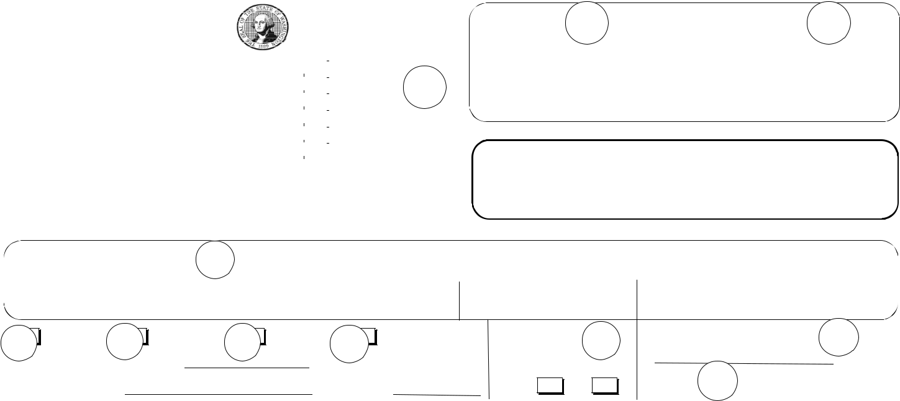

5 | New plan 6 | Addendum | 7 | Renewal | 8 | Resubmittal | Electrical servic: |  | 9 |  | Occupancey Group: |  |  | 10
 |  |  |  |  |  |  |  |  |  |  |  | / | / | 10
 | Plan Approval No |  |  | Building |  |  | Amps |  |  |  |  | / | /
 |  |  |  |  |  |  |  |  |  |  |  | 11
 | Serial No. |  |  | Area Sq. Ft |  |  | Phase | 1 |  | 3 | Use: | 11
Installation location |  |  |  | City |  |  | State | ZIP+4 |  |  | County
 | 13
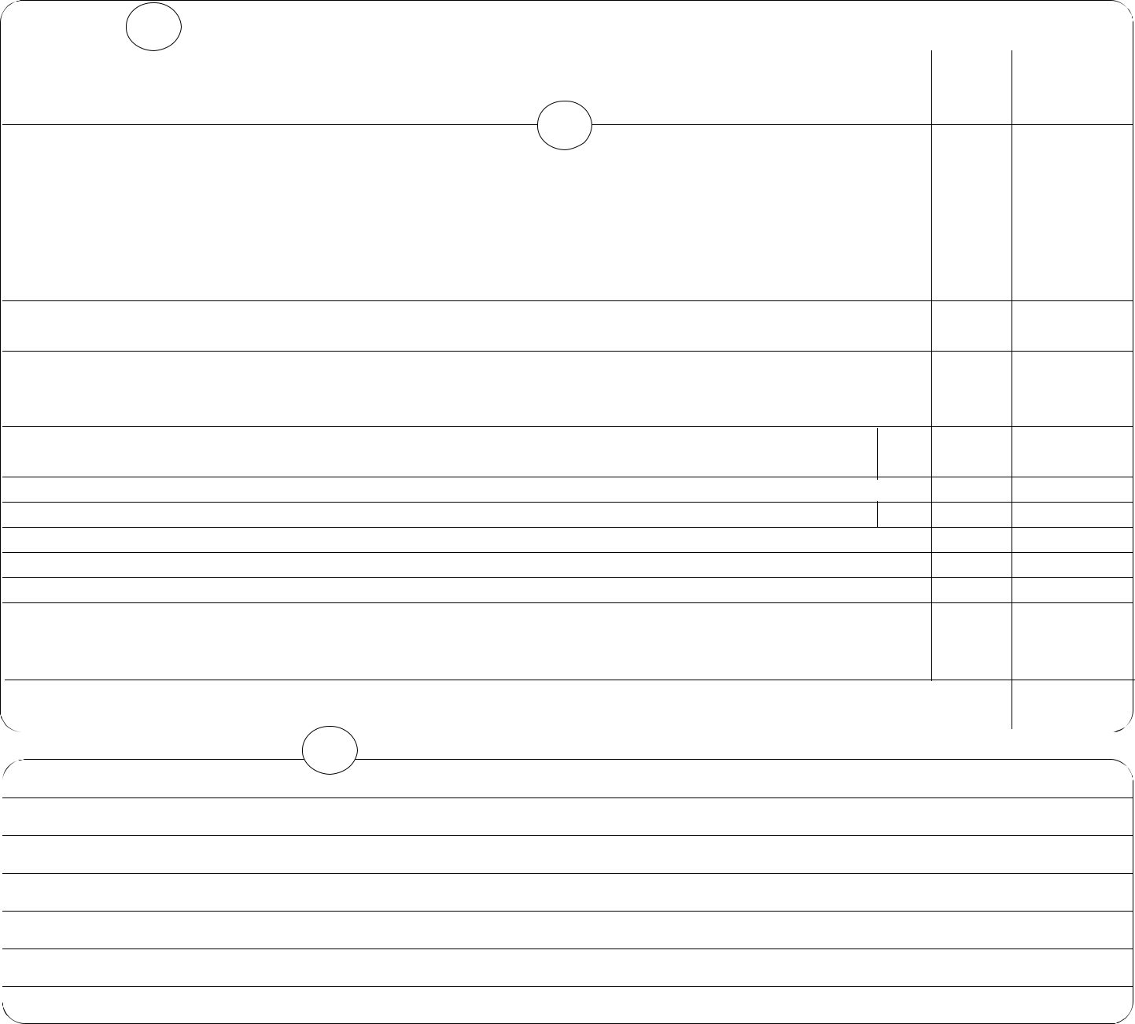
 | ELECTRICAL PLAN REVIEW (When required by WAC 296-46-140, Plan review for educational, |  |  |  |  |  | Unit |  |  | Unit |  |  |  | Total
 | institutional or health care facilities and other buildings. See WAC 296-150 C/F-3000 for fee schedule) |  |  |  |  |  |  |  |  |  | Amount |  |  |  | Amount
 | Electrical plan submission fee
 | Service/Feeder ampacity: Each design option is addtional.14
 | 0-100
 | 101 | - 200
 | 201 | - 400
 | 401 | - 600
 | 601 | - 800 | f623-016-000 sample
 | 801 | - 1000 | see
 | Over 1000 |  | see
 | Over 600 volts surcharge |  | instructions
 |  |  | on reverse
 | Thermostats: |  | side
 | First
 | Each additional

Low voltage fire alarm and burglar alarm:

Each control panel and up to four circuits or zones

Each additional circuit or zone

Generators, refer to appropriate service/feeder ampacity fees

Note: Altered services or feeders shall be charged to the fee schedule rate per the service/feeder ampacity fees

Supplemental submission of plans (resubmittal, addendums, renewals, code upda tes, etc.) shall be
charged per hour or fraction of an hour |  | On
Attached | Attached/Design | On |  |  | $
Attached | Attached/Design | On | Total Fees Paid |  | $
L&I Review | Professional Review | file |  |  | $

14

- Electical floor plans, related drawings - minimum of two complete sets required. Number of sheets:

- One line/riser diagram:

    - Specifications:

    - Load calculations:

  - Fault calculations:

  - Metered demand records:

    - Panel schedules:

F623-017-000 sample elect plan approval request 8-98

