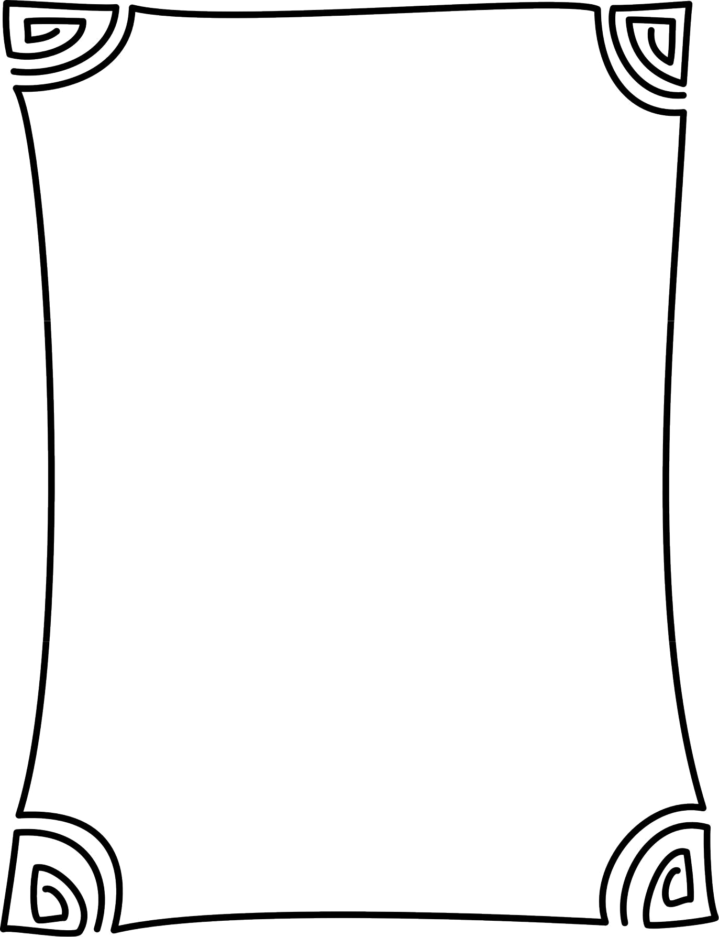

NEWSPAPER

PROJECT

Novel Response

Name ________________________

Copyright © 2014 Brain Waves Instruction Permission to copy for classroom use only.
Copying for more than one teacher or classroom is prohibited without one paid license per teacher.
Creating a Newspaper
You are going to create a newspaper based on a novel you’ve read. Your

newspaper will have six articles and will look similar to the example below. Carefully following the step-by-step instructions will help you create a product that reflects your understanding of the novel and one that you are proud to share.
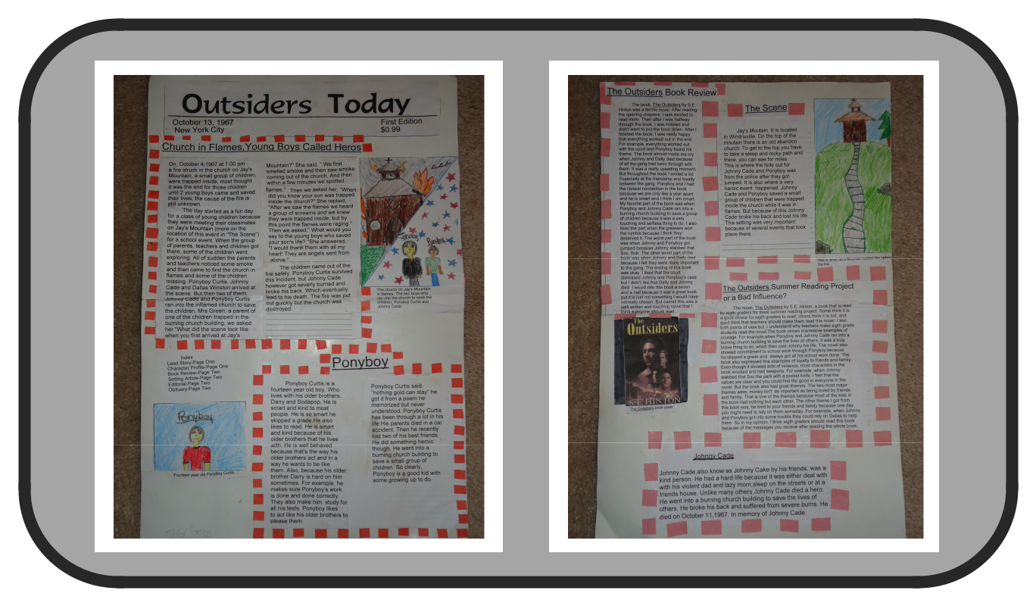

- Read a novel. You may want to take notes on the main characters, plot, and setting as you read. This information will help you write about your reading without the frustration of flipping back and forth in the book trying to find information.

- Complete the rough draft worksheets. These worksheets are not graded.

- Have an adult proofread your rough drafts. The adult is not helping you with the content of your writing, adding information to your writing, or taking out information from your writing. He or she is helping you correct spelling, grammar, and punctuation errors.

- Create a final copy. Neatly transfer your rough draft writing to the final copy resources to assemble the newspaper for a grade.

- Assemble the newspaper following the specified format for a grade.

- Review the grading rubric at the end of this packet. You may use the rubric as a checklist to help you earn your best possible grade.

Copyright © 2014 Brain Waves Instruction Permission to copy for classroom use only.
Copying for more than one teacher or classroom is prohibited without one paid license per teacher.

A
READ THE NOVEL &

COMPLETE THE PRE-WRITE WORKSHEETS

- Thoroughly complete all the pre-write worksheets for each article.

- These pre-write worksheets will guide you in writing your newspaper articles.

- Using your pre-write worksheets as a guide, write the rough draft for each article.

- Ask an adult to review your rough drafts for spelling, grammar, and punctuation errors. The adult is not helping you write the content of your rough drafts or final articles. He or she is helping you proofread your rough drafts so that your final articles reflect your best work!

Frequently Asked Questions

What if I run out of room on my final copy?

Continue your response on a separate sheet of paper. Place the additional sheet of paper behind your final copy paper.

While it is acceptable to write more information than you are prompted for, this should not take away from the overall neat and clean impression of your newspaper.

What if I need additional final copy resources?

You may use your own paper; however, please be sure your paper is the same size as the final copy resources provided to you.

What if I am just plain confused?

- Complete as much as you can.
- Use your model to assemble the newspaper.
- Do your best.

Copyright © 2014 Brain Waves Instruction Permission to copy for classroom use only.
Copying for more than one teacher or classroom is prohibited without one paid license per teacher.
Lead Story (Planning)
On the front page of your newspaper, write a lead story that gives details about one key event from your novel.
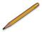

Choose one key event from the novel -- this event will serve as the lead story:

___________________________________________________________________________

Create an interesting headline for the article (you may change this later):

___________________________________________________________________________

List everyone involved in your news story: ____________________________ ____________________________ ____________________________ ____________________________

____________________________ ____________________________ ____________________________ ____________________________

Where did this event happen?

___________________________________________________________________________

Describe the scene where the event took place:

___________________________________________________________________________

___________________________________________________________________________

___________________________________________________________________________

When did this event take place?

Date: _________________________

Time: _____________________

What happened? Make this information very detailed.

- _________________________________________________________________________

- _________________________________________________________________________

- _________________________________________________________________________

- _________________________________________________________________________

- _________________________________________________________________________

Copyright © 2014 Brain Waves Instruction Permission to copy for classroom use only.
Copying for more than one teacher or classroom is prohibited without one paid license per teacher.

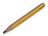
Why did this event happen?

___________________________________________________________________________

___________________________________________________________________________

How was the conflict or issue resolved?

___________________________________________________________________________

___________________________________________________________________________

Who will you interview (a character from the book) about this story? What questions will you ask? How would the character answer the questions?

I will interview: ______________________________________________________________

The questions I will ask the character I am interviewing:

Question: ___________________________________________________________________

Answer: ____________________________________________________________________

Question: __________________________________________________________________

Answer: ____________________________________________________________________

Question: __________________________________________________________________

Answer: ____________________________________________________________________

LEAD (Summarize the information from above):

Who: ______________________________________________________________________

What happened: _____________________________________________________________

When: _____________________________________________________________________

Where: ____________________________________________________________________

Why: ______________________________________________________________________

Combine the answers to each of the lead questions above into one sentence. This sentence will serve as the first sentence in the opening paragraph of your article:
___________________________________________________________________________

___________________________________________________________________________

___________________________________________________________________________

Copyright © 2014 Brain Waves Instruction Permission to copy for classroom use only.
Copying for more than one teacher or classroom is prohibited without one paid license per teacher.
Lead Story (Rough Draft)
Write the rough draft of your lead story below.

The space provided is equivalent to the space allotted on the final copy.
Your final copy can either be handwritten or typed.


Structure of News Article

Headline ⇨ captures the reader’s attention (first line)

First Paragraph ⇨ Includes the lead sentence that hooks the readers or captures their attention
Middle Paragraphs ⇨ Detailed information on who, what, when, where, and why Last Paragraph ⇨ How the conflict or issue was resolved

If you type your article, remember to create columns.


______________________________________ ______________________________________ ______________________________________ ______________________________________ ______________________________________ ______________________________________ ______________________________________ ______________________________________ ______________________________________ ______________________________________ ______________________________________ ______________________________________ ______________________________________ ______________________________________ ______________________________________ ______________________________________ ______________________________________ ______________________________________ ______________________________________ ______________________________________ ______________________________________ ______________________________________ ______________________________________ ______________________________________ ______________________________________ ______________________________________ ______________________________________ ______________________________________ ______________________________________ ______________________________________ ______________________________________

_______________________________________ _______________________________________ _______________________________________ _______________________________________ _______________________________________ _______________________________________ _______________________________________ _______________________________________ _______________________________________ _______________________________________ _______________________________________ _______________________________________ _______________________________________ _______________________________________ _______________________________________ _______________________________________ _______________________________________ _______________________________________ _______________________________________ _______________________________________ _______________________________________ _______________________________________ _______________________________________ _______________________________________ _______________________________________ _______________________________________ _______________________________________ _______________________________________ _______________________________________ _______________________________________ _______________________________________

Review the spelling, grammar, and punctuation of your first draft. Transfer your review to the final copy paper provided to you. Paste the final copy in the space designated on your newspaper template.

Copyright © 2014 Brain Waves Instruction Permission to copy for classroom use only.
Copying for more than one teacher or classroom is prohibited without one paid license per teacher.

Character Profile Article (Planning)

_____

Choose one character to write about: ______________________________________

Describe this character. Use information and details from the story:

___________________________________________________________________________

___________________________________________________________________________

___________________________________________________________________________

___________________________________________________________________________

___________________________________________________________________________

___________________________________________________________________________

___________________________________________________________________________

___________________________________________________________________________

___________________________________________________________________________

What has this character done that is significant?

__________________________________________________________________________

___________________________________________________________________________

___________________________________________________________________________

___________________________________________________________________________

___________________________________________________________________________

___________________________________________________________________________

___________________________________________________________________________

___________________________________________________________________________

___________________________________________________________________________

Copyright © 2014 Brain Waves Instruction Permission to copy for classroom use only.
Copying for more than one teacher or classroom is prohibited without one paid license per teacher.
Write one significant or meaningful quote from this character. Include this quote (in

quotation marks) in your article: _________________________________________________

___________________________________________________________________________

___________________________________________________________________________

___________________________________________________________________________

Why does this character act the way (s)he does?

___________________________________________________________________________

___________________________________________________________________________

___________________________________________________________________________

___________________________________________________________________________

___________________________________________________________________________

___________________________________________________________________________

___________________________________________________________________________

If you could interview this character, what questions would you ask? How do you imagine (s)he would answer your questions?

  - ________________________________________________________________

  - ________________________________________________________________

________________________________________________________________

- ________________________________________________________________

- ________________________________________________________________

________________________________________________________________

- ________________________________________________________________

A: ________________________________________________________________

________________________________________________________________

Copyright © 2014 Brain Waves Instruction Permission to copy for classroom use only.
Copying for more than one teacher or classroom is prohibited without one paid license per teacher.
Character Profile (Rough Draft)

Write the rough draft of your character profile article below.

The space provided is equivalent to the space allotted on the final copy.

If you prefer to type your final copy, ensure that it fits in the space provided.

Don’t forget to include a headline.


___________________________________________________________________________

______________________________________ ______________________________________ ______________________________________ ______________________________________ ______________________________________ ______________________________________ ______________________________________ ______________________________________ ______________________________________ ______________________________________ ______________________________________ ______________________________________ ______________________________________ ______________________________________ ______________________________________ ______________________________________ ______________________________________ ______________________________________ ______________________________________ ______________________________________ ______________________________________ ______________________________________ ______________________________________ ______________________________________

_______________________________________ _______________________________________ _______________________________________ _______________________________________ _______________________________________ _______________________________________ _______________________________________ _______________________________________ _______________________________________ _______________________________________ _______________________________________ _______________________________________ _______________________________________ _______________________________________ _______________________________________ _______________________________________ _______________________________________ _______________________________________ _______________________________________ _______________________________________ _______________________________________ _______________________________________ _______________________________________ _______________________________________

Review the spelling, grammar, and punctuation of your first draft. Transfer your review to the final copy paper provided to you. Paste the final copy in the space designated on your newspaper template.

Copyright © 2014 Brain Waves Instruction Permission to copy for classroom use only.
Copying for more than one teacher or classroom is prohibited without one paid license per teacher.

Book Review (Planning)
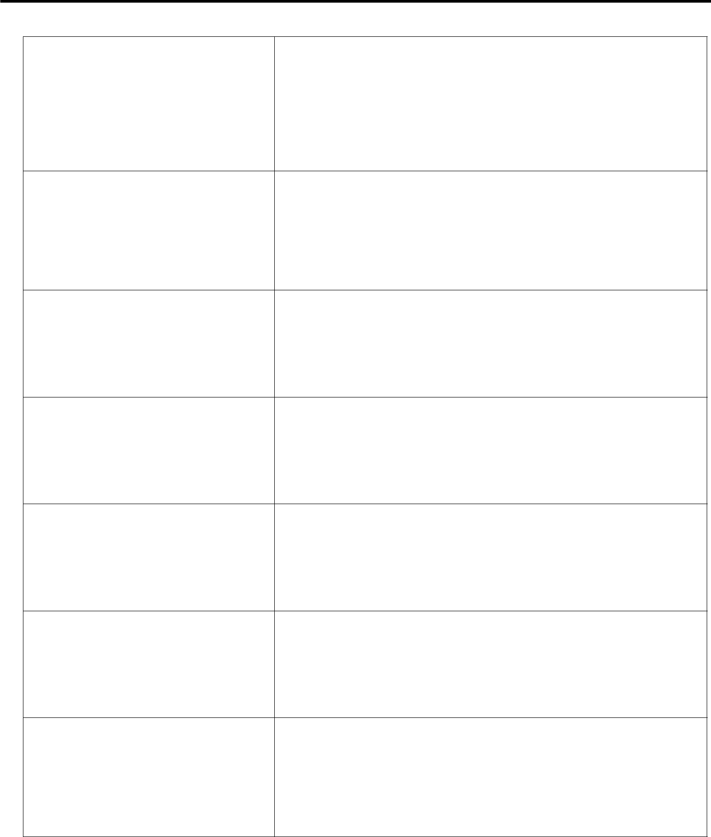

FEELINGS

What were your feelings after

reading the opening chapter(s) of
this book? After reading half the

book? After finishing the book?

REACTIONS
Did the book make you laugh? Cry?
Smile? Cheer? Think? Wonder?

Explain your reactions.

CONNECTIONS
Explain connections between the
book and your own life.

BEST PARTS
What were the best parts of the

story? Why?

WORST PARTS
What were the worst parts of the

story? Why?

ENDING
Do you like the way the book

ended? Why or why not?

RATING
Rate the book between 1 and 10

(10 being the highest or best
possible rating.) Explain your

rating.

Copyright © 2014 Brain Waves Instruction Permission to copy for classroom use only.
Copying for more than one teacher or classroom is prohibited without one paid license per teacher.

Book Review
(Rough Draft)

Combine your answers to the book review questions to create one well-developed paragraph.

The space provided is equivalent to the space allotted on the final copy.

If you prefer to type your final copy, ensure that it fits in the space provided.

Don’t forget to include a headline.


Review the spelling,

grammar, and

punctuation of your first

draft.

Transfer your review to

the final copy paper
provided to you.

Glue the final copy in

the space designated
on your newspaper

template.

___________________________________________


___________________________________________

___________________________________________

___________________________________________

___________________________________________

___________________________________________

___________________________________________

___________________________________________

___________________________________________

___________________________________________

___________________________________________

___________________________________________

___________________________________________

___________________________________________

___________________________________________

___________________________________________

___________________________________________

___________________________________________

___________________________________________

___________________________________________

___________________________________________

___________________________________________

___________________________________________

___________________________________________

___________________________________________

___________________________________________

___________________________________________

___________________________________________

___________________________________________

Copyright © 2014 Brain Waves Instruction Permission to copy for classroom use only.
Copying for more than one teacher or classroom is prohibited without one paid license per teacher.

Setting Profile Article (Planning)
Write a mini-article about one setting from the novel.

Refer to the setting graphic organizer for ideas.
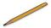

Pick one setting from the novel:

___________________________________________________________________________

List descriptive details explaining the setting:

__________________________________________________________________________

__________________________________________________________________________

__________________________________________________________________________
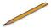

Why is this setting important in the context of the novel?

__________________________________________________________________________

__________________________________________________________________________

__________________________________________________________________________

When does this setting occur in the novel?

__________________________________________________________________________

__________________________________________________________________________

__________________________________________________________________________

How or why is the setting significant to the time period of the story?

__________________________________________________________________________

__________________________________________________________________________

__________________________________________________________________________
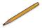

Write an interesting, eye-catching headline for an article about the setting:

__________________________________________________________________________

Copyright © 2014 Brain Waves Instruction Permission to copy for classroom use only.
Copying for more than one teacher or classroom is prohibited without one paid license per teacher.
Setting Profile Article (Rough Draft)

Write the rough draft of your setting profile article below.

Write the article from the perspective of a travel guide.

Explain to the reader what the place is, where it is, and why it is important.

The space provided is equivalent to the space allotted on the final copy.

If you prefer to type your final copy, ensure that it fits in the space provided.

Don’t forget to include a headline.

Setting Profile Article
Rough Draft


___________________________________________

___________________________________________

___________________________________________

___________________________________________

___________________________________________

___________________________________________

___________________________________________

___________________________________________

___________________________________________

___________________________________________

___________________________________________

___________________________________________

___________________________________________

___________________________________________

___________________________________________

___________________________________________

___________________________________________

___________________________________________

___________________________________________


Review the spelling, grammar, and punctuation of your first draft. Transfer your review to the final copy paper provided to you. Paste the final copy in the space designated on your newspaper template.

Copyright © 2014 Brain Waves Instruction Permission to copy for classroom use only.
Copying for more than one teacher or classroom is prohibited without one paid license per teacher.
Editorial (Planning)
An editorial is an article in a newspaper that expresses the opinion of its editors and/or publishers. You are going to write an editorial that expresses your opinion of the novel you read.

Think about:

- What message or advice did this novel portray? o Why did the author write this book?

- What have you learned about life from reading this book?

Using your answers to the above questions, write an editorial that clearly states your opinion on the following questions: Should this novel be required reading for Middle School students? Why or why not?

What are the advantages of reading this book?

__________________________________________________________________

__________________________________________________________________

__________________________________________________________________

What are the disadvantages of reading this book?

__________________________________________________________________

__________________________________________________________________

__________________________________________________________________

List and discuss the themes in this book:

__________________________________________________________________

__________________________________________________________________

__________________________________________________________________

__________________________________________________________________

__________________________________________________________________

__________________________________________________________________

Should this novel be required reading for Middle School students?

_____Yes _____No

Why or why not?

__________________________________________________________________

__________________________________________________________________

__________________________________________________________________

Compile all your answers to the above questions in a well-written editorial. Practice

Copyright © 2014 Brain Waves Instruction Permission to copy for classroom use only.
Copying for more than one teacher or classroom is prohibited without one paid license per teacher.
Editorial (Rough Draft)
Write the rough draft of your editorial below.

The space provided is equivalent to the space allotted on the final copy.

If you prefer to type your final copy, ensure that it fits in the space provided.

Don’t forget to include a headline.


__________________________________________________________________________________

__________________________________________________________________________________

__________________________________________________________________________________

__________________________________________________________________________________

__________________________________________________________________________________

__________________________________________________________________________________

__________________________________________________________________________________

__________________________________________________________________________________

__________________________________________________________________________________

__________________________________________________________________________________

__________________________________________________________________________________

__________________________________________________________________________________

__________________________________________________________________________________

__________________________________________________________________________________

__________________________________________________________________________________

__________________________________________________________________________________

__________________________________________________________________________________

__________________________________________________________________________________

__________________________________________________________________________________

__________________________________________________________________________________

__________________________________________________________________________________

__________________________________________________________________________________

Write your response on the rough draft on the following p


Review the spelling, grammar, and punctuation of your first draft. Transfer your review to the final copy paper provided to you. Paste the final copy in the space designated on your newspaper template.

Copyright © 2014 Brain Waves Instruction Permission to copy for classroom use only.
Copying for more than one teacher or classroom is prohibited without one paid license per teacher.
EXTRA! EXTRA! EXTRA! (Planning)
Choose one of the following features to add to your newspaper.

Complete the pre-write before beginning the final copy.

Only complete the pre-write for the one extra feature you have selected.

The one extra feature I am going to include in my newspaper is:

_____ Advice Column

_____ Comic

_____ Obituary
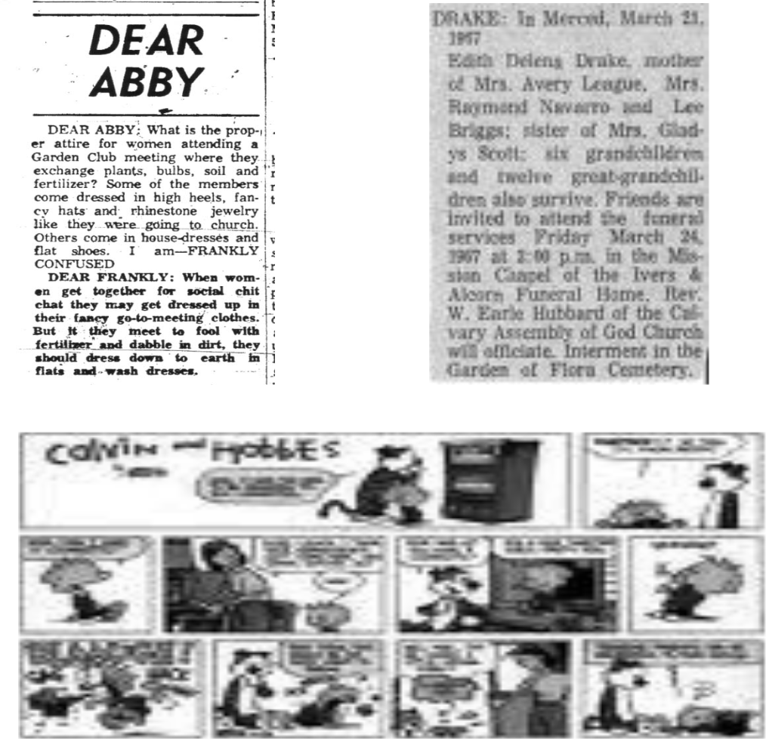

Copyright © 2014 Brain Waves Instruction Permission to copy for classroom use only.
Copying for more than one teacher or classroom is prohibited without one paid license per teacher.
Advice Column (Planning)
Imagine the main character in the novel wrote a letter to an advice columnist, seeking advice about a problem (s)he experienced in the book. Write a response to the character about how the problem could be solved.

PRE-WRITE



Review

the

spelling,
grammar,
and
punctuatio
n of your first draft.

Transfer

your

review to
the final
copy
paper
provided
to you.

Glue the

final copy
in the

space
designated

on your

Main Character: ________________________________________________________

Problem: _____________________________________________________________

Short letter to advice columnist explaining the problem:

_____________________________________________________________________

_____________________________________________________________________

_____________________________________________________________________

_____________________________________________________________________

Response from advice columnist:

_____________________________________________________________________

_____________________________________________________________________

_____________________________________________________________________

_____________________________________________________________________

_____________________________________________________________________

_____________________________________________________________________

Pre-write the advice column below, including the question and the answer:


_______________________________________________________________________________

_______________________________________________________________________________

_______________________________________________________________________________

_______________________________________________________________________________

_______________________________________________________________________________

_______________________________________________________________________________

_______________________________________________________________________________

_______________________________________________________________________________

_______________________________________________________________________________

_______________________________________________________________________________

_______________________________________________________________________________

_______________________________________________________________________________

_______________________________________________________________________________

_______________________________________________________________________________

_______________________________________________________________________________

Copyright © 2014 Brain Waves Instruction Permission to copy for classroom use only.
Copying for more than one teacher or classroom is prohibited without one paid license per teacher.

Comic (Planning)
Design a four-panel comic strip illustrating something funny that happened in the story.

Create a title for the comic.

Include dialogue bubbles for the characters.

Comic strips should be completely colored – no pencil/pen drawings.


PRE-WRITE

Event to illustrate: ______________________________________________________

Title of comic strip: ______________________________________________________

Characters included in the comic strip: ______________________________________

Setting of the comic strip: _________________________________________________

The dialogue bubbles are going to say:

Bubble 1: _______________________________________________________________

Bubble 2: _______________________________________________________________

Bubble 3: _______________________________________________________________

Bubble 4: _______________________________________________________________

Sketch the comic in the boxes below:

aaaaaaaaaaaaaaaaa aaaaaaaaaaaaaaaaa aaaaaaaaaaaaaaaaa aaaaaaaaaaaaaaaaa
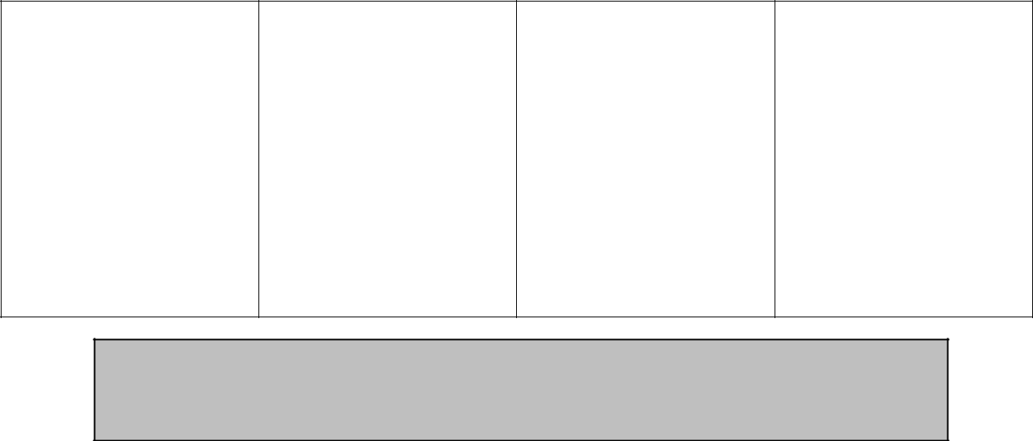

Review the spelling, grammar, and punctuation of your first draft.

Transfer your review to the final copy paper provided to you.

Paste the final copy in the space designated on your newspaper template.

Copyright © 2014 Brain Waves Instruction Permission to copy for classroom use only.
Copying for more than one teacher or classroom is prohibited without one paid license per teacher.

Obituary (Planning)
Write an obituary for someone who died in the story.

Summarize who s(he) was as a person and a bit about his/her life.


PRE-WRITE

Who died? _______________________________________ (This will be your title.)

When/how did (s)he die?

Who was (s)he? How did (s)he live his/her life?

__________________________________________________________________

__________________________________________________________________

__________________________________________________________________

__________________________________________________________________

Additional important and/or interesting information about him/her:

__________________________________________________________________

__________________________________________________________________

__________________________________________________________________

__________________________________________________________________

Pre-write the obituary below:

_______________________________________________________________________________

_______________________________________________________________________________

_______________________________________________________________________________

_______________________________________________________________________________

_______________________________________________________________________________

_______________________________________________________________________________

_______________________________________________________________________________

_______________________________________________________________________________

_______________________________________________________________________________

_______________________________________________________________________________

_______________________________________________________________________________

_______________________________________________________________________________

_______________________________________________________________________________

_______________________________________________________________________________

_______________________________________________________________________________


Review the spelling, grammar, and punctuation of your first draft.

Transfer your review to the final copy paper provided to you.

Paste the final copy in the space designated on your newspaper template.

Copyright © 2014 Brain Waves Instruction Permission to copy for classroom use only.
Copying for more than one teacher or classroom is prohibited without one paid license per teacher.

Newspaper Pictures
Include pictures to correspond with each news article.

Note: You will not include a picture for the book review or the special feature.

All illustrations and pictures must be in color and must fit in the boxes below.

You may draw pictures by hand or cut out pictures from a magazine or newspaper.

Cut out the boxes provided for each article and glue them to the final copy of your

newspaper.


LEAD STORY


CHARACTER PROFILE

Copyright © 2014 Brain Waves Instruction Permission to copy for classroom use only.
Copying for more than one teacher or classroom is prohibited without one paid license per teacher.

SETTING ARTICLE


EDITORIAL


Copyright © 2014 Brain Waves Instruction Permission to copy for classroom use only.
Copying for more than one teacher or classroom is prohibited without one paid license per teacher.
Newspaper Masthead
The masthead is the title block or logo identifying the newspaper at the top of the front page. Sometimes an emblem or a motto is also placed within the masthead.

Sample:
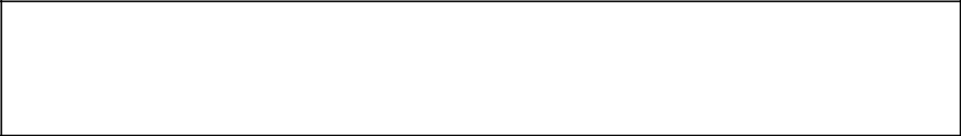
 | Newspaper Title
Date published | Edition
Location published | Price

Think about the novel’s setting and content for inspiration and create a title for

your newspaper:

______________________________________________________

Considering the content of the novel, on what date is your newspaper being

____________________________________________________________________

Considering the content of the novel, where is your newspaper being published?

____________________________________________________________________

What edition is this newspaper (ex: First Edition; Sunday Edition; Volume

III, etc._? ___________________________________________________________

Considering the setting of the novel, how much does your paper cost?

___________

Create a masthead design below, including all of the above information:
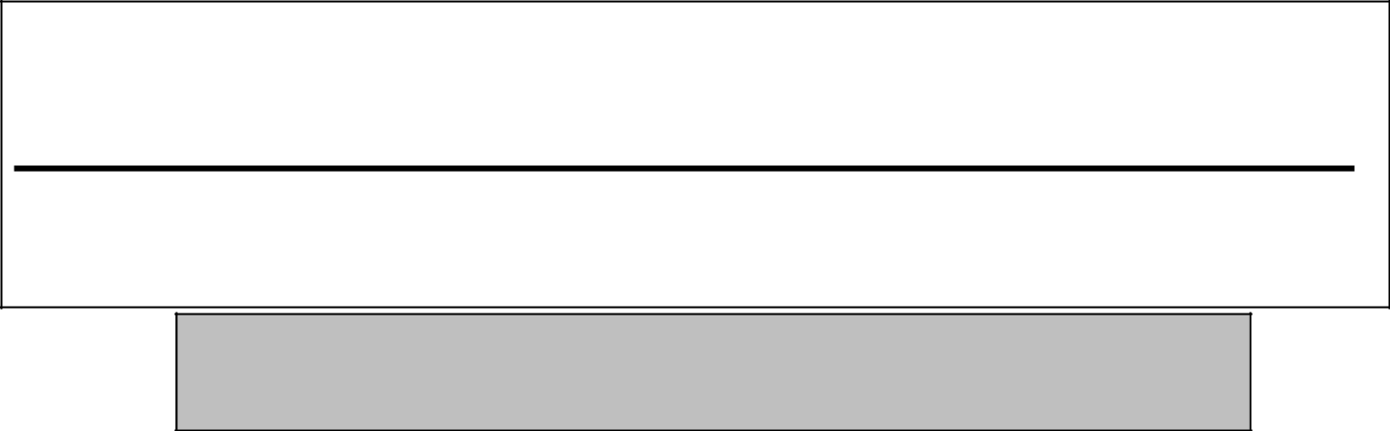

Review the spelling, grammar, and punctuation.

Transfer your review to the final copy paper provided to you.
Paste the final copy in the space designated on your newspaper template.
Copyright © 2014 Brain Waves Instruction | Permission to copy for classroom use only.
Copying for more than one teacher or classroom is prohibited without one paid license per teacher.
B
WRITE FINAL COPIES

- Review the spelling, grammar and punctuation of your pre-writes.

- Transfer your pre-writes to the following final copy papers.

- Glue the final copy of each article to the space designated on the newspaper template.
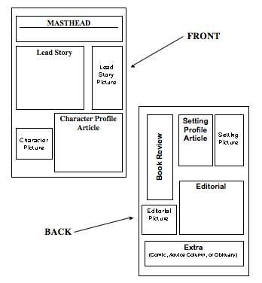

Copyright © 2014 Brain Waves Instruction Permission to copy for classroom use only.
Copying for more than one teacher or classroom is prohibited without one paid license per teacher.
Lead Story

Final Copy

Write the final copy of your lead story below.

Cut out the box and glue it to your newspaper in the designated space.

If you prefer to type your final copy, ensure that it fits in the space provided.

Don’t forget to include a headline.

______________________________________ | _______________________________________
______________________________________ | _______________________________________
______________________________________ | _______________________________________
______________________________________ | _______________________________________
______________________________________ | _______________________________________
______________________________________ | _______________________________________
______________________________________ | _______________________________________
______________________________________ | _______________________________________
______________________________________ | _______________________________________
______________________________________ | _______________________________________
______________________________________ | _______________________________________
______________________________________ | _______________________________________
______________________________________ | _______________________________________
______________________________________ | _______________________________________
______________________________________ | _______________________________________
______________________________________ | _______________________________________
______________________________________ | _______________________________________
______________________________________ | _______________________________________
______________________________________ | _______________________________________
______________________________________ | _______________________________________
______________________________________ | _______________________________________
______________________________________ | _______________________________________
______________________________________ | _______________________________________
______________________________________ | _______________________________________
______________________________________ | _______________________________________
______________________________________ | _______________________________________
______________________________________ | _______________________________________
______________________________________ | _______________________________________
______________________________________ | _______________________________________
______________________________________ | _______________________________________
______________________________________ | _______________________________________
______________________________________ | _______________________________________
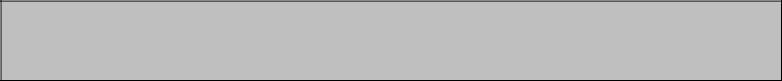

Review the spelling, grammar, and punctuation.

Glue the final copy in the designated space on your newspaper template.

Copyright © 2014 Brain Waves Instruction Permission to copy for classroom use only.
Copying for more than one teacher or classroom is prohibited without one paid license per teacher.
Character Profile Article

Final Copy

Write the final copy of your character profile article below.

Cut out the box and glue it to your newspaper in the designated space.

If you prefer to type your final copy, ensure that it fits in the space provided.

Don’t forget to include a headline.

______________________________________ | _______________________________________
______________________________________ | _______________________________________
______________________________________ | _______________________________________
______________________________________ | _______________________________________
______________________________________ | _______________________________________
______________________________________ | _______________________________________
______________________________________ | _______________________________________
______________________________________ | _______________________________________
______________________________________ | _______________________________________
______________________________________ | _______________________________________
______________________________________ | _______________________________________
______________________________________ | _______________________________________
______________________________________ | _______________________________________
______________________________________ | _______________________________________
______________________________________ | _______________________________________
______________________________________ | _______________________________________
______________________________________ | _______________________________________
______________________________________ | _______________________________________
______________________________________ | _______________________________________
______________________________________ | _______________________________________
______________________________________ | _______________________________________
______________________________________ | _______________________________________
______________________________________ | _______________________________________
______________________________________ | _______________________________________
______________________________________ | _______________________________________

Review the spelling, grammar, and punctuation.

Glue the final copy in the designated space on your newspaper template.

Copyright © 2014 Brain Waves Instruction Permission to copy for classroom use only.
Copying for more than one teacher or classroom is prohibited without one paid license per teacher.
Book Review

Final Copy

Write the final copy of your book review in the box.

Cut out the box and glue it to your newspaper in the designated space.

If you prefer to type your final copy, ensure that it fits in the space provided.

Don’t forget to include a

headline.


Review the spelling,

grammar, and
punctuation.

Glue the final copy in the designated space on your newspaper template.

___________________________________________

___________________________________________

___________________________________________

___________________________________________

___________________________________________

___________________________________________

___________________________________________

___________________________________________

___________________________________________

___________________________________________

___________________________________________

___________________________________________

___________________________________________

___________________________________________

___________________________________________

___________________________________________

___________________________________________

___________________________________________

___________________________________________

___________________________________________

___________________________________________

___________________________________________

___________________________________________

___________________________________________

___________________________________________

___________________________________________

___________________________________________

___________________________________________

___________________________________________

Copyright © 2014 Brain Waves Instruction Permission to copy for classroom use only.
Copying for more than one teacher or classroom is prohibited without one paid license per teacher.

Setting Profile Article
Final Copy

Write the final copy of your setting profile article below.

Cut out the box and glue it to your newspaper final copy.

If you prefer to type your final copy, ensure that it fits in the space provided.

Don’t forget to include a headline.

___________________________________________

___________________________________________

___________________________________________

___________________________________________

___________________________________________

___________________________________________

___________________________________________

___________________________________________

___________________________________________

___________________________________________

___________________________________________

___________________________________________

___________________________________________

___________________________________________

___________________________________________

___________________________________________

___________________________________________

___________________________________________

___________________________________________

Review the spelling, grammar, and punctuation.

Glue the final copy in the designated space on your newspaper template.

Copyright © 2014 Brain Waves Instruction Permission to copy for classroom use only.
Copying for more than one teacher or classroom is prohibited without one paid license per teacher.

Editorial
Final Copy

Write the final copy of your editorial below.

__________________________________________________________________________________

__________________________________________________________________________________

__________________________________________________________________________________

__________________________________________________________________________________

__________________________________________________________________________________

__________________________________________________________________________________

__________________________________________________________________________________

__________________________________________________________________________________

__________________________________________________________________________________

__________________________________________________________________________________

__________________________________________________________________________________

__________________________________________________________________________________

__________________________________________________________________________________

__________________________________________________________________________________

__________________________________________________________________________________

__________________________________________________________________________________

__________________________________________________________________________________

__________________________________________________________________________________

__________________________________________________________________________________

__________________________________________________________________________________

__________________________________________________________________________________

__________________________________________________________________________________


Review the spelling, grammar, and punctuation.

Glue the final copy in the designated space on your newspaper template.

Copyright © 2014 Brain Waves Instruction Permission to copy for classroom use only.

Copying for more than one teacher or classroom is prohibited without one paid license per teacher.

Comic Strip
(Extra Feature)
Final Copy

Write the final copy of your comic strip below.

Cut out the box and glue it to your newspaper in the designated space.

Be sure to color your comic strip and include speech bubbles.

Don’t forget to include a headline.

aaaaaaaaaaaaaaaaa

aaaaaaaaaaaaaaaaa

aaaaaaaaaaaaaaaaa


aaaaaaaaaaaaaaaaa

Review the spelling, grammar, and punctuation.

Glue the final copy in the designated space on your newspaper template.

Copyright © 2014 Brain Waves Instruction Permission to copy for classroom use only.

Copying for more than one teacher or classroom is prohibited without one paid license per teacher.

Advice Column
(Extra Feature)
Final Copy

Write the final copy of your advice column below.

Cut out the box and glue it to your newspaper in the designated space.

If you prefer to type your final copy, ensure that it fits in the space provided.

Don’t forget to include a headline.


_______________________________________________________________________________

_______________________________________________________________________________

_______________________________________________________________________________

_______________________________________________________________________________

_______________________________________________________________________________

_______________________________________________________________________________

_______________________________________________________________________________

_______________________________________________________________________________

_______________________________________________________________________________

_______________________________________________________________________________

_______________________________________________________________________________


Review the spelling, grammar, and punctuation.

Glue the final copy in the designated space on your newspaper template.

Copyright © 2014 Brain Waves Instruction Permission to copy for classroom use only.

Copying for more than one teacher or classroom is prohibited without one paid license per teacher.

Obituary
(Extra Feature)
Final Copy

Write the final copy of your obituary below.

Cut out the box and glue it to your newspaper in the designated space

If you prefer to type your final copy, ensure that it fits in the space provided.

Don’t forget to include a headline.

_______________________________________________________________________________

_______________________________________________________________________________

_______________________________________________________________________________

_______________________________________________________________________________

_______________________________________________________________________________

_______________________________________________________________________________

_______________________________________________________________________________

_______________________________________________________________________________

_______________________________________________________________________________

_______________________________________________________________________________

_______________________________________________________________________________

Review the spelling, grammar, and punctuation.

Glue the final copy in the designated space on your newspaper template.

Copyright © 2014 Brain Waves Instruction Permission to copy for classroom use only.

Copying for more than one teacher or classroom is prohibited without one paid license per teacher.
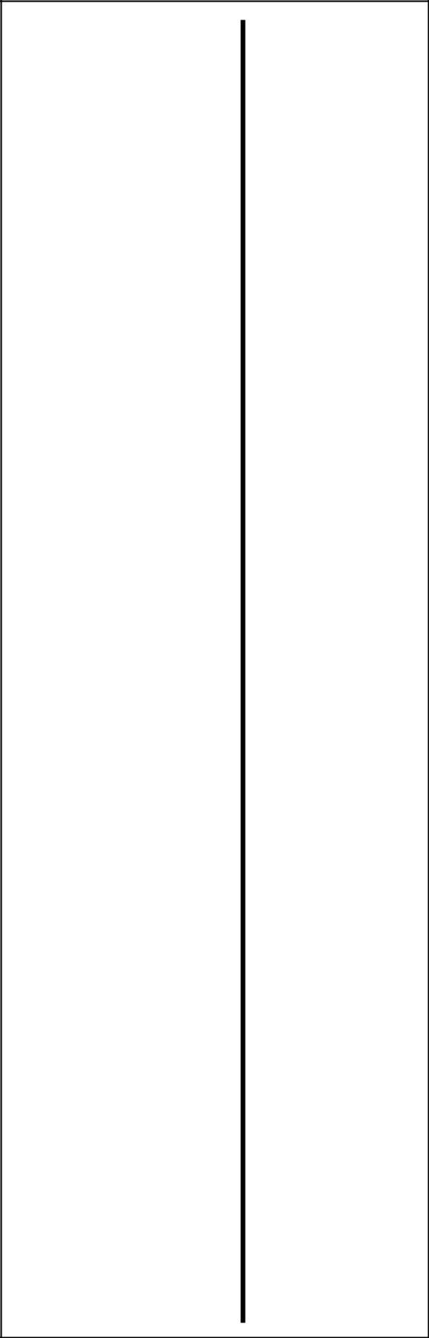

Masthead
Final Copy

Design the final copy

of your masthead.

Then, cut out the box and

glue it to the final copy of
your newspaper.

If you prefer to type your

final copy, ensure that it

fits in the space provided.


Review the spelling,

grammar, and

punctuation.

Glue the final copy in

the designated space

on your newspaper

template.

Copyright © 2014 Brain Waves Instruction Permission to copy for classroom use only.

Copying for more than one teacher or classroom is prohibited without one paid license per teacher.
C
ASSEMBLE THE NEWSPAPER

Follow the model below to assemble the final newspaper:
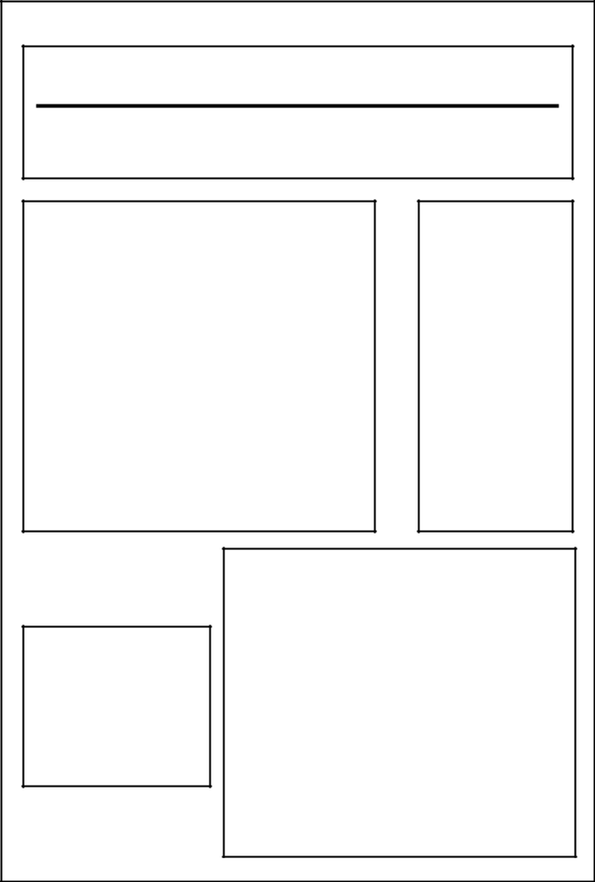

MASTHEAD

Lead Story

Lead

Story
Picture

Character Profile

Article

Character

Picture


BACK 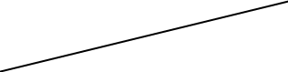

FRONT

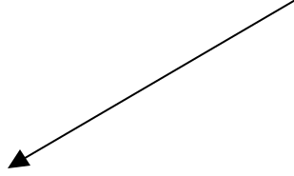

 |  |  |  |  | Setting
 | BookReview |  |  |  | Profile |  | Setting
 | BookReview |  |  |  | Article |  | Setting
 | BookReview |  |  |  | Article |  | Picture
 |  |  |  |  | Editorial
 | Editorial
 | Picture

Extra

(Comic, Advice Column, or Obituary)

Copyright © 2014 Brain Waves Instruction Permission to copy for classroom use only.

Copying for more than one teacher or classroom is prohibited without one paid license per teacher.

