Name: Who is

wanted?

Character: What do

they look like?

Describe them.

Crime: What are they

wanted for? What

have they done?

Where were they last

seen?

Reward: What is the

reward?

Contact: Who do you

tell if you see them?
WANTED


WANTED

Name:

Occupation:

Height:

Hair:

Eyes:

Appearance:

Character:

Last seen:

Crime:

Reward:

If you see this person inform the police immediately.
WANTED

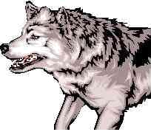

Name:

Colour:

Eyes:

Teeth:

Character:

Last seen:

Wanted for:

Reward:

If you see this wolf inform the woodcutter immediately.


WANTED

Name:

Occupation:

Height:

Hair:

Eyes:

Appearance:

Character:

Last seen:

Crime:

Reward:

If you see this person inform the police immediately.
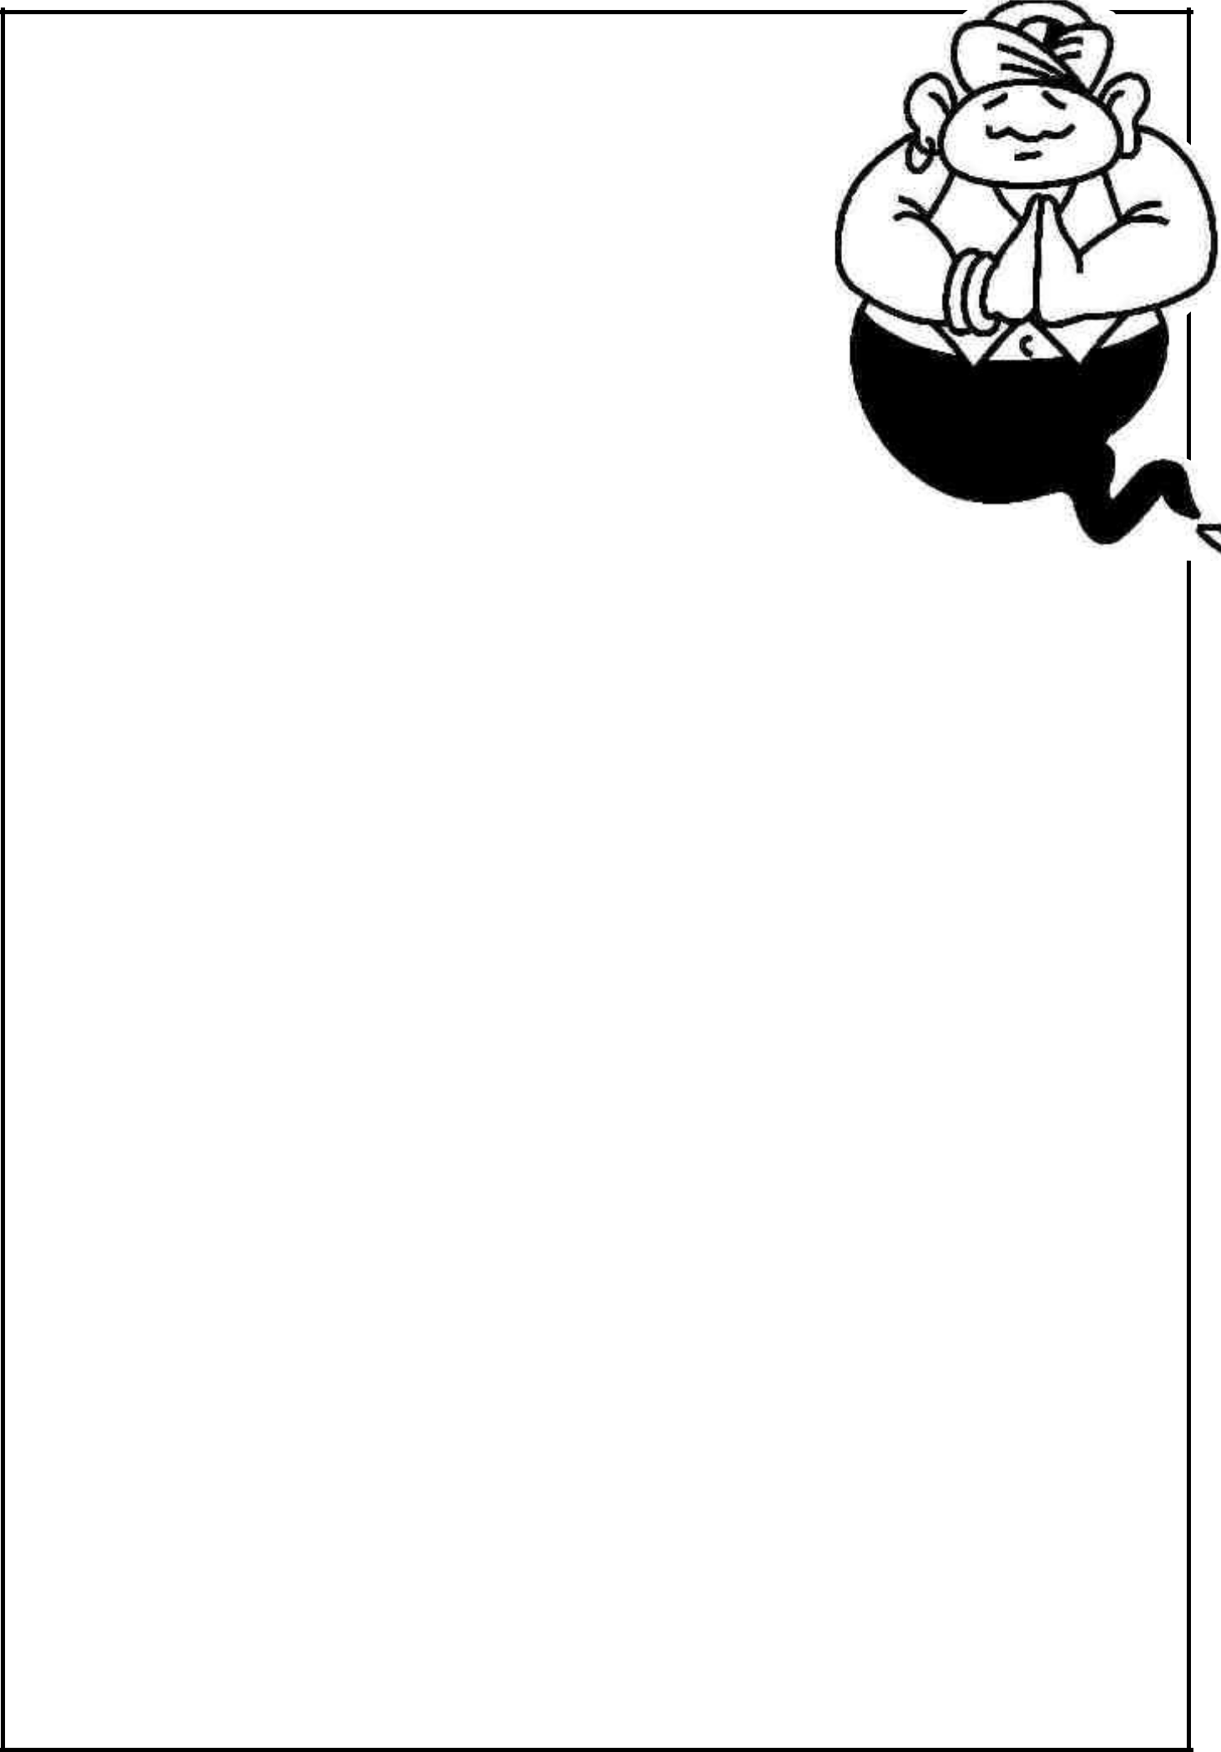
WANTED

Name:

Occupation:

Height:

Hair:

Eyes:

Appearance:

Character:

Last seen:

Wanted for:

Reward:

If you see this person inform the police immediately.


WANTED

Name:

Occupation:

Height:

Hair:

Eyes:

Appearance:

Character:

Last seen:

Crime:

Reward:

If you see this person inform the police immediately.

MISSING

Name:

Occupation:

Height:

Hair:

Eyes:

Appearance:

Character:

Last seen:

Reward:

If you see this person inform the circus immediately.

MISSING

Name:

Occupation:

Height:

Hair:

Eyes:

Appearance:

Character:

Last seen:

Reward:

If you see this person inform the chief tooth fairy immediately.
MISSING
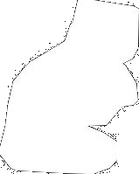
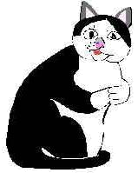

Name:

Owner:

Appearance:

Character:

Last seen:

Reward:

If you see this pet please inform the owners immediately by telephoning this number

MISSING

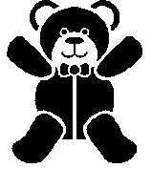

Name:

Belongs to:

Height:

Appearance:

Character:

Last seen:

Reward:

If you see this teddy inform the family immediately by telephoning this number

WANTED

Name:

Occupation:

Height:

Hair:

Eyes:

Appearance:

Character:

Last seen:

Crime:

Reward:

If you see this person inform the police immediately.

MISSING

Name:

Belongs to:

Height:

Appearance:

Character:

Last seen:

Reward:

If you see this _________

inform the family immediately by telephoning this number _______

