Manfred the Baddie by John Fardell
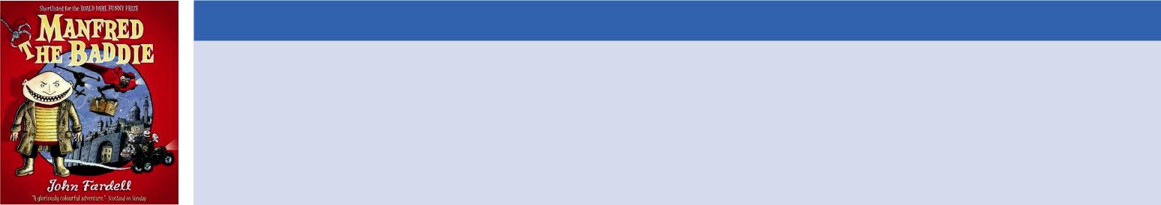

Unit overview

This three-week unit of work immerses children in the plot, language and characters of John Fardell’s illustrated picture book Manfred the Baddie. The text is used to develop reading comprehension, vocabulary and writing. Grammar and punctuation are examined within the context of the text – interrogating how and why it’s used by the author, and for what purpose in the story. Opportunities are given for the children to rehearse the correct use of basic grammar and punctuation. Children make connections with themes on a personal level and create varied, meaningful writing outcomes. The unit culminates in a final piece of work where the children apply all that they have learned in this story to create one of their own. All extracts, resources, session planning and teaching slides are included within this unit.
Recommended Year Group: Year 1


Recommended Term: Summer 2

Recommended Edition: 9781849160445

Key questions

- Is it ever ok to steal?

- How can we help people to feel better when they are ill?
- Can people change their behaviour?

Writing outcomes

Themes and cross-curricular links

- History – inventions and inventors

- DT – inventions, designing and making sandwiches

- Art – portraits and famous artists

- SMSC – stealing, saying sorry

- Drama – role-playing scenes, hot-seating, reading aloud

- Extra curriculum: A trip to an art gallery.

Related books for wider reading

- How the Grinch Stole Christmas by Dr Seuss
- Alan’s Big Scary Teeth by Jarvis

- Camille and the Sunflowers by Laurence Anholt

Curriculum coverage


Spoken language:

- give well-structured descriptions, explanations and narratives for different purposes, including for expressing feelings
- use spoken language to develop understanding through speculating, hypothesising, imagining and exploring ideas
- participate in discussions, presentations, performances, role play, improvisations
- consider and evaluate different viewpoints, attending to and building on the contributions of others

Reading

- link what they read or hear to their own experiences
- discuss word meanings, linking new meanings to those already known
- understand both the books they can already read accurately and fluently and those they listen to by: ♣
– drawing on what they already know or on background information and vocabulary provided by the teacher
– checking that the text makes sense to them as they read and correcting inaccurate reading
– discussing the significance of the title and events ♣
– making inferences on the basis of what is being said and done
– predicting what might happen on the basis of

what has been read so far

– participate in discussion about what is read to them, taking turns and listening to what others say
– explain clearly their understanding of what is read to them.
- making comparisons within and across books

  - discuss and evaluate how authors use language, including figurative language, considering the impact on the reader

Writing

- write sentences by:

– saying out loud what they are going to write about
– composing a sentence orally before writing it ♣

– sequencing sentences to form short narratives

♣

– re-reading what they have written to check that it makes sense
– discussing what they have written with the teacher or other pupils
– reading aloud their writing clearly enough to be heard by their peers and the teacher.
- leave spaces between words

- join words and joining clauses using and

- begin to punctuate sentences using a capital letter and a full stop, question mark or exclamation mark
- use a capital letter for names of people, places, the days of the week, and the personal pronoun ‘I’

- A ‘Get Well’ card/message (session 6) – to empathise
- Instructions for making a sandwich (session 8) – to inform
- A character description in the form of a Wanted poster (session 3) – to inform
- A comic strip story in the style of Manfred the Baddie (sessions 12-15) – to entertain






Rising Stars 2019 © Hodder & Stoughton Limited

Planning Overview

Week 1

Objectives and outcomes summary:

This week the children will:

- explore their understanding of a baddie character in a story and understand their motivations

- analyse language to portray a character

- create empathy for reading through exploring the thoughts and feelings of characters in a story and create thought bubbles for the characters

- make inferences and predictions based on reading and justify opinions about the reading

- take part in a simple debate

Page focus: 1–11

Resources provided:

- Video clip of ‘Night Ninja’ in Disney’s PJ Masks https://www.youtube.com/watch?v=hTLc1BQCNE0

- Illustration of Manfred the Baddie

- Blue print illustrations

- Question prompts

- Opinion prompts

- Starter activities – capital letters, ‘wh’ words




Week 2



Objectives and outcomes summary:

This week the children will:

- develop a deeper understanding of characters in the story

- develop an understanding of the character of Manfred the Baddie in order to empathise with him and write him a ‘get well’ message

- Plan and write a set of instructions for making a sandwich and create a baddie and goodie character of their own

Page focus: the story as a whole

Resources provided:

- Illustration of Manfred the Baddie

- Sandwich design sheet

- Opinion prompts

- Success Criteria

- Story planning template

- Starter activity – ‘ai’ words



Week 3



Objectives and outcomes summary:

This week the children will:

- develop an understanding of the plot of the story and the concept of a baddie becoming a goodie

- plan and write the beginning, middle and end of their own version of the story

- celebrate the success of their own writing

Page focus: the story as a whole

Resources provided:

- Planning Template

- Comic Strip

- Success Criteria

Rising Stars 2019 © Hodder & Stoughton Limited


SESSION 8

 | Learning objective |  | To write instructions for making a sandwich
 | Outcomes |  | To write a set of instructions for making a sandwich.
 | Key vocabulary |  | instructions, sequence, capital letter, full stop, finger space
 | Activities |  | ● Starter: Sequencing question (see Teaching slide 16)
 |  |  | ● Recap on sandwiches designs created in previous lesson. How will we explain to Manfred how we would like our
 |  |  | sandwiches? How can we make sure our instructions are clear for Manfred to follow? We need to write him some
 |  |  | instructions.
 |  |  | ● Teacher to show the children a plan for their own favourite sandwich. What do I need to do first? (Wash hands.)
 |  |  | Model writing a title and the first instruction. In pairs discuss what Manfred will need to do next. Model writing
 |  |  | instructions for making a sandwich, inviting children to say what will come next in the sequence. Model using capital,
 |  |  | letters, full stops and finger spaces. Create your own success criteria together, using the suggestion here as guidance.
 |  |  | You might want to make a sandwich and have the children describe what you are doing, while you are modelling. You
 |  |  | could pretend to miss a step etc…
 |  |  | ● Children to write instructions for making their own sandwich.
 |  |  | ● Plenary: Invite some children to read and share their instructions with the rest of the class. Do they make sense? Are
 |  |  | they clear? Does anyone need to change anything? The rest of the class could pretend to follow the instructions as
 |  |  | they are read aloud, to test if they work. Allow time for editing.
 | Teacher guidance |  | ● Sandwiches could be made as part of a DT lesson following guidelines for health and safety, or you might have one
 |  |  | child make one of the sandwiches, according to the instructions written, and discuss how they might be improved
 |  |  | (peer assessment and editing).
 |  |  | ● Some children may need to use the writing template provided.
 |  |  | ● Success Criteria for the writing might be: title, number instructions and to put the instructions in order.
 | Rising Stars 2019 © Hodder & Stoughton Limited
 |  |  | 16
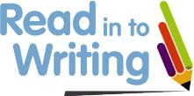
 |  | Resources needed |  | ● Teaching slide 17: sequencing question.
 |  |  |  | ● Teaching slide 18: Success Criteria for writing a sandwich.
 |  |  |  | ● Teaching slide 19: Model instructions for writing a sandwich.
 |  |  |  | ● Pupil resource: Writing template
 |  | Curriculum coverage |  | Reading
 |  |  |  | ● 1b identify / explain key aspects of fiction and non-fiction texts, such as characters, events, titles and information.
 |  |  |  | ● 1c identify and explain the sequence of events in texts.
 |  |  |  | ● 1d make inferences from the text.
 |  |  |  | ● 1e predict what might happen on the basis of what has been read so far.

Writing

- Pupils should be taught to write sentences by:

  - saying out loud what they are going to write about

  - composing a sentence orally before writing it

  - sequencing sentences to form short narratives

  - re-reading what they have written to check that it makes sense

  - discussing what they have written with the teacher or other pupils

  - reading aloud their writing clearly enough to be heard by their peers and the teacher.

GPS

- Leave spaces between words.

- Join words and joining clauses using and.

- Begin to punctuate sentences using a capital letter and a full stop, question mark or exclamation mark.

- Use a capital letter for names of people, places, the days of the week, and the personal pronoun ‘I’.

Rising Stars 2019 © Hodder & Stoughton Limited

17

Purpose: to write instructions for making a sandwich so that it can be made for you.

Audience: Manfred.
How to make Miss/Mrs/Mr (insert teacher’s name)
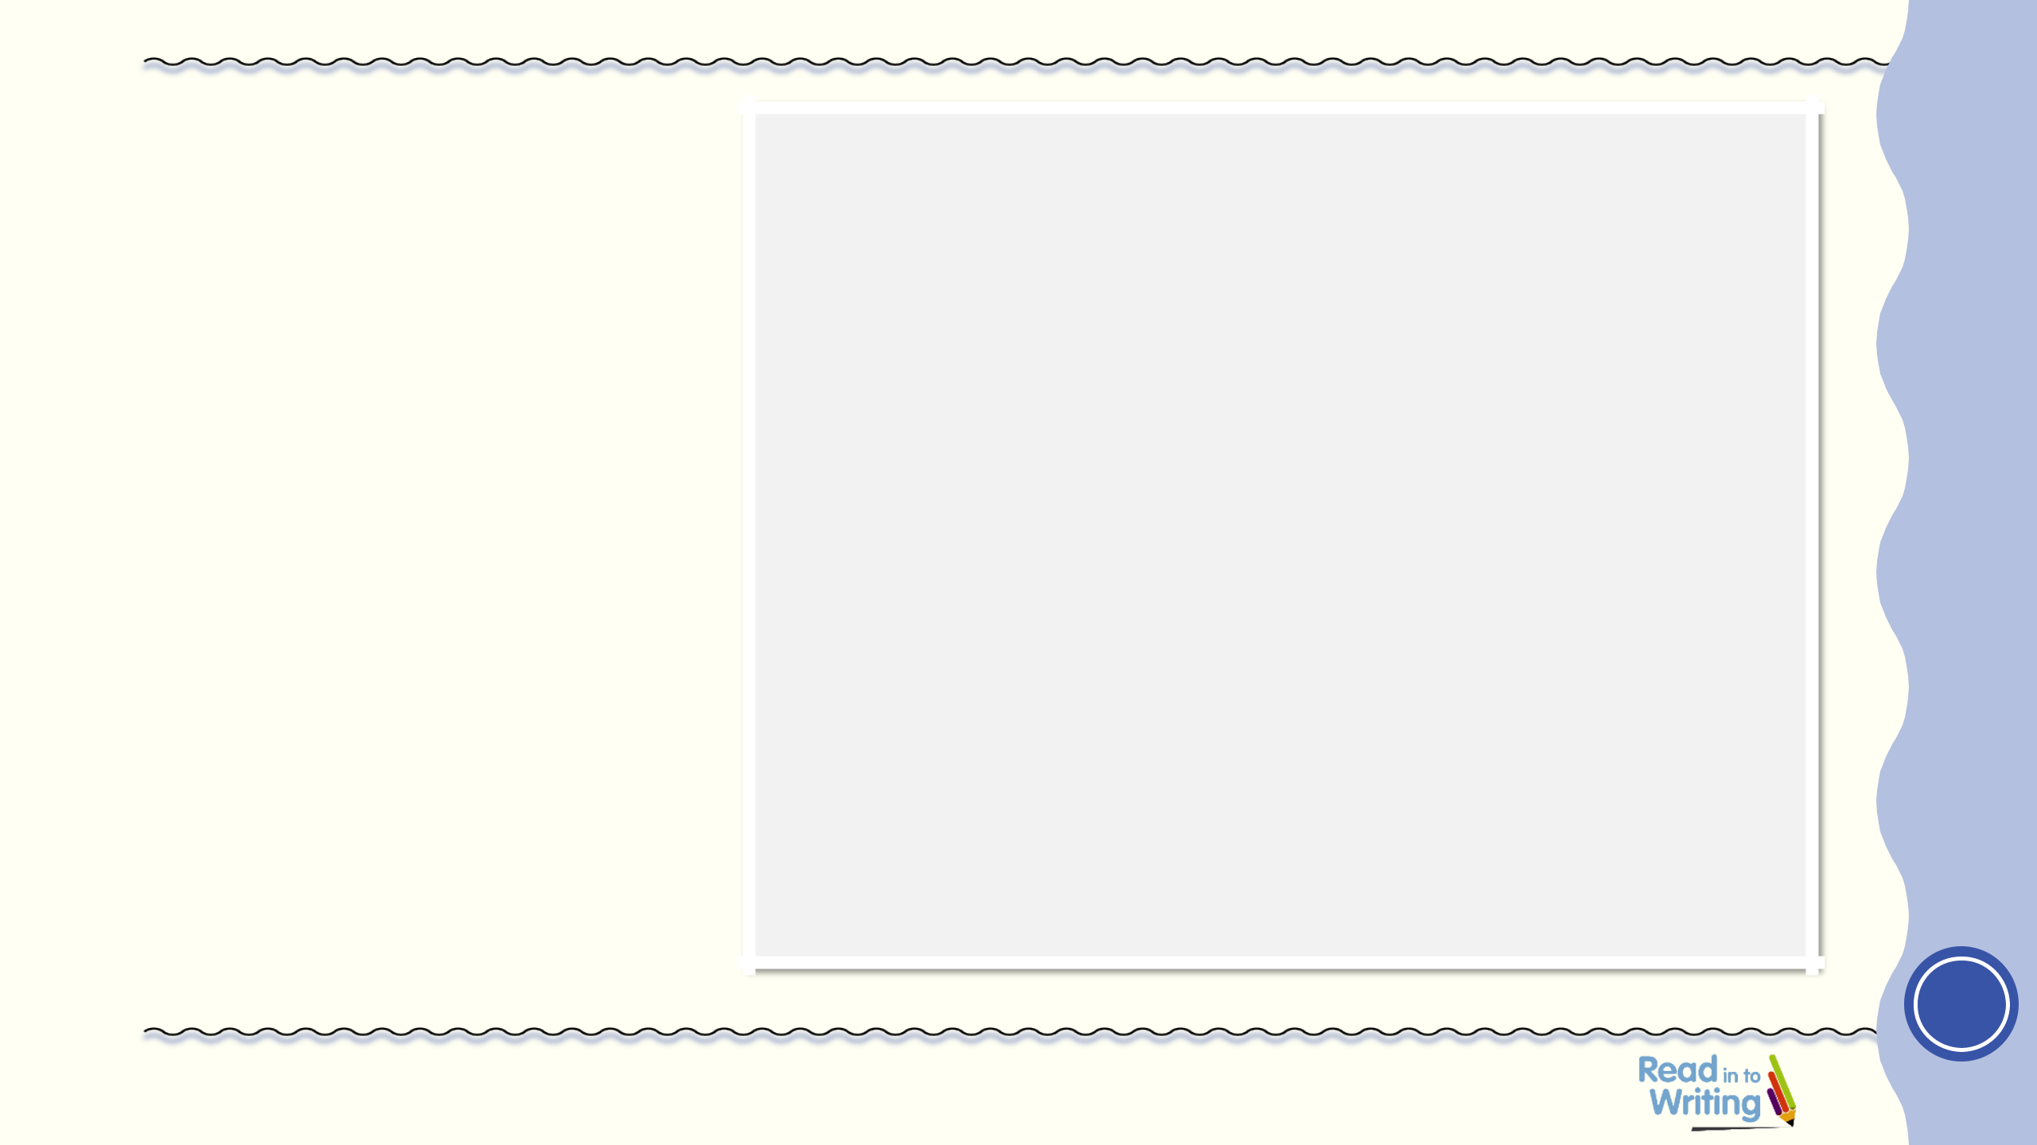
favourite sandwich

Ingredients
Brown bread Butter
Cheese Tomato
Pickle
Equipment

Knife Spoon

- Wash your hands.
- Butter two slices of brown bread.

- Slice cheese and place on top of one slice of bread.

- Cut a tomato and place on top of the cheese.

- Scoop out a spoonful of pickle and spread on top of the tomato.

- Place the second slice on bread on top.

- Cut into four triangles.

- Eat and enjoy!

Use with Session 8

1

Rising Stars 2019 © Hodder & Stoughton Limited

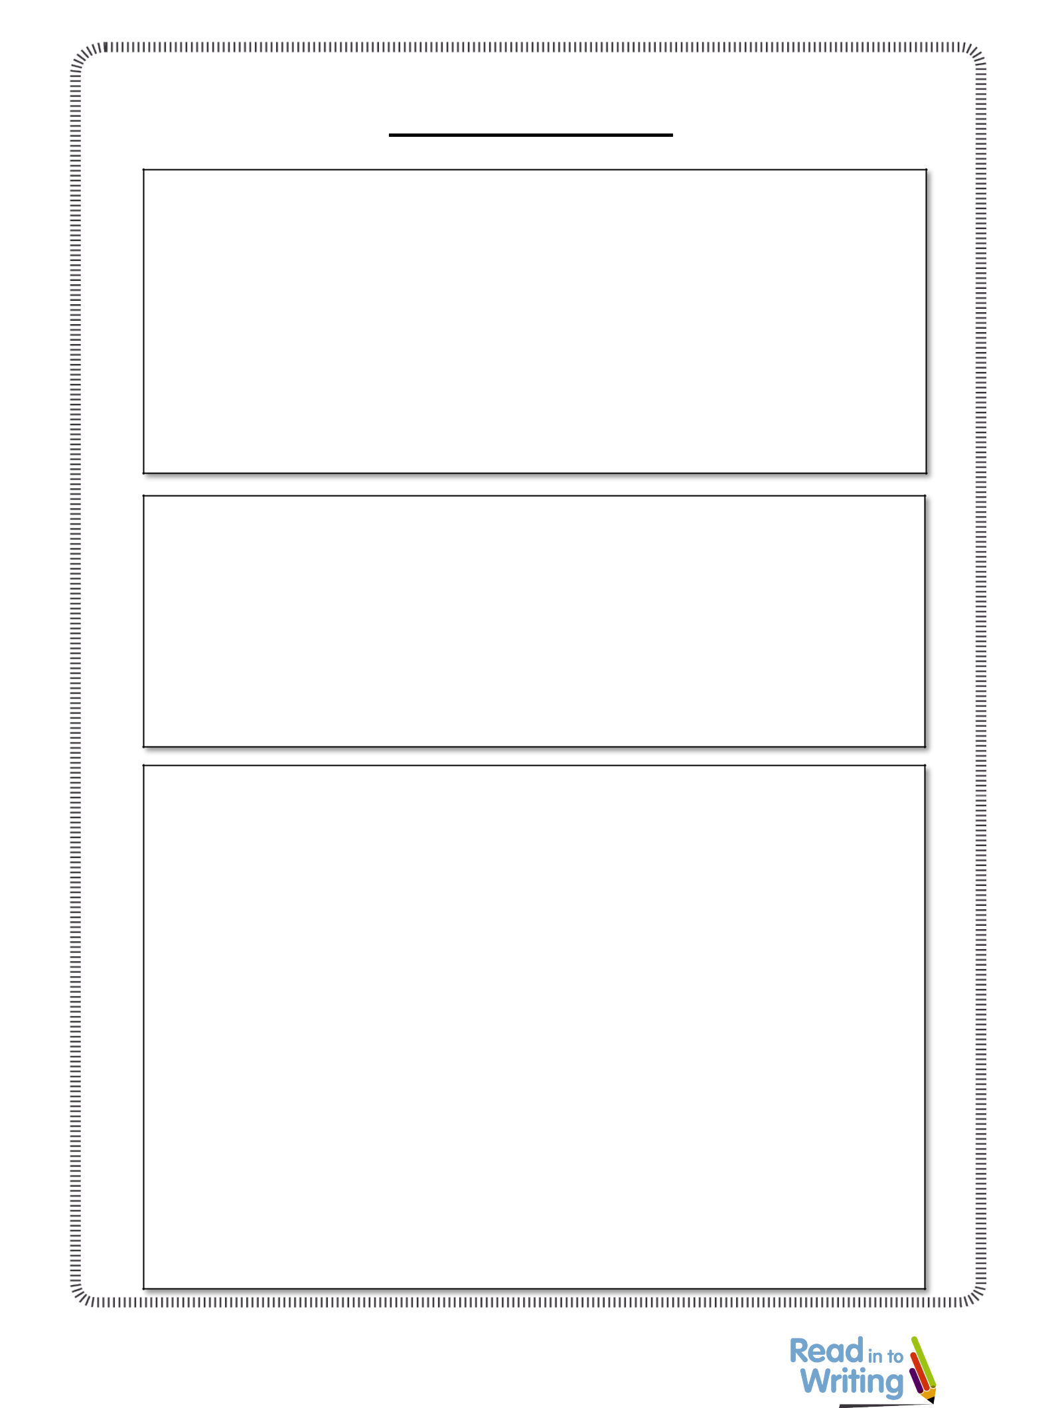
Session 8 Writing template Manfred the Baddie by John Fardell

How to make a sandwich

Equipment

To make my sandwich you will need:

●

●

●

Instructions

1.

2.

3.

4.

5.

Rising Stars 2019 © Hodder & Stoughton Limited 1

Oi Frog! by Kes Gray and Jim Field
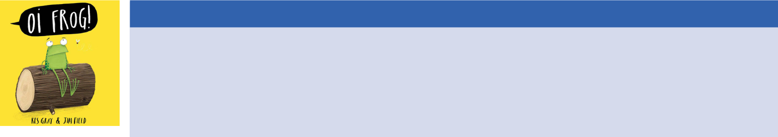

Unit overview

This three-week unit of work immerses children in the hilarious language, rhyme and characters of the award winning illustrated picture book series Oi Frog!, Oi Dog!, Oi Cat! and Oi Duck-Billed Platypus! The text is used to develop reading comprehension, vocabulary and writing including the exploration of rhyme and rhyming words. Opportunities are also given for the children to rehearse the correct use of basic grammar and punctuation. Children make connections with themes on a personal level and create varied, meaningful writing outcomes. The unit culminates in a final piece of work where the children apply all that they have learned in this story to create a short rhyming story of their own. All extracts, resources, session planning and teaching slides are included within this unit.


Recommended Year Group: Year 1 Recommended Term: Autumn 2 / Spring 1 Recommended Editions:

Oi Frog! 9781444910865 Oi Dog! 9781444919592 Oi Cat! (with Claire Gray) 9781444932522 Oi Duck-Billed Platypus! 9781444937329

Key questions

• Why do we have rules?

• Is it ever ok to change the rules?

Themes and cross-curricular links

- Science – lifecycles, habitats, adaptation

- Geography – animal homes, habitats around the world

- ICT – research using the internet, digital photography

- SMSC – rules

- Drama – role-playing scenes, hot-seating, freeze frames, reading aloud

- Extra curriculum – a trip to a zoo or animal park

Related books for wider reading

- Fox in Socks by Dr Seuss

- Tadpole’s Promise by Jeanne Willis and Tony Ross
- Rumble in the Jungle by Giles Andreae

Curriculum coverage

Spoken language:

- use relevant strategies to build their vocabulary

- give well-structured descriptions, explanations and narratives for different purposes, including for expressing feelings
- use spoken language to develop understanding through speculating, hypothesising, imagining and exploring ideas
- participate in discussions, presentations, performances, role play, improvisations and
- consider and evaluate different viewpoints, attending to and building on the contributions of others

Reading:

- link what they read or hear read to their own experiences
- discuss word meanings, linking new meanings to those already known
- understand both the books they can already read accurately and fluently and those they listen to by:
– drawing on what they already know or on background information and vocabulary provided by the teacher
– discussing the significance of the title and events
– making inferences on the basis of what is being said and done
– predicting what might happen on the basis of what has been read so far
• learn to appreciate rhymes and poems

- participate in discussion about what is read to them, taking turns and listening to what others say
- explain clearly their understanding of what is read to them
- making comparisons within and across books

- discuss and evaluate how authors use language, including figurative language, considering the impact on the reader

Writing:

- write sentences by:

– saying out loud what they are going to write about
– composing a sentence orally before writing it

– sequencing sentences to form short narratives

– re-reading what they have written to check that it makes sense
– discuss what they have written with the teacher or other pupils
– read aloud their writing clearly enough to be heard by their peers and the teacher
- leave spaces between words

- join words and joining clauses using ‘and’

- begin to punctuate sentences using a capital letter and a full stop, question mark or exclamation mark
- use a capital letter for names of people, places, the days of the week, and the personal pronoun ‘I’

• What can we do if someone doesn’t follow the

rules?

Writing outcomes

- An information page about frogs (session 2) – to inform
- Character thought bubbles (session 3) – to empathise
- A letter from one character to another (session 4) – to instruct
- A letter of complaint (session 8) – to inform

- A rhyming story in the style of the Oi! books (sessions 11–14) – to entertain

Essential teaching guidance

- Children may want to ask about the more unusual animals in the book, e.g. ibex, kookaburra, duck-billed platypus so it may be useful to do some background research in order to answer their questions.

- Some of the children may already be familiar with these popular stories, so bear this in mind when asking for predictions etc. It may be worth gauging who has read the books before starting the unit to avoid any plot spoilers!

- A few of the sessions involving drama may require a larger open space to allow for movement.



Rising Stars 2019 © Hodder & Stoughton Limited

Planning Overview

Week 1

Objectives and outcomes summary:

This week the children will:

- build up a knowledge of frogs through a variety of research methods

- use research to write an information page about frogs

- explore the differences between characters in a story

- empathise with characters through writing though bubbles

- write a letter from one character to another

- sequence the events of a story

Title focus: Oi Frog!

Resources provided:

- Teaching slide – Question words prompt

- Enlarged copy of the endpapers of the book Oi Frog!

- Video clip https://www.youtube.com/watch?v=S82JsUiMdZo

- Teaching slide and pupil resource – Research Q&A sheet

- Teaching slide – Question mark activity

- Teaching slide and pupil resource – Information page writing templates (also to be presented and used as worksheets)

- Pupil resource – Photographs/pictures of frogs for the children to cut out and stick to their non-fiction pages

- Teaching slide – Success Criteria for writing an information page/non-chronological report

- Teaching slide – Questions from pages 1-8 of the book

- Teaching slide – Illustration of the cat and frog from page 3

- Video clip https://vimeo.com/85242028

- Pupil resource – Illustrations from pages 1-8, with blank thought bubbles to be filled in

- Teaching slide and pupil resource – Letter from the animals asking what they can sit on

- Teaching slide – Success Criteria for writing a letter.

- Teaching slide – Alphabetical order starter activity

- Pupil resource – Sequence the images from the story

Week 2

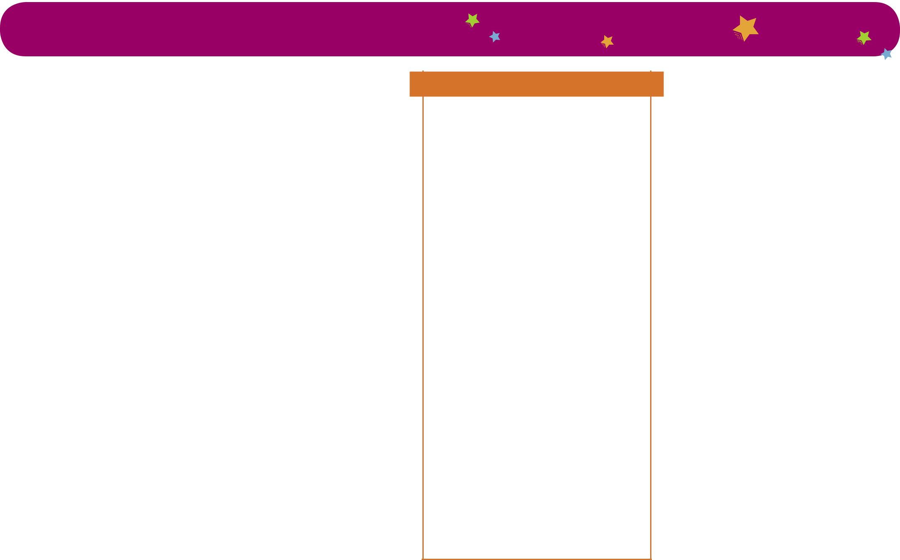

Objectives and outcomes summary:

This week the children will:

- develop a deeper understanding of characters in the story and why they might behave in a certain way

- explore the purpose of rules

- focus on the use of adjectives and collate a list of adjectives for use in their own writing

- write a letter of complaint

- identify and explore rhyming words

Title focus: Oi Frog!, Oi Dog!, Oi Cat! and Oi Duck-Billed Platypus!

Resources provided:

- Teaching slide – Question and answer prompts

- Teaching slide – Starter activity

- Teaching slide – Starter activity

- Teaching slide – Success Criteria for writing a letter of complaint

- Teaching slide – Rhyming pair words

- Pupil resource – Pages 7-8 of Oi Duck-Billed Platypus! for labelling


Week 3



Objectives and outcomes summary:

This week the children will:

- plan and write a short rhyming story of their own

- celebrate the success of their own writing

Title focus: Oi Frog!, Oi Dog!, Oi Cat! and Oi Duck-Billed Platypus!

Resources provided:

- Teaching slide and pupil resource – Planning template for children’s own stories

- Teaching slide – Rhyming Riddles

- Teaching slide – Success Criteria for writing a rhyming story

Rising Stars 2019 © Hodder & Stoughton Limited

 | SESSION 3
 | OOi
 | Learning objective |  |  | To understand the differences between characters in a story
 | Outcomes |  |  | Children describe the characteristics of frog and cat
 | Key vocabulary |  |  | Character, features, personality, adjective, question, question mark
 | Activities |  |  | ● Read pages 1-8 of Oi Frog! aloud to the children emphasising the humour.
 |  |  |  | ● In pairs, discuss the characters of frog and cat. What words would you use to describe the frog? What words would
 |  |  |  | you use to describe the cat?
 |  |  |  | ● Collect feedback of words to add to the working wall.
 |  |  |  | ● Did anybody identify any questions in the story? (“Can I sit on a mat?” asked the frog. / “What about a chair?” said
 |  |  |  | the frog/ “Perhaps I could sit on a stool?” said the frog/ “What about a sofa?” said the frog.) Display these questions
 |  |  |  | on the board. The children to rehearse asking these questions in different voices, e.g. angrily, happily, quietly, etc.
 |  |  |  | ● Children to work in pairs and take turns role-playing the characters of cat and frog, asking each other the questions
 |  |  |  | and answering them.
 |  |  |  | ● Display the illustrations of cat and frog on page 3 of the book. What expressions do they have on their faces? What
 |  |  |  | are they thinking/feeling? Children to discuss in pairs. Teacher to model adding thought bubbles to these
 |  |  |  | illustrations for the characters of frog and cat, e.g. Cat – Look at that silly frog. He needs to do as he’s told. Frog – I
 |  |  |  | really don’t want to sit on that log. It looks very uncomfortable. I would rather be sitting on a cosy leaf. Why is he
 |  |  |  | telling me what to do?
 |  |  |  | ● Show the children the trailer for the book https://vimeo.com/85242028 How are the other animals feeling?
 |  |  |  | ● Give the children copies of the illustrations from pages 1-2, 4, 5-6 & 7-8 and some blank thought bubbles (see pupil
 |  |  |  | resources). Children to write their own thought bubbles for the rest of the illustrations.
 |  |  |  | ● Collect feedback and add illustrations and thought bubbles to the working wall.
 |  |  |  | ● Plenary – ask the children – At this point in the book, would you rather be the cat or the frog? You could send
 |  |  |  | children to opposite ends of the room depending on their view. Ask the children to explain their opinions. Can you
 |  |  |  | think of a question you would like to ask about the book so far? Or Can you think of a question you would like to


Rising Stars 2019 © Hodder & Stoughton Limited

6
 |  |  | ask one of the characters?
 | Teacher guidance |  | ● Turn off auto play next video on the video clip link as it will forward straight to the next link which may not be
 |  |  | appropriate!
 | Resources needed |  | ● Teaching slide – Questions from pages 1-8 of Oi Frog!
 |  |  | ● Teaching slide – Illustration of the cat and frog from page 3
 |  |  | ● Video clip https://vimeo.com/85242028
 |  |  | ● Pupil Resource – Illustrations from pages 1-8, with blank thought bubbles to be filled in.
 | Coverage |  | Reading
 |  |  | ● 1a draw on knowledge of vocabulary to understand texts.
 |  |  | ● 1b identify / explain key aspects of fiction and non-fiction texts, such as characters, events, titles and information.
 |  |  | ● 1d make inferences from the text.
 |  |  | ● 1e predict what might happen on the basis of what has been read so far.
 |  |  | Writing
 |  |  | ● Discuss what they have written with the teacher or other pupils.
 |  |  | GPS
 |  |  | ● Begin to punctuate sentences using a capital letter and a full stop, question mark or exclamation mark.

Rising Stars 2019 © Hodder & Stoughton Limited

7

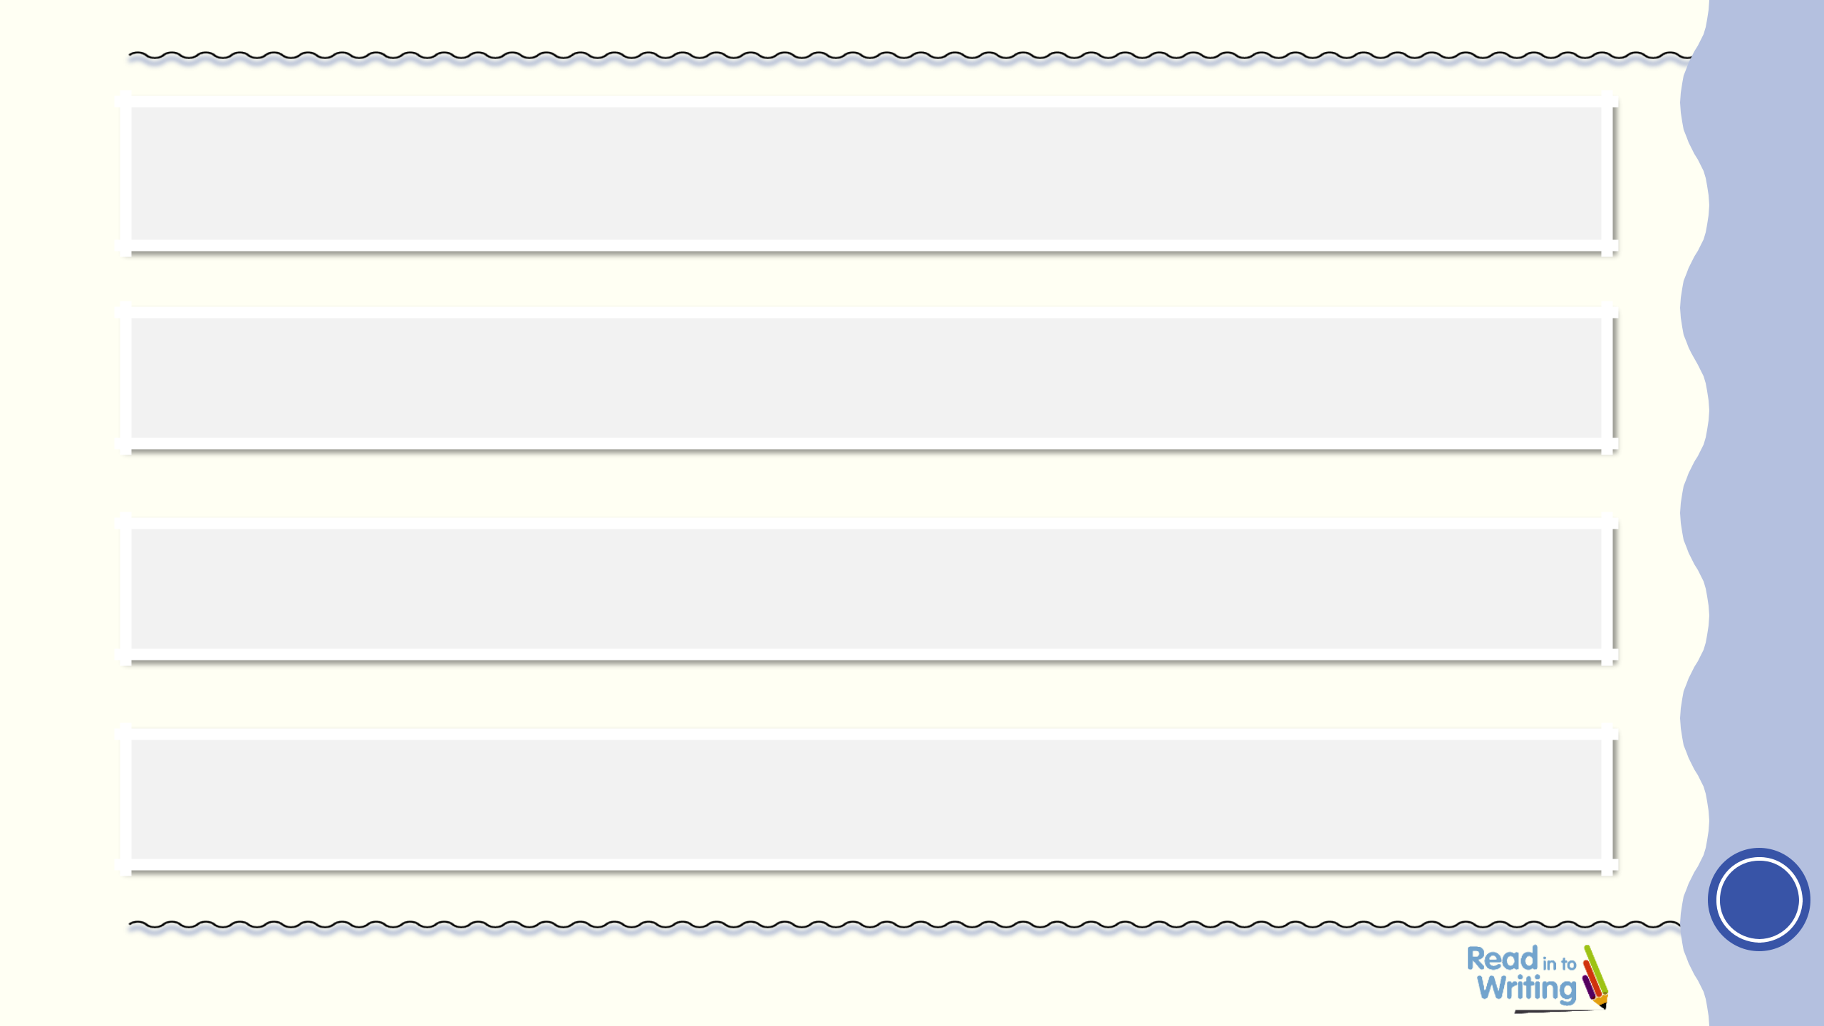
“Can’t I sit on a mat?” asked the frog.

“What about a chair?” said the frog.

“Perhaps I could sit on a stool?” said the frog.

“What about a sofa?” said the frog.

Use with Session 3

1

Rising Stars 2019 © Hodder & Stoughton Limited

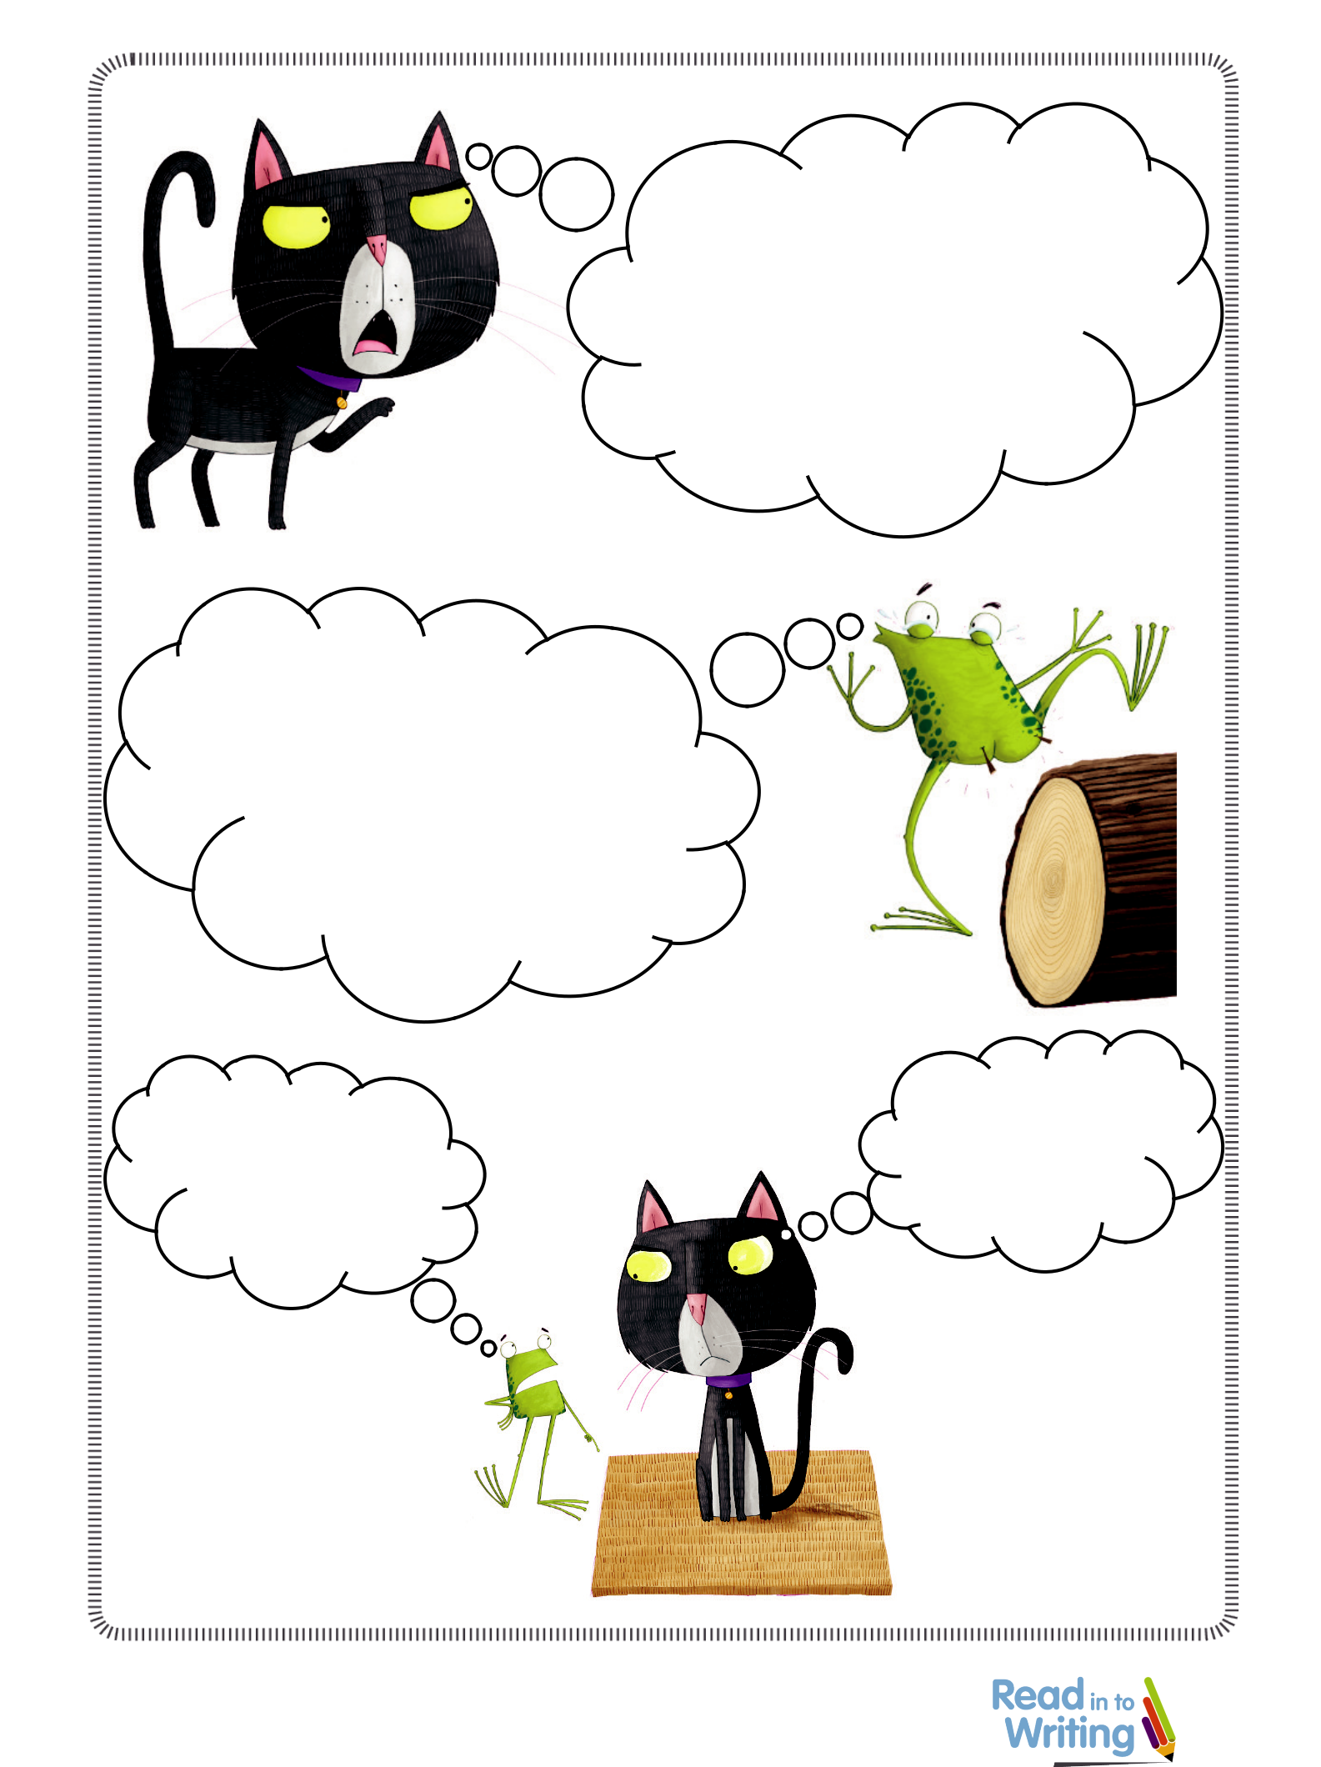
Session 3 Thought bubbles

Rising Stars 2019 © Hodder & Stoughton Limited 1

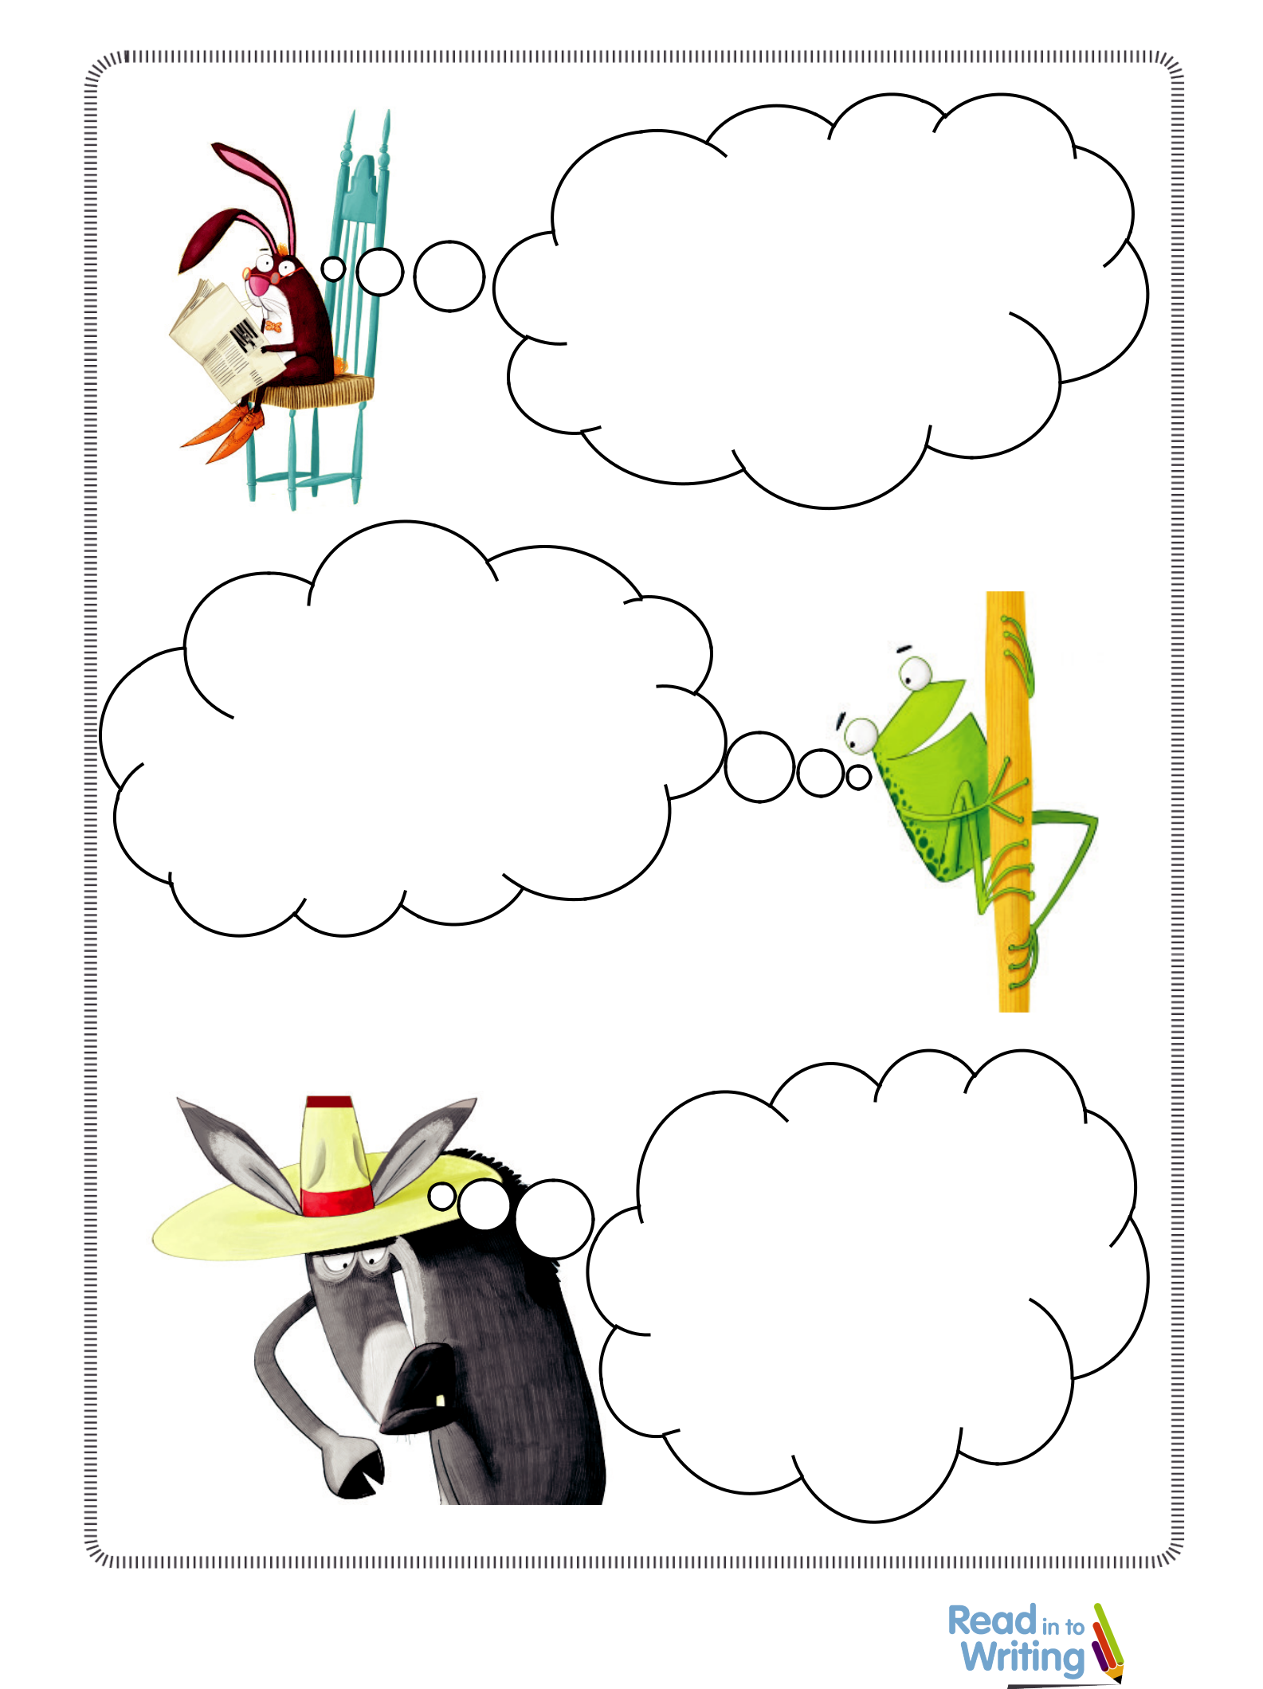
Session 3 Thought bubbles

Read in to Writing Year 1 © 2019 Rising Stars UK Ltd 2

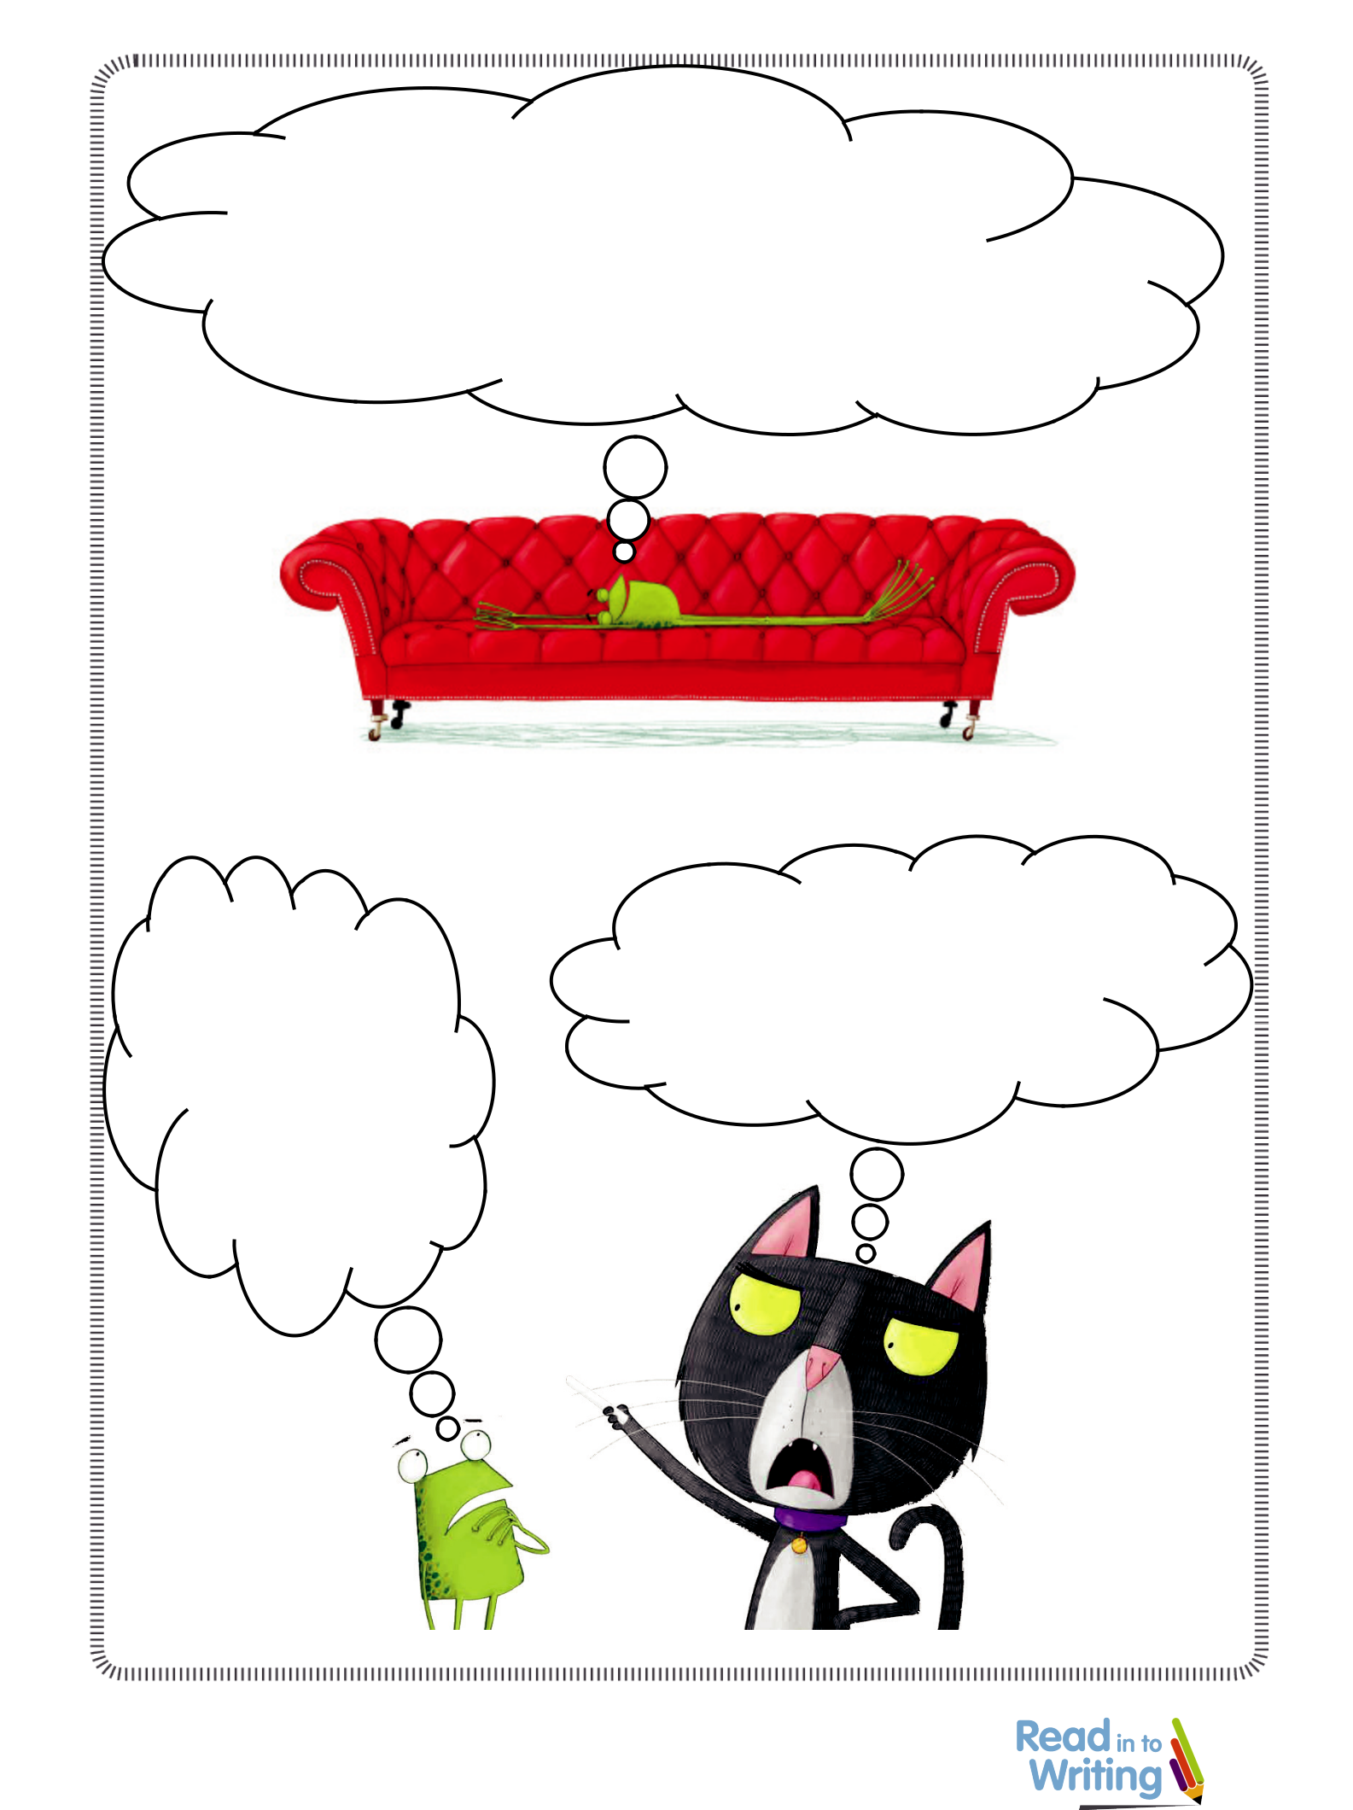
Session 3 Thought bubbles

Read in to Writing Year 1 © 2019 Rising Stars UK Ltd 3

The Queen’s Hat and The Queen’s Handbag by Steve Antony
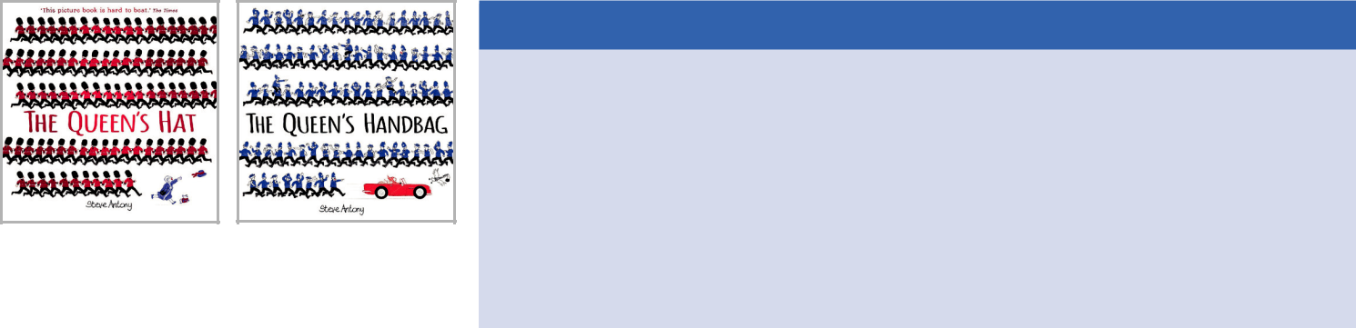
Recommended Year Group: Year 1 Recommended Term: Summer Recommended Editions:

The Queen’s Hat: 9781444919158

Essential teaching guidance



- There are four books in this series. Although they all follow a similar theme, each book has its own strengths and they can all be used with the same cohort. This unit will focus on The Queen’s Hat and The Queen’s Handbag, with additional suggested activities for the other two books.

- The activities have been planned for Year 1 – teachers should use their professional discretion based on the knowledge of their cohort about how long the unit may take their class and adapt the timeframes accordingly.

- Steve Antony is an incredible illustrator and his books have so much depth and detail in the images. Although there are many activities that provide opportunities to look at the illustrations in detail, every double spread could be used to generate valuable discussions with Year 1 (we strongly advise buying multiple copies of the book so that illustrations can be shared with the children, for example spotting the Queen, her corgi and her butler on every page as well as finding key figures such as Mo Farah, Mary Berry and Mr Panda in the books!)


Unit overview

Steve Antony’s ‘Queen Collection’ series is made up of four books – The Queen’s Hat, The Queen’s Handbag, The Queen’s Present and The Queen’s Lift-Off. Each book follows a similar plot as
the Queen adventures across London, Great Britain, the world and though space to try and recover a lost object, while being accompanied by an increasingly large entourage. The beautiful illustrations are just as important as the words and all four books will inspire readers and in turn engage writers. The 20 sessions in this unit focus on The Queen’s Hat and The Queen’s Handbag, but also included are additional suggested activities for The Queen’s Present and The Queen’s Lift-Off for teachers wishing to extend the unit to study the whole series. This unit includes a wealth of cross-curricular opportunities to be taught as part of a broad and balanced curriculum.

All extracts, resources, session planning and teaching slides are included within this unit.


Curriculum coverage

Spoken language:

• listen and respond appropriately to adults and their peers

- ask relevant questions to extend their understanding and knowledge

- articulate and justify answers

- maintain attention and participate actively in collaborative conversations

- participate in discussions and role play

Reading:

- apply phonic knowledge and skills as the route to decode words

- read words with contractions and understand that the apostrophe represents the omitted letter(s)
- re-read books to build up their fluency and confidence in word reading

- be encouraged to link to what they read

- discuss word meanings, linking new meanings to those already known

- make inferences on the basis of what is being said and done

- predict what might happen on the basis of what has been read so far

- explain clearly understanding of what is read to them – sequence the events in the order that they happened

Grammar, punctuation and spelling:

- leave spaces between words

- use ‘and’ to join words and clauses

- punctuate sentences using a capital letter and a full stop, question mark or exclamation mark

- use a capital letter for the pronoun ‘I’ and names of people and places

Writing:

- form lower-case letters in the correct direction, starting and finishing in the right place

- form capital letters

- oral rehearsal – saying sentences out loud/composing them orally

- re-read what they have written to check that it makes sense

The Queen’s Handbag: 9781444925548

The Queen’s Present: 9781444925647

The Queen’s Lift-Off: 9781444934229


Key questions

• What do you think the book might be about?

• What do these words mean?

- Can you number the events in the order that they happened?
- Can you skim and scan?

- When you are reading a partner’s writing, what will you be looking for?
- Do you know words that have similar meanings to each other?
- Do you know what a diary is?

- Where could the hat land in our school community?

- What is Steve Antony’s style?

- What do the two books have in common?

- What do you think the Queen might have in her handbag?

- Would Santa help everybody? (The Queen’s Present)

- What would happen if the Queen went to space? (The Queen’s Lift-Off)

Writing outcomes

- A prediction (session 1) – Who is the ‘someone special’ that the Queen is going to see?
- A sequence (sessions 3) – Sequencing the events in the story
- Speech bubbles (sessions 4 and 5) – Writing in role as the wind
- A diary entry (sessions 7 and 8) – Retelling the story as a chosen character
- Own versions of the story (sessions 9 and 18-20) –

A shorter piece based in the school community, and a longer piece based on a location of choice

- Sentence work (session 12) – Can we improve Steve Antony’s sentences?
- Lists (sessions 13 and 17) – Alliterative animals, and what does the Queen have in her handbag?
- Why I stole the Queen’s handbag (session 14) – Writing in role as the sneaky swan

Rising Stars 2019 © Hodder & Stoughton Limited


Themes and cross-curricular links

• History: Research the Royal Family – share a family tree and focus on the Queen’s

grandchildren (children could then create their own family trees). London history – The

Plague, The Gunpowder Plot and The Great Fire of London, etc. History behind various

Planning Overview
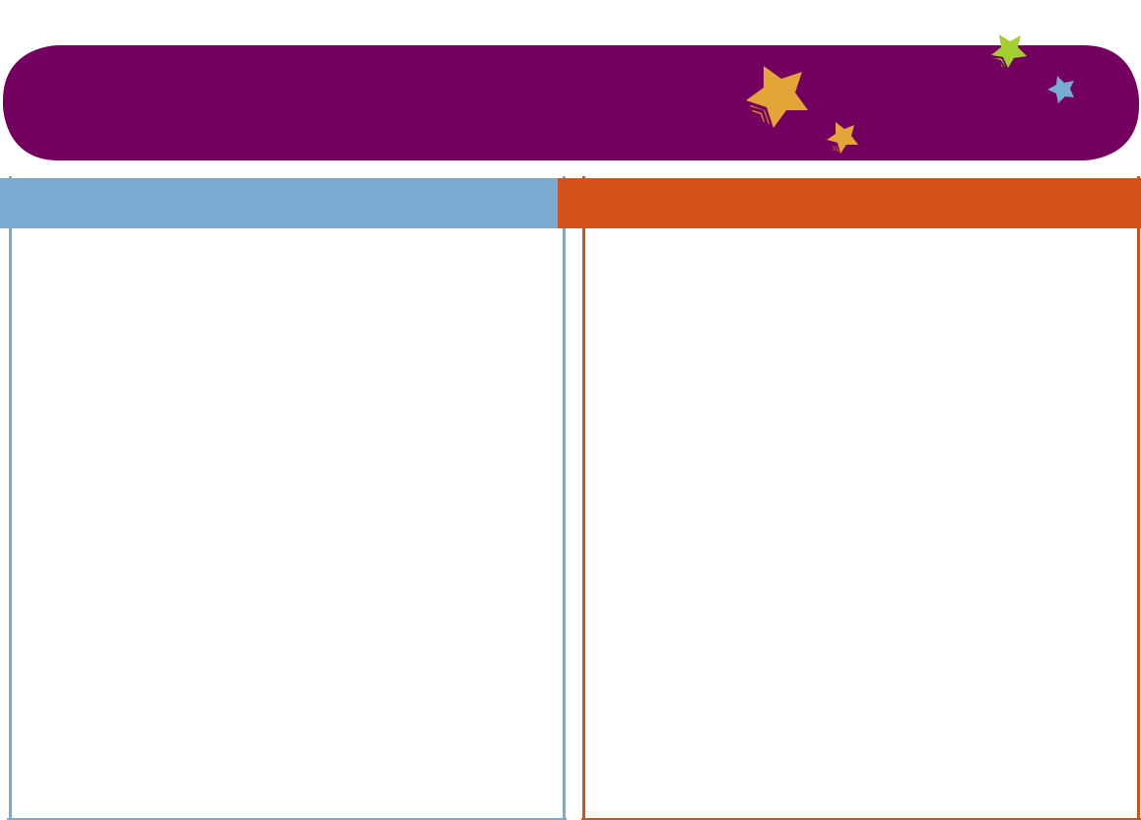

landmarks.

• Geography: Landmarks of London, landmarks of the UK. These books could support a local

area study including the school community. Creating an informational fact file or leaflet about a location or writing a postcard from a location.

• Science: The seasons – consider how the Queen’s journey may have been different/

more difficult in the different seasons. What hat would she be wearing in winter and what

obstacles might she face?

• Art: Blow paint across various media to form art in the style of Jackson Pollock, Steve Antony’s

‘Guide to drawing a corgi’

• DT: Design and create huge versions of the landmarks from junk modelling and/or

construction on a huge map of the UK. Create smaller versions of landmarks for displays.

Make a hat for the Queen.

• SMSC: Helping others, friendship, the Royal Family. Writing ‘thank you letters’ from the

Queen, writing letters to Steve Antony

• Drama: Role on the wall, hot seating and conscience alley

• There are more specific cross-curricular opportunities outlined in some teacher guidance

sections within the planning

Extend the unit with further book studies from the same series

The Queen’s Present

This is a Christmas book – The Queen is looking for Christmas presents for her grandchildren and gets into Santa’s sleigh to fly around the world with him in the quest to find gifts. It might be a good idea for Year 2 teachers to read this story to their class in December, if the class studied the first wo books in Year 1. They will be familiar with Steve Antony’s style from Year 1 and will enjoy another book in the series. See The Queen’s Present Activity Ideas!

The Queen’s Lift-Off

Teachers could choose to do an additional week(s) using this text, particularly if space is a topic or if the cohort particularly enjoyed the other Steve Antony books. The reading/sentence level activities could be repeated using this text. The contents of the Queen’s bag spill out in this book

– children will enjoy seeing what was in it and could compare the contents to their predictions made when studying The Queen’s Handbag. See The Queen’s Lift-Off Activity Ideas!

Related books for wider reading


• Rosie’s Walk by Pat Hutchins


- On the Way Home by Jill Murphy

• A Walk in New York/Paris by Salvatore Rubbino

- Elmer’s Walk by David McKee

- A Walk in the Park by Anthony Browne

- A Street Through Time by Steve Noon

• The Owl and the Pussy-Cat by Edward Lear

Week 1

Objectives and outcomes summary:

This week the children will:

- read the story together, modelling the application of phonics and fluent reading

- predict what might happen based on what they know – using capital letters for names of people
- model oral rehearsal (conventions of writing) and check writing for sense

- develop an understanding of the plot. Sequence what happens in the story and discuss
- explain the pros and cons of the wind and present this in speech bubbles – using the pronoun ‘I’

Resources provided:

- Pupil resource – Predictions

- Pupil resource – Proof-reading hand

- Pupil resource – Events

- Pupil resource – Wind speech bubble

- Teaching slides to support discussion


Week 3

Objectives and outcomes summary:

This week the children will:

- predict what may happen based on what they already know about Steve Antony as an author
- make inferences based on the plot

- explore the author’s choice of verbs and add adverbs to enhance the sentences – re-read sentences for sense

- explore the character of the ‘sneaky swan’ through role play – why might the swan need the bag?
- use contractions – ‘and’ to join words and phrases and the pronoun ‘I’

Resources provided:

- Pupil resource – Predictions

- Pupil resource – How and where?

- Pupil resource – Destinations

- Pupil resource – Why I stole the Queen’s handbag

- Teaching slides to support discussion

Week 2

Objectives and outcomes summary

This week the children will:

- analyse language and discuss the importance of using the right words in their own writing – discussing word meanings

- recount the events in the form of a diary (Queen/ Queen’s men, horses, corgi or the wind) – using contractions

- discuss where the Queen’s Hat might go in the school community - using ‘and’ to join words and clauses (physically taking it to places and taking photographs to create a class book)

Resources provided:

- Pupil resource – Diary plan

- Pupil resource – Diary template


• Pupil resource – Planning template

- Pupil resource – Whole class book template

- Teaching slides to support discussion

Week 4

Objectives and outcomes summary:

This week the children will:

- ask/answer questions about the two books read – discuss the style, characters and plot

- write a list using noun phrases and the conjunction ‘and’ – What does the Queen have in her handbag?
- imitate the style of Steve Antony and write their own story

Resources provided:

- Pupil resource – Book comparison

- Pupil resource – Handbag template

- Pupil resource – Planning template

- Teaching slides to support discussion

Rising Stars 2019 © Hodder & Stoughton Limited

 | SESSION 12
 | OOi
 | Learning objective |  | To talk about language and word choices
 | Outcomes |  | ● To informally discuss the function of verbs and how the choice of verb can change the meaning
 |  |  | ● To match how and where within the text
 | Key vocabulary |  | How, where
 | Key questions |  | ● Do you think carefully about the words you will use in your writing?
 | Activities |  | ● Re-read the book and ask children to remember how many places the Queen went to. Remind the children that Steve
 |  |  | Antony has used landmarks from the UK.
 |  |  | ● Display the first teaching slide and ask children to fix the sentence: What is wrong with this sentence? Discuss the
 |  |  | role of capital letters for the name of the Queen and the places that she visits. The corrected sentence is on the next
 |  |  | teaching slide.
 |  |  | ● Display the next three teaching slides and ask the children to read the sentences in pairs. Do we think the writing is
 |  |  | interesting? Stress the repetition of the verb ‘went’ and ask: Did Steve Antony do that is his book?
 |  |  | ● Using the next three teaching slides, explain to the children that whilst we read this book, we will change the way
 |  |  | the Queen travelled to the one used in the book. As a class, complete the sentences with the verb that Steve Antony
 |  |  | used. Can we add adverbs to describe how she travelled? (For example, ‘drove quickly,’ ‘flew bravely,’ ‘dived
 |  |  | carefully’ and ‘cycled fast’).
 |  |  | ● Explain to the children that we need to choose the best words in our writing, so the reader really understands what
 |  |  | we have written.
 |  |  | ● Using the next four teaching slides, Pupil resource – How and where? and Pupil resource – Destinations, explain to
 |  |  | the children that as a class they are going to work together to stick in the places the Queen visited and how she
 |  |  | travelled there. The first one has already been completed (Drove/Windsor Castle).
 | Teacher guidance |  | ● The final activity could be a whole-class session or small-group sessions depending on the cohort.

Rising Stars 2019 © Hodder & Stoughton Limited

23

 | Resources needed |  | ● Teaching slides
 |  |  | ● Pupil resource – How and where?
 |  |  | ● Pupil resource – Destinations
 | Curriculum coverage |  | ● 1a) Vocabulary in context
 |  |  | ● Discuss word meanings, linking new meanings to those already known
 |  |  | ● Sequence the events – showing understanding of what they have read

Rising Stars 2019 © Hodder & Stoughton Limited

24

How the Queen

travelled

Where the Queen
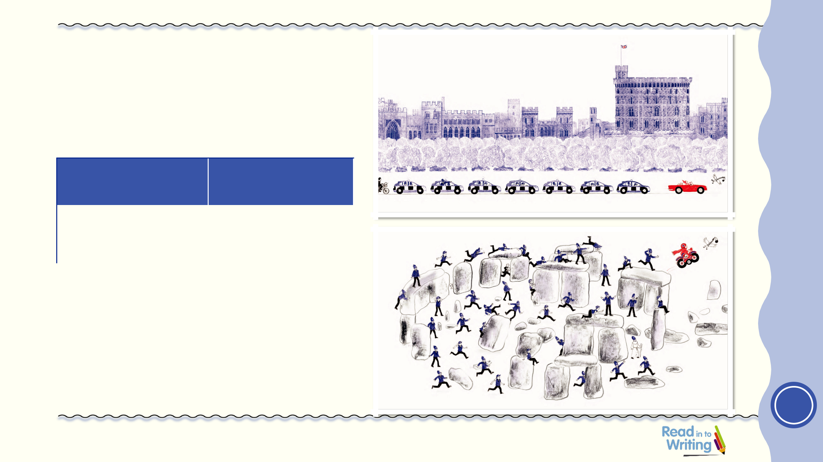
travelled to

Drove | Windsor Castle

Use with Session 12

1

Rising Stars 2019 © Hodder & Stoughton Limited

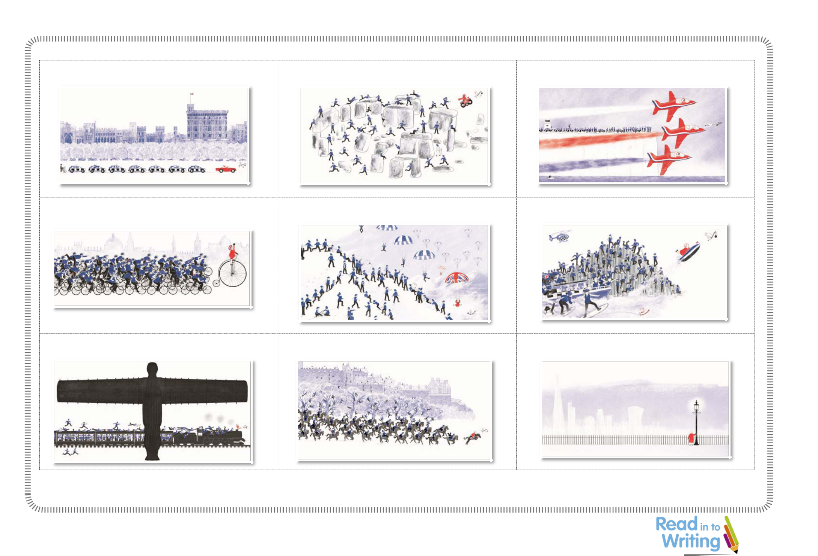
Session 12 Destinations

Windsor Castle Stonehenge The White Cliffs of Dover

Oxford Snowdonia The Giant’s Causeway

The Angel of the North Edinburgh Castle London

Rising Stars 2019 © Hodder & Stoughton Limited
1

Recommended Year Group: Year 1
Where the Wild Things Are by Maurice Sendak Recommended Term: Spring 1 / Spring 2

Recommended Edition: 9780099408390

Unit overview

This three-week unit of work teaches many aspects of the Year 1 English curriculum through exploration of the magical, prize-winning, classic picture book Where the Wild Things Are by Maurice Sendak. The text is used to develop reading comprehension skills, including inference and vocabulary generation, as well as word-reading skills. Spelling and grammar will be rehearsed within the context of the text – comparing the characters and practising the use of suffixes. Children will work on their writing skills by discreet handwriting, story mapping and sequencing. They will also have the opportunity to re-enact through drama and music. This leads to the writing of a response to a letter and their own innovated versions of the story in a final piece of narrative writing which incorporates the prior learning from the unit and the creation of a class anthology of the children’s original work. All resources, session planning and teaching slides are included within this unit.


Themes and cross-curricular links

- Music – musical accompaniment to enhance storytelling and communicate mood

- Geography – making maps of story setting

- Computing – algorithms, instructions for travelling from Where the Wild Things Are to Max’s bedroom

- Maths – co-ordinates

- Art – making props and masks for storytelling and drawing, painting characters for description

- Drama – role playing scenes, sequencing/ retelling the story, hot seating, reading aloud

- SMSC – exploring themes of friendship, loneliness and love, responsibility and respect, kindness and fairness, British value of democracy



Writing outcomes

- Annotated story maps (session 2) – familiarising, sequencing and planning
- Character description (session 6) – describing and then comparing their own wild things (to entertain), vocabulary generation and use of comparative language (-er, -est suffixes)

- Missing poster (session 8) – vocabulary generation and application of comparative language learned (to inform/explain)
- A letter to the Wild Things (session 9) – persuasive writing

- Retelling the story with innovation (session 12) – narrative writing (to entertain), an original version of the story, and creation of a class anthology of original work



Curriculum coverage

Spoken language:

- participate actively in discussions, role play and presentations, speaking audibly and fluently
- listen and respond appropriately to adults and peers

- ask relevant questions to extend understanding and knowledge

- use spoken language to articulate and justify answers and opinions

- use spoken language to give well-structured descriptions and explore narratives for different purposes
- use relevant strategies to build vocabulary

- use spoken language to develop understanding through imagination and exploration of ideas
- discuss what they have written with the teacher or other pupils

- read writing aloud, clearly enough to be heard by peers and the teacher

Reading:

- become very familiar with a key story, retelling and identifying its particular characteristics and genre
- discuss the significance of the title of the book and the events

- use phonic knowledge and skills, supported by the accompanying slides, as the route to decode words when accessing the text independently
- identify and join in with the predictable phrases of the text in oral retellings

- discuss themes from the text, such as love, friendship, respect and responsibility, making links to own experiences
- identify and explain the sequence of events in the text

- develop vocabulary by discussing word meanings, linking new meanings to those already known
- demonstrate understanding of the text, drawing on prior knowledge, background information and vocabulary provided by the teacher to support understanding
- draw inferences, such as inferring characters’ feelings, thoughts and motives, on the basis of what is being said and done
- predict what might happen next on the basis of what has been read so far

Grammar, punctuation and spelling:

- use the capital letter and full stop to punctuate statements

- use capital letters for proper nouns, including the names of characters, titles and the pronoun ‘I’
- use the exclamation mark, and being encouraging to use voices to express its use in role play and performance
- use the question mark to punctuate questions after question words such as ‘what’, ‘who’, ‘where’, ‘why’ and ‘when’

- use the apostrophe for omission in contractions such as ‘we’ll’

- use the coordinating conjunction ‘and’ to join phrases and extend sentences

- identify nouns, verbs, adjectives and noun phrases in texts

- use adjectives and expanded noun phrases to describe character

- use commas to separate lists of adjectives and to punctuate noun phrases

- use commas in the letter format

- understand spelling rules, such as -ll in words such as pull

- add the suffixes –ed, -s and -ing with no change to the root word, use -ed to form verbs in the simple past tense, use -ing when forming verbs in the progressive form, use -s to indicate plural nouns

- add the suffixes -er and -est with no change to the root word, use the comparative and superlative forms when describing and comparing characters from the text
- add the prefix -un to verbs and adjectives

- learn Year 1 common exception words: when, where, here, there, love, one, push, pull, full, come, some, once, ask, school, friend, put, our, house
- learn phonics alternative graphemes: ai/ay/a-e, ur/ir/er, or/au/aw, air/air/ear

Writing:

- identify the audience for and purpose of the writing and using similar shared writing as models for their own
- plan and develop initial ideas, drawing on collaborative reading and role-play opportunities
- plan writing by saying out loud what they are going to write about and compose a sentence orally before writing it
- construct sentences using a range of vocabulary and grammatical features such as joining words and clauses using ‘and’
- write short narratives by sequencing sentences

- edit and improve writing by re-reading what has been written to check that it makes sense
- accurately punctuate sentences using a range of punctuation such as capital letters at the start of a sentence (as well as for proper nouns and the personal pronoun ‘I’), spaces between words, full stops, question marks and exclamation marks
- spelling and phonics: accurately spell common exception words from the Year 1 list and words containing the single letter graphemes and digraphs and trigraphs covered so far

- handwriting: form lower-case letters and capital letters in the correct direction, starting and finishing in the right place and understanding which letters belong to which

handwriting families

Rising Stars 2019 © Hodder & Stoughton Limited

Planning Overview


Key questions

- Did you enjoy the story? What did you like about it?

- What do you think about the character of Max?

- Was Max’s mother right to call him “Wild Thing” and send him to bed without any supper?
- Did Max really go to Where the Wild Things Are?

- Were there any words or any language features that you enjoyed? Why?

- How do the predictable phrases contribute to the story?

- What impact do the illustrations have upon the reader?

Essential teaching guidance

- It could be very useful to create an English ‘Working Wall’ to accompany the unit. Generated language and vocabulary could be added to this for future reference as the unit progresses.

- Teachers should be aware that children need to develop both skimming and scanning strategies to gain understanding and retrieve specific information from a text.

- Through close study of the text, the unit provides plenty of opportunities to teach and consolidate a range of Year 1 GAPS requirements, including phonics. Raising awareness of these is supported by the teaching slides.

- When introducing contextualised weekly spelling of Year 1 common exception words, teachers may want to encourage strategies for remembering these.

- Scanning could be encouraged and developed by initially searching for visual clues in a detailed picture before progressing to text.
- Picture books like this one are an excellent resource for developing inference skills which can be developed through good questioning, discussion and modelling.

- Organising elements of the original story into a table provides the children with a clear structure to organise their own innovative ideas.


Week 1

Objectives and outcomes summary:

This week the children will:

- become familiar with the story and key vocabulary, introduce and pre-read the text

- retell the story, sequencing the events in the correct order

- revisit, sequence and retell the story, joining in with predictable phrases
- develop understanding of the story, retrieve information, infer from the text, explain their understanding and predict what might happen next in SATs-style comprehension activities

- retell and perform a familiar story through drama and performance, portray character through voice and movement

- rehearse contextualised handwriting, form letters from the long ladder family correctly with the correct series of strokes and consolidate the -ll spelling rule and use of the apostrophe in ‘we’ll’

- learn contextualised phonics: review ai/ay/a-e, and teach ur/ir/er

Resources provided:

- Teaching slides to aid discussion

- Pupil resource – Story language

- Pupil resource – Adverbial cards

- Pupil resource – Definition matching

- Pupil resource – Comprehension questions

- Pupil resource – Handwriting template

Week 2

Objectives and outcomes summary:

This week the children will:

- develop and generate descriptive vocabulary to describe Max, the wild things and their own artwork and use this in sentences (including ‘and’) to write a character description

- make further use of their growing vocabulary to compare the characters and learn to add and apply the suffixes -er and -est when generating comparative and superlative language

- develop a deeper understanding of character and purposes for writing through role play, hot seating and exploring the school grounds in search of a missing Max, as a hook to the creation of informative “Missing” posters to display around school to find him

- explore point of view through discussion and role play and persuade the wild things that Max needs to stay at home by writing a letter in response to the wild things’ letter to the children

- have opportunities for spoken language and peer feedback as children orally present their work to the class

- rehearse contextualised handwriting: review letters from the long ladder family correctly with the correct series of strokes and consolidate the use of the capital letter for the pronoun ‘I’ and the apostrophe in the word, ‘I’ll’

- learn contextualised phonics: review ur/ir/er, teach: or/ au/aw

Resources provided:

- Teaching slides to aid discussion

- Pupil resource – Missing poster template

- Pupil resource – SATs-style questions

- Pupil resource – Handwriting template

Related books for wider reading

- The Gruffalo by Julia Donaldson
- The Jolly Postman or Other People’s Letters by Janet and Allan Ahlberg


Week 3

Objectives and outcomes summary:

This week the children will:

- generate ideas for changes to the original story in preparation for their own innovative versions by plotting their ideas in a table alongside elements of the original story and comparing the two

- have opportunities to experience the writing process through collaborative shared writing of a class story before attempting their own writing

- draw on their reading and role play as a model for their own writing

- write innovative stories changing characters and settings but reflecting the style of the author and the pattern and language of the story

- experience their teacher modelling the editing process, using examples from the children’s work, before editing and improving their own

- design their own front covers and write their own blurbs for their own stories and a class anthology

- read their stories to an audience and reflect on feedback given

Resources provided:

- Teaching slides to aid discussion

- Pupil resource – Story planning template

- Pupil resource – Writing template

- Pupil resource – Handwriting template

Rising Stars 2019 © Hodder & Stoughton Limited

SESSION 8

 | Learning objective |  |  | To describe the character of Max: appearance, personality and behaviour
 | Outcomes |  |  | ● To write a character description of Max, focussing on his appearance, personality traits and behaviour
 |  |  |  | ● To use the vocabulary and grammar learned in previous sessions in the unit within sentences
 |  |  |  | ● To have a clear sense of purpose and audience for their writing task
 | Key vocabulary
 | Key vocabulary |  |  | Noun, adjective, suffix, exclamation mark, sentence, describe, feature(s), poster, missing
 | Key questions
 | Key questions |  |  | ● What is a poster?
 |  |  |  | ● What might a poster be used for?
 |  |  |  | ● What do you need to include on a poster? What features do you need to include?
 |  |  |  | ● Why do you think the wild things want Max to go back?
 |  |  |  | ● How could we help the wild things find Max?
 | Activities |  |  | ● Set up the delivery of an imaginary letter from the wild things to the children of the class; the letter, asking for the
 |  |  |  | children’s help, should explain that they are missing Max and really want to get him back to be the king of all the wild
 |  |  |  | things again and should also explain that they have reason to believe that he might be somewhere near the school;
 |  |  |  | add details which might convince the children that Max might be found somewhere around the local environment.
 |  |  |  | Clues, e.g. props such as wolf footprints, a wolf mask, a wolf tail or a crown, could have been laid around the school
 |  |  |  | and school grounds for the children to find prior to the arrival of the letter.
 |  |  |  | ● Encourage the children to discuss why they think the wild things have sent the letter. Why do you think they want
 |  |  |  | Max to go back? Remind children of the wild things’ final dialogue.
 |  |  |  | ● Ensure the children agree to help the wild things (Should we help the wild things?), then ask for suggestions of areas
 |  |  |  | around the school where Max might be found and go on a detective hunt to look for clues.
 |  |  |  | ● Once back in the classroom, share the children’s findings and ask for suggestions on how they might help the wild
 |  |  |  | things find Max. What can we do to find something or someone that is missing? Introduce the concept of the
 |  |  |  | poster, drawing on children’s possible experiences of missing pets (teaching slide 27). Introduce and explain the term
 |  |  |  | missing. What is a poster? How could a poster help the wild things find Max? Encourage the children’s suggestions

Rising Stars 2019 © Hodder & Stoughton Limited

26

and, if necessary, suggest that they make posters which, in the light of the clues found (real and imagined) by the children, could be displayed around the school to encourage the other children and staff to look out for him too.
- Look at the examples of ‘Missing’ posters (teaching slide 28). What features do you notice? What do we need to include on our posters? Who would be reading our poster around school? Identify and discuss features, e.g. size of letters, use of the exclamation mark, photograph/picture of Max, detailed physical description, description of what Max might be doing.

- Remind children of the vocabulary and comparative sentences generated in the previous sessions and use these with sentence starter prompts (teaching slides 29 and 30); model verbalising, writing and editing sentences to describe Max, encouraging contributions from the children to produce a short descriptive text which would help the audience recognise Max. The text should include the target grammar points, i.e. identify nouns and adjectives, –er,

–est suffixes and the use of ‘and’, the use of the exclamation mark and key vocabulary. It should describe Max’s appearance and information about his behaviour and personality. Generate a list of success criteria with the children and remind them of the purpose of the poster if required.

- Using the suggestions and input generated from the children, model creating a ‘Missing’ poster (teaching slide 31). Verbalise the process of choice, for example, ‘I’m going to write the word MISSING in large capital letters to make it stand out’. Ask the children to check if we have included everything against the agreed success criteria. The finished example could be added to the working wall as an excellent example for future reference.
- After the shared writing activity, children can then have a go at producing their own ‘Missing’ posters (Pupil resource). These could be displayed around the school.
- Display teaching slide 27 to remind the children of what they should include or think about as they create their posters.

Follow-up activities

- As part of a PSHE session, the session could provide an opportunity to extend the discussion with a debate about Max’s behaviour, the themes of responsibility and consequences and/or friendship and love; it also provides a

Rising Stars 2019 © Hodder & Stoughton Limited

27

stimulus for discussion about the British Value of democracy, e.g. How should we decide who is in charge? Who should make the rules?

- The character of Max could be explored further through hot seating: children could generate questions to interview children playing the role of Max.

 | Teacher guidance
 | Teacher guidance |  |  | ● | This session aims to provides further opportunity to apply and extend the focus vocabulary and grammar and the
 |  |  |  |  | success criteria generated should reflect this.
 |  |  |  | ● Examples of suggested vocabulary, model sentences and exemplar success criteria are provided on the teaching
 |  |  |  |  | slides.
 |  |  |  | ● Make explicit and reinforce grammar points as they occur throughout the session.
 |  |  |  | ● Children’s thinking about character could be extended by reflecting on and discussing how the wild things’ opinion of
 |  |  |  |  | Max might differ from their own. How might the wild things describe Max? How would you describe him?
 | Resources needed
 | Resources needed |  |  | ● | Teaching slides
 |  |  |  | ● Pupil resource – Missing poster template
 |  |  |  | ● Imaginary letter from the wild things to the children of the class (prepared in advance)
 |  |  |  | ● Character props to leave as clues around the school (e.g. wolf tail) (optional)
 |  |  |  | ● Small whiteboards and pens for draft writing
 | Curriculum coverage
 | Curriculum coverage |  |  | ● | Purpose: to inform/explain – poster to help find Max. Audience: children and staff around school
 |  |  |  | ● Acquiring a wide vocabulary, an understanding of grammar and knowledge of linguistic conventions for reading,
 |  |  |  |  | writing and spoken language
 |  |  |  | ● Writing clearly, accurately and coherently, adapting their language and style in and for a range of contexts, purposes
 |  |  |  |  | and audiences
 |  |  |  | ● | Writing sentences by:
 |  |  |  |  | ● saying out loud what they are going to write about
 |  |  |  |  | ● composing a sentence orally before writing it

Rising Stars 2019 © Hodder & Stoughton Limited

28

  - re-reading what they have written to check that it makes sense

  - discussing what they have written with the teacher or other children

  - reading aloud their writing clearly enough to be heard by their peers and the teacher

- Leaving spaces between words

- Joining words and clauses using ‘and’

- Beginning to punctuate sentences using a capital letter and a full stop

Embedded grammar

- Identifying nouns and adjectives

- Adding prefixes and suffixes: using –er and –est where no change is needed in the spelling of root words (for example quicker, quickest)
- Using the exclamation mark

- Using ‘and’ to join words and phrases

Rising Stars 2019 © Hodder & Stoughton Limited

29

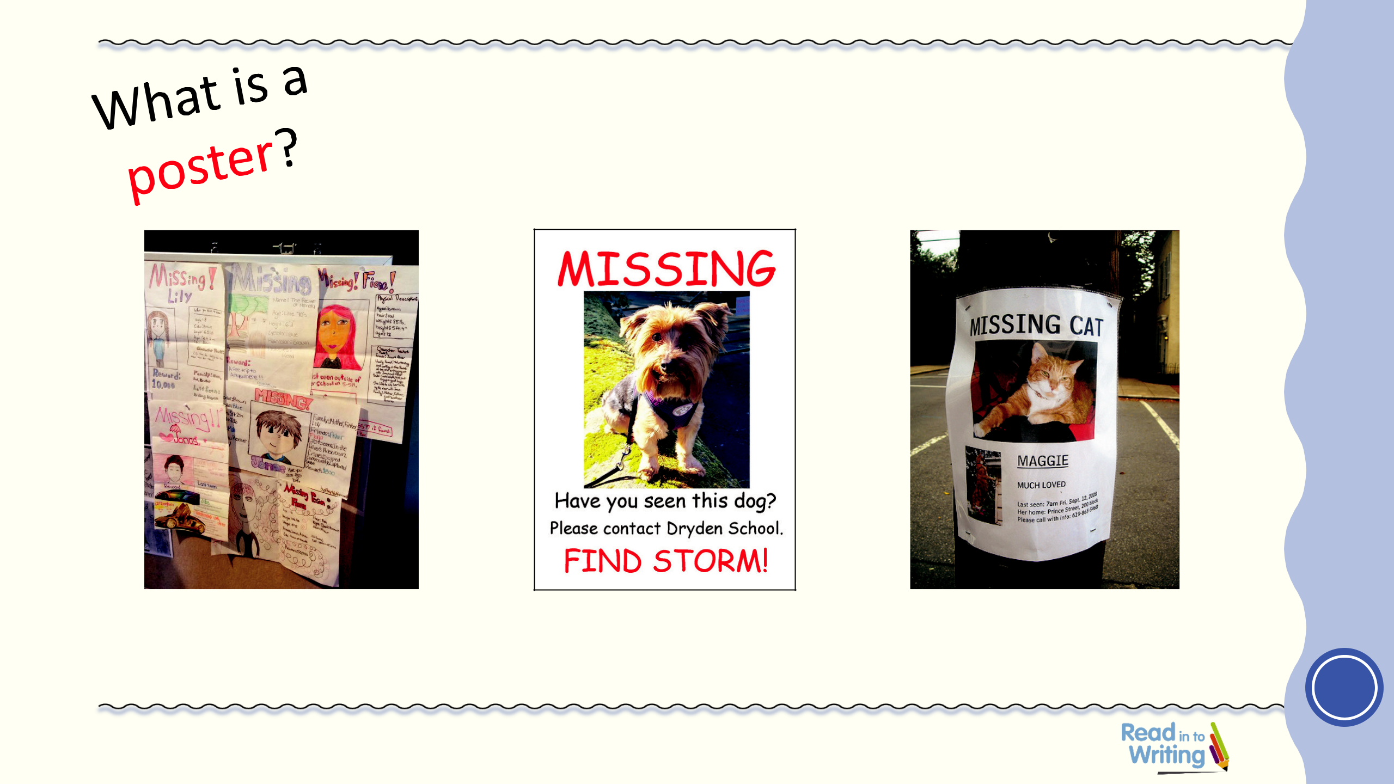
Missing!

How could a poster help us find Max?

Use with
Session 8

1

Rising Stars 2019 © Hodder & Stoughton Limited

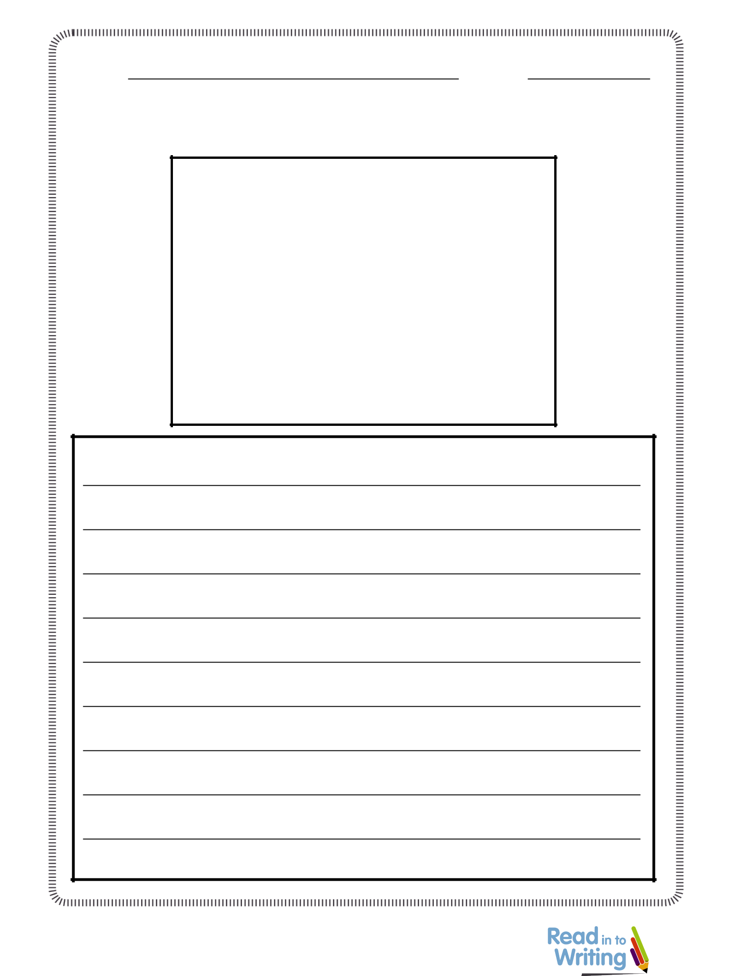
Session 8 Missing poster template

Name: Date:

MISSING!

Rising Stars 2019 © Hodder & Stoughton Limited 1

