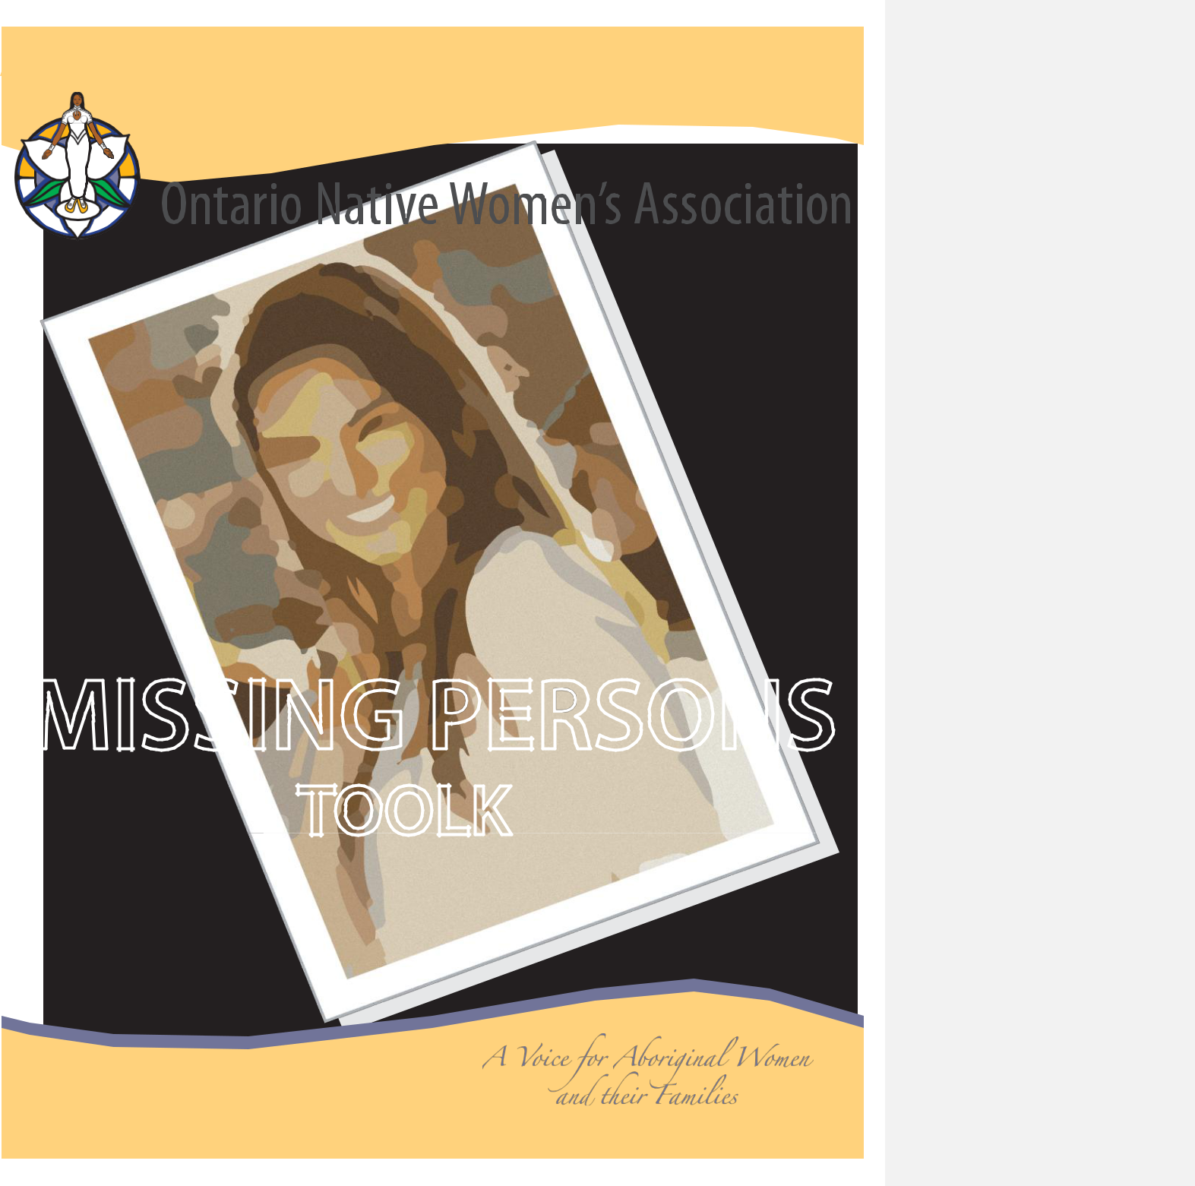

ONWA | Missing Persons Toolkit i

MISSING PERSONS
TOOLKIT

AUGUST 2014


ONWA | Missing Persons Toolkit ii

Dear Families,

As the staff and Board of Directors at the Ontario Native Women’s Association, our hearts go out to the families and friends of our Missing and Murdered Indigenous Women (MMIW). In response to the devastating circumstances many people find themselves in when a loved one goes missing, we have developed this toolkit based upon the Missing Persons Toolkit produced by Ka Ni Kanichihk Inc.

This toolkit has been created for you. It is a comprehensive guide to assist friends and families in making necessary connections to vital resources available in our communities. It provides step-by-step instructions on what to do in the immediate and long term, what to expect when dealing with law enforcement agencies and media outlets, and offers traditional self-care plans to stay positive during this most difficult time.

Please remember that you are not alone. Along with the programs and services ONWA offers, there are many other support services, programs and caring people in our communities that you can connect with.

The MMIW Programs at ONWA are here for families of Missing and Murdered Indigenous Women to provide victim services and culturally rooted family supports across the province of Ontario. Our ONWA Programs provide wholistic, trauma informed care in safe spaces that are unique to the needs of the individual families.

We are honoured that so many have shared their stories and experiences with us and would like to express our sincerest gratitude for your courage, strength and resilience!

Respectfully,


www.onwa.ca
Head Office: 150 City Road∙ P.O. Box15-684 City Road
Fort William First Nation, ON P7J1K3 ∙
Toll Free:1-800-667-0816 ∙ Phone: (807)577-1492 ∙ Fax:(807)623-1104
Satellite Office: 380 Ray Blvd ∙ Thunder Bay, ON P7B4E6 ∙ Phone: (807)623-3442

ONWA | Missing Persons Toolkit

Table of Contents

PAGE

- Mandate and Objectives

- General Information on Reporting a Missing Adult

- First 24 Hours Checklist

- 48 Hours & Beyond Checklist

- Detailed Description

- How to Make a Missing Person Poster

- Guide to Working with Social Media

- Working with the Police

- Points of Contact

- Working with the Media

- Family & Friends Contact List

- Checklist for Hospitals, Rehabilitation Centres and Places Known to Frequent

- Communication Log

- Holistic Health & The Four Directions

- Self - Care Plan of Care

- Notes Pages

- The Aboriginal Victim and Family Liaison Program

ONWA | Missing Persons Toolkit | 1


Mandate and Objectives

Mandate

The Ontario Native Women’s Association (ONWA) is a non-profit organization that empowers and supports all Indigenous women and their families in the province of Ontario.

Affiliated with the Native Women’s Association of Canada (NWAC), ONWA encourages the participation of Indigenous women in the development of Federal, Provincial, Municipal/Local government policies that impact their lives and ensure issues affecting Indigenous women and their families are heard at key government tables.

ONWA is committed to providing services that strengthen communities and guarantees the preservation of Indigenous culture, identity, art, language and heritage. Ending violence against Indigenous women and their families and ensuring equal access to justice, education, health, environment stewardship and economic development, sits at the cornerstone of the organization. ONWA insists on social and culture well-being for all Indigenous women and their families, so that all women regardless of tribal heritage may live their best lives.

Guiding Principles

ONWA’s guiding principle is that all Indigenous ancestry will be treated with dignity, respect and equality; benefits and services will be extended to all, no matter where one lives and regardless of Tribal Heritage.

Aims and Objectives

To build relationships with all levels of government and other organizations to collaborate on all socio-economic issues affecting the well-being of all Indigenous women and their families.

To increase Indigenous women’s skills and capacity in planning, developing, and managing an array of programs and services that directly impacts their lives and those of their families. (mental)

To continue to work towards unity amongst Indigenous women and their families to affect positive change in society in recognizing the importance of diversity and inclusion of all people.

- Through a communication strategy with our membership we will encourage a unified voice to fully participate politically to ensure Indigenous women and their families are appropriately represented

To promote and advance equality and social justice issues as they affect the realities of Indigenous women’s lives. (emotional)

- Designing of resource materials and capacity development opportunities

ONWA | Missing Persons Toolkit 2

To preserve and promote the sacred roles of Indigenous women and their families as valued and respected members in the community. (spiritual)

Services are provided in a culturally respectful manner

Provide opportunities for Indigenous women to learn and teach traditional ways to future generations that are unique to Indigenous culture.


Disclaimer

All information in the Missing Persons Toolkit has been developed for informational purposes only. The Ontario Native Women’s Association (ONWA) is not responsible for any discrepancy, exclusion or conflict in the information provided.

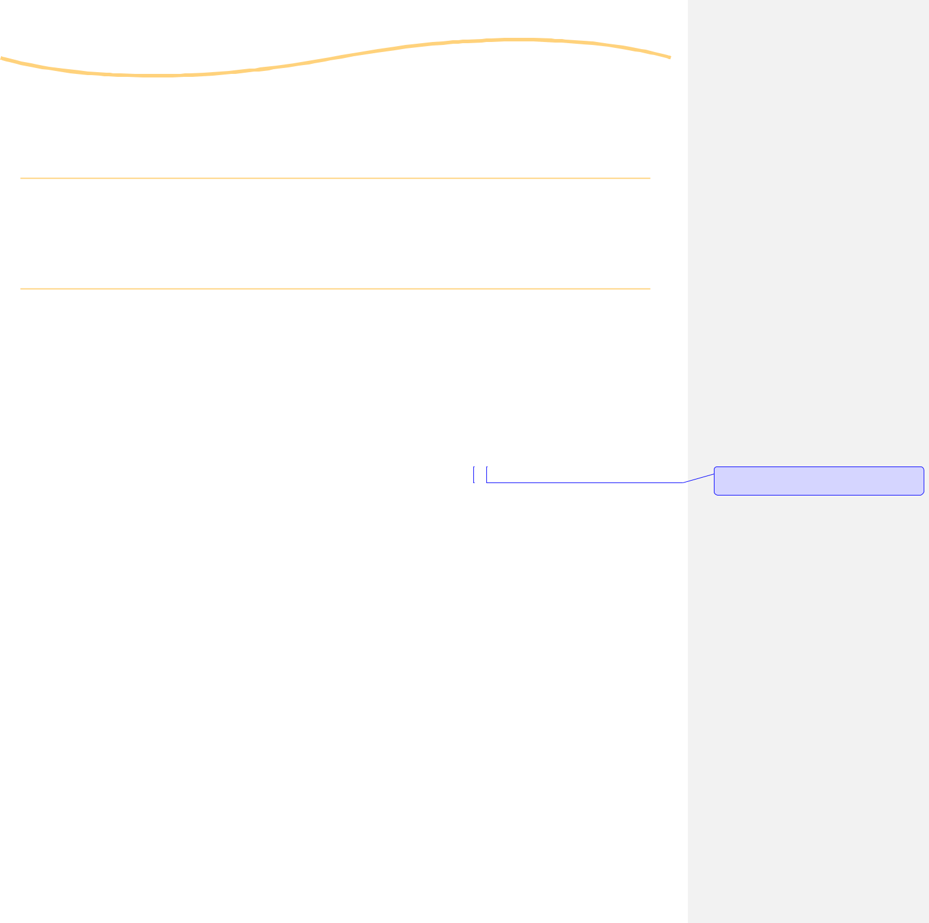

ONWA | Missing Persons Toolkit | 2

General Information on Reporting a Missing Adult

Adults over the age of 18:

They can choose to leave home and cut off all contact with friends and family - this is not considered a crime. In this situation, law enforcement is very limited to what they are able to do, and under no obligation to the family to disclose any information unless specifically permitted by the individual.

If the child is under the age of 18:

The Amber Alert is a province wide innovative program that partners the province’s law enforcement community, media broadcasting agencies, and the public in locating abducted children.

AMBER:

Alert is a comprehensive plan which provides a coordinated and rapid response to child abductions throughout your province. It provides the public with immediate and up-to-date information about a child abduction by widespread media broadcasts and solicits the public’s help in the safe and swift return of the child. There is also an Amber Alert Ontario page on Facebook.

If you have reason to believe there may be foul play contact police immediately at 9-1-1. If there are no signs of foul play, and the person has gone missing in Thunder Bay, Kenora, or surrounding area, contact authorities.

Comment [RS1]: All of Ontario if were looking at making this a provincial tool kit???

ONWA | Missing Persons Toolkit 3

First 24 Hours Checklist

Important steps to take when you become aware a relative or friend is missing.
These forms can be found at the back of this toolkit.

NOTES:
o Contact all family, friends and acquaintance to confirm that the person is indeed missing.

- Conduct your own search with family, friends, hangouts and hospitals prior to reporting them missing to the police.

- Keep detailed notes and documentation of who you talk to, when, and main points of the conversation as well as all efforts of your search.

- Contact all relatives, friends, foster-families and any contacts in other communities, and other provinces, to ensure that your loved one has not gone to stay with them.

- Complete a detailed description of the missing person; hair and eye color (glasses/coloured contacts), height, weight, scars, tattoos or any distinguishing marks or piercings, what they were wearing. Note if they are on any medications, if they have any health/mental health issues, etc. Focus on distinctive features, as well as jewelry always worn by your loved one.

- Write down a detailed pattern of behaviour for your loved one. Write down what your loved one’s typical day would be like – Work? School? Childcare? Family Visits? Friends? Volunteering? Note: Have there been any changes to their routine recently.

- Report the person missing to the police! It is not necessary to wait 24-48 hours particularly if you have noticed a change in their behaviour or routines. Write down the case number, contact person spoken to, as well as the Officer’s badge number for easy reference. Let all family members know who the contact person for police is. Police will contact only one person per family and try a maximum of two phone numbers. It is important that these phone numbers work, and have accessible voicemail.

ONWA | Missing Persons Toolkit 4

NOTES:
o Confirm your loved one’s name will be added to the CPIC

(Canadian Police Information Centre) database, which
is a nation-wide access communication system to basic
information on your missing relative or friend.

- Record ALL contacts and conversations you have during your search for your loved one.

- Log all the names, phone numbers, and addresses you can think of for people your loved one would have had contact with. Ask these contacts for other contacts you may not have. Ensure you touch base with all of these people. Provide any updates to the police.

- Check cell phones and email accounts for activity. Check social media websites (Facebook, Twitter, Skype, blogs, etc.) to see if there has been any activity on the missing person’s accounts.

- Gather as many photos as possible of the missing person for police to use in the Missing Persons Poster. You can even use pictures on Facebook or other websites – just save them to a computer.

- Seek support from family, friends and organizations. If you don’t know who to turn to for help, call the Ontario Native Women’s Association at 1-800-667-0816, www.onwa.ca or use the www.211ontario.ca website.

- Keep your compiled list of support people and their contact information near the phone so others can make calls to follow up with contacts of your loved one when you are not at home.

- Make sure someone is answering the phone 24 hours a day and delegate this ‘phone duty’ between family members and friends so you are supported. Keep ALL voicemail boxes clear so messages are not missed.


- Contact the Missing Kids.ca – Canada’s missing children

resource centre at 1-866-KID-TIPS (543-8477) to request assistance in your search or visit www.missingkids.ca

ONWA | Missing Persons Toolkit 5

48 Hours & Beyond Checklist

This list is designed to support you with the important things you can do
to continue the search when a relative or friend is missing.

NOTES:
o Confirm with the police or RCMP who the contact(s) will
be, and make sure the police have their name and correct
contact numbers.

- Ask police to release a picture you have chosen of your missing loved one to the media along with a statement on behalf of the family.

- Designate a family media spokesperson. Ideally, this person should be someone who feels comfortable and confident when speaking to the media and can keep things clear and brief. You may also want to designate a back-up media contact if your first contact may not always be available.

- Designate a family member to be the coordinator for organizing phone monitoring. This person can also be responsible for checking in with family members needing support. Again, make sure someone is answering the phone 24 hours a day and all voicemail is cleared so messages are not missed if a call is not answered.

- Hold a meeting with family and friends to plan what needs to be done to continue the search and decide on who is responsible for each task. Choose one or two designated organizers to follow up with all family and friends who have been given search-related tasks to make sure that these tasks are getting done. Follow up meetings and communication is essential.

- Ask all family members to make a list of friends who may be able to offer supports (meals, childcare, rides, putting up posters, etc.) This permits family members to be available for police and media work, and ensure they can take a break and get some rest.

- Make and put the poster up everywhere; especially the places where your loved one regularly hangs out. Circulate the poster via email to contact lists and social media sites, encourage friends and family to do the same.

ONWA | Missing Persons Toolkit 6

o | Provide a list of full names, phone numbers and addresses | NOTES:
 | wherever possible. Keep this list updated and accurate.
 | Include a list of your loved ones doctors, dentist and other
 | care providers. Look up their provincial medical card number
 | as well as any additional health care card numbers they may
 | have.

- List if your loved one is in school or training. List any and all teachers, trainers, counsellors etc. that they may have mentioned.

- List banks, credit unions, or cheque cashing places that your loved one deals with. If you can access copies of their bank/ credit card statements (if any) keep these handy for police.

- If your loved one is a status Indian, locate their status card number, as well as list the contact information for their band office. Identify whether your loved one has a passport.

- Start a Facebook page or group for your loved one to share information about their disappearance and invite ALL of your Facebook contacts.

- Provide police with the information on all of your loved one’s online accounts including Facebook, Bebo, Twitter, MySpace, Hotmail, Gmail or any other email/online providers. Police may have the ability to check activity on these accounts.

- If foul play is suspected, ask about a Crime Stoppers video or any other ways you can inform the public. Talk to your assigned police officer about this or call Crime Stoppers at

  - 222-8477.

- Place your loved one’s toothbrush or hairbrush, as well as an article of worn clothing, in sealed Ziploc bag in case the police request it in future. Tape it closed and date when this was done. This will help you from opening it from time to


time, or from someone mistaking it for something else and removing items.

- The ONWA Aboriginal Victim Family Liaison workers can assist you for support and advocacy through this very difficult process. Call 1-800-667-0816 to be directed to the
AVFL nearest you.

ONWA | Missing Persons Toolkit 7

Detailed Description


Hair Colour/Style
(most Recent + known to have)

Eye Colour / Glasses /
Coloured Contacts

Height / Weight

Medications

Medical / Mental Health Condition

Birthmarks/Scars /
Distinguishing Marks

Tattoos / Piercings

Pant Colour
(Jeans, shorts, capris)

Shirt Colour
(Hoodie, Zip-up, long sleeve, t-shirt)

Shoe Colour/Type/Size

Jacket type, Colour

Jewelry Wearing

Person last spoken to

Person last seen with and where/
Known to frequent

ONWA | Missing Persons Toolkit 8

Detailed Description

Please use this section to note identifying scars, birthmarks, moles, piercing, tattoos, etc

Front and left side view: | Special Notes:




Back and right side view:




Special Notes:

ONWA | Missing Persons Toolkit 9

How to Create a Missing Person Poster

Once you have completed your report with the police, it is crucial
NOTES:
to get the word out as quickly as possible about the person who is missing. Creating a missing persons poster is a good way to accomplish this – it lets the public know who the person is, their Identifying marks, and who to contact if they have seen or heard of her whereabouts. Making the poster will require a few items. The most important one is at least one recent picture of the person missing! The Ontario Native Women’s Association AVFL workers can assist you with making the posters, printing, and distribution.

When making the poster, follow these tips:

- Have pictures of the individual (clear and visible) available for easy access. Scan the pictures (unless you already have electronic copies) and save each in a useable format. If possible, include pictures that show any distinguishing marks (birthmarks, scars, piercings and tattoos). Resize the pictures and make any other edits needed. Save the pictures on your desktop or create a folder on your computer.

- Note all relevant and pertinent information – a description of what they were wearing when you saw them last, or type of clothing worn, vehicles involved (year, make, model, color/distinguishing decals and/or paint/, window tints, dents, etc., and license plate number). Include information such as last place seen, who they were with, and where they are known to frequent, and so on.

- Verify any phone numbers of local police detachments or organizations involved and all web addresses included on the missing person poster. Contact information is very important and needs to be accurate.

- Open the blank poster template. Insert the pictures on the missing person poster.

- Include critical information on your missing person’s poster. Have someone review your poster for errors. Save a copy of the missing person poster. You can print copies of it or send it out through email. It will be readily available for future edits and use.


Missing Persons Poster:

9 Example

10 Blank Template
Resource: someoneismissing.com

MISSING
Jane Doe


AGE -

21

EYES -

Brown

HAIR -

Brown

HEIGHT -

5 ft. 4 in.

WEIGHT -

125 lbs.

LAST SEEN -

7:30 p.m.

August 18, 2014

310 Memorial Ave

Thunder Bay, ON

Jane Doe was last seen leaving the 310 Memorial Ave. Tim Hortons on August 18, 2014 at roughly 7:30 p.m. in a dark blue, 1997 Lincoln Town Car.

Jane Doe was last seen wearing black pants, a pink floral shirt, and white tennis shoes.

Attempts to contact Jane Doe, as well as an initial search, have been unsuccessful.

Anyone with information PLEASE CALL:
Thunder Bay, Crime Stoppers Tip-line: 807-684-1309
PLEASE HELP!
REWARD, up to: $ 1,000

MISSING

AGE -

EYES -

HAIR -

HEIGHT -

WEIGHT -

LAST SEEN -

Anyone with information PLEASE CALL:

PLEASE HELP!
REWARD:



ONWA | Missing Persons Toolkit | 12

Guide to Working with Social Media

Instructions and information to support you in using Social Media in your search for your loved one:
For many social media sites, you will need to start with an email account. Social media includes
Facebook, Bebo, Twitter, Gmail, and Hotmail (for those who do not have a current email, etc).

Hotmail Instructions

Type in www.hotmail.com and look to your bottom left to sign up for an account.

You will be redirected to a page where you need to enter all your information and choose a name for your account.

Make sure to pick a name that will be easy to remember, and write it down to avoid having to search or make up a new account. Often using a version of your first and last name is ideal if you are able to.

When choosing your password try to choose wisely to ensure no-one can easily access your account.
Choose something that is easy for you to remember but difficult for others to figure out.

When you are asked for an alternate email address, and if you do not have one you will have the option of answering a security question.

After all this information is entered, you will then be forwarded to your new Hotmail account with further instructions on managing it.

Tip: Add all your email contacts immediately to your “address book” so they are easy to access for sending email updates.

Facebook Instructions | www.facebook.com
Bebo Instructions | www.bebo.com
Twitter Instructions | www.twitter.com
Gmail Instructions | www.gmail.com

Formatted: Font: 11 pt, Italic, Font color:

Auto, Character scale: 100%

Formatted: Font: Italic

ONWA | Missing Persons Toolkit 13

Working with the Police

It is important to remember that there is no 24-hour waiting period to report a person missing!

When a loved one has gone missing, it is an extremely stressful situation for the family. A positive relationship with the police helps everyone stay focused on finding the missing person.

What will the police ask?

Expect the police to ask you to complete your own search of family, friends, hangouts and hospitals before they take a missing persons report.

Be prepared to answer any number of questions. If you are unsure about why they are asking a particular question, you can just ask them why they want that information.

What to expect from the Police

- Always remember that as a family member of a missing person, you have rights.

- You can ask for your police contacts name and badge number, and case file number.

- You can ask what follow ups the police will be doing.

- You can ask if similar cases have been reported.

- You can give consent to check if your loved ones identification has been used nation-wide (driver’s license, credit cards, bank cards etc.)

- Do not hesitate to ask the police any questions you may have. You can call missing persons with your case number and ask for updates or for clarity on information previously given to you.

- You can request police do media updates, a Crime Stoppers video (if foul play is suspected) and other awareness campaigns.

- Try hard to think of small details about the time before your loved one went missing – even small things can be very significant for police so do not hesitate to tell them everything.

- If your family is offering a reward, make police aware of the details as it may impact the number of tips that are coming in about your loved one (rewards increase the number of tips). Police are not responsible for offering rewards, nor will they communicate the details of the reward that is being offered.

The majority of missing persons are located within three days; most are located within 24 hours of being reported missing. The success of finding a missing person is greatly increased by the contributions and efforts of friends, family, and the community.

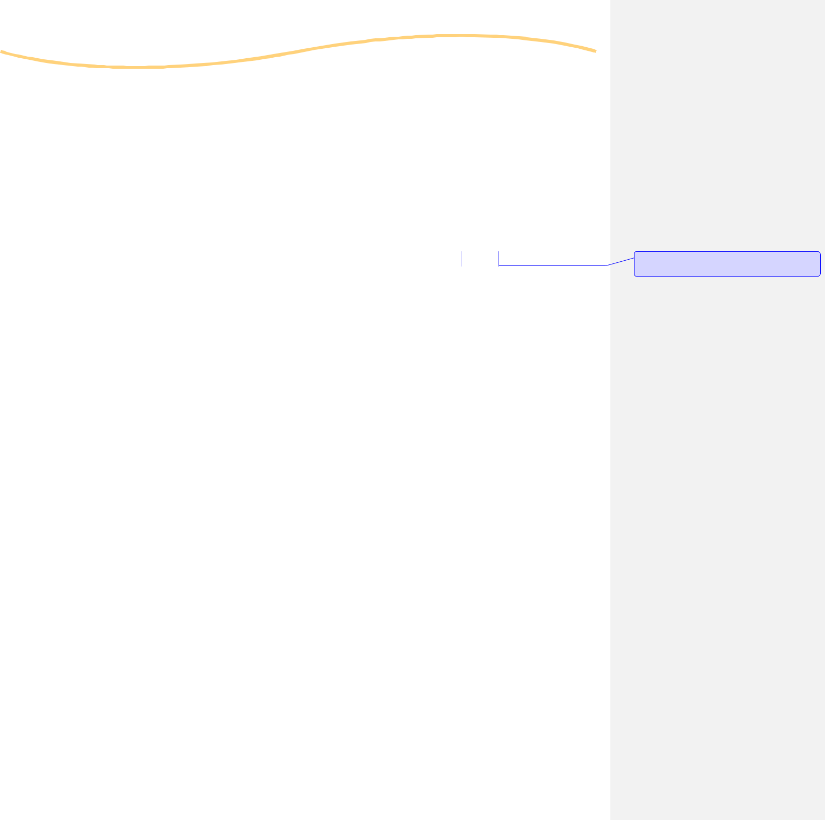

ONWA | Missing Persons Toolkit | 14

Missing Persons cases include:

- Runaway youths

- Voluntarily missing adults

- Wandered/Alzheimer patients

- Parental abductions where there is immediate danger to the child

- Non-family abductions

- Custody dispute abductions

- Unknown circumstances

- Unusual/suspicious circumstances

The Ontario Provincial Police, Nishnawbe-Aski and Grand Council Treaty #3 Police Services handle requests from other agencies to try and locate people who may be in Thunder Bay, Kenora, and surrounding area. Local and Provincial authorities are trained to use best practice tools and procedures in their investigations.

Endangered Missing Persons:

- A person with a disability (physical or mental)

- A person who is very young (naive) or elderly (Alzheimer’s)

- Prescription medication dependent

- Unfamiliar with the city

We recognize that persons who are associated with violent behaviour or that engage in a lifestyle that is considered to be high-risk (environmental conditions, homelessness, gang involvement, addictions, and sex trade) are also considered “endangered.”

Authorities conduct a Risk Assessment on every missing person reported and if the assessment dictates, a uniform car will be dispatched to begin the investigation. If additional resources are needed in the investigation, authorities will call in other detachments and agencies to lead or assist in their area of expertise.

Missing Children:

The majority of missing persons reported are young, under 18 years of age. The most common reason a youth is reported missing is that they have run away from their place of residence. There are a variety of risks attached to children who run away and unknowingly expose themselves to a variety of elements (addictions, abuse, exploitation, etc.)

Custody disputes are another common reason where children are being reported missing or abducted. Local authorities where the report is taken investigate these incidents, unless immediate bodily harm is a risk factor to the child. If it is believed that the child will be removed from the city, province, or country, or that there are other safety concerns for the child – other specialized units will be called in to continue the investigation.

Missingkids.ca (https://missingkids.ca) offers a variety of services to families of missing children. This is a service that everyone (friends, family, and authorities) can access and is available to offer assistance when investigating reports of missing children.

Comment [RS2]: Same comment about making it provincial???

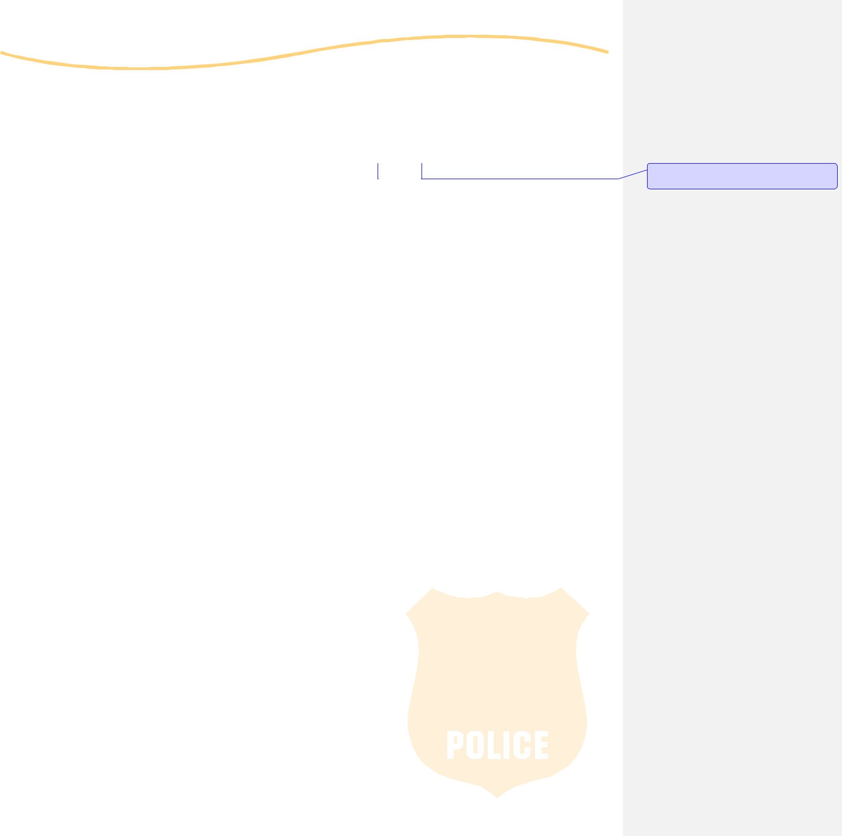

ONWA | Missing Persons Toolkit | 15

Points of Contact

Police detachments listed are for the Thunder Bay and Kenora sites, however if you require further assistance in locating a detachment closer to you please call ONWA @ 1-800-667-0816 to speak with one of the Aboriginal Victim and Family Liaisons.

Thunder Bay: Kenora:

Comment [RS3]: Again, this is specific to 2

sites….

Thunder Bay Regional Health Sciences Centre
980 Oliver Rd,
Thunder Bay, ON P7B 6V4
Tel: 807-684-6000

Thunder Bay Indian Friendship Centre 401 N. Cumberland St. Thunder Bay, ON P7A 4P7 Tel: 807-345-5840

Ontario Provincial Police North West Region Headquarters 615 James St. South, 2nd Floor Thunder Bay, ON P7E 6P6
Tel: 807- 473-2700 Fax: 807- 473-2796

Anishinabek Police Services
Fort William Detachment 109 Mission Rd.
Thunder Bay, ON P7J1K9

Tel: 807-625-0232

City of Thunder Bay Police

1200 Balmoral St, Thunder Bay, ON P7B 5Z5 General Inquiries: 807-684-1200
Complaints against Police Officers: 807-684-1286
Criminal Investigation: 807-684-1214
Court Office: 807-684-1300
Crime Stoppers Tips: 807-684-1309
Victim Assistance Unit: 807-684-1290

City of Thunder Bay Police
Victim Assistance Unit
1825 Arthur St. East
Thunder Bay, ON P7E 5N7
Tel: 807-625-1290

Lake of the Woods District Hospital
21 Sylvan St.
Kenora, ON P9N 3W7
Tel: 807-468-9861

Nechee Friendship Centre
1301 Railway St.
Kenora, ON P9N 0B2
Tel: 807-468-5440

Ontario Provincial Police
350 Highway 17A
(Kenora By-Pass)
Tel: 807-548-5534

Treaty #3 Police Hdqts.
P.O. Box 1480
Kenora, ON P9N 3X7
Tel: 807-548-5474 Fax: 807-548-8387
Emergency Contact: 1-888-310-1122

Kenora Municipal Detachment
1125 Highway 17E
Tel: 807-467-2111



ONWA | Missing Persons Toolkit | 16

Working with the Media

It is your right to request a media interview! Authorities will issue an initial request for the public’s help in locating your loved one, but it will be your responsibility to follow up. It is best to have a designated individual or family member be the media representative and for them to call or email different media outlets (radio, TV, large and small local papers) to suggest they cover your loved one’s story. The ONWA AVFL program can help with setting this up.

A generic template of a Media Release can be found online. If you need assistance creating the media release please call ONWA at 1-800- 667-0186. After sending out the initial media release, it is important to do weekly follow up media releases and the AVFL is available to assist you with these until your loved one safely returns home.

If you choose to do the Media Release by yourself, ensure you get a business card listing the name, contact information and media organization the reporter works for. Keep this information in the Communication Log for easy access so you can contact for updates.

Reporters receive many assignments every day and they often will not have real information on your story – you are the expert who knows the details and how you would like the reporting on your loved ones’ story handled. Provide the Media with the same precise information you have the police so they reporter can effectively relay your story.

A respectful relationship between you and the Media will ease the stress of the situation. In either case, whether how they relayed your message is accurate or inaccurate – communicate this with them. This helps to educate the report as well as ensuring what you want relayed is what they say.

The media will ask you for the phone number of the police detachment or investigator who is handling your case.

Always provide media with the Crime Stoppers phone number and remind them that Crime Stoppers provides a $2000 cash reward for information. If the family is offering an additional reward, this also needs to be mentioned.

Comment [RS4]: Change to MMIW programs wherever it is specific to AVFL????

ONWA | Missing Persons Toolkit 17

This is a draft Media Release for reference detailing what information the family should include.

DRAFT - Media Release

City/town, Province

Month, day, year

For Immediate Release

Missing Person – (name of missing person)

The family of (MISSING PERSON’S NAME HERE) requests the public’s assistance in their efforts to locate their missing loved one. In collaboration with the (INSERT POLICE AGENCY NAME HERE) and the Missing Persons Unit, they are attempting to determine the whereabouts of (MISSING PERSON’S NAME HERE) from (CITY, PROVINCE HERE). On (DATE, MONTH YEAR), (MISSING PERSON’S NAME HERE) was reported to the police as missing. Repeated attempts to contact (MISSING PERSON’S NAME HERE), as well as an initial search, have been unsuccessful.

(MISSING PERSON’S NAME HERE) was last seen or heard from on (DATE, MONTH, YEAR, TIME HERE), and was last seen at (LOCATION HERE- CHECK WITH POLICE IF OK TO RELEASE). (MISSING PERSON’S NAME HERE) is (ETHNICITY HERE) and was last seen wearing (DESCRIPTION OF CLOTHING HERE). (MISSING PERSON’S NAME HERE) has (EYE COLOUR/GLASSES/CONTACTS/HAIR COLOUR AND STYLE), is (HEIGHT AND WEIGHT HERE), and has (TATTOOS, SCARS, PIERCINGS, BIRTHMARKS, DISTINGUISHING MARKS HERE). Please take the time to look at the attached photographs and help us locate our loved one.

Any assistance with locating (MISSING PERSON’S NAME HERE) is greatly appreciated by the family.

If you have seen or have knowledge of the location of, or have any information that could help us locate our loved one please contact (POLICE AGENCY HERE) at (POLICE PHONE NUMBER) or Crime Stoppers at 1-800- 222-8477 as soon as possible. Callers to Crime Stoppers never have to reveal their identity and may be eligible for a cash reward of up to $2,000.

Contact: (INSERT FAMILY MEDIA CONTACT NAME, PHONE NUMBER, EMAIL ETC. INSERT POLICE/RCMP CONTACT NUMBERS HERE AGAIN)

ONWA | Missing Persons Toolkit 18

Family and Friend Contact List


Name of Friend or Family Member

Phone Number

Alternate Contact
Information

Notes

ONWA | Missing Persons Toolkit 19

Checklist for Hospitals, Rehabilitation Centres
and Places Known to Frequent


Name

Address

Phone Number

Date/Time

Notes

ONWA | Missing Persons Toolkit 20

Communication Log


Date/Time

Name of Contact

In Person / On Phone

Address/
Phone Number

Notes

ONWA | Missing Persons Toolkit | 21


Holistic Health & Thethe Four Directions

It is extremely imperative that you make sure you are taking care of yourself. Keeping yourself in balance and caring for the four quadrants of self will make it easier to care for and help others during this difficult and stressful time. Maintaining balance in your circle will help you and loved ones stay positive and optimistic.


Emotional

The Emotional dimension deals with secure well-being and attachment, healthy self-confidence and emotional stability. We need to learn to cope with our emotions and in doing so effectively create a holistic balance within ourselves.


Spiritual

The Spiritual dimension deals with the inner self and all that is, accepting and acknowledging who we are. When need to focus on keeping our spirits pure and our minds clear. Wellness factors include praying, learning or hearing traditional songs, the sound of the drum, participating in cultural ceremonies, knowing the language and understanding their connection and relationship to self, family, nation, land, animals and the spirit world.


Physical

The Physical dimension of the medicine wheel deals with the functional operation of the body. Doing good things with and to your body will assist in protecting it and contributes to the natural filter process. It is important to take care of yourself physically and avoid toxin-like substances (alcohol, drugs, tobacco).


Mental

The Mental dimension deals with the well-being of one’s mind. Be open to continuous learning. Wellness factors related to the mental dimensions include the ability to communicate, concentrate, problem solve, understand and organize concepts. Spending quality time with friends and family will ease your thoughts. Surround yourself with positive people and surroundings. Each person contributes either positively or negatively to his or her environment and community so it is in everyone’s best interest to strive for a healthy relationship with the world and all of the creatures in it.


Talk for Healing 1-855-554-HEAL (4325) www.talk4healing.com is a free and culturally safe telephone help line for Indigenous Women living in Northern Ontario, living in urban, rural and remote communities on and off reserve. It is a confidential, 24 hour, 7 day a week helpline offering services in English, Ojibway, Oji-Cree

and Cree. Services provided are culturally sensitive crisis counselling, advice and support, personalized information and referrals, and scheduled counselling sessions. Counsellors are accepting of Indigenous women’s issues in a non-judgmental way and are there to help you find the path to personal healing.

ONWA | Missing Persons Toolkit 22

Self - Care Plan of Care

What you may be experiencing currently
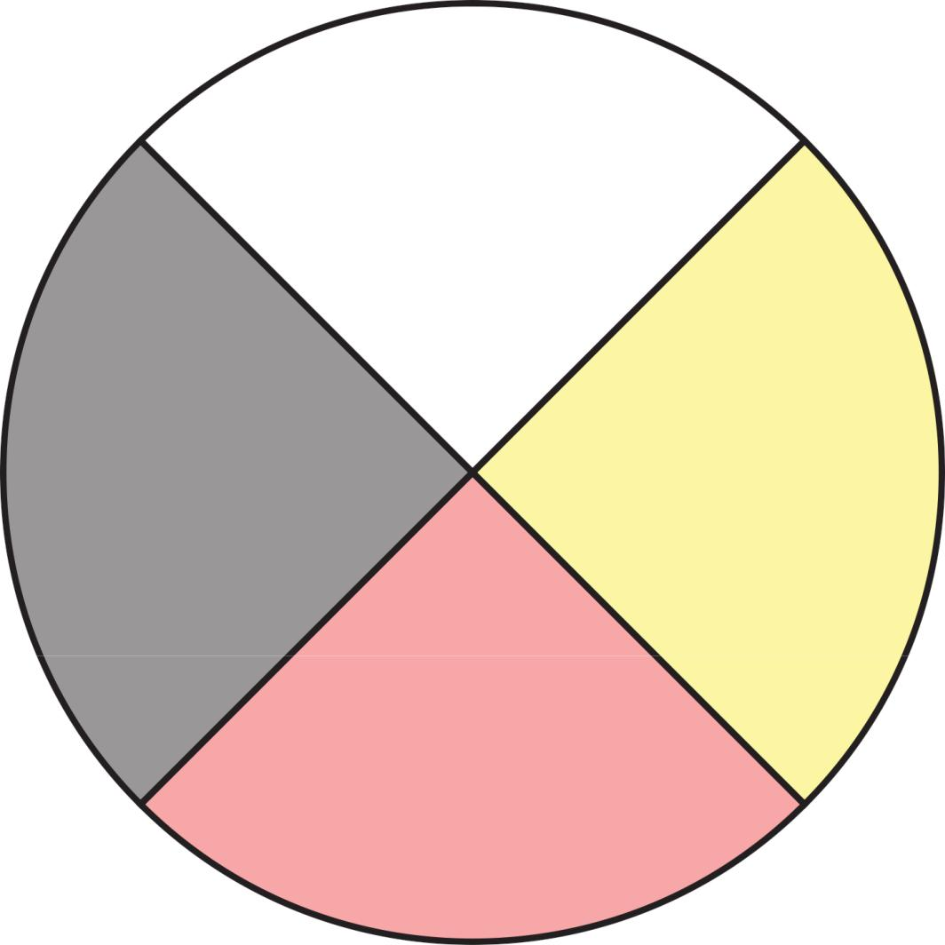

Spiritual

Any change in behaviour,
withdrawal, irritability, anger,
restlessness, irregular sleeping
patterns, change in social activity,
restoring to old coping habits, loss/
increase of appetite, loss/increase
of alcohol consumption, increasing
anxiety, absenteeism, pacing

Emotional | Physical
Fear, Guilt, Grief, Denial, Anxiety, | Chills, Thirst, Vomiting, Nausea,
Fear, Guilt, Grief, Denial, Anxiety, | Dizziness, Headaches, Chest pains,
Agitation, Depression, Intense anger, | Dizziness, Headaches, Chest pains,
Agitation, Depression, Intense anger, | elevated blood pressure, shock
Feeling overwhelmed, disconnection, | elevated blood pressure, shock
Feeling overwhelmed, disconnection, | symptoms, tension, Insomnia,
loss of emotional control, | symptoms, tension, Insomnia,
loss of emotional control, | Fatigue, Exhaustion, stomach/
inappropriate emotional response, | Fatigue, Exhaustion, stomach/
inappropriate emotional response, | digestive problems
emotional outbursts | digestive problems

Mental

Confusion, nightmares, Hyper-
vigilance, suspiciousness, difficulty
problem solving, difficulty making
decisions, poor concentrations/
memory, heightened/lowered
alertness, Hyper-critical

Any of these symptoms may need medical attention. Maintain regular contact with your doctor if any of these symptoms persist.

ONWA | Missing Persons Toolkit | 23

Self - Care Plan of Care

What you can do to take care of yourself

Spiritual

Write poetry, read, talk through
your feelings with someone you
trust or sit with an Elder/Medicine
person, listen to calming music, get
sufficient sleep and rest, walk with
mother earth, controlled breathing
techniques, meditate and relaxation
exercises, fast, attend ceremony and
sweat lodges, smudge to cleanse
your mind

Emotional

Talk through your feelings with
someone you trust or sit with an |  |  | Physical
Elder/Traditional Healer or |  |  | Drink lots of water, eat healthy, get
Medicine person, listen to calming |  |  | Drink lots of water, eat healthy, get
 |  |  | sufficient sleep and rest, moderate
music, get sufficient sleep and |  |  | sufficient sleep and rest, moderate
 |  |  | exercise, hobbies, walk with
rest, walk with mother earth, |  |  | exercise, hobbies, walk with
 |  |  | mother earth, controlled breathing
controlled breathing techniques, |  |  | mother earth, controlled breathing
 |  |  | techniques, meditate and relaxation
meditate and relaxation exercises, |  |  | techniques, meditate and relaxation
 |  |  | exercises
read, fast, attend ceremony and |  |  | exercises
sweat lodges, smudge to cleanse
 | your mind

Mental

Get sufficient sleep and rest, walk
with mother earth, controlled
breathing techniques, meditate and
relaxation exercises, read, sit with an
Elder/Medicine person, fast, attend
ceremony and sweat lodges, smudge
to cleanse your mind

ONWA | Missing Persons Toolkit 24

Self - Care Plan of Care

Use this to complete your own plan of care


Spiritual

Emotional Physical

Mental

ONWA | Missing Persons Toolkit 25

Notes Page

ONWA | Missing Persons Toolkit 26

Notes Page

ONWA | Missing Persons Toolkit 27

ONWA’S PROGRAMMING LOCATIONS

Thunder Bay | Dryden | Kenora
380 Ray Blvd | 24 Duke Street | 136 Main Street S
1-800-667-0816 | 1-800-667-0816 | 1-800-667-0816
Geraldton | Timmins | Sioux Lookout
200 McKenzie Ave | 145 Wilson Ave | 26 A Second Ave N
1-800-667-0816 | 1-705-360-1877 | 1-800-667-0816
Ottawa | Hamilton | Napanee
1066 Somerset Street W | 1900 King Street E | 465 Advance Avenue
1-613-722-5543 | 1-888-308-6559 | 1-613-438-5741


