
To Those I Love

When I am gone, just release me, and let me go. So I can move into my afterglow. You mustn't tie me down with your tears, let’s be happy that we had so many years. I gave you my love, you can only guess how much you gave me in happiness. I thank you for the love each have shown, but now it's time I traveled on alone. So grieve a while for me, if grieve you must, then let your grief be comforted by trust. It’s only for a while that we must part, so bless the memories within your heart. And when you must come this way alone, I'll greet you with a smile, and say..."Welcome Home."

Family Acknowledgement
The family of Deinta Tashawn Nance expressed the greatest appreciation for the show of love and sympathy shown by everyone. Thank you for all the cards, flowers, calls, visits, words of comfort and prayers. For all the kindness you’ve shown, we thank you very much for sympathy in sorrowing days, for friendships healing touch. With gratitude our hearts are full, though words cannot convey the tender thoughts and thankfulness we hold for you today. God Bless Each Of You.

The Family

Weep Not For Me
Weep not for me, but be content. I was not yours, but only lent.
Please dry those tears and weep no more. My soul has only gone before.
There’s a great reward, I’ve done my work. I’ve labored long, I’ve sung my song.
Now this race of life is run. His crown awaits me at the setting sun.
Weep not for me, but be content I was not yours, but only lent.

Professional Care and Services Entrusted To:

Carter-Taylor-Williams Mortuary
601 N. Center Street - San Antonio, Texas

Office: 210-227-7311 210-227-7311
www.ctwmortuary.com
Mrs. Vera Williams Young, Funeral Director “Never put a question mark where God has placed a period.” Floral Arrangements By: A Dream Weaver Florist 210-472-3080 603 S. Alamo

In Loving Memory
Of

Sunrise
March 10, 1996

Sunset
December 28, 2020

Deinta Tashawnhawnashawnhawn

nancece

Tuesday, January 5, 2021
1:00 PM

O. J. Carter Memorial Chapel
601 N. Center Street

San Antonio, Texas

Rev. Steven Owens, Sr., Officiating

Printing By: Carter-Taylor-Williams Mortuary

Life’s Journey

Deinta Tashawn Nance was born, March 10, 1996 to Almeer Nance and Shamane Earls Nance in Knoxville, Tennessee. He accepted Christ at the Mt. Olive Baptist Church in Knoxville under the leadership of Pastor Kelly M. Smith. Deinta received his formal education in the public school system attending Taft High School and graduating from San Antonio Leadership Academy.

“Tay”, as he was affectionately called by family and friends, was a very talented person. You would always find him trying to put something together or take things apart. He was always there for his family. He was a kind hearted father, brother and grandson. Throughout all of life’s tough battles he always told us he loved us no matter what, wrong or right. Deinta was the best father to his girls and he was good to his siblings. Ever since he was little his grandmother and grandfather had many adventures even through the ups and downs he always had a smile on his face. His smile could light up the darkest rooms. Deinta had an agenda in this life that only he could keep. He will forever be a part of us and will always live in our hearts. God’s garden was missing a flower and he called Deinta’s name. Annie answered the call and now God’s garden is complete for a while. We loved Deinta but God Loved Him Best.

Deinta was preceded in death by his mother, Sharmane Nance, both grandfathers, Charles Earls and Louis Ellis, both grandmothers, Lena Ellism and Laura Earls and his uncle, Charles Louis Earls. He leaves to cherish his memory his two daughters, Nova and Nola; his girlfriend and mother of his children, Myeisha Triplett; father, Almeer Nance; grandmothers, Diane and Algie Morris and Vickie Woods; two sisters, Jameerial Johnson and Hidaijai Holmes; brothers, Demontrail Holmes and Mark Nolan; aunt, Net Nance; his other parents, Clem and Latrice Triplett and a host of other aunts, uncles, cousins and friends.

The Celebration Service
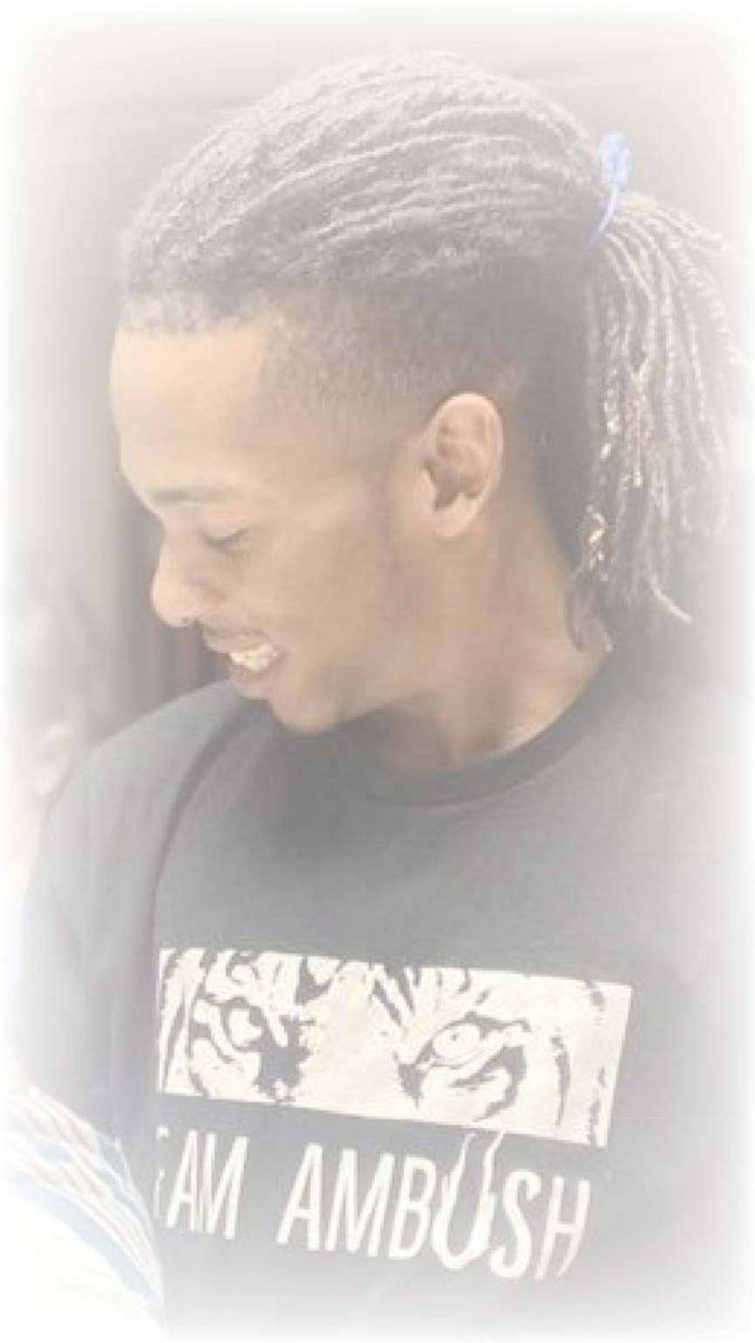

Seating Of The Family

Selection “Take Me To The King”

By: Tamela Mann

Reading From The Holy Scriptures

Old Testament

New Testament

Prayer Of Comfort |  | Rev. Steven Owens, Sr.
Expressions Of Love (Limit Two Minutes Please) |  | Family and Friends
Family Tribute |  | Mrs. Diane Morris (Grandmother)
Selection | “My Story Is The Song”
 | By: Sean McGee
Words Of Comfort |  | Rev. Steven Owens, Sr.

Pastor, Lilly Of The Valley Baptist Church

Committal

Recessional

Deintaeinta Tashawnashawn Nanceance

