Memorial Card Sample

BACK FRONT
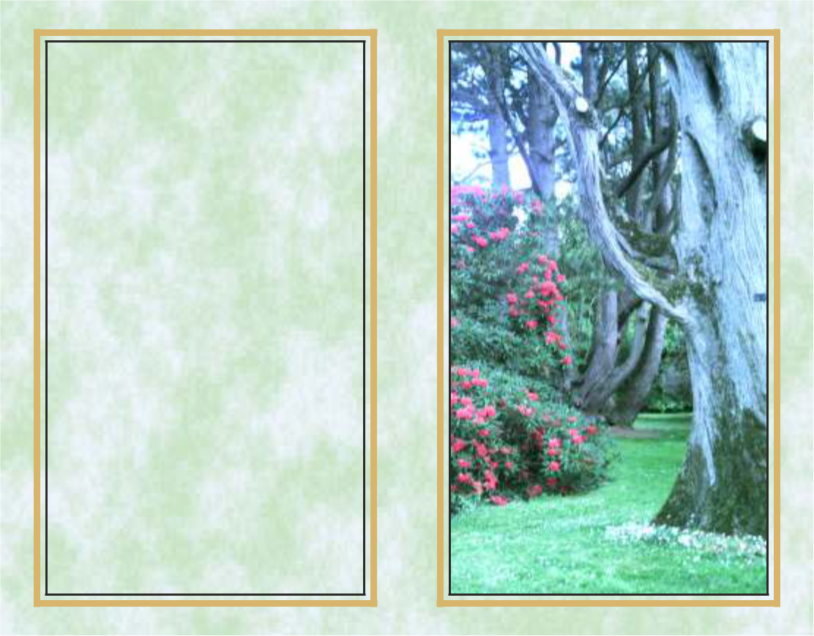

We hold you close

within our hearts,

And there you shall remain,

To walk with us

throughout our lives,

Until we meet again.

So rest in peace dear Mum

And thanks for all

you’ve done,

We pray that God

has given you,

The crown you’ve truly won.

Sureprint

INSIDE LEFT INSIDE RIGHT




IN LOVING MEMORY OF

John Smith

Address,

Address,
Address.

who died on

5th November, 2018
Aged 58 years
Rest In Peace

Your life was one of kindly deeds,

A helping hand for others’ needs,

Sincere and true in heart and mind,

Beautiful memories left behind.

Don’t grieve for me for now I’m free,

I’m following the path God laid for me.
I took His hand when I heard Him call,
I turned my back and left it all,
I could not stay another day,
To laugh, to love, to work or play.
Tasks left undone must stay that way,
I found that peace at close of day.
If my parting has left a void,
Then fill it with remembered joy,
A friendship shared, a laugh, a kiss,
Ah yes these things I too will miss.
Be not burdened with times of sorrow,
I wish you the sunshine of tomorrow.
My life’s been full,
I’ve savoured much,
Good friends, good times,
A loved one’s touch.
Perhaps my time seemed all too brief,
Don’t lengthen it now with undue grief,
Lift up your hearts and share with me,
God wanted me now, He set me free.



SURE PRINT


Memorial Card Sample

BACK FRONT
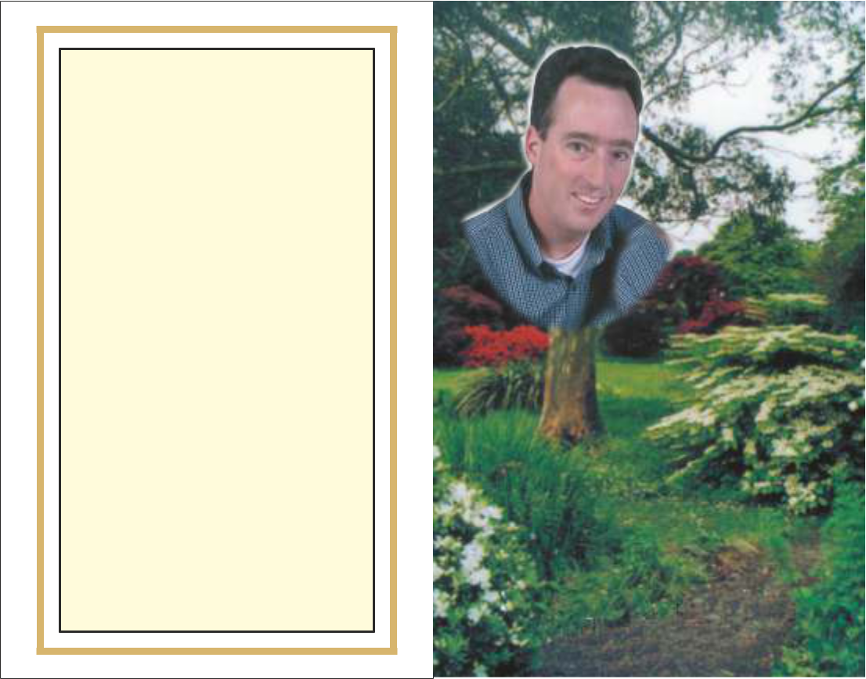

After Glow

***

I'd like the memory of me

to be a happy one.

I'd like to leave an after glow

of smiles when life is done.

I'd like to leave an echo,


whispering softly

down the ways.

Of happy times and laughing

times and bright and sunny days.

I'd like the tears of those

who grieve, to dry

before the sun,

Of happy memories that I

leave when life is done.

INSIDE LEFT





In Loving Memory of

John Murphy

Murphy Road,

Clonmel,

Co. Tipperary.

who died on

18th May, 2016

Aged 84 Years

Rest In Peace

Remembering

John

INSIDE RIGHT

We hold you close

within our hearts,

And there you shall remain,

To walk with us

throughout our lives,

Until we meet again.

So rest in peace dear loved one

And thanks for all

you’ve done,

We pray that God

has given you,

The crown you’ve truly won.

SURE PRINT

Bookmark Sample

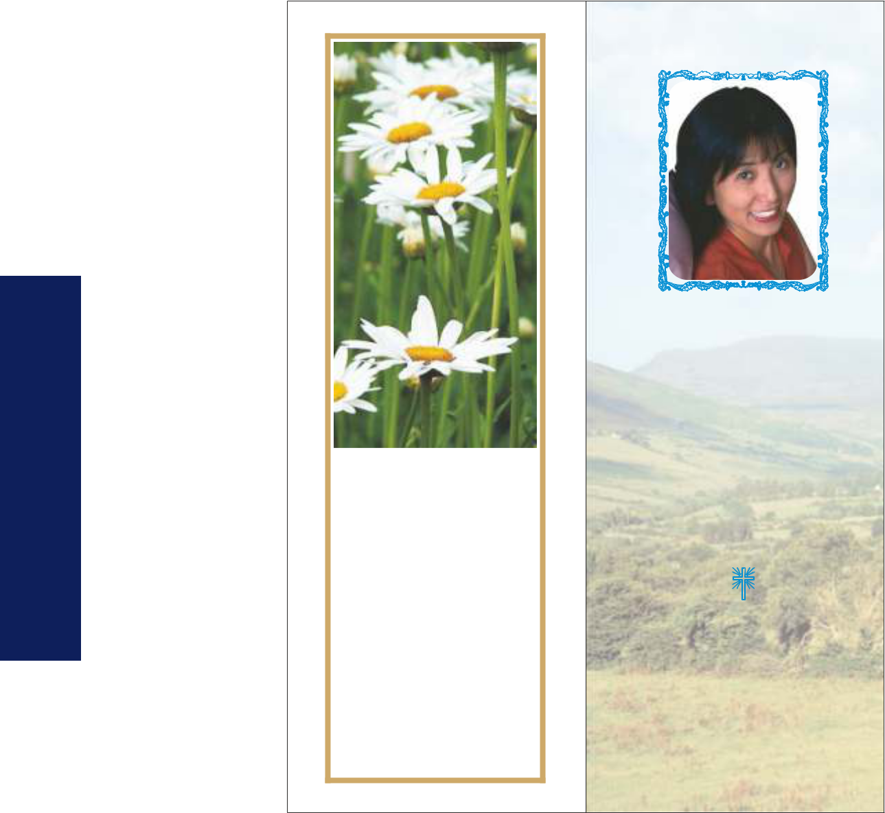

We lost a mother with a

heart of gold,
How much we miss her
can never be told.
She shared our troubles and
helped us along,
If we follow her footsteps
we will never go wrong.

!

We miss you from
your fireside chair,
Your loving smile and gentle air,
Your vacant place no one can fill,
We miss you mother
And always will.

In Loving Memory of :

Mary Smith

Address,

Address,
Address.

who died on

10th June, 2018
Aged 66 years

Rest in Peace

God saw the road was getting rough,

The hill was hard to climb,
He gently closed your weary eyes, And whispered “Peace be Thine”.

***

Your painful days are over,

Your restless nights have passed,
God gently closed your eyes,
And gave you peace at last.

***

ACTUAL SIZE:

5.75 cm across

and

15.65 cm down

Front Back

Keepsake Card Sample
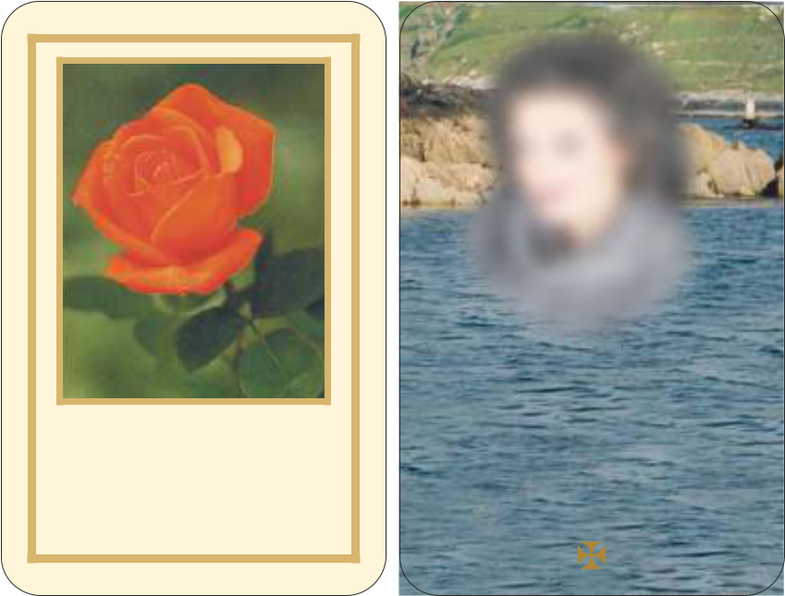

A light is from our household gone,

A voice we loved is still,

A place is vacant in our home,

That never can be filled.

In Loving Memory of

Mary Lynch

Clonmel, Co. Tipperary.

who died on

26th June, 2015
Aged 75 years

Rest in Peace

SURE PRINT

Acknowledgement Card Sample


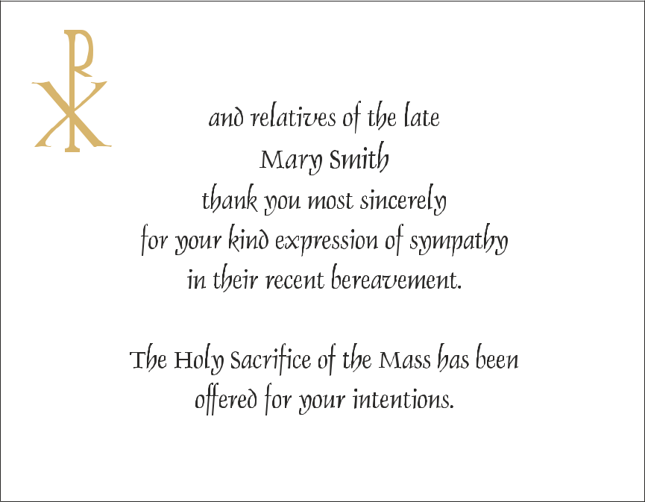

Address

Xxxxxxxx,

Xxxxxxxx, Month, Year

ACTUAL SIZE OF SINGLE ACKNOWLEDGEMENT:

11.45 cm across and 8.90cm down approx.

Please call in store for

full catalogue on memorial cards.

Customers may provide their own personal photographs, verses, prayers and any other content
to be used on the cards.

SURE PRINT

