Hillsborough County Aviation Authority

LANDSCAPE MAINTENANCE SERVICES CONTRACT

COMPANY: AMERIPRIDE PEST CONTROL SERVICES, INC., dba PRIME-SCAPE SERVICES

Term Date: April 2, 2018 through April 1, 2019

Board Date: March 1, 2018

Prepared by: Procurement Department
Hillsborough County Aviation Authority
P.O. Box 22287

Tampa, Florida 33622
 |  | TABLE OF CONTENTS
ARTICLE |  | CONTRACT
ARTICLE | 1 | CONTRACT
ARTICLE 2 |  | SCOPE OF WORK
ARTICLE 3 |  | TERM
ARTICLE 4 |  | FEES AND PAYMENTS
ARTICLE 5 |  | TAXES
ARTICLE 6 |  | OWNERSHIP OF DOCUMENTS
ARTICLE 7 |  | QUALITY ASSURANCE
ARTICLE 8 |  | NON-EXCLUSIVE
ARTICLE 9 |  | DEFAULT AND TERMINATION
ARTICLE 10 |  | CANCELLATION
ARTICLE 11 |  | INDEMNIFICATION
ARTICLE 12 |  | ACCOUNTING RECORDS AND AUDIT REQUIREMENTS
ARTICLE 13 |  | INSURANCE
ARTICLE 14 |  | NON-DISCRIMINATION / CIVIL RIGHTS
ARTICLE 15 |  | WOMAN AND MINORITY-OWNED BUSINESS ENTERPRISE
ARTICLE 16 |  | AUTHORITY APPROVALS
ARTICLE 17 |  | DISPUTE RESOLUTION
ARTICLE 18 |  | NON-EXCLUSIVE RIGHTS
ARTICLE 19 |  | WAIVER OF CLAIMS
ARTICLE 20 |  | COMPLIANCE WITH LAWS, REGULATIONS, ORDINANCES, RULES
ARTICLE 21 |  | COMPLIANCE WITH PUBLIC RECORDS LAW
ARTICLE 22 |  | CONTRACT MADE IN FLORIDA
ARTICLE 23 |  | NOTICES AND COMMUNICATIONS
ARTICLE 24 |  | SUBORDINATION OF AGREEMENT
ARTICLE 25 |  | SUBORDINATION TO TRUST AGREEMENT
ARTICLE 26 |  | ASSIGNMENT AND SUBCONTRACTING / SUBLEASING
ARTICLE 27 |  | VENUE
ARTICLE 28 |  | RELATIONSHIP OF THE PARTIES
ARTICLE 29 |  | RIGHT TO AMEND
ARTICLE 30 |  | TIME IS OF THE ESSENCE
ARTICLE 31 |  | AMERICANS WITH DISABILITIES ACT
ARTICLE 32 |  | AGENT FOR SERVICE OF PROCESS
ARTICLE 33 |  | INVALIDITY OF CLAUSES
ARTICLE 34 |  | HEADINGS
ARTICLE 35 |  | COMPLETE CONTRACT
ARTICLE 36 |  | MISCELLANEOUS
ARTICLE 37 |  | ORGANIZATION AND AUTHORITY TO ENTER INTO CONTRACT
ARTICLE 38 |  | ORDER OF PRECEDENCE
EXHIBIT A |  | SCOPE OF WORK, LANDSCAPE MAINTENANCE SERVICES

_____________________________________________________________________________________________________________________

Hillsborough County Aviation Authority

Landscape Maintenance Services

Page 2 of 28

ITB No. 18-534-009
INVITATION TO BID

HILLSBOROUGH COUNTY AVIATION AUTHORITY
LANDSCAPE MAINTENANCE SERVICES

This Contract for Landscape Maintenance Services (hereinafter referred to as Contract) is made and entered into this 2nd day of April, 2018 between the Hillsborough County Aviation Authority, a public body corporate under the laws of the State of Florida whose post office address is Post Office Box 22287, Tampa, Florida 33622 (hereinafter referred to as Authority), and Ameripride Pest Control Services, Inc., dba Prime-Scape Services, a Florida corporation, authorized to do business in the State of Florida, (hereinafter referred to as Company), (collectively hereinafter referred to as the Parties).

For and in consideration of the mutual covenants hereof, the Parties do hereby agree as follows:

ARTICLE 1

CONTRACT

1.01 Definitions
The following terms will have the meanings as set forth below:

- Airports: Tampa International, Peter. O. Knight, Tampa Executive and Plant City Airports.

- CEO: Authority Chief Executive Officer.

- Contract Documents: The following documents are a part of this Contract and are

hereby incorporated by reference: the terms and conditions as contained in this Contract; Invitation to Bid (ITB) No. 18-534-009, Landscape Maintenance Services, dated December 13, 2017, and all its addenda; and Company’s response to ITB No. 18-534-009, Landscape Maintenance Services, and any subsequent information submitted by Company during the evaluation process.

- Contract Manager: Authority representative responsible for coordinating and overseeing Contract to include, but not be limited to, monitoring, interpreting and overseeing the Services with regard to the quality performed, the manner of performance, and Authority satisfaction with performance levels.

- Cycle: A scheduled performance of Services.

_____________________________________________________________________________________________________________________

Hillsborough County Aviation Authority

Landscape Maintenance Services

Page 3 of 28

ITB No. 18-534-009
INVITATION TO BID

- Personnel: Individuals who are directly employed or contracted by Company to perform the Services at the Airport.

- Project Manager: Company employee responsible for the day to day management of the Services.

- Services: Services as described in Exhibit A, Scope of Work, Landscape Maintenance Services.

1.02 Exhibit
The following Exhibit is attached hereto and is hereby incorporated and made a part of this Contract. Based on the needs of Authority, the Exhibit may be modified from time to time by letter to Company without formal amendment to this Contract.

Exhibit A, Scope of Work, Landscape Maintenance Services

ARTICLE 2

SCOPE OF WORK

Company agrees to provide the Services as set forth in Exhibit A, Scope of Work, Landscape Maintenance Services.

ARTICLE 3

TERM

3.01 Effective Date

This Contract will become effective upon execution by Company and approval and execution by Authority. This Contract may be executed in one or more counterparts, each of which will be deemed an original and all of which will be taken together and deemed to be one instrument.

3.02 Term

The Term of this Contract commences on April 2, 2018 and will continue through April 1, 2019 unless terminated earlier as provided herein.

3.03 Renewal Option
This Contract may be renewed at the same terms and conditions hereunder for two (2), one -year periods at the discretion of the CEO. Such renewal will be effective by issuance of a written letter to Company by Authority. If all such renewals are exercised, this Contract will have a final termination date of April 1, 2021.

_____________________________________________________________________________________________________________________

Hillsborough County Aviation Authority

Landscape Maintenance Services

Page 4 of 28

ITB No. 18-534-009
INVITATION TO BID

3.04 Early Termination
Authority may terminate this Contract, without cause, by giving thirty (30) days written notice to Company.

ARTICLE 4

FEES AND PAYMENTS

4.01 Fees
Authority will pay Company for the initial year of this Contract based on the approved fees provided below.

Location No. 1 |  | Service | Price Per Cycle
Tampa International Airport
Cargo Road |  | Mowing | $968.75
Cargo Road |  | Landscape Bed | $375.00
Cargo Road |  | Maintenance | $375.00
Hoover Blvd. |  | Mowing | $343.75
Spruce and Obrien Streets |  | Mowing | $93.75
Spruce and Obrien Streets |  | Landscape Bed | $75.00
Spruce and Obrien Streets |  | Maintenance | $75.00

4.02 Price Adjustments
Company will notify Authority prior to each renewal of any requested fee adjustments. Documentation must be submitted by Company at least thirty (30) calendar days prior to the renewal effective date. Any increases or decreases to the fees will be based on the change in the Consumer Price Index (CPI) published by the Bureau of Statistics, U.S. Department of Labor, using: Not Seasonally Adjusted, All Urban Consumers (CPI-U), U.S. City Average, Item: Gardening and Lawn Care Services, using finalized data for the date, six (6) months prior to the renewal effective date.

Authority will review the appropriate annual data and inform the Company, concerning the calculations derived for granting or not granting increases (or decreases). The decision for granting increases (or decreases) shall rest solely with Authority.

4.03 Invoices
Invoices required by this Contract will be created and submitted by Company to Authority Finance Department via Oracle iSupplier® Portal Full Access in a form acceptable to Authority and include at a minimum the invoice date, invoice amount, dates of Services, and purchase order number.

_____________________________________________________________________________________________________________________

Hillsborough County Aviation Authority

Landscape Maintenance Services

Page 5 of 28

ITB No. 18-534-009
INVITATION TO BID

4.04 Payment Method
Company will receive electronic payments via Automated Clearing House (ACH) – VIP Supplier, ACH – Standard, ePayables, or Purchasing Card (PCard). Information regarding the electronic payment methods and processes including net terms is available on Authority website at www.TampaAirport.com > Learn about TPA > Airport Business > Procurement > More Information – Electronic Payment Methods. Authority reserves the right to modify the electronic payment methods and processes at any time. Company may change its selected electronic payment method during the term of this Contract in coordination with Accounts Payable.

4.05 Payment When Services Are Terminated at the Convenience of Authority
In the event of termination of this Contract for the convenience of Authority, Authority will compensate Company as listed below; however, in no event shall Company be entitled to any damages or remedies for wrongful termination.

- All work performed prior to the effective date of termination; and

- Expenses incurred by Company in effecting the termination of this Contract as approved in advance by Authority.

4.06 Prompt Payment
Company must pay any of its subcontractor(s) who have submitted verified invoices for work already performed within ten (10) calendar days of being paid by Authority. Any exception to this prompt payment provision will only be for good cause with prior written approval of Authority. Failure of Company to pay any of its subcontractor(s) accordingly will be a material breach of this Contract.

ARTICLE 5

TAXES

All taxes of any kind and character payable on account of the Services and materials furnished under this Contract will be paid by Company. The laws of the State of Florida provide that sales tax and use taxes are payable by Company upon the tangible personal property incorporated in the work and such taxes will be paid by Company. Authority is exempt from all State and federal sales, use and transportation taxes.

_____________________________________________________________________________________________________________________

Hillsborough County Aviation Authority

Landscape Maintenance Services

Page 6 of 28

ITB No. 18-534-009
INVITATION TO BID

ARTICLE 6

OWNERSHIP OF DOCUMENTS

All documents, papers, letters, maps, books, tapes, photographs, films, sound recordings, data processing software, or other material, regardless of the physical form or characteristics made by Company or its employees incident to, or in the course of, Services to Authority, will be and remain the property of Authority.

ARTICLE 7

QUALITY ASSURANCE

Company will be solely responsible for the quality of all Services furnished by Company, its employees and/or its subcontractors under this Contract. All Services furnished by Company, its employees and/or its subcontractors must be performed in accordance with best management practices and best professional judgment, in a timely manner, and must be fit and suitable for the purposes intended by Authority. Company's Services and deliverables must conform with all applicable federal and State laws, regulations and ordinances.

ARTICLE 8

NON-EXCLUSIVE

Company acknowledges that Authority has, or may hire, others to perform Services similar to or the same as that which is within Company's scope of work under this Contract. Company further acknowledges that this Contract is not a guarantee of the assignment of any work and that the assignment of work to others is solely within Authority discretion.

ARTICLE 9

DEFAULT AND TERMINATION

9.01 Events of Default
Company will be deemed to be in default of this Contract upon the occurrence of any of the following:

- The failure or omission by Company to perform its obligations under this Contract or the breach of any terms, conditions and covenants required herein.

_____________________________________________________________________________________________________________________

Hillsborough County Aviation Authority

Landscape Maintenance Services

Page 7 of 28

ITB No. 18-534-009
INVITATION TO BID

- The conduct of any business or performance of any acts at the Airports not specifically authorized in this Contract, failure to perform any of the provisions of this Contract, or by any other agreement between Authority and Company, and Company’s failure to discontinue that business or those acts within ten (10) days of receipt by Company of Authority written notice to cease said business or acts.

- The divestiture of Company’s estate herein by operation of law, by dissolution, or by liquidation, not including a merger or sale of assets.

- The appointment of a trustee, custodian, or receiver of all or a substantial portion of Company’s assets; or the insolvency of Company; or if Company will take the benefit of any present or future insolvency statute, will make a general assignment for the benefit of creditors, or will seek a reorganization or the readjustment of its indebtedness under any law or statute of the United States or of any state thereof including the filing by Company of a voluntary petition of bankruptcy or the institution of proceedings against Company for the adjudication of Company as bankrupt pursuant thereto.

- Company’s violation of Florida Statute Section 287.133 concerning criminal activity on contracts with public entities.

9.02 Authority Remedies
In the event of any of the foregoing events of default enumerated in this Article, and following ten (10) days' notice by Authority and Company's failure to cure, Authority, at its election, may exercise any one or more of the following options or remedies, the exercise of any of which will not be deemed to preclude the exercise of any other remedy herein listed or otherwise provided by statute or general law:

A. Terminate Company's rights under this Contract and, in accordance with law, Company will remain liable for all payments or other sums due under this Contract and for all damages suffered by Authority because of Company's breach of any of the covenants of this Contract; or

- Treat this Contract as remaining in existence, curing Company's default by performing or paying the obligation which Company has breached. In such event all sums paid or expenses incurred by Authority directly or indirectly in curing Company's default will become immediately due and payable as well as interest thereon, from the date such fees or charges became due to the date of payment, at 12 percent per annum or to the maximum extent permitted by law.

- No waiver by Authority at any time of any of the terms, conditions, covenants, or agreements of this Contract, or noncompliance therewith, will be deemed or taken as

_____________________________________________________________________________________________________________________

Hillsborough County Aviation Authority

Landscape Maintenance Services

Page 8 of 28

ITB No. 18-534-009
INVITATION TO BID

a waiver at any time thereafter of the same or any other term, condition, covenant, or agreement herein contained, nor of the strict and prompt performance thereof by Company. No delay, failure, or omission of Authority to exercise any right, power, privilege, or option arising from any default nor subsequent acceptance of fees or charges then or thereafter accrued will impair any such right, power, privilege, or option, or be construed to be a waiver of any such default. No notice by Authority will be required to restore or revive time is of the essence hereof after waiver by Authority or default in one or more instances. No option, right, power, remedy, or privilege of Authority will be construed as being exhausted or discharged by the exercise thereof in one or more instances. It is agreed that each and all of the rights, powers, options, or remedies given to Authority by this Contract are cumulative and that the exercise of one right, power, option, or remedy by Authority will not impair its rights to any other right, power, option, or remedy available under this Contract or provided by law. No act or thing done by Authority or Authority agents or employees during the Term will be deemed an acceptance of the surrender of this Contract, and no acceptance of surrender will be valid unless in writing.

9.03 Continuing Responsibilities of Company
Notwithstanding the occurrence of any event of default, Company will remain liable to Authority for all payments payable hereunder and for all preceding breaches of any covenant of this Contract. Furthermore, unless Authority elects to cancel this Contract, Company will remain liable for and promptly pay any and all payments accruing hereunder until termination of this Contract as set forth in this Contract or until this Contract is canceled by Company.

9.04 Company’s Remedies
Upon thirty (30) days’ written notice to Authority, Company may terminate this Contract and all of its obligations hereunder, if Company is not in default of any term, provision, or covenant of this Contract or in the payment of any fees or charges to Authority, and only upon or after the occurrence of any of the following events: the inability of Company to use Airport(s) for a period of longer than ninety (90) consecutive days due to war, terrorism, or the issuance of any order, rule or regulation by a competent governmental authority or court having jurisdiction over Authority, preventing Company from operating its business for a period of ninety (90) consecutive days, provided, however that such inability or such order, rule or regulation is not due to any fault or negligence of Company.

In the event it is determined by a court of competent jurisdiction that Authority has wrongfully terminated this Contract, then such termination shall automatically be deemed a termination for convenience under Article 4.05.

_____________________________________________________________________________________________________________________

Hillsborough County Aviation Authority

Landscape Maintenance Services

Page 9 of 28

ITB No. 18-534-009
INVITATION TO BID

ARTICLE 10

CANCELLATION

This Contract may be cancelled by Authority upon thirty (30) day notice to Company.

ARTICLE 11

INDEMNIFICATION

- To the maximum extent permitted by Florida law, in addition to Company’s obligation to provide pay for and maintain insurance as set forth elsewhere in this Contract, Company will indemnify and hold harmless the Authority, its members, officers, agents, employees, and volunteers from any and all liabilities, suits, claims, expenses, losses, costs, fines and damages (including but not limited to claims for attorney’s fees and court costs) caused in whole or in part by the:

  - Presence on, use or occupancy of Authority’s property;

  - Acts, omissions, negligence (including professional negligence and malpractice), recklessness, intentional wrongful conduct, activities, or operations;

  - Any breach of the terms of this Contract;

  - Performance, non-performance or purported performance of this Contract;

  - Violation of any law, regulation, rule or ordinance;

  - Infringement of any patent, copyright, trademark, trade dress or trade secret rights; and/or

  - Contamination of the soil, groundwater, surface water, storm water, air or the environment by fuel, gas, chemicals or any other substance deemed by the Environmental Protection Agency or other regulatory agency to be an environmental contaminant

of the Company or the Company’s officers, employees, agents, volunteers, subcontractors, invitees, or any other person directly or indirectly employed or utilized by the Company, regardless of whether the liability, suit, claim, expense, loss, cost, fine or damages is caused in part by an indemnified party.

- In addition to the duty to indemnify and hold harmless, Company will have the separate and independent duty to defend the Authority, its members, officers, agents, employees, and volunteers from all suits, claims or actions of any nature seeking damages, expenses, losses, costs, fines or attorney’s fees in the event the suit, claim, or action of any nature arises in whole or in part from the:

_____________________________________________________________________________________________________________________

Hillsborough County Aviation Authority

Landscape Maintenance Services

Page 10 of 28

ITB No. 18-534-009

INVITATION TO BID

- Presence on, use or occupancy of Authority’s property;

- Acts, omissions, negligence (including professional negligence and malpractice), recklessness, intentional wrongful conduct, activities, or operations;

- Any breach of the terms of this Contract;

- Performance, non-performance or purported performance of this Contract;

- Violation of any law, regulation, rule or ordinance;

- Infringement of any patent, copyright, trademark, trade dress or trade secret rights; and/or
- Contamination of the soil, groundwater, surface water, storm water, air or the environment by fuel, gas, chemicals or any other substance deemed by the Environmental Protection Agency or other regulatory agency to be an environmental contaminant

of or by the Company or the Company’s officers, employees, agents, volunteers, subcontractors, invitees, or any other person directly or indirectly employed or utilized by the Company regardless of whether it is caused in part by the Authority, its members, officers, agents, employees, or volunteers. This duty to defend exists immediately upon presentation of written notice of a suit, claim or action of any nature to the Company by a party entitled to a defense hereunder.

- If the above indemnity or defense provisions or any part of the above indemnity or defense provisions are limited by Florida Statute § 725.06 (1), or any other applicable law, then with respect to the part so limited, the monetary limitation on the extent of the indemnification shall be the greater of the (i) monetary value of this Contract, (ii) coverage amount of Commercial General Liability Insurance required under the Contract, or (iii) $1,000,000.00. Otherwise, the obligations of this Article will not be limited by the amount of any insurance required to be obtained or maintained under this Contract.

- Company's obligations to defend and indemnify as described in this Article will survive the expiration or earlier termination of this Contract until it is determined by final judgment that any suit, claim or other action against the Authority, its members, officers, agents, employees, and volunteers if fully and finally barred by the applicable statute of limitations or repose.

- Nothing in this Contract will be construed as a waiver of any immunity from or limitation of liability the Authority, or its members, officers, agents, employees, and volunteers may have under the doctrine of sovereign immunity under common law or statute.

_____________________________________________________________________________________________________________________

Hillsborough County Aviation Authority

Landscape Maintenance Services

Page 11 of 28

ITB No. 18-534-009

INVITATION TO BID

- The Authority and its members, officers, agents, employees, and volunteers reserve the right, at their option, to participate in the defense of any suit, without relieving Company of any of its obligations under this Article.

- If this Contract or any part of this Contract is deemed to conflict in any way with any law, this Contract or such part of this Contract will be considered modified by such law to remedy the conflict.

- If the above Articles A - G or any part of Articles A – G is deemed to conflict in any way with any law, the Article or part of the Article will be considered modified by such law to remedy the conflict.

ARTICLE 12

ACCOUNTING RECORDS AND AUDIT REQUIREMENTS

12.01 Books and Records
In connection with payments to Company under this Contract, it is agreed Company will maintain full and accurate books of account and records customarily used in this type of business operation, in conformity with Generally Accepted Accounting Principles (GAAP). Company will maintain such books and records for five years after the end of the term of this Contract. Records include, but are not limited to, all documents and research related to this Contract. Company will not destroy any records related to this Contract without the express written permission of the Authority.

12.02 Financial Reports
Company will submit all financial reports required by Authority, in the form and within the time period required by Authority.

12.03 Authority Right to Perform Audits, Inspections, or Attestation Engagements
At any time or times during the term of the Contract or within three years after the end of the Contract, Authority, or its duly authorized representative, will be permitted to initiate and perform audits, inspections or attestation engagements over Company’s records for the purpose of determining payment eligibility under the Contract or over selected operations performed by Company under this Contract for the purpose of determining compliance with the Contract.

Free and unrestricted access will be granted to all of Company’s records directly pertinent to this Contract or any work order, as well as records of parent, affiliate and subsidiary companies and any subconsultants or subcontractors. If the records are kept at locations other than the Airport(s), Company will arrange for said records to be brought to a location convenient to Authority auditors to conduct the engagement as set forth in this

_____________________________________________________________________________________________________________________

Hillsborough County Aviation Authority

Landscape Maintenance Services

Page 12 of 28

ITB No. 18-534-009

INVITATION TO BID

Article. Or, Company may transport Authority team to Company headquarters for purposes of undertaking said engagement. In such event, Company will pay reasonable costs of transportation, food and lodging for Authority team. In the event Company maintains its accounting or Contract information in electronic format, upon request by Authority auditors, Company will provide a download or extract of data files in a computer readable format acceptable to the Authority at no additional cost.

Authority has the right during the engagement to interview Company’s employees, subconsultants, and subcontractors, and to make photocopies of records as needed.

Company agrees to deliver or provide access to all records requested by Authority auditors within fourteen (14) calendar days of the request at the initiation of the engagement and to deliver or provide access to all other records requested during the engagement within seven (7) calendar days of each request. The parties recognize that Authority will incur additional costs if records requested by Authority auditors are not provided in a timely manner and that the amount of those costs is difficult to determine with certainty. Consequently, the parties agree that Company may be charged a penalty fee of one hundred dollars ($100.00), in addition to all other contractual financial requirements, for each item in a records request, per calendar day, for each time Company is late in submitting requested records to perform the engagement. Accrual of fee will continue until specific performance is accomplished.

If, as a result of any engagement, it is determined that Company has overcharged Authority, Company will re-pay Authority for the overcharge and the Authority may assess interest of up to twelve percent (12%) on the overcharge from the date the overcharge occurred. If it is determined that Company has overcharged Authority by more than three percent of the reimbursable amount, excluding any lump sum amount, contained in this Contract, Company will also pay for the entire cost of the engagement.

Company will include a provision providing Authority the same access to business records at the subconsultant and subcontractor level in all of its subconsultant and subcontractor agreements executed related to this Contract.

ARTICLE 13

INSURANCE

13.01 Insurance
Company must maintain the following limits and coverages uninterrupted or amended through the Term of this Contract. In the event Company becomes in default of the following requirements, Authority reserves the right to take whatever actions deemed necessary to protect its interests. Required liability policies other than Workers’ Compensation/Employer’s Liability and Professional Liability will provide that Authority,

_____________________________________________________________________________________________________________________

Hillsborough County Aviation Authority

Landscape Maintenance Services

Page 13 of 28

ITB No. 18-534-009

INVITATION TO BID

members of Authority governing body, and Authority officers, volunteers and employees are included as additional insured.

13.02 Required Coverage – Minimum Limits

- Commercial General Liability Insurance
The minimum limits of insurance (inclusive of any amounts provided by an umbrella or excess policy) covering the work performed pursuant to this Contract will be the amounts specified herein. Coverage will be provided for liability resulting out of, or in connection with, ongoing operations performed by, or on behalf of, Company under this Contract or the use or occupancy of Authority premises by, or on behalf of, Company in connection with this Contract. The Commercial General Liability Insurance shall not contain any exclusion of property damage arising out of defective work, including the damages, costs and expenses incurred in connection with the removal, destruction, ripping or tearing of non-defective property in order to access or repair the defective work. Coverage shall be provided on a form no more restrictive than ISO Form CG 00 01. Additional insurance coverage shall be provided on a form no more restrictive than ISO Form CG 20 10 10 01 and CG 20 37 10 01.

 | Contract Specific
General Aggregate | $2,000,000
Each Occurrence | $2,000,000
Personal and Advertising Injury Each Occurrence | $2,000,000
Products and Completed Operations Aggregate | $2,000,000

- Workers’ Compensation and Employer’s Liability Insurance

The minimum limits insurance (inclusive of any amount provided by an umbrella or excess policy) are:

Part One: | “Statutory”
Part Two:
Each Accident | $1,000,000
Disease – Policy Limit | $1,000,000
Disease – Each Employee | $1,000,000

- Business Automobile Liability Insurance
Coverage will be provided for all owned, hired and non-owned vehicles. Coverage shall be provided on a form no more restrictive than ISO Form CA 00 01.

The minimum limits of insurance (inclusive of any amounts provided by an umbrella or excess policy) covering the work performed pursuant to this Contract will be:

Each Occurrence – Bodily Injury and Property Damage

_____________________________________________________________________________________________________________________

Hillsborough County Aviation Authority

Landscape Maintenance Services

Page 14 of 28

ITB No. 18-534-009

INVITATION TO BID

combined | $1,000,000

- Waiver of Subrogation
Company, for itself and on behalf of its insurers, to the full extent permitted by law without voiding the insurance required by the Contract, waives all rights against Authority, members of Authority governing body and Authority officers, volunteers and employees, for damages or loss to the extent covered and paid for by any insurance maintained by Company.

13.03 Conditions of Acceptance
The insurance maintained by Company must conform at all times with Authority Standard Procedure S250.06, Contractual Insurance Terms and Conditions, which may be amended from time to time and can be downloaded from Authority website at www.TampaAirport.com > Learn about TPA > Airport Business > Procurement > Additional Supplier Resources.

ARTICLE 14

NON-DISCRIMINATION / CIVIL RIGHTS

Company will not discriminate on the basis of race, color, national origin, or sex in the performance of this Contract. Company agrees to comply with the requirements detailed in Civil Rights/Non-Discrimination, Non-Federal Provisions OR Civil Rights/Non-Discrimination, Federal Provisions>. The document can be found on the Authority website at: www.TampaAirport.com > Learn about TPA > Airport Business > Procurement > Additional Supplier Resources.

ARTICLE 15

WOMAN AND MINORITY-OWNED BUSINESS ENTERPRISE

15.01 Authority Policy
Authority is committed to the participation of Woman and Minority-Owned Business Enterprises (W/MBEs) in non-concession, non-federally funded contracting opportunities in accordance with Authority W/MBE Policy and Program. Company will take all necessary and reasonable steps in accordance therewith to ensure that W/MBEs are encouraged to compete for and perform subcontracts under this Contract.

15.02 Non-Discrimination

- Company and any subcontractor of Company will not discriminate on the basis of race, color, national origin, or sex in the performance of this Contract. Company will carry

_____________________________________________________________________________________________________________________

Hillsborough County Aviation Authority

Landscape Maintenance Services

Page 15 of 28

ITB No. 18-534-009

INVITATION TO BID

out applicable requirements of Authority W/MBE Policy and Program in the award and administration of this Contract. Failure by Company to carry out these requirements is a material breach of this Contract, which may result in the termination of this Contract or such other remedy as Authority deems appropriate.

- Company agrees that it will not discriminate against any business owner because of the owner’s race, color, national origin, or sex in connection with the award or performance of any agreement, management contract, or subcontract, purchase or lease agreement.

- Company agrees to include the statements in paragraphs (A) and (B) above in any subsequent agreement or contract that it enters and cause those businesses to similarly include the statements in further agreements or contracts.

15.03 W/MBE Participation

A. W/MBE Expectancy: No specific expectancy for W/MBE participation has been established for this Contract; however, Company agrees to make a good faith effort, in accordance with Authority W/MBE Policy and Program, throughout the Term of this Contract, to contract with W/MBE firms certified as a woman-owned or minority-owned business by the City of Tampa, Hillsborough County, the State of Florida Department of Management Services, Office of Supplier Diversity, or as a Disadvantaged Business Enterprise (DBE) under the Florida Unified Certification Program pursuant to 49 CFR part 26 in the performance of this Contract.

- W/MBE Termination and Substitution: Company is prohibited from terminating or altering or changing the scope of work of a W/MBE subcontractor except upon written approval of Authority in accordance with Authority procedures relating to W/MBE terminations contained in the W/MBE Policy and Program. Failure to comply with the procedure relating to W/MBE terminations or changes during this Contract will be a material violation of this Contract and will invoke the sanctions for non-compliance specified in this Contract and the W/MBE Policy and Program.

- Monitoring: Authority will monitor the ongoing good faith efforts of Company in meeting the requirements of this Article. Authority will have access to the necessary records to examine such information as may be appropriate for the purpose of investigating and determining compliance with this Article, including, but not limited to, records, records of expenditures, contracts between Company and the W/MBE participant, and other records pertaining to W/MBE participation, which Company will maintain for a minimum of three years following the end of this Contract. Opportunities for W/MBE participation will be reviewed prior to the exercise of any renewal, extension or material amendment of this Contract to consider whether an adjustment in the W/MBE requirement is warranted. Without limiting the

_____________________________________________________________________________________________________________________

Hillsborough County Aviation Authority

Landscape Maintenance Services

Page 16 of 28

ITB No. 18-534-009

INVITATION TO BID

requirements of this Contract, Authority reserves the right to review and approve all sub-leases or subcontracts utilized by Company for the achievement of these goals.

- Prompt Payment: Company agrees to pay each subcontractor under this Contract for satisfactory performance of its contract no later than ten (10) calendar days from the receipt of each payment Company receives from Authority. Company agrees further to release retainage payments to each subcontractor within ten (10) calendar days after the subcontractor’s work is satisfactorily completed. Any delay or postponement of payment from the above referenced time frame may occur only for good cause following written approval of Authority. This clause applies to both W/MBE and non-W/MBE subcontractors.

ARTICLE 16

AUTHORITY APPROVALS

Except as otherwise specifically indicated elsewhere in this Contract, wherever in this Contract approvals are required to be given or received by Authority, it is understood that the CEO or designee is hereby empowered to act on behalf of Authority.

ARTICLE 17

DISPUTE RESOLUTION

17.01 Claims and Disputes

- A claim is a written demand or assertion by one of the parties seeking, as a matter of right, an adjustment or interpretation of this Contract, payment of money, extension of time or other relief with respect to the terms of this Contract. The term claim also includes other matters in question between Authority and Company arising out of or relating to this Contract. The responsibility to substantiate claims will rest with the party making the claim.

- If for any reason Company deems that additional cost or Contract time is due to Company for work not clearly provided for in this Contract, or previously authorized changes in the work, Company will notify Authority in writing of its intention to claim such additional cost or Contract time. Company will give Authority the opportunity to keep strict account of actual cost and/or time associated with the claim. The failure to give proper notice as required herein will constitute a waiver of said claim.

_____________________________________________________________________________________________________________________

Hillsborough County Aviation Authority

Landscape Maintenance Services

Page 17 of 28

ITB No. 18-534-009

INVITATION TO BID

- Written notice of intention to claim must be made within ten (10) days after Company first recognizes the condition giving rise to the claim or before the work begins on which Company bases the claim, whichever is earlier.

- When the work on which the claim for additional cost or Contract time is based has been completed, Company will, within ten (10) days, submit Company’s written claim to Authority. Such claim by Company, and the fact that Authority has kept strict account of the actual cost and/or time associated with the claim, will not in any way be construed as proving or substantiating the validity of the claim.

- Pending final resolution of a claim, unless otherwise agreed in writing, Company will proceed diligently with performance of this Contract and maintain effective progress to complete the work within this Contract time(s) set forth in the Contract.

17.02 Resolution of Claims and Disputes

- The following shall occur as a condition precedent to Authority review of a claim unless waived in writing by Authority.

First Meeting: Within five (5) days after a claim is submitted in writing, the Company’s representatives who have authority to resolve the dispute shall meet with Authority representatives who have authority to resolve the dispute in a good faith attempt to resolve the dispute. If a party intends to be accompanied at a meeting by legal counsel, the other party shall be given at least three (3) working days’ notice of such and also may be accompanied by legal counsel. All negotiations pursuant to this clause are confidential and shall be treated as compromise and settlement negotiations for purposes of rules of evidence.

Second Meeting: If the First Meeting fails to resolve the dispute or if the parties fail to meet, a senior executive for Company and for Authority, neither of which have day to day Contract responsibilities, shall meet, within ten (10) days after a dispute occurs, in an attempt to resolve the dispute and any other identified disputes or any unresolved issues that may lead to dispute. Authority may invite other parties as necessary to this meeting. If a party intends to be accompanied at a meeting by legal counsel, the other party shall be given at least three (3) working days’ notice of such and also may be accompanied by legal counsel. All negotiations pursuant to this clause are confidential and shall be treated as compromise and settlement negotiations for purposes of rules of evidence.

Following the First Meeting and the Second Meeting, Authority will review Company’s claims and may (1) request additional information from Company which will be immediately provided to Authority, or (2) render a decision on all or part of

_____________________________________________________________________________________________________________________

Hillsborough County Aviation Authority

Landscape Maintenance Services

Page 18 of 28

ITB No. 18-534-009

INVITATION TO BID

the claim in writing within twenty one (21) days following the receipt of such claim or receipt of additional information requested.

If Authority decides that the work related to such claim should proceed regardless of Authority disposition of such claim, Authority will issue to Company a written directive to proceed. Company will proceed as instructed.

- Prior to the initiation of any litigation to resolve disputes between the parties, the parties will make a good faith effort to resolve any such disputes by negotiation between representatives with decision-making power. Following negotiations, as a condition precedent to litigation, the parties will mediate any dispute with a mediator selected by Authority. Such mediation shall occur in Hillsborough County, Florida.

ARTICLE 18

NON-EXCLUSIVE RIGHTS

This Contract will not be construed to grant or authorize the granting of an exclusive right within the meaning of 49 USC 40103(e) or 49 USC 47107(a), as may be amended from time to time, and related regulations.

ARTICLE 19

WAIVER OF CLAIMS

Company hereby waives any claim against the City of Tampa, Hillsborough County, State of Florida and Authority, and its officers, Board Members, agents, or employees, for loss of anticipated profits caused by any suit or proceedings directly or indirectly attacking the validity of this Contract or any part thereof, or by any judgment or award in any suit or proceeding declaring this Contract null, void, or voidable, or delaying the same, or any part hereof, from being carried out.

ARTICLE 20

COMPLIANCE WITH LAWS, REGULATIONS, ORDINANCES, RULES

Company, its officers, employees, agents, subcontractors, or those under its control, will at all times comply with applicable federal, state, and local laws and regulations, Airport Rules and Regulations, Policies, Standard Procedures, and Operating Directives as are now or may hereinafter be prescribed by Authority, all applicable health rules and regulations and other mandates whether existing or as promulgated from time to time by the federal, state, or local government, or Authority including, but not limited to, permitted and restricted activities,

_____________________________________________________________________________________________________________________

Hillsborough County Aviation Authority

Landscape Maintenance Services

Page 19 of 28

ITB No. 18-534-009

INVITATION TO BID

security matters, parking, ingress and egress, environmental and storm water regulations and any other operational matters related to the operation of Airport. Company, its officers, employees, agents, subcontractors, and those under its control, will comply with safety, operational, or security measures required of Company or Authority by the Federal Government including but not limited to Federal Aviation Administration (FAA) or Transportation Security Administration (TSA) . If Company, its officers, employees, agents, subcontractors or those under its control will fail or refuse to comply with said measures and such non -compliance results in a monetary penalty being assessed against Authority, then, in addition to any other remedies available to Authority, Company will be responsible and will reimburse Authority in the full amount of any such monetary penalty or other damages. This amount must be paid by Company within 15 days from the date of written notice.

ARTICLE 21

COMPLIANCE WITH PUBLIC RECORDS LAW

IF THE COMPANY HAS QUESTIONS REGARDING THE APPLICATION OF CHAPTER 119, FLORIDA STATUTES, TO THE COMPANY’S DUTY TO PROVIDE PUBLIC RECORDS RELATING TO THIS CONTRACT, CONTACT THE CUSTODIAN OF PUBLIC RECORDS AT (813) 870-8721, ADMCENTRALRECORDS@TAMPAAIRPORT.COM, HILLSBOROUGH COUNTY AVIATION AUTHORITY, P.O.BOX 22287, TAMPA FL 33622.

Company agrees in accordance with Florida Statute Section 119.0701 to comply with public records laws including the following:

- Keep and maintain public records required by Authority in order to perform the Services contemplated by this Contract.

- Upon request from Authority custodian of public records, provide Authority with a copy of the requested records or allow the records to be inspected or copied within a reasonable time at a cost that does not exceed the cost provided in Chapter 119, Fla. Stat. or as otherwise provided by law.

- Ensure that public records that are exempt or confidential and exempt from public records disclosure requirements are not disclosed except as authorized by law for the duration of this Contract Term and following completion of this Contract.

- Upon completion of this Contract, keep and maintain public records required by Authority to perform the Services. Company shall meet all applicable requirements for retaining public records. All records stored electronically must be provided to

_____________________________________________________________________________________________________________________

Hillsborough County Aviation Authority

Landscape Maintenance Services

Page 20 of 28

ITB No. 18-534-009

INVITATION TO BID

Authority, upon request from Authority custodian of public records, in a format that is compatible with the information technology systems of Authority.

ARTICLE 22

CONTRACT MADE IN FLORIDA

This Contract has been made in and shall be construed in accordance with the laws of the State of Florida. All duties, obligations and liabilities of Authority and Company related to this Contract are expressly set forth herein and this Contract can only be amended in writing and agreed to by both parties.

ARTICLE 23

NOTICES AND COMMUNICATIONS

All notices or communications whether to Authority or to Company pursuant hereto will be deemed validly given, served, or delivered, upon receipt by the party by hand delivery, or three

- days after depositing such notice or communication in a postal receptacle, or one (1) day after depositing such notice or communication with a reputable overnight courier service, and addressed as follows:

TO AUTHORITY: | TO COMPANY:
(MAIL DELIVERY) | (MAIL DELIVERY)
HILLSBOROUGH COUNTY AVIATION AUTHORITY | <INSERT IN TABLE>
TAMPA INTERNATIONAL AIRPORT
P.O. BOX 22287
TAMPA, FLORIDA 33622-2287
ATTN: CHIEF EXECUTIVE OFFICER
OR
(HAND DELIVERY) | (HAND DELIVERY)
HILLSBOROUGH COUNTY AVIATION AUTHORITY | <INSERT IN TABLE>
TAMPA INTERNATIONAL AIRPORT
4160 GEORGE J. BEAN PARKWAY
SUITE 2400, ADMINISTRATIVE OFFICES BUILDING
2ND LEVEL, RED SIDE
TAMPA, FLORIDA 33607-1470
ATTN: CHIEF EXECUTIVE OFFICER

_____________________________________________________________________________________________________________________

Hillsborough County Aviation Authority

Landscape Maintenance Services

Page 21 of 28

ITB No. 18-534-009

INVITATION TO BID

or to such other address as either Party may designate in writing by notice to the other Party delivered in accordance with the provisions of this Article.

If notice is sent through a mail system, a verifiable tracking documentation such as a certified return receipt or overnight mail tracking receipt is required.

ARTICLE 24

SUBORDINATION OF AGREEMENT

It is mutually understood and agreed that this Contract will be subordinate to the provisions of any existing or future agreement between Authority and the United States of America, its Boards, Agencies, Commissions, and others, relative to the operation or maintenance of the Airport, the execution of which has been or may be required as a condition precedent to the expenditure of federal funds for the development of the Airport, and this Contract will be subordinate to the license or permit of entry which may be granted by the Secretary of Defense.

ARTICLE 25

SUBORDINATION TO TRUST AGREEMENT

This Contract and all rights of Company hereunder are expressly subject and subordinate to the terms, covenants, conditions and provisions of any Trust Agreements or other debt instruments executed by Authority to secure bonds issued by or other obligations of Authority. The obligations of Company hereunder may be pledged, transferred, hypothecated, or assigned at any time by Authority to secure such obligations. Conflicts between the terms of this Contract and the provisions, covenants and requirements of the debt instruments mentioned above will be resolved in favor of the provisions, covenants and requirements of such debt instruments.

ARTICLE 26

ASSIGNMENT AND SUBCONTRACTING / SUBLEASING

Company will not assign, subcontract, sublease, or license this Contract without the prior written consent of Authority. Such consent may be withheld at the sole discretion of Authority. If assignment, subcontract, sublease, or license is approved, Company will be solely responsible for ensuring that its assignee, subcontractor, sublessee, or licensee perform pursuant to and in compliance with the terms of this Contract.

In no event will any approved assignment, subcontract, sublease, or license diminish Authority rights to enforce any and all provisions of this Contract.

_____________________________________________________________________________________________________________________

Hillsborough County Aviation Authority

Landscape Maintenance Services

Page 22 of 28

ITB No. 18-534-009

INVITATION TO BID

Before any assignment, subcontract, sublease, or license becomes effective, the assignee, subcontractor, sublessee, or licensee will assume and agree by written instruments to be bound by the terms and conditions of this Contract during the remainder of the Term. When seeking consent to an assignment hereunder, Company will submit a fully executed original of the document or instrument of assignment to Authority.

ARTICLE 27

VENUE

Venue for any action brought pursuant to this Contract will be the County or Circuit Court in Hillsborough County, Florida, or in the Tampa Division of the U.S. District Court for the Middle District of Florida.

ARTICLE 28

RELATIONSHIP OF THE PARTIES

Company is and will be deemed to be an independent contractor and operator responsible to all parties for its respective acts or omissions, and Authority will in no way be responsible therefore.

ARTICLE 29

RIGHT TO AMEND

In the event that the United States Government including but not limited to the FAA and TSA, or its successors, Florida Department of Transportation, or its successors, or any other governmental agency requires modifications or changes in this Contract as a condition precedent to the granting of funds for the improvement of the Airport(s), Company agrees to consent to such amendments, modifications, revisions, supplements, or deletions of any of the terms, conditions, or requirements of this Contract as may be reasonably required to obtain such funds; provided, however, that in no event will Company be required, pursuant to this paragraph, to agree to an increase in the charges provided for hereunder.

ARTICLE 30

TIME IS OF THE ESSENCE

Time is of the essence of this Contract.

_____________________________________________________________________________________________________________________

Hillsborough County Aviation Authority

Landscape Maintenance Services

Page 23 of 28

ITB No. 18-534-009

INVITATION TO BID

ARTICLE 31

AMERICANS WITH DISABILITIES ACT

Company will comply with the applicable requirements of the Americans with Disabilities Act; the Florida Americans with Disabilities Accessibility Implementation Act; Florida Building Code, Florida Accessibility Code for Building Construction; and any similar or successor laws, ordinances, rules, standards, codes, guidelines, and regulations and will cooperate with Authority concerning the same subject matter.

ARTICLE 32

AGENT FOR SERVICE OF PROCESS

It is expressly agreed and understood that if Company is not a resident of the State of Florida, or is an association or partnership without a member or partner resident of said State, or is a foreign corporation, then in any such event Company does designate the Secretary of State, State of Florida, as its agent for the purpose of service of process in any court action between it and Authority arising out of or based upon this Contract, and the service will be made as provided by the laws of the State of Florida, for service upon a non-resident. It is further expressly agreed, covenanted, and stipulated that if for any reason service of such process is not possible, and Company does not have a duly noted resident agent for service of process, as an alternative method of service of process, Company may be personally served with such process out of this State, by the certified return receipt mailing of such complaint and process or other documents to Company at the address set out hereinafter in this Contract or in the event of a foreign address, deliver by Federal Express and that such service will constitute valid service upon Company as of the date of mailing and Company will have thirty (30) days from date of mailing to respond thereto. It is further expressly understood that Company hereby agrees to the process so served, submits to the jurisdiction of the state or federal courts located in Hillsborough County, Florida, and waives any and all obligation and protest thereto, any laws to the contrary notwithstanding.

ARTICLE 33

INVALIDITY OF CLAUSES

The invalidity of any part, portion, sentence, article, paragraph, provision, or clause of this Contract will not have the effect of invalidating any other part, portion, sentence, article, paragraph, provision, or clause of this Contract, and the remainder of this Contract will be valid and enforced to the fullest extent permitted by law.

_____________________________________________________________________________________________________________________

Hillsborough County Aviation Authority

Landscape Maintenance Services

Page 24 of 28

ITB No. 18-534-009

INVITATION TO BID

ARTICLE 34

HEADINGS

The headings contained herein, including the Table of Contents, are for convenience in reference and are not intended to define or limit the scope of any provisions of this Contract. If for any reason there is a conflict between content and headings, the content will control.

ARTICLE 35

COMPLETE CONTRACT

This Contract represents the complete understanding between the Parties, and any prior contracts, agreements or representations, whether written or verbal, are hereby superseded. This Contract may subsequently be amended only by written instrument signed by the Parties hereto, unless provided otherwise within the terms and conditions of this Contract.

ARTICLE 36

MISCELLANEOUS

Wherever used, the singular will include the plural, the plural the singular, and the use of any gender will include both genders.

ARTICLE 37

ORGANIZATION AND AUTHORITY TO ENTER INTO CONTRACT

The undersigned representative of Company hereby warrants and certifies to Authority that Company is an organization in good standing in its state of registration, that it is authorized to do business in the State of Florida, and that the undersigned officer is authorized and empowered to bind the organization to the terms of this Contract by his or her signature thereto and neither Company, its officers or any holders of more than five percent (5%) of the voting stock of Company have been found in violation of Florida Statute, Section 287.133, concerning Criminal Activity on Contracts with Public Entities. If Company is a corporation whose shares are not regularly and publicly traded on a recognized stock exchange, Company represents that the ownership and power to vote the majority of its outstanding capital stock belongs to and is vested in the officer or officers executing this Contract.

_____________________________________________________________________________________________________________________

Hillsborough County Aviation Authority

Landscape Maintenance Services

Page 25 of 28

ITB No. 18-534-009

INVITATION TO BID

ARTICLE 38

ORDER OF PRECEDENCE

In the event of any conflict(s) among the Contract Documents, Company will present conflict for resolution to Authority. Any costs resulting from Authority resolution of the conflict shall be borne by Company.

[The remainder of this page was intentionally left blank]

_____________________________________________________________________________________________________________________

Hillsborough County Aviation Authority

Landscape Maintenance Services

Page 26 of 28

ITB No. 18-534-009

INVITATION TO BID

IN WITNESS WHEREOF, the parties hereto have set their hands and corporate seals on this

______ day of __________________, 20__.

HILLSBOROUGH COUNTY AVIATION
AUTHORITY

ATTEST: |  |  | BY:
 | Victor D. Crist, Secretary |  | Robert I. Watkins, Chairman
Address: | PO Box 22287 |  | Address: PO Box 22287
 | Tampa FL |  | Tampa FL
WITNESS:
 | Signature
 | Printed Name
 |  |  | Approved as to form for legal sufficiency:
 |  |  | BY:
 |  |  | David Scott Knight, Assistant General Counsel

HILLSBOROUGH COUNTY AVIATION AUTHORITY STATE OF FLORIDA

COUNTY OF HILLSBOROUGH

The foregoing instrument was acknowledged before me this ____ day of ____________, 20__, by Robert I. Watkins,

in the capacity of Chairman of the Board of Directors, and Victor D. Crist, in the capacity of Secretary of the Board of Directors, HILLSBOROUGH COUNTY AVIATION AUTHORITY, a public body corporate under the laws of the State of Florida, on its behalf. They are personally known to me and they did not take an oath.

Stamp or Seal of Notary

Signature of Notary

Printed Name

Date Notary Commission Expires (if not on stamp or seal)

_____________________________________________________________________________________________________________________

Hillsborough County Aviation Authority

Landscape Maintenance Services

Page 27 of 28

ITB No. 18-534-009

INVITATION TO BID

Signed in the Presence of:

Witness

Printed Name

Witness

Printed Name

COMPANY: Ameripride Pest Control Services, Inc., dba Prime-Scape Services

BY:

Signature

Title

Printed Name

Printed Address

City/State/Zip

COMPANY: Ameripride Pest Control Services, Inc., dba Prime-Scape Services

STATE OF

COUNTY OF

The foregoing instrument was acknowledge before me this day of |  |  |  |  | __ , 20__,
by ________________________________in the capacity of ______________________________ |  |  |  |  |  |  |  |  |  | _,
 | (Individual’s Name) |  |  |  | (Individual’s Title)
at |  |  | , a corporation, on its behalf
 | (Company Name) |  |  |  |  |  |  |  | (He is / She is)
 |  | known to me and has produced
 | (Personally / Not Personally) |  |  |  | (Form of Identification)

Stamp or Seal of Notary

Signature of Notary

Printed Name

Date Notary Commission Expires (if not on stamp or seal)

_____________________________________________________________________________________________________________________

Hillsborough County Aviation Authority
Landscape Maintenance Services Page 28 of 28
ITB No. 18-534-009 INVITATION TO BID

EXHIBIT A
SCOPE OF WORK
LANDSCAPE MAINTENANCE SERVICES

Table of Contents

PART ONE – GENERAL

- Work Requirements and Locations
- Regulations

- Work Hours
- Company’s Personnel
- Company’s Project Manager
- Responsibilities of Authority
- Tools and Equipment
- Airport Operations

PART TWO – TASKS

- Performance Requirements
- Mowing Cycles
- Landscape Bed Maintenance Cycles
- Trash and Debris Removal
- Lighting

- Inspection and Approval
- Safety Requirements
- Extra Work and Change in Work

PART THREE - AERIAL MAPS OF LANDSCAPE MAINTEANCE SERVICE AREAS

- Tampa International Airport Sites:

  - Tampa International Airport overview
  - Hoover Blvd. 1
  - Hoover Blvd. 2
  - North End of Cargo Road - Hillsborough Ave. to Cayuga Street
  - Middle of Cargo Road – Cayuga Street and Ohio Ave.
  - South End of Cargo Road – Ohio Ave. to Tampa Bay Blvd.
  - O’Brien Street and Spruce Street

PART ONE - GENERAL

- WORK REQUIREMENTS AND LOCATIONS:

- Company will furnish all labor, supervision, equipment, tools, materials and supplies, licenses, permits, and all other items necessary or proper for, or incidental to, performing

Exhibit A - Scope of Work
Hillsborough County Aviation Authority | April 2, 2018
Landscape Maintenance Services | Page 1 of 17
ITB No. 18-534-009 | INVITATION TO BID

landscape maintenance services at Tampa International in accordance with this Scope of Work.

- Company will refer to attached aerial maps for description of service locations. NOTE: Acreage quantities are approximate.
Tampa International Airport

Mowing Maintenance Cycles

Location | Acreage | Cycles March 1ST – | Cycles November 1ST
Location | Acreage | October 31ST | – February 28TH
Hoover Blvd. | 10.56 | 35 | 9
Cargo Road | 32.51 | 35 | 9
O’Brien Street & Spruce Street | 6 | 35 | 9

Landscape Bed Maintenance Cycles

Location | Acreage | Cycles
Hoover Blvd. | None | N/A
Cargo Road | 3.0 | 12
O’Brien Street and Spruce Street | 0.5 | 12

- REGULATIONS: Company will:

  - Comply with all applicable federal, state and local laws, ordinances, rules and regulations pertaining to the performance of work specified herein.

Note: There may be local restrictions on the use of fertilizer.

  - Obtain all permits, licenses and certificates as may be required by Federal, State and local laws, ordinances, rules and regulations, for the proper execution of the work specified herein.

  - Comply with Federal and State right-to-know laws if hazardous materials are used. Make MSDS (Materials and Safety Data Sheets) available to all Company personnel and the Project Manager.

  - Keep a copy of any and all licenses, registrations and permits on the job site while performing the Services.

  - Abide by all State and Federal regulations on wages and hours, including but not limited to the Florida Human Relations Act, the Federal National Labor Relations Act, the Federal

Hillsborough County Aviation Authority

Landscape Maintenance Services

ITB No. 18-534-009

SCOPE OF WORK

Page 2 of 17
December 6, 2017

Fair Labor Standards Act, the Federal Civil Rights Act of 1964, as amended, and the Americans with Disabilities Act.

- WORK HOURS:

  - Standard Work Hours
Standard Work Hours will be 7:30 a.m. through 3:30 p.m., Monday through Friday, excluding Authority observed holidays.

  - Non-Standard Work Hours
Non-Standard Work Hours will be any days and times outside the Standard Work Hours. Non-Standard Work Hours must be arranged with prior approval of the Contract Manager. The Cargo Road location may allow for earlier start times and extended work hours. Company will advise Contract Manager, in writing 48 hours in advance of its projected work schedule, of any request to perform Services during Non-Standard Work Hours.

- COMPANY’S PERSONNEL:

    - Company will require all prospective Personnel to show proof of citizenship, or proof from the United States Immigration and Naturalization Service of valid entry permits and/or work permits for legal aliens and proof that such legal aliens are eligible to be employed in the United States.

    - Should Company engage Personnel who are illiterate in English, Company will train such Personnel to identify and understand all signs and notices in and/or around the areas where Services are being performed. Company will have someone in attendance at all times who can communicate instructions to said Personnel.

    - Company will have at least one member of any individual work crew or unit who can communicate clearly in English with the public and Authority representatives while on Authority property.

    - While working on Authority property, all Personnel will wear neat appearing uniforms with Company name and/or logo. The uniform may be a pullover type T-shirt or button type shirt with Company name and/or logo, and must be approved in writing in advance by Authority.

    - Personnel will not solicit or accept gratuities for any reason whatsoever from Authority tenants, customers or staff at any of the Airports.

    - Company will be responsible for ensuring that all property found by Personnel on Authority property is turned over to Authority Lost and Found.

Hillsborough County Aviation Authority

Landscape Maintenance Services

ITB No. 18-534-009

SCOPE OF WORK

Page 3 of 17
December 6, 2017

  - A valid Florida driver license (Commercial Driver License, if applicable) will be required of all Personnel operating motor vehicles or motorized equipment on roadways in or around Authority property.

  - Each Company motor vehicle brought onto Authority property will have Company’s business name and/or logo prominently displayed on both front doors of such vehicle.

- COMPANY’S PROJECT MANAGER:

Company Project Manager will:

  - Be subject to prior written approval by Authority.

  - Be responsible for assuring Authority that the Services are being performed by Company in accordance with this Contract.

  - Represent Company in the performance of Company’s obligations under this Contract. All instruction and notices given by Authority to Project Manager will be as binding as if given to Company. All statements made by Project Manager or designee will be as binding as if made by Company.

  - Be available, by cell phone, to Authority at any time in the event of an emergency condition is declared by CEO or designee.

- RESPONSIBLITIES OF THE AUTHORITY:

Authority is responsible for all care and maintenance of the irrigation systems, fertilizing and mulching at Tampa International Airport only.

Contractor will be responsible for all care and maintenance of the irrigation systems, tree trimming, fertilizing and mulching at all three General Aviation Airports.

- TOOLS AND EQUIPMENT:

  - Company will:

    - Maintain all tools and equipment in good working order, assure they are safe to use, and are used in the manner in which they were intended.

    - Not store any vehicle or equipment when not in use on Authority property. Any vehicle or equipment that becomes inoperative or that ceases to work properly must be removed from the work area immediately.

  - Authority will have the right at any time to:

Hillsborough County Aviation Authority

Landscape Maintenance Services

ITB No. 18-534-009

SCOPE OF WORK

Page 4 of 17
December 6, 2017

  - Examine equipment, vehicles, spray apparatus, tools, materials and supplies used by Company or Company Personnel.

  - Direct Company to remove any equipment, vehicles, spray apparatus, tools, materials or supplies determined by Authority to be unsafe or not in good working condition and require Company to repair or replace promptly.

- AIRPORT OPERATIONS

Airport operations will be maintained throughout this Contract. The Company will in no way curtail or handicap normal operational characteristics of the Airport facility except as specifically indicated and specified in this Contract.

It is the explicit intention of this Contract that the safety of aircraft, as well as the Company's equipment and Personnel, is the most important consideration. It is understood and agreed that the Company will provide for the free and unobstructed movement of aircraft in the Air Operations Area (AOA) of the Airport(s), including approach and departure surfaces, with respect to Company’s own operations and the operations of all Company’s subcontractors. It is further understood and agreed that the Company will provide for the uninterrupted operation of visual and electronic signals (including power supplies thereto) used in the guidance of aircraft while operating to, from, and upon the Airport(s).

PART TWO – TASKS

- PERFORMANCE REQUIREMENTS: Company will:

  - Perform all of its obligations and functions under this Contract in accordance with Contract specifications.

  - Adjust and coordinate its activities to the needs and requirements of Authority and perform its activities so as not to annoy, disturb, endanger, unreasonably interfere with or delay the operations or activities of Authority.

  - Perform Services in a neat and professional manner, and in compliance with all Federal and State regulations. Follow all Occupational Safety and Health Administration (OSHA) rules and regulations at all times.

  - Report any work required beyond that which is specified herein in advance to the Contract Manager. At no time will work beyond what is specified herein be performed without prior written authorization from the Contract Manager.

- Report immediately to the Contract Manager any spillage or dumping of hazardous materials on Authority property.

Hillsborough County Aviation Authority

Landscape Maintenance Services

ITB No. 18-534-009

SCOPE OF WORK

Page 5 of 17
December 6, 2017

  - Be responsible for cleanup and any associated costs for any spillage of hazardous materials caused by Company.

  - Provide all Personnel appropriate safety gear, including but not limited to, safety vests, approved sign structures warning vehicular traffic as defined by Florida Department of Transportation - Maintenance of Traffic (FDOT-MOT), when working near roadways and an appropriate fall protection system as required by OSHA, when working from any platforms.

  - Be responsible for cleanup and removal of debris unless the debris is directly caused by a hurricane, irrigation problems or tropical storm that is individually named by the National Weather Service or by a tornado that has been confirmed by the National Weather Service.

  - Report all damage, vandalism, irrigation problems, or unsafe conditions to the Contract Manager immediately.

  - Advise the Contract Manager immediately, by phone and follow-up written e-mail, of any defect or condition which may adversely affect the work, including any conditions which are not covered under the Services.

- MOWING CYCLES:

  - Frequency

Subject to adjustments for unusual weather or growing conditions, mowing of the St. Augustine and Bahia turf areas will be completed no less than once every seven (7) days, at each Airport, from March 1st through October 31st, and no less than once every fourteen (14) days, at each Airport, from November 1st through February 28, for approximately forty-four (44) mowing cycles per year.

  - Finish Height

All St. Augustine turf will be mowed using rotary mowers to a commercial finish height of 3.5" to 4”; Bahia will be mowed to a finish height of 4” to 5”.

  - Excessively Wet Areas
Mowing excessively wet areas will be avoided. No turf areas are to be line trimmed unless authorized by the Contract Manager. Areas where large mowers are not practical or would damage property must be mowed using small walk-behind equipment.

  - Gouges or Scalping of Turf
No gouges or scalping of turf will be allowed. Company will ensure that all mower blades are kept sharpened at all times. Damaged or uneven surfaces, washouts or unsafe areas will be promptly reported to Contract Manager. Company will periodically alter mowing patterns to avoid rutting.

Hillsborough County Aviation Authority

Landscape Maintenance Services

ITB No. 18-534-009

SCOPE OF WORK

Page 6 of 17
December 6, 2017

- Thatch Buildup
Company will employ preventative methods to avoid thatch buildup, which is defined as a spongy buildup of dead and living grass, shoots, stems and roots. Should for any reason a sizable thatch layer of 1" to 2" or greater develop, Company will be responsible for its removal. Thatch removal will be performed during March through August when the turf is rapidly growing. Related costs will be included in the mowing unit prices.

- Water Structures
Mowing around water structures such as lakes, canals, and drainage ditches will be to water's edge at time of each mowing. Grass clippings must be prevented from entering retention ponds and water structures. Mowing will be performed to a natural boundary, fence, road or curb. Water levels are likely to fluctuate during the Term of this Contract. If operating equipment near water's edge is unsafe, Company will be required to line trim down to water's edge. Mowing over litter or debris will not be permitted.

- Public Thoroughfares

Areas to be mowed are in and around public thoroughfares. Pedestrian and vehicular traffic exists throughout all areas to be maintained by Company. The safety and convenience of the public is of paramount importance in the execution of Company Contract obligations. Company will not compromise public safety nor allow any condition that will endanger or inconvenience the public in the performance of Contract obligations.

- Curbs, Gutters, Walks, Roads and Fence lines

Curbs, gutters, walks, roads, and fence lines will be raked, blown, vacuumed and/or cleaned of excess clippings leaves, sticks, twigs, palm fronds, or any other debris each Cycle.

- Edging and Trimming Company will:
  - Trim and properly edge all shrub, groundcover, and flowerbeds as well as tree rings, curbs, walls, sidewalks, and remove clippings. Trimming and edging will be performed every Mowing Cycle. Damage by Company to property or existing vegetation by improper trimming or edging will be promptly repaired or replaced at Company’s expense.

  - Use mechanical blade type edger to vertically cut grass surfaces along curbs and bed lines to maintain a clean sharp appearance at all times. Keep edger blades sharpened at all times.

  - Trim all edged surfaces and all other structures such as fire hydrants, sign bases, light pole bases, columns, tree braces, fences, guardrails, and drainage structures, each Mowing Cycle.

Hillsborough County Aviation Authority

Landscape Maintenance Services

ITB No. 18-534-009

SCOPE OF WORK

Page 7 of 17
December 6, 2017

    - Assure grounds, sidewalks, and other affected surfaces are raked and cleaned of clippings, leaves, sticks, twigs, and litter each Mowing Cycle. Materials cleaned from grounds will be disposed of each day in a Company provided container.

- LANDSCAPE BED MAINTENANCE CYCLES:

  - Weeding Company will:
    - Remove weeds, undesirable grasses, or any extraneous plants. Weed control will be performed to ensure that there is not more than 10% weed coverage or emergence in the landscape beds at any time. Examples of acceptable and unacceptable weeding of Authority landscape beds are pictured below.

    - Use herbicides as required and recommended for the control of weeds in landscape beds. Weed control by hand/or spraying will continue through the year as required and as specified by the Contract Manager.

    - Control weeds from emerging between sidewalk cracks, sidewalk edges, parking stalls & bumper stops, curbs and any other hardscape surface. Company may use string-trimmers or chemical control to accomplish this. This will be performed each Landscape Bed Maintenance Cycle wherever necessary.

    - Control weeds at the edges of beds where there is no turf or mulch such as parking lot islands and borders up to the beginning of hedges and or desirable plants.

    - Notify Contract Manager of the following before any herbicides are used: site application rates, application schedule, and particulars with reference to chemical composition. All herbicides and application details are subject to the approval of the Contract Manager.

    - Inspect lawns, beds, and other landscape surface areas and report all depressions, wash-outs, or other defects within the surfaces and systems of these areas to the Contract Manager within twenty-four (24) hours.

    - Keep drainage ditches and inlets within the landscape maintenance service areas free of nuisance weed species and other debris to assure proper drainage and to keep the landscape aesthetically pleasing, through manual or mechanical removal.

Hillsborough County Aviation Authority

Landscape Maintenance Services

ITB No. 18-534-009

SCOPE OF WORK

Page 8 of 17
December 6, 2017

Unacceptable Weeding
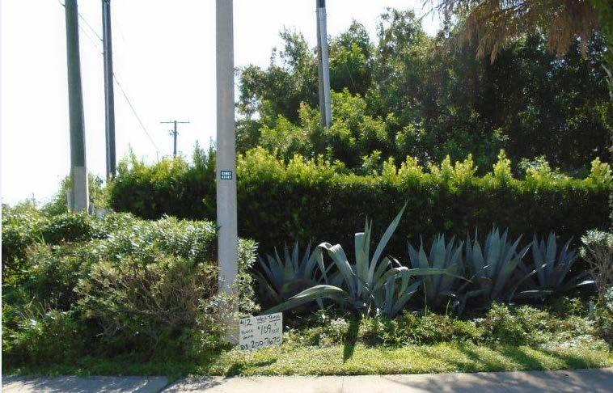

Acceptable Weeding
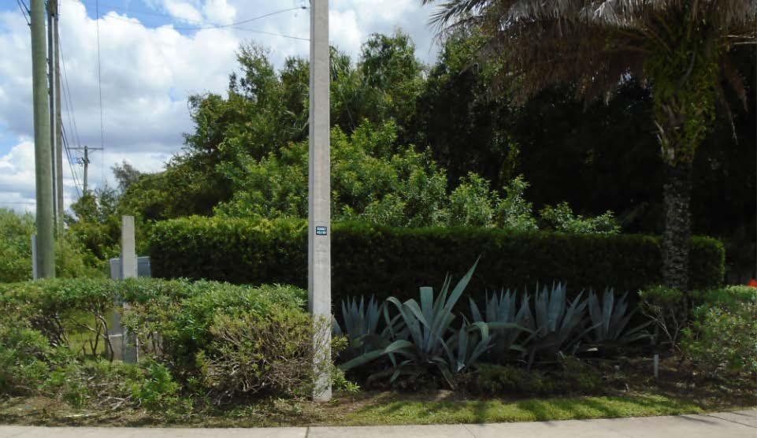

Hillsborough County Aviation Authority

Landscape Maintenance Services

ITB No. 18-534-009

SCOPE OF WORK

Page 9 of 17
December 6, 2017

  - Pruning: Company will:
    - Prune, thin, and trim all shrubs and groundcover at least once every month or as directed by the Contract Manager to keep plant material healthy, to maintain the natural character of the species, to control shape and to prevent overcrowding. Pruning in general consists of the removal of dead, dying, broken, fungus infected, insect infested and superfluous landscape material.

    - Periodically cut vines and groundcover plants to encourage lateral growth.

    - Periodically trim palm trees of dead fronds and boots.

    - Promptly restore all lawn and shrub areas damaged by pruning equipment at Company expense.

    - Prune and remove branches damaged by storms or vehicles, nuisance growth that obstructs vision, traffic signage, vehicle traffic, walks, and lighting as needed.

    - Remove moss from trees, fence and fence line adjacent to landscape beds.

D. TRASH AND DEBRIS REMOVAL:

Company will:

  - Keep walkways, roadways, and roadway drains, free from accumulation of waste materials, and other debris resulting from the performance of Services, including human discarded trash and litter.

  - Remove all waste materials, debris, tools, equipment, and surplus materials, from Authority property at the completion of each Cycle.

  - Remove collected debris from the work site at the conclusion of each Cycle. No unauthorized dumping on site will be allowed.

- LIGHTING: Company will:
  - Keep all landscape accent lighting free of debris including, but not limited to, grass clippings, pine bark and pine straw, soil and insects.

  - Be responsible for readjusting any lights knocked out of adjustment due to maintenance and for any damages to the lighting caused by Company.

Hillsborough County Aviation Authority

Landscape Maintenance Services

ITB No. 18-534-009

SCOPE OF WORK

Page 10 of 17

December 6, 2017

- INSPECTION AND APPROVAL:

Upon completion of each Cycle, the Contract Manager will inspect areas where work has been performed. The Contract Manager will notify Project Manager, in writing, of any noted deficiencies. Company must correct deficiencies within seven (7) working days following receipt of written notice.

  - SAFETY REQUIREMENTS:

Company will:

  - Be solely and completely responsible for initiating, maintaining, and supervising all safety precautions and programs in connection with any and all work performed.

  - Be solely responsible for compliance with all safety regulations, Federal, State, and local laws or regulations, including but not limited to OSHA, Environmental Protection Agency (EPA), FDOT-MOT, or other agency requirements.

  - Take all necessary precautions for safety of, and provide the necessary protection to prevent injury to, all Personnel on the work site and other persons including, but not limited to, the general public who may be affected thereby.

- EXTRA WORK AND CHANGES IN WORK

  - At Authority’s request, Company will provide additional related services not specifically identified in this Scope of Work (Extra Work). All work will be subject to inspection and acceptance by the Authority.

  - In the event that Extra Work or changes to the work result in any decrease or increase in time required and/or cost to the Authority, Company must immediately advise Authority in writing of the changes for review and approval. Compensation for all changes to the work or Extra Work will be in accordance with Article 4, Fees and Payments, as outlined in this Contract.

PART THREE –AERIAL MAPS OF LANDSCAPE MAINTEANCE SERVICE AREAS

- TAMPA INTERNATION AIRPORT SITES:

  - Tampa International Airport overview
  - Hoover Blvd. 1
  - Hoover Blvd. 2
  - North End of Cargo Road – Hillsborough Ave. to Cayuga Street
  - Middle of Cargo Road – Cayuga Street to Ohio Ave.
  - South End of Cargo Road – Ohio Ave. to Tampa Bay Blvd.
  - Obrien Street and Spruce Street

Hillsborough County Aviation Authority

Landscape Maintenance Services

ITB No. 18-534-009

SCOPE OF WORK

Page 11 of 17

December 6, 2017

PART THREE - AERIAL MAPS OF LANDSCAPE MAINTEANCE SERVICE AREAS

1. Tampa International Airport overview
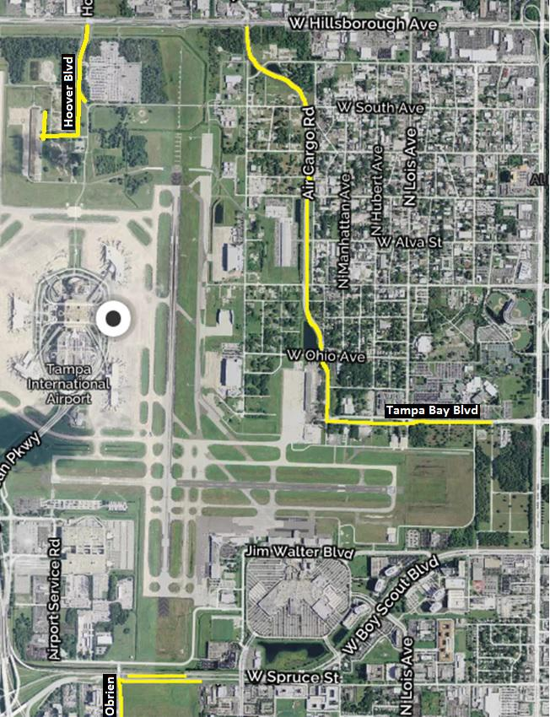

Hillsborough County Aviation Authority

Landscape Maintenance Services

ITB No. 18-534-009

SCOPE OF WORK

Page 12 of 17

December 6, 2017

2. Hoover Blvd. 1
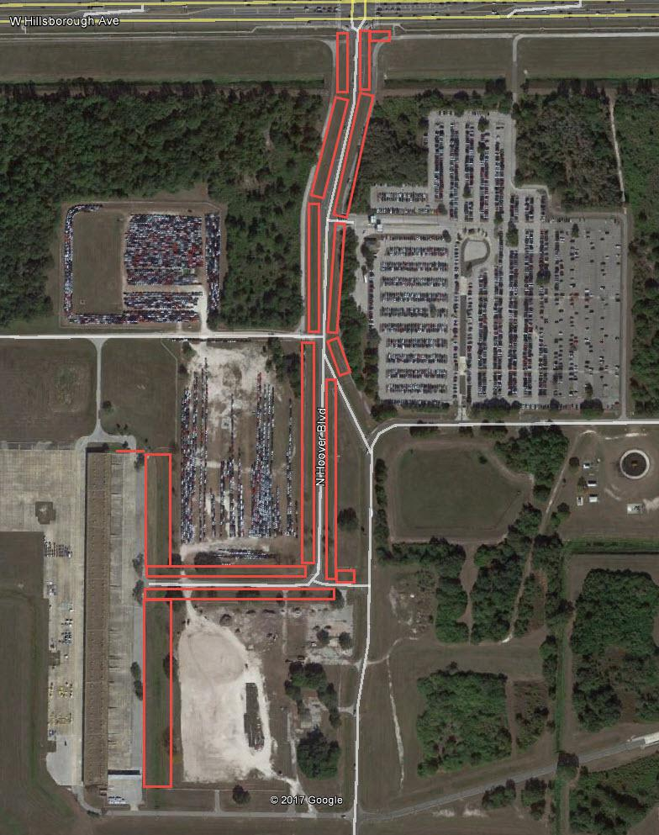

Hillsborough County Aviation Authority

Landscape Maintenance Services

ITB No. 18-534-009

SCOPE OF WORK

Page 13 of 17

December 6, 2017

3. Hoover Bivd. 2
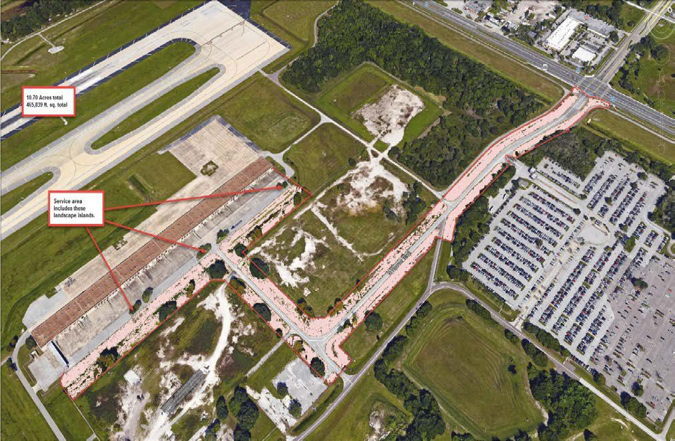

Hillsborough County Aviation Authority

Landscape Maintenance Services

ITB No. 18-534-009

SCOPE OF WORK

Page 14 of 17

December 6, 2017

4. North End of Cargo Road – Hillsborough Ave. to Cayuga Street
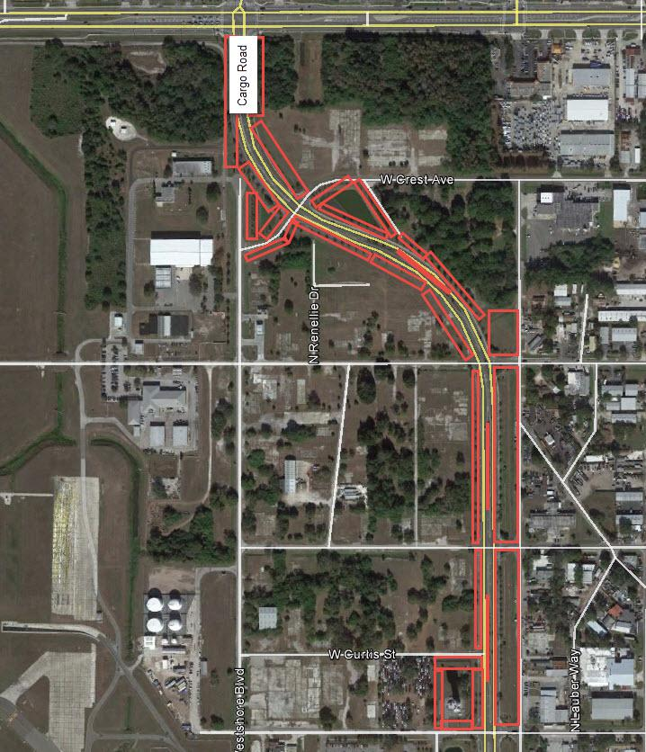

Hillsborough County Aviation Authority

Landscape Maintenance Services

ITB No. 18-534-009

SCOPE OF WORK

Page 15 of 17

December 6, 2017

5. Middle of Cargo Road – Cayuga Street to Ohio Ave.
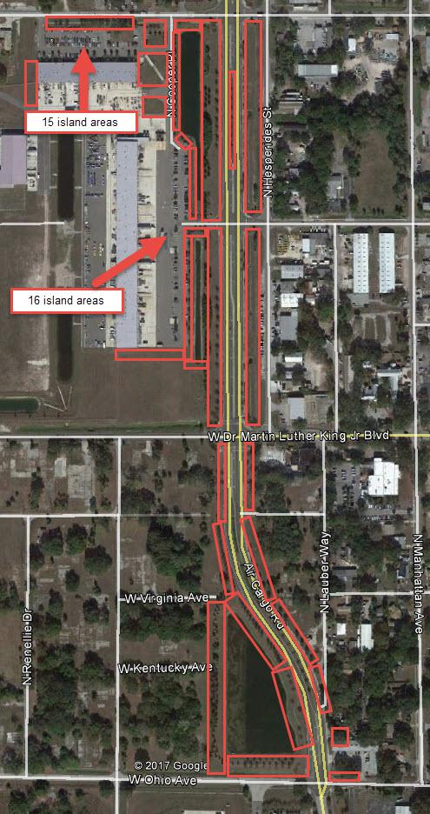

Hillsborough County Aviation Authority

Landscape Maintenance Services

ITB No. 18-534-009

SCOPE OF WORK

Page 16 of 17

December 6, 2017

6. South End of Cargo Road - Ohio Ave. to Tampa Bay Blvd.
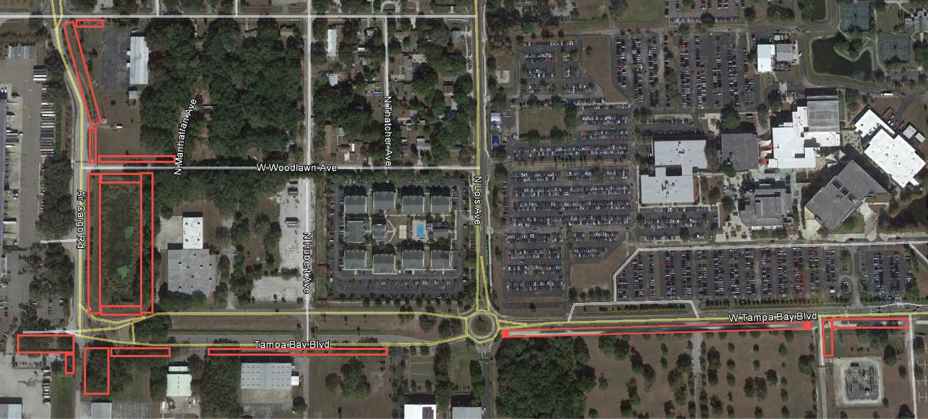

7. Obrien Street and Spruce Street
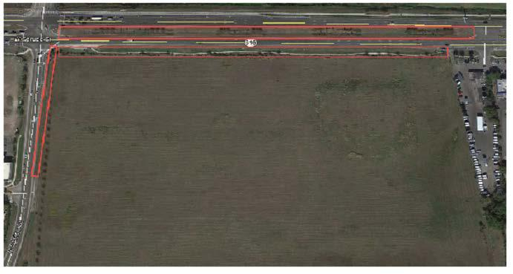

Hillsborough County Aviation Authority

Landscape Maintenance Services

ITB No. 18-534-009

SCOPE OF WORK

Page 17 of 17

December 6, 2017

