SUNLIGHT GENERAL PROJECTS: MORRIS COUNTY

SUMMARY OF ATTACHED INVOICES:

PAGE: | DATE: | PAYEE: | SERVICES RENDERED: | PAYABLE:
2 | 1/1/2020 | AZIMUTH 180 SOLAR ELECTRIC, LLC | JANUARY 2020 OPERATIONS & MAINTENANCE | $ | 10,889.29
3 | 1/1/2020 | SUNLIGHT GENERAL CAPITAL MANAGEMENT, LLC | JANUARY 2020 ASSET MANAGEMENT | $ | 11,536.09
4 | 1/3/2020 | MAHONEY SABOL & COMPANY, LLP | PROJECT COMPANY 2018 FINANCIALS & TAX RETURNS | $ | 1,500.00
5,6 | 12/2/2019 | BGC ENVIRONMENTAL BROKERAGE SERVICES LP | SREC BROKERAGE FEE 12/02/19 DEAL | $ | 1,000.00
7 | 12/10/2019 GT ENVIRONMENTAL FINANCE, LLC |  | SREC BROKERAGE FEE 12/10/19 DEAL | $ | 500.00
 |  |  |  | $ | 25,425.38

01 Jan 2020


O&M INVOICE

01 Jan 2020 – 31 Jan 2020

Per the Operations and Maintenance Agreement for Morris Renewable Energy Projects by and between SunLight General Morris Solar, LLC and Azimuth 180 Solar Electric, LLC dated January 24, 2013, please find this invoicing statement for the period indicated above.

The payable monthly amount is based on a $15.45/kW DC annual fee times 8,457.71, which is the total DC capacity of the arrays in service.

Bill To:
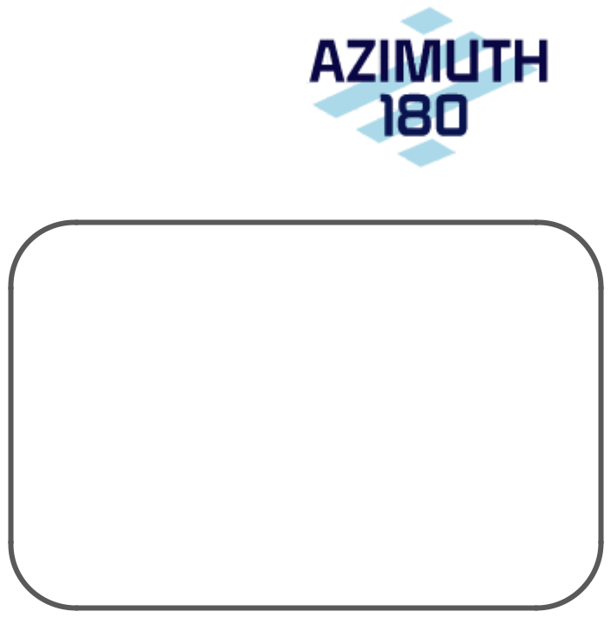

SunLight General Morris Solar, LLC 135 E. 57th St., Fl. 6

New York, NY 10022

Total: $10,889.29
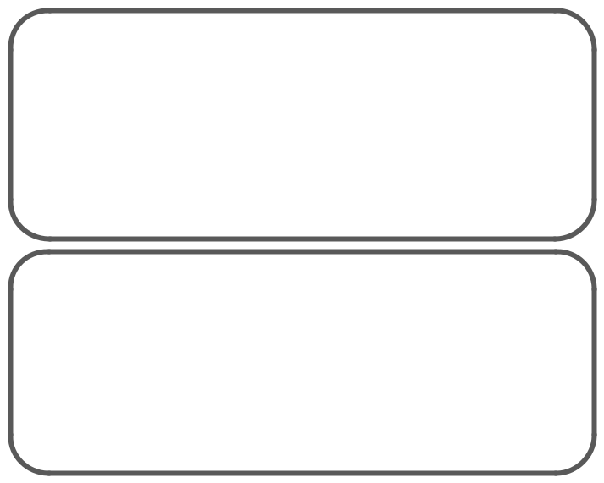

Remittance by ACH:

Account: Azimuth 180 Solar Electric, LLC

Account No.: 171383890

ABA/Routing No.: 021000021

Remittance by check:

Azimuth 180 Solar Electric, LLC

135 E. 57th St., Fl. 6

New York, NY 10022

01 Jan 2020

ASSET MANAGEMENT INVOICE

01 Jan 2020 – 31 Jan 2020

Per the Asset Management Agreement for Morris Renewable Energy Projects by and between SunLight General Morris Solar, LLC and SunLight General Capital Management, LLC dated January 24, 2013, please find this invoicing statement for the period indicated above.

The payable monthly amount is based on 1) a $75,000 annual fee and 2) a $7.50/kW DC annual fee times 8,457.71, which is the total DC capacity of the arrays in service.

Bill To:
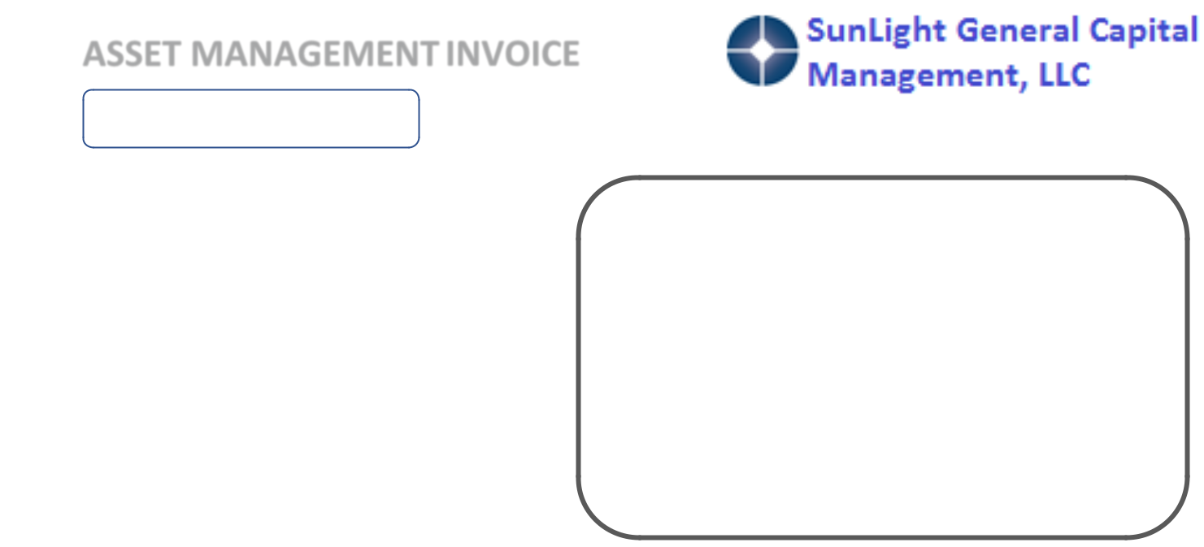

SunLight General Morris Solar, LLC 135 E. 57th St., Fl. 6

New York, NY 10022

Total: $11,536.09
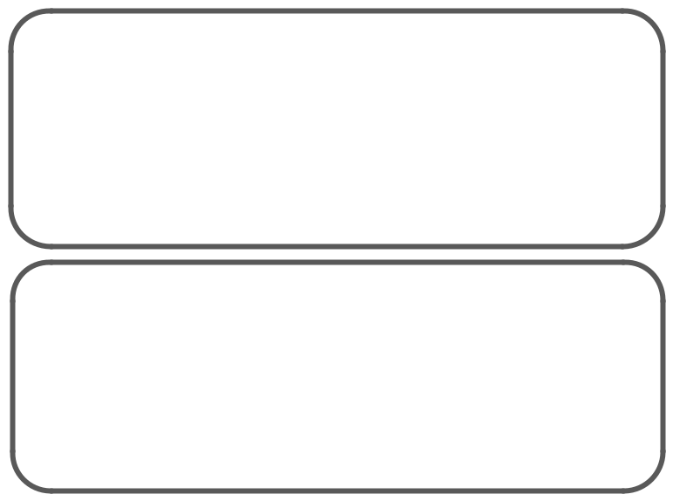

Remittance by ACH:

Account: SunLight General Capital Management, LLC

Account No.: 893705947

ABA/Routing No.: 021000021

Remittance by check:

SunLight General Capital Management, LLC

135 E. 57th St. Fl. 6

New York, NY 10022

80 Plains Road


PO Box 934

Essex, CT 06426-0934

Phone: 860-767-9999

Fax: 860-767-0353

 | Invoice: | 639193
Sunlight General Capital - Tax | Date: | 1/3/2020
Attn: Stacey L. Hughes | Due Date: | 2/2/2020
135 East 57th Street
6th Floor | Client Number: JB1630
New York, NY 10022

Please include our client number on your check

For professional services rendered:

Preparation and filing of 2018 Federal and State tax returns for the year ended

December 31, 2018:

Sunlight General Capital, LLC | $ | 2,000.00
Sunlight General Mercer Solar, LLC |  | 1,500.00
Sunlight General Morris Solar, LLC |  | 1,500.00
Sunlight General Somerset Solar, LLC |  | 1,500.00
Sunlight General Sussex Solar, LLC |  | 1,500.00
Preparation and filing of 2018 Federal and State tax |  | 1,600.00
returns for E. Klehe and S. Hughes
Preparation and filing of 2016 amended Federal and |  | 1,900.00
State tax returns for E. Klehe
Invoice Total | $ | 11,500.00

Payments are due 30 days after invoice date.

Interest may be added at a rate of 1.5% per month on outstanding balances over 30 days.

We also accept MasterCard, Visa, Discover and American Express

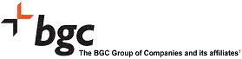
Brittany Muscatell Invoice Id: BGC-Dec-2019-00002725

199 Water Street Group Id: 30350

18th Floor Statement Date: 31Dec19

New York 10038 Statement Period: Dec-2019

Tel #: 646 346 7268 Fax #: 646 346 7268 Statement ID: 51404

Email: BMuscatell@bgcpartners.com Description: BGC Environmental

Accounts Payable

135 E 57th St

FL 6

New York

10022

NY

UNITED STATES

Statement

Statement Summary

Current Month Trades(Details attached)

Prior Periods (Details provided with

previous statements)

2019

USD

1,000.00

Total Amount Due | 1,000.00

Invoice is Payable upon Receipt

Payment Instructions

CURRENCY: USD

BANK: The Bank Of New York Mellon, New York

SWIFT: IRVTUS3N

ACCOUNT: BGC Environmental Brokerage Services LP

ATTENTION: A/C# 8901380911 ABA# 021000018

The BGC Group includes BGC Brokers L.P., (London head office, Switzerland, Dubai and Copenhagen branches); BGC Brokers US. L.P.; BGC Capital Markets (Hong Kong), Limited; BGC Capital Markets (Japan), LLC; BGC Capital Markets L.P.; BGC Capital Markets and FX Broker (Korea) Ltd;

BGC Financial L.P.; BGC Derivative Markets LP; BGC Partners (Singapore) LTD; BGC Partners (Australia) Pty Limited; BGC Securities (Australia) Pty Limited (Sydney head office and New Zealand branch - NZ GST 117-360-512); BGC Securities (Hong Kong) LLC (Incorporated in United States of America with limited liability); BGC Securities Sarl;

BGC Shoken Kaisha, Limited; BGC Partners CIS LLC;

and such other entities as may form part of the BGC Group from time to time.

Registered Tax Nos: UK BGC Group Registration (VAT: 577 4068 09), BGC Partners (Singapore) Ltd (GST: 200819105C), BGC Capital Markets and FX Broker (Korea) Ltd (GST: 104-86-07196), BGC Partners (Australia) Pty Ltd (ABN: 62 092 873 099, AFSL 221315), BGC Shoken Kaisha, Limited (126365), BGC Capital Markets (Japan), LLC

(126373).

* - Trades have Taxes Page 1 of 2

Brittany Muscatell Invoice Id: BGC-Dec-2019-00002725

199 Water Street Group Id: 30350

18th Floor Statement Date: 31Dec19

New York 10038 Statement Period: Dec-2019

Tel #: 646 346 7268 Fax #: 646 346 7268 Statement ID: 51404

Email: BMuscatell@bgcpartners.com Description: BGC Environmental

Current Month Activity

Client Location: SUNLMORRIS--SUNLIGHT GENERAL MORRIS SOLAR LLC, NY

Business Group: ENVBRK--EMISSION

Bill
Ccy: USD
Legal | Trade Reference | Confirmation Reference | Trade Date | Price | Volume - | Product Description | Counterparty | Bill | Billing Ccy Bro | Tax | Total Billing
Entity |  |  |  |  |  |  |  | Ccy |  |  | Brokerage
BGC Environmental | 9997891S15 | 12021902 | 02/Dec/2019 | 198.0000 | 1,000 | Nj Sol EY22 | Exelon Generation Company | USD | 1,000.00 | 0.00 | 1,000.00
Brokerage Services, LP |  |  |  |  |  |  | LLC, Chicago
 |  |  |  |  |  |  |  |  |  | USD | 1,000.00

The BGC Group includes BGC Brokers L.P., (London head office, Switzerland, Dubai and Copenhagen branches); BGC Brokers US. L.P.; BGC Capital Markets (Hong Kong), Limited; BGC Capital Markets (Japan), LLC; BGC Capital Markets L.P.; BGC Capital Markets and FX Broker (Korea) Ltd;

BGC Financial L.P.; BGC Derivative Markets LP; BGC Partners (Singapore) LTD; BGC Partners (Australia) Pty Limited; BGC Securities (Australia) Pty Limited (Sydney head office and New Zealand branch - NZ GST 117-360-512); BGC Securities (Hong Kong) LLC (Incorporated in United States of America with limited liability); BGC Securities Sarl;

BGC Shoken Kaisha, Limited; BGC Partners CIS LLC;

and such other entities as may form part of the BGC Group from time to time.

Registered Tax Nos: UK BGC Group Registration (VAT: 577 4068 09), BGC Partners (Singapore) Ltd (GST: 200819105C), BGC Capital Markets and FX Broker (Korea) Ltd (GST: 104-86-07196), BGC Partners (Australia) Pty Ltd (ABN: 62 092 873 099, AFSL 221315), BGC Shoken Kaisha, Limited (126365), BGC Capital Markets (Japan), LLC

(126373).

* - Trades have Taxes Page 2 of 2


TRADE CONFIRMATION

TRADE DETAILS

Trade ID: 4045-S

Trade Date: 12/10/2019

Trade Time: 10:49 Central

Type: OTC

PRODUCT DETAILS

Commodity: SREC

Product: RY 2020 NJ SRECs

Delivery: Firm

Basis: PJM-GATS

Delivery Date: On or before July 15, 2020

Start Date:

End Date:

Terms:

6/1/2019

5/31/2020

This Deal is Subject to Contract & Credit.

This trade becomes binding when a written confirmation is fully executed or affirmed in writing by both parties.

COUNTERPARTIES

Seller: | SunLight General Morris Solar |  | Buyer: | Direct Energy Business
 | LLC |  |  | Marketing, LLC
Address: | 135 E. 57th St. Fl. 16 |  | Address: | 12 Greenway Plaza, Suite 250
City/ST/Zip: | New York, NY 10022 |  | City/ST/Zip: | Houston , TX 77046
Contact: | Joe Shipley |  | Contact: | Tom Miller
Email: | jshipley@sunlightgeneral.com |  | Email: | thomas.miller@directenergy.com
Phone: | 212-286-1801 Ex. 4 |  | Phone: | 732-516-7561
INVOICE DETAILS
Invoice Date: | 12/10/2019 | Please Remit Payment No Later Than 30 Days To:
Volume: | 500 | JPMorgan Chase Bank, N.A.
Price: | $231.00 | For the Account of GT Environmental Finance, LLC
Price: | $231.00 | ABA Routing # 111000614
Rate: | $1.000 | Account Number 723291969
Total: | $500.00
Amount Due: | $500.00

We Thank You For This Business Opportunity!

 |  |  | SUNLIGHT GENERAL PROJECTS: MORRIS COUNTY
 |  |  |  | SUMMARY OF ATTACHED INVOICES:
PAGE: DATE: |  | PAYEE: |  |  | SERVICES RENDERED:
2 | 2/1/2020 | AZIMUTH 180 SOLAR ELECTRIC, LLC |  |  | FEBRUARY 2020 OPERATIONS & MAINTENANCE
3 | 2/1/2020 | SUNLIGHT GENERAL CAPITAL MANAGEMENT, LLC |  |  | FEBRUARY 2020 ASSET MANAGEMENT
4 | 3/1/2020 | AZIMUTH 180 SOLAR ELECTRIC, LLC |  |  | MARCH 2020 OPERATIONS & MAINTENANCE
5 | 3/1/2020 | SUNLIGHT GENERAL CAPITAL MANAGEMENT, LLC |  |  | MARCH 2020 ASSET MANAGEMENT

PAYABLE: $ 10,889.29 $ 11,536.09 $ 10,889.29 $ 11,536.09

$ 44,850.76

01 Feb 2020

O&M INVOICE

01 Feb 2020 – 29 Feb 2020

Per the Operations and Maintenance Agreement for Morris Renewable Energy Projects by and between SunLight General Morris Solar, LLC and Azimuth 180 Solar Electric, LLC dated January 24, 2013, please find this invoicing statement for the period indicated above.

The payable monthly amount is based on a $15.45/kW DC annual fee times 8,457.71, which is the total DC capacity of the arrays in service.

Bill To:

SunLight General Morris Solar, LLC 135 E. 57th St., Fl. 6

New York, NY 10022

Total: $10,889.29

Remittance by ACH:

Account: Azimuth 180 Solar Electric, LLC

Account No.: 171383890

ABA/Routing No.: 021000021

Remittance by check:

Azimuth 180 Solar Electric, LLC

135 E. 57th St., Fl. 6

New York, NY 10022

01 Feb 2020

ASSET MANAGEMENT INVOICE

01 Feb 2020 – 29 Feb 2020

Per the Asset Management Agreement for Morris Renewable Energy Projects by and between SunLight General Morris Solar, LLC and SunLight General Capital Management, LLC dated January 24, 2013, please find this invoicing statement for the period indicated above.

The payable monthly amount is based on 1) a $75,000 annual fee and 2) a $7.50/kW DC annual fee times 8,457.71, which is the total DC capacity of the arrays in service.

Bill To:

SunLight General Morris Solar, LLC 135 E. 57th St., Fl. 6

New York, NY 10022

Total: $11,536.09

Remittance by ACH:

Account: SunLight General Capital Management, LLC

Account No.: 893705947

ABA/Routing No.: 021000021

Remittance by check:

SunLight General Capital Management, LLC

135 E. 57th St. Fl. 6

New York, NY 10022

01 Mar 2020

O&M INVOICE

01 Mar 2020 – 31 Mar 2020

Per the Operations and Maintenance Agreement for Morris Renewable Energy Projects by and between SunLight General Morris Solar, LLC and Azimuth 180 Solar Electric, LLC dated January 24, 2013, please find this invoicing statement for the period indicated above.

The payable monthly amount is based on a $15.45/kW DC annual fee times 8,457.71, which is the total DC capacity of the arrays in service.

Bill To:

SunLight General Morris Solar, LLC 135 E. 57th St., Fl. 6

New York, NY 10022

Total: $10,889.29

Remittance by ACH:

Account: Azimuth 180 Solar Electric, LLC

Account No.: 171383890

ABA/Routing No.: 021000021

Remittance by check:

Azimuth 180 Solar Electric, LLC

135 E. 57th St., Fl. 6

New York, NY 10022

01 Mar 2020

ASSET MANAGEMENT INVOICE

01 Mar 2020 – 31 Mar 2020

Per the Asset Management Agreement for Morris Renewable Energy Projects by and between SunLight General Morris Solar, LLC and SunLight General Capital Management, LLC dated January 24, 2013, please find this invoicing statement for the period indicated above.

The payable monthly amount is based on 1) a $75,000 annual fee and 2) a $7.50/kW DC annual fee times 8,457.71, which is the total DC capacity of the arrays in service.

Bill To:

SunLight General Morris Solar, LLC 135 E. 57th St., Fl. 6

New York, NY 10022

Total: $11,536.09

Remittance by ACH:

Account: SunLight General Capital Management, LLC

Account No.: 893705947

ABA/Routing No.: 021000021

Remittance by check:

SunLight General Capital Management, LLC

135 E. 57th St. Fl. 6

New York, NY 10022

SUNLIGHT GENERAL PROJECTS: MORRIS COUNTY

SUMMARY OF ATTACHED INVOICES:

PAGE: | DATE: | PAYEE: | SERVICES RENDERED:
2 | 4/1/2020 | AZIMUTH 180 SOLAR ELECTRIC, LLC | APRIL 2020 OPERATIONS & MAINTENANCE
3 | 4/1/2020 | SUNLIGHT GENERAL CAPITAL MANAGEMENT, LLC | APRIL 2020 ASSET MANAGEMENT
4 | 8/30/2019 SUNLIGHT GENERAL CAPITAL, LLC |  | O&M EXPENSES: COST RELATING TO A RENTING A
 |  |  | SCISSOR LIFT TO REPAIR AN OPTIMIZER AT MORRIS
5 |  |  | COUNTY PSTA 1
5 | 9/10/2019 SUNLIGHT GENERAL CAPITAL, LLC |  | O&M EXPENSES: COST RELATING TO A RENTING A
 |  |  | SCISSOR LIFT TO REPAIR AN OPTIMIZER AT MORRIS
6 |  |  | COUNTY PSTA 2
6 | 9/11/2019 SUNLIGHT GENERAL CAPITAL, LLC |  | O&M EXPENSES: COST RELATING TO A STRUCTURAL
 |  |  | EVALUATION FOR THE COUNTY COLLEGE OF MORRIS

PAYABLE: $ 10,889.29 $ 11,536.09 $ 570.44

$ 362.53

$ 1,500.00

$ 24,858.35

01 Apr 2020

O&M INVOICE

01 Apr 2020 – 30 Apr 2020

Per the Operations and Maintenance Agreement for Morris Renewable Energy Projects by and between SunLight General Morris Solar, LLC and Azimuth 180 Solar Electric, LLC dated January 24, 2013, please find this invoicing statement for the period indicated above.

The payable monthly amount is based on a $15.45/kW DC annual fee times 8,457.71, which is the total DC capacity of the arrays in service.

Bill To:

SunLight General Morris Solar, LLC 135 E. 57th St., Fl. 6

New York, NY 10022

Total: $10,889.29

Remittance by ACH:

Account: Azimuth 180 Solar Electric, LLC

Account No.: 171383890

ABA/Routing No.: 021000021

Remittance by check:

Azimuth 180 Solar Electric, LLC

135 E. 57th St., Fl. 6

New York, NY 10022

01 Apr 2020

ASSET MANAGEMENT INVOICE

01 Apr 2020 – 30 Apr 2020

Per the Asset Management Agreement for Morris Renewable Energy Projects by and between SunLight General Morris Solar, LLC and SunLight General Capital Management, LLC dated January 24, 2013, please find this invoicing statement for the period indicated above.

The payable monthly amount is based on 1) a $75,000 annual fee and 2) a $7.50/kW DC annual fee times 8,457.71, which is the total DC capacity of the arrays in service.

Bill To:

SunLight General Morris Solar, LLC 135 E. 57th St., Fl. 6

New York, NY 10022

Total: $11,536.09

Remittance by ACH:

Account: SunLight General Capital Management, LLC

Account No.: 893705947

ABA/Routing No.: 021000021

Remittance by check:

SunLight General Capital Management, LLC

135 E. 57th St. Fl. 6

New York, NY 10022

EQUIPMENT RENTAL AGREEMENT

ABC SCISSORLIFT RENTAL llC

200 East Glen Road
Denville, NJ 07834
www.abcscissorliftrental.com

PH. 973 885-8200 Fax 973 586-8687

Sold To

Sun Light General Capital

 |  |  | TERMS Payment In Advance
Snow plowing
 |  |  | Date | Sale No.
 |  |  | 8/29/2019 | 2934
 | Ship To
 | PSTA
 | 500 West Hanover Ave
 | Morristown, NJH

Check No. | Payment Method | Ship Date
 | Visa | 9/3/2019

Description | Qty | Rate | Amount
2632 lift rental 1wk |  | 350.00 | 350.00T
Rental Protection - Does not cover personal injury, property |  | 10.00% | 35.00T
damage, liability, or theft.
Delivery and pickup |  | 150.00 | 150.00T

- SCISSOR LIFT MUST BE USED WITH FLOORING PROTECTION AT ALL TIMES

- IF EQUIPMENT RENTAL IS NOT TERMINATED BY INITIAL DUE DATE, THE RENTAL PERIOD WILL CONTINUE UNTILL THE LESSEE NOTIFIES THE LESSOR OF TERMINATION

- CUSTOMER/OPERATOR(S) ARE FULLY FAMILIAR WITH THE OPERATION AND USE OF RENTED EQUIPMENT.

- I HAVE READ AND UNDERSTAND THE TERMS OF THIS AGREEMENT.

SIGNATURE__________________________ PRINT NAME__________________________

Subtotal | $535.00
Sales Tax (6.625%) | $35.44
Total | $570.44

MACHINE MUST BE CLEANED OFF AND FREE OF PAINT AND DEBRIS OR A CHARGE OF $80 WILL BE APPLIED!! THANKS.

EQUIPMENT RENTAL AGREEMENT

ABC SCISSORLIFT RENTAL llC

200 East Glen Road
Denville, NJ 07834
www.abcscissorliftrental.com

PH. 973 885-8200 Fax 973 586-8687

Sold To

Sun Light General Capital

 |  |  | TERMS Payment In Advance
Snow plowing
 |  |  | Date | Sale No.
 |  |  | 9/9/2019 | 2946
 | Ship To
 | PSTA
 | 500 West Hanover Ave
 | Morristown, NJH

Check No. | Payment Method | Ship Date
 | Visa | 9/9/2019

Description | Qty | Rate | Amount
33ft rough terrain lift 1wk balance (340.00 ) |  | 340.00 | 340.00T

- SCISSOR LIFT MUST BE USED WITH FLOORING PROTECTION AT ALL TIMES

- IF EQUIPMENT RENTAL IS NOT TERMINATED BY INITIAL DUE DATE, THE RENTAL PERIOD WILL CONTINUE UNTILL THE LESSEE NOTIFIES THE LESSOR OF TERMINATION

- CUSTOMER/OPERATOR(S) ARE FULLY FAMILIAR WITH THE OPERATION AND USE OF RENTED EQUIPMENT.

- I HAVE READ AND UNDERSTAND THE TERMS OF THIS AGREEMENT.

SIGNATURE__________________________ PRINT NAME__________________________

Subtotal | $340.00
Sales Tax (6.625%) | $22.53
Total | $362.53

MACHINE MUST BE CLEANED OFF AND FREE OF PAINT AND DEBRIS OR A CHARGE OF $80 WILL BE APPLIED!! THANKS.

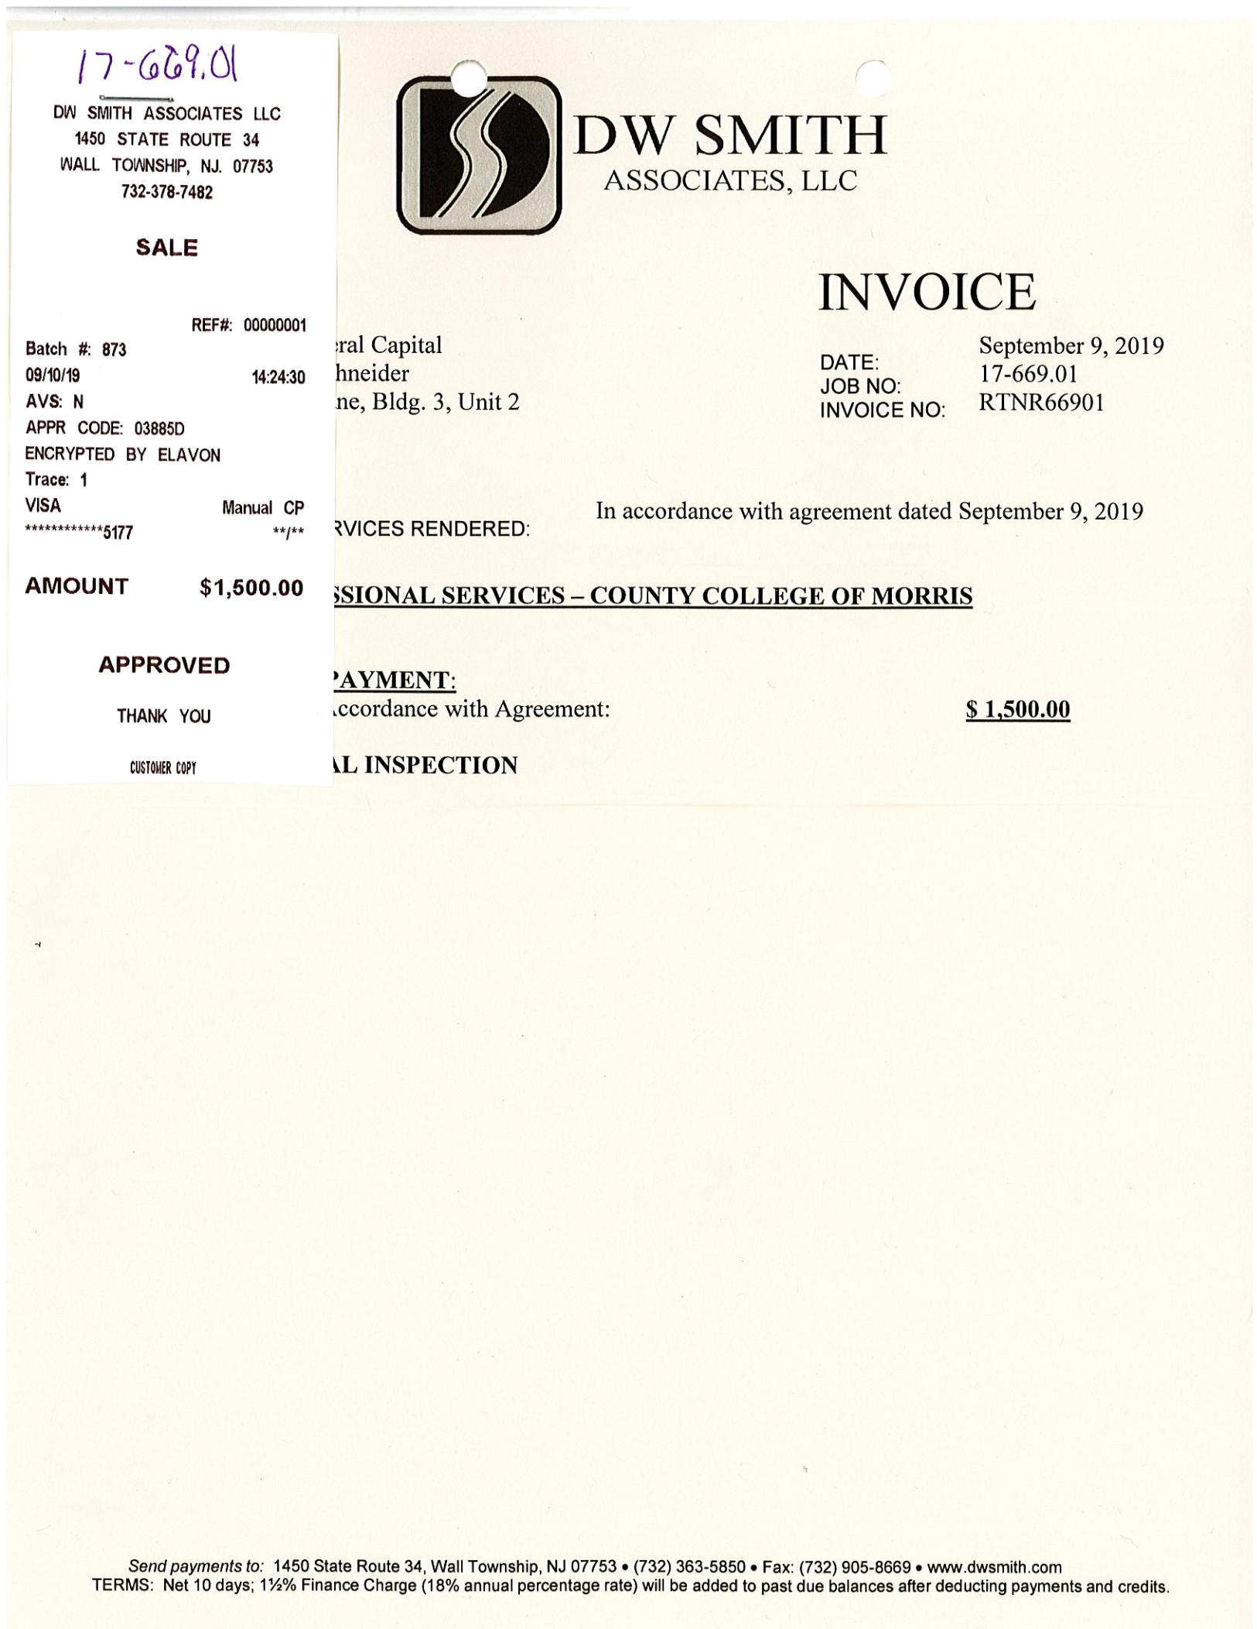
 |  |  | SUNLIGHT GENERAL PROJECTS: MORRIS COUNTY
 |  |  |  | SUMMARY OF ATTACHED INVOICES:
PAGE: DATE: |  | PAYEE: |  |  | SERVICES RENDERED:
2 | 5/1/2020 | AZIMUTH 180 SOLAR ELECTRIC, LLC |  |  | MAY 2020 OPERATIONS & MAINTENANCE
3 | 5/1/2020 | SUNLIGHT GENERAL CAPITAL MANAGEMENT, LLC |  |  | MAY 2020 ASSET MANAGEMENT
4 | 5/13/2020 | AMEREX BROKERS, LLC |  |  | SREC BROKER FEES 05/13/20 DEAL
5 | 5/13/2020 | AMEREX BROKERS, LLC |  |  | SREC BROKER FEES 05/13/20 DEAL
6 | 5/13/2020 | MAHONEY, SABOL & COMPANY LLP |  |  | 2019 AUDITED FS - PROJECT COMPANY
7 | 5/14/2020 | GT ENVIRONMENTAL FINANCE, LLC |  |  | SREC BROKERAGE FEE 05/14/20 DEAL
8 | 5/18/2020 | AMEREX BROKERS, LLC |  |  | SREC BROKER FEES 05/18/20 DEAL

PAYABLE:

$ 10,889.29

$ 11,536.09

$ 2,000.00

$ 500.00

$ 12,850.00

$ 1,000.00

$ 4,500.00

$ 43,275.38

01 May 2020

O&M INVOICE

01 May 2020 – 31 May 2020

Per the Operations and Maintenance Agreement for Morris Renewable Energy Projects by and between SunLight General Morris Solar, LLC and Azimuth 180 Solar Electric, LLC dated January 24, 2013, please find this invoicing statement for the period indicated above.

The payable monthly amount is based on a $15.45/kW DC annual fee times 8,457.71, which is the total DC capacity of the arrays in service.

Bill To:

SunLight General Morris Solar, LLC 135 E. 57th St., Fl. 6

New York, NY 10022

Total: $10,889.29

Remittance by ACH:

Account: Azimuth 180 Solar Electric, LLC

Account No.: 171383890

ABA/Routing No.: 021000021

Remittance by check:

Azimuth 180 Solar Electric, LLC

135 E. 57th St., Fl. 6

New York, NY 10022

01 May 2020

ASSET MANAGEMENT INVOICE

01 May 2020 – 31 May 2020

Per the Asset Management Agreement for Morris Renewable Energy Projects by and between SunLight General Morris Solar, LLC and SunLight General Capital Management, LLC dated January 24, 2013, please find this invoicing statement for the period indicated above.

The payable monthly amount is based on 1) a $75,000 annual fee and 2) a $7.50/kW DC annual fee times 8,457.71, which is the total DC capacity of the arrays in service.

Bill To:

SunLight General Morris Solar, LLC 135 E. 57th St., Fl. 6

New York, NY 10022

Total: $11,536.09

Remittance by ACH:

Account: SunLight General Capital Management, LLC

Account No.: 893705947

ABA/Routing No.: 021000021

Remittance by check:

SunLight General Capital Management, LLC

135 E. 57th St. Fl. 6

New York, NY 10022

Amerex Brokers LLC

One Sugar Creek Center Blvd., Suite 700 Sugar Land, TX 77478 Phone: 281-340-5277 Fax: 281-340-5262

NJ Solar RECs

May 13, 2020 3:18 PM

TO:

FROM:

Confirmation #:

Joseph Shipley

Nicholas Wells, Tom Gibson

FX-2072773-A

Transaction

Date:

May 13 2020 3:18PM

Seller:
ATTN: Joseph Shipley Email: jshipley@sunlightgeneral.com Phone: 2122861801x4

Sunlight General Morris Solar LLC
135 E 57th St Fl 6
New York, NY USA

Buyer:

ATTN: Paul Joyce Email: paul.joyce@dteenergy.com Phone: 7138874187

DTE Energy Trading Inc
414 S Main Street Suite 200
Ann Arbor, MI USA 48104

Price:

USD $218 per REC

Vintage:

RY2022

Total Volume:

2000 RECs

Certification:

Credit &

Agreement:

This trade is subject to credit and a mutually acceptable sales and purchase agreement.

Other Terms:
Delivered on or before July 15, 2022.

Brokerage

Agreement:

Amerex Brokers LLC is to receive $2000.000 (USD) from Sunlight General Morris Solar LLC with invoice forthcoming.

Notes:
None

Each of the parties (the "Parties") to the transaction (the "Transaction") described in this confirmation agrees that (i) Amerex acted solely as the broker for the Transaction, (ii) the Parties themselves determined the terms and conditions of the Transaction, (iii) Amerex made no representations or warranties regarding the financial capability or legal authority of the other Party to perform its obligations under the Transaction (the "Obligations"), (iv) the Parties are solely responsible for performing their respective Obligations, (v) if the other Party defaults in its Obligations, the nondefaulting Party will look solely to the defaulting Party for the performance of its obligations, (vi) Amerex will have no duty to perform the defaulting Party's Obligations or to pay any damages caused by or related to the default, (vii) it will have no recourse against Amerex if the other Party is prohibited or restricted from entering into the Transaction or from performing any or all of its Obligations, and (viii) it will hold Amerex harmless from any liabilities which may arise out of any dispute between the Parties with respect to the Transaction. Important Notice: If this confirmation contains any terms or conditions which are contrary to your (meaning either the "Buyer's" or the "Seller's") understanding of the Transaction ("Discrepancies"), you must notify us (meaning "Amerex") of the Discrepancies before the close of business (meaning "5:00 p.m. CPT") on the first business day after you receive or have electronic access to this confirmation. If you do not notify us of any Discrepancies before the deadline described in the preceding sentence, you will be deemed to have agreed to the terms and conditions of the Transaction set forth in this confirmation.

Would you like web-based confirms? Visit www.confirmhub.com. Thank you for your business.

Amerex Brokers LLC

One Sugar Creek Center Blvd., Suite 700 Sugar Land, TX 77478 Phone: 281-340-5277 Fax: 281-340-5262

NJ Solar RECs

May 13, 2020 3:23 PM

TO:

FROM:

Confirmation #:

Joseph Shipley

Nicholas Wells, Jason Paul

FX-2072776-A

Transaction

Date:

May 13 2020 3:23PM

Seller:
ATTN: Joseph Shipley Email: jshipley@sunlightgeneral.com Phone: 2122861801x4

Sunlight General Morris Solar LLC
135 E 57th St Fl 6
New York, NY USA

Buyer:

ATTN: Laura Duklewski Email: Laura.duklewski@constellation.com Phone: 4104683784

Exelon Generation Company LLC
100 Constellation Way Suite 500 C
Baltimore, MD USA 21202

Price:

USD $233 per REC

Vintage:

RY2021

Total Volume:

500 RECs

Certification:

Credit &

Agreement:

This trade is subject to credit and a mutually acceptable sales and purchase agreement.

Other Terms:
Delivered on or before July 15, 2021.

Brokerage

Agreement:

Amerex Brokers LLC is to receive $500.000 (USD) from Sunlight General Morris Solar LLC with invoice forthcoming.

Notes:
None

Each of the parties (the "Parties") to the transaction (the "Transaction") described in this confirmation agrees that (i) Amerex acted solely as the broker for the Transaction, (ii) the Parties themselves determined the terms and conditions of the Transaction, (iii) Amerex made no representations or warranties regarding the financial capability or legal authority of the other Party to perform its obligations under the Transaction (the "Obligations"), (iv) the Parties are solely responsible for performing their respective Obligations, (v) if the other Party defaults in its Obligations, the nondefaulting Party will look solely to the defaulting Party for the performance of its obligations, (vi) Amerex will have no duty to perform the defaulting Party's Obligations or to pay any damages caused by or related to the default, (vii) it will have no recourse against Amerex if the other Party is prohibited or restricted from entering into the Transaction or from performing any or all of its Obligations, and (viii) it will hold Amerex harmless from any liabilities which may arise out of any dispute between the Parties with respect to the Transaction. Important Notice: If this confirmation contains any terms or conditions which are contrary to your (meaning either the "Buyer's" or the "Seller's") understanding of the Transaction ("Discrepancies"), you must notify us (meaning "Amerex") of the Discrepancies before the close of business (meaning "5:00 p.m. CPT") on the first business day after you receive or have electronic access to this confirmation. If you do not notify us of any Discrepancies before the deadline described in the preceding sentence, you will be deemed to have agreed to the terms and conditions of the Transaction set forth in this confirmation.

Would you like web-based confirms? Visit www.confirmhub.com. Thank you for your business.



 | 80 Plains Road
 | PO Box 934
 | Essex, CT | 06426-0934
 | Phone: 860-767-9999
 | Fax:860-767-0353
 | Invoices: | 640912 - 640915
Sunlight General Capital, LLC | Date: | 5/13/2020
Attn: Stacey Hughes | Due Date: | 6/12/2020
135 57th St., Sixth Floor
New York, NY 10022 | Client Number: JB1657-JB1660

Please include our client number on your check

__________________________________________________________________________________________________

For professional services rendered:

Final billing per engagement letters in connection with

the financial statement audits as of and for the year

ended December 31, 2019 for the following entities:

Sunlight General Sussex Solar, LLC | $ | 12,850.00
Sunlight General Somerset Solar, LLC | $ | 12,850.00
Sunlight General Morris Solar, LLC | $ | 12,850.00
Sunlight General Mercer Solar, LLC | $ | 12,850.00

Payments are due 30 days after invoice date.

Interest may be added at a rate of 1.5% per month on outstanding balances over 30 days.

We also accept MasterCard, Visa, Discover and American Express


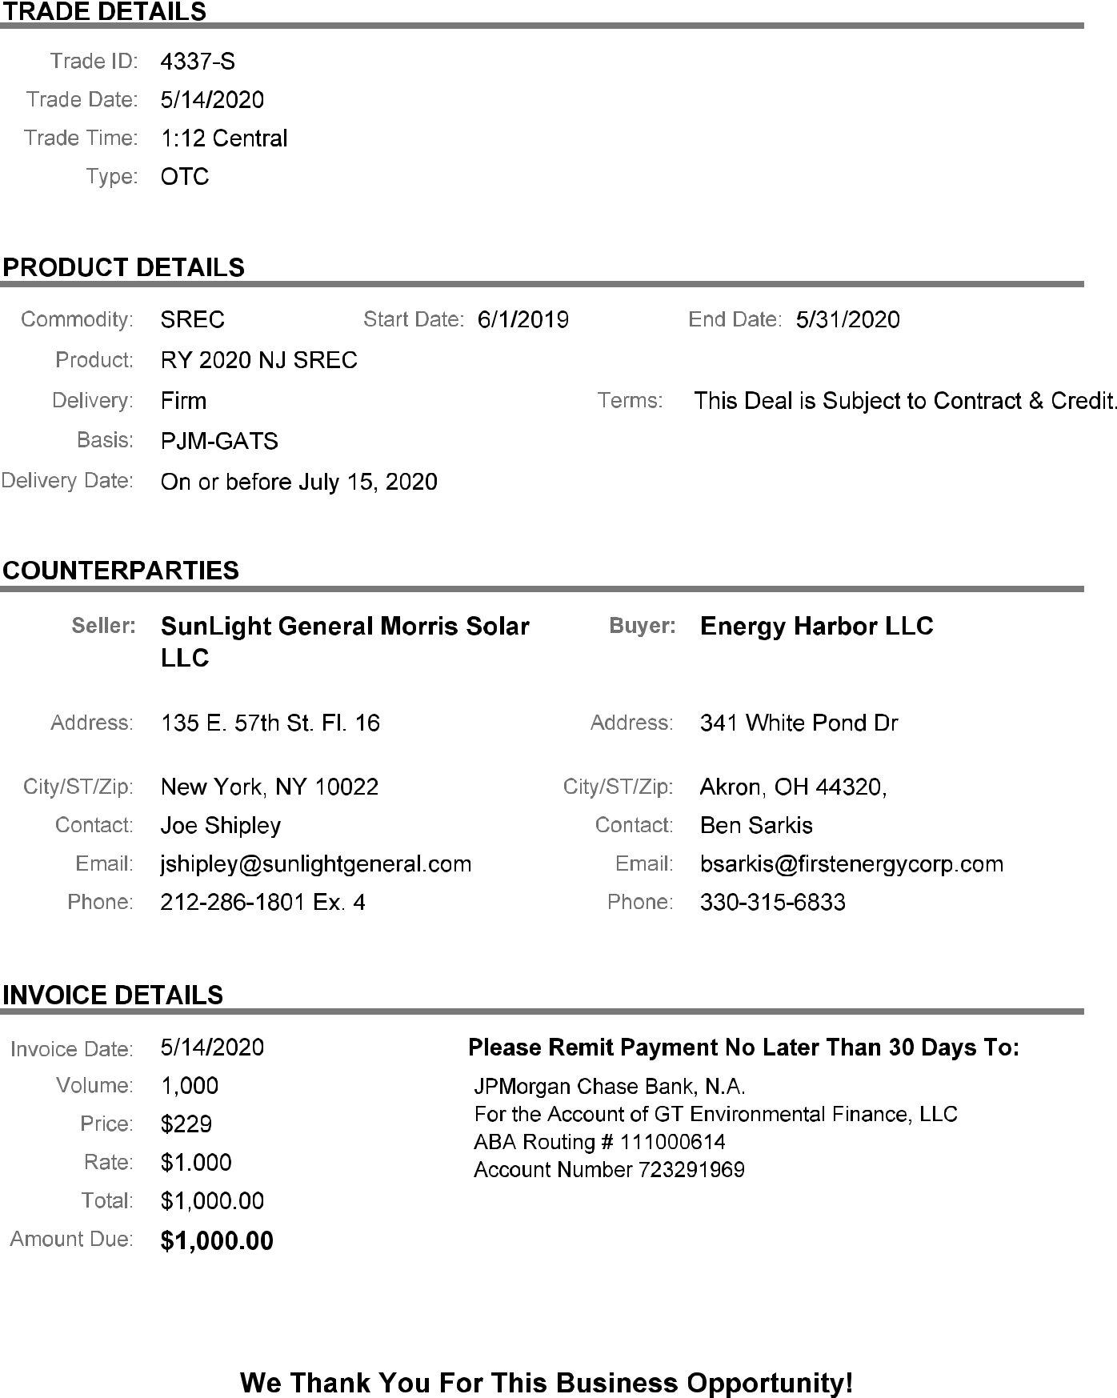
Amerex Brokers LLC

One Sugar Creek Center Blvd., Suite 700 Sugar Land, TX 77478 Phone: 281-340-5277 Fax: 281-340-5262

NJ Solar RECs

May 18, 2020 9:43 AM

TO:

FROM:

Confirmation #:

Joseph Shipley

Nicholas Wells, Tom Gibson

FX-2073016-A

Transaction

Date:

May 18 2020 9:43AM

Seller:
ATTN: Joseph Shipley Email: jshipley@sunlightgeneral.com Phone: 2122861801x4

Sunlight General Morris Solar LLC
135 E 57th St Fl 6
New York, NY USA

Buyer:

ATTN: Rob Lawrence Email: robert_lawrence@transcanada.com Phone: 6196848044

Calpine Energy Solutions, LLC
401 West A Street Suite 500 401 West A Street Suite 500
San Diego, CA USA 92101

Price:

USD $202.5 per REC

Vintage:

RY2023

Total Volume:

4500 RECs

Certification:

Credit &

Agreement:

This trade is subject to credit and a mutually acceptable sales and purchase agreement.

Other Terms:
Delivered on or before 7/15/2023.

Calpine Energy Solutions to initiate contracts.

Brokerage

Agreement:

Amerex Brokers LLC is to receive $4500.000 (USD) from Sunlight General Morris Solar LLC with invoice forthcoming.

Notes:
None

Each of the parties (the "Parties") to the transaction (the "Transaction") described in this confirmation agrees that (i) Amerex acted solely as the broker for the Transaction, (ii) the Parties themselves determined the terms and conditions of the Transaction, (iii) Amerex made no representations or warranties regarding the financial capability or legal authority of the other Party to perform its obligations under the Transaction (the "Obligations"), (iv) the Parties are solely responsible for performing their respective Obligations, (v) if the other Party defaults in its Obligations, the nondefaulting Party will look solely to the defaulting Party for the performance of its obligations, (vi) Amerex will have no duty to perform the defaulting Party's Obligations or to pay any damages caused by or related to the default, (vii) it will have no recourse against Amerex if the other Party is prohibited or restricted from entering into the Transaction or from performing any or all of its Obligations, and (viii) it will hold Amerex harmless from any liabilities which may arise out of any dispute between the Parties with respect to the Transaction. Important Notice: If this confirmation contains any terms or conditions which are contrary to your (meaning either the "Buyer's" or the "Seller's") understanding of the Transaction ("Discrepancies"), you must notify us (meaning "Amerex") of the Discrepancies before the close of business (meaning "5:00 p.m. CPT") on the first business day after you receive or have electronic access to this confirmation. If you do not notify us of any Discrepancies before the deadline described in the preceding sentence, you will be deemed to have agreed to the terms and conditions of the Transaction set forth in this confirmation.

Would you like web-based confirms? Visit www.confirmhub.com. Thank you for your business.

SUNLIGHT GENERAL PROJECTS: MORRIS COUNTY

SUMMARY OF ATTACHED INVOICES:

PAGE: | DATE: | PAYEE: | SERVICES RENDERED:
2 | 6/1/2020 | AZIMUTH 180 SOLAR ELECTRIC, LLC | JUNE 2020 OPERATIONS & MAINTENANCE
3 | 6/1/2020 | SUNLIGHT GENERAL CAPITAL MANAGEMENT, LLC | JUNE 2020 ASSET MANAGEMENT
4 | 6/24/2020 | AZIMUTH 180 SOLAR ELECTRIC, LLC | APRIL, MAY, JUNE 2020 LANDSCAPING
5 | 5/18/2020 SUNLIGHT GENERAL CAPITAL, LLC |  | O&M EXPENSES: COST RELATING TO A PURCHASE OF
6 |  |  | EQUIPMENT FOR COUNTY COLLEGE OF MORRIS
6 | 6/16/2020 TRIDENT BROKERAGE SERVICES LLC |  | SREC BROKERAGE FEE 06/16/2020 DEAL

PAYABLE: $ 10,889.29 $ 11,536.09 $ 5,913.00 $ 2,503.48

$ 1,000.00

$ 31,841.86

01 Jun 2020

O&M INVOICE

01 Jun 2020 – 30 Jun 2020

Per the Operations and Maintenance Agreement for Morris Renewable Energy Projects by and between SunLight General Morris Solar, LLC and Azimuth 180 Solar Electric, LLC dated January 24, 2013, please find this invoicing statement for the period indicated above.

The payable monthly amount is based on a $15.45/kW DC annual fee times 8,457.71, which is the total DC capacity of the arrays in service.

Bill To:

SunLight General Morris Solar, LLC 135 E. 57th St., Fl. 6

New York, NY 10022

Total: $10,889.29

Remittance by ACH:

Account: Azimuth 180 Solar Electric, LLC

Account No.: 171383890

ABA/Routing No.: 021000021

Remittance by check:

Azimuth 180 Solar Electric, LLC

135 E. 57th St., Fl. 6

New York, NY 10022

01 Jun 2020

ASSET MANAGEMENT INVOICE

01 Jun 2020 – 30 Jun 2020

Per the Asset Management Agreement for Morris Renewable Energy Projects by and between SunLight General Morris Solar, LLC and SunLight General Capital Management, LLC dated January 24, 2013, please find this invoicing statement for the period indicated above.

The payable monthly amount is based on 1) a $75,000 annual fee and 2) a $7.50/kW DC annual fee times 8,457.71, which is the total DC capacity of the arrays in service.

Bill To:

SunLight General Morris Solar, LLC 135 E. 57th St., Fl. 6

New York, NY 10022

Total: $11,536.09

Remittance by ACH:

Account: SunLight General Capital Management, LLC

Account No.: 893705947

ABA/Routing No.: 021000021

Remittance by check:

SunLight General Capital Management, LLC

135 E. 57th St. Fl. 6

New York, NY 10022

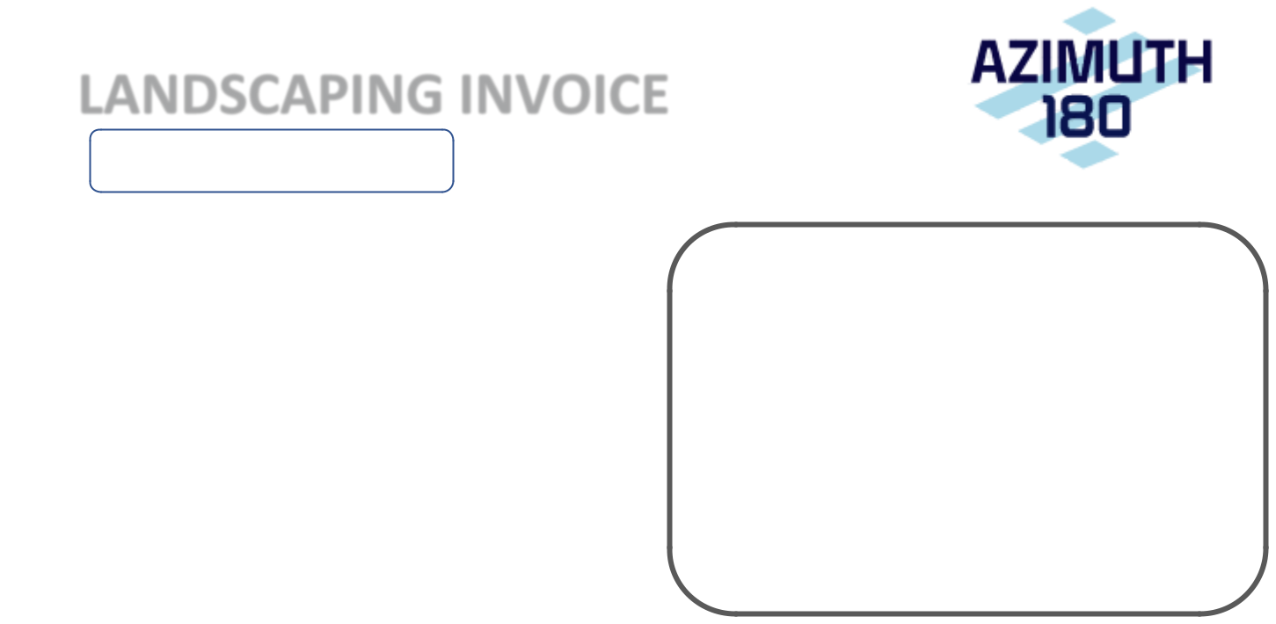
24 Jun 2020

LANDSCAPING INVOICE

01 Apr 2020 – 30 Jun 2020

This is an invoice for landscaping services rendered during the period shown above at the following sites:

Bragg Intermediate School
Black River Middle School
Chester Municipal Building
Long Valley Middle School
Morris County Office of Temporary
Assistance
Randolph High School
Sandshore Elementary School

Tinc Road School

Bill To:

SunLight General Morris Solar, LLC 135 E. 57th St., Fl. 6

New York, NY 10022

Total: $5,913.00

Remittance by ACH:

Account: Azimuth 180 Solar Electric, LLC

Account No.: 171383890

ABA/Routing No.: 021000021

Remittance by check:

Azimuth 180 Solar Electric, LLC

135 E. 57th St., Fl. 6

New York, NY 10022

 | Connected Solutions Group |  |  |  |  | Invoice
 | 8529 Meadowbridge Road
 |  |  |  | Rep | Date |  | Invoice #
 | Suite 300
 |  |  |  | JK | 5/18/2020 |  | 40372
 | Mechanicsville VA 23116 |  |  | JK | 5/18/2020 |  | 40372
Bill To |  |  | Ship To
SunLight General Morris Solar LLC |  |  | Stephen Schneider
Atn: Steve Schneider |  |  | 209 Harvard Avenue
135 East 57th Street, 16th Floor |  |  | Point Pleasant Beach, NJ 08742
New York, New York 10022

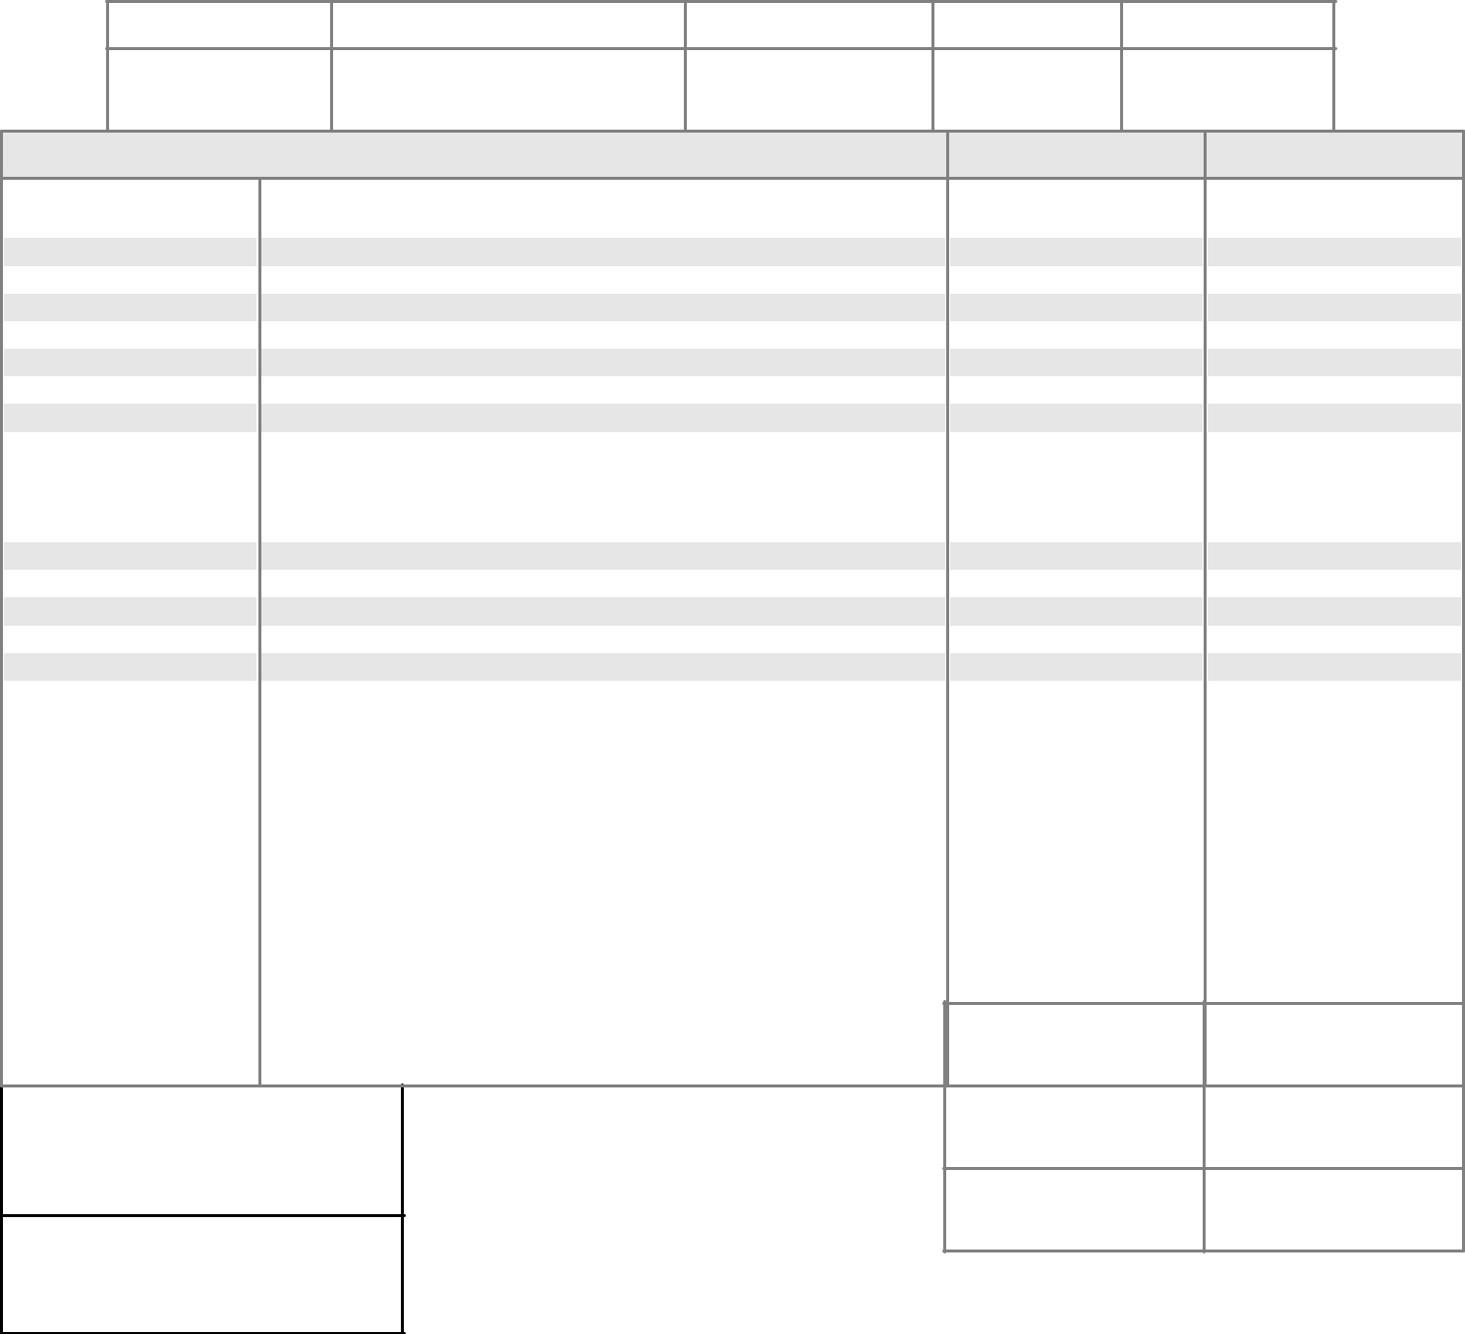

S.O. No.

P.O. Number

Payment Terms

Due Date

Ship Method

32794

CC

5/18/2020

UPS Ground

Quantity Description

- VZW - Encore BANDIT 2 W / 120/240 VAC Power - B2000-CV4G-0000-1BAC70 - brand New

- DIn rail clip - DIN-MNT44

- Encore Remote Install Support - EN-TIPS

- Labrador Antenna PTAWM2L15B

- UPS Ground Shipping 1Z1017660352617506

- Processing Fee

- **Manufacturer Warranty**

TAX EXEMPT

A late charge of 3% will be

charged to all invoices that

become 30 days past due.

For returns,15% restock fee +

shipping deducted for

non-warranty issues available for
30 days.

Price Each

1,899.00

16.00

299.00

199.00

17.56

72.92

0.00

0.00%

Total

Applied Payment

Balance Due

Amount

1,899.00

16.00

299.00

199.00

17.56

72.92

0.00

0.00

$2,503.48

-$2,503.48

$0.00

 Trident Brokerage Services LLC

Confirmation of Transaction (0079324-S)

Trade Type : New Jersey Solar REC (Physical)

Deal No : 0079324-S

Trade Date : 06/16/2020

To : Joseph Shipley
Sunlight General Morris Solar LLC

From : Trident Brokerage Services LLC

Buyer : Exelon Generation Company, LLC
Laura Duklewski 410-468-3784 laura.duklewski@constellation.com
1310 Point Street
Baltimore, MD 21231

Seller : Sunlight General Morris Solar LLC
Joseph Shipley 212-286-1801 jshipley@sunlightgeneral.com
135 E. 57th St.
6th Floor
New York, NY 10022

Product : SREC - Solar Renewable Energy Certificates

Term : RY 20

Unit Quantity : 1000 Total REC(s)

Total Quantity : 1000 MWh

Location : PJM- New Jersey SREC

Delivery Method : On or before 07/15/2020

Price : $228.50 USD/REC

Credit Term : Subject to contract and credit.

Commission Rate : $1.00 USD/REC

Total Amount Due : Trident Brokerage Services LLC is to receive $1000.00 USD from Sunlight General Morris Solar LLC with invoice forthcoming

Contact Details Should you require any further information please contact: Confirmation Dept at e.heim@tridentotc.com

Buyer and Seller understand that Trident Brokerage Services LLC has acted as agent for both parties solely for the purpose of matching up the parties to the transaction. Trident Brokerage Services LLC shall have no liability to any party if any party is for any reason prohibited or restricted from entering into this transaction. The fee charged to you in this transaction is a negotiated fee which may not be the same as charged in similar transactions. The fee is payable upon receipt of our invoice. All aspects and terms of the transaction were determined and agreed to solely by the Buyer and Seller and compliance with the terms of this transaction is strictly their obligation. If any disputes occurs the Buyer and Seller agree to hold Trident Brokerage Services LLC its affiliates and their respective successors harmless from any liabilities which result therefrom. This Confirmation shall insure to the benefit of Trident Brokerage Services LLC its affiliates and respective successors.

The Buyer and Seller (each a "Party") understand that Trident Brokerage Services LLC has acted as agent for both parties hereto solely for the purpose of introducing the Parties with respect to the herein confirmed swap transaction (the "Transaction"). Each Party acknowledges and agrees that (i) It is capable of understanding the Transaction, assessing the merits thereof and, in fact, understands and accepts the terms, conditions of the Transaction and also assumes the risks attendant thereto; (ii) each Party is responsible for evaluating the merits of the Transaction and the creditworthiness of the other party thereto; (iii) Trident Brokerage Services LLC shall not be responsible for either Party's performance of its respective obligations with respect to the Transaction nor does Trident Brokerage Services LLC make any representation or assume any liability in respect of the creditworthiness, financial condition or legal capacity of a Party; and (iv) Trident Brokerage Services LLC shall have no liability to either party in the event a Party is prohibited or restricted from entering into the Transaction or if the Transaction is voided or rejected, including without limitation an exchange or either Party's clearing facility .
SUNLIGHT GENERAL PROJECTS: MORRIS COUNTY

SUMMARY OF ATTACHED INVOICES:

PAGE: | DATE: | PAYEE: | SERVICES RENDERED: | PAYABLE:
2 | 7/1/2020 | AZIMUTH 180 SOLAR ELECTRIC, LLC | JULY 2020 OPERATIONS & MAINTENANCE | $ | 10,889.29
3 | 7/1/2020 | SUNLIGHT GENERAL CAPITAL MANAGEMENT, LLC | JULY 2020 ASSET MANAGEMENT | $ | 11,536.09
4 | 7/1/2020 AZIMUTH 180 SOLAR ELECTRIC, LLC |  | JULY 2020 LANDSCAPING | $ | 1,971.00
 |  |  |  | $ | 24,396.38

01 Jul 2020

O&M INVOICE

01 Jul 2020 – 31 Jul 2020

Per the Operations and Maintenance Agreement for Morris Renewable Energy Projects by and between SunLight General Morris Solar, LLC and Azimuth 180 Solar Electric, LLC dated January 24, 2013, please find this invoicing statement for the period indicated above.

The payable monthly amount is based on a $15.45/kW DC annual fee times 8,457.71, which is the total DC capacity of the arrays in service.

Bill To:

SunLight General Morris Solar, LLC 135 E. 57th St., Fl. 6

New York, NY 10022

Total: $10,889.29

Remittance by ACH:

Account: Azimuth 180 Solar Electric, LLC

Account No.: 171383890

ABA/Routing No.: 021000021

Remittance by check:

Azimuth 180 Solar Electric, LLC

135 E. 57th St., Fl. 6

New York, NY 10022

01 Jul 2020

ASSET MANAGEMENT INVOICE

01 Jul 2020 – 31 Jul 2020

Per the Asset Management Agreement for Morris Renewable Energy Projects by and between SunLight General Morris Solar, LLC and SunLight General Capital Management, LLC dated January 24, 2013, please find this invoicing statement for the period indicated above.

The payable monthly amount is based on 1) a $75,000 annual fee and 2) a $7.50/kW DC annual fee times 8,457.71, which is the total DC capacity of the arrays in service.

Bill To:

SunLight General Morris Solar, LLC 135 E. 57th St., Fl. 6

New York, NY 10022

Total: $11,536.09

Remittance by ACH:

Account: SunLight General Capital Management, LLC

Account No.: 893705947

ABA/Routing No.: 021000021

Remittance by check:

SunLight General Capital Management, LLC

135 E. 57th St. Fl. 6

New York, NY 10022

06 Jul 2020

LANDSCAPING INVOICE

01 Jul 2020 – 31 Jul 2020

This is an invoice for landscaping services rendered during the period shown above at the following sites:

Bragg Intermediate School
Black River Middle School
Chester Municipal Building
Long Valley Middle School
Morris County Office of Temporary
Assistance
Randolph High School
Sandshore Elementary School

Tinc Road School

Bill To:

SunLight General Morris Solar, LLC 135 E. 57th St., Fl. 6

New York, NY 10022

Total: $1,971.00

Remittance by ACH:

Account: Azimuth 180 Solar Electric, LLC

Account No.: 171383890

ABA/Routing No.: 021000021

Remittance by check:

Azimuth 180 Solar Electric, LLC

135 E. 57th St., Fl. 6

New York, NY 10022

SUNLIGHT GENERAL PROJECTS: MORRIS COUNTY

SUMMARY OF ATTACHED INVOICES:

PAGE: | DATE: | PAYEE: | SERVICES RENDERED:
2 | 8/1/2020 | AZIMUTH 180 SOLAR ELECTRIC, LLC | AUGUST 2020 OPERATIONS & MAINTENANCE
3 | 8/1/2020 | SUNLIGHT GENERAL CAPITAL MANAGEMENT, LLC | AUGUST 2020 ASSET MANAGEMENT
4 | 8/1/2020 | AZIMUTH 180 SOLAR ELECTRIC, LLC | AUGUST 2020 LANDSCAPING
5 | 7/10/2020 SUNLIGHT GENERAL CAPITAL, LLC |  | O&M EXPENSES: RENEWING SUBSCRIPTION TO LOGMEIN
 |  |  | (REMOTE ACCESS PLATFORM TO ACCESS AND MAINTAIN KIOSKS)

PAYABLE: $ 10,889.29 $ 11,536.09 $ 1,971.00 $ 442.66

$ 24,839.04

01 Aug 2020

O&M INVOICE

01 Aug 2020 – 31 Aug 2020

Per the Operations and Maintenance Agreement for Morris Renewable Energy Projects by and between SunLight General Morris Solar, LLC and Azimuth 180 Solar Electric, LLC dated January 24, 2013, please find this invoicing statement for the period indicated above.

The payable monthly amount is based on a $15.45/kW DC annual fee times 8,457.71, which is the total DC capacity of the arrays in service.

Bill To:

SunLight General Morris Solar, LLC 135 E. 57th St., Fl. 6

New York, NY 10022

Total: $10,889.29

Remittance by ACH:

Account: Azimuth 180 Solar Electric, LLC

Account No.: 171383890

ABA/Routing No.: 021000021

Remittance by check:

Azimuth 180 Solar Electric, LLC

135 E. 57th St., Fl. 6

New York, NY 10022

01 Aug 2020

ASSET MANAGEMENT INVOICE

01 Aug 2020 – 31 Aug 2020

Per the Asset Management Agreement for Morris Renewable Energy Projects by and between SunLight General Morris Solar, LLC and SunLight General Capital Management, LLC dated January 24, 2013, please find this invoicing statement for the period indicated above.

The payable monthly amount is based on 1) a $75,000 annual fee and 2) a $7.50/kW DC annual fee times 8,457.71, which is the total DC capacity of the arrays in service.

Bill To:

SunLight General Morris Solar, LLC 135 E. 57th St., Fl. 6

New York, NY 10022

Total: $11,536.09

Remittance by ACH:

Account: SunLight General Capital Management, LLC

Account No.: 893705947

ABA/Routing No.: 021000021

Remittance by check:

SunLight General Capital Management, LLC

135 E. 57th St. Fl. 6

New York, NY 10022

20 Aug 2020

LANDSCAPING INVOICE

01 Aug 2020 – 31 Aug 2020

This is an invoice for landscaping services rendered during the period shown above at the following sites:

Bragg Intermediate School
Black River Middle School
Chester Municipal Building
Long Valley Middle School
Morris County Office of Temporary
Assistance
Randolph High School
Sandshore Elementary School

Tinc Road School

Bill To:

Azimuth 180 Solar Electric, LLC 135 E. 57th St., Fl. 6

New York, NY 10022

Total: $1,971.00

Remittance by ACH:

Account: SunLight General Morris Solar, LLC

Account No.: 169131820

ABA/Routing No.: 021000021

Remittance by check:

SunLight General Morris Solar, LLC

U.S. BANK OPERATIONS CENTER

ATTN: TRUST FINANCE MANAGEMENT

P.O. BOX 86

LOCKBOX SERVICES: SDS-12-2640

 |  |  | Invoice
 |  |  | Acknowledgement
 |  |  | Transaction Date:
 |  |  | 7/10/2020
 |  |  | LMI Order ID:
 |  |  | LWRCCK7A004000B
 |  |  | Invoice ID:
 |  |  | 08d824c1-d4f1-4f6a-8a4a-51b9d918cbda
Sold By: |  |  | Sold To:
LogMeIn USA, Inc. |  |  | SunLight General Capital
320 Summer St. |  |  | Stephen Schneider
Boston, MA 02210 |  |  | 109 Stryker Lane Building 3, Unit 2
US Tax ID: 81-2216538 |  |  | Hillsborough 08844
 |  |  | NJ, United States
Quantity |  | Description |  | Transaction Date |  | Unit Price | Total Price USD
1 |  | Central Base 100 yearly subscription |  |  | 7/10/2020 | USD $1,327.99 | USD $1,327.99
 |  |  |  |  |  | Total: | USD $1,327.99


Portion applicable to Morris: $442.66

PAID in FULL on Card xxxx-xxxx-xxxx-7752

This document, along with the Order Acknowledgement Email will verify your purchase of LogMeIn products and services.
 |  |  | SUNLIGHT GENERAL PROJECTS: MORRIS COUNTY
 |  |  |  | SUMMARY OF ATTACHED INVOICES:
PAGE: DATE: |  | PAYEE: |  |  | SERVICES RENDERED:
2 | 9/1/2020 | AZIMUTH 180 SOLAR ELECTRIC, LLC |  |  | SEPTEMBER 2020 OPERATIONS & MAINTENANCE
3 | 9/1/2020 | SUNLIGHT GENERAL CAPITAL MANAGEMENT, LLC |  |  | SEPTEMBER 2020 ASSET MANAGEMENT
4 | 9/1/2020 | AZIMUTH 180 SOLAR ELECTRIC, LLC |  |  | SEPTEMBER 2020 LANDSCAPING

PAYABLE:

$ 10,889.29

$ 11,536.09

$ 1,971.00

$ 24,396.38

01 Sep 2020

O&M INVOICE

01 Sep 2020 – 30 Sep 2020

Per the Operations and Maintenance Agreement for Morris Renewable Energy Projects by and between SunLight General Morris Solar, LLC and Azimuth 180 Solar Electric, LLC dated January 24, 2013, please find this invoicing statement for the period indicated above.

The payable monthly amount is based on a $15.45/kW DC annual fee times 8,457.71, which is the total DC capacity of the arrays in service.

Bill To:

SunLight General Morris Solar, LLC 135 E. 57th St., Fl. 6

New York, NY 10022

Total: $10,889.29

Remittance by ACH:

Account: Azimuth 180 Solar Electric, LLC

Account No.: 171383890

ABA/Routing No.: 021000021

Remittance by check:

Azimuth 180 Solar Electric, LLC

135 E. 57th St., Fl. 6

New York, NY 10022

01 Sep 2020

ASSET MANAGEMENT INVOICE

01 Sep 2020 – 30 Sep 2020

Per the Asset Management Agreement for Morris Renewable Energy Projects by and between SunLight General Morris Solar, LLC and SunLight General Capital Management, LLC dated January 24, 2013, please find this invoicing statement for the period indicated above.

The payable monthly amount is based on 1) a $75,000 annual fee and 2) a $7.50/kW DC annual fee times 8,457.71, which is the total DC capacity of the arrays in service.

Bill To:

SunLight General Morris Solar, LLC 135 E. 57th St., Fl. 6

New York, NY 10022

Total: $11,536.09

Remittance by ACH:

Account: SunLight General Capital Management, LLC

Account No.: 893705947

ABA/Routing No.: 021000021

Remittance by check:

SunLight General Capital Management, LLC

135 E. 57th St. Fl. 6

New York, NY 10022

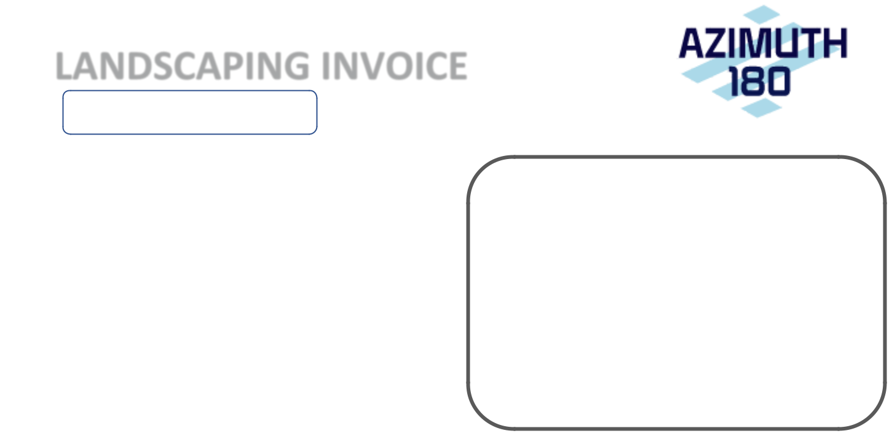
22 Sep 2020

LANDSCAPING INVOICE

01 Sep 2020 – 30 Sep 2020

This is an invoice for landscaping services rendered during the period shown above at the following sites:

Bragg Intermediate School
Black River Middle School
Chester Municipal Building
Long Valley Middle School
Morris County Office of Temporary
Assistance
Randolph High School
Sandshore Elementary School
Tinc Road School

Bill To:

SunLight General Morris Solar, LLC 135 E. 57th St., Fl. 6 New York, NY 10022

Total: $1,971.00

Remittance by ACH:

Account: Azimuth 180 Solar Electric, LLC

Account No.: 171383890

ABA/Routing No.: 021000021

Remittance by check:

Azimuth 180 Solar Electric, LLC

135 E. 57th St., Fl. 6

New York, NY 10022

SUNLIGHT GENERAL PROJECTS: MORRIS COUNTY

SUMMARY OF ATTACHED INVOICES:

PAGE: | DATE: | PAYEE: | SERVICES RENDERED: | PAYABLE:
2 | 10/1/2020 | AZIMUTH 180 SOLAR ELECTRIC, LLC | OCTOBER 2020 OPERATIONS & MAINTENANCE | $ | 10,889.29
3 | 10/1/2020 | SUNLIGHT GENERAL CAPITAL MANAGEMENT, LLC | OCTOBER 2020 ASSET MANAGEMENT | $ | 11,536.09
4 | 10/1/2020 | AZIMUTH 180 SOLAR ELECTRIC, LLC | OCTOBER 2020 LANDSCAPING | $ | 1,971.00
5 | 7/29/2020 SUNLIGHT GENERAL CAPITAL, LLC |  | O&M EXPENSES: COST RELATING TO A PURCHASE OF EQUIPMENT | $ | 207.00
6 |  |  | FOR CHATAM HIGH SCHOOL | $ | 15.31
6 | 7/30/2020 SUNLIGHT GENERAL CAPITAL, LLC |  | O&M EXPENSES: COST RELATED TO SHIPPING EQUIPMENT TO | $ | 15.31
7 |  |  | COUNTY COLLEGE OF MORRIS | $ | 973.99
7 | 8/18/2020 SUNLIGHT GENERAL CAPITAL, LLC |  | O&M EXPENSES: COST RELATING TO BREAKER REPAIR AT MORRIS | $ | 973.99
8 |  |  | LIBRARY | $ | 2,139.80
8 | 9/28/2020 SUNLIGHT GENERAL CAPITAL, LLC |  | O&M EXPENSES: COST RELATING TO A PURCHASE OF EQUIPMENT | $ | 2,139.80
9 |  |  | FOR STONYBROOK | $ | 78.00
9 | 10/13/2020 SUNLIGHT GENERAL CAPITAL, LLC |  | 2020 NEW JERSEY LLC ANNUAL REPORTING FEE - PROJECT | $ | 78.00
10 |  |  | COMPANY: SUNLIGHT GENERAL MORRIS HOLDINGS, LLC | $ | 78.00
10 | 10/13/2020 SUNLIGHT GENERAL CAPITAL, LLC |  | 2020 NEW JERSEY LLC ANNUAL REPORTING FEE - PROJECT | $ | 78.00
 |  |  | COMPANY: SUNLIGHT GENERAL MORRIS SOLAR, LLC
 |  |  |  | $ | 27,888.48

01 Oct 2020


O&M INVOICE

01 Oct 2020 – 31 Oct 2020

Per the Operations and Maintenance Agreement for Morris Renewable Energy Projects by and between SunLight General Morris Solar, LLC and Azimuth 180 Solar Electric, LLC dated January 24, 2013, please find this invoicing statement for the period indicated above.

The payable monthly amount is based on a $15.45/kW DC annual fee times 8,457.71, which is the total DC capacity of the arrays in service.

Bill To:

SunLight General Morris Solar, LLC 135 E. 57th St., Fl. 6 New York, NY 10022

Total: $10,889.29

Remittance by ACH:

Account: Azimuth 180 Solar Electric, LLC

Account No.: 171383890

ABA/Routing No.: 021000021

Remittance by check:

Azimuth 180 Solar Electric, LLC

135 E. 57th St., Fl. 6

New York, NY 10022

01 Oct 2020

ASSET MANAGEMENT INVOICE

01 Oct 2020 – 31 Oct 2020

Per the Asset Management Agreement for Morris Renewable Energy Projects by and between SunLight General Morris Solar, LLC and SunLight General Capital Management, LLC dated January 24, 2013, please find this invoicing statement for the period indicated above.

The payable monthly amount is based on 1) a $75,000 annual fee and 2) a $7.50/kW DC annual fee times 8,457.71, which is the total DC capacity of the arrays in service.

Bill To:
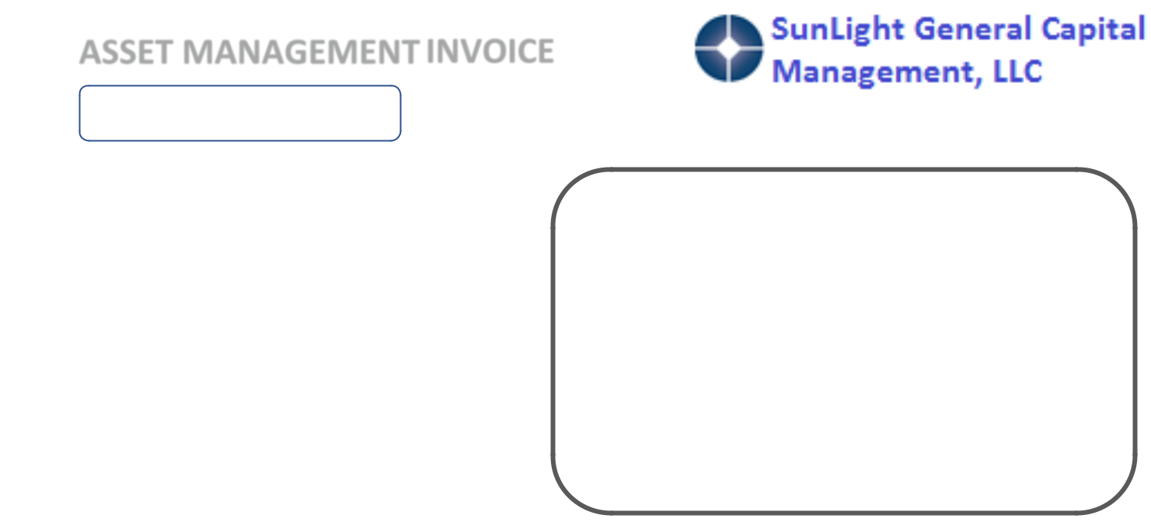

SunLight General Morris Solar, LLC 135 E. 57th St., Fl. 6 New York, NY 10022

Total: $11,536.09

Remittance by ACH:

Account: SunLight General Capital Management, LLC

Account No.: 893705947

ABA/Routing No.: 021000021

Remittance by check:

SunLight General Capital Management, LLC

135 E. 57th St. Fl. 6

New York, NY 10022

19 Oct 2020

LANDSCAPING INVOICE

01 Oct 2020 – 31 Oct 2020

This is an invoice for landscaping services rendered during the period shown above at the following sites:

Bragg Intermediate School
Black River Middle School
Chester Municipal Building
Long Valley Middle School
Morris County Office of Temporary
Assistance
Randolph High School
Sandshore Elementary School
Tinc Road School

Bill To:

SunLight General Morris Solar, LLC 135 E. 57th St., Fl. 6 New York, NY 10022

Total: $1,971.00

Remittance by ACH:

Account: Azimuth 180 Solar Electric, LLC

Account No.: 171383890

ABA/Routing No.: 021000021

Remittance by check:

Azimuth 180 Solar Electric, LLC

135 E. 57th St., Fl. 6

New York, NY 10022

7/29/2020 |  | Sunlight General Capital Mail - Payment Confirmation #3812867 ***Please do not reply***
 |  |  | Ed Wells <ewells@sunlightgeneral.com>
 | Payment Confirmation #3812867 ***Please do not reply***
 | 1 message
 | paymentconfirmation@unitedtranzactions.com <paymentconfirmation@unitedtranzactions.com> |  | Wed, Jul 29, 2020 at 3:28 PM
 | To: ewells@sunlightgeneral.com



Dear Valued Customer,

This email confirms that a Credit Card payment initiated by SOLECTRIA RENEWABLES, LLC (CC-API)

has been processed

Please find the payment below and retain this receipt for your records.

Transaction #: 3812867

Customer #: 1024550

Transaction Date: 7/29/2020 3:27:35 PM

Invoice #: 15812298

Name On Card: Stephen Schneider

Card Type: VISA

Card #: ************7752

Amount: $207.00

Tax: $0.00

Status: Sale - Approved

Thank you,

United TranzActions

© Copyright 2010 UTA.

2811 Corporate Way, Miramar, FL 33025
(954) 431-5256 · 1-800-858-5256 · Fax: (954) 499-0377

ABOUT THIS MESSAGE

This message and any attachments are intended only for the use of the addressee and may contain information that is privileged and confidential. If the reader of the message is not the intended recipient or an authorized representative of the intended recipient, you are hereby notified that any dissemination of this communication is strictly prohibited. If you have received this communication in error, notify the sender immediately by return email and delete the message and any attachments from your system.

https://mail.google.com/mail/u/0?ik=46ad722a38&view=pt&search=all&permthid=thread-f%3A1673580663442335507&simpl=msg-f%3A16735806634… 1/1

7/30/2020 |  |  |  |  | Shipment Receipt | UPS
 | Shipment Receipt |  |  | July 30, 2020 |  | 1ZV3VT684220020411
 | Where
 | Ship From |  |  | Ship To
 | SunLight General Capital, Ed Wells |  |  | First Energy, Kevin Printz
 | 109 STRYKER LN, BUILDING 3, UNIT 2, HILLSBOROUGH, NJ 08844 |  |  | 2800 Centre Ave, READING, PA 19605
 | EWELLS@SUNLIGHTGENERAL.COM, 7322724471 |  |  | kprintz@firstenergycorp.com
 | What
 | Package 1 - 1ZV3VT684220020411
 | Weight |  |  | Dimensions | Reference Numbers | Delivery Confirmation
 | 4 lbs |  |  | 11 in x 11 in x 10 in | 7302020 | Signature Required
 |  |  |  | My Packaging
 | Service Details - UPS Ground
 | Estimated Delivery Friday July 31, 2020 , End of Day
 | Additional Options
 | Payment
 | Bill Shipping Charges To: Visa ending in 7752
 | Promo: easy
 | Shipping Total
 | Shipping Fees |  |  | Additional Option Fees |  | Subtotals
 | Package 1 |  |  | Package 1 |  |  | Shipping Fees | $11.84
 | UPS Ground | $11.84 |  | Delivery Confirmation | $5.25 |  | Additional Option Fees | $5.25
 | Transportation Charges: for services listed as guaranteed, refunds apply to |  |  |  |  |  | Combined Charges | $17.09
 |  |  |  |  |  |  | Contract Rate | $15.31
 | transportation charges only. See Terms and Conditions in the Service Guide |  |  |  |  |  | Contract Rate | $15.31
 | for details. Certain commodities and high value shipments may require |  |  |  |  | Rate includes a fuel Surcharge, but excludes taxes, duties and other
 | additional transit time for customs clearance.
 |  |  |  |  |  | charges that may apply to the shipment.

Your invoice may vary from the displayed reference rates

Note: This document is not an invoice.

All shipments are subject to the UPS Tariff/Terms and Conditions of Service (“UPS terms”) in effect on the date of shipment, which are available at www.ups.com/terms. Pursuant to the UPS Terms, UPS’s maximum liability for loss or damage to each domestic package or international shipment is limited to $100, unless the shipper declares a greater value in the declared value field of the UPS shipping system used and pays the applicable charge (in which case UPS’s maximum liability is the declared value). Special terms apply to some services and articles. Please review the UPS Terms for liability limits, exclusions from liability, maximum declared values, prohibited items, and other important terms of service. The shipper agrees that in the absence of a greater declared value, $100 value is a reasonable limitation under the circumstances of the transportation. Claims not timely made (generally noticed within sixty days and filed within nine months, but filed within sixty days for international shipments) are deemed waived and will not be paid. See the UPS Terms for details. Under no circumstances will UPS be liable for any special, incidental, or consequential damages.

1/1

11925 I 70 Frontage Rd N #300 Wheat Ridge, CO 80033


CALL
(877) 999-7077

BILL TO

Ed Wells
209 Harvard Ave.
Point Pleasant Beach NJ 08742

SALES REP | EMAIL |  |  | DIRECT
Word, Tyler G | tyler@widespread.com |  |  | 469-317-9182
PO # |  | SHIP METHOD
#KE050QHD |  | UPS Next Day Air Saver®

VISIT | CASH SALE
widespread.com
EMAIL
sales@widespread.com
 |  |  |  |  |  |  |  |  | T16213

SHIP TO

Ed Wells
SunLight General Capital
109 STRYKER LN, BUILDING 3, UNIT 2 HILLSBOROUGH NJ 08844

 |  | CASH SALE # |  | ORDER #
 |  | T16213 |  | T21943
DATE | PAYMENT METHOD
8/18/2020 | VISA | ** 7752
TRACKING #

1Z84E26R1394209685

ITEM | QTY | RATE | AMOUNT
HFD3125BP10 | Re-Certified | 1 | $787.95 | $787.95
HFD3125BP10, Cutler Hammer / Eaton / Westinghouse, Series C, type HFD, 3P, 3PH, 125A, 600V, 65kA@480V,
high interrupting capacity, 40¬∫C, bolt-on, complete with non-interchangeable, LI - Long-Time and Instantaneous
trip functions and load side lug terminals, thermal magnetic, molded case circuit breakers, originally sold in bulk
pack of 10, however, pricing listed is individual
 |  | SubTotal | $787.95
 |  | Shipping | $125.52
 |  | Tax (%) | $60.52
 |  | TOTAL | $973.99
 |  | Paid | ($973.99)

DISCLAIMER
Widespread Electrical Sales must authorize all returns & exchanges. All returns and exchanges must be made within 30 DAYS of cash sale date. All
returns and exchanges are subject to at least a 30% restocking charge. Authorized returns outside the 30 day period, may or may not be returnable | T16213
with up to a 100% restocking charge. | T16213
1 of 1

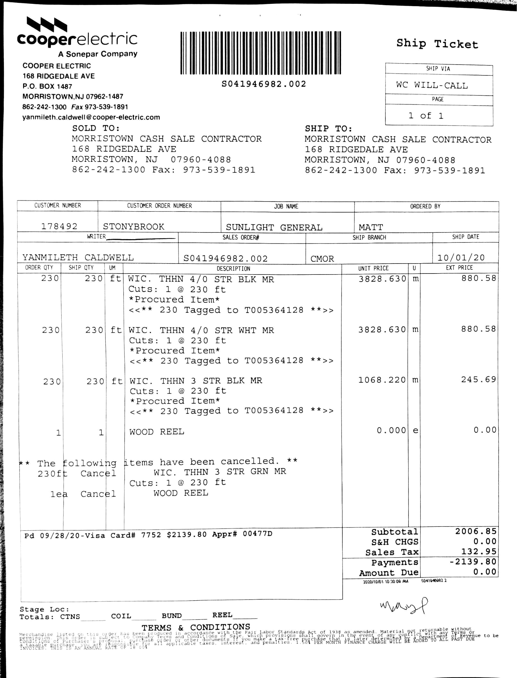

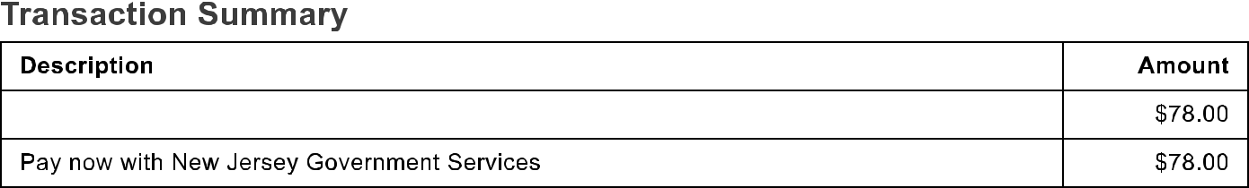
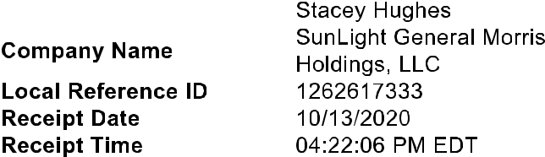




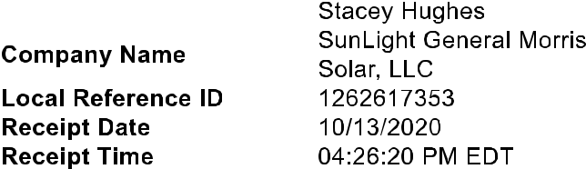


SUNLIGHT GENERAL PROJECTS: MORRIS COUNTY

SUMMARY OF ATTACHED INVOICES:

PAGE: | DATE: | PAYEE: | SERVICES RENDERED:
2 | 11/1/2020 | AZIMUTH 180 SOLAR ELECTRIC, LLC | NOVEMBER 2020 OPERATIONS & MAINTENANCE
3 | 11/1/2020 | SUNLIGHT GENERAL CAPITAL MANAGEMENT, LLC | NOVEMBER 2020 ASSET MANAGEMENT
4 | 9/15/2020 | SUNLIGHT GENERAL CAPITAL, LLC | GL PREMIUM AUDIT BY ACE/CHUBB, PREMIUM REASSESSMENT
5 | 10/30/2020 | MAHONEY SABOL & COMPANY, LLP | PROJECT CO. PREP OF 2019 FEDERAL AND STATE TAX RETURNS

PAYABLE: $ 10,889.29 $ 11,536.09

$ | 369.61
$ | 1,575.00
$ 24,369.99

01 Nov 2020

O&M INVOICE

01 Nov 2020 – 30 Nov 2020

Per the Operations and Maintenance Agreement for Morris Renewable Energy Projects by and between SunLight General Morris Solar, LLC and Azimuth 180 Solar Electric, LLC dated January 24, 2013, please find this invoicing statement for the period indicated above.

The payable monthly amount is based on a $15.45/kW DC annual fee times 8,457.71, which is the total DC capacity of the arrays in service.

Bill To:

SunLight General Morris Solar, LLC PO BOX 8543

NEW YORK, NY 10150

Total: $10,889.29

Remittance by ACH:

Account: Azimuth 180 Solar Electric, LLC

Account No.: 171383890

ABA/Routing No.: 021000021

Remittance by check:

Azimuth 180 Solar Electric, LLC

PO BOX 8543

NEW YORK, NY 10150

01 Nov 2020

ASSET MANAGEMENT INVOICE

01 Nov 2020 – 30 Nov 2020

Per the Asset Management Agreement for Morris Renewable Energy Projects by and between SunLight General Morris Solar, LLC and SunLight General Capital Management, LLC dated January 24, 2013, please find this invoicing statement for the period indicated above.

The payable monthly amount is based on 1) a $75,000 annual fee and 2) a $7.50/kW DC annual fee times 8,457.71, which is the total DC capacity of the arrays in service.

Bill To:

SunLight General Morris Solar, LLC PO BOX 8543

NEW YORK, NY 10150

Total: $11,536.09

Remittance by ACH:

Account: SunLight General Capital Management, LLC

Account No.: 893705947

ABA/Routing No.: 021000021

Remittance by check:

SunLight General Capital Management, LLC

PO BOX 8543

NEW YORK, NY 10150

0.002CAEC60C-A7 974580DF-FFC |  |  |  | 2,149.00 | 2,149.00 |  |  | INVOICE
0.00 | 1 | 1.00 |  | 2,149.00 | 2,149.00
0.00 | 1 | 1.00 | 1 | 2,149.00 | 2,149.00
0.00 | 1 | 1.00 | 1 | 2,149.00 | 2,149.00
 |  |  |  |  |  |  | Customer | SunLight General Capital LLC
 |  |  |  |  |  |  | Acct # | 9295
 |  |  |  |  |  |  | Date | 09/15/2020
 |  |  |  |  |  |  | Customer | Bruce Spiller
 |  |  |  |  |  |  | Service | Evelyn Burchfield
 |  |  |  |  |  |  | Page | 1 of 1
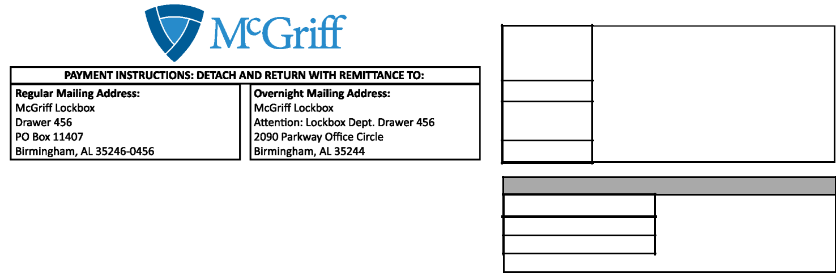

SunLight General Capital LLC

135 E. 57th St, 6th Floor #104

New York, NY 10022-0000

Payment Information

Invoice Summary | $ | 2,149.00
Payment Amount
Payment for: |  | Invoice#147073
G27620310004
 |  | Thank You

Please detach and return with payment


Customer: SunLight General Capital LLC



Invoice | Effective | Transaction |  | Description

Amount

147073

07/11/2019

Premium audit

Policy #G27620310004 07/11/2018-07/11/2019

ACE AMERICAN INSURANCE CO / WESTCHESTER FIRE INS CO

General Liability - Premium audit

2,149.00


Total

$ 2,149.00

Thank You

Please pay by invoice. Premiums are due and payable upon receipt or on the effective date whichever is later. Thank you!

McGriff, Seibels & Williams, Inc. | (205)252-9871

2211 7th Ave South

Birmingham, AL 35233

Date

09/15/2020

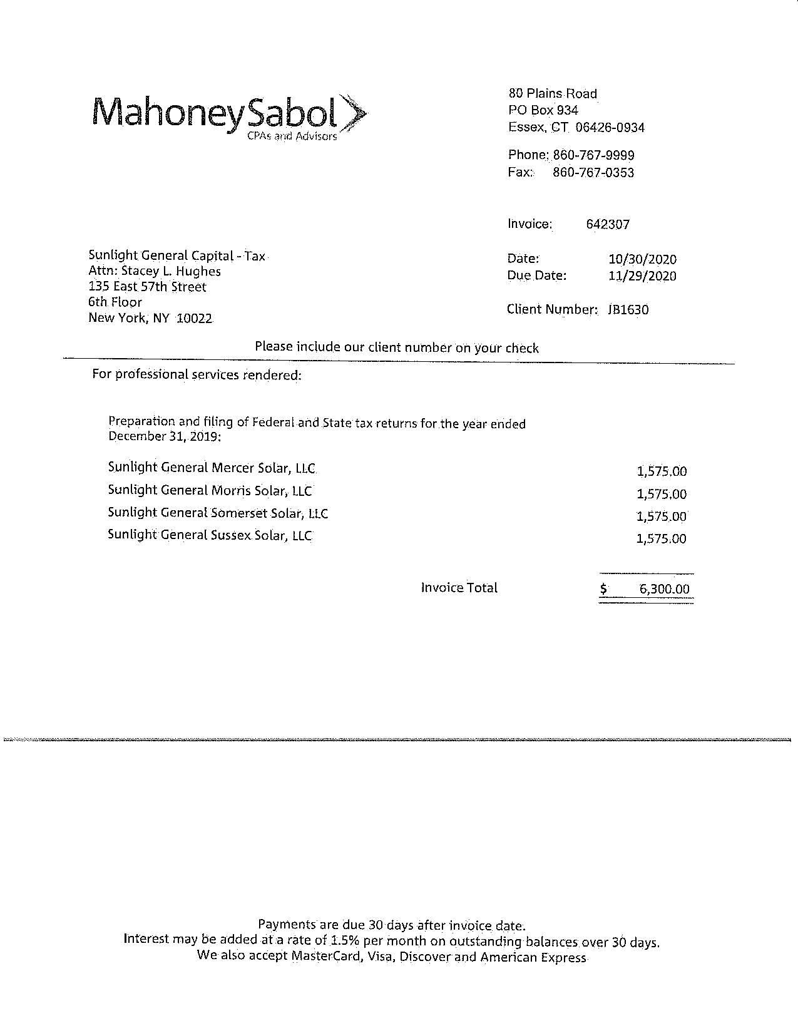
SUNLIGHT GENERAL PROJECTS: MORRIS COUNTY

SUMMARY OF ATTACHED INVOICES:

PAGE: | DATE: | PAYEE: | SERVICES RENDERED: | PAYABLE:
2 | 12/1/2020 | AZIMUTH 180 SOLAR ELECTRIC, LLC | DECEMBER 2020 OPERATIONS & MAINTENANCE | $ | 10,889.29
3 | 12/1/2020 SUNLIGHT GENERAL CAPITAL MANAGEMENT, LLC |  | DECEMBER 2020 ASSET MANAGEMENT | $ | 11,536.09
 |  |  |  | $ | 22,425.38

01 Dec 2020

O&M INVOICE

01 Dec 2020 – 31 Dec 2020

Per the Operations and Maintenance Agreement for Morris Renewable Energy Projects by and between SunLight General Morris Solar, LLC and Azimuth 180 Solar Electric, LLC dated January 24, 2013, please find this invoicing statement for the period indicated above.

The payable monthly amount is based on a $15.45/kW DC annual fee times 8,457.71, which is the total DC capacity of the arrays in service.

Bill To:

SunLight General Morris Solar, LLC PO BOX 8543

NEW YORK, NY 10150

Total: $10,889.29

Remittance by ACH:

Account: Azimuth 180 Solar Electric, LLC

Account No.: 171383890

ABA/Routing No.: 021000021

Remittance by check:

Azimuth 180 Solar Electric, LLC

PO BOX 8543

NEW YORK, NY 10150

01 Dec 2020

ASSET MANAGEMENT INVOICE

01 Dec 2020 – 31 Dec 2020

Per the Asset Management Agreement for Morris Renewable Energy Projects by and between SunLight General Morris Solar, LLC and SunLight General Capital Management, LLC dated January 24, 2013, please find this invoicing statement for the period indicated above.

The payable monthly amount is based on 1) a $75,000 annual fee and 2) a $7.50/kW DC annual fee times 8,457.71, which is the total DC capacity of the arrays in service.

Bill To:

SunLight General Morris Solar, LLC PO BOX 8543

NEW YORK, NY 10150

Total: $11,536.09

Remittance by ACH:

Account: SunLight General Capital Management, LLC

Account No.: 893705947

ABA/Routing No.: 021000021

Remittance by check:

SunLight General Capital Management, LLC

PO BOX 8543

NEW YORK, NY 10150

