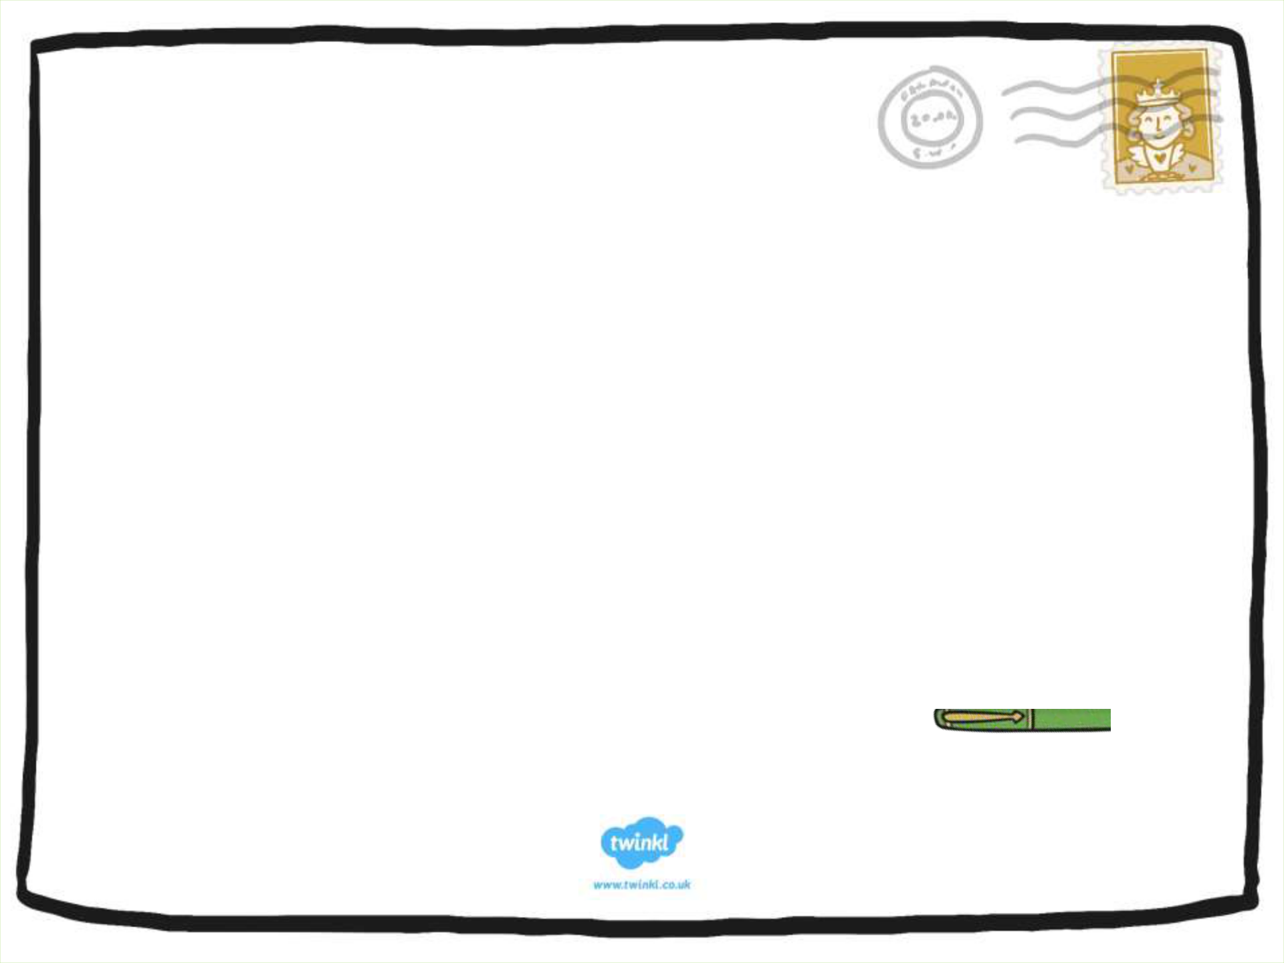

Letter
Writing

An informative PowerPoint about

Letter Writing

NEXT

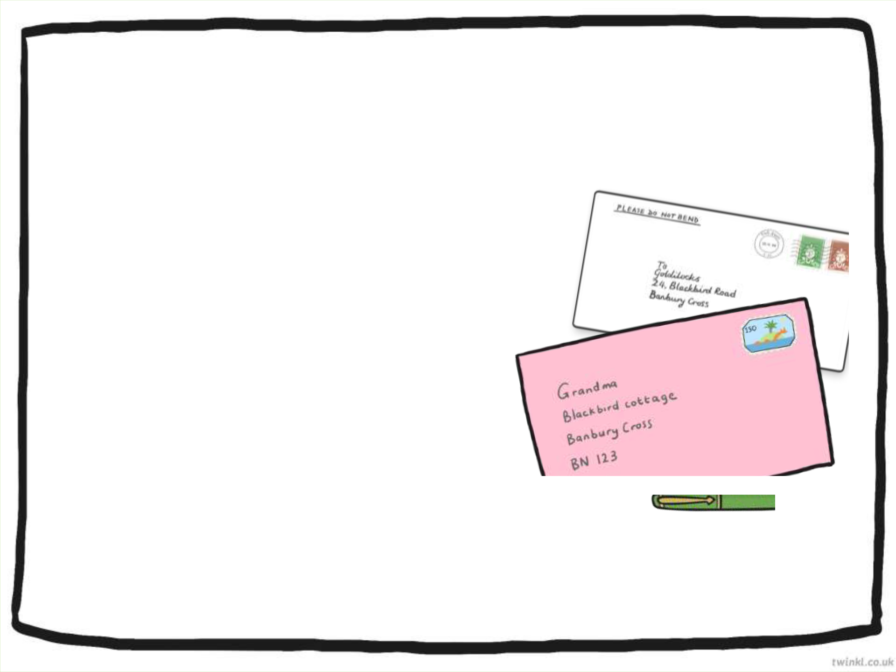
Why Are Letters Important?

Have you ever received a letter?

What was the letter about?

Did you keep the letter to share again?

Did you write back and send a reply?

NEXT

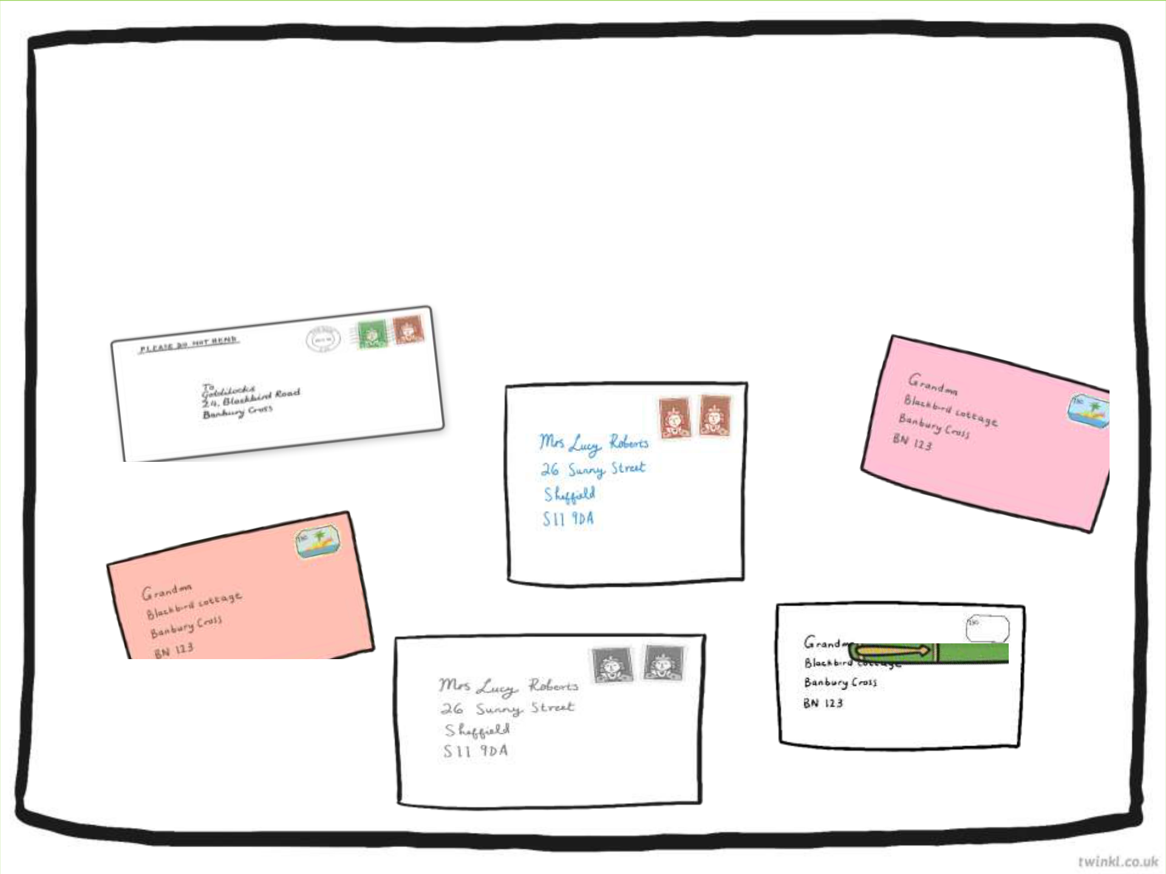
Different Types of Letters

People send letters for many different reasons.

Can you think why you might send or receive a letter?

To say,

“thank you.”

To make

appointments

To write to

friends or family

To send a

postcard telling

someone about

your holiday

To complain

To give or receive information

NEXT

Click a letter to reveal

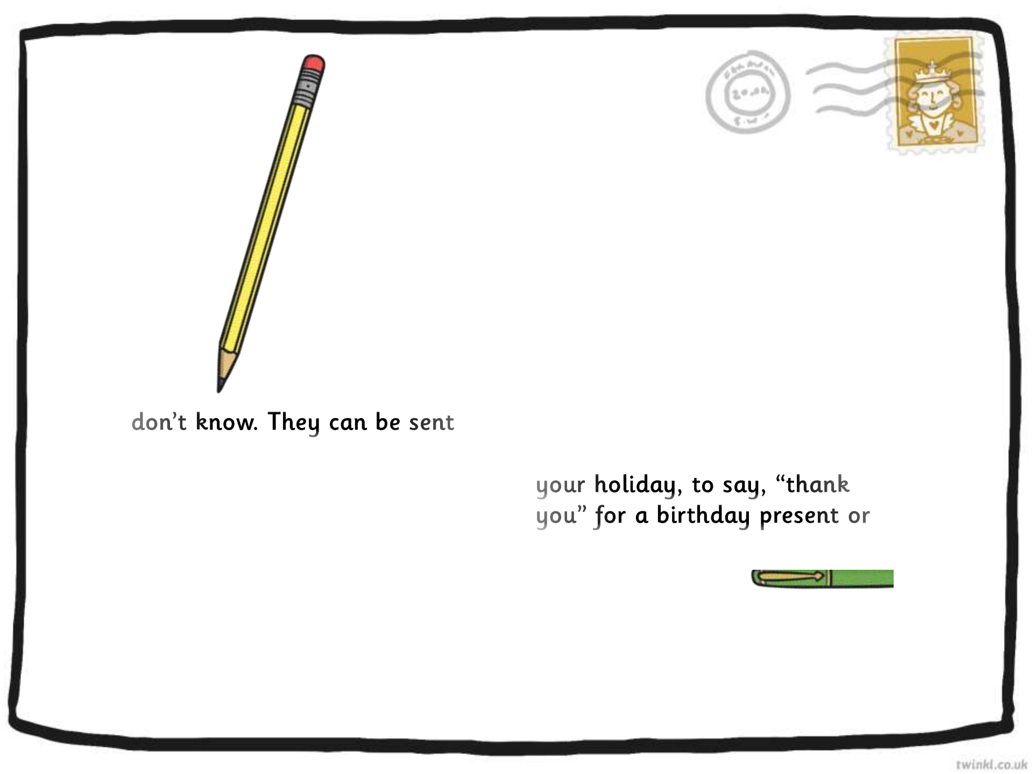

Different Types of Letters

Letters can be organised under two headings. These are called

formal letters and informal letters.

Formal letters are letters Informal letters are letters

which are sent to people you which are sent to people you

know. For example, sending a

for different reasons, for postcard telling someone about

example to complain about

something, to give or ask for

information or to make an writing to friends or family

appointment. Formal letters who might live a long way

are usually set out in a certain from you.

way.

NEXT

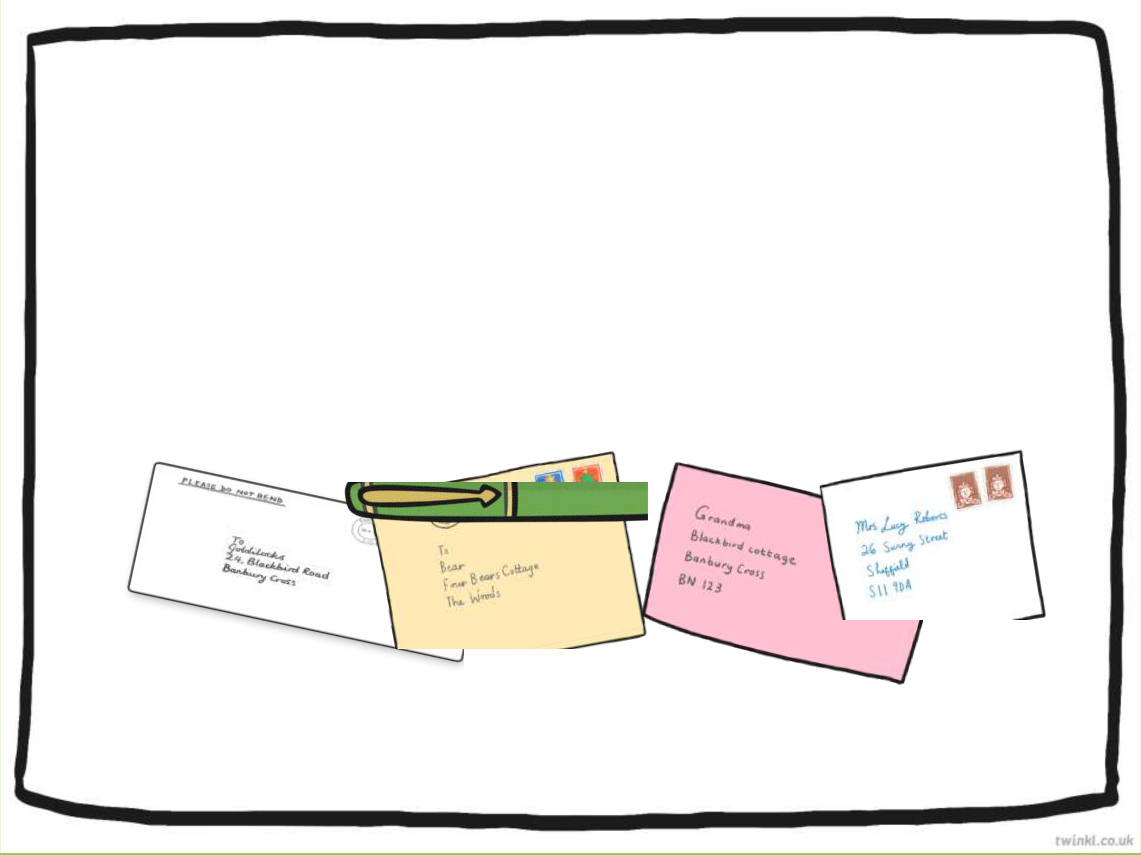
Activity

Sorting Letters Game

Look at the letters on the next few slides and see if you can

sort them into formal and informal letters.

When you have decided which type of letter you think they are click on the answer envelope to reveal the answer.

START

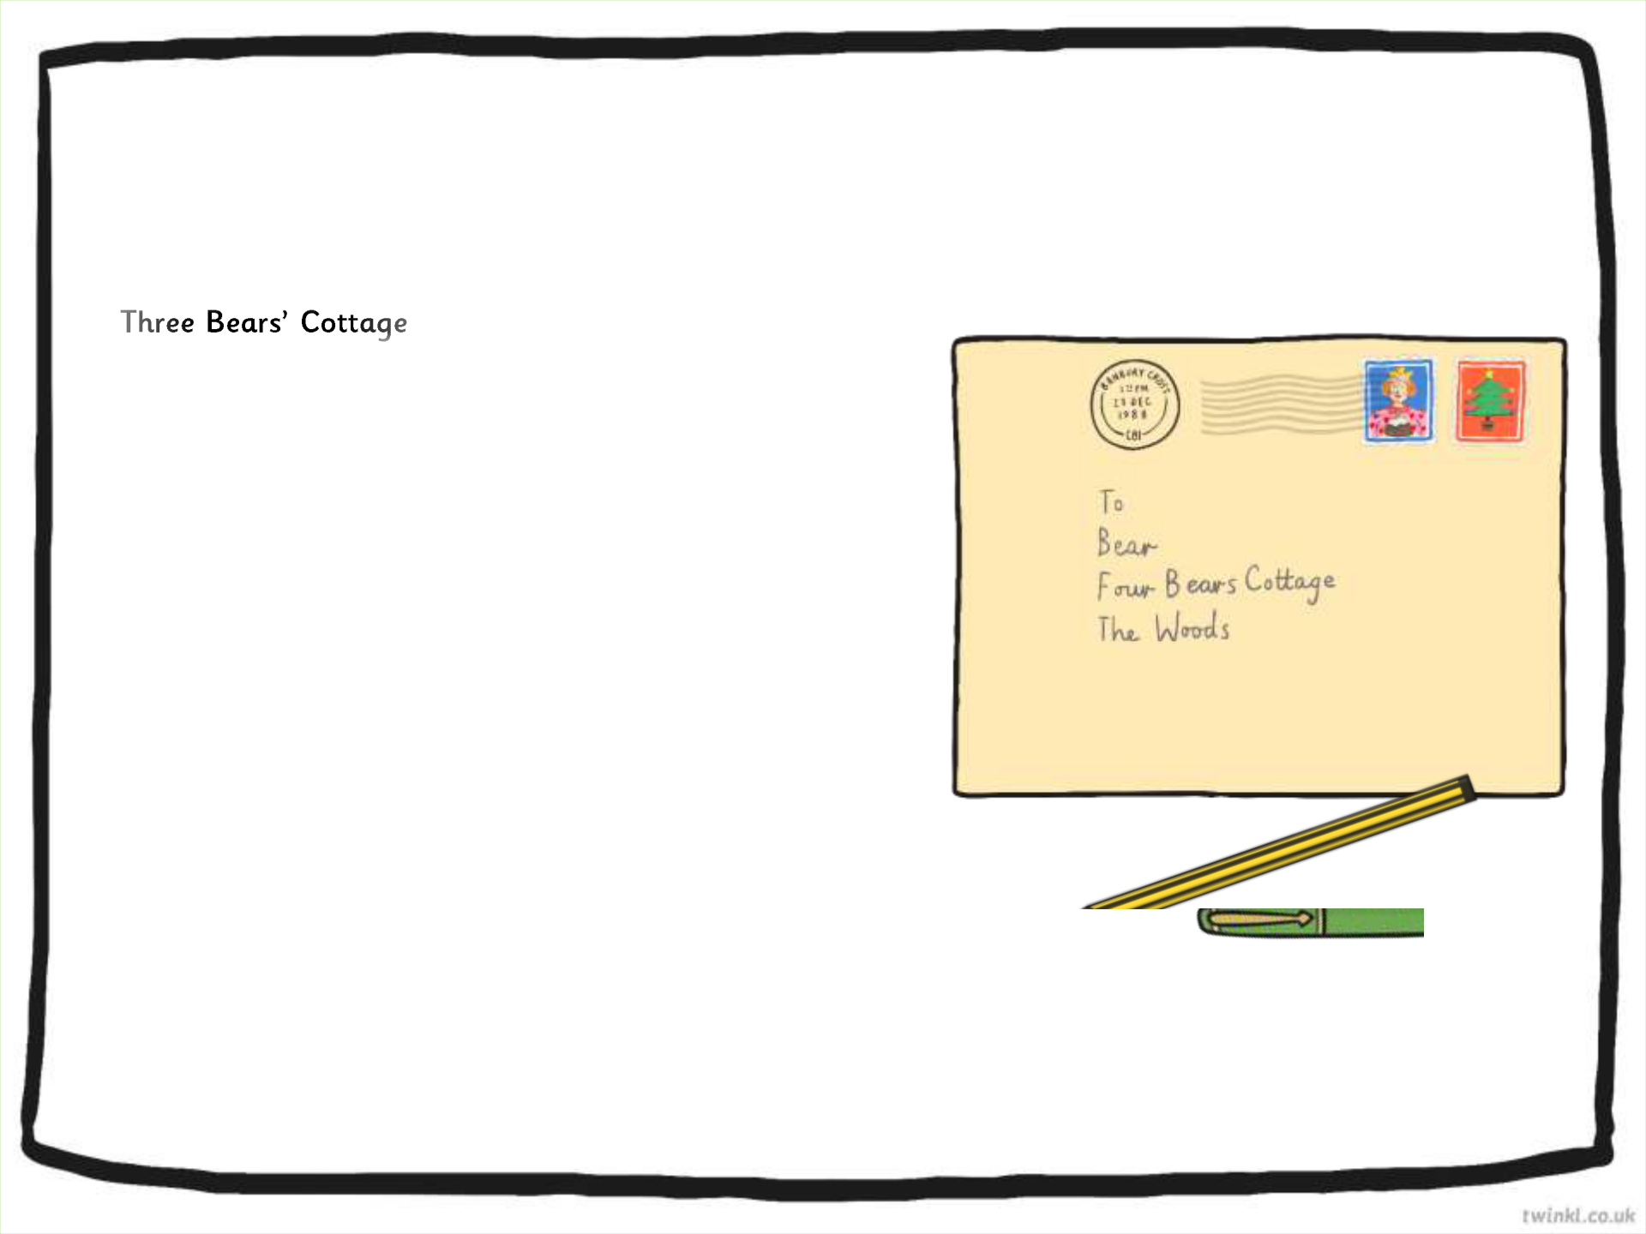

The Three Bears | Goldilocks
Fairy Tale Land | Bramble House
Fairy Tale Land | Fairy Tale Land
FL00 ABC | FL01 DEF
Dear Daddy Bear, | Monday 1st June 2015

I am writing to complain about the chairs in your sitting room. They are most uncomfortable and when I sat on one whilst visiting recently it broke. I fell and I hurt my leg! I would be most grateful if you could use stronger wood in future.

Also, I was very upset that you were cross when you saw me in your house. If you do not wish to have visitors (even people you do not know) then you should not leave your front door unlocked.

Yours Sincerely

Goldilocks

A letter of complaint is a formal letter. It contains the addressAnswerofthepersonthat the letter is being s nt to, along with the address of the person who is writing the letter.

NEXT

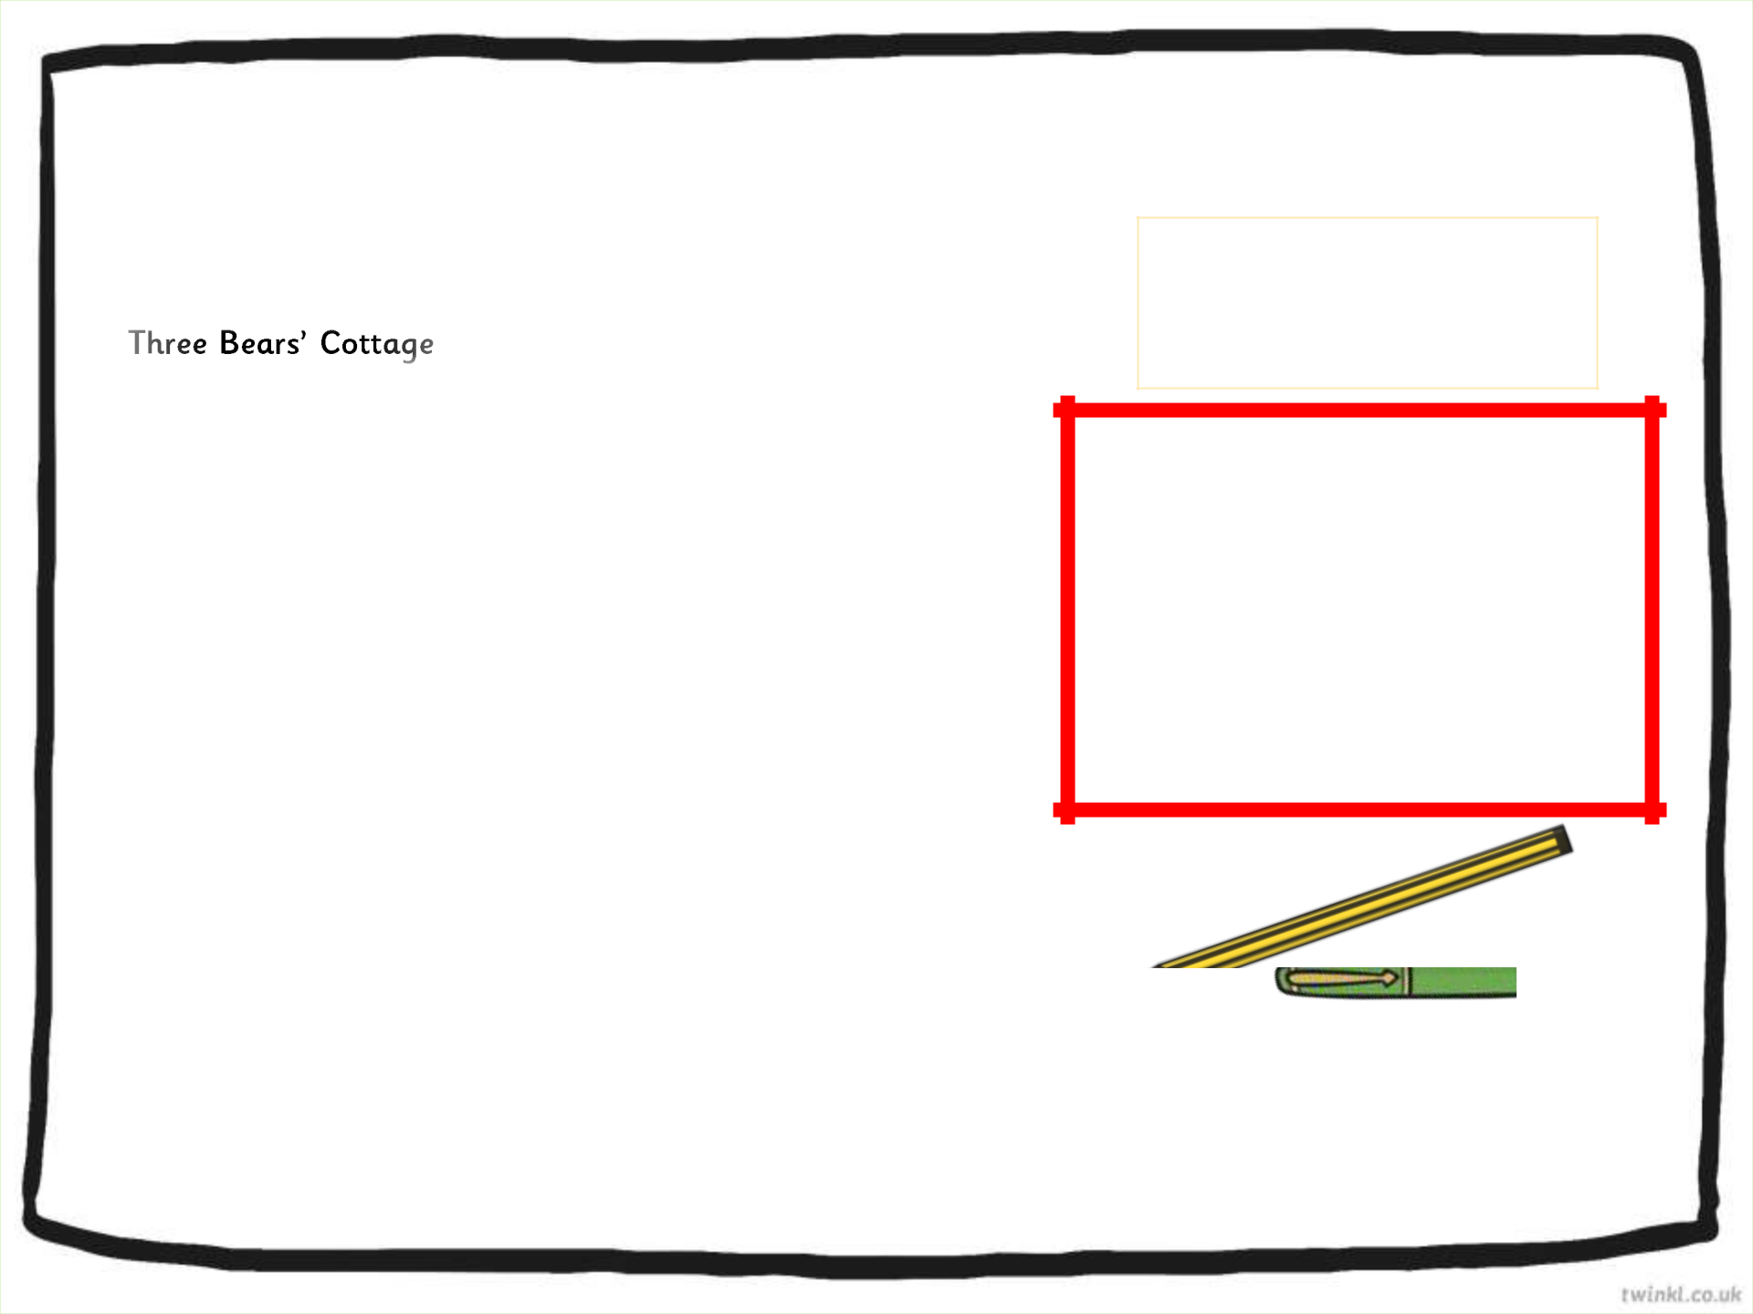

The Three Bears | Goldilocks
Fairy Tale Land | Bramble House
Fairy Tale Land | Fairy Tale Land
FL00 ABC | FL01 DEF
Dear Daddy Bear, | Monday 1st June 2015

I am writing to complain about the chairs in your sitting room. They are most uncomfortable and when I sat on one whilst visiting recently it broke. I fell and I hurt my leg! I would be most grateful if you could use stronger wood in future.

Also, I was very upset that you were cross when you saw me in your house. If you do not wish to have visitors (even people you do not know) then you should not leave your front door unlocked.

Yours Sincerely

Goldilocks

Answer

A letter of complaint is a formal letter. It contains the address of the person that the letter is being sent to, along with the address of the person who is writing the letter.

NEXT

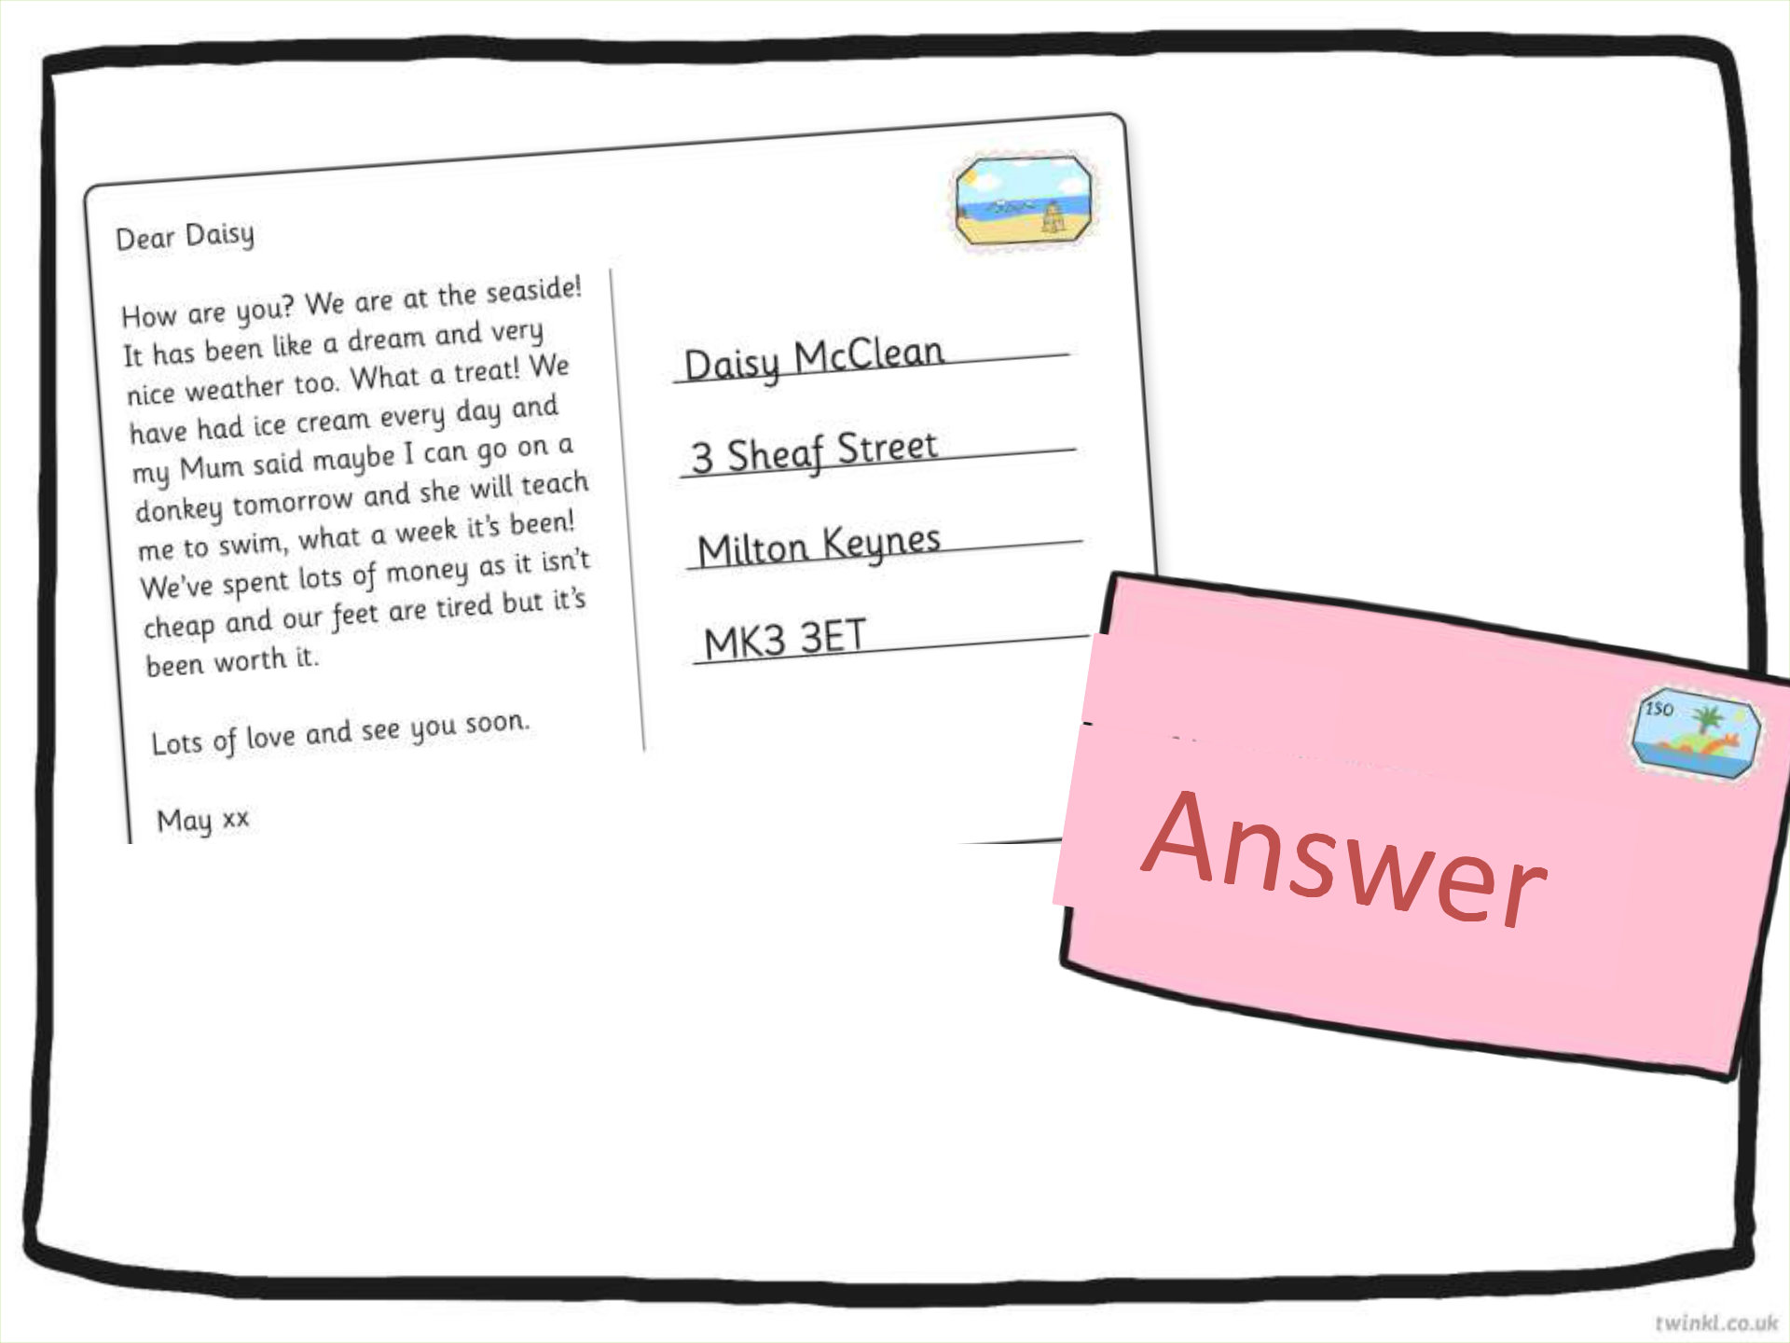

postcard is

NEXT

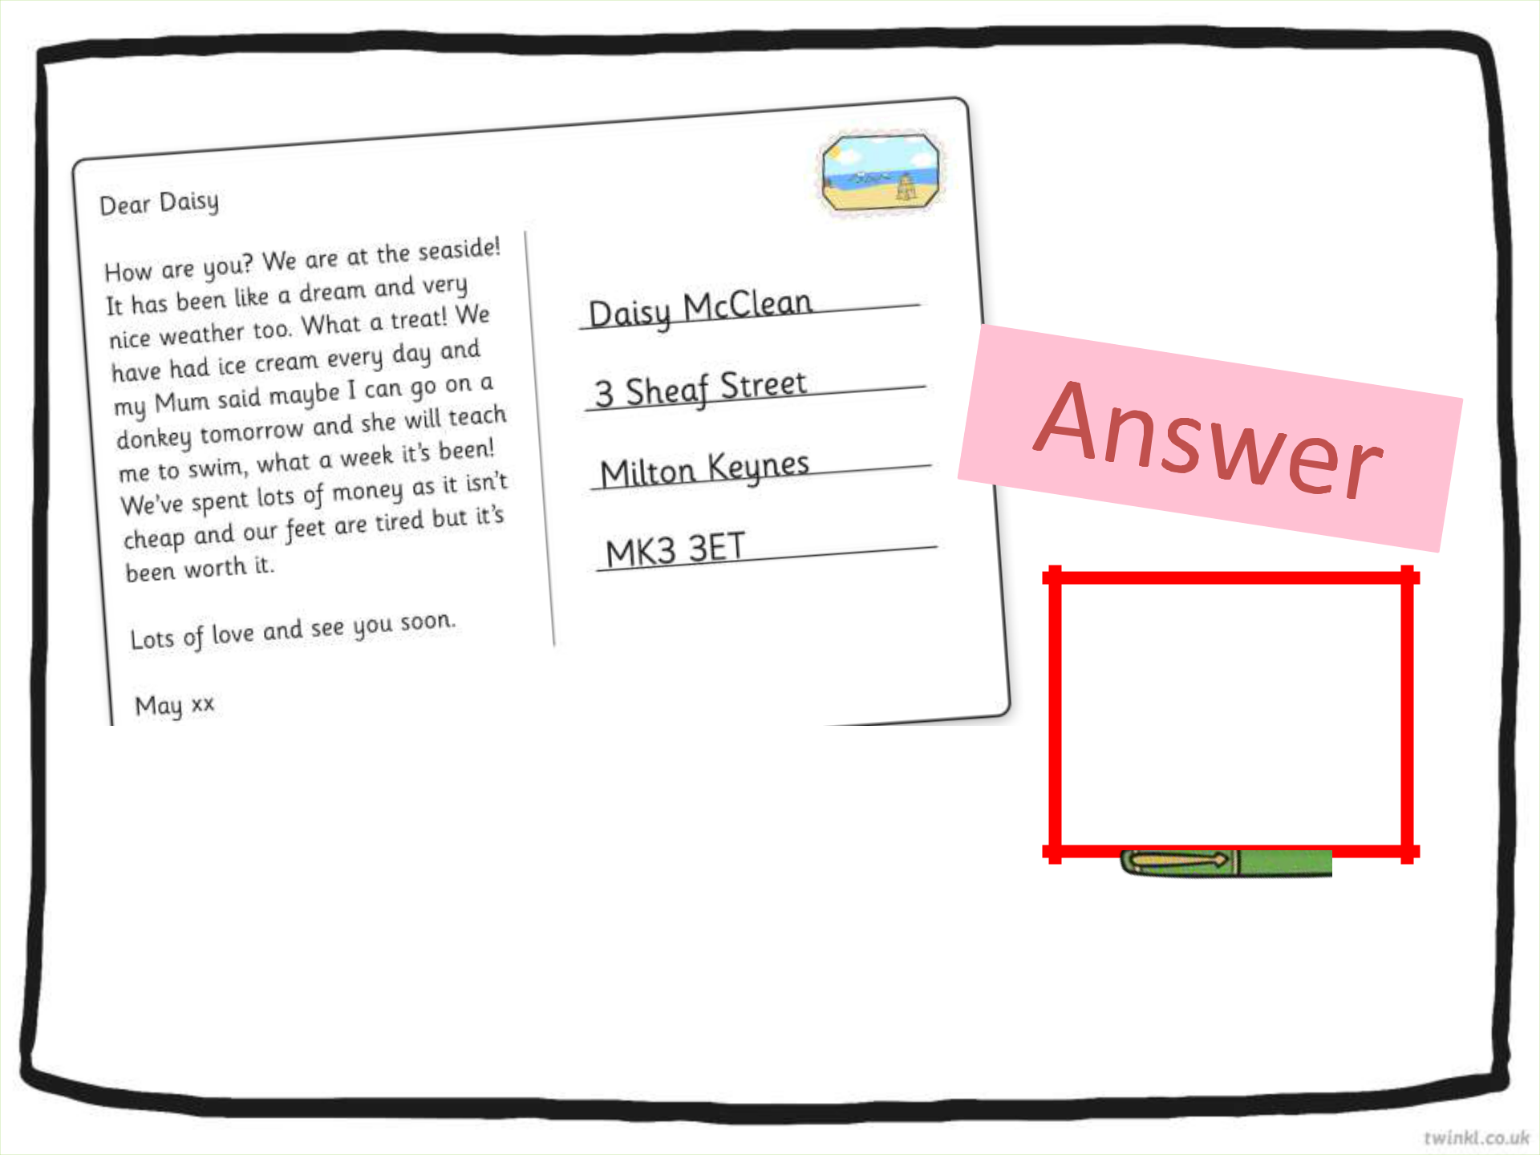

A postcard is an informal letter, usually sent to someone you know.

NEXT

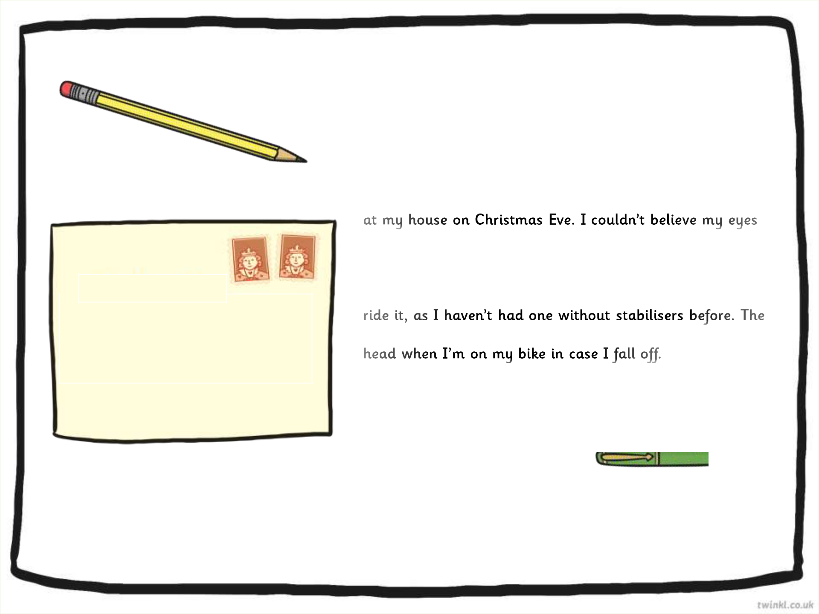

Dear Santa,
Daisy Happy

Flat 23 Clarence House

Long Lane

Caggletonville

CA12 4ON

Friday 2nd January 2015

 A thank-you letter is often an informal letter. It containsAnswertheaddrssof the person that the letter is from and the date.

I am writing to thank you for the lovely presents you left

when I saw them all and so beautifully wrapped. Your elves must have been very busy this year.

I especially loved the bike and have been learning how to

pink helmet is a perfect fit and I wear it to protect my

My brother James loved his train set and has been playing with it everyday since you delivered it. He loves the noises it makes and connecting all of the carriages together.

I hope you and Mrs Clause have a lovely holiday and the elves and reindeers have a well deserved rest.

Love from

Daisy xx NEXT

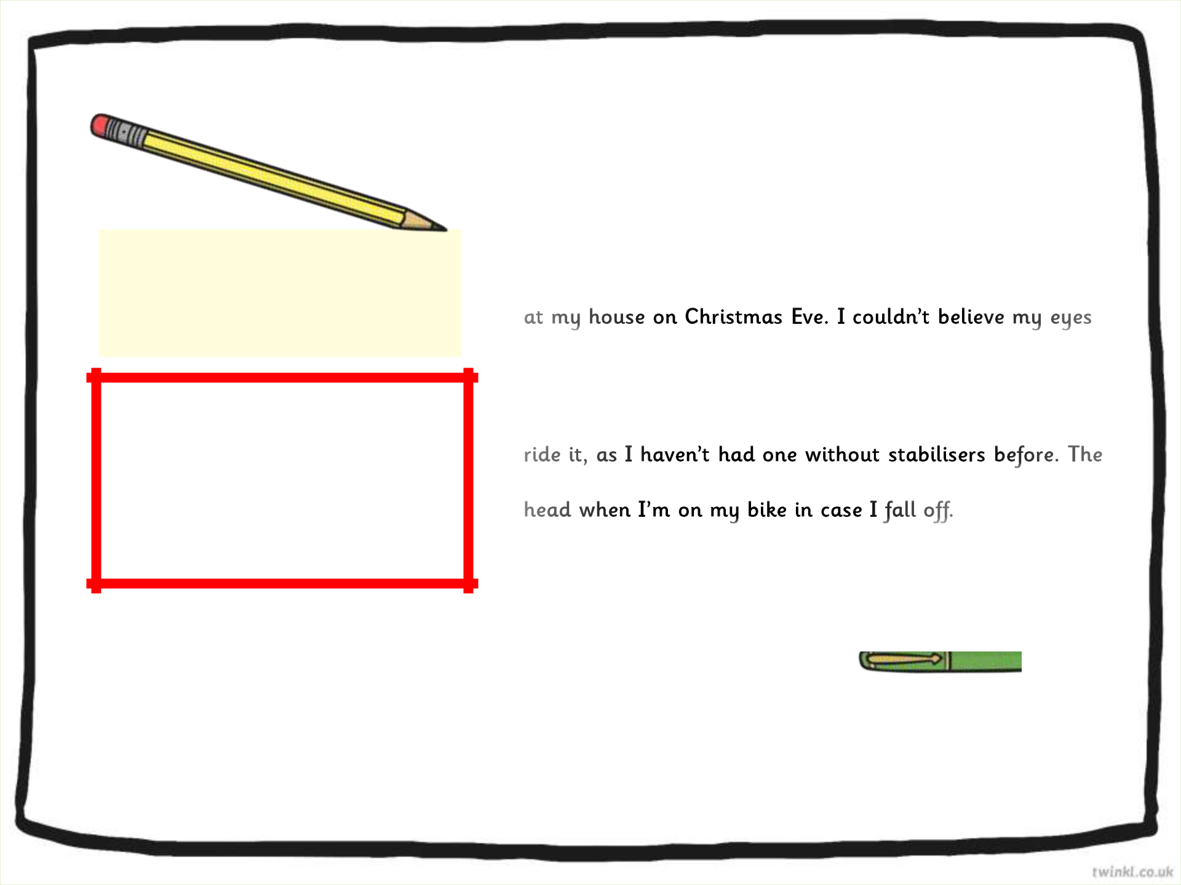

Dear Santa,
Daisy Happy

Flat 23 Clarence House

Long Lane

Caggletonville

CA12 4ON

Friday 2nd January 2015

Answer

- thank-you letter is often an informal letter. It contains the address of the person that the letter is from and the date.

I am writing to thank you for the lovely presents you left

when I saw them all and so beautifully wrapped. Your elves must have been very busy this year.

I especially loved the bike and have been learning how to

pink helmet is a perfect fit and I wear it to protect my

My brother James loved his train set and has been playing with it everyday since you delivered it. He loves the noises it makes and connecting all of the carriages together.

I hope you and Mrs Clause have a lovely holiday and the elves and reindeers have a well deserved rest.

Love from

Daisy xx NEXT

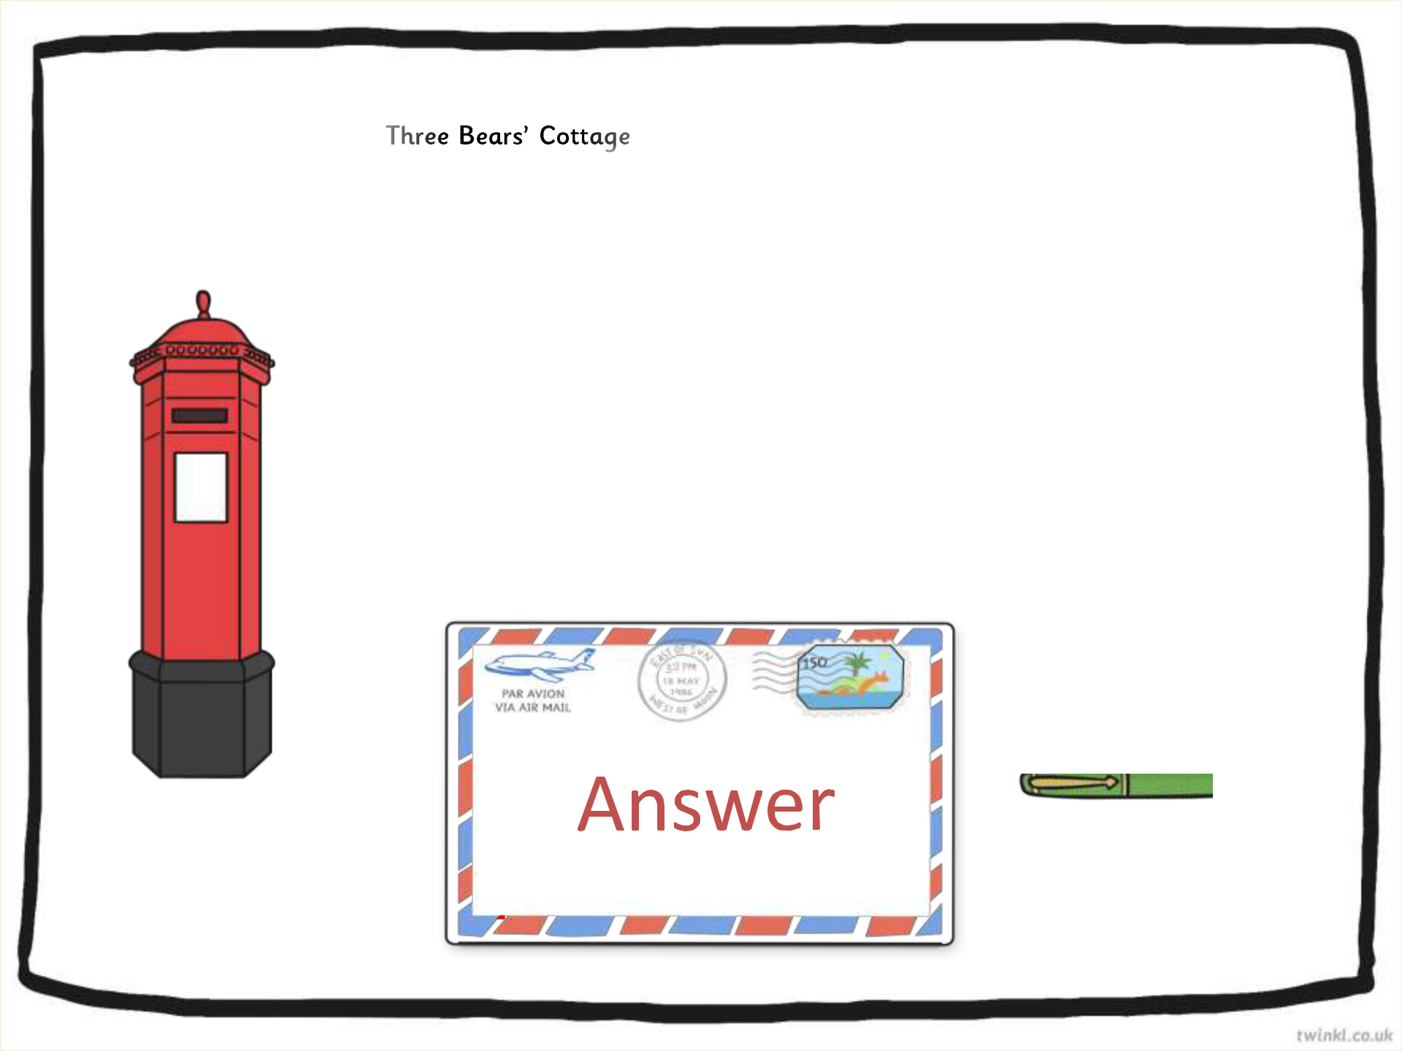  Mummy Bear | Get Well Hospital
 | Healthy Road
Fairy Tale Land | Any Town
FL00 ABC | AN3 JKL
 | Wednesday 3rd June 2015

Dear Mummy Bear,

I am writing to inform you that you have an appointment with Doctor Cure on Friday 29th June at 10am. If you are unable to attend please could you contact us as soon as possible to arrange a more suitable time.

Yours Sincerely

Nurse Caring

A letter for an appointment is

a formal letter. Formal letters

NEXT

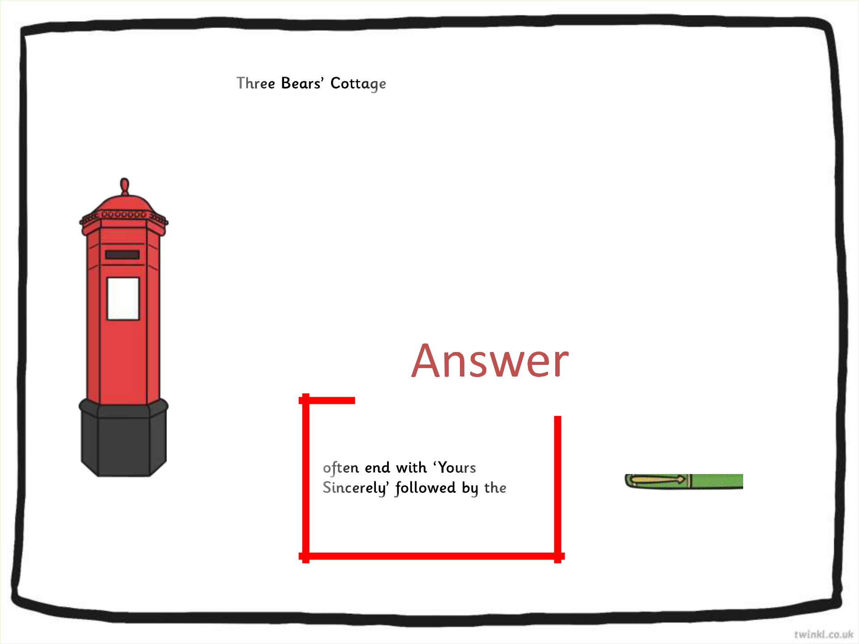  Mummy Bear | Get Well Hospital
 | Healthy Road
Fairy Tale Land | Any Town
FL00 ABC | AN3 JKL
 | Wednesday 3rd June 2015

Dear Mummy Bear,

I am writing to inform you that you have an appointment with Doctor Cure on Friday 29th June at 10am. If you are unable to attend please could you contact us as soon as possible to arrange a more suitable time.

Yours Sincerely

Nurse Caring

A letter for an appointment is

a formal letter. Formal letters

name of the person who is

writing the letter.

NEXT

A letter sent to a friend or family member can be finished in a more familiar

by the name of the person who is writing the letter.

Dark Wood Lane
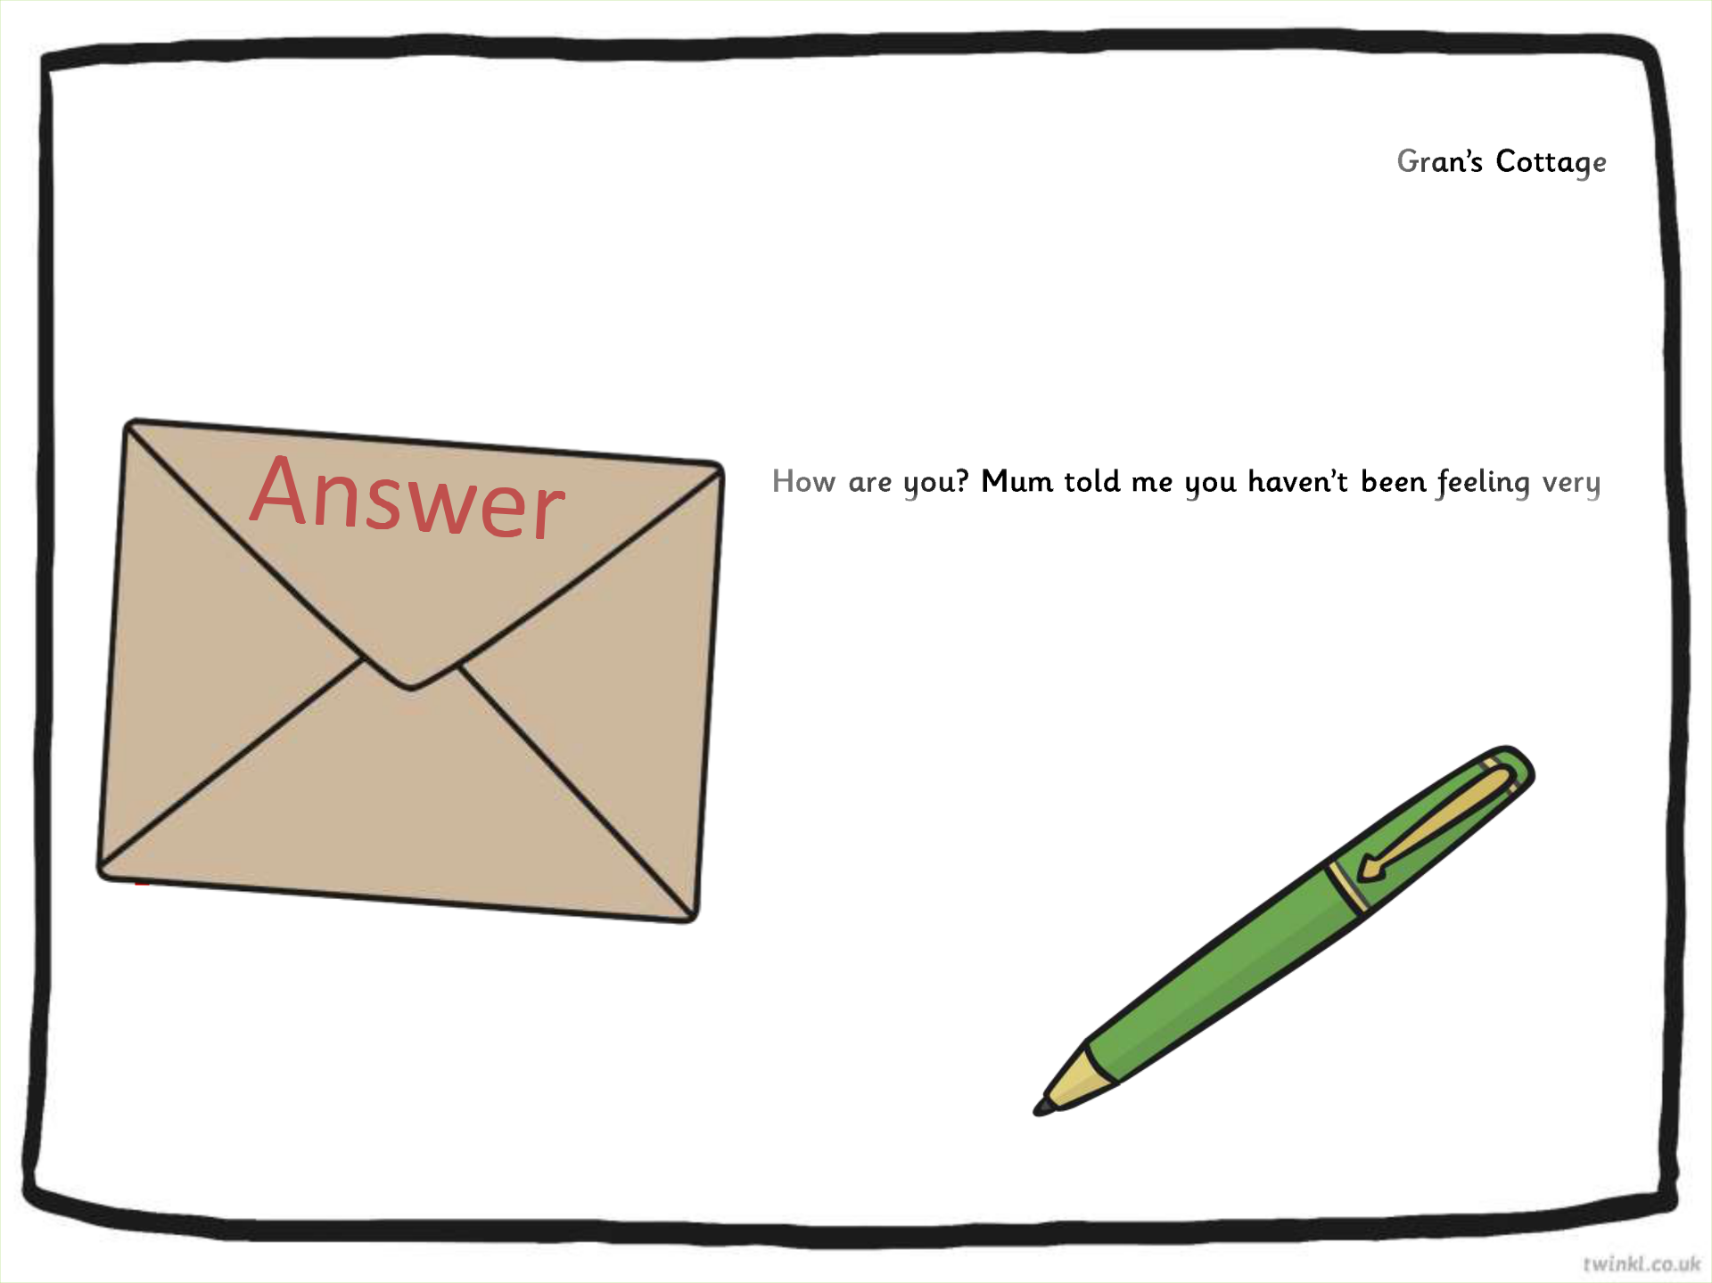
Forest Town

FT1 LMN

Friday 23rd May 2015

Dear Gran,

well. I have baked you some of your favourite cakes and wondered when it would be possible for me to come and visit?

Hope to see you soon.

Lots of love

Little Red Riding Hood xx

Answer

A letter sent to a friend or family member can be finished in a more familiar

by the name of the person who is writing the letter.

Dark Wood Lane
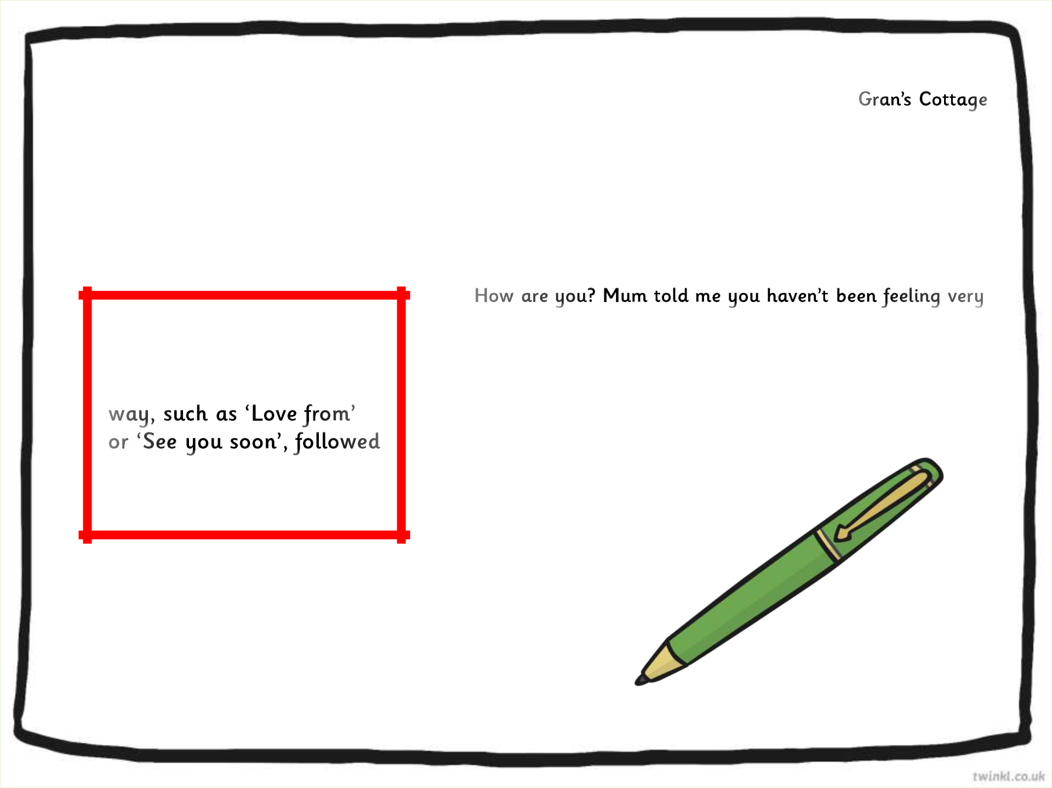
Forest Town

FT1 LMN

Friday 23rd May 2015

Dear Gran,

well. I have baked you some of your favourite cakes and wondered when it would be possible for me to come and visit?

Hope to see you soon.

Lots of love

Little Red Riding Hood xx

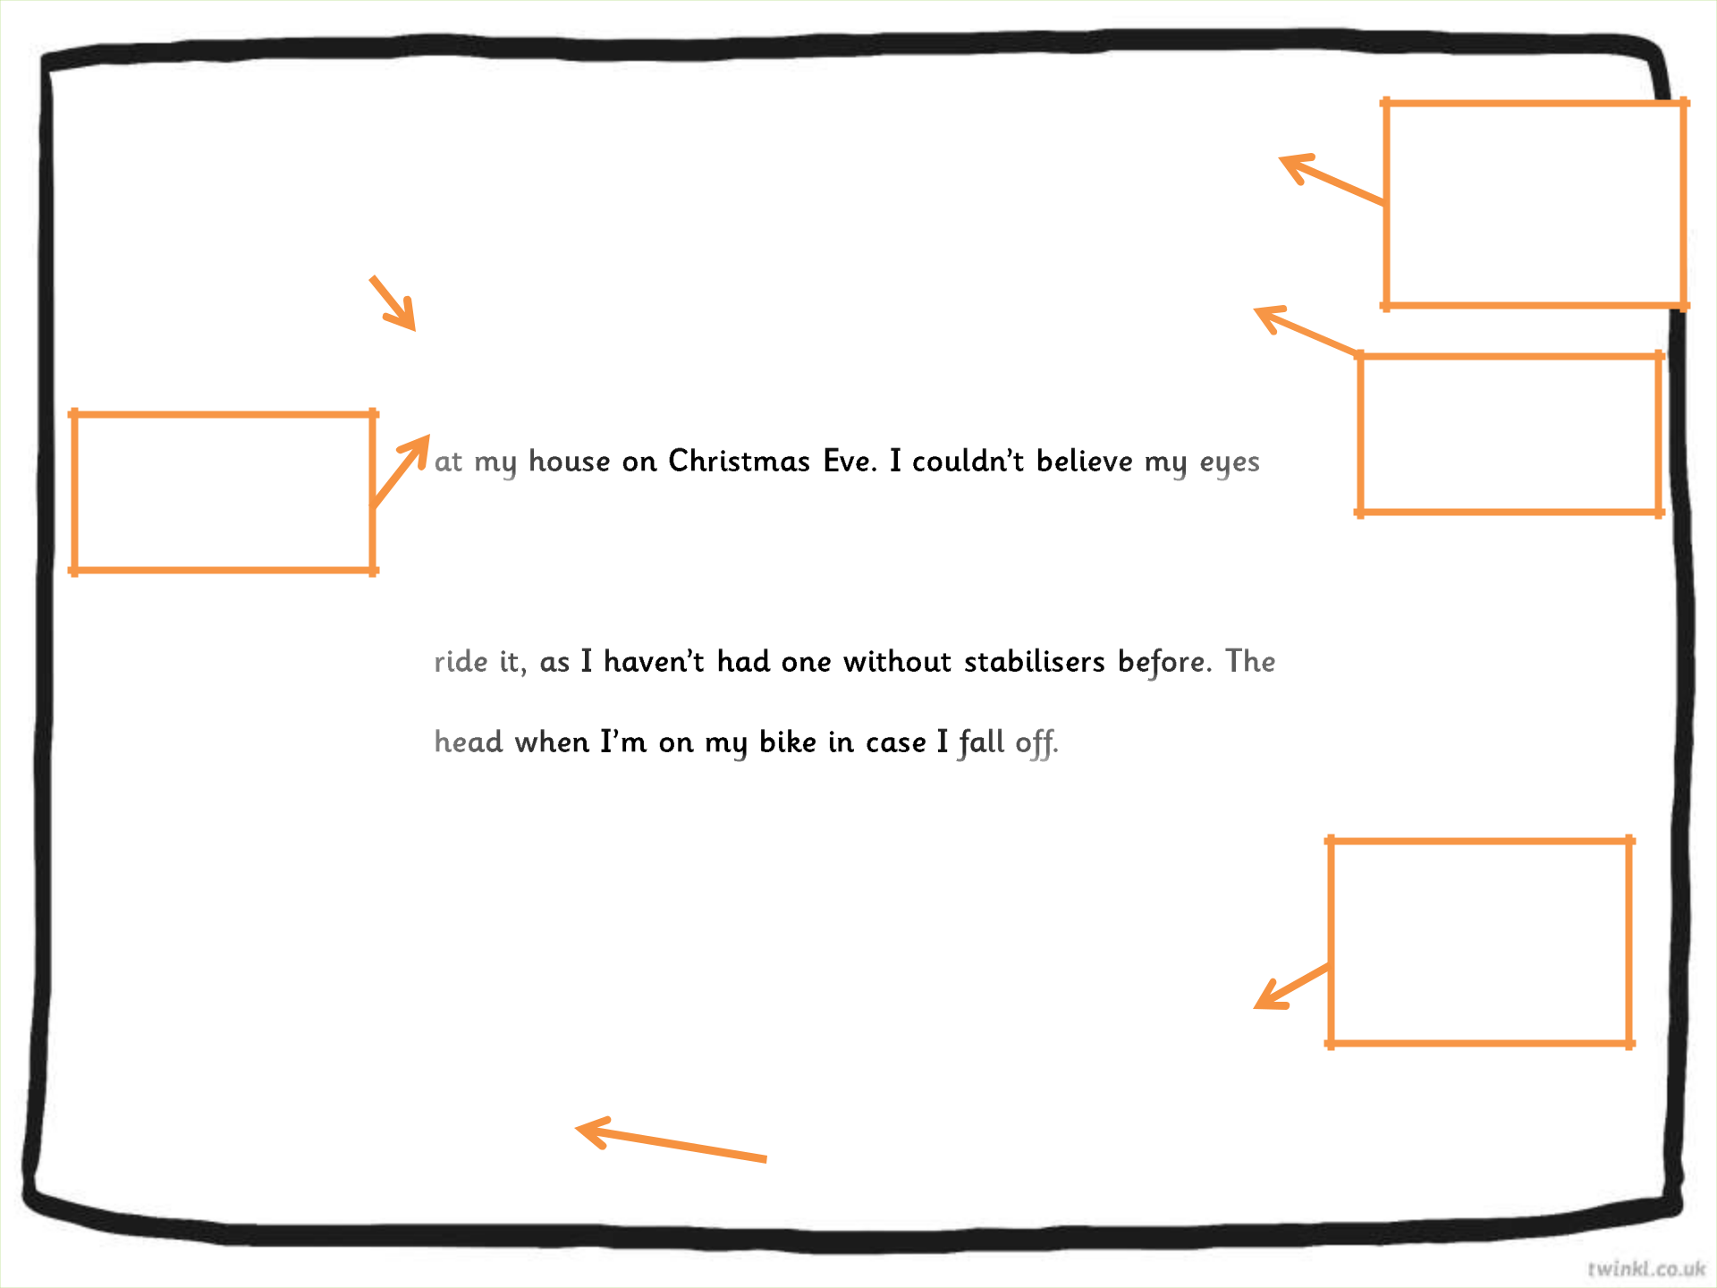  Features of an Informal |  | Daisy Happy
 |  | Flat 23 Clarence House
Letter |  | Long Lane
 |  | Caggletonville
 |  | CA12 4ON
Greeting – Who |  | CA12 4ON
is the letter to? | Dear Santa, | Friday 2nd January 2015

Sender’s Address

– This allows the reader to reply to the letter.

Date – When

Introduction – Why are you writing to them?
I am writing to thank you for the lovely presents you left

when I saw them all and so beautifully wrapped. Your elves must have been very busy this year.

I especially loved the bike and have been learning how to

pink helmet is a perfect fit and I wear it to protect my

My brother James loved his train set and has been playing with it everyday since you delivered it. He loves the noises it makes and connecting all of the carriages together.

I hope you and Mrs Clause have a lovely holiday and the elves and reindeers have a well deserved rest.

was the letter written?

Conclusion – End with a kind message to them.

Love from

Daisy xx | Sign off – Who is the letter from?

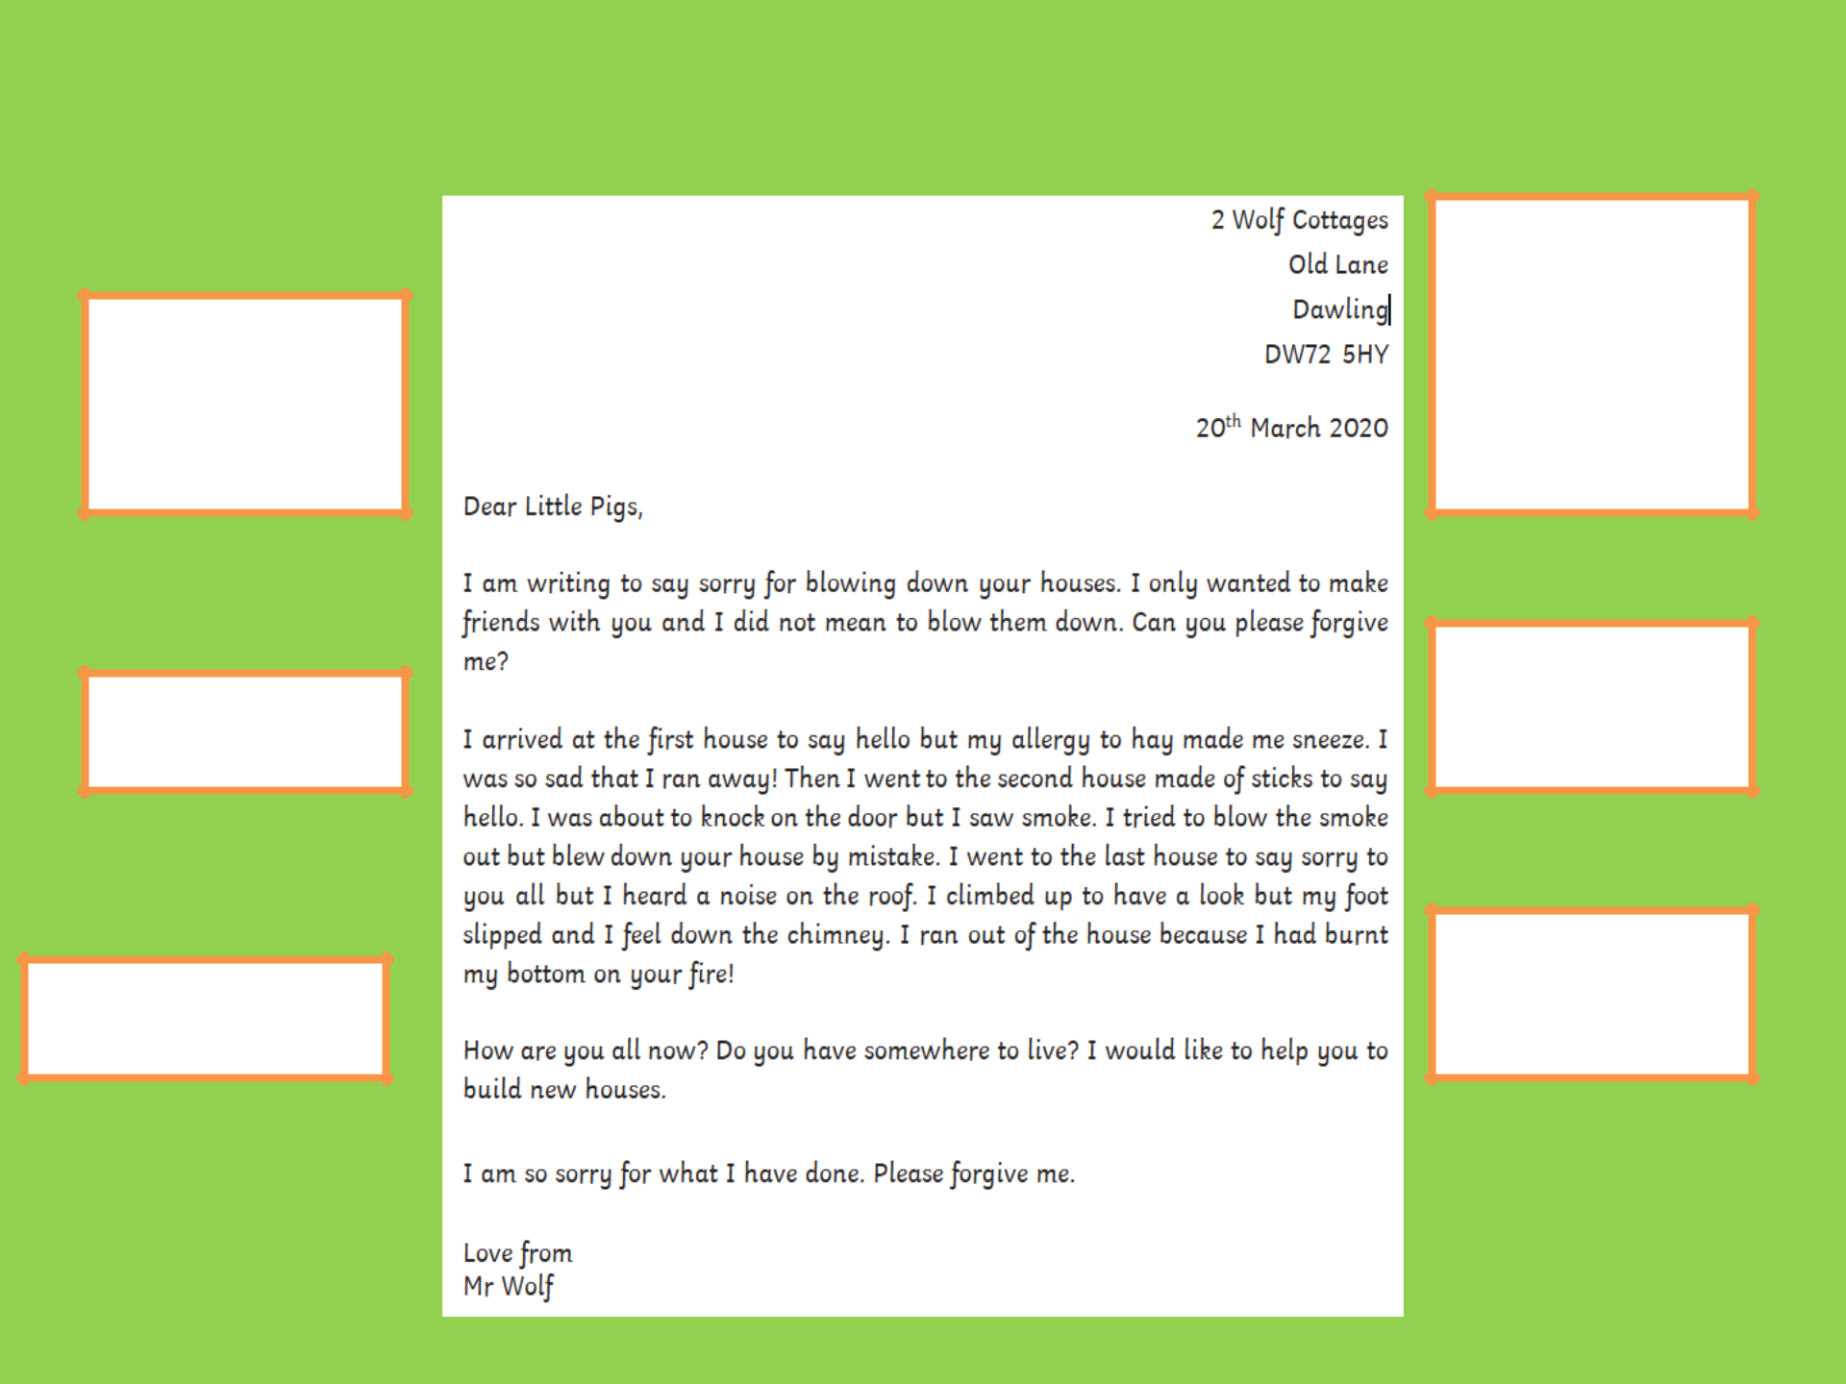
Can you find these features on the Example Letter?

Sender’s Address

– This allows the reader to reply to the letter.

Greeting – Who

is the letter to?

Sign off – Who is the letter from?

Conclusion – Sum up your

letter and end with a kind message to them.

Introduction – Why are you writing to them?

Date – When was the letter written?

