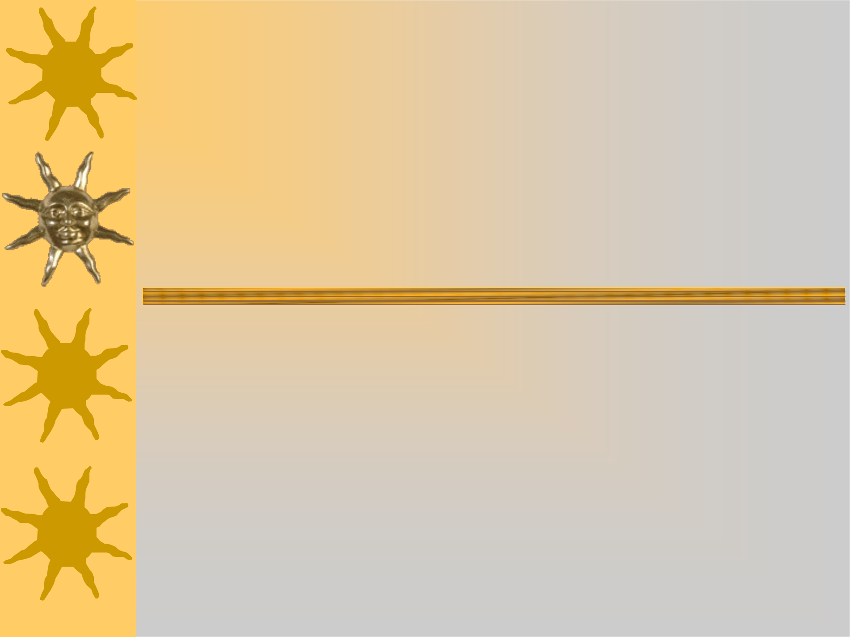
How to set out an

Informal

letter

(Modern)

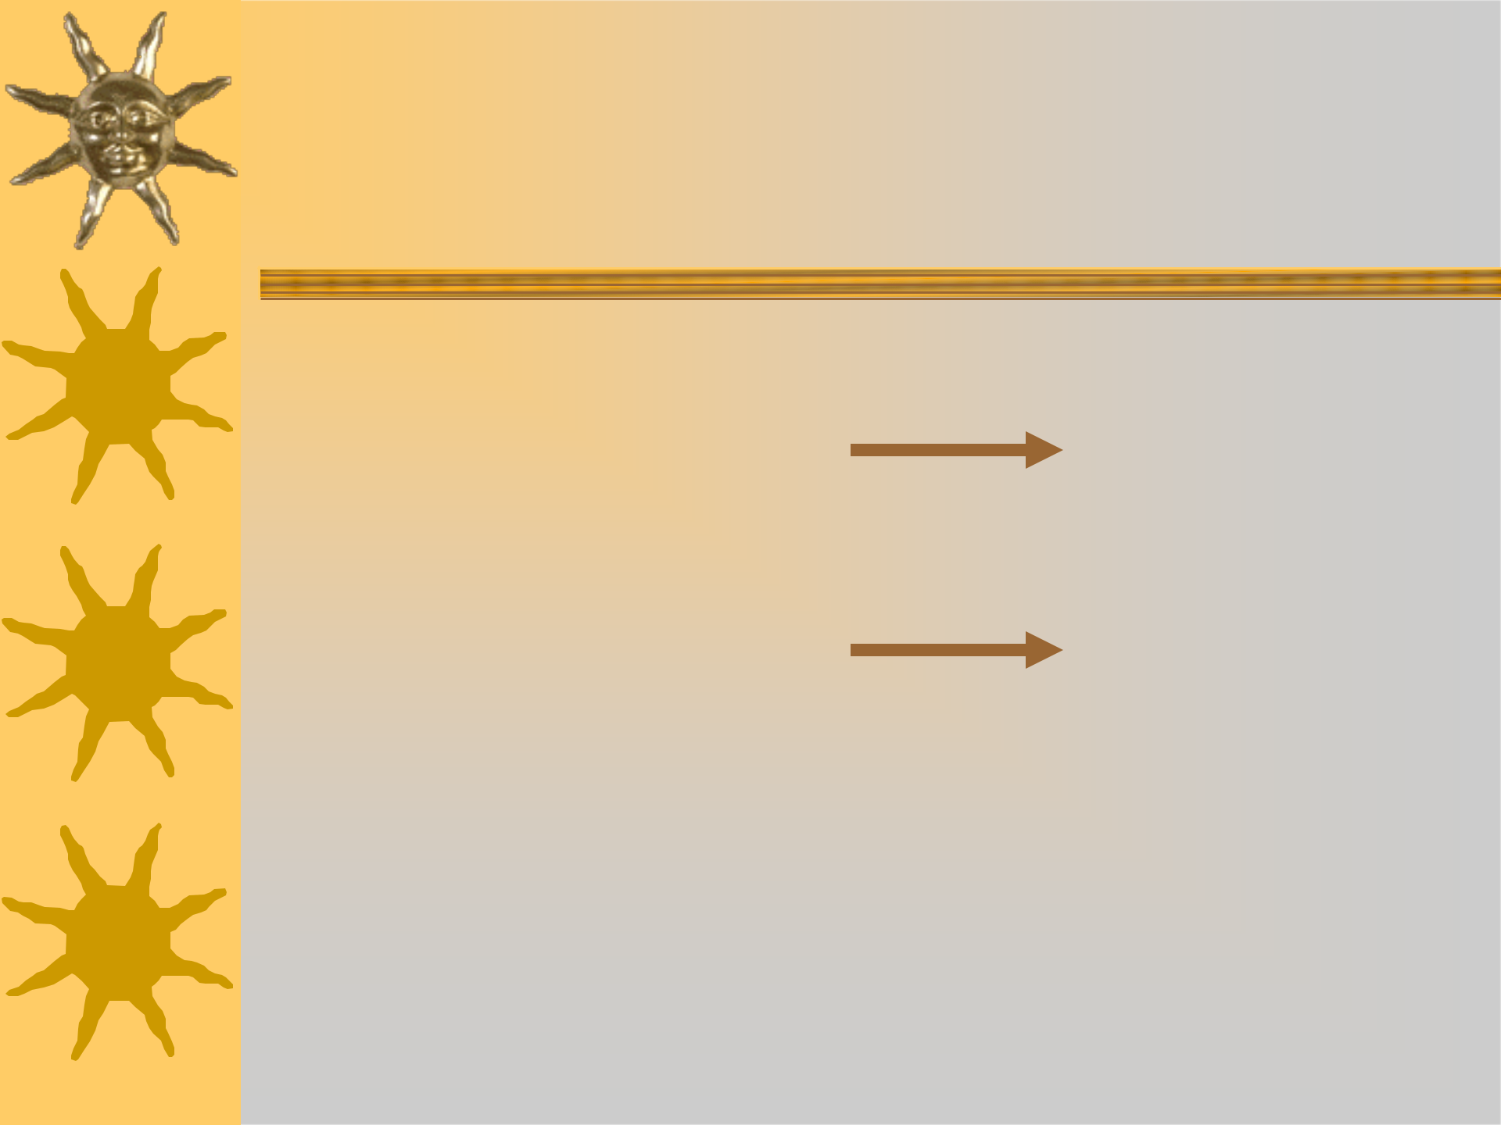
Informal or Personal letter

(Modern)

Your Primary School,
First write your
Your Street,
address over
Your town,
here on the right
Your County
hand side.
Postcode

_{Now}June25th_{the}2004_{date}

That’s^{Dear} over here! 

Then drop down one line and write

Dear

by the left hand margin.
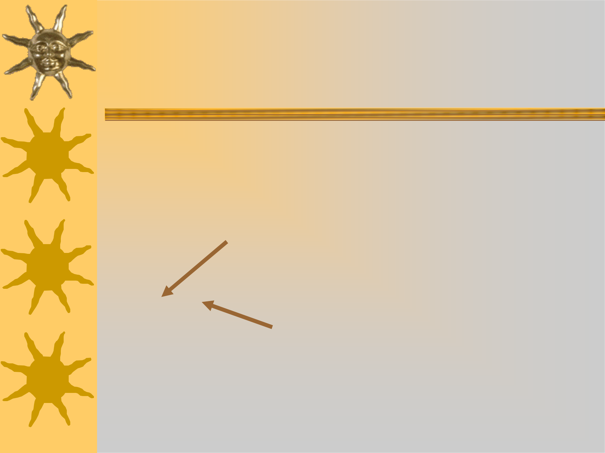
Informal or Personal letter

(Modern)

 |  | Your Primary School,
 |  | Your Street,
Who is the letter to? |  | Your town,
 |  | Your County
Write that here. |  | Postcode
 |  | June 25th 2004
Dear | ,

And don’t forget the comma afterwards!
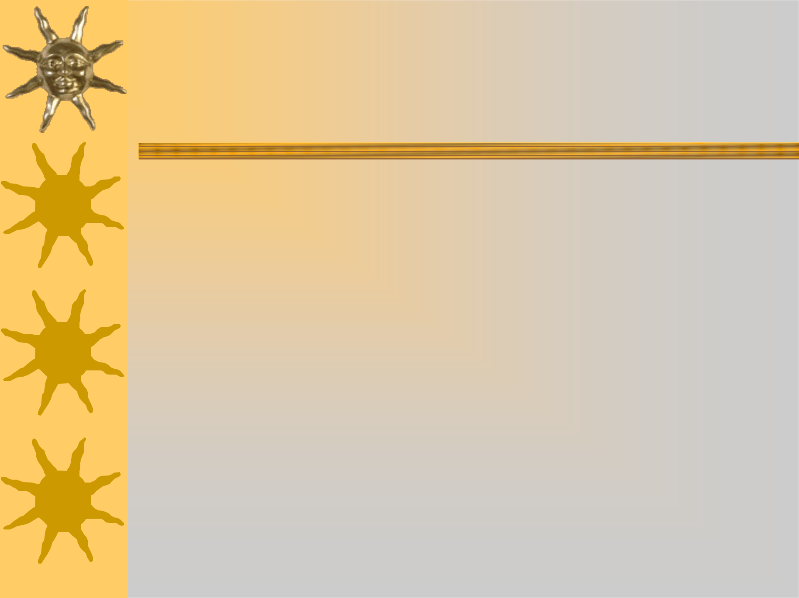
Informal or Personal letter

(Modern)

Your Primary School,

Your Street,

Your town,

Your County

Postcode

June 25th 2004
Dear ,

You’re writing to a friend or relative so you can be chatty

and friendly in your opening paragraph.
Informal or Personal letter

(Modern)

Dear ,

Hi, how are you doing? I know that you’ve just moved up a year at school. What’s your new teacher like?

In your first paragraph you could tell your friend or

relative some exciting news…

In your second paragraph you could tell your friend or

relative how you’re feeling…

In your third paragraph you could tell your friend or relative a secret…
Informal or Personal letter

(Modern)

At the end of your letter, don’t forget to sign off.

Because you know them well,

say goodbye in a friendly way…

TakBestLovehinkingtsofwishesfromcareloveof you

Finally, sign your name.

Nigel

Your letter could look something like this:

Your Primary School,

Your Street,

Your town,

Your County

Postcode

June 25th 2004

Dear Scott,

Hi, how are you doing? I know that you’ve just moved up a year at school. What’s your new teacher like? I bet he’s really cool. Does he teach you how to write letters? Ours does. Today, my teacher taught us how to set a personal letter out correctly.

I’m in the top group for Literacy which is great. My two best friends in class are in the group too so we have a lot of fun. I’ve just started to use a fountain pen to write with, so my handwriting’s getting really neat. I have to be very careful not to smudge my work; do you have fountain pens at school?

We’ve been swimming nearly every day since Easter. Our school has an outdoor pool which is fantastic. It’s a bit cold to start with, but you soon warm up. I’ve learned to swim breaststroke now, but I still need to work on my frog’s legs!

Well, I’m running out of room, so I’d better say goodbye for now. I hope your new class is good fun and you’re learning lots!

Best wishes,

Nigel

How to set out an

Informal

letter

(Traditional)

Informal or Personal letter

(Traditional)

Your Primary School,
First write your
Your Street,
address over
Your town,
here on the right

With a sloping margin ^{Your County hand side.}
Postcode
_{Now}June25th_{the}2004_{date}

That’s^{Dear} over here!

Then drop down one line and write

Dear

by the left hand margin.
Informal or Personal letter

(Traditional)

 |  | Your Primary School,
 |  | Your Street,
Who is the letter to? |  | Your town,
 |  | Your County
Write that here. |  | Postcode
 |  | June 25th 2004
Dear | ,

And don’t forget the comma afterwards!
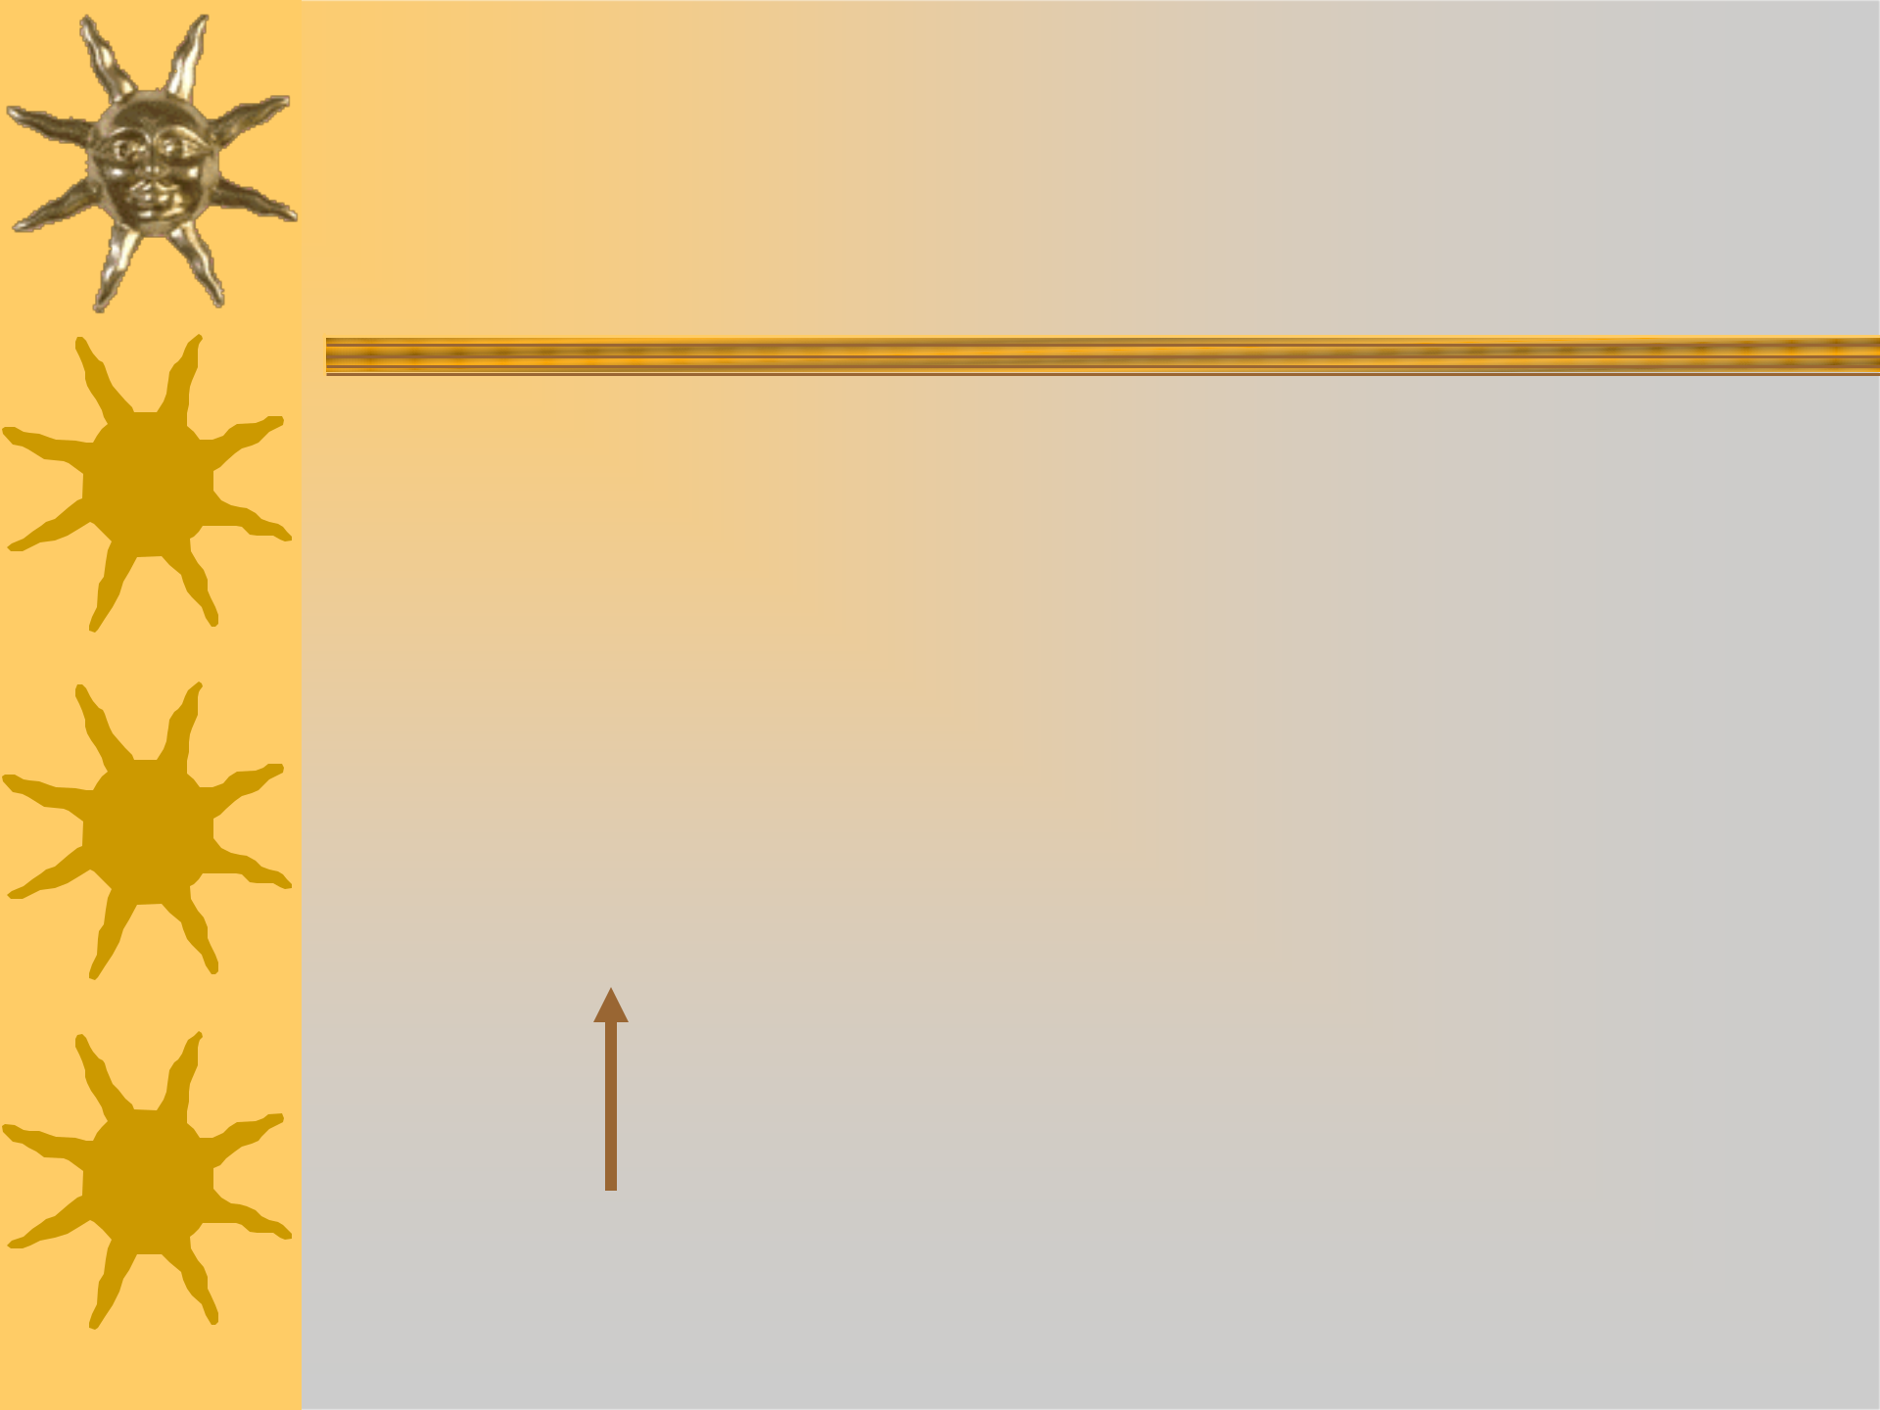
Informal or Personal letter

(Traditional)

Your Primary School,

Your Street,

Your town,

Your County

Postcode

June 25th 2004
Dear ,

You’re writing to a friend or relative so you can be chatty

and friendly in your opening paragraph.

Write your first word under this comma.
Informal or Personal letter

(Traditional)

Dear Scott,

Hi, how are you doing? I know that you’ve just moved up a year at school. What’s your new teacher like?

 In your first paragraph you could tell your

friend or relative some exciting news…

In your second paragraph you could tell your

friend or relative how you’re feeling…

In your third paragraph you could tell your friend or relative a secret…
Informal or Personal letter

(Traditional)

At the end of your letter, don’t forget to sign off.

Because you know them well,

say goodbye in a friendly way…

TakBestLovehinkingtsofwishesfromcareloveof you

Finally, sign your name.

Nigel
Your letter could look something like this:

Your Primary School,

Your Street,

Your town,

Your County

Postcode

June 25th 2004

Dear Scott,

Hi, how are you doing? I know that you’ve just moved up a year at school.
What’s your new teacher like? I bet he’s really cool. Does he teach you how to write letters?
Ours does. Today, my teacher taught us how to set a personal letter out correctly.

I’m in the top group for Literacy which is great. My two best friends in class are in the group too so we have a lot of fun. I’ve just started to use a fountain pen to write with, so my handwriting’s getting really neat. I have to be very careful not to smudge my work; do you have fountain pens at school?

We’ve been swimming nearly every day since Easter. Our school has an outdoor pool which is fantastic. It’s a bit cold to start with, but you soon warm up. I’ve learned to swim breaststroke now, but I still need to work on my frog’s legs!

Well, I’m running out of room, so I’d better say goodbye for now. I hope your new class is good fun and you’re learning lots!

Best wishes,

Nigel

