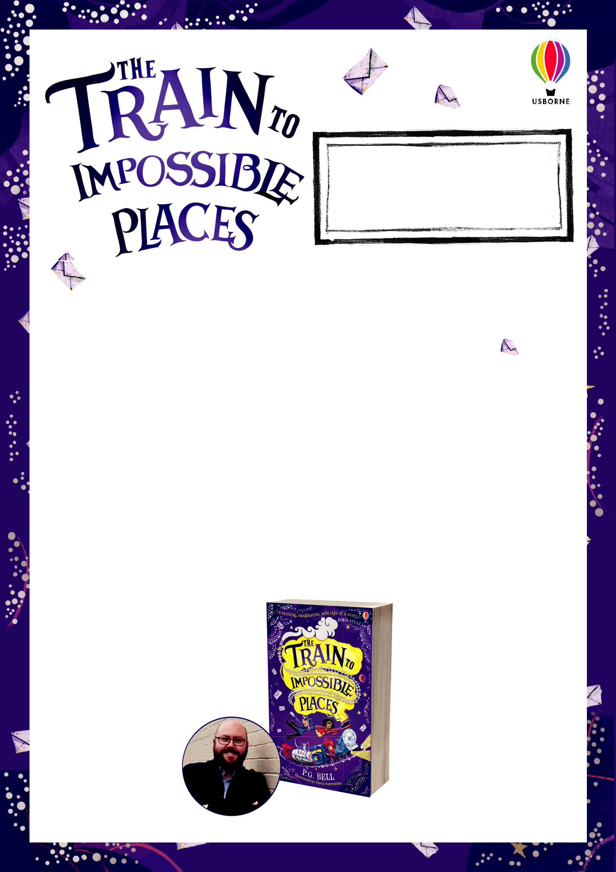

WILMOT’S GUIDE TO

LETTER WRITING!

by P. G. BELL

THE AIM

RESOURCES FOR KS2 TEACHERS

Visit youtube.com/usbornepublishing for videos of P. G. Bell reading an extract and sharing Wilmot’s top letter writing tips.

For all teachers in Impossible Places…

This resource pack is based on The Train to Impossible Places, the highly acclaimed new book by P. G. Bell, a magical journey for you and your KS2 class to embark upon…

The activities included focus in particular on letter writing. They use a series of ‘Top Tips’ from Postmaster and resident letter-writing expert, Wilmot Grunt, to encourage pupils to interrogate the components of a successful letter.

The activities also include reading comprehension questions to support and elevate understanding of the text and to improve reading inference, retrieval and predictive skills, as well as providing opportunities for your class to immerse themselves in P. G. Bell’s magical world, where impossible becomes possible…

It’s time to jump on board!

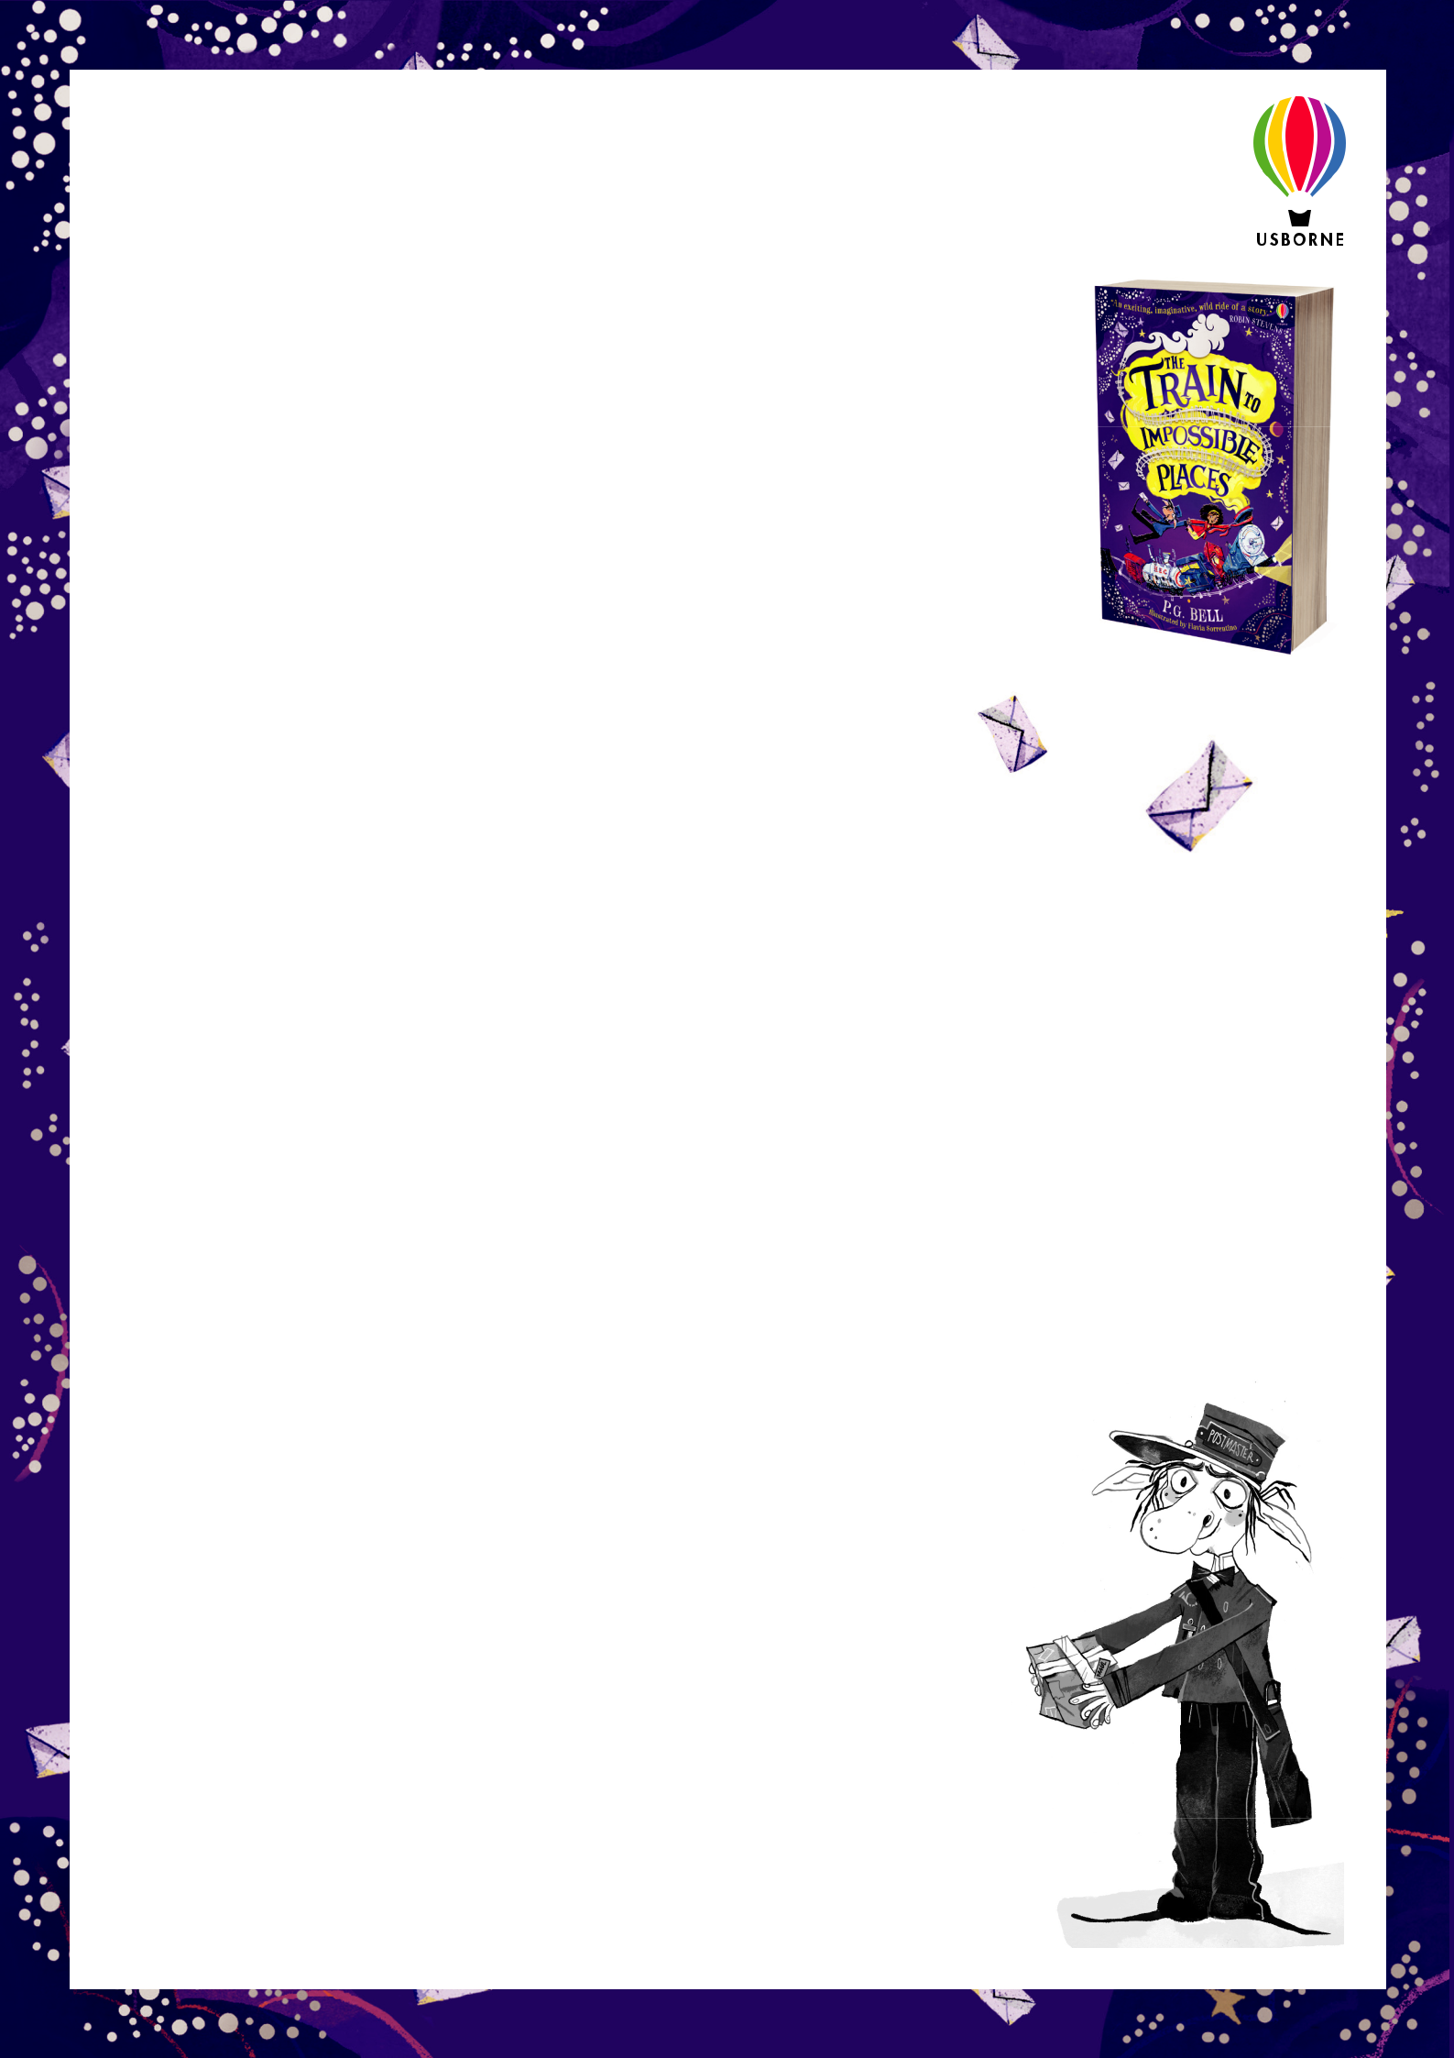
Illustrations by Flavia Sorrentino © Copyright Usborne Publishing Ltd. 2018
ABOUT THE BOOK

Join the journey to Impossible Places, where there’s magic at every stop…

Suzy is surprised to find a grumpy troll building a railway through her house

– especially when a gigantic steam train crashes into her hallway! This is the Impossible Postal Express, the trusty delivery service of the Union of Impossible Places, and Suzy becomes its newest recruit. And with her cursed first package, an Impossible adventure begins.

Welcome to the Impossible Places… Where there’s fuzzics not physics, where adventure meets magic and where the journey will never, ever take you where you expect it to.

OBJECTIVES AND OUTCOMES

Lesson 1: A Note from Postmaster Wilmot Grunt…

Objectives:

- To discuss the importance of letter writing and how this has changed over time

- To use reading comprehension skills to make inferences about a character in the book

- To annotate and label a letter according to identifi ed success criteria

Outcomes: A list of criteria for a successful letter; an annotated letter using ‘Wilmot’s Top Tips’.

Lesson 2: Formal and Informal Letters

Objectives:

- To understand and defi ne the terms: ‘formal’ and ‘informal’

- To identify the differences in language and tone between ‘formal’ and ‘informal’ letters

- To write the opening of a letter according to recipient chosen and formal/informal conventions

Outcomes: A list of features of formal and informal letters; an opening to a letter written in formal or informal style.

Lesson 3: Letters to Impossible Places

Objectives:

- To recap and refl ect on learning about letter writing

- To write a full letter to a recipient of choice using the correct form, structure, language and tone

- To create a postage stamp for a letter

Outcome: A letter to a recipient of choice; a magical postage stamp!

Illustrations by Flavia Sorrentino © Copyright Usborne Publishing Ltd. 2018

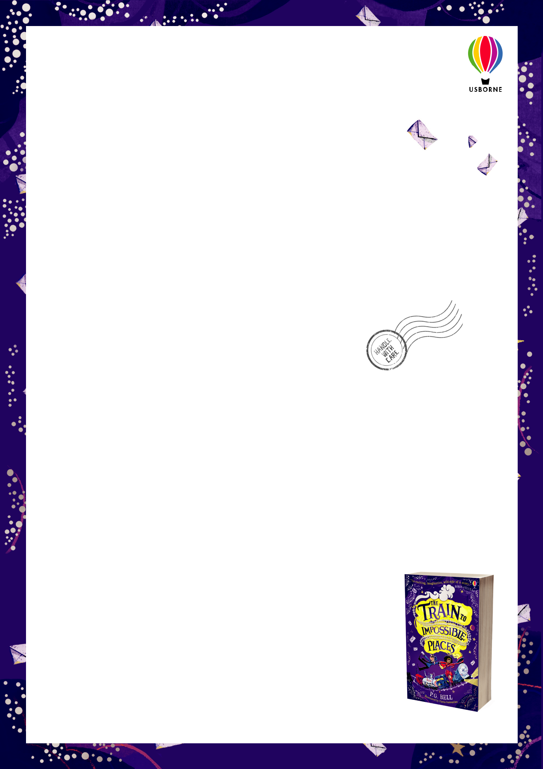
LESSON ONE A NOTE FROM POSTMASTER WILMOT GRUNT…

Lead-in questions:

- When was the last time you wrote a letter? Who was it to?

- Why do you think people don’t write letters as much these days?

- Who would you most like to write a letter to? Why?

Task 1:

In the book, the main character, Suzy, is whisked on board the magical delivery express train where she meets a troll-boy called Wilmot, who is in charge of delivering the post all over the Union of Impossible Places!

As you might’ve guessed already, Wilmot is a bit of an expert when it comes to delivering post, not to mention when it comes to writing letters!

In pairs, take a look at Wilmot’s very own letter – addressed to YOU, the reader! – along with his ‘Top Tips on How to Write a Letter’.

Task 2:

In pairs or groups, answer the questions below:

- Why do you think Wilmot loves writing letters?

- Who does Wilmot send a lot of letters to?

- Can you fi nd examples of things that are quirky, odd or unusual about Wilmot’s letter to the reader?

Task 3:

Now, see if you can fi nd examples of Wilmot’s advice in his OWN letter! Does he keep up with his own high standards?

In pairs, annotate and label your copy of Wilmot’s letter with all of the things that Wilmot suggests in his Top Tips, summarised below:

- Make sure the recipient’s address is on the left-hand side of the page, with the sender’s address on the right-hand side.

- Make sure your greeting is correct, depending on how well you know

the recipient! (e.g. formal or informal language.)

- Make sure that the content of your letter is appropriate, fun and engaging!

- Make sure that you end your letter with the correct sign-off (Yours faithfully, Yours sincerely, or something more informal!).

FINALLY: How many marks out of 4 would you give Wilmot’s letter? Would you give his letter any bonus points? Why?

Extension task: Where do you think the writer purposefully bends some of his own rules to make the letter more engaging and funny for the reader?

Illustrations by Flavia Sorrentino © Copyright Usborne Publishing Ltd. 2018

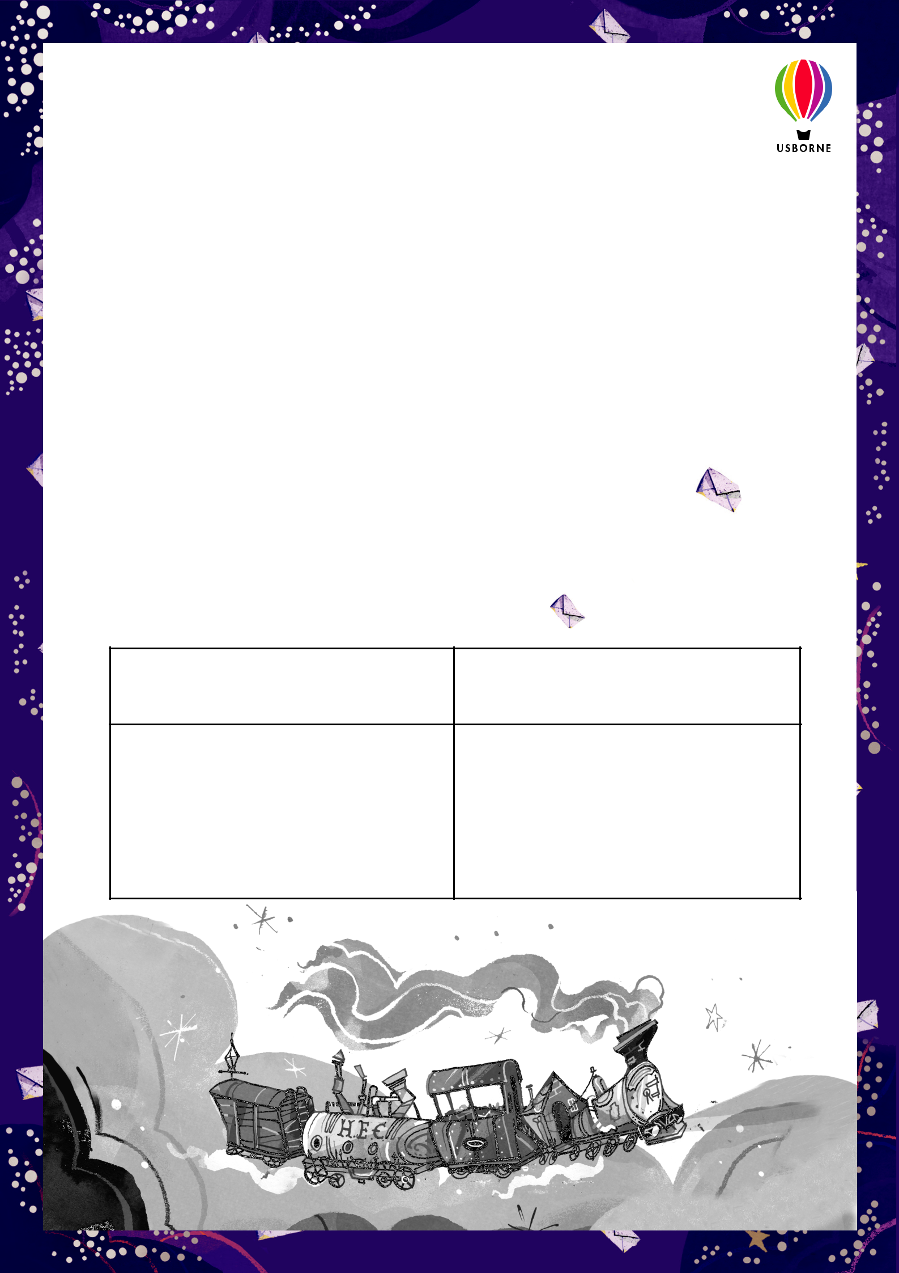
LESSON TWO FORMAL AND INFORMAL LETTERS

Lead-in questions:

- What do we mean by the word ‘formal’? What do we mean by the word ‘informal’?

- Do you think Wilmot’s letter was ‘formal’ or ‘informal’? Give reasons for your answers.

Task 1:

One of Wilmot’s Top Tips on How to Write a Letter is to consider how well you know the person that you are writing to.

Consider how well you would know the people on the list below. If you were to write a letter to one of them, would it be a formal or informal letter? In pairs, put the recipients into one of two categories using the table below.

- MY BEST FRIEND

- MY MUM

- MY TEACHER

- A POLITICIAN

- AN AUTHOR (e.g. P. G. BELL!)

- AN EMPLOYER (e.g. A JOB APPLICATION)

FORMAL | INFORMAL

Illustrations by Flavia Sorrentino © Copyright Usborne Publishing Ltd. 2018

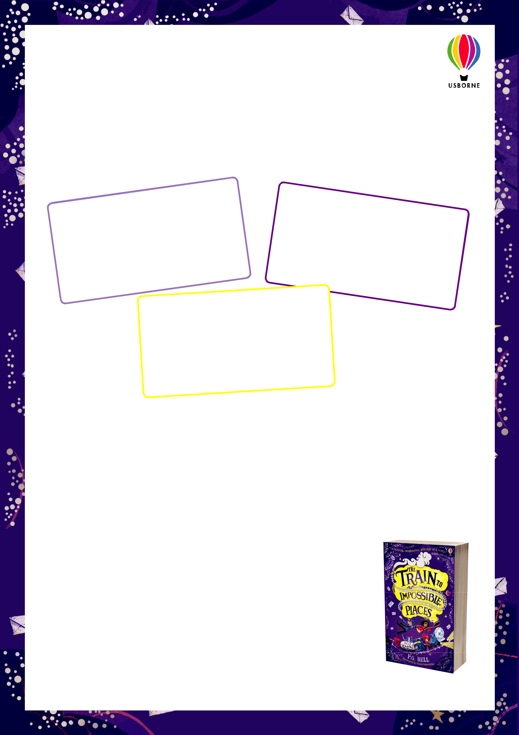
Task 2:

Can you guess how the language and tone would be different for a formal and an informal letter?

Write your opening in one of the boxes provided; when you have fi nished, put it into a hat or a bag in the middle of the room.

Dear | John, |  | by | thanking |  | you
Let me begin |  |  | by
 |  |  |  | contributions
for your |  | recent
 |  |  |  |  |  | .
to our football |  |  |  | team | fund

 | Dear
 | I am | Sir / Madam,
 | I am | writing to |  |  | complain
about
 |  | a recent
I |  |  |  | holiday |  | that
I | booked via |  |  |  |  | that
 |  |  | your agency.

Hi Alice!
How you doing? Hope all’s
. I’m | so lookin’ forward
well
to seeing you soon!

Task 3:

How did you make your decisions in Task 2? Make a list of the different words or phrases that helped you to categorise the different openings into ‘formal’ or ‘informal’. What are the differences in language and tone? Consider, for example, the use of abbreviated words (I’m, all’s, lookin’) as well as vocabulary choices.

Task 4:

Choose one of the recipients from Task 1 and write your own letter opening. Remember to consider whether the letter you are writing is formal or informal – and adjust your

language and tone accordingly. Write your opening in the boxes provided below; when you have fi nished, cut it out and put it into a hat or bag in the middle of the room. Don’t forget to include an appropriate greeting!

Take it in turns to read out the different letter openings. Can you guess whether they are formal or informal?

Illustrations by Flavia Sorrentino © Copyright Usborne Publishing Ltd. 2018

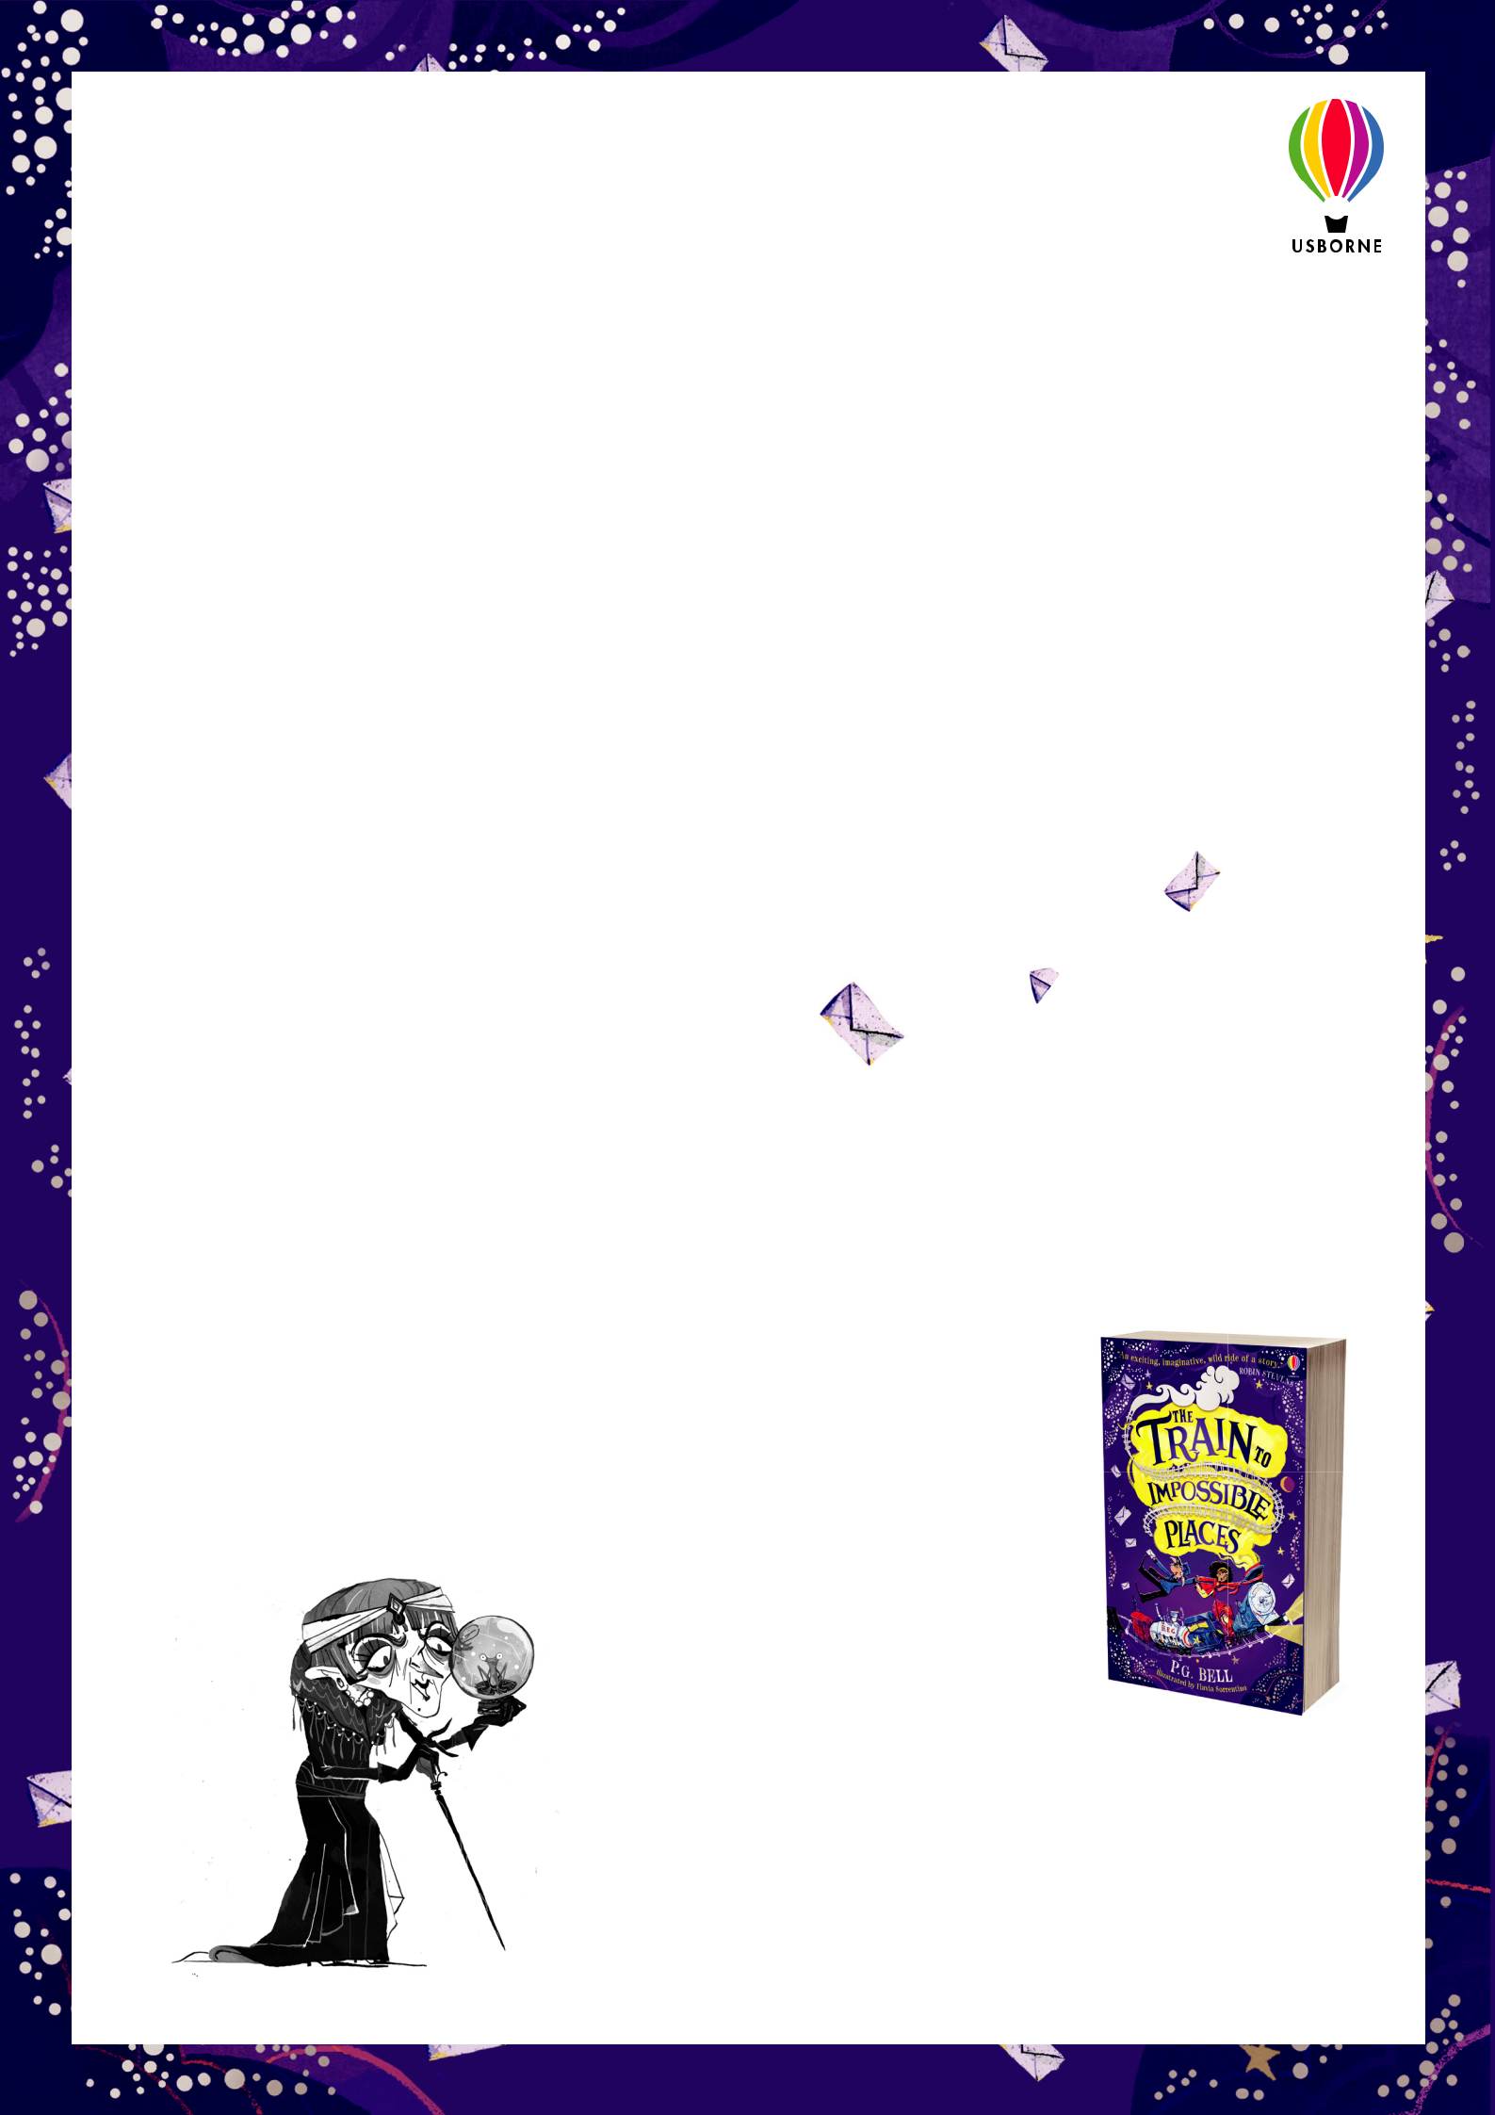

LESSON THREE LETTERS TO IMPOSSIBLE PLACES

Lead-in questions:

- If you could write a letter to anyone in the world, who would you write it to?

- What is your favourite ‘Top Tip’ for writing a letter?

Task 1:

It’s time to put all of your letter-writing skills to the test. Using everything you have learned, including all of Wilmot’s Top Tips, you’re going to write a letter to a recipient of your choice – it can even be P. G. Bell himself!

Before you begin, use an A3 sheet of paper to create a map of everything you would like to say in your letter. Use the headings below to help you start planning:

- Will your letter be formal or informal? Why?

- What language choices will you make? What vocabulary will you use?

- What sort of tone will your letter have?

- How will you open your letter?

- How will you close your letter?

- How many paragraphs will it have?

- What will you say in each paragraph?

Task 2:

It’s time to get writing! Use the template provided (based on Wilmot’s Top Tips!) to write your letter. Don’t forget that you can bend the rules sometimes… but there has to be a good reason!

Task 3:

Wilmot’s fi nal tip is to ‘always remember to put a stamp on your envelope’. Design your very own magical stamps on the templates provided, they can be as weird and wonderful (and impossible) as you like! Use some of Flavia Sorrentino’s illustrations from the book as inspiration – you can see some of them dotted around this resource pack!

Finally, don’t forget to share all of your work with us –

including your letters and magical stamps – on Twitter at

 @Usborne  @petergbell

Illustrations by Flavia Sorrentino © Copyright Usborne Publishing Ltd. 2018

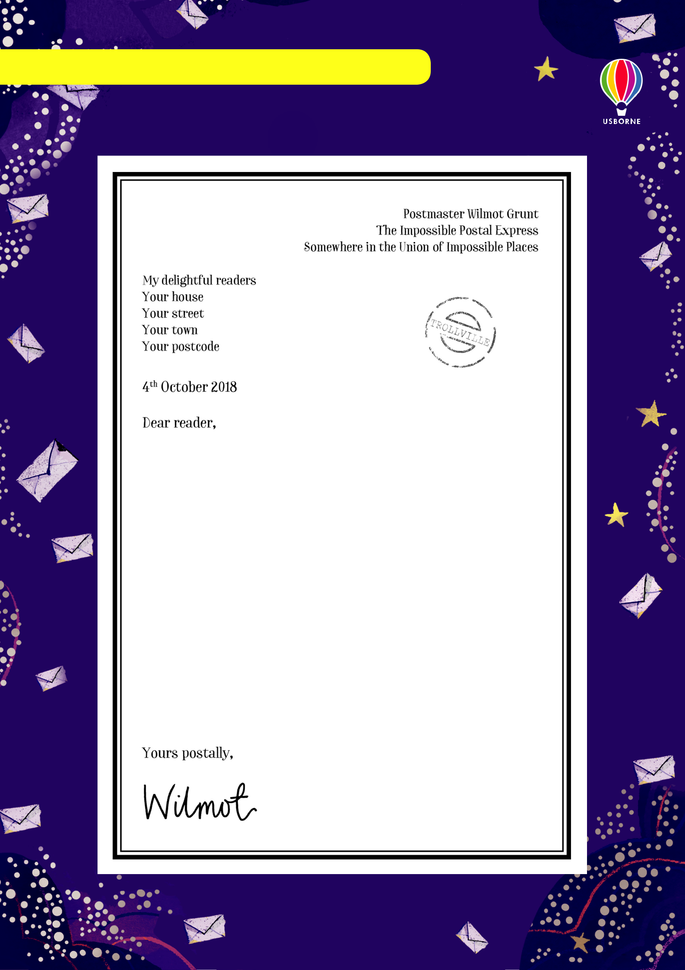
LESSON ONE: TASK 1 – LETTER WRITING

Letter writing with Wilmot

I am very excited to be writing you a letter about writing letters! That sounds confusing, but it’s not, I promise. I love letters of all shapes and sizes, and I spend a lot of time looking at and admiring them (and also delivering them, from time to time).

You can send letters to whoever you want. I send a lot of letters

to my mum, though I have to deliver them myself, which does

defeat the point a little... Ask your teacher for my handy guide on how

to write letters. I hope you enjoy reading it, and if you do, why not

give it a go yourself and write a letter to a friend, to myself, or

even to P.G. Bell, who wrote this story?
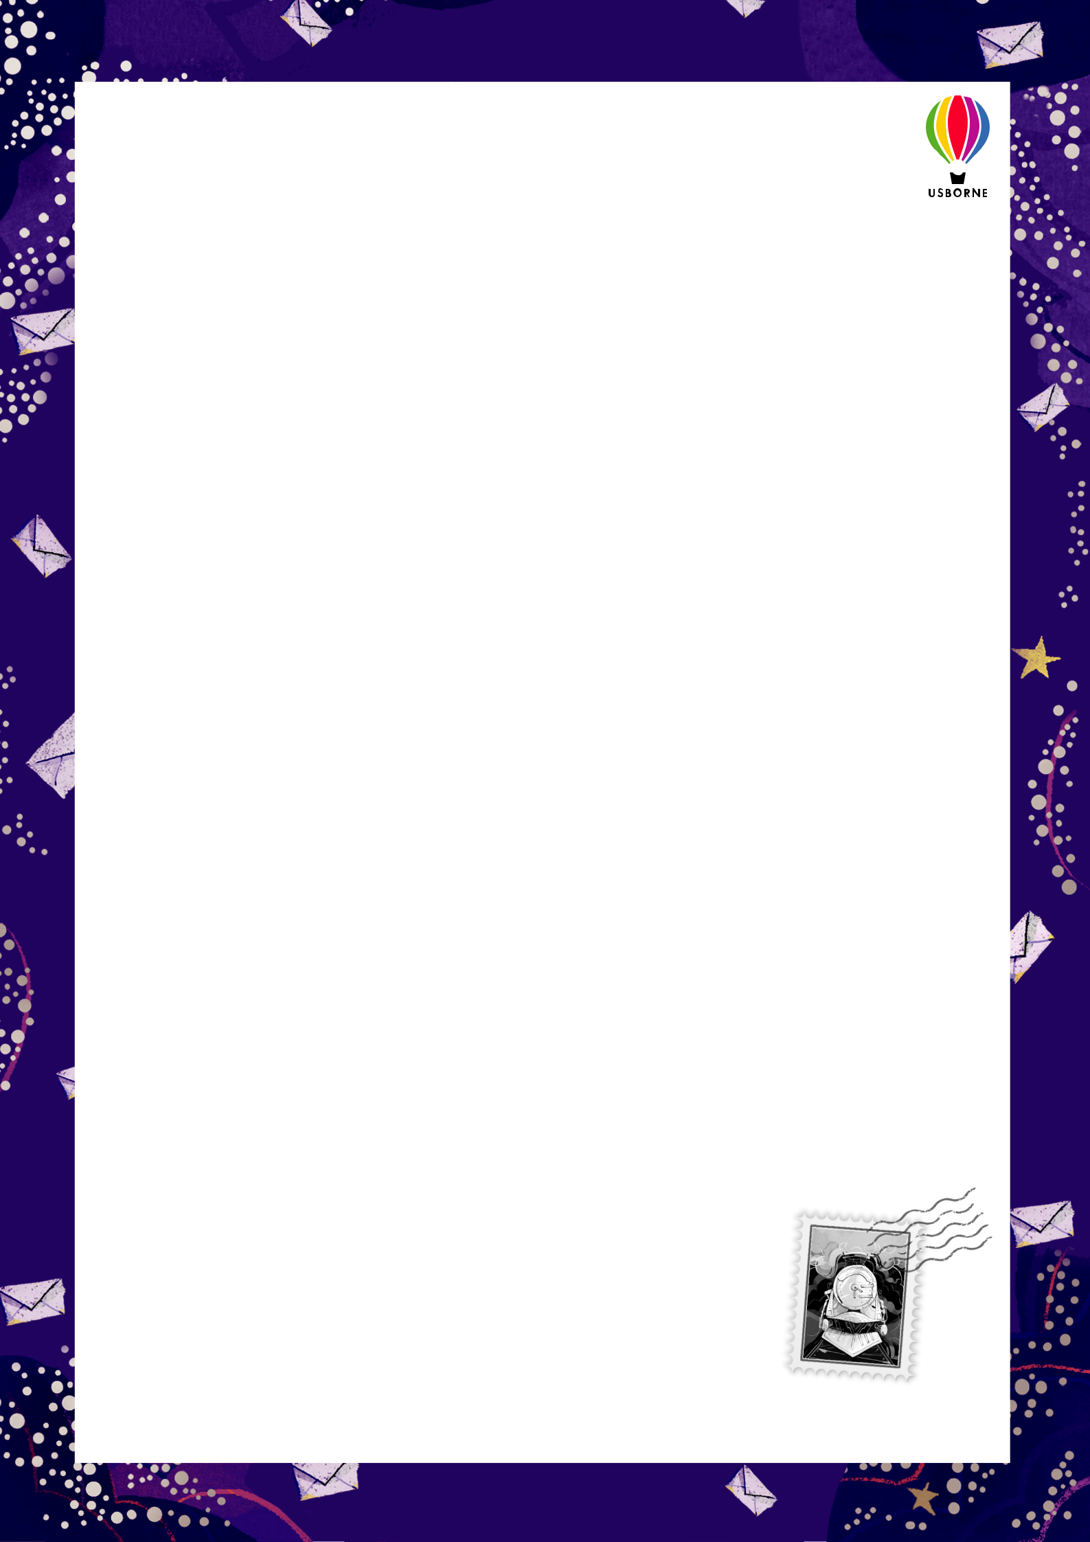
Wilmot’s top tips on how to write a letter

There are a few important questions to ask yourself before you begin a letter…

Do you know the address of the person you’re writing to?

This is very important, because if you don’t, you won’t be able to send your letter! The address of whoever you’re writing to should go on the left-hand side of the page, and your address should go in the top-right corner of the letter.

How well do you know the person you’re writing to?

This will change how you open and close a letter. If you know someone well, you can start your letter with “Dear Wilmot”, for example. Or if you don’t know them very well, and perhaps don’t like them very much, you could try “To my enemy, Wilmot”. If you don’t know them at all, you can write “Dear Sir / Madam”, or “To Whom it May Concern”.

What are you writing about?

Now you get to do the fun bit – writing. You can write about anything you’d like. I like to tell my mum about the adventures I’m having, the sandwiches I had for lunch, and how excited I will be to see her. You can even add in some doodles if you’d like.

How are you going to end your letter?

If you don’t know the name of the person you’re writing to, you should finish a letter with “Yours faithfully”, and then your name, or if you do know the person, you can finish with “Yours sincerely”. If you don’t want to be too formal, though, you could try a friendly “Best wishes”, or “Kind regards”, or “Lots of love” (that’s my favourite). It’s also very important to sign your name at the end; I like using my fancy pens for this!

And, finally – always remember to put a stamp on your envelope. Happy writing!

If you’d like to try out your letter-writing skills, you can write to P. G. Bell, author of The Train to Impossible Places, to tell him all about your own sandwiches, or how much you liked the book. His address is: P. G. Bell, Usborne Publishing, 83-85 Saffron Hill, London, EC1N 8RT.
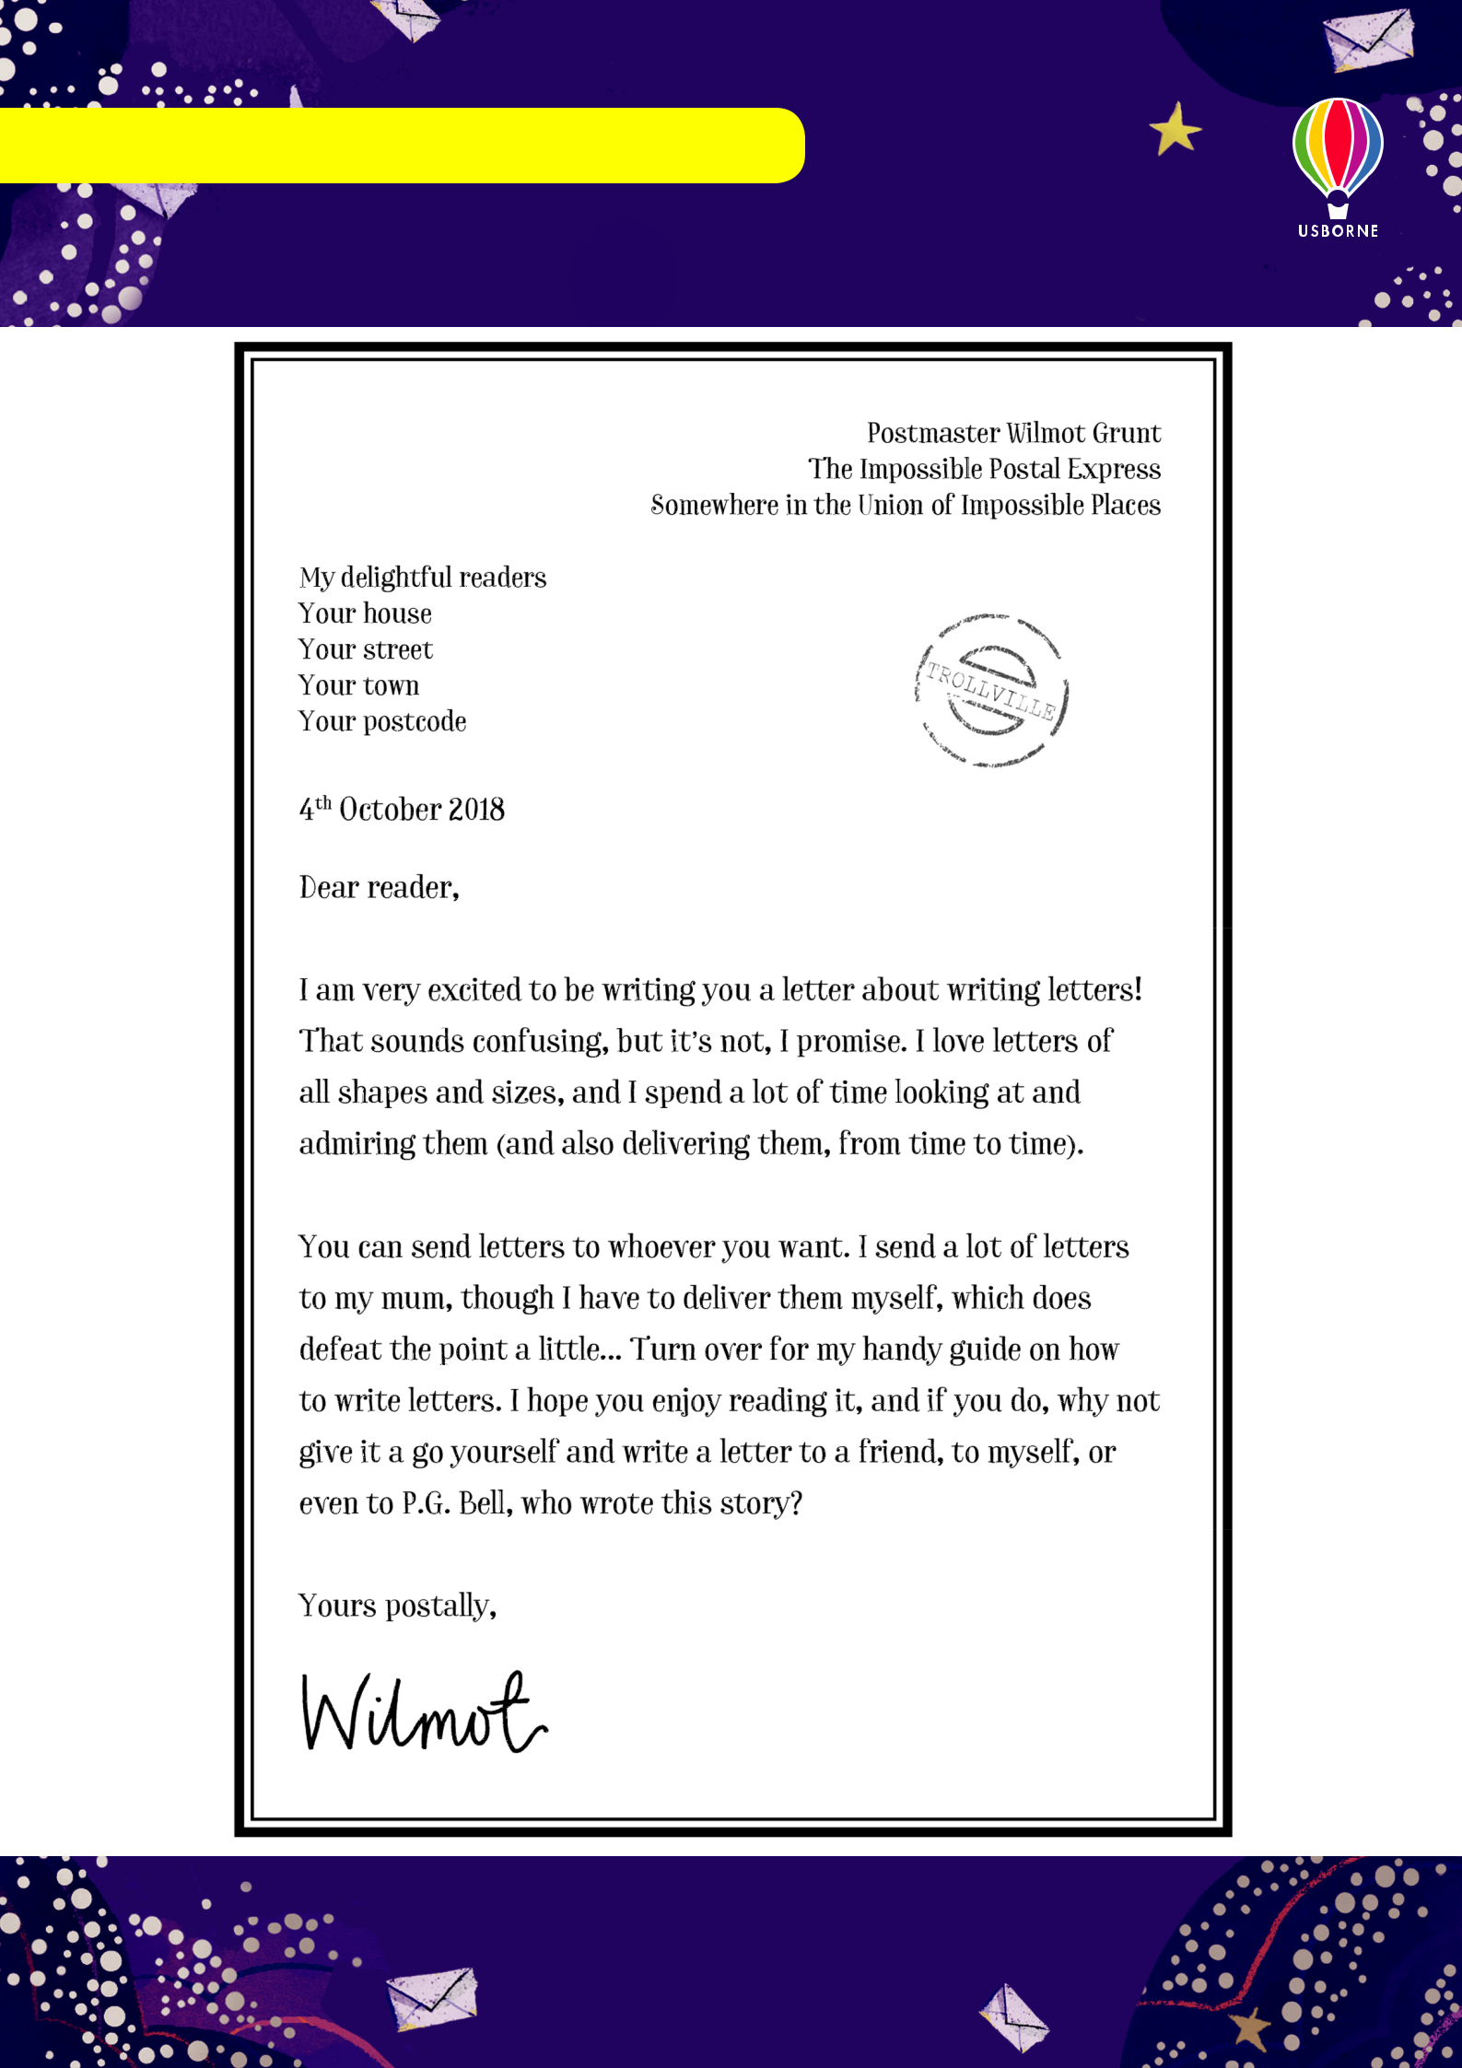
LESSON ONE: TASK 3 – LETTER TO ANNOTATE

Letter writing with Wilmot
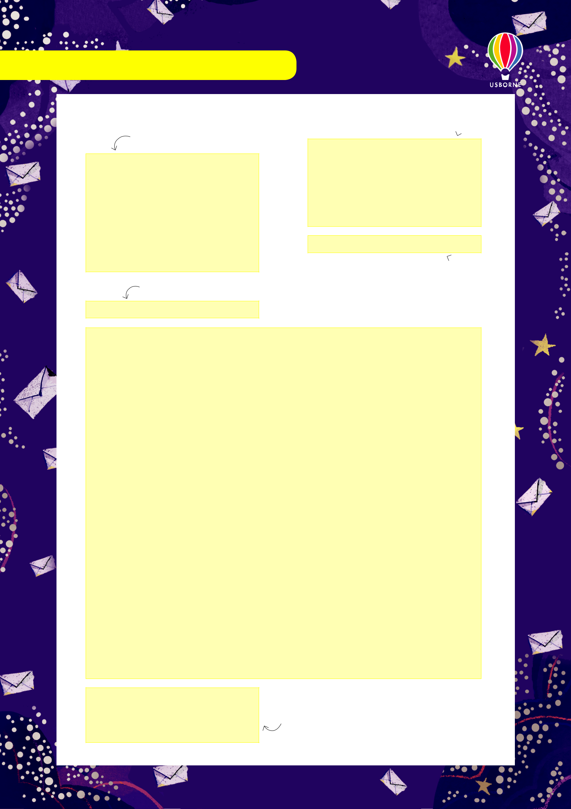
LESSON THREE: TASK 2 – LETTER TEMPLATE

Recipient’s address

Greeting

Your address 

Date

Your letter

Closing farewell

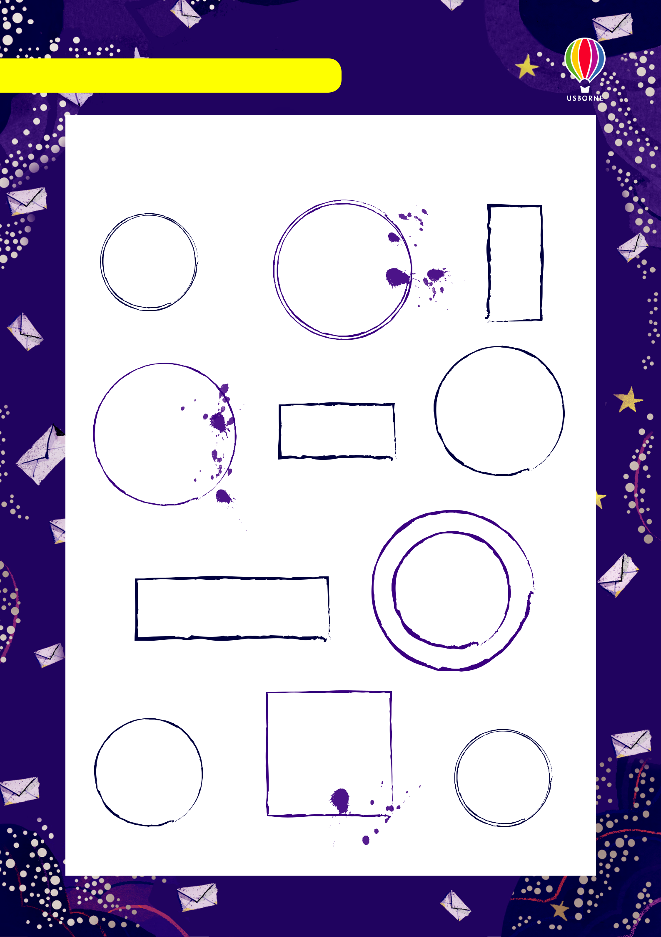
LESSON THREE: TASK 3 – STAMP DESIGNS

Design your very own magical stamps in the space below, they can be as weird and wonderful (and impossible) as you like!



LESSON TWO: TASK 4 – LETTER OPENINGS



