

TERMS OF SERVICE

Influencer Agreement

Upon acceptance by you this agreement (“Agreement”) shall set forth the material terms between you (“Influencer”

or “you”), and GoPro, Inc. (“GoPro”, “our” or “us”), whereby you agree to join GoPro's family of advocates in accordance with

the terms and conditions detailed below.

GoPro, through its relationship with Apifia, Inc. DBA Mavrck (“Mavrck”), provides access to the websites accessible at gopro.mavrck.co (collectively, the “Service”). This Agreement, which incorporate our Terms of Use and Privacy Policy, as well as Mavrck's Terms of Use and Privacy Policy (collectively “TOU”), govern your use of the Service. It is therefore important that you read and understand these TOU.

- Acceptance of this Agreement. YOU ACKNOWLEDGE AND AGREE THAT, BY ACCESSING OR USING THE SERVICE, YOU, YOUR HEIRS, SUCCESSORS AND ASSIGNS ARE INDICATING THAT YOU HAVE READ, UNDERSTAND AND AGREE TO BE BOUND BY THIS AGREEMENT, WHETHER OR NOT YOU HAVE REGISTERED ON OR THROUGH THE SERVICE. IF YOU DO NOT AGREE TO THESE TOU, THEN YOU HAVE NO RIGHT TO ACCESS OR USE THE SERVICE. If you are agreeing to these TOU on behalf of a corporate entity, you represent and warrant that you have the legal authority to bind such corporate entity to the terms and conditions contained in these TOU, in which case the terms “you” and “your” shall refer to such corporate entity. If, after your electronic acceptance of these TOU, GoPro finds that you do not have the legal authority to bind such corporate entity, you will be personally responsible for the obligations contained in these TOU. GoPro shall not be liable for any loss or damage resulting from GoPro’s reliance on any instruction, notice, document or communication reasonably believed by GoPro to be genuine and originating from an authorized representative of your corporate entity. If there is reasonable doubt about the authenticity of any such instruction, notice, document or communication, GoPro reserves the right (but undertakes no duty) to require additional authentication from you. You further agree to be bound by these TOU for transactions entered into by you, anyone acting as your agent and anyone who uses the Service, whether or not authorized by you.

- Termination. Notwithstanding anything herein to the contrary, your access to the Service may be terminated immediately by GoPro or Mavrck at any time, for any reason with or without cause.
3. | Compliance with | Laws. | ​You shall | at all time comply with all Applicable Laws, including without limitation,
clearly | and conspicuously | disclosing | all paid | endorsements and/or testimonials contained in any social media posts made about
GoPro. | In the event GoPro or Mavrck notifies you that any social media post violates any Applicable Laws (in GoPro’s sole
discretion), including, without limitation, your failure to provide a clear and conspicuous disclaimer or any required hashtag provided by GoPro, you shall remove and/or revise such social media post to ensure its compliance within one (1) calendar day. As used herein, “Applicable Laws” shall mean all applicable laws, rules, regulations, industry codes of practice and regulatory guidelines, including the Federal Trade Commission’s (“FTC”)’s “Guides Concerning the Use of Endorsements and Testimonials in Advertising” and related guidance, the FTC’s “.com Disclosures” guidance, the FTC’s “Native Advertising: A Guide for Businesses” and the FTC’s guidance on clear and conspicuous disclosures in social media advertising. Further, you shall comply with GoPro's Endorsement Disclosure Guidelines, attached hereto as ​Schedule A​ and incorporated herein by reference.

- Feedback. From time to time you may provide suggestions, ideas, or other feedback to GoPro (whether written, verbal or in any other format or manner) in connection with this Agreement or otherwise, including, but not limited to, feedback regarding your experience using the GoPro products (collectively “Feedback”). You acknowledge and agree that all Feedback will be the sole and exclusive property of GoPro and you hereby irrevocably assigns to GoPro and agrees to irrevocably assign to GoPro all of your right, title, and interest in and to all Feedback, including without limitation all intellectual property rights therein. At GoPro’s request and expense, you will execute necessary documents and take such further acts as GoPro may reasonably request to assist GoPro to acquire, perfect, and maintain its intellectual property rights and other legal protections for the Feedback.

- Representations and Warranties​. You represent and warrant to us that (i) you have the full right and authority to enter into this Agreement and no further payments will be due to third parties with respect thereto; (ii) you are eighteen (18) years of age or older and are not a member of any union (e.g., SAG-AFTRA); (iii) you own all rights in and to the social media account(s) associated with you; (iv) you shall perform the services and your obligations hereunder in compliance with all Applicable Laws in all respects and make all required disclosures; (v) any and all social media posts you make do not contain material that violates or infringes another’s rights, including but not limited to privacy, publicity or intellectual property rights; (vi) you will not at any time do or say anything detrimental about GoPro (including GoPro's products); and (vii) you will comply with the attached ​Schedule A GoPro's Endorsement Guidelines (which are incorporated into this Agreement by reference) and all other terms, conditions and guidelines provided to you by GoPro.

- Release of Liability. IN NO EVENT WILL GOPRO BE LIABLE TO YOU FOR ANY INCIDENTAL, SPECIAL, CONSEQUENTIAL OR PUNITIVE DAMAGES (INCLUDING, WITHOUT LIMITATION, LOSS OF PROFITS, USE OR OTHER ECONOMIC ADVANTAGE), REGARDLESS OF THE THEORY OF LIABILITY, ARISING FROM OR RELATED TO THIS AGREEMENT, EVEN IF ADVISED OF THE POSSIBILITY OF SUCH DAMAGES.

1

Indemnity. You agree to indemnify and hold harmless GoPro and GoPro's shareholders, officers, directors, employees, subsidiaries, affiliates, agencies and independent contractors from and against any and all claims, demands, suits, judgments, losses, or expenses of any nature whatsoever (including reasonable attorney’s fees) arising directly or indirectly out of your social media accounts and your breach of any of your representations, warranties or covenants contained in this Agreement.

- Non-Disparagement. You agree that you will not make any statements that disparage or reflect unfavorably on the products or services of GoPro.

- Confidentiality​You. will not use or disclose Confidential Information without the prior written consent of GoPro, and will take reasonable measures to maintain the Confidential Information in strict confidence. For purposes of this Agreement, "Confidential Information" means (a) the specific terms and conditions of this Agreement; (b) any GoPro products being used or tested incidental to this Agreement, without limitation documentation, design and function specifications, and other technical information exchanged under this Agreement; and (c) information disclosed by GoPro that is not generally known to the public, that is clearly and obviously marked "Confidential" or "Proprietary", or which a reasonable person should know is confidential under the circumstances..

- Independent Contractors​. Nothingin this Agreement creates any partnership or joint venture between you and us. All of your activities under this Agreement will be performed as an independent contractor and not as an agent for or employee of GoPro. Under no circumstances will you be deemed or construed to be an employee of GoPro. You agree not to make any agreement, representation or warranty on behalf of GoPro or to hold yourself out as an agent of the GoPro with the authority to do so. You acknowledge and agree that you are not eligible for nor entitled to receive any compensation, benefits or other incidents of employment that GoPro makes available to its employees. You acknowledge and agree that it will be your responsibility to maintain such health, liability, hazard, personal injury and other insurance policies as you deem reasonably necessary for any injuries that you may incur while wearing the GoPro products.

- Counterparts​. Theparties agree that pdf signatures shall have the same force and effect as though they were original signatures. This Agreement may be executed in counterparts, each of which shall be deemed an original, but all of which, taken together, shall constitute one and the same instrument.

- Entire Understanding. This agreement constitutes the entire understanding among the parties and supersedes all prior oral or written agreements with respect to the subject matter of this Agreement.

- Governing Law. ​This agreement shall be governed by the laws of the State of California and you agree to submit to the exclusive jurisdiction of the courts located in San Mateo, California.

- Disclaimer. As between You and GoPro, GoPro products (if any) are provided “AS IS” without warranties of any kind. Except as expressly set forth herein, all conditions, representations and warranties, whether express, implied, statutory or otherwise, including, but not limited to, any implied warranty of merchantability, fitness for a particular purpose or non-infringement of third party rights, are hereby disclaimed to the maximum extent permitted by applicable law. GoPro makes no guarantees and does not warrant that the GoPro products or GoPro will be successful or generate any revenue for any party.

- Assignment. You may not assign or transfer this Agreement or any rights granted hereunder, by operation of law or otherwise, without GoPro’s prior written consent, and any attempt to do so, without such consent, will be void. GoPro may freely assign this Agreement. This Agreement will bind and inure to the benefit of the parties and their respective successors and permitted assigns.

- Notice. Where written notice is required, email is acceptable.

- Severability. If, for any reason, a court of competent jurisdiction finds any provision of this Agreement invalid or unenforceable, that provision of the Agreement will be enforced to the maximum extent permissible and the other provisions of this Agreement will remain in full force and effect.

- Waiver. The failure by either party to enforce any provision of this Agreement will not constitute a waiver of future enforcement of that or any other provision.

- Amendments. Any waiver, modification or amendment of any provision of this Agreement will be effective only if in writing and signed by duly authorized representatives of both parties.

2

TERMS OF SERVICE
Schedule A

GoPro Endorsement Disclosure Guidlines

As brand advocate for GoPro, you must disclose your relationship with GoPro anytime you share your opinion of a product, post that you received free product(s) from GoPro, conduct a giveaway, or post on social media at a GoPro event. Here’s a guide to help you make all necessary disclosures in three easy steps.

Guidelines:

Step 1: Your posts should reflect your honest opinion regarding your use of GoPro products. For example, you should not discuss how your camera functions if you have not yet taken it out of the box, and you should not make claims about your camera that do not reflect your personal experiences using it.

Step 2: Make your disclosure about your relationship with GoPro “clear and conspicuous.”

Do:

- Include the disclosure close to your discussion of GoPro products.

- Use an easy-to-read font and shade that stands out against the background.

- Repeat your disclosure each time you discuss a GoPro product, even if you’ve already discussed the product previously.

Don’t:

- Include your disclosure only on your Twitter profile, on the homepage of your blog, or in some other location that is not close to the product discussion.
- Assume that your relationship with GoPro can be inferred from statements you have made elsewhere.

- Only make a disclosure the first time you discuss a product.

Step 3: Tailor your disclosure to the medium on which it is presented.

- For video platforms like YouTube:

oIn general, disclosures should be included on the screen long enough to be noticed, read, and understood.

oDisclosures should not be including ONLY in a video description box.

See the following page for more information :

3

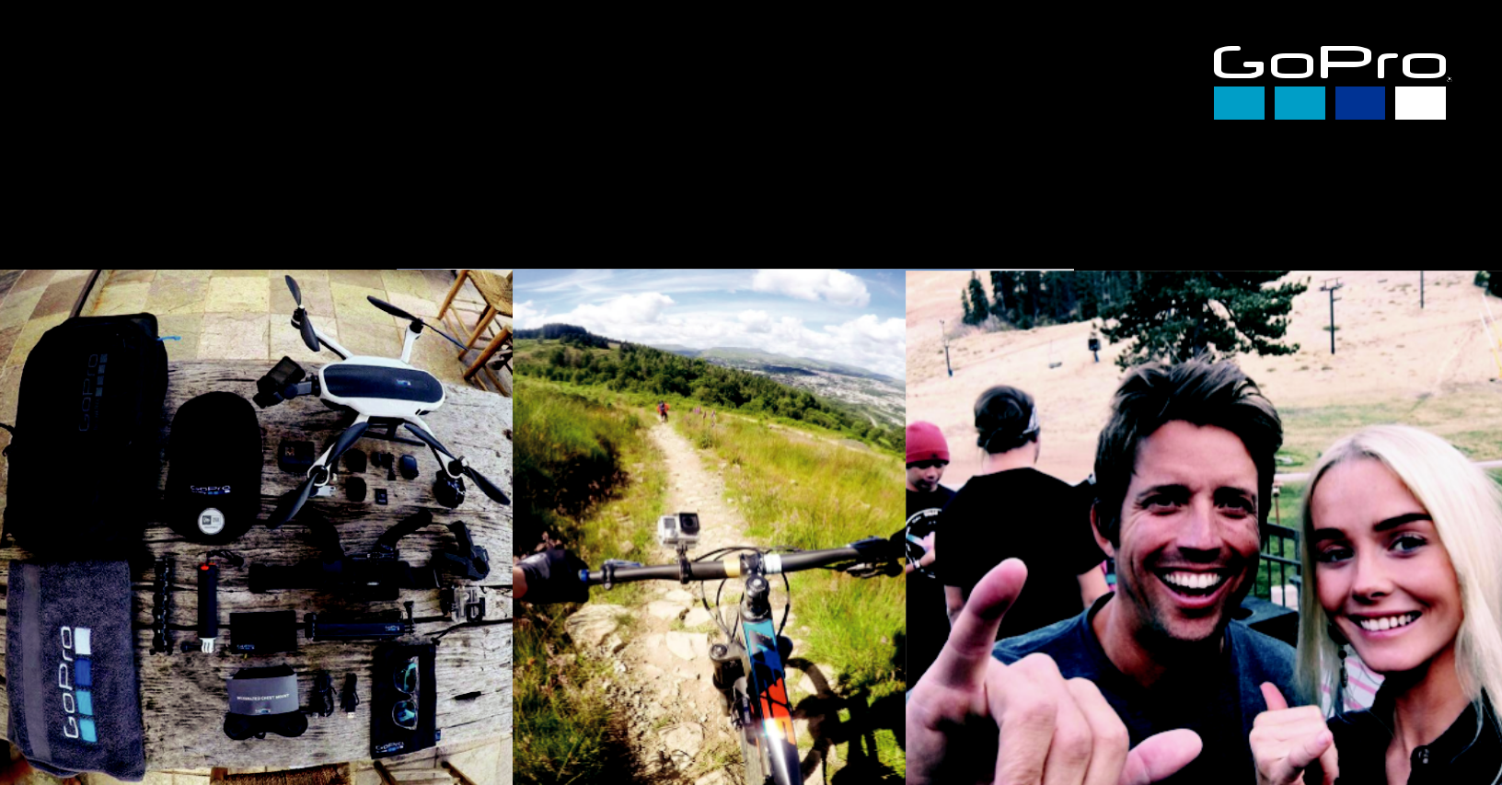
We know capturing what you love with GoPro is part of your everyday life. When sharing your opinion about a product or experience provided by GoPro, it’s important to disclose your relationship with us on social media.

What does that mean? Let your community know that we’ve hooked you up!

Here are times when you would follow these guidelines:

BEING WELCOMED TO THE FAMILY

We are stoked to kit you out as part of your oﬃcial welcome into the family, however want your community to know about any gi s you’ve received

EARLY ACCESS TO PRODUCTS

If we provide you with a new product to trial or own, disclosure within the first post is required


PARTICIPATING IN AN EXPERIENCE

If we provide you with an experience or bring you to an event, please let your community know it was courtesy of and paid for by GoPro

While diﬀerent geographic regions may have their own rules and regulations, as a North American company GoPro asks that all influencers from around the world follow these guidelines.

So how should you disclose your relationship with us?

Tagging @GoPro or including a call out within your

social media bio is not enough to satisfy Federal Trade

Commission (FTC) guidelines for disclosure of product

reviews, gi s and experiences.

ENSURE YOUR POSTS ARE COMPLIANT:

Disclose in context of the claim: Ensure the visuals within the

post are relevant to your reason for disclosure

Stand out from other information: Your community should be

able to easily notice the disclosure

Use clear and unambiguous language: Don’t bury within

blocks of text, hashtag groupings or comments

The following examples serve to aid you in creating proper post disclosures across your social media channels
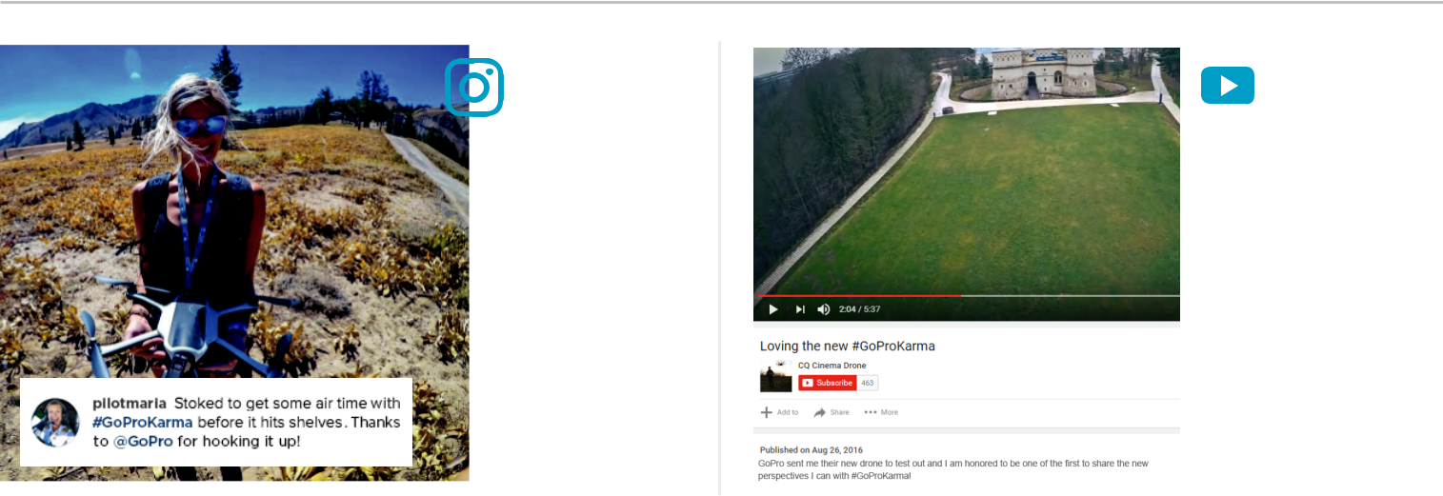

Keep disclosure brief and

be clear that the brand

provided you with product.
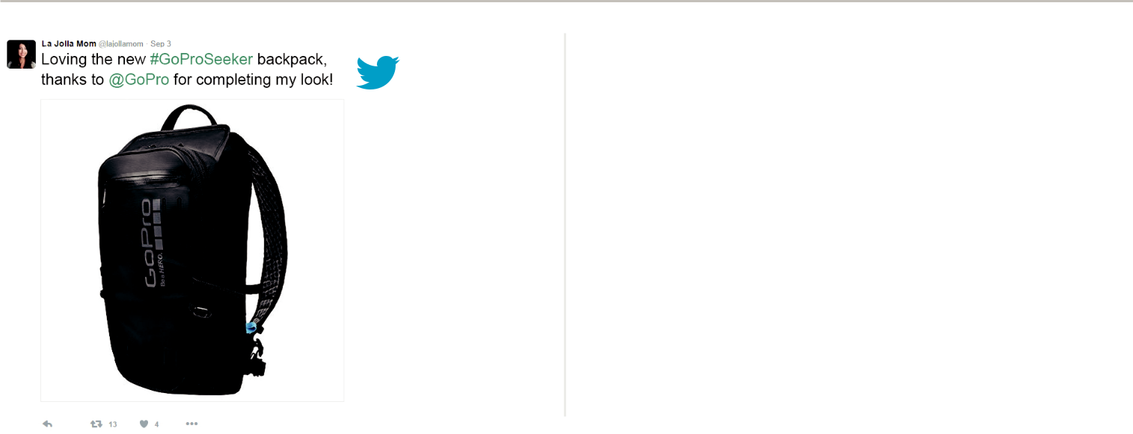

With limited characters,

keep copy short and sweet

and either lead or end with

the disclosure.
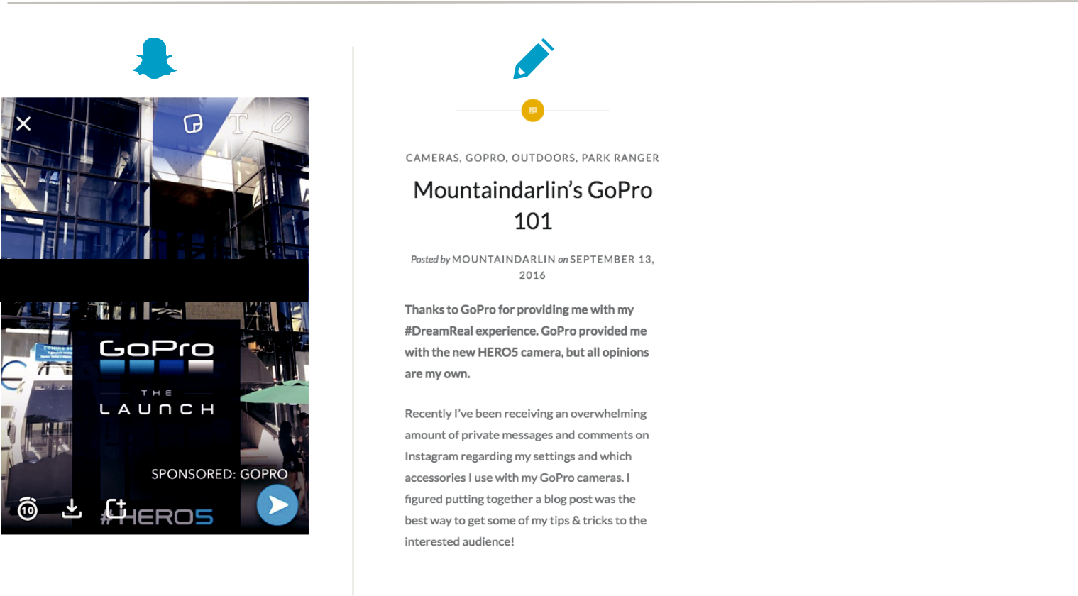

Includes paid promotion



All the above applies –

both in the video and in

the description.

Disclosures should be

presented at the start of

the video and should not

be obscured by other ads,

or add an optional

on-screen graphic that

reads “Includes paid

promotion”.

Content has to be made with the Facebook
branded content tool, which will show in the header where the name of the page is shown. Disclosure should still be mentioned in the copy.

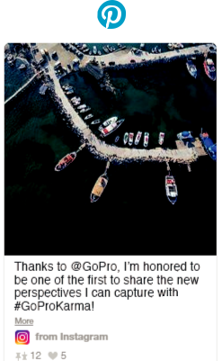

Stoked to be at the @GoPro launch!

Snaps must disclose the brand provided the opportunity.

When writing blog posts, disclosure wording can be longer and more descriptive.

All the above applies, and when running a contest it is important to incorporate a hashtag like #sweepstakes and can be paired with #GoProChallenge.

If you are unsure whether you need to disclose a post or whether you are using appropriate tagging, reach out to your Relationships Manager.

