Unit 7 Prose



A Birthday Letter

Jawaharlal Nehru


Warm up

 Have you ever received a personal letter from your friends or relatives?

 If yes, from whom and about what?

 Have you ever written a personal letter to anyone?

 If yes, to whom and about what?
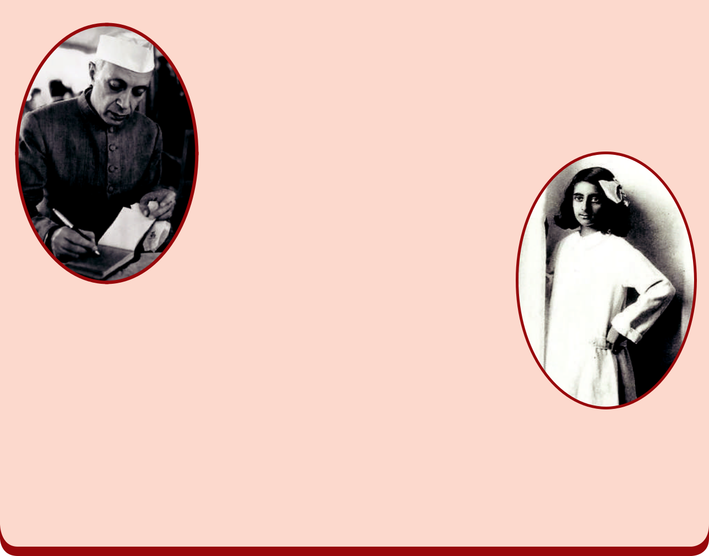

It was the summer of 1928, when Jawaharlal Nehru began writing letters to his young daughter, Indira, who was in Mussoorie at that time. In his letters, he speaks to his daughter on a wide range of topics, including

languages, trade, history, geography, science, epics and evolution. When Indira was about to turn 13 in 1930, Nehru started sending her more detailed letters. These letters

contained his understanding of the world which he wanted to further impart to his daughter. Even while he was in

prison, he wanted to make sure that his child is not devoid of her father's teachings. Over the next four years, Nehru continuously wrote to his daughter from prison and his words are still inspiring.

The letters written by Nehru from the various prisons in British India to his daughter Indira, were published in 1942 as a book called "Glimpses of World History". It is a collection 196 letters on world history.

177 English

Book 1.indb 177

21-01-2020 17:29:19



Now read the letter from Jawaharlal Nehru to his daughter Indira.

Central Prison, Naini
October 26, 1930

My dear Indira,

On your birthday you have been in the habit of receiving presents and good wishes. Good wishes you will still have in full measure, but what present can I send you from Naini Prison? My presents cannot be very material or solid. They can be of the mind and spirit. Things that even the high walls of prison cannot stop.

You know sweetheart, how I dislike sermonising and doling out good advice. I have always thought that the best way to find out what is right and what is not right, what should be done and what should not be done, is not by giving a sermon, but by talking and discussing, and out of discussion sometimes a little bit of truth comes out. I have liked my talks with you and we have discussed many things, but the world is wide and beyond our world lie other wonderful and mysterious worlds. None of us need ever be bored or imagine that we have learned everything worth learning and become very wise.

But what am I to do then? A letter can hardly take the place of a talk; at best it is a one-sided affair. Imagine that I have made a suggestion to you for you to think over, as if we really were having a talk.

In history we read of great periods in the life of nations, of great men and women. Do you remember how fascinated you were when you first read the story of Joan of Arc, and how your ambition was to be something like her? Ordinary men and women are not usually heroic. They think of their bread and butter, of their children, of their household worries and the like. But a time comes when a whole people become interested in a great cause. Then history helps even

 From which prison did Nehru write this letter?

 Did Nehru send any presents to Indira?

English | 178

 Which historical character inspired young Indira?

 What helps the ordinary men and women to become heroes?

Book 1.indb 178

21-01-2020 17:29:20



simple, ordinary men and women to become heroes. Great leaders have something in them which inspires a whole people and makes them do great deeds . In India a great leader, full of love for all who suffer and eager to help them, has inspired our people to great actions and noble sacrifice. He has helped to make the starving, the poor and the oppressed free and happy.

Bapuji is in prison, but the magic of his message has stolen the hearts of India’s millions. Men and women, and even little children, come out of their little shells and become India’s soldiers of freedom. In India today we are making history, and you and I are fortunate to see this happening before our eyes and to take some part ourselves in this great drama.

If we are to be India’s soldiers, we have to respect India’s honour, and that honour is a sacred trust. It is no easy matter to decide what is right and what is not. One little test I shall ask you to apply whenever you are in doubt. Never do anything in secret or anything that you would wish to hide. For the desire to hide anything means that you are afraid, and fear is a bad thing and unworthy of you. Be brave, and all the rest follows.

You know that in our great Freedom Movement, under Bapuji’s leadership, there is no room for secrecy or hiding. We have nothing to hide. We are not afraid of what we do or what we say. We work in the sun and in the light. Even so in our private lives let us make friends with the sun and work in the light and do nothing secretly and if you do so, my dear, you will grow up a child of the light, unafraid and serene and unruffled, whatever may happen.

I have written a very long letter to you. And yet there is so much I would like to tell you. How can a letter contain it? Good-bye, little one, and may you grow up into a brave soldier in India’s service.
With all my love and good wishes.

Your loving father,

 Who is addressed as ‘Bapuji’?

 What should the soldiers of India respect?

179 English

Book 1.indb 179

21-01-2020 17:29:20

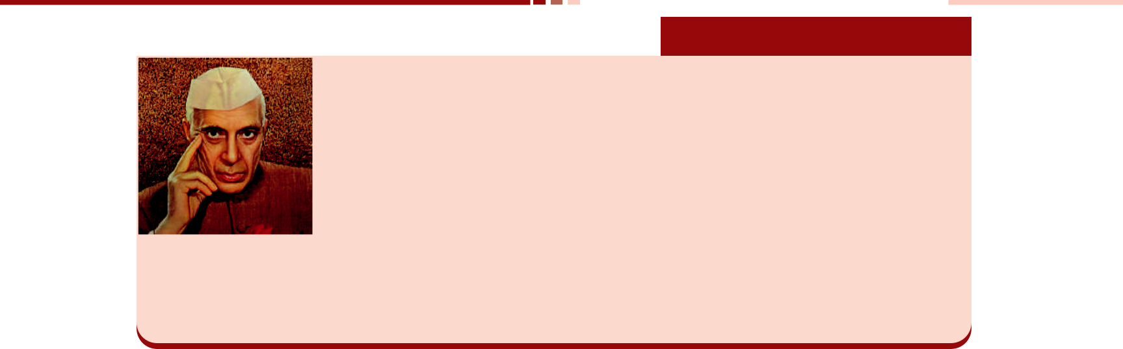

About the Author

Jawaharlal Nehru (14 November 1889 – 27 May 1964) was the first Prime Minister of India and a central figure in Indian politics before and after independence. He emerged as an eminent leader of the Indian independence movement under the tutelage of Mahatma Gandhi and served India as Prime Minister from its establishment as an independent nation in 1947 until his death

in 1964. He is considered to be the architect of the modern Indian nation-state: a sovereign, socialist, secular, and democratic republic. He was also known as ‘Pandit Nehru’ while many Indian children knew him as ‘Uncle Nehru’.


Glossary

sermon (n) - ceremony in which a priest gives a talk on a religious or moral

subject

fascinated (adj.) - extremely attracted

deed (n) - a brave or noble act

starving (adj.) - suffering or dying from hunger

oppressed (adj.) - governed in an unfair and cruel way and prevented from having

opportunities and freedom

sacred (adj.) - considered to be holy and deserving respect

serene (adj.) - peaceful and calm

unruffled (adj.) - not nervous or worried, usually despite a difficult situation

A. Answer the following questions in one or two sentences.


1. Why could not Nehru send any presents to Indira?

2. What cannot be stopped even by the high walls of prisons?

3. Why did Nehru dislike sermonizing?

4. What does history tell us?

5. What do ordinary men and women usually think of?

6. When do ordinary men and women become heroes?

7. What does the phrase ‘great drama’ refer to?

8. Why are the freedom fighters under Gandhi not afraid of anything?

English | 180

Book 1.indb 180

21-01-2020 17:29:20

B. Answer the following in about 80 - 100 words each.

1. Explain the important elements of Nehru’s letter.

2. Imagine yourself as Indira and write a reply letter to your father, Nehru for the letter you received on your birthday.

C. Match the words with correct Synonym and Antonym from the table.


S.No | Word | Synonym | Antonym
`1 | wide | privilege | freedom
2 | noble | valiant | public
3 | oppress | valuable | coward
4 | honour | personal | ignoble
5 | worthy | gentle | dishonour
6 | private | broad | narrow
7 | brave | subdue | unworthy

Think and answer.


What is the difference between an opinion and a fact?

  - An opinion is one’s feelings or thoughts about somebody/something.

  - A fact is a piece of information that can be proved to be true. D. Identify, whether the following statements are of OPINION or FACT
1. On your birthday you have been in the habit of receiving presents and good wishes. (Opinion/Fact)

2. I have liked my talks with you. (Opinion/Fact)

3. The best way to find what is wrong and right is by discussing. (Opinion/Fact)

4. A letter can hardly take the place of a talk. (Opinion/Fact)

5. For the desire to hide anything means that you are afraid. (Opinion/Fact)


*LISTENING

E. *Listen to the dialogue and answer the following questions.

1. | Aadhav and Raghav are _____________.
 | a. | brothers | b. friends |  |  |  |  |  |  | c. colleagues | d. classmates
2. | The brothers are planning to celebrate their ___________ wedding anniversary.
 | a. | uncle’s | b. parents’ |  |  |  |  |  |  | c. grandparents’ | d. sister’s
 |  |  |  |  |  |  |  |  |  | *Listening text is on Page - 213
 |  |  |  |  |  |  |  |  |  | 181 | English

Book 1.indb 181

21-01-2020 17:29:20

3. The wedding anniversary is on _____________.

a. March 2nd b. April 2nd c. May 2nd d. June 2nd

- As part of the celebration, the brothers have planned to make their parents to ____________.

a. visit an orphanage b. donate some money

c. plant a mango sapling d. conduct a game

- State whether the statement is true or false.

The brothers have decided to borrow money for the wedding anniversary celebration.


READING

Anne Frank’s Diary Entry about her birthday.


Sunday, June 14, 1942

Dear Kitty,

I hope I will be able to confide everything to you(the diary), as I have never been able to confide in anyone, and I hope you will be a great source of comfort and support.
I’ll begin from the moment I got you, the moment I saw you lying on the table among my other birthday presents. (I went along when you were bought, but that doesn’t count.)
On Friday, June 12, I was awake at six o’ clock, which isn’t surprising, since it was my birthday. But I’m not allowed to get up at that hour, so I had to control my curiosity until quarter to seven. When I couldn’t wait any longer, I went to the dining room, where Moortje (the cat) welcomed me by rubbing against my legs.

A little after seven I went to Dad and Mom and then to the living room to open my presents, and you were the first thing I saw, maybe one of my nicest presents. Then a bouquet of roses, some peonies and a potted plant. From Dad and Mom, I got a blue blouse, a game, a bottle of grape juice, a puzzle, a jar of cold cream and a gift certificate for two books. I got another book as well, Camera Obscura (but my sister Margot already has it, so I exchanged mine for something else), a platter of homemade cookies (which I made myself, of course, since I’ve become quite an expert at baking cookies), lots of candy and a strawberry tart from Mother.

Then Hanneli my classmate came to pick me up, and we went to school. During recess I passed out cookies to my teachers and my class, and then it was time to get back to work. As it was my birthday, I got to decide which game my classmates would play, and I chose volleyball. Afterward they all danced around me in a circle and sang “Happy Birthday.”

English 182

Book 1.indb 182

21-01-2020 17:29:21

F. Answer the following questions based on the given reading passage.

1. What is the name of her diary?

2. Why did Anne want to exchange the book ‘Camera Obscura’?

3. Who baked the homemade cookies?

4. What game did Anne choose to play?

5. Which gift did Anne value the most?


SPEAKING

G. Imagine you are going to celebrate your forthcoming birthday at an orphanage/old-age home.

Deliver a short speech about your birthday celebration by using the following hints.

- The reasons for choosing an orphanage/old-age home.

- The people who accompany you.

- The food which you are going to offer them.

- The useful gifts/articles which you are going to give them.

→ Other events like cake cutting, conducting games etc.


WRITING

Developing Hints

Developing hints is developing the phrases into full sentences and then into a meaningful coherent paragraph.

Points to remember :

- Read the hints twice or thrice carefully.

- Understand the passage well.

- Jot down the points.

 If the events in the passage are in present tense, write the story in the past tense.

  - Arrange the matter in two or three paragraphs.

  - Give a suitable title.

H. Write a meaningful paragraph using the hints given below.

Mahesh – celebrates – 14th birthday – an old-age home – family, friends – informs home in advance – delegates tasks – friends buy things necessary – arrives home early – decorates place – balloons, colour papers – inmates gathered – cuts cake – sing song, claps – distributes cakes – expresses his feelings – gets blessings – offers things – bedsheets, footwear etc. needed – fun, entertainment – happy and content.

183 English

Book 1.indb 183

21-01-2020 17:29:21



Grammar

Determiners

Observe the nouns in the following sentences and words before them.

- An apple is a healthy fruit.

- Two cats have drunk a bowl of milk.

- My father has many cars.


Determiners are the words that introduce a noun and provide some information about it (but do not describe it).

Determiners are followed by a noun.

 The ball  Five cats

 His son  Some students

Types of Determiners


Articles

Demonstratives

Possessive Adjectives

a, an, the

this, that

these, those

my, our, your,

his, her, its, their

Quantifiers

Cardinal Numbers

Ordinal Numbers

some, any, few, little,

more, much, many, every

one, two, three, twenty,

forty, hundred etc.

first, second, third,

twentieth etc.

→ The quantifiers all, any, enough, less, a lot of, more, most, no, none

of, some etc., are used with both countable and uncountable nouns.

  - The quantifiers both, each, either, fewer, neither etc., are used only with countable nouns.

- Choose the Correct Determiner

1. Could you bring me ________ tools I left in the garden? (this, those, these)

2. ________ Earth revolves around the sun. (the, a, an)

3. I found ________ one rupee coin in the playground while playing. (a, an, the)

4. There aren’t ________ students in the library. (much, many, a lot)

English | 184

Book 1.indb 184

21-01-2020 17:29:21

5. It was ________ unforgettable experience. (a, an, the)

6. I haven’t got ________ pictures in my bedroom. (some, any, many)

7. He said that he wanted to become ________ engineer. (a, an, the)

8. Kokila gave a pen to ______ child in the classroom on her birthday. (any, all, each)

9. I’ve got to solve ________ math problems before I go to sleep. (all, some, any)

10. India is ________ largest democracy in the world. (a, an, the)

11. My father doesn’t drink ________ coffee. (much, many, a lot)

12. I always keep ________ money in my wallet for emergencies. (any, every, some)

13. This year we are celebrating my sister’s ________ birthday. (a, two, second)

14. I have ________ pencils with me. (a, three, third)

15. ‘What is that noise?’ I think it is ________ aeroplane. (a, an, the)

Reported Speech

Look at the following sentences

She said, “I have won the first prize.” (Direct Speech)

She said that she had won the first prize. (Indirect Speech)

 In the first sentence, the reporter conveys the message of the girl using her actual words i.e., (“I have won the first prize.”)

 In the second sentence, the reporter conveys her message but in his own words without any change in the meaning. (She said that she had won the first prize.)

 In direct speech, we reproduce the actual words of the speaker. We place spoken words within inverted commas (“ ”).

 In indirect speech (also called Reported Speech), we report the words of the speaker with a few changes.

Key Terminology

Direct Speech


She said, “I have won the first prize.”

Reporting verb Direct speech

185 English

Book 1.indb 185

21-01-2020 17:29:21

Reporting Statements

We make the following changes when reporting the statements.

- Change the pronouns

- Reporting verb followed by ‘that’

- Change the tense, time and place

(e.g.) Kowsalya said, “We watched a film yesterday.”

Kowsalya said that they watched a film the day before.




pronoun tense time

Reporting Imperatives

To report an imperative, use the pattern –

request/order/suggest + someone + to infinitive

(e.g.) Karthi said to Ram, “Please, switch on the fan.”

Karthi requested Ram to switch on the fan.

Reporting Questions

When reporting questions, we use the pattern:

asked/ wanted to know + question word + pronoun + verb

(e.g.) She said to me, “Where did you go?”

She asked me where I went.

Note: If the 'wh' question is missing, if or whether is added.

(e.g.) Praveena asked, “Have you watered the plants?” Praveena asked if/whether I had watered the plants.


Sometimes it is not necessary to report everything that is said word by word. It may be better to use ‘reporting verbs’ which summarise what was communicated.

English 186

Book 1.indb 186

21-01-2020 17:29:21

Below are some of the most commonly used verbs of this kind.


accept | advise | apologise | ask | assure | blame
complain | complement | congratulate | explain | greet | hope
invite | offer | order | persuade | promise | remind
regret | say | suggest | tell | thank | answer
warn | encourage | regret | sympathize | refuse | instruct

Remember these rules of change


Pronouns

Direct Speech |  | Indirect Speech
Direct Speech | Masculine | Feminine | Plural
I | he | she | -
You (Subject) | he | she | they
you (Object) | him | her | them
your | his | her | their
my | his | her | their
myself | himself | herself | themselves
we | - | - | they
us | - | - | them


Denoting Time and Position

Direct Speech | Indirect Speech
this | that
these | those
now | then
ago | before
last night | the previous night
next day | the following day

Denoting Time and Position

Direct Speech | Indirect Speech
today | that day
yesterday | the previous day
tomorrow | the next day
next week | the following week
last week | the previous week
here | there

187 English

Book 1.indb 187

21-01-2020 17:29:21

B. Observe the following call-outs. Reporter (C) has reported the sentences of Speaker (A).

Now, help Reporter (C) report the rest of the sentences of Speaker (A).

A (Speaker) | B (Questioner)
I have to go. | What did he say?
Can you hear me? | What did she say?
Consult the doctor. | What did he say?
I won’t go to the party. | What did he say?
When did you come? | What did she say?
Don’t touch the wire. | What did she say?
 | What did he say?
 | What did he say?
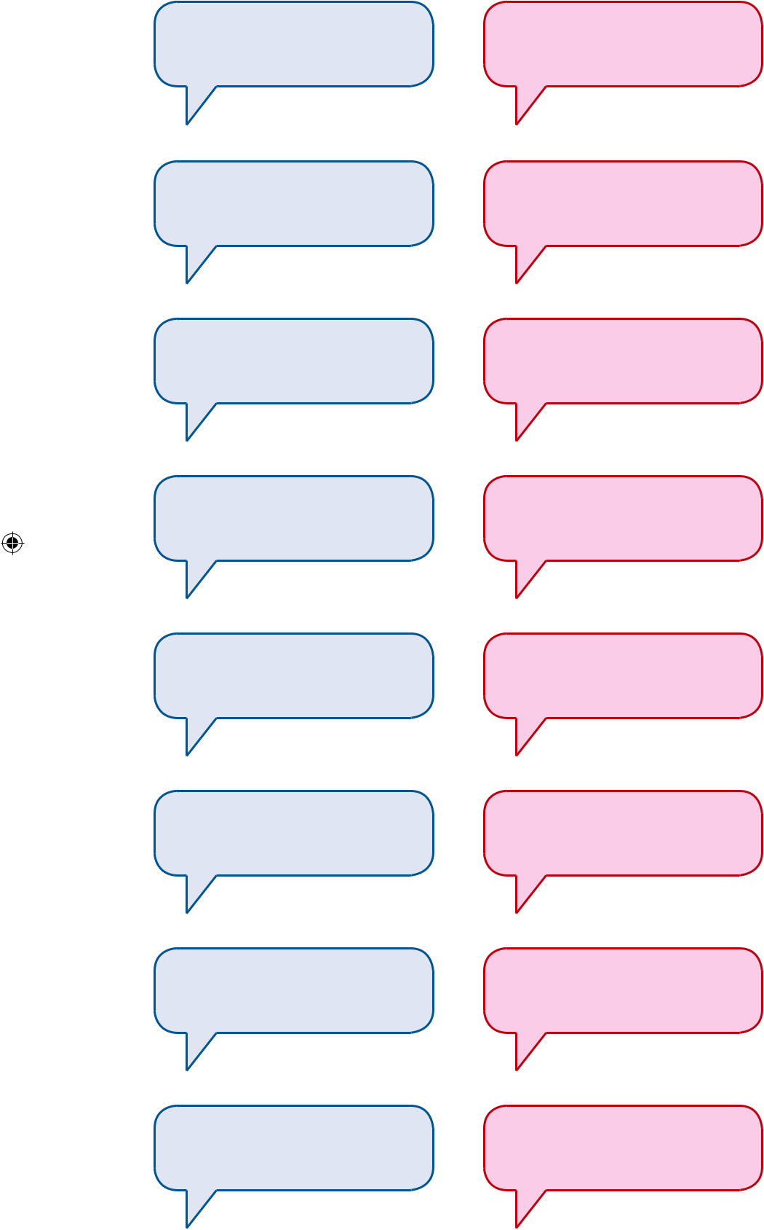

C (Reporter)


He said that he
wanted to go.

(say)

She asked if you could

hear her.

(ask)

He advised you to
consult the doctor.

(advise)

(say)

(ask)

(warn)

English 188

Book 1.indb 188

21-01-2020 17:29:21

C. Report the following sentences.

- Pushpa said, “Do not spoil the eco-system.”

- Ebin said, “Have you booked the tickets to Delhi?”

- Rehman said to Tilak, “When are we leaving to our native?”

- Maha said, “Lakshan, you should get up early in the morning.”

- Gladin said to his mother, “Can you, please, buy me a hot-chocolate?”

- “Tomorrow I have to take a test in English”, said Sudha.

- Amali said to her sister, “I need your help to arrange the books in the shelf.”

- “Why don’t you use crayons for colouring?” said Prabhu to his son.


Project

D. Write a Diary entry each day for a month and compile them into a book. You may also name your diary as Anne Frank did.


Diary writing is one of the most personal and informal categories of writing. A diary writing can be based on an experience, a scene, a description or narration of certain event or any other thing or activity that the writer considers worth writing in his/her personal diary.

The style and tone is generally informal and personal. However, it depends on the subject. You can freely express your viewpoints and feelings. As the diary is writer’s personal document, the diary entry doesn’t need any signature.

The more frequently you write entries in your diary, the more you will enjoy doing it and the more you will learn from them.

189 English

Book 1.indb 189

21-01-2020 17:29:21

Unit 7 Poem


The Stick-together Families

Edgar Albert Guest

Warm up

At the heart of life lie the relationships you have with other people: with family, classmates and friends close-by and far away. All relationships are based on some commonly accepted values like respect, honesty, consideration and commitment. Think about all the important relationships in your life and complete the table given below.
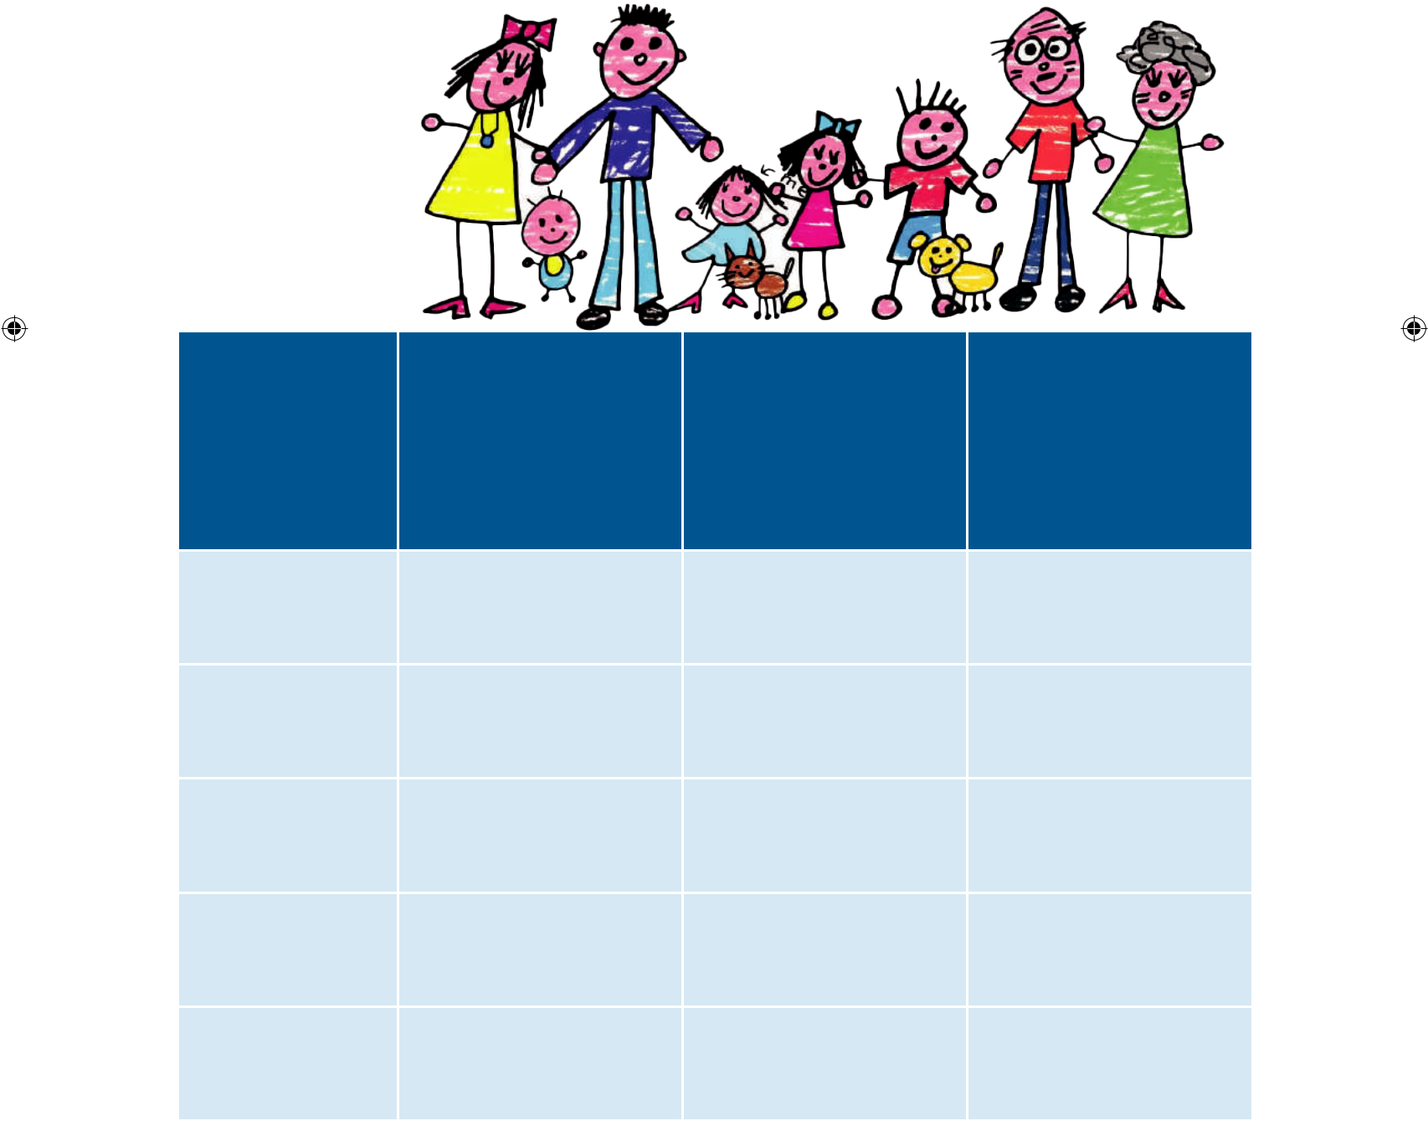

 |  |  |  |  |  |  |  | What are the
 | What I value the |  |  |  |  |  |  | things that | What could I do
Relationship | most about this |  |  |  |  |  |  | may/do cause | to improve this
 | relationship |  |  |  |  |  |  | unpleasantness in | relationship?
 |  |  |  |  |  |  |  | this relationship?
Grandparents
Parents
Siblings
Friends
Teachers
English | 190

Book 1.indb 190

21-01-2020 17:29:22



The stick-together families are happier by far

Than the brothers and the sisters who take separate highways are.

The gladdest people living are the wholesome folks who make

A circle at the fireside that no power but death can break.

And the finest of conventions ever held beneath the sun

Are the little family gatherings whenthe busy dayis done.

There are rich folk, there are poor folk, whoimagine theyarewise,

And they're very quicktoshatter all the little family ties.

Each goes searchingafter pleasureinhis own selected way,

Each with strangers likes to wander,and with strangerslikes to play.

But it's bitternesstheyharvest, and it'sempty joy they find,

For the children thatarewisest are the stick-togetherkind.

There are somewho seemtofancy that for gladness they mustroam,

That for smilesthat are the brightest theymust wander far fromhome.

That the strange friend is the true friend, and they travelfar astray

They waste their livesin striving for a joy that'sfaraway,

But the gladdest sort of people, when the busy day is done, Are the brothers and the sisters who together sharetheir fun.

It's the stick-together family that wins the joys of earth,

That hears the sweetest music and that finds the finest mirth;

It's the old home roof that shelters all the charm that life can give;

There you find the gladdest play-ground, there the happiest spot to live.

And, O weary, wandering brother, if contentment you would win,

Come you back unto the fireside and be comrade with your kin.

Book 1.indb 191

191 English

21-01-2020 17:29:23



Glossary

conventions (n) | - a large formal meeting of people who have a similar interest
shatter (v) | - to break suddenly into very small pieces
astray (adv.) | - away from the correct path or correct way of doing something
mirth (n) | - | laughter, humour or happiness
comrade (n) | - | a friend

- Based on your understanding of the poem, answer the questions in a sentence or two.
  - The gladdest people living are the wholesome folks who make A circle at the fireside that no power but death can break.
    - Who are the gladdest people living ?

    - Where do they gather?

    - What can break their unity?

  - And the finest of conventions ever held beneath the sun Are the little family gatherings when the busy day is done.

a. When do they have their family gatherings?

b. Where do they have their family conventions?

c. What does the poet mean by ‘finest conventions'?

- There are rich folk, there are poor folk, who imagine they are wise, And they're very quick to shatter all the little family ties.
  - What do the rich and poor folk imagine themselves to be?

  - What do they do to their families?

c . Whom does 'they' refer to?

- There are some who seem to fancy that for gladness they must roam, That for smiles that are the brightest they must wander far from home
  - Why do they roam?

  - According to them, when do they get bright smiles?

- But the gladdest sort of people, when the busy day is done, Are the brothers and the sisters who together share their fun.
  - Who are the gladdest people?

  - When do they share their fun?

  - What does 'who' refer to?

English 192

Book 1.indb 192

21-01-2020 17:29:23

  - It's the stick-together family that wins the joys of earth,

That hears the sweetest music and that finds the finest mirth;

    - Who wins the joys of the earth?

    - How do they find their joy?

    - What does the poet mean by 'stick-together family'?

- Based on the understanding of the poem, fill in the blanks using the words and phrases given below to make a meaningful summary of the poem.

brothers and | bitterness | joint family | share their fun | rich and the
sisters | bitterness | joint family | share their fun | poor folk
shatter their | charm of life | separate ways | the joy of earth | stick-together
family | charm of life | separate ways | the joy of earth | families

The poet brings out the difference in the attitudes of children living in joint family and nuclear family. The ________________ are the happiest of all. Where as the

_________________ of nuclear families take ______________. The gladdest people are

the children from _______________ who circle near the fireside. No power other than

death can break them. The _______________ imagine themselves to be wise and in the

process they ______________ ties. Each of them goes searching for pleasure in their

own selected way. They harvest only ____________ and find empty joy. But the wisest

among them are the children of the stick-together families. When the busy day is done, they together ______________. The stick-together family wins _______________. The

old house shelters all the ______________. The poet invites wandering brothers to

come and join the stick-together families in their fireside and have fun.

- Answer the following questions in about 80 - 100 words.

  - The stick-together families are the happiest of all. Explain.

  - Bring out the difference between the children of the joint family and nuclear family.

Figure of speech


Personification

Personification is a figure of speech in which an inanimate object or abstraction is given human qualities or abilities.
E.g. It's the stick-together family that wins the joys of earth,...

Imagery

Imagery means to use figurative language to represent objects, actions, and ideas in such a way that it appeals to our physical senses.
E.g. That hears the sweetest music...

193 English

Book 1.indb 193

21-01-2020 17:29:23



Metaphor

Metaphor is a figure of speech that makes an implicit, implied, or hidden comparison between two things that are unrelated, but which share some common characteristics

E.g. It's the old home roof that shelters....

There you find the gladdest play-ground...

- Answer the following

  - There are rich folk, there are poor folk, who imagine they are wise,...

Pick out the words in alliteration.

  - Mention the rhyme scheme of the poem.



*LISTENING

- Listen to the passage and fill in the blanks with appropriate answer.

  - A person is valued based on his _______________.

  - _______________ does not happen overnight.

3. A close family bond is like a _______________.

- A strong foundation for any individual comes from being with a __________.

- A gift not only with _______________, but _______________ who care and love us beyond themselves.



SPEAKING

- “The building actually rests on the well laid out foundation and hence is strong and still.” How can this be related to a family? Discuss with your partner and share your views in the class.


WRITING

- Write a four-line poem with rhyming words describing your family.

*Listening text is on Page - 214

English 194

Book 1.indb 194

21-01-2020 17:29:23

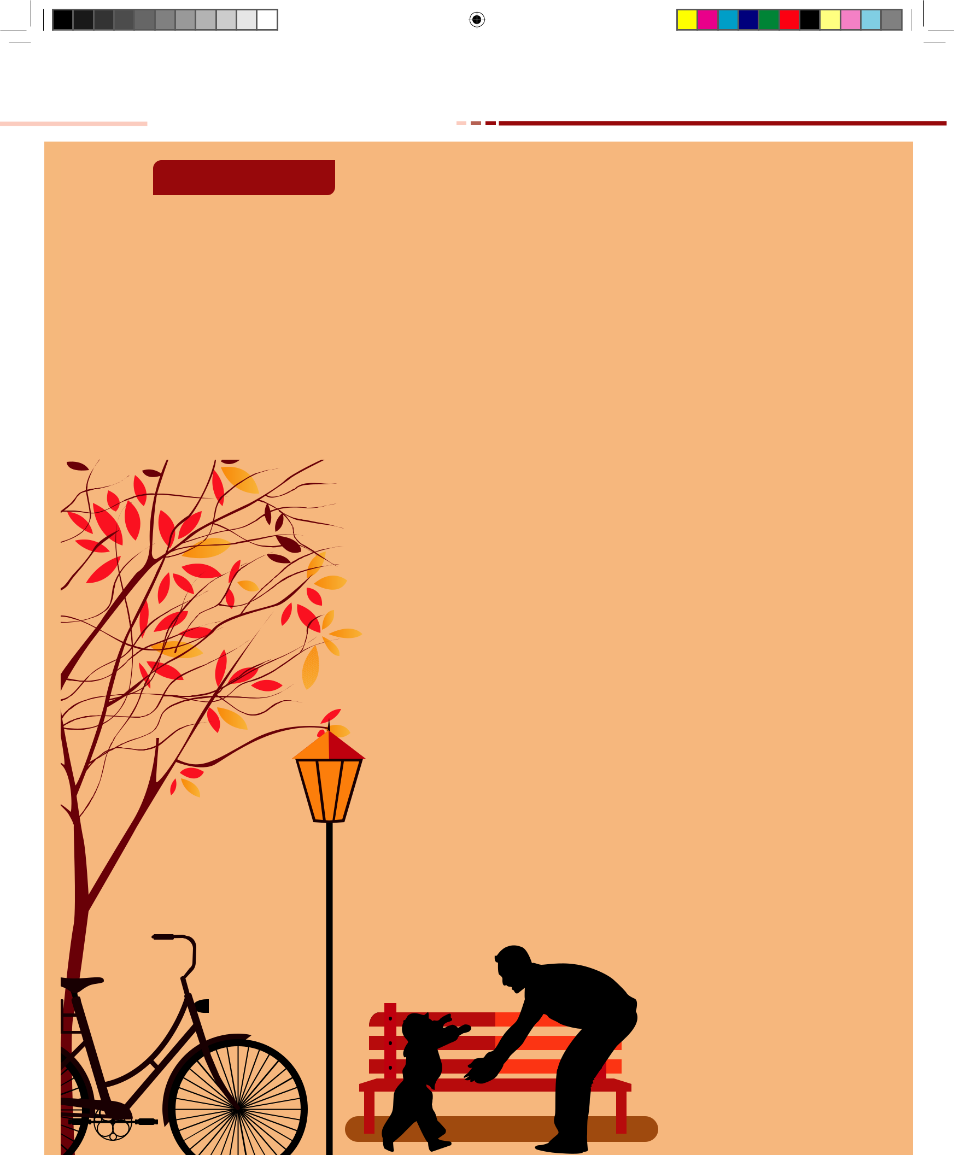

Read and Enjoy

Memories of My Dad

Rebecca D.Cook.

He wasn’t a hero

Known by the world,

But a hero he was

To his little girl.

My daddy was God,

Who knew all things.

And better than Santa,

With the gifts he’d bring.

I knew his voice

Before I could speak.

And loves it when

He would sing me to sleep.

He taught me life’s lessons

Or right from wrong

And instilled in me values

That I might be strong.

And so, dear Dad

My best memory to recall

Is the gift of your presence,

The greatest gift of all.

Book 1.indb 195

195 English

21-01-2020 17:29:23


Unit7Supplementary
The Christmas Truce

Aaron Shepard

Warm Up

⬇ Name one festival which you like the most.

⬇ How do you celebrate that festival?

⬇ Narrate a memorable incident which happened

during that celebration.

This piece, set during World War I, highlights the beauty of unlikely friendships and fellowship. It is a British soldier’s letter to his sister on how all enmity was forgotten as British and German soldiers celebrated Christmas together.

Christmas Day, 1914

My dear sister Janet,

It is 2:00 in the morning and most of our men are asleep in their dugouts – yet I could not sleep before writing to you about what happened here on Christmas Eve. In truth, what happened seems almost like a fairy tale, and if I had not been through it myself, I would scarce believe it. While you and the family sang carols before the fire there in London, I did the same with enemy soldiers here on the battlefields of France!

As I wrote before, there has been little serious fighting of late. The first battles of the war left so many dead that both sides have held back until replacements could come from home. So, we have mostly stayed in our trenches and waited.

But what a terrible waiting it has been! Knowing that any moment an artillery shell might land and explode beside us in the trench, killing or maiming several men. And in daylight not daring to lift our heads above ground, for fear of a sniper’s bullet.

And the rain – it has fallen almost daily. Of course, it collects right in our trenches, where we must bail it out with pots and pans. And with the rain has come mud – a good foot or deeper. It splatters and cakes everything, and constantly sucks at our boots. One new recruit got his feet stuck in it, and then his hands too when he tried to get out.

English 196

Book 1.indb 196

21-01-2020 17:29:24


Through all this, we could not help feeling curious about the German soldiers across the way. After all, they faced the same dangers we did and slogged about in the same muck. What’s more, their first trench was only fifty yards from ours. Between us lay No Man’s Land, bordered on both sides by barbed wire - yet they were close enough we sometimes heard their voices.

Of course, we hated them when they killed our friends. But other times, we joked about them and almost felt we had something in common. And now it seems they felt the same.

Just yesterday morning - Christmas Eve Day - we had our first good freeze. Cold as we were, we welcomed it, because at least the mud froze solid. Everything was tinged white with frost while a bright sun shone over everything. Perfect Christmas weather!

During the day, there was little shelling or rifle fire from either side. And as darkness fell on our Christmas Eve, the shooting stopped entirely. Our first complete silence in months! We hoped it might promise a peaceful holiday, but didn’t count on it. We’d been told the Germans might attack and try to catch us off guard.

I went to the dugout to rest, and lying on my cot, I must have drifted asleep. All at once my friend John was shaking me awake, saying, “Come and see! See what the Germans are doing!” I grabbed my rifle, stumbled out into the trench, and stuck my head cautiously above the sandbags.

I never hope to see a stranger and more lovely sight. Clusters of tiny lights were shining all along the German line, left and right as far as the eye could see.

“What is it?” I asked in bewilderment, and John answered, “Christmas trees!”

And so it was. The Germans had placed Christmas trees in front of their trenches, lit by candle or lantern, like beacons of goodwill.

And then we heard them singing.

Stille nacht, heilige nacht…

This carol may not yet be familiar to us in Britain, but John knew it and translated: “Silent Night, Holy Night.” I’ve never heard one lovelier – or more meaningful, in that quiet, clear night, its darkness softened by a first – quarter moon.

When the song finished, the men in our trenches applauded. Yes, British soldiers applauded Germans! Then one of our own men started singing, and we all joined in.

The first Nowell, the angel did say …

In truth, we sounded not nearly as good as the Germans, with their fine harmonies. But they responded with enthusiastic applause of their own and then began another.

197 English

Book 1.indb 197

21-01-2020 17:29:25


O Tannenbaum, o Tannenbaum…

Then we replied.

O come all ye faithful…

But this time they joined in, singing the words in Latin.

Adeste fideles…

Britain and Germany harmonizing across No Man’s Land! I would have thought nothing could be more amazing – but what came next was even more so.

“English, come over!” we heard one of them shout. “You no shoot, we no shoot.”

There in the trenches, we looked at each other in bewilderment. Then one of us shouted jokingly, “You come over here.”

To our astonishment, we saw two figures rise from a trench, climb over their barbed wire, and advance unprotected across No Man’s Land. One of them called, “Send officer to talk.”

I saw one of our men lift his rifle to the ready, and no doubt others did the same - but our captain called out, “Hold your fire.” Then he climbed out and went to meet the Germans halfway.

We heard them talking, and a few minutes later, the captain came back and announced, “We’ve agreed that there will be no shooting before midnight tomorrow. But sentries are to remain on duty, and the rest of you, stay alert.”

Across the way, we could make out groups of two or three men starting out of trenches and coming towards us. Then some of us climbed out too, and in minutes, there we were in No Man’s Land – over a hundred soldiers and officers of each side, shaking hands with men we’d been trying to kill just hours earlier!

Before long, a bonfire was built and around it we mingled – British khaki and German grey.

I must say, the Germans were the better dressed, with fresh uniforms for the holiday.

Only a couple of our men knew German, but more of the Germans knew English. I asked one of them why that was so.

“Because many have worked in England!” he said. “Before all this, I was a waiter at the Hotel Cecil. Perhaps I waited on your table!”

“Perhaps you did!” I said, laughing.

Another German had been a porter at Victoria Station. He showed me a picture of his family back in Munich. It was so lovely, I told him I would like to meet his family members someday. He happily gave me his family’s address.

English 198

Book 1.indb 198

21-01-2020 17:29:26


Even those who could not converse could still exchange gifts – our tea for their coffee, our corned meat for their sausage. Badges and buttons from uniforms changed owners, and one of our boys walked off with a spiked helmet! I myself traded a jack knife for a leather equipment belt – a fine souvenir to show when I get home.

As it grew late, a few more songs were traded around the fire, and then all joined in for – I am not lying to you – “Auld Lang Syne.” Then we parted with promises to meet again tomorrow, and there was even some talk of a football match.

I was just starting back to the trenches when an older German soldier clutched my arm. “My God,” he said, “why cannot we have peace and all go home?”

I told him gently, “That you must ask your emperor.”

He looked at me searchingly and said, “Perhaps, my friend. But we must also ask our hearts.” And so, dear sister, tell me, has there ever been such a Christmas Eve in all history? What does it all mean, this impossible befriending of enemies?

For the fighting here, of course, it means regrettably little. Decent fellows those soldiers may be, but they follow orders and we do the same. Besides, we are here to stop their army and send it home, and never could we shirk that duty.

Still, one cannot help but imagine what would happen if the spirit shown here were caught by the nations of the world. Disputes may arise but what if our leaders were to offer good wishes in place of warnings; songs in place of insults; gifts in place of reprisals? Would not all wars end at once?

All nations say they want peace. Yet on this Christmas morning, I wonder if we want it quite enough.

Your loving brother,

Tom

About the Author

Aaron Shepard (October 7, 1950) is the award-winning author of Savitri: A Tale of Ancient India, The Legend of Lightning Larry, The Sea King’s Daughter, and many more children’s books. Aaron’s specialty is retelling folktales and other traditional literature from around the world. His work has been honoured by the American Library Association, the National Council for the Social Studies, the American Folklore Society, the New York Public Library, and the Bank Street College of Education.

199 English

Book 1.indb 199

21-01-2020 17:29:27



Glossary

truce (n) |  | - an agreement to stop fighting or arguing for a period of time
dugout (n) |  | - a trench that is dug and roofed over as a shelter for troops
carols (n) |  | - a religious folk song or popular hymn, particularly one associated
 |  | with Christmas.
trenches | (n) | - a long, narrow ditch
maim (v) |  | - injure or wound seriously and leave permanent damage to body
 |  | or parts
splatter | (n) | - a small quantity of something moist or liquid
slog (v) |  | - work hard over a period of time
muck (n) |  | - dirt, rubbish, or waste matter.
stumble (v) |  | - trip or momentarily lose one's balance; almost fall
bewilderment (n) |  | - a feeling of being perplexed and confused.


 “Aung Lang Syne” is a Scots poem written by Robert Burns in 1788 and set to the tune of a traditional folk song. In many English-speaking nations, it is traditionally sung during the New Year’s Eve. The song’s title may be loosely translated

as “for the old times” or “long long ago”.

- Choose the correct answer.


1. | The story is set during the _____________.
 | a. World War I | b. World War II
 | c. Kargil War | d. Indo-China War
2. | The story is about the celebration of _____________ festival.
 | a. Deepavali | b. Pongal |  |  |  |  |  |  |  | c. Ramzan | d. Christmas
3. | Tom called the incidents happened there as a ____________.
 | a. fairy tale | b. poetry |  |  |  |  |  |  |  | c. tragedy | d. comedy
4. | The Germans had placed Christmas trees in front of their__________.
 | a. houses | b. trench |  |  |  |  |  |  |  | c. tanks | d. cars
5. | One of the German soldiers worked as a _________ at Victoria Station.
 | a. tea-seller | b. ticket-checker |  |  |  |  |  |  |  | c. porter | d. shop keeper
English |  | 200

Book 1.indb 200

21-01-2020 17:29:27

- Identify the character, speaker or both of the following lines.

1. Our first complete silence in months!

2. Come and see! See what the Germans are doing!

3. Hold your fire.

4. You no shoot, we no shoot.

5. My God, why cannot we have peace and all go home?

- Answer the following questions in about 100 – 120 words.

1. Narrate the Christmas celebration as happened in the war field.

- Think and answer.

1. Do you envision a similar truce taking place in any wars or fighting today? Explain.

2. Today, much of what we know about the truce comes from soldiers’ postcards home. In the postcard given below, write a short message home, imagine that you took part in the 1914 Christmas Truce.


Book 1.indb 201

201 English

21-01-2020 17:29:28



ICT CORNER

Reported Speech

This webpage from British Council helps the students to learn reported speech with examples. Students can also try the online worksheets to improve their learning.

Steps

- Type the URL link given below in the browser or scan the QR code.

- Read the instructions which are given above the video, then watch the video to know about the content.

- Read the explanation and examples for different types of reported speech.

- Click the “Check Your Grammar” tab to practice “Matching, Error Correction and Gap Fill” exercises on your own and check your answers online.

- You can also download and use the resources offline which is given under “Worksheets and Downloads” tab.

Download Link

Type the following link in your browser or click or scan the QR code to download the application and install it.

http://learnenglishteens.britishcouncil.org/grammar/intermediate-grammar/reported-speech

English 202

Book 1.indb 202

21-01-2020 17:29:28

LISTENING PASSAGES

LEARNING THE GAME

H. Listen to the following story

The Olympic Games began in Greece about three thousand years ago. All wars stopped for the Olympics in those days. The discus and the Pentathlon began in these early Olympic Games. In 394 the Romans stopped the Greek Olympic Games, because they didn’t like them. In 1896, a Frenchman – Pierre de Coubertin began the Olympic Games again. These days the Olympic Games usually happen every

four years. But how did the Paralympics for disabled begin? In the 1940s Sir Ludwig Guttmann was a doctor at the stoke Mandeville hospital in England. At the hospital there were many disabled soldiers from World War II and Guttmann wanted these soldiers to get better by doing sports.

The Paralympics are younger than the Olympics, but they are getting bigger all the time. The first true paralympic Games happened in Rome in 1960. Four hundred disabled athletes from twenty-three different countries came to these Games. At the Bejing Paralympics in 2008, there were 4,000 disabled athletes from 144 countries! These days there are Paralympic Games every four years, and because it’s easier for Paralympic athletes to stay in Olympic hotels and to run in Olympic stadiums, the Paralympics usually happen in the Olympic cities, too. Think of swimming with only one leg against people with two legs. Think of running with artificial legs. Think of playing basketball in a wheelchair. Disabled people can do some wonderful things!

[Source : True Heroes of Sport by Donatella Fitzgerald]

THE SPIRIT OF ADVENTURE

D. Leena has a great fascination for adventure. During her winter holidays she wishes to explore an adventure sport. Listen to the conversation between Leena and her mother and complete the dictionary activity.


Mother :

Leena, what are your plans for the winter vacation? I thought we could go to a heritage site in India.

203 English

Book 1.indb 203

21-01-2020 17:29:28

Leena :

No Mom. This time, I wish to take up an adventure sport which I have been planning for long. But I am not sure whether we have good options for adventure sports in India.

Mother :

Why not! India is a versatile and multifaceted country and every part of it offers some new adventure to see, some new place to visit. Ranging from the wonderful treks on the powerful and the bold mountain ranges of Himalayas, sky diving adventures in the west, hill stations of the south, proclaiming beauty of the Karst caves to the desert trips in Thar, all the varieties are found in one nation.

Leena :

That’s great to know that with the brooding modern nation, you can savour all the adventures either in the midst of towns or surrounded with the nature’s bounty.

Mother :

But we must carefully choose the organization that offer such programmes. We should go for ones that are registered with Adventure Tour Operators Association of India and Ministry of Tourism.

Leena :

Ok, Mom. Let us see if any of those places have bungee jumping. I have been dreaming of doing this dare-devil jump for the past two years.

Mother :

If you are really ready for bungee-jumping, I suggest we go to Rishikesh. Apart from leaping off a cliff, you can do white-water rafting too. What do you say? Let's talk to your father and ask him to do some enquiries.

Leena :

Yaayyy!!! I am so excited. I can’t wait for Dad to come back from office.

A POISON TREE

F. Listening input for Anger Management


It’s natural to get angry. But it’s a virtue to know how to handle it. It deals with certain anger management issues . Here are some of the best anger management tips to help you get over being angry quickly.

Meditation is definitely a great technique to calm your inner self, thereby

controlling those sudden angry outbursts. Meditation does not always require that you sit in a place and keep peeping at the watch. You need a peaceful place to sit upright.

English 204

Book 1.indb 204

21-01-2020 17:29:28

Start relaxing with the top of your head and then slowly release the tension of your body, one muscle at a time and breathe deeply.

Try to connect yourself with your inner person. There is a person living inside you who always tells you how to act. After a strong situation, it is you that inner person who understands you better than anyone else. So initiate a positive conversation within yourself. Close your eyes and speak to yourself and calm yourself.

Anger is something that releases the tension you have been feeling all the while but who will take care of the reason why you got angry in the first place? It is as simple as a solution that you need. Forgive and forget . It’s easier to get the apologies over and done with right away so you can forget about your anger and move on.

Start good one by saying , “I’m sorry” or “I forgive you”. Forgiving is a blessing. Spread the goodness. Instead of allowing others to laugh at you, laugh at yourself. Think of all the words you said and think of how you could have changed the situation by acting in a different way.

OLD MAN RIVER

F. Listening input for fill in the blanks


The 2015 South Indian floods resulted from heavy rainfall generat-ed by the annual north east monsoon in November-December 2015. They affected the Coromandel Coast region of the South Indian states of Tamil Nadu and Andhra Pradesh, and the union territory of

Puducherry, with Tamil Nadu and the city of Chennai particularly hard- hit. More than 500 people were killed and over 18 lakh people were displaced. With estimates of damages and losses ranging from nearly 200 billion rupees to over 1 trillion rupees, the floods were the costliest to have occurred in 2015, and were among the costliest natural disasters of the year. The flooding has been attributed to the2014-16 El-Nino event.

ON KILLING A TREE

G. *Listen to the speech and complete the exercises that follow.

Nammazhwar was born in 1938 in Elangadu, Thanjavur District, and he graduated from Annamalai University with a B.Sc. in Agriculture. In 1963, he began working for the Agricultural Regional Research Station, a government organisation in Kovilpatti, as a scientist, conducting trials on spacing and use of various chemical fertilizers in cotton and millet crops. During his tenure there, the government had conducted various experiments

205 English

Book 1.indb 205

21-01-2020 17:29:28

in rain-fed land, using expensive inputs like hybrid seeds, chemical fertilizers and chemical pesticides which Nammazhwar considered futile as the farmers were resource poor. Based on his experience, he felt very strongly that it was imperative to totally reorient the research work being undertaken. But his peers at the institute paid little attention to his advice. Frustrated, he left the institute in 1969.

For the next 10 years, he was an agronomist for Island of Peace, an organisation founded by the Nobel Laureate Dominique Pire. His focus was on improving the standard of living through agricultural development in the Kalakad block of Tirunelveli District, Tamil Nadu. It was at this time that he realised that to get optimal results in farming, farmers should rely only minimally on external inputs. All inputs should come from within

the farm. So called waste should be recycled and used as input. This revelation was a turning point in his life. He completely lost trust in conventional farming practices and began experimenting with sustainable agricultural methods.

Vegetables have a short lifespan compared to fruit crops. By making use of modern technologies and inputs, their lifespan can perhaps be extended to say about a year. But if there is a simple method of growing vegetables throughout the year, without any costly gadgets, modern technologies, or costly inputs, it is definitely worth a try for the farmers.

He advocated the ‘Bread sandwich’ method. In this method once the soil is made ready and the suggested practices followed, one need not work on the soil for the second time. They can go on sowing and reaping, all through the year.

He always said it was no use trying to teach a farmer. Instead, one should make the farmer understand the issue. He never stopped learning from them
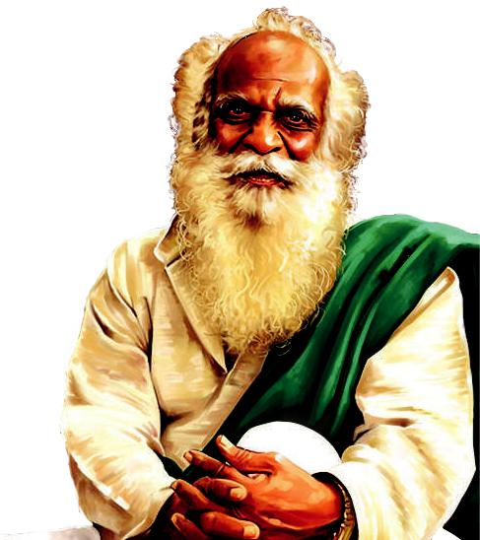
himself and had become a vast repository of farming practices and knowledge that he shared with whoever was interested. He never pushed ideas down anyone’s throat. Each farm is unique according to the farmers’ understanding and the conditions, Nammazhwar would say. He would keep experimenting with what he learned from the farmers, refined this knowledge and then gave it back to them.

He often said “Farming is not a way of producing crops to make money. It is a way of living, and a way of living that is possible even in the 21st century.” He trained hundreds of farm youths as trainers and helped many farmers to be master trainers—all this without the support of the government.

English 206

Book 1.indb 206

21-01-2020 17:29:29

SEVENTEEN ORANGES

F. *Listen to the play and answer the questions that follow.


Krishna Deva Raya’s greedy minister, Chatur Pandit, arrives at the court with a red peacock.

Krishna Deva Raya: I have never seen such a creature!

Courtiers: We agree.

Chatur Pandit: Please accept this gift, Your Majesty! My servants searched the jungles to find this creature.

Tenali Raman (thinks): How can a bird so bright survive in the jungle? It will be easily spotted by other animals.

Krishna Deva Raya: Thank you, Chatur Pandit! How can we reward you?

Chatur Pandit: Your Majesty, 1000 gold coins will be enough, as I spent that to get the bird.

Tenali Raman: Your Majesty, I think we should observe this peacock for a while before we give Chatur Pandit his reward. I will go to the jungles and get more birds like these.

Krishna Deva Raya: Alright, Tenali. You have two weeks.

(Tenali Raman did not go to the jungles.)

Tenali Raman (to his attendants): Look for the person who has painted that peacock red.

Attendants: Yes, sir!

(The attendants found the painter.)
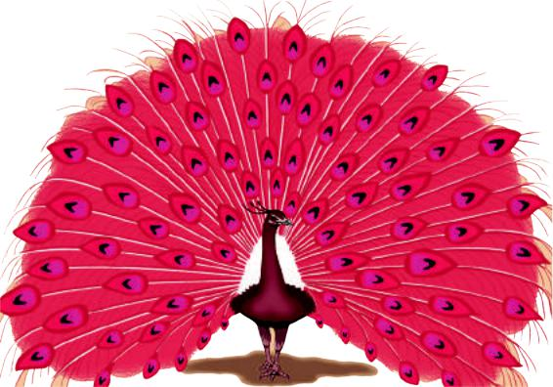

Tenali Raman (to the painter): Don’t worry, I won’t punish you. Just paint another four peacocks the same colour.

Painter: Yes sir.

(Tenali Raman takes the peacocks to the court, two weeks later.)

Krishna Deva Raya: Bravo, Tenali.

207 English

Book 1.indb 207

21-01-2020 17:29:30

Treasurer, give him 1000 gold coins.

Tenali Raman: That is not what they cost, Your Majesty.

Krishna Deva Raya: What is your price then, Tenali Raman?

Tenali Raman: A bucket of water, a bag of red paint, and a gold coin for this artist.

Krishna Deva Raya (angrily): Chatur Pandit, I sentence you to…

Tenali Raman: Your Majesty, your desire for fame led you to believe a red peacock could exist. For a long time, there has been needless spending on such curiosities.

It is better that your subjects are prosperous, rather than a display of wealth. I request you to let Chatur Pandit go and reward the artist for highlighting this matter.

Krishna Deva Raya: You’re right, Tenali.

Chatur Pandit (falls at the king’s feet): Your Majesty, please forgive me.

Krishna Deva Raya: I will do so, but you are banished from the court for a month.

And you must return the gifts you got earlier.

(It starts to rain and the peacocks dance. The rain washes off their red colour.)

Krishna Deva Raya (laughs): Look, Tenali!

(Tenali smiles.)

(The people of the kingdom dance in the rain.)

The people (to each other): We are lucky to have a king who is not afraid to admit his mistake.

(Chatur Pandit walks home alone in the rain.)

THE SPIDER AND THE FLY
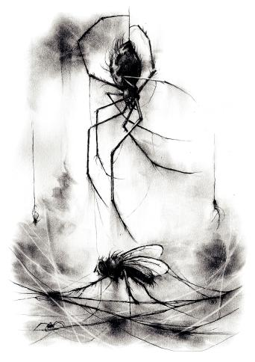

D. *Listen to the passage and fill in the blanks with appropriate answers.

Trust is one of the most important things anyone can have in a relationship because trust is what makes the foundation of a relationship. Without trust there is no relationship at all because everything you do or make of the relationship will be based on truth. Trust is


English 208

Book 1.indb 208

21-01-2020 17:29:30

a very rare thing to find and if you are able to give it in return, your life is so much better and more fulfilling for everyone involved. Trusting people can hurt sometimes because they betray you, but you learn from the situation and move on to the next adventure in your life. Just don't let small bumps in the road throw you back to not trusting and being cold. Simply keep moving forward and you will have a wonderfully fulfilling life that will be filled with good people that care and are trustworthy.

(slightly adapted)

WATER THE ELIXIR OF LIFE

Severn Cullis-Suzuki (born November 30, 1979 in Vancouver, British Columbia) is a Canadian environmental activist. She has spoken around the world

about environmental issues, urging listeners to define their values, act with the future in mind, and take individual responsibility. In 1992, at age 12, Cullis-Suzuki raised money with members of ECO to attend the Earth Summit in Rio de Janeiro. Cullis-Suzuki presented environmental issues from a youth’s perspective at the summit, where she was applauded for her speech to the delegates.

E. *Listen to the speech and complete the exercises that follow.


Hello. I'm Severn Suzuki, speaking for ECO, the Environmental Children's Organization. We are

- group of 12- and 13-year-olds trying to make a difference: Vanessa Suttie, Morgan Geisler, Michelle Quigg, and me. We've raised all the money to come here ourselves, to come 5,000 miles to tell you adults you must change your ways.

Coming up here today, I have no hidden agenda. I am fighting for my future. Losing my future is not like losing an election or a few points on the stock market. I am here to speak for all generations to come. I am here to speak on behalf of the starving children around the world whose cries go unheard. I am here to speak for the

countless animals dying across this planet because they have nowhere left to go.

I am afraid to go out in the sun now because of the holes in our ozone. I am afraid to breathe the air because I don't know what chemicals are in it. I used to go fishing

209 English

Book 1.indb 209

21-01-2020 17:29:30

in Vancouver — my home — with my dad, until just a few years ago we found the fish full of cancers. And now we hear of animals and plants going extinct every day, vanishing forever.

In my life, I have dreamt of seeing the great herds of wild animals, jungles and rainforests, full of birds and butterflies, but now I wonder if they will even exist for my children to see. Did you have to worry of these things when you were my age? All this is happening before our eyes and yet we act as if we have all the time we want and all the solutions. I'm only a child, and I don't have all the solutions. I want you to realize, neither do you. You don't know how to fix the holes in our ozone layer. You don't know how to bring the salmon back up a dead stream. You don't know how to bring back an animal now extinct. And you can't bring back the forest that once grew where there is now a desert. If you don't know how to fix it, please stop breaking it.

Here you may be delegates of your government, business people, organizers, reporters or politicians. But really you are mothers and fathers, sisters and brothers, aunts and uncles, and all of you are someone's child. I am only a child, yet I know we are all part of a family 5 billion strong. In fact, 30 million species strong. And borders and governments will never change that. I am only a child, yet I know that we're all in this together and should act as one single world towards one single goal. In my anger, I am not blind, and in my fear, I am not afraid of telling the world how I feel. In my country, we make so much waste. We buy and throw away, buy and throw away, buy and throw away, and yet Northern countries will not share with the needy. Even when we have more than enough, we are afraid to share. We are afraid to let go of some of our wealth.

In Canada, we live the privileged life with plenty of food, water and shelter. We have watches, bicycles, computers and television sets. The list could go on for two days. Two days ago here in Brazil, we were shocked when we spent time with some children living on the streets. This is what one child told us, "I wish I was rich. And if I were, I would give all the street children food, clothes, medicines, shelter, and love and affection.” If a child on the streets who has nothing is willing to share, why are we who have everything still so greedy? I can't stop thinking that these are children my own age; that it makes a tremendous difference where you are born; that I could be one of the children living in the favelas of Rio. I could be a child starving in Somalia, or a victim of war in the Middle East or a beggar in India. I am only a child, yet

I know that if all the money spent on war was spent on finding environmental answers, ending poverty and finding treaties, what a wonderful place this Earth would be.

At school, even in kindergarten, you teach us how to behave in the world. You teach us to not fight with others; to work things out; to respect others; to clean up

English 210

Book 1.indb 210

21-01-2020 17:29:30

our mess; not to hurt other creatures; to share, not be greedy. Then why do you go out and do the things you tell us not to do? Do not forget why you are attending these conferences – who you are doing this for. We are your own children. You are deciding what kind of world we are growing up in.

Parents should be able to comfort their children by saying "Everything's going to be all right. It's not the end of the world. And we're doing the best we can." But I don't think you can say that to us anymore. Are we even on your list of priorities? My dad always says, "You are what you do, not what you say." Well, what you do makes me cry at night. You grown-ups say you love us, but I challenge you, please make your actions reflect your words. Thank you.

FROM ZERO TO INFINITY

D. Listen to the Passage Two Geniuses

Many people regard the scientist Albert Einstein as one of twentieth century’s greatest geniuses. He was a physicist whose research into the working of the universe made such inventions as nuclear energy, space travel and television possible.

Anecdotes about Einstein show that he had a great sense of humour.


One such anecdote tells that as a young man with a growing reputation, he received many invitations to go to universities to explain his theories. On these trips he was always chauffeured by the same person—a man called Hans. Hans often said to him, “It’s a pleasure to drive a genius like you, Dr. Einstein.”

One evening, on their way to a remote university, Einstein said, “I wish I didn’t have to give my lecture tonight, Hans. I’m so tired. But I can’t let my audience down, can I.”

“You don’t need to,” said Hans. “We’ll change places, and I’ll give the lecture for you. I’ve listened to it a dozen times. I don’t understand it, but I know it by heart. And

no one knows you at the university, do they? No one will find out.”

Einstein eventually agreed with Hans, but said to him, “Don’t try to answer any questions, whatever you do.”

They changed places, and at the university, Hans was greeted and led to the platform in a great hall crowded with professors and students. Einstein joined the

211 English

Book 1.indb 211

21-01-2020 17:29:30

audience and listened to Hans give his lecture perfectly, and joined in the applause at the end.
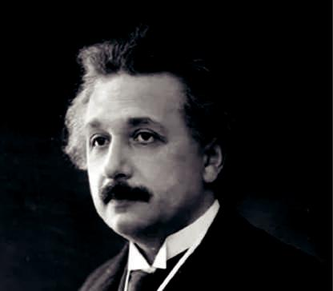

\ However, before Hans could get off the platform, a professor shouted from the audi-ence, “I’d like to ask you a question. Its very difficult but please answer it.” He then asked the question so difficult that Hans had no idea what he was talking about.

\ Einstein thought, “Oh Dear, now we’re in trouble.” But Hans just laughed and said, “That’s not a difficult question, sir. In fact, it’s so easy even my driver knows how to answer it. Hans, stand up and……..”

Einstein stood up and answered the question perfectly.

\ They left the university, with Einstein driving. A little later, Hans offered to take over from him. “No, my friend,” laughed Einstein, “it’s a pleasure to drive a genius like

you.”

THE COMET

F. Listen to the Passage Comets

Comets, meteors and asteroids have several things in common. First, they are believed to be remnants of the materials that created the Sun and the planets. Basically, they’re leftovers. Comets, meteors and asteroids are too small to be planets. Some are only a few feet in size, while others are a mile or more long.


\ Comets are mostly made of ice. They are very old. As comets trav-el close to the Sun, some of the ice melts off and becomes a gas. This melting process causes bits of dust and debris to trail behind the comet. This tail can be seen in the night sky as a bright, quickly-moving light.

\Comets orbit at the very edge of the galaxy, past Pluto.

English 212

Book 1.indb 212

21-01-2020 17:29:30

A BIRTHDAY LETTER

E. A Dialogue between Brothers


Raghav: Hi Aadhav! I need to discuss something important with you.

Aadhav: Hi Raghav! I am free now. Come on. Let us discuss.

Raghav: Do you remember that coming April 2nd is our parents’ wedding anniversary?

Aadhav: Thank you for reminding me, Bro. I have almost forgotten that. How shall we celebrate it?

Raghav: Shall we plan for a surprise celebration?

Aadhav: Yes, of course, Bro.

Raghav: How about inviting our friends and close relatives for the party to surprise our parents?

Aadhav: Yeah. That would be a real surprise! Shall we also have cake cutting?

Raghav: Yes, we shall. But, we have to do something unique. What else shall we do then?

Aadhav: Why don't we make our parents plant a sapling as a part of the celebra-tion?

Raghav: That’s a good one! I know a person who owns a nursery garden. I’ll buy mango sapling and we’ll make our parents plant it.
Aadhav: Great, it will be a memorable one. I have saved some money. Let’s make use of it for the arrangements.

Raghav: Let me also contribute my savings to make this celebration useful and memorable.

THE STICK-TOGETHER FAMILIES E. Listen to the Passage Family

Family is where we all belong to and from where our identity comes from. A person is valued based on his family and upbringing. Family is a bond, a long lasting relationship that holds a bond with each other. There are many values that one has to learn to get the

family bonding in the right manner. Bonding does not happen overnight. It forms with every second, every minute that you spend with your loved ones. The understanding, the acceptance, the belonging and the security all enclosed together is how a family bond is formed.

A close family bond is like a safe harbour, where we feel secure and where we trust that

213 English

Book 1.indb 213

21-01-2020 17:29:30

we have someone always there to whom we could turn to when we need them the most.

It is through a family that we learn the values of love, trust, hope, belief, cul-tures, morals, traditions and every little matter that concerns to us. A strong foun-dation for any individual comes from being with a supportive family.

Family is one among the greatest gifts that we get from God. To have par-ents, who support us, teach us values in life, and gives us a strong foundation in character, teach us the importance of love and being loved, trust to be there for one another and many other morals that could be obtained only from a family. A gift not only with lovable parents, but siblings who care and love us beyond themselves. We cannot buy or demand all these things in life, as we are being given to understand their importance.

To be part of a happy family, one should always thank God for the blessing we have in lives, as having a family who cares and loves us is the greatest blessing that any person could get in life.
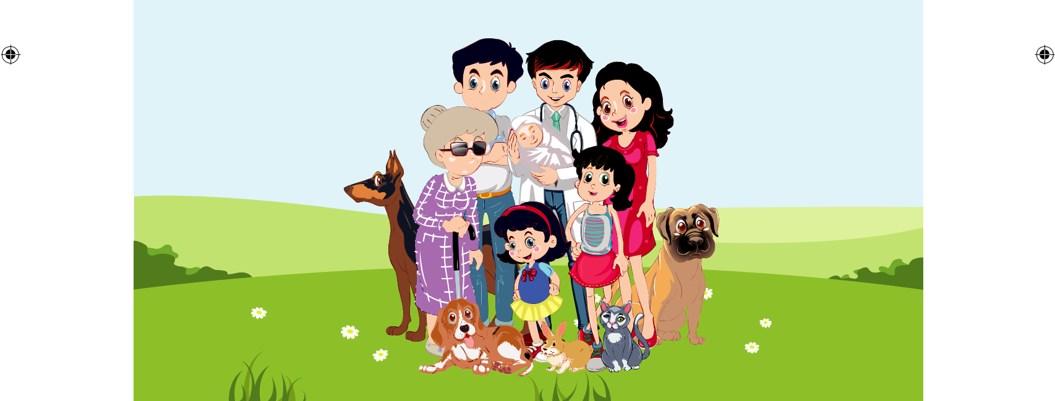

Useful Weblinks

- Ramanujan Mathematical Society - www.ramanujanmathsociety.org/

- ISRO - Government of India - https://www.isro.gov.in/

- Asteroids and Comets: Information and Facts | National Geographic https://www.nationalgeographic.com/science/space/solar-system/asteroids-comets/

English 214

Book 1.indb 214

21-01-2020 17:29:31

Acknowledgement


We express our gratitude to the writers and publishers whose contributions have been included in this book. Copyright permission for use of these materials have been applied for, however information on copyright permission for some of the material could not be found. We would be grateful for information for the same.

Prose

❖ Learning the Game - Sachin Ramesh Tendulkar (Published by Hodder & Stoughton, UK)

❖ I can’t Climb Trees Anymore - Ruskin Bond

❖ Old Man River - Dorathy Deming (Drama)

❖ Seventeen Oranges - Bill Naughton

❖ Water – The Elixir of Life - Sir C.V. Raman

❖ From Zero to Infinity - Biography of Srinivasa Ramanujan  A Birthday Letter - Jawaharlal Nehru

Poem

❖ Stopping by Woods on a Snowy Evening - Robert Frost

❖ Leisure - William Henry Davies

❖ A Poison Tree - William Blake

❖ The Power of a Smile - Tupac Shakur

❖ On Killing a Tree - Gieve Patel

❖ Advice from a Tree - Ilan Shamir

❖ The Spider and The Fly - Mary Howitt

❖ Never Trust a Mirror - Erin Hanson

❖ The River - Ilan Shamir

❖ Nature the Gentlest Mother - Emily Dickinson

❖ The Comet - Norman Littleford

❖ The Star - Jane Taylor

❖ The Stick-Together Families - Edgar Albert Guest

❖ Memories of My Dad - Rebecca D.cook

Supplementary

❖ The Envious Neighbour - A Japanese Folk Tale

❖ The Fun they Had - Isaac Asimov

❖ Earthquake - M.S.Mahadevan

❖ The Cat and the Pain-Killer - Mark Twain

❖ Little Cyclone The Story of a Grizzly Cub - William Temple Honarday  Mother’s Voice - Vasil Berezhnoy
❖ The Christmas Truce - Aaron Shepard

Listening Passage

❖ Speech In Environmental Children’s Organization - Severn Suzuki  Environmental Crusader Of India - Dr.G. Nammazhwar  Two Geniuses

215 English

Book 1.indb 215

21-01-2020 17:29:31

English – Class IX

List of Authors and Reviewers

Advisory Committee

Rajeswary P, ELT Consultant,

Former Education Officer, CBSE.

Domain Experts

Vijayalakshmi P, Principal,

Chinmaya Vidyalaya, Virugambakkam, Chennai.

Seethalakshmi Viswanath, Retired Principal, Amrita Vidyalayam, Chennai.

Reviewers

Nagalakshmi B, ELT Consultant, Chennai. Daniel David Head, Department of English (SFS) Madras Christian College, Tambaram, Chennai. Hema Natarajan Associate Professor of English, Rajalakshmi Engineering College, Thandalam. Savithri P Asst. Professor of English,
Sri Meenakshi Govt. Arts College for Women, Madurai.
Hemalatha NN Asst. Professor of English (SFS)

Madras Christian College, Tambaram, Chennai.

Academic Coordinators

Sagayaraj L

B.T. Asst., Govt. Girls Hr. Sec. School,

Tiruttani, Thiruvallur.

Ajitha N D

B.T. Asst., Govt. Hr. Sec. School,

Alagianallur, Virudhunagar.

Art and Design Team

Illustration

Ravikumar B, Erode

Manoharan S

Vasuki L

Graphics & Layout

V2 Innovations, Gopalapuram, Chennai.

Wrapper Design

Kathir Arumugam

In-House QC

Rajesh Thangappan

Arun Kamaraj P

Co-ordination

Ramesh Munisamy

Authors

Inthumathi G G Asst. Professor of English, Vivekanandha College, Karur.

Petra Elizabeth Chithra J H.M.,

Govt. High School,Puthutheru, Thanjavur.

Sasikala B P.G. Asst., ADWHSS,

Meenambakkam, Kancheepuram.

Rekha Rayen E B.T. Asst., GHSS, Okkiam, Thoraipakkam, Kancheepuram.

Sujith Gladwin E B.T. Asst., GHS., Vellur, Virudhunagar.

Jaya Prabhu P B.T. Asst., GHS., Poondi, Thanjavur.

Lourds Anita T B.T. Asst., GHSS., Moolaikaraipatti, Tirunelveli.

Muthu Raman K B.T. Asst., GGHSS., Pattukkottai, Thanjavur.

Chandrashekar N B.T. Asst., Govt. Model

Hr. Sec. School, Kelamangalam, Krishnagiri.

Sethu Raman R B.T. Asst., PUMS., Melakkudieruppu, Ariyalur.

Vasundhara K P.G.T.,

Chinmaya Vidyalaya,Chennai.

Antony Raj M B.T. Asst.,

St. Bedes AIHSS.,Chennai.

QR Code Management

R. Jaganathan S.G. Asst., (SPOC), PUMS., Ganesapuram - Polur, Thiruvannamalai.

This book has been printed on 80 G.S.M.
Elegant Maplitho paper.

Printed by offset at:

English 216

Book 1.indb 216

21-01-2020 17:29:31

Notes

Book 1.indb 217

217 English

21-01-2020 17:29:31

Notes

English 218

Book 1.indb 218

21-01-2020 17:29:31

