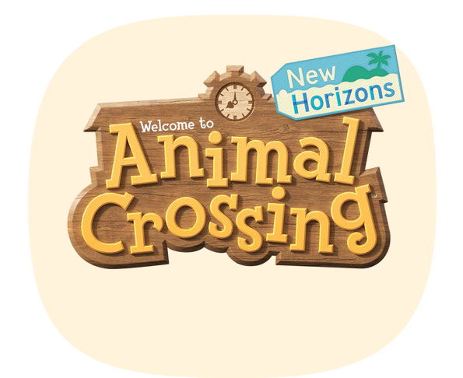

2021 Birthday
Calendar



© 2021 Nintendo.


JANUARY 2021

sunday monday tuesday wednesday
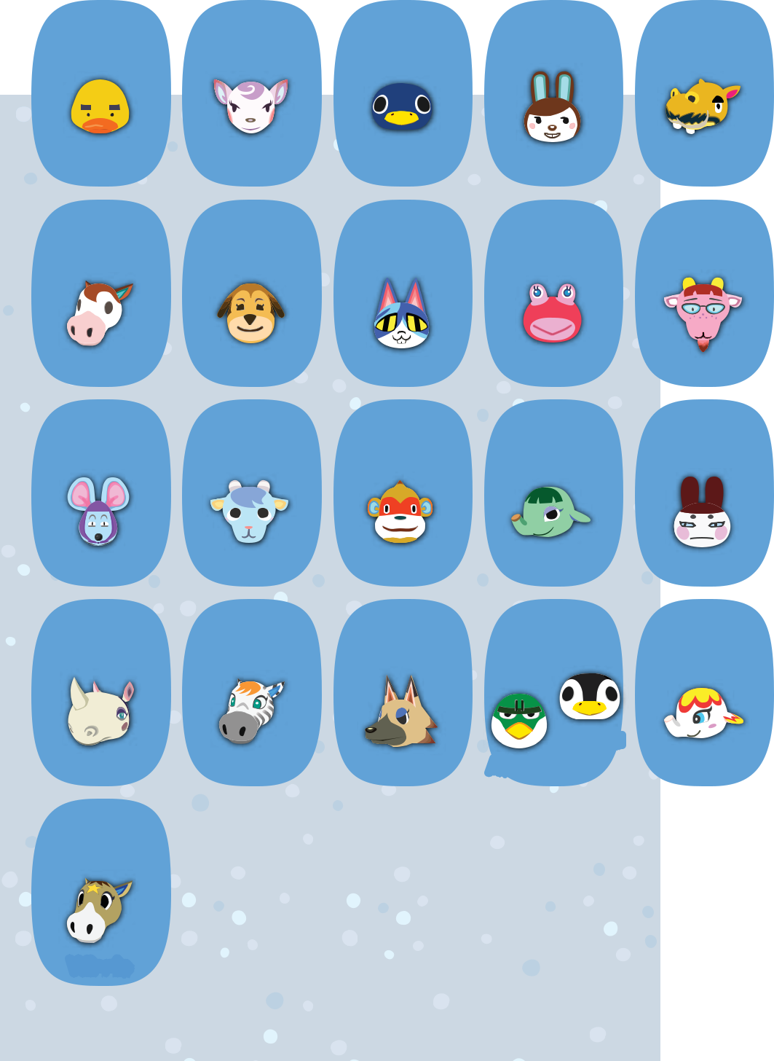

3 4 5 6

Joey Diana Roald Carmen

10 11 1213

Papi Maddie Moe Puddles

17 1819 20

Rizzo Sherb Simon Opal

thursday friday saturday

- 2
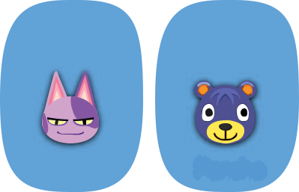

Bob Poncho
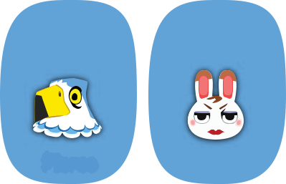

7 8 9

Harry Pierce Tiffany
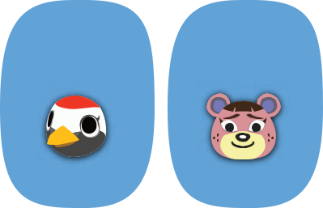

14 15 16

Velma Gladys Ursala
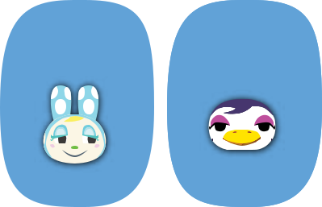

21 22 23

Genji Francine Gwen


24 25

Rhonda Savannah

31

26 27

⁰⁶ Aurora

Vivian Admiral

28 29 30

Margie Cube Flurry
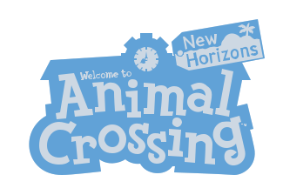

Winnie

FEBRUARY 2021

sunday monday tuesday wednesday thursday friday saturday

1 2 3 4 5 6
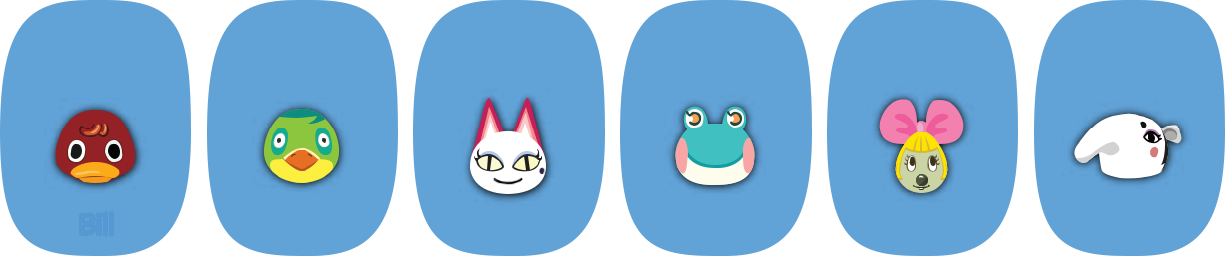

 | Bill | Jitters | Olivia | Lily | Penelope | Annalisa
7 | 8 | 9 | 10 | 11 | 12 | 13
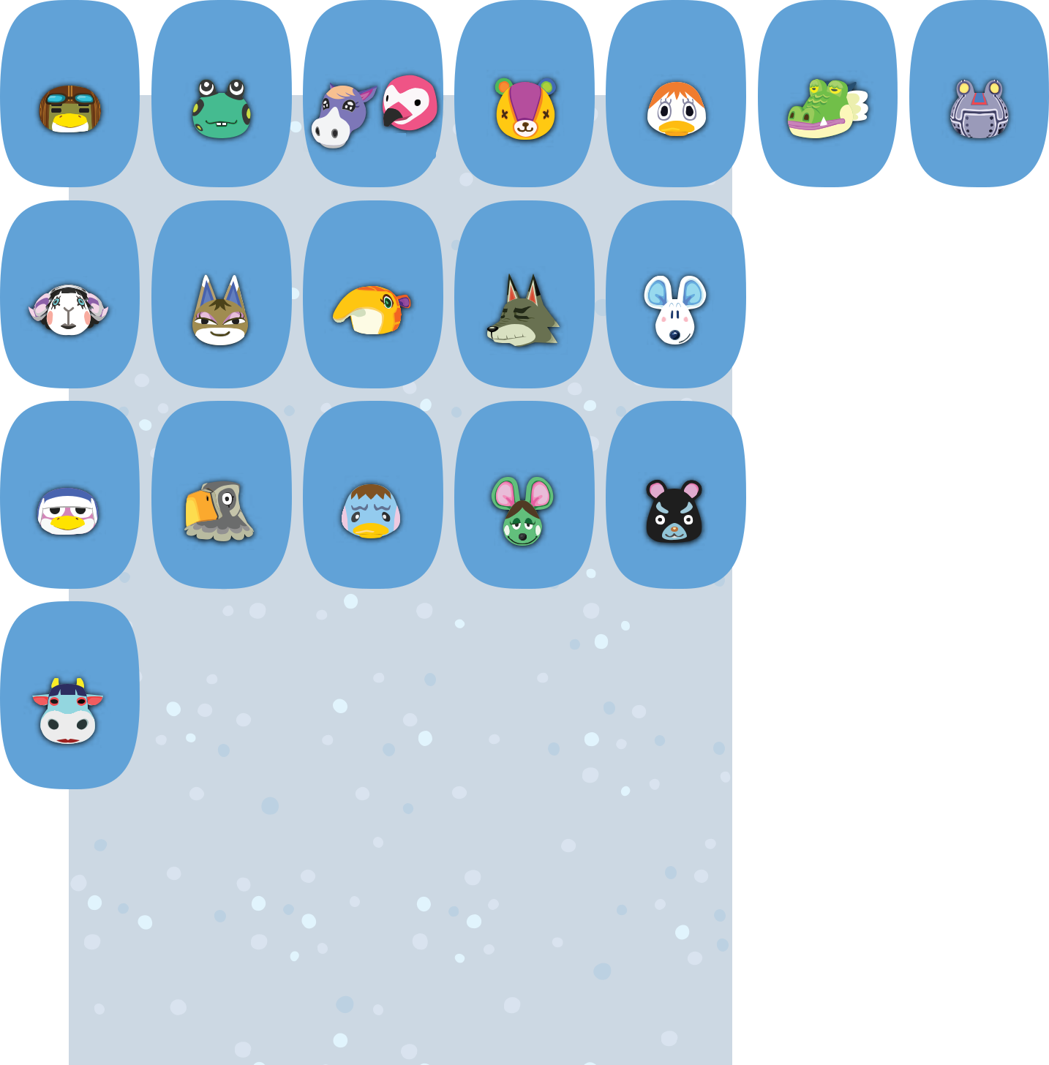

Boomer | Frobert | Cleo | Flora | Pompom
Boomer | Frobert | Cleo | Stitches | Pompom

14 1516 17 18

Muffy | Kitty | Anabelle | Dobie | Dora
21 | 22 | 23 | 24 | 25

Puck Avery Pate Anicotti Hamphrey

28

Drago Ribbot

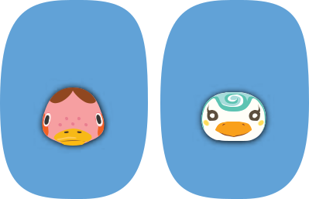

19 20

Freckles Sprinkle

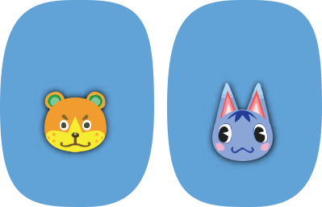

26 27

Sheldon Rosie

Naomi
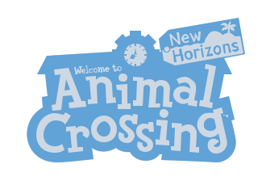


MARCH 2021

sunday monday tuesday wednesday thursday friday saturday

1 2 3 4 5 6
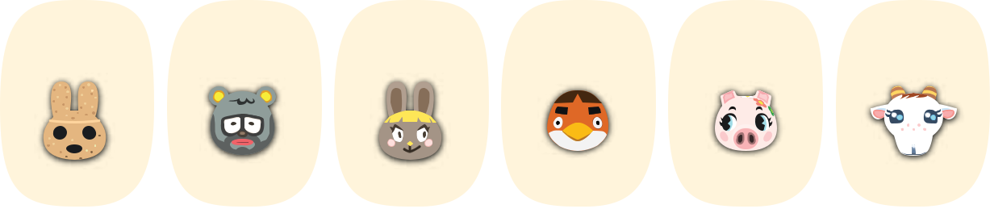

 | Coco | Barold | Bonbon | Anchovy | Gala | Chevre
7 | 8 | 9 | 10 | 11 | 12 | 13
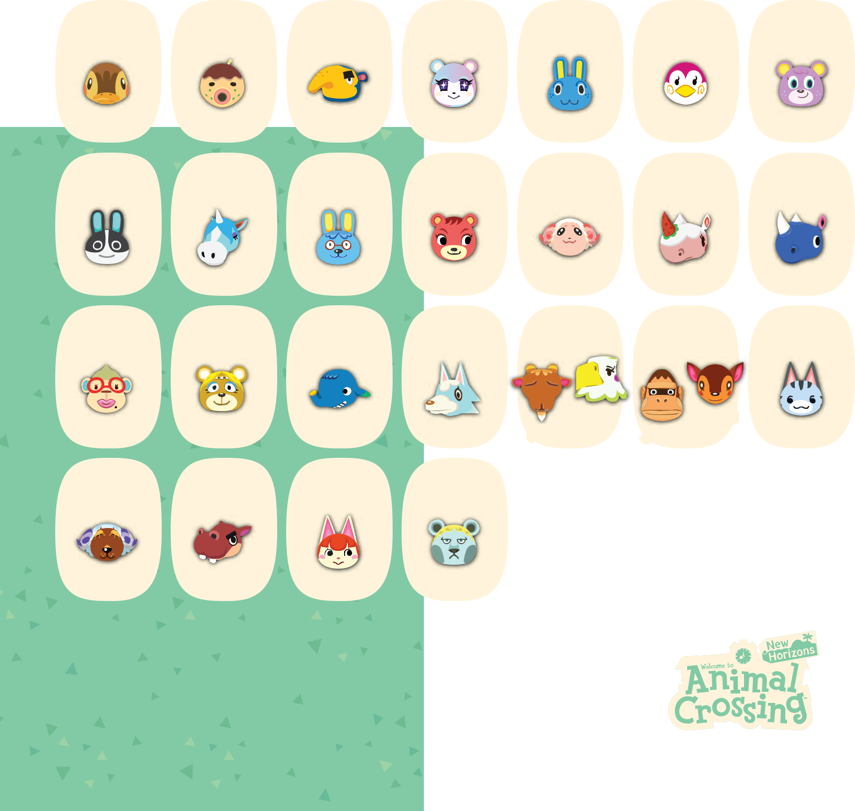

Molly Zucker Cyrano Judy Hopkins

14 15 16 17 18

Midge Megan

19 20

Dotty Julian Doc Cheri Dom Merengue Hornsby

21 22 23 24 25 26 27

Celia
Elise Paula Axel Skye Billy

28 29 30 31

Fauna
Louie Lolly

Baabara Biff Felicity Klaus

APRIL 2021

sunday monday tuesday wednesday thursday friday saturday

1 2 3
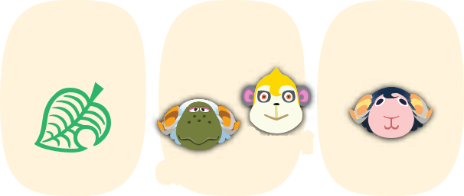

Tammi

Cashmere Eunice
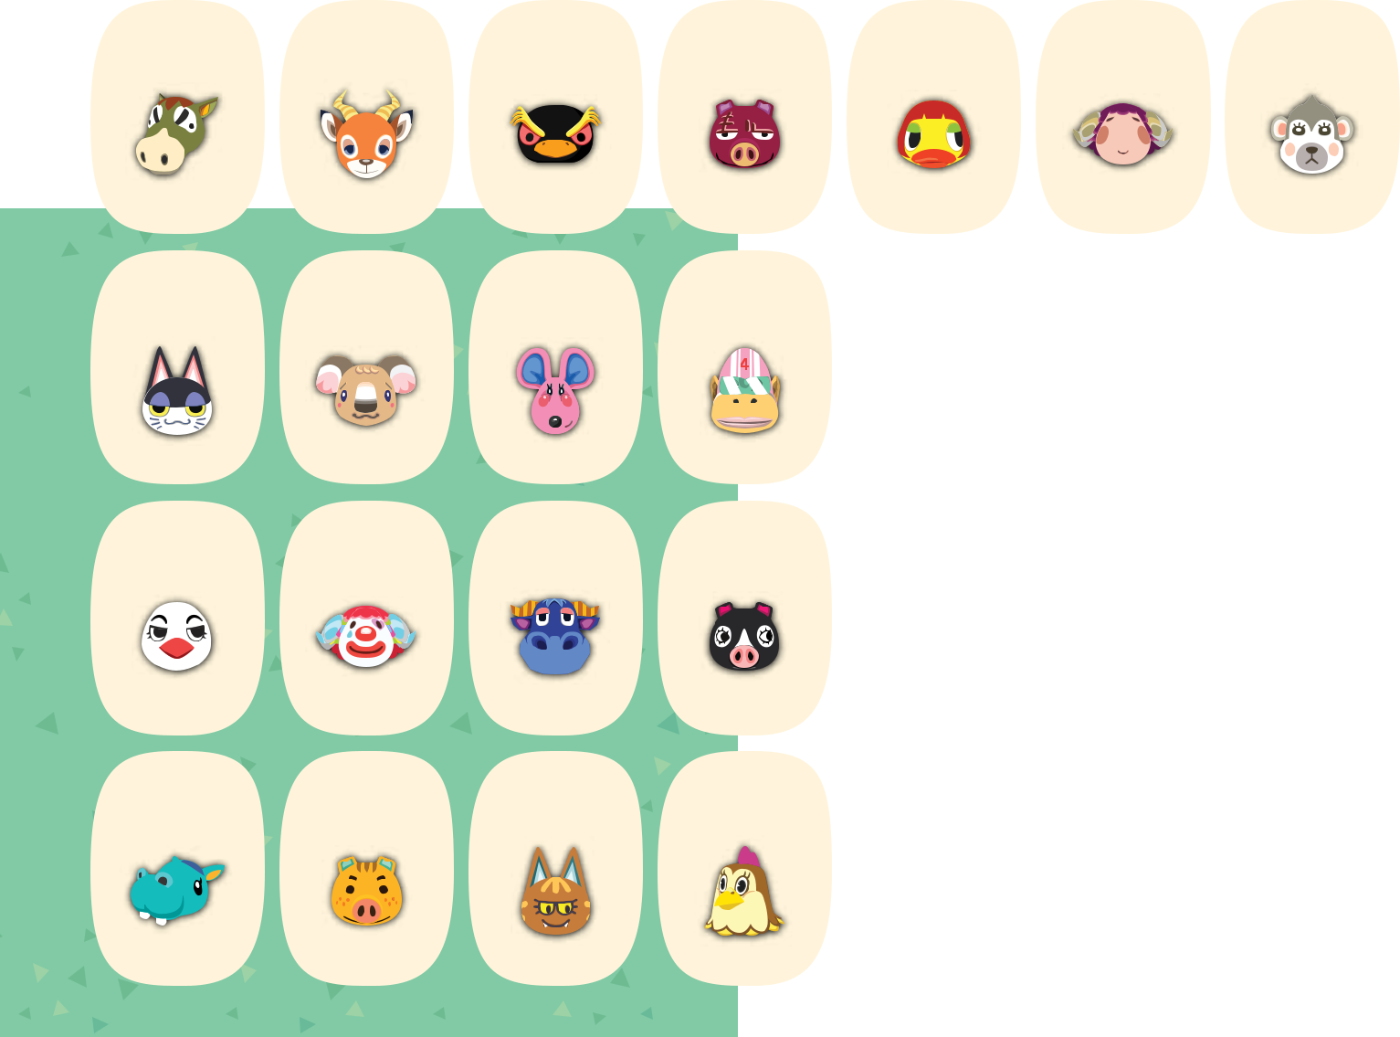

4 5 6 7 8 9 10

Buck Beau

11 12

Hopper Rasher

13 14

Maelle Stella Shari

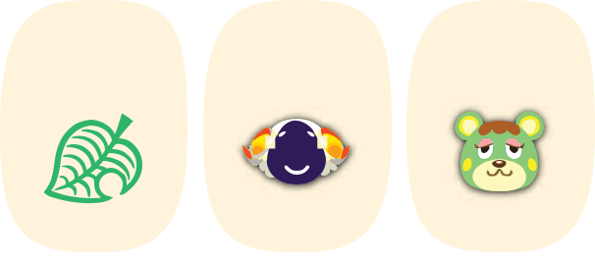

15 16 17

Punchy | Melba | Candi | Rocket | Vesta | Charlise

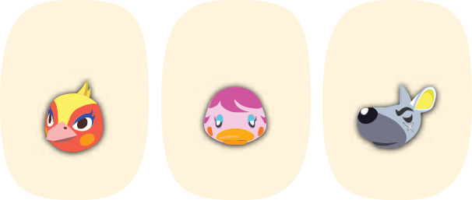

18 | 19 | 20 | 21 | 22 | 23 | 24
0511
Piper | Pietro | Stu | Agnes | Phoebe | Miranda | Walt
25 | 26 | 27 | 28 | 29 | 30

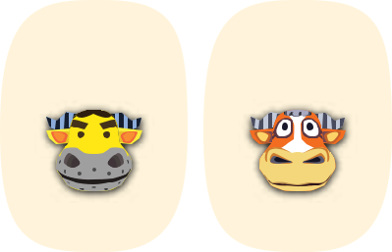

Bertha Kevin Katt Ava Coach Angus


MAY 2021

sunday monday tuesday wednesday thursday friday saturday

1


 |  |  |  |  |  | Clyde
2 | 3 | 4 | 5 | 6 | 7 | 8
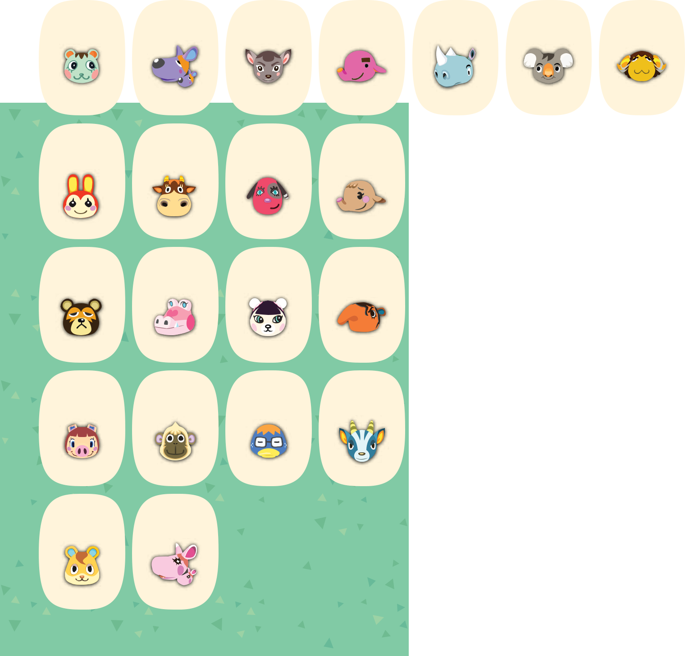

Mint

Sylvia

Deirdre

Paolo

Tank



Ozzie



Curlos



9 10

11 12

13

14

15

Bunnie

Patty

Cherry

Ellie

Biskit



Canberra



Leonardo



16 17

18 19

20

21

22

Ike Gayle Pekoe Olaf T-Bone June Colton

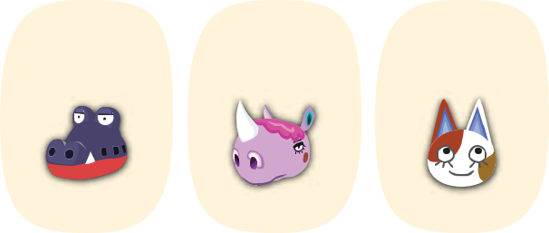

23 24 25 26 27 28 29

Peggy Deli Derwin Bruce Del Renée Purrl

30 31
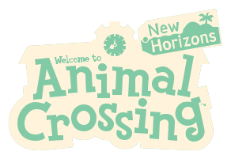

Hamlet Marcie


JUNE 2021

sunday monday tuesday wednesday thursday friday saturday

1 2 3 4 5
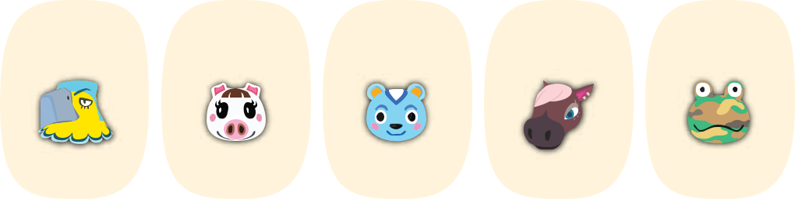

 |  | Keaton | Lucy | Filbert | Reneigh | Camofrog
6 | 7 | 8 | 9 | 10 | 11 | 12
Raddle | Zell |  |  | Cyd
Raddle | Zell | Peanut | Alfonso | Walker | Pudge | Bettina
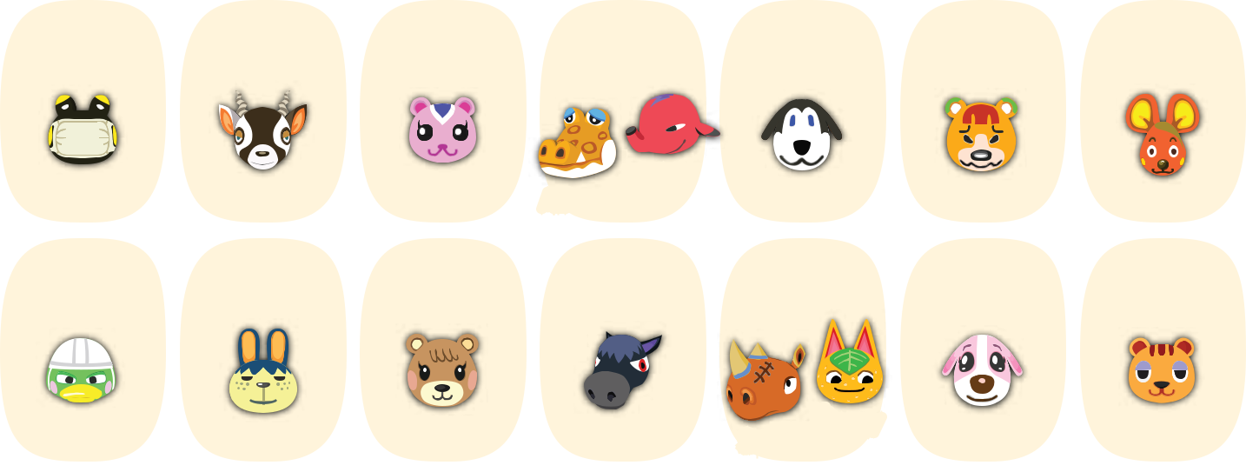

13 14 15 16 17 18 19

Scoot | Pippy | Maple | Roscoe | Spike ^{Tangy} | Cookie | Sally
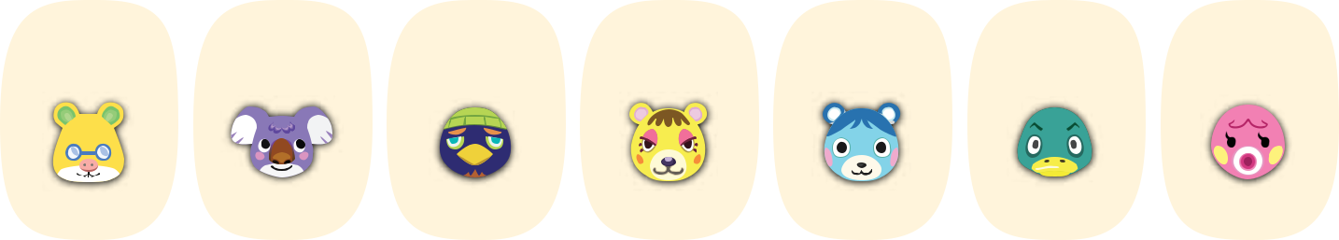

20 21 22 23 24 25 26

Graham Sydney Jacques Tammy Bluebear Drake Marina
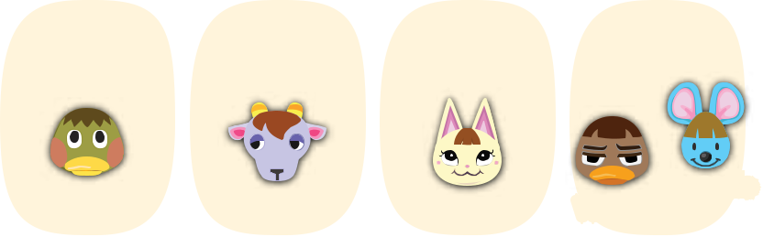

27 28 29 30

Deena Kidd Merry Weber ^{Broccolo}
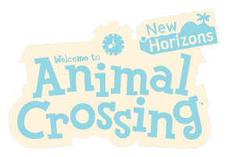

JULY 2021

sunday monday tuesday wednesday thursday

1


 |  |  |  | Curt
4 | 5 | 6 | 7 | 8
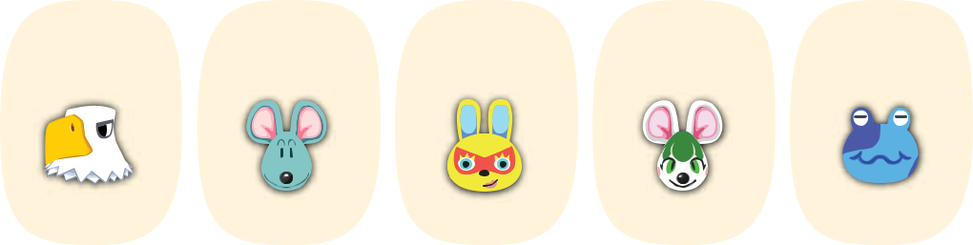

Apollo Samson Mira Bree Jeremiah
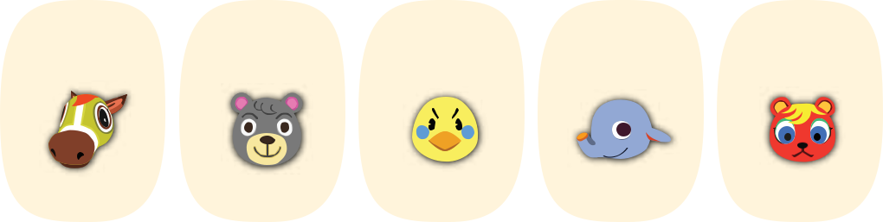

11 12 13 14 15

Victoria Olive Twiggy Dizzy Caroline
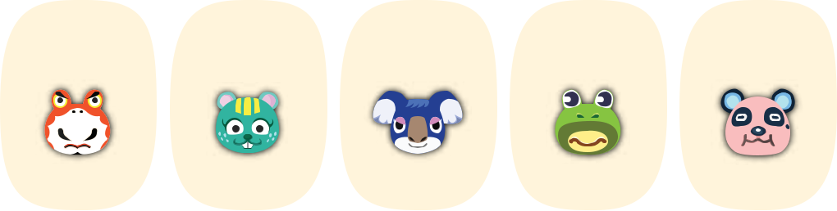

18 19 20 21 22

Croque Nibbles Yuka Prince Chow
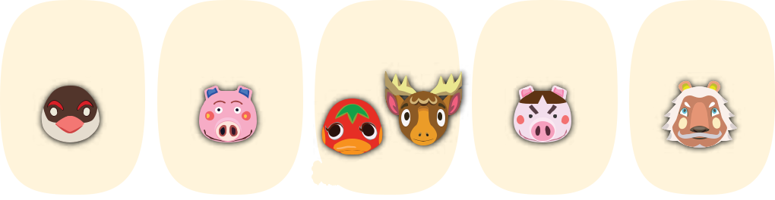

25 26 27 28 29

friday saturday

2 3
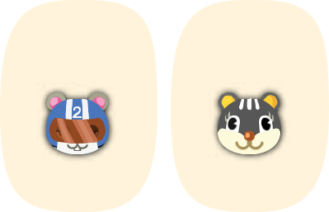

Agent S Blaire
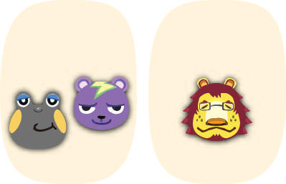

9 10

Huck ^{Static} Mott
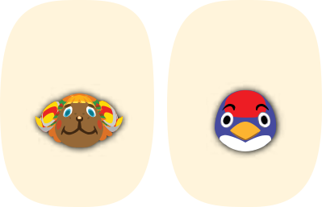

16 17

Frita Jay
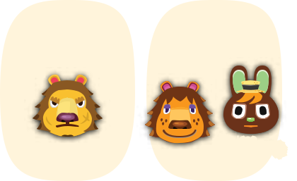

23 24

Elvis | Rex | O'Hare
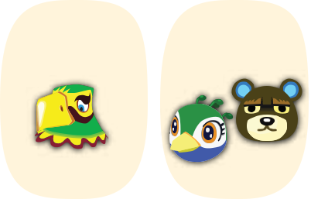

30 31

Peck Curly Ketchup ^{Erik} Truffles Lionel Frank Julia ^{Grizzly}
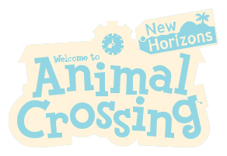

AUGUST 2021

sunday monday tuesday wednesday thursday friday

1 2 3 4 5 6
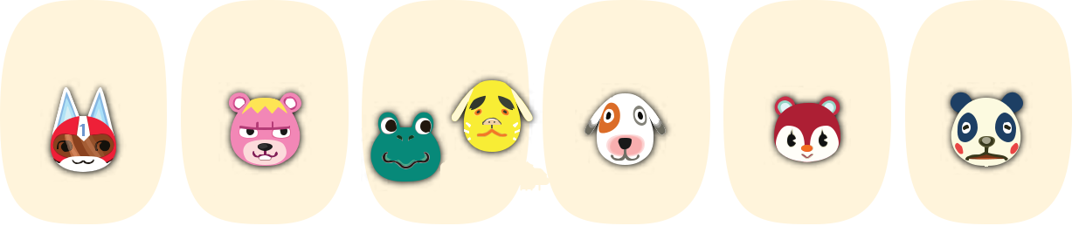

saturday

7


Kid Cat Vladimir Tad ^{Benjamin} Bones Poppy Chester
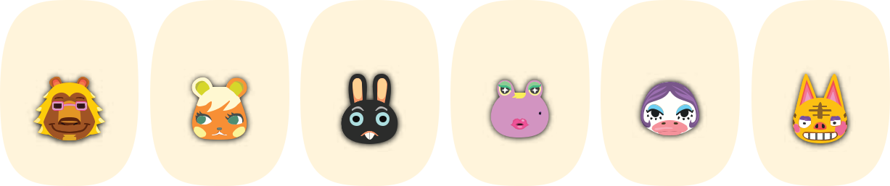

Boots


Rory

8 | 9 | 10 | 11 | 12 | 13

Bud Soleil Cole Gigi Gloria Tabby
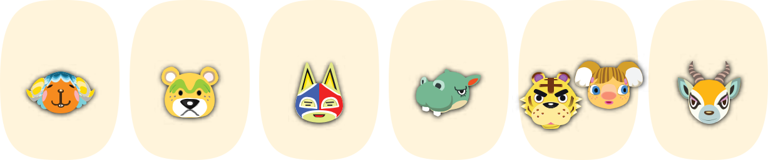

15 16 17 18 19 20

Alice
Wendy Nate Stinky Rocco Tybalt Lopez
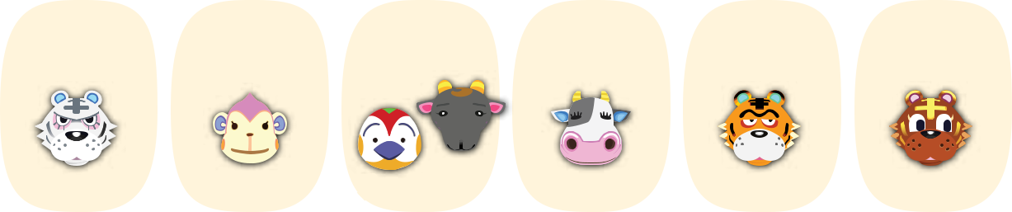

22 23 24 25 26 27

Rolf Nana Jacob ^{Nan} Tipper Rowan Bangle
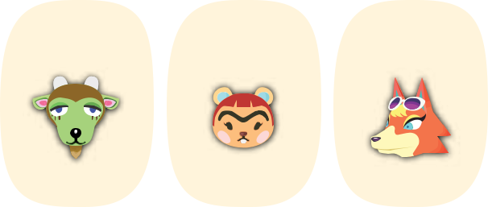

29 30 31

14

Leopold ^{Rod}


21

Wart Jr.


28

Chrissy

Gruff Hazel Audie
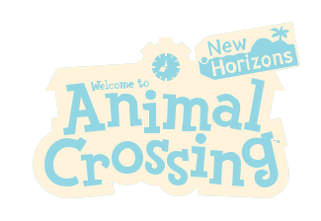


SEPTEMBER 2021

sunday monday tuesday wednesday thursday friday saturday

1 2 3 4
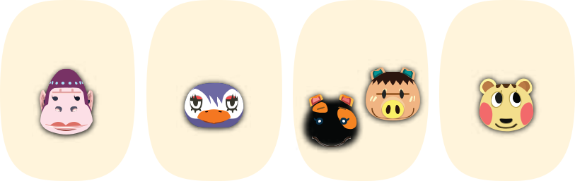

 Spork

Violet Flo Maggie Cally
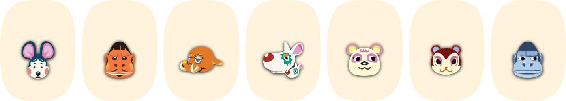

5 6 7 8 9 10 11

Greta Cesar Tucker Astrid Pinky Pecan Peewee
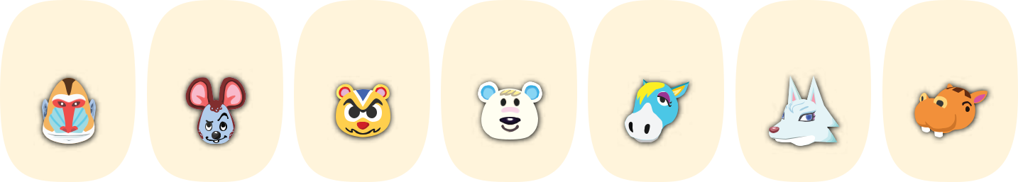

12 13 14 15 16 17 18

Boone Moose Ricky Tutu Ed Whitney Bubbles
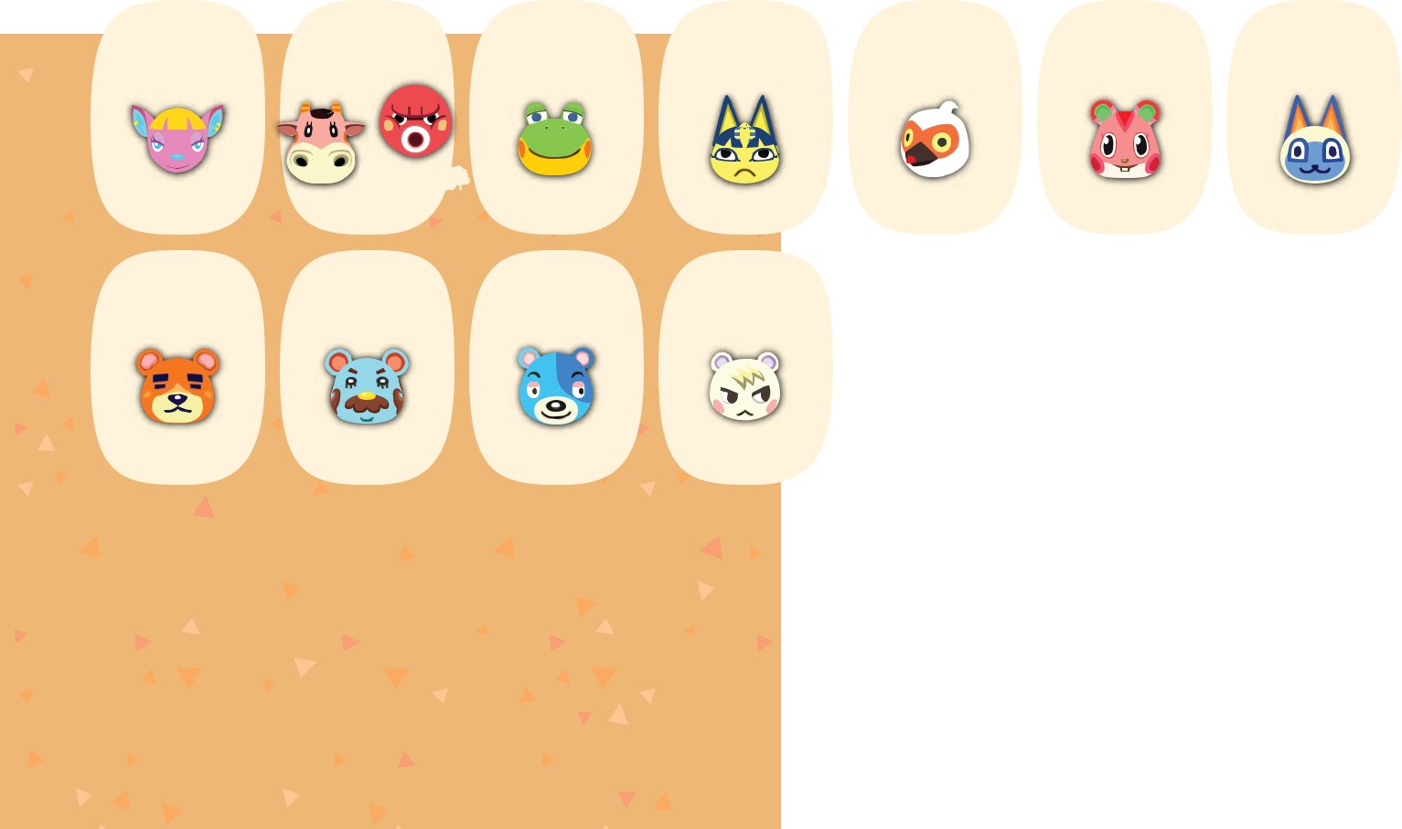

19 20 21 22 23 24 25

 | Octavian |  |  |  | Apple
Fuchsia | Norma | Henry | Ankha | Cranston | Apple | Mitzi

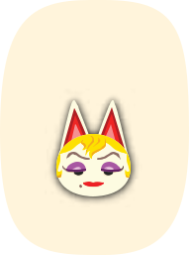

26 27 28 29 30

Teddy Beardo Kody Marshal Monique
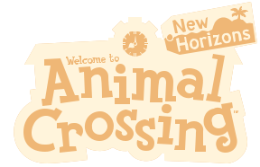

OCTOBER 2021

sunday monday
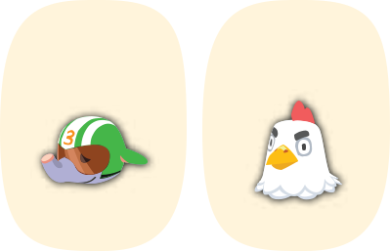

3 4

Big Top Goose


tuesday wednesday thursday friday saturday

1 2
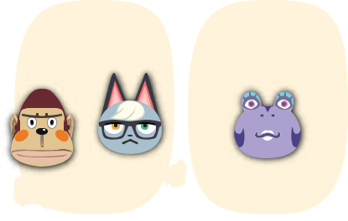

Boyd ^{Raymond} Diva
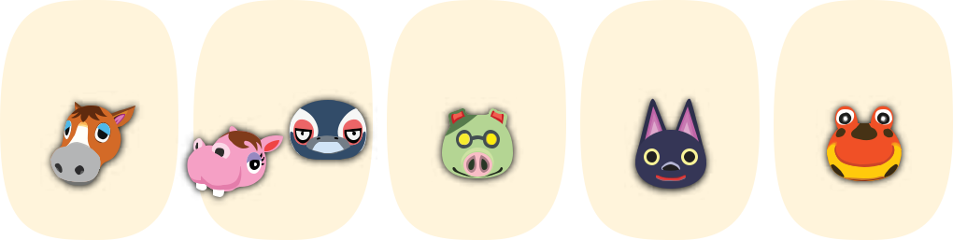

5 6 7 8 9

Tex

Elmer Bitty Cobb Kiki Drift
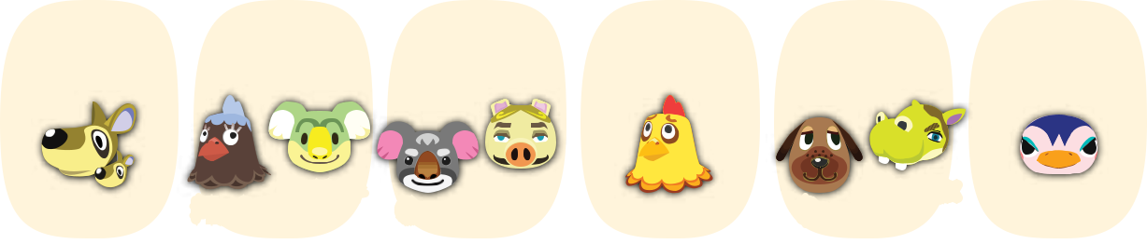

10 11

Benedict Kitt

12 13 14

Plucky ^{Lyman} Gonzo ^{Chops} Egbert
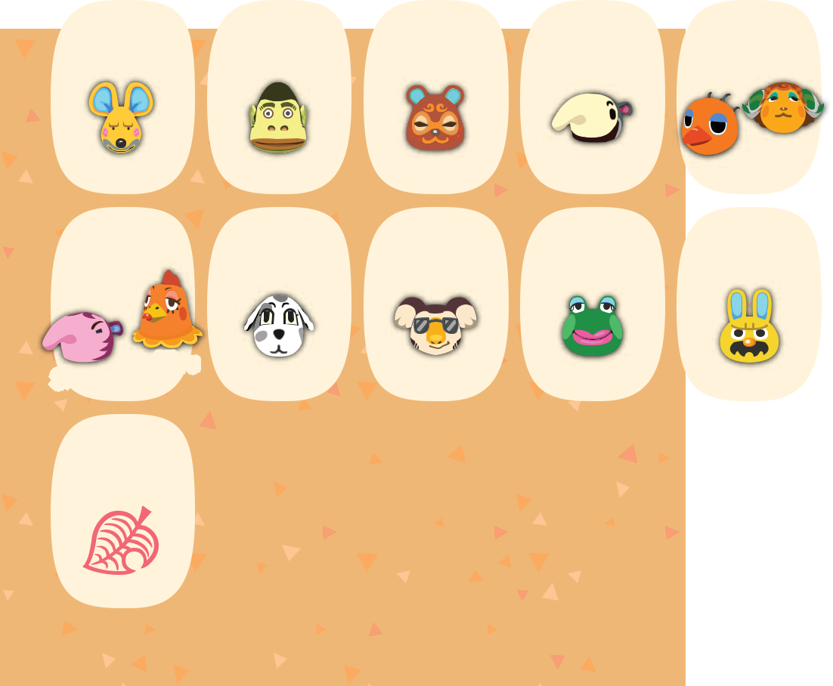

15 16

Bea | Hippeux | Friga
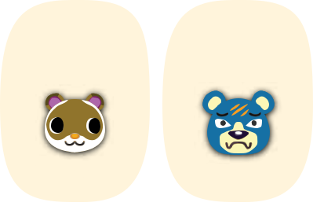

17 | 18 | 19 | 20 | 21 | 22 | 23
Limberg | Al |  |  | Timbra | Sylvana
Limberg | Al | Clay | Antonio | Sandy | Sylvana | Groucho
24 | 25 | 26 | 27 | 28 | 29 | 30
 |  |  |  |  |  | pgn09
 |  |  |  |  |  | カマボコ
_{Snooty} Broffina | Portia | Eugene | Jambette | Gaston | Rodeo | Wade
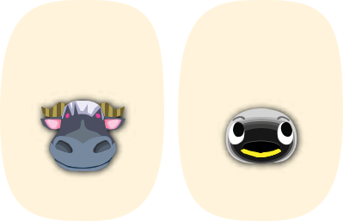

31
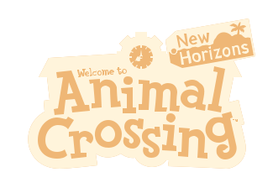

NOVEMBER 2021

sunday monday tuesday wednesday thursday friday saturday

1 2 3 4 5 6
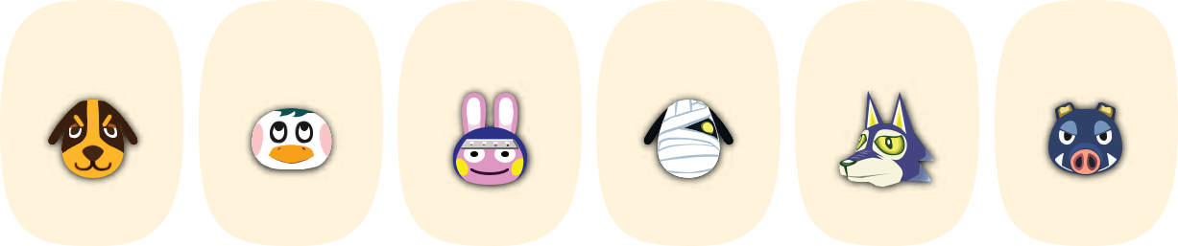

 | Butch | Iggly | Snake | Lucky | Lobo | Boris
7 | 8 | 9 | 10 | 11 | 12 | 13
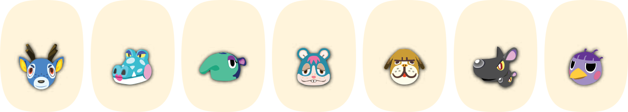

Bam | Alli | Pango | Rodney
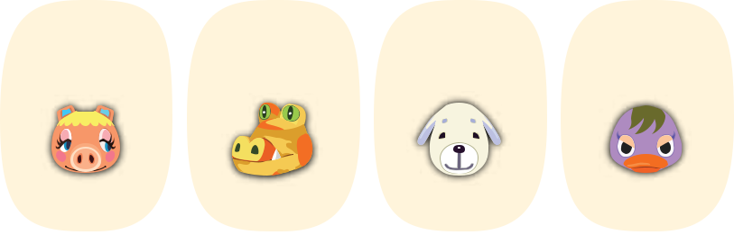

14 15 16 17

Mac Mathilda Queenie
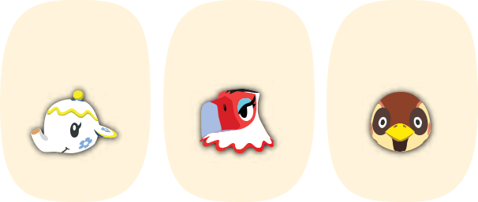

18 19 20

Pancetti Sly Daisy Mallary Tia Amelia Sparro
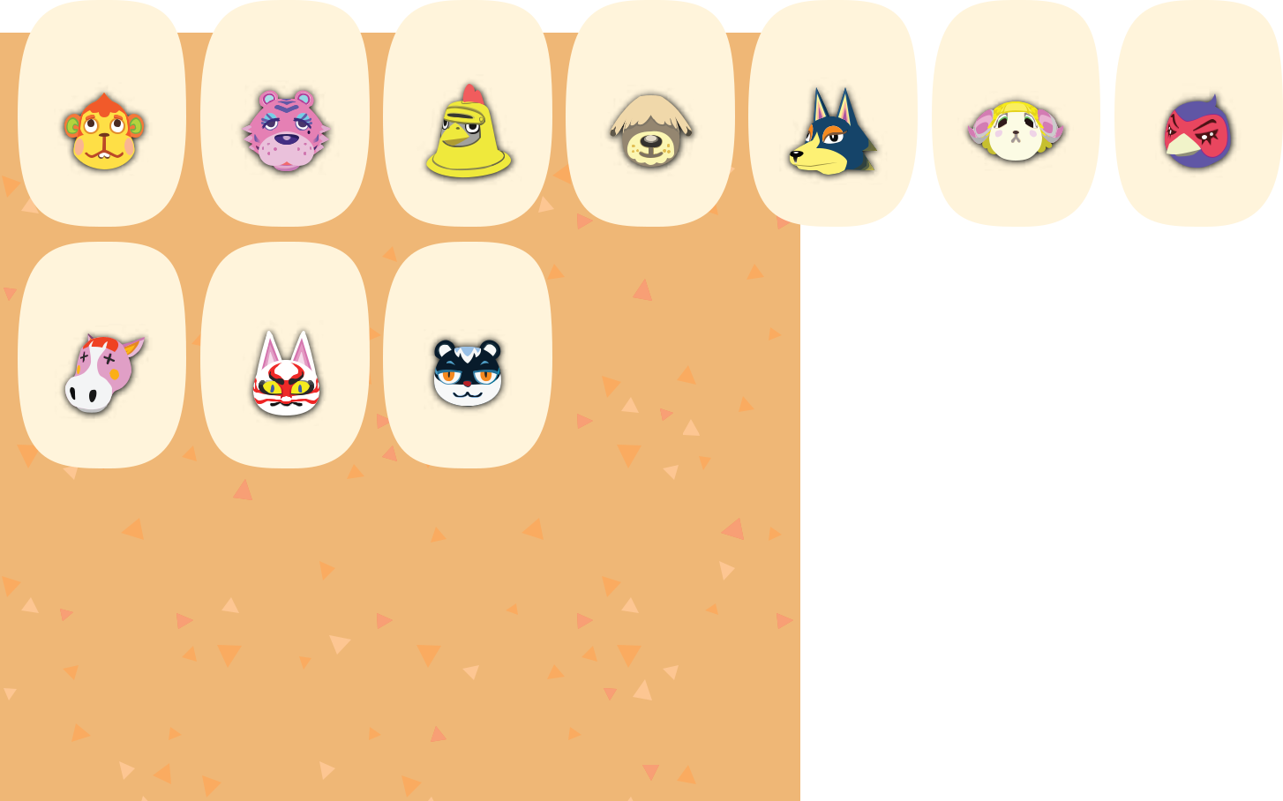

21 22 23 24 25 26 27

Flip | Claudia | Knox | Shep | Wolfgang | Willow | Phil

28 29 30

Peaches Kabuki Tasha


DECEMBER 2021

sunday monday tuesday wednesday thursday friday saturday

1 2 3 4
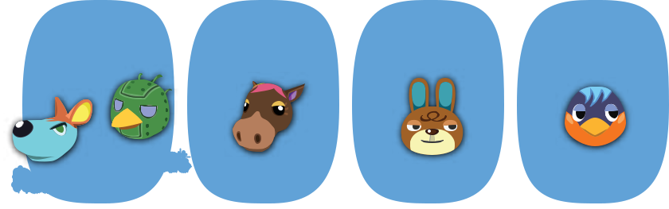

Rooney ^{Sprocket} Annalise Claude Robin
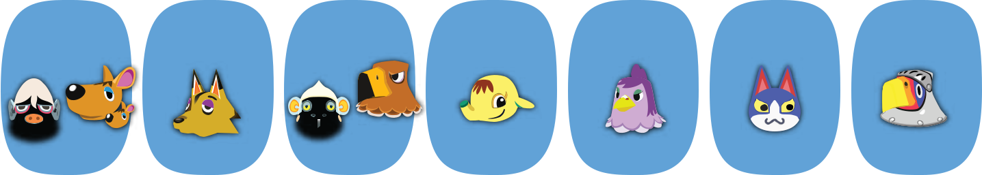

5 6 7 8 9 10 11

 Carrie  Buzz
_{Hans} Kyle Monty Eloise Becky Tom Sterling
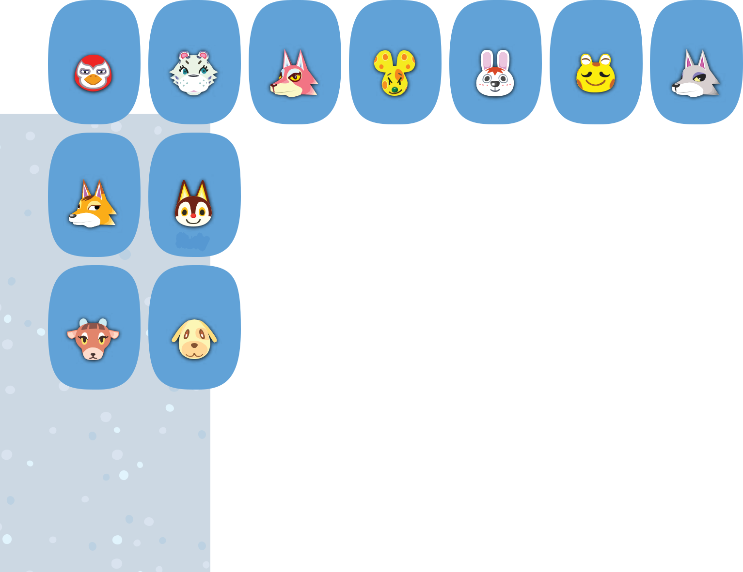

12 13 14 15 16 17 18

Lucha Bianca Freya Chadder Gabi Cousteau Fang

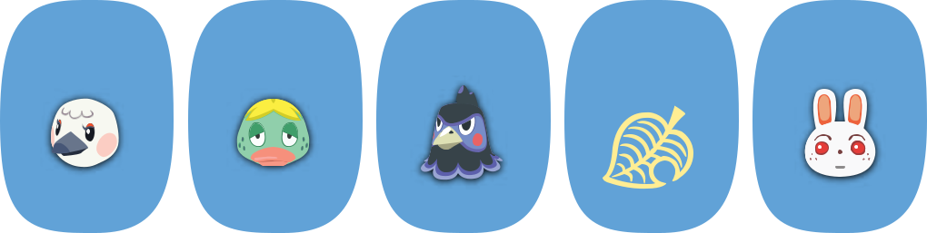

19 20 21 22 23 24 25

Chief Rudy Blanche Quillson Ken Ruby

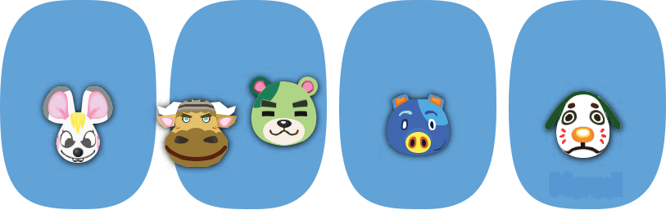

26 27 28 29 30 31

Pashmina Goldie Bella Vic ^{Murphy} Hugh Marcel


