HAPPYBIRTHDAY!

MINIBIRTHDAYCALENDAR
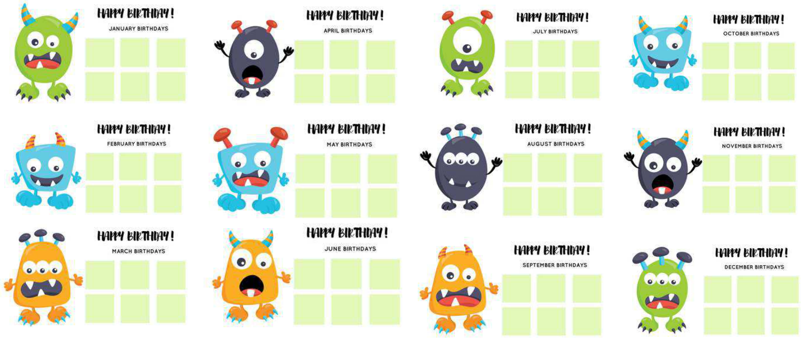
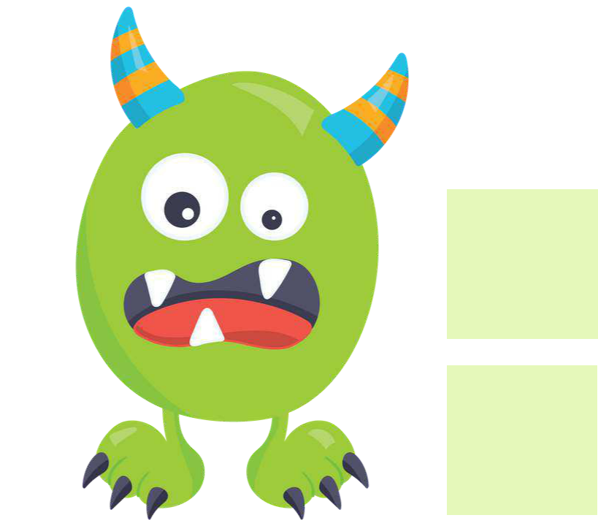
HAPPYBIRTHDAY!

JANUARYBIRTHDAYS



HAPPYBIRTHDAY!

FEBRUARYBIRTHDAYS


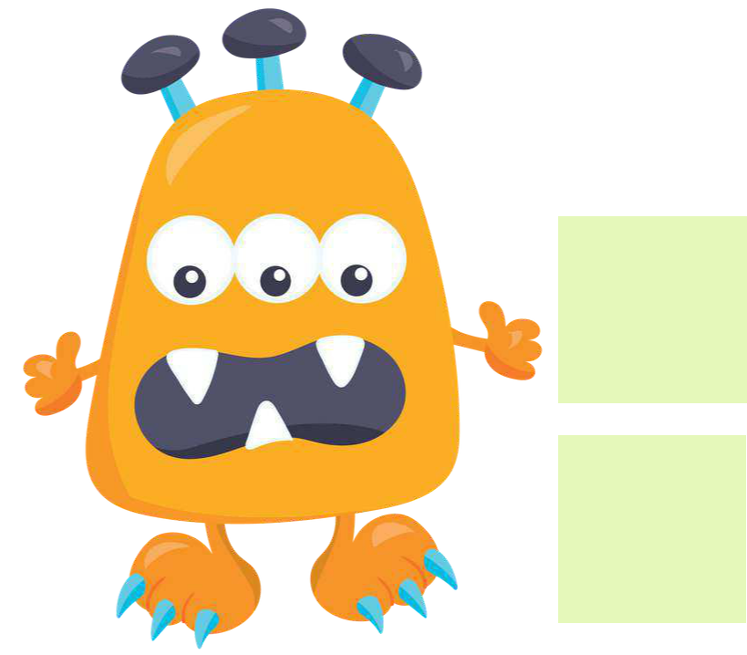
HAPPYBIRTHDAY!

MARCHBIRTHDAYS


HAPPYBIRTHDAY!

APRILBIRTHDAYS

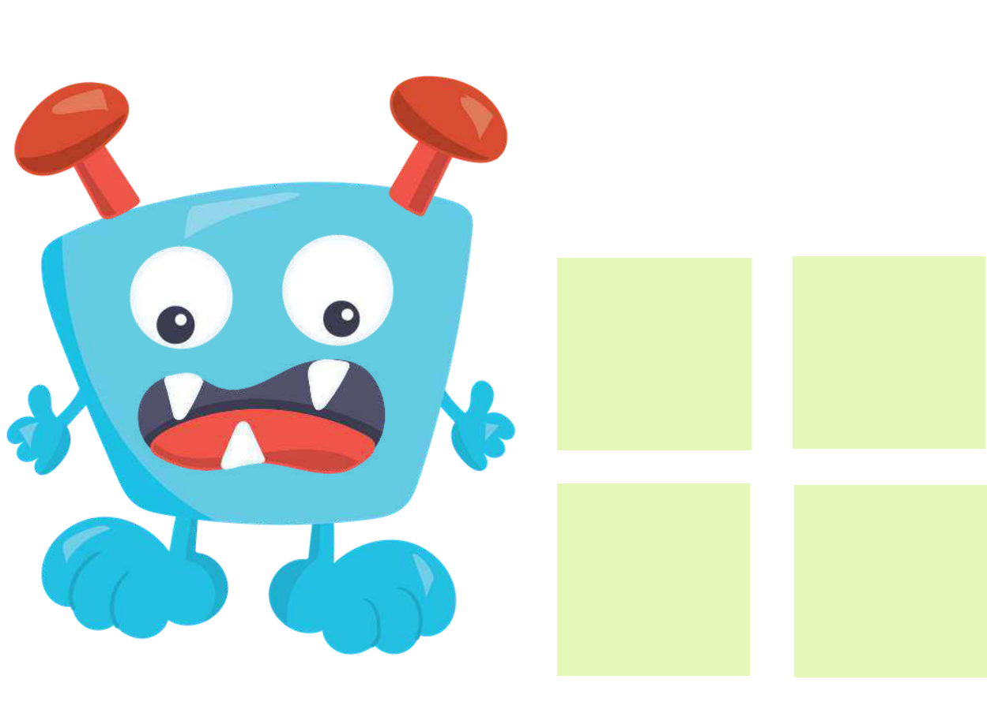
HAPPYBIRTHDAY!

MAYBIRTHDAYS


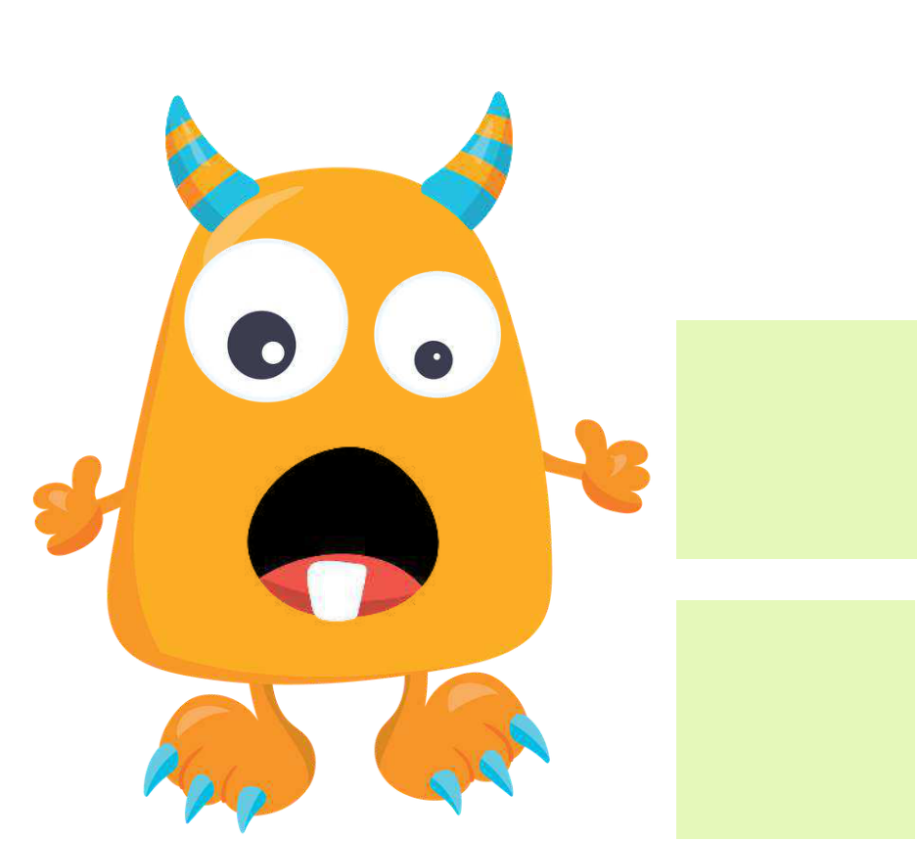
HAPPYBIRTHDAY!

JUNEBIRTHDAYS

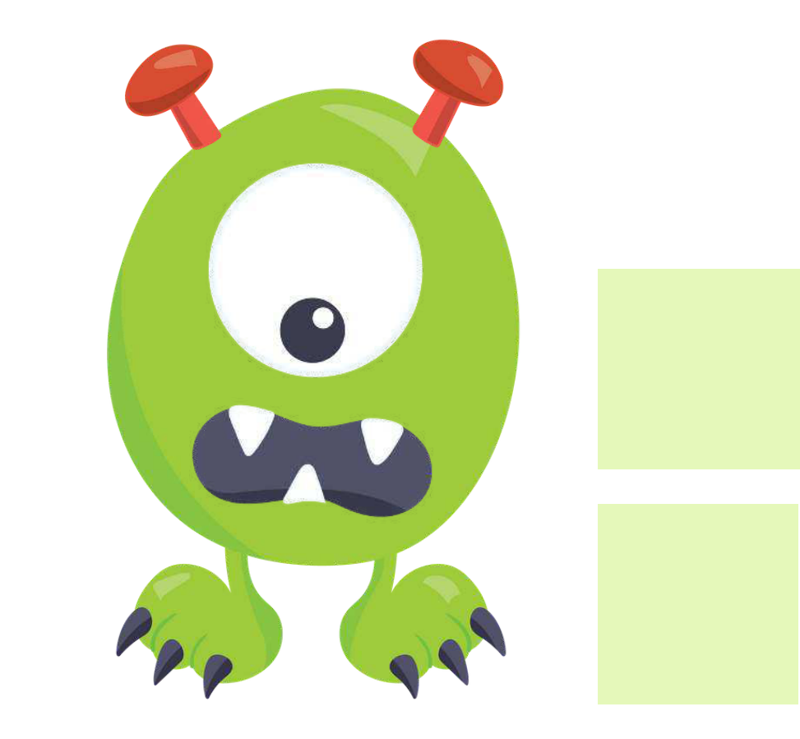
HAPPYBIRTHDAY!

JULYBIRTHDAYS


HAPPYBIRTHDAY!

AUGUSTBIRTHDAYS

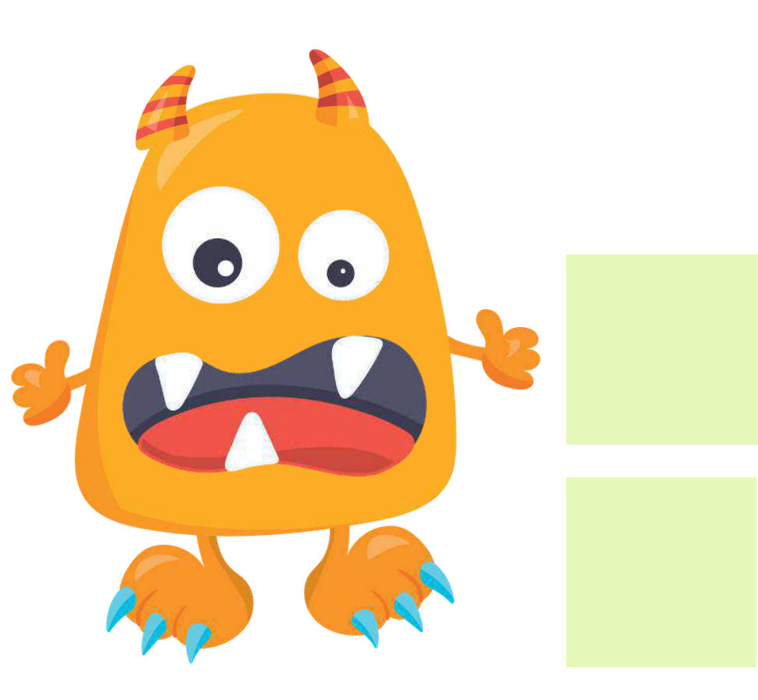
HAPPYBIRTHDAY!

SEPTEMBERBIRTHDAYS


HAPPYBIRTHDAY!

OCTOBERBIRTHDAYS


HAPPYBIRTHDAY!

NOVEMBERBIRTHDAYS


HAPPYBIRTHDAY!

DECEMBERBIRTHDAYS

