ASSET PURCHASE AGREEMENT

THIS ASSET PURCHASE AGREEMENT (the “Agreement”) is entered into as of the
____ day of ________________, 2014, by and between ______________________
______________________________________________________(“Purchaser”) and Hanscoms
Truck Stop, Inc. (“Seller”).

WITNESSETH:

WHEREAS, Seller presently operates convenience stores and fuel stations from various locations (the “Stores”) and is in the process of selling its interest in the real and personal property comprising certain of its Stores; and

WHEREAS, Purchaser desires to purchase from Seller, and Seller desires to sell to Purchaser, the location having an address of _______________________________________,
__________________________________________________________________and being
more particularly described in this Agreement and Schedule 1.1(a) (the “Location”), and the related personal property used to operate the Location, and the fuel and merchandise inventory which is owned by Seller and now situated at the Location, subject to terms and conditions contained herein;

NOW, THEREFORE, in consideration of the premises and the mutual representations, warranties, covenants and agreements set forth above and in the body of this Agreement, upon the terms and subject to the conditions hereinabove and hereinafter set forth, and other good and valuable consideration, the receipt and sufficiency of which are hereby acknowledged, the parties hereto agree as follows:

- PURCHASE AND SALE OF ASSETS

1.1 Assets to be Sold. On the terms and subject to the conditions set forth in this Agreement, at Closing, Seller shall sell, transfer and assign to Purchaser, and Purchaser shall purchase and receive from Seller, all of Seller’s right, title and interest in and to the following properties, assets and rights (except the Excluded Assets as hereinafter defined) related to or used or held for use in connection with the Location as the same may exist as of the Closing (hereinafter defined) (collectively, the “Assets”):

- Any real property owned or leased by Seller at the Location more particularly described on Schedule 1.1(a), together with all buildings, improvements, easements and appurtenances thereon and thereto (collectively, the “Real Property”);

- All inventories of merchandise, supplies and motor fuels owned by Seller present at the Location at Closing (collectively, the “Inventory”);

- Any furniture, fixtures, equipment and other tangible personal property owned by Seller and now situated at the Real Property, which may include the items listed in Schedule 1.1(b) (collectively, the “Tangible Personal Property”);

#24597639_V1
- All motor fuel fixtures and equipment now attached to or used in connection with the Real Property including, without limitation, any petroleum pumps and dispensers, underground fuel storage tanks, canopies, fuel lines, fittings and connections used in the ordinary course of business at the Real Property to receive, store and dispense motor fuels (collectively, the “Fuel Equipment”);

- Except as otherwise provided, to the extent that the same may be transferred pursuant to their respective terms and applicable laws, rules and regulations, any operating permits, underground storage tank notifications or registrations, if any, and other permits, licenses, filings and other governmental authorizations, agreements, contracts, and approvals;

- Any plans and specifications, surveys, blueprints and drawings in Seller’s possession now or as of the Closing related solely to any buildings and improvements at the Location; and

- Any and all rights, duties and obligations of Seller as contained in the real estate lease contracts as set forth on Schedule 1.1(g) hereof.

1.2 Excluded Assets. Seller and Purchaser expressly understand and agree that Seller is not hereunder selling, assigning, transferring, conveying or delivering to Purchaser any assets, properties, rights, contracts or claims other than the Assets including, without limitation, any of the following (collectively, the “Excluded Assets”):

- All minute books, tax returns, books of original entry and other corporate or entity records of Seller and its affiliates;

- All insurance policies and proceeds thereof payable to Seller or its affiliates (except to the extent of, and subject to, the provisions of this Agreement regarding a casualty loss to the Location following the date hereof);

- All cash and accounts receivable of Seller and its affiliates;

- All tax refunds, credits and benefits with respect to the Assets to the extent the same relate to periods before the Closing;

- All intangible personal property, trademarks, patents, copyrights and other intellectual property and property rights of Seller and its affiliates;

- All deposits and prepaid expenses of Seller and its affiliates;

- All properties, assets, rights and business interests of Seller and its affiliates situated at sites other than the Location; and

- All reimbursements to which Seller or its affiliates are entitled under any state petroleum storage tank fund for any costs incurred prior to the Closing.

#24597639_V1

2

- All personal property not owned or leased by the Seller which is located at the Real Property.

1.3 Assumed Liabilities. Subject to the limitations set forth herein and in Section 1.4 hereof, Purchaser hereby agrees, effective as of the Closing, to pay, perform and discharge, according to their terms, all of the terms, conditions, covenants and agreements on the part of Seller to be paid, performed and discharged on and after the Closing and those liabilities contained in those certain real estate lease contracts as set forth on Schedule 1.1(g) hereof; provided, however, that such liabilities shall include, and Purchaser expressly agrees to perform and discharge after the Closing (subject to Section 8.6 hereof), all obligations of Seller and all obligations as owner of the Fuel Equipment and as property owner or lessee of the Real Property related to the investigation or remediation of any petroleum products and/or hazardous substances in, under or near the Real Property to the extent required by applicable Law (collectively, the “Assumed Liabilities”). The Assumed Liabilities shall in no event include any liabilities and obligations arising out of the foregoing in connection with any transactions or events occurring before the Closing (except as specifically provided herein).

1.4 Excluded Liabilities . The transaction contemplated by this Agreement is the purchase and sale of assets and not a de facto merger of Seller and Purchaser. Purchaser is not a successor in interest to Seller, and neither Seller nor any shareholder, officer, director, manager, member or partner of Seller, as the case may be, shall have any continuing participation in the ownership or management of any Real Property transferred hereunder after the Closing. Except as specifically set forth in this Agreement, Seller and Purchaser agree that Purchaser shall not assume or become liable for any debts, liabilities or obligations of any kind of Seller existing on the Closing Date or thereafter incurred by Seller, whether known or unknown, absolute or contingent, mature or unmatured, liquidated or unliquidated, or accrued or pending including, without limitation, any debts, liabilities or obligations with respect to the Excluded Assets (collectively, the “Excluded Liabilities”).

1.5 Definitions. Capitalized terms not defined elsewhere in this Agreement are defined in Article XII hereof.

- PURCHASE PRICE AND ESCROW

2.1 As consideration for the Assets Purchaser shall pay to Seller the sum of $________________ (the “Purchase Price”), which sum shall not include the value of the
Inventory as determined according to Section 3.4 hereof (the “Inventory Value”), subject to adjustment as provided in this Agreement.

2.2 Purchaser has this day deposited with Tranzon Auction Properties as escrow agent (the “Escrow Agent”) the sum of $25,000.00 (the “Initial Deposit”) and Purchaser shall, within five (5) business days of the public auction, deposit with the Escrow Agent, via cashier’s check or wire transfer, a sum (the “Additional Deposit”) which will, together with the Initial Deposit, equal ten percent (10%) of the Purchase Price (the Initial Deposit and the Additional Deposit being collectively referred to as the “Deposit”).

#24597639_V1

3

2.3 The balance of the Purchase Price plus the Inventory Value (collectively, the “Total Consideration”) shall be paid by Purchaser to Seller at Closing, subject to adjustment as provided herein. The Deposit shall be held in a non-interest bearing escrow account by Escrow Agent. At the Closing, the Deposit will be disbursed to Seller as a credit against the Total Consideration. If the Closing does not occur for any reason, then the Deposit will be distributed according to Article X hereof.

2.4 All payments by Purchaser to Seller under this Agreement at the Closing shall be made by bank check payable to Seller, or as Seller may direct in writing, or by wire transfer of immediately available funds to Seller, or as Seller may direct in writing, before the Closing.

2.5 The Total Consideration shall be allocated between and among the Inventory based on the Inventory Value; the Tangible Personal Property based on its book value at the Closing; the Fuel Equipment based on its book value at the Closing; and the balance of the Total Consideration shall be allocated to the Real Property setting forth in detail the allocation of the fair market value of the real estate and the allocation of the value of the improvements located thereon. Subject to the requirements of any applicable tax Law and the rulings of any applicable governmental agency, all tax returns and reports filed by Purchaser and Seller shall be prepared consistently with the foregoing allocation. Seller and Purchaser agree to notify the other in the event that any adjustment is so required or imposed by applicable Law.

- PHYSICAL COUNT PROCEDURES AND VALUATION OF INVENTORY

3.1 Physical Count Inventory Procedures. Not more than three (3) days before the Closing, unless otherwise agreed in writing by Seller and Purchaser, a physical count of the Inventory at the Location (the “Physical Inventory”) shall be taken by an independent inventory company as identified by Seller (the “Independent Auditor”). Purchaser will pay the fee charged by the Independent Auditor. Unless otherwise agreed in writing by Seller and Purchaser, the procedures for conducting the Inventory count and valuing the Inventory are set forth in this Article III.

3.2 Cut-over Time. Transfer of Inventory and operations at the Location and transfer of ownership of any real estate in connection therewith, if applicable, will be effective as of the commencement of business on the day of the Closing or, if the Location operates on a 24-hour basis, as of its normal shift beginning as close as practicable to 5:00 a.m. on the day of the Closing (the “Cut-over Time”). All deliveries of Inventory to, and all sales of Inventory at, the Location before the Cut-over Time shall be for the benefit of and chargeable to the account of Seller and after the Cut-over Time shall be for the benefit of and chargeable to the account of Purchaser. To the extent that the Physical Inventory at the Location occurs before or after the Cut-over Time, the amount of Merchandise Inventory, Supplies Inventory and Petroleum Inventory determined for the Location shall be adjusted to reflect deliveries and sales between the time of the actual count or measurement of Merchandise Inventory, Supplies Inventory and Petroleum Inventory and the Cut-over Time.

3.3 Physical Inventory Procedures.

#24597639_V1

4

- Observation Rights. Both Seller’s and Purchaser’s representatives shall have the right to be present to observe the taking of any Physical Inventory.

- Merchandise and Supply Inventory. A physical count of actual quantities of Merchandise Inventory and Supplies Inventory will be taken by the Independent Auditor as close as practicable to the Cut-over Time. Damaged and out of date Merchandise and Supplies Inventory shall not be purchased by Purchaser.

- Petroleum Inventory. A measurement of the amount of the Petroleum Inventory at the Location shall be made as close as practicable to the Cut-over Time. Arrangements will be made to have employees at the Location take and record console and dollar/gallon readings and mechanical pump readings as of the Cut-over Time, as verified by the Independent Auditor. The Petroleum Inventory will be measured by automatic tank gauging system for reading the underground tanks. Manual sticking of the tanks shall be done for the sole purpose of determining sediment and water levels, which shall be deducted from the automatic tank gauging gallon computation to compute the Petroleum Inventory. Simultaneously, retail pump meter readings will be taken and recorded. All tank inventories shall be taken at ambient conditions and calculated with any automatic equipment which is available at the Location. A comparison of total Location volumes as calculated from the Physical Inventory will be compared to the Location’s book inventory and sales records. Excessive variances should be questioned and, if necessary, a second Physical Inventory shall be taken to ensure the accuracy of the reported readings.

3.4 Valuation of Inventory. The Inventory Value shall be the sum of the following:

- Merchandise Inventory. Merchandise Inventory (other than beer, wine, Food Services Items (as hereinafter defined) and cigarettes) will be priced at seventy percent (70%) of Seller’s retail price of each item and Food Service Items and cigarettes will be priced at Seller’s cost. Beer, wine and other alcoholic beverages will be priced at eighty percent (80%) of Seller’s retail price. The term “Food Service Items” shall mean any food or beverage item prepared for human consumption and served for consumption either on or off the Location. The term “Food Service Items” shall exclude any food or beverage wholly packaged off the premises except (a) sandwiches, or (b) beverages in unsealed containers.

- Supplies Inventory. The normal operating level of supplies will be maintained and shall be valued at Seller’s cost.

- Cash Drawer. The amount of the Cash Drawer shall be included in the value of the Inventory for such Location.

- Petroleum Inventory. The Petroleum Inventory will be valued utilizing Seller’s cost of each grade of product for the last pre-Closing delivery to the Location plus the current freight rate charged to transport the product to the Location. The total value of Petroleum Inventory is to include all state sales and state and federal excise taxes (“Fuel Taxes”), whether or not paid by Seller and whether or not Purchaser holds an

#24597639_V1

5

exemption certificate. To the extent not previously paid by Seller, all Fuel Taxes included in the Inventory Value will be remitted by Seller to the applicable taxing jurisdiction promptly following the Closing.

- Survival. The obligations of Seller under Sections 3.4(d), 3.4(e) and this 3.4(f) shall survive the Closing.

3.5 Costs. Purchaser shall be solely responsible for all of the costs and expenses of the Inventory audit taken at the Location and shall indemnify, defend and hold harmless Seller and its affiliates from and against all such costs and expenses. This obligation shall survive the Closing.

IV. CLOSING, DELIVERIES AND ADJUSTMENTS

4.1 Closing. The purchase and sale of the Assets (the “Closing”) shall occur on a date and time as designated in writing by Seller to Purchaser with at least five (5) business days’ notice, but in no event later than the date that is forty-five (45) days following the date of execution of this Agreement, at the offices of Shaines & McEachern, PA, 282 Corporate Drive, Pease International Tradeport, Portsmouth, NH 03801. The actual date on which the Closing occurs is referred to herein as the “Closing Date.”

4.2 Proceedings at Closing. All proceedings to be taken and any documents to be executed and delivered by any of the parties at the Closing shall be deemed to have been taken, executed and delivered simultaneously, and no proceedings shall be deemed taken nor any documents executed or delivered until all have been taken, executed and delivered. Upon Purchaser’s written request to Seller, Seller may, in its sole and absolute discretion, extend the date of the Closing for up to an additional thirty (30) day period.

4.3 Deliveries by Seller to Purchaser. At the Closing, Seller shall deliver to Purchaser the following, duly executed:

- an executed deed with respect to the Real Property (the “Deed”), in the form of a quitclaim deed or comparable deed customary in the state where the property is located, or (if applicable) an assignment in such form as Seller may reasonably prescribe of the ground lease pursuant to which Seller derives its leasehold interest in the Real Property, in either case conveying Seller’s interest to the Real Property without further representation or warranty;

- an executed Bill of Sale for the Assets other than the Real Property;

- an executed settlement statement showing all components of the Total Consideration and itemizing the closing costs and prorations contemplated by this Agreement (the “Settlement Statement”); and

- with respect to Seller, a copy of a certificate of good standing or legal existence from the state where the Location is situated, dated as of a date reasonably close to the Closing Date.

#24597639_V1

6

4.4 Deliveries by Purchaser to Seller. At the Closing, Purchaser shall deliver to Seller the following, duly executed:

- immediately available funds in the amount of the balance of the Total Consideration referred to in Section 2.3 hereof;

- the Settlement Statement; and

- with respect to a Purchaser that is an entity, a copy of a certificate of good standing or legal existence from Purchaser’s state of incorporation and from the state where the Location is situated, dated as of a date reasonably close to the Closing Date.

4.5 Payment of Excise, Sales and Transfer Taxes. All Excise, Transfer and Sales Taxes imposed on the transfer of the Assets, whether real property or personal property, shall be paid by Purchaser, and Purchaser and Seller shall file such tax and information returns as each may be required to file in connection therewith according to applicable Law. Purchaser shall indemnify, defend and hold Seller harmless for any liability that Seller may incur as a result of Purchaser’s failure to pay any such taxes directly to the appropriate taxing authorities. As used herein, these taxes shall include Federal, state and local excise, sales, and all other documentary stamp, conveyance, transfer, and other taxes or charges imposed on the sale of the Assets and the recording of instruments of transfer but shall exclude income, franchise, or like taxes levied on or measured by the net income of a party, which taxes shall be the obligation of the party receiving such income. Notwithstanding the foregoing, Seller shall be responsible to pay the documentary stamp transfer tax imposed on the sale of the Real Property.

4.6 Property Tax and Assessment Prorations. All applicable real estate taxes, ad valorem property taxes etc. which are due as of the date of closing and which constitute a lien on any of the Assets being transferred by Seller to Purchaser, shall be prorated between the parties as of the Closing Date.

4.7 Rents, Deposits and Prepaid Expenses. Rents, deposits, prepaid expenses, and similar items relating to the Assets and benefiting either Seller or Purchaser shall be prorated between the parties as of the Closing Date.

4.8 Utilities. Charges for water, gas, power, light and other utility services shall be the responsibility of Seller with respect to service up to the Closing Date and shall be Purchaser’s responsibility with respect to service on and after the Closing Date. The parties shall endeavor to obtain meter readings or other evidence of the amounts of due for utilities before the Closing but if such readings or evidence cannot be obtained before the Closing, then the Closing shall be completed without adjustment of the same, and upon obtaining such reading or evidence after Closing, Seller shall pay to Purchaser any utility charges incurred before the Closing based upon such reading. Purchaser shall transfer all utilities from Seller’s name within three (3) days following the Closing or Seller shall have the right to order the disconnection of such services. Seller’s utility deposits are, and shall remain, the property of Seller, and Purchaser shall be responsible for providing its own utility deposits.

#24597639_V1

7

- REPRESENTATIONS AND WARRANTIES OF SELLER Seller hereby represents and warrants to Purchaser as follows:

5.1 Organization and Good Standing. Seller is a corporation duly organized and validly existing and in good standing under the Laws of the of the state they are licensed to conduct business in. Seller is duly authorized to do business in each State where Locations are being offered for sale, and has the power and authority to enter into and to perform its obligations under this Agreement and each other agreement, document, instrument or certificate contemplated by this Agreement or to be executed by Seller in connection with the consummation of the transactions contemplated by this Agreement (all such other agreements, documents, instruments and certificates required to be executed by Seller being hereinafter referred to, collectively, as the “Seller Documents”).

5.2 Title to Assets. Seller is the owner of the Assets and shall convey at Closing title to the Assets free and clear of all liens and encumbrances, subject only to Permitted Encumbrances.

VI. REPRESENTATIONS AND WARRANTIES OF PURCHASER

Purchaser represents and warrants to Seller as follows:

6.1 Organization and Good Standing. Purchaser is a _________________________
duly organized, validly existing, and in good standing under the Laws of its state of organization or incorporation and has the organizational power and authority to own its property and to carry on its business as now conducted and to enter into and to perform its obligations under this Agreement and each other agreement, document, instrument or certificate contemplated by this Agreement or to be executed by Purchaser in connection with the consummation of the transactions contemplated by this Agreement (all such other agreements, documents, instruments and certificates required to be executed by Purchaser being hereinafter referred to, collectively, as the “Purchaser Documents”) and to perform fully its obligations hereunder and thereunder.

6.2 Due Authorization; Enforceability; Absence of Conflicts. The execution, delivery and performance by Purchaser of this Agreement and each Purchaser Document has been duly authorized and approved by all necessary action on the part of Purchaser. This Agreement has been, and the Purchaser Documents will be at or before the Closing, duly executed and delivered by Purchaser and (assuming the due authorization, execution and delivery by the other parties hereto and thereto) this Agreement constitutes, and the Purchaser Documents when so executed and delivered will constitute, legal, valid and binding obligations of Purchaser, enforceable against Purchaser according to their respective terms. None of the execution and delivery by Purchaser of this Agreement and the Purchaser Documents, or the consummation of the transactions contemplated hereby or thereby, or compliance by Purchaser with any of the provisions hereof or thereof, will (i) conflict with, or result in the breach of, any provision of the organizational or governing documents of Purchaser, (ii) conflict with, violate, result in the breach or termination of, or constitute a default under, any agreement to which Purchaser is a party or by which it or any of its properties or assets is bound or subject or (iii) constitute a violation of any Law applicable to Purchaser.

#24597639_V1

8

6.3 Consents and Approvals. No consent, waiver, approval, order, permit or authorization of, or declaration or filing with, or notification to, any person or governmental body is required on the part of Purchaser in connection with the execution and delivery of this Agreement or the Purchaser Documents or the compliance by Purchaser with any of the provisions hereof or thereof.

6.4 Litigation. There is no legal proceeding pending or, to the knowledge of Purchaser, threatened against Purchaser that seeks to enjoin or obtain damages with respect to the consummation of the transactions contemplated by this Agreement or that questions the validity of this Agreement, the Purchaser Documents or any action taken or to be taken by Purchaser in connection with the consummation of the transactions contemplated hereby or thereby.

6.5 Brokerage Fees. Purchaser represents and warrants that it has not acted in a manner that could cause Seller to incur liability to any person for brokerage commissions, finders fees or other remuneration in connection with the sale of the Assets or the transactions contemplated by this Agreement and Purchaser shall indemnify, defend and hold Seller harmless with respect to any such claims resulting from Purchaser’s actions.

6.6 Financial Capacity. Purchaser has the net worth, financial standing, access to required liquidity and the necessary borrowing capacity to consummate the transactions contemplated by this Agreement.

VII. DUE DILIGENCE AND DISCLAIMER OF WARRANTIES

7.1 Confidential Information. Purchaser acknowledges that it has completed its due diligence investigation of the Location and, in connection with such due diligence, has received confidential and proprietary information about the Location and other convenience stores and fuel stations operated by Seller and its affiliates (the “Confidential Information”). In addition to the terms of this Agreement, Purchaser shall continue to be bound by all agreements under which it received such Confidential Information. If this Agreement is terminated before the Closing, then Purchaser promptly shall return to Seller or destroy all Confidential Information and shall not retain copies thereof, including all information, surveys, evaluations and financial reports.

7.2 Notices to Governmental Agencies. If Purchaser’s due diligence reveals any condition at the Location that in Purchaser’s judgment may require disclosure to any governmental agency or authority, then Purchaser shall immediately notify Seller thereof in writing with commercial reasonable detail supporting Purchaser’s findings. In such event, Seller, and not Purchaser, Purchaser’s agents, or anyone acting on Purchaser’s behalf, shall make such legal determinations regarding such disclosures as Seller deems appropriate.

7.3 Purchaser Acknowledgements. Purchaser specifically acknowledges that, except for Seller’s representations in Article V, Purchaser is not relying on any representations or warranties of any kind whatsoever, express or implied, from Seller or any broker, accountants, attorneys or other agents as to any matters concerning the Assets including, but not limited to: (a) the condition or safety of the Real Property or any improvements thereon, including plumbing, sewer, heating and electrical systems, roofing, air conditioning, if any, foundations, soils and

#24597639_V1

9

geology, lot size, or suitability of the Real Property or its improvements for a particular purpose;
- whether the appliances, if any, plumbing or utilities are in working order; (c) the habitability or suitability for occupancy of any structure and the quality of its construction; (d) the fitness or condition of any tangible personal property; (e) whether the fixtures or improvements, including the Fuel Equipment, are structurally sound, in good condition or state of repair, or in compliance with applicable Laws; (f) the profits or losses relating to operations at the Location; (g) the legal or tax consequences of this Agreement or the transactions contemplated hereby; (h) the environmental condition of the Real Property including, but not limited to, the possible presence of petroleum products or hazardous substances in, under, adjacent to or near the Real Property; and (i) the completeness or accuracy of any information provided to Purchaser by Seller or its agents. Purchaser understands the legal significance of the foregoing provisions and acknowledges that they are a material inducement to Seller’s willingness to enter into this Agreement and to consummate the transactions contemplated hereby.

7.4 DISCLAIMER OF REPRESENTATIONS AND WARRANTIES. PURCHASER ACKNOWLEDGES THAT PURCHASER HAS BEEN GIVEN THE OPPORTUNITY TO EXAMINE ALL ASPECTS OF THE REAL PROPERTY AND OTHER ASSETS AND TO REVIEW ALL FILES CONCERNING THE LOCATION MAINTAINED BY SELLER AND ITS ENVIRONMENTAL CONSULTANTS AND ALL STATE AGENCIES HAVING JURISDICTION OVER THE LOCATION BEFORE PURCHASER’S EXECUTION AND DELIVERY OF THIS AGREEMENT. ACCORDINGLY, PURCHASER AGREES THAT THE ASSETS SHALL BE SOLD AND THAT PURCHASER SHALL ACCEPT POSSESSION OF THE ASSETS AT CLOSING STRICTLY ON AN “AS IS, WHERE IS, WITH ALL FAULTS” BASIS, WITH NO RIGHT OF SET-OFF OR REDUCTION IN THE TOTAL CONSIDERATION EXCEPT FOR ADJUSTMENTS EXPRESSLY CONTEMPLATED AND SET FORTH IN WRITING BY THIS AGREEMENT AND THAT, EXCEPT FOR SELLER’S LIMITED REPRESENTATIONS SET FORTH IN ARTICLE V HEREOF, THE SALE OF ASSETS AND OTHER TRANSACTIONS CONTEMPLATED BY THIS AGREEMENT SHALL BE WITHOUT REPRESENTATION OR WARRANTY OF ANY KIND, EXPRESS OR IMPLIED, INCLUDING ANY WARRANTY OF INCOME POTENTIAL, OPERATING EXPENSES, USES, MERCHANTABILITY OR FITNESS FOR A PARTICULAR PURPOSE, AND SELLER DOES HEREBY DISCLAIM AND RENOUNCE ANY SUCH REPRESENTATION OR WARRANTY.

VIII. ADDITIONAL AGREEMENTS AND COVENANTS

8.1 Title to Real Property. At the Closing, Purchaser shall obtain record title to Seller’s interest in the Real Property, subject only to the Permitted Encumbrances.

8.2 Announcements. Before the Closing, neither Seller nor Purchaser shall make any public announcements concerning the execution and delivery of this Agreement or the transactions contemplated hereby without first obtaining the prior written consent of the other.

8.3 Insurance and Casualty. Seller covenants and agrees to keep the Assets insured, at Seller’s expense, in such amounts as presently insured through the Closing. On any material damage to or destruction of the Real Property or any portion thereof before the Closing, the

#24597639_V1

10

Closing shall at Seller’s sole discretion nevertheless proceed; provided, however, that unless before the Closing the same shall have been restored by Seller to its condition as of the date hereof, at the Closing, Seller shall pay over or assign to Purchaser any insurance proceeds due Seller as a result of such damage or destruction (without recourse to Seller) and Purchaser shall assume responsibility for such repair and shall receive a credit against the Total Consideration for any applicable policy deductible or uninsured damage up to a maximum credit equal to the difference between the amount of the Total Consideration and the amount of the insurance proceeds payable to Seller and assigned to Purchaser hereunder. At Purchaser’s sole expense, Purchaser covenants and agrees to obtain hazard and public liability insurance coverage upon the Assets, in such amounts as presently insured, effective at the Cut -over Time, and to provide a certificate evidencing such insurance to Seller at least ten (10) days prior to the Closing.

8.4 Condemnation. If before the Closing, any part of the Real Property is taken, or noticed for taking, by eminent domain, then Seller shall promptly give Purchaser written notice thereof and the Closing shall, at Seller’s sole discretion, nevertheless proceed; provided, however, Seller shall, at the Closing, deliver to Purchaser the net proceeds of any award or other proceeds of such taking which may have been collected by Seller before the Closing or, if the award or other proceeds have not been fully collected, then Seller shall deliver to Purchaser an assignment (without recourse to Seller) of Seller’s right to any such award or other proceeds which may be payable as a result of any such taking, and Purchaser shall pay to Seller at the Closing the full Total Consideration without offset or reduction.

8.5 Mutual Cooperation. From and after the date hereof and until the Closing Date:

- Purchaser hereby covenants and agrees with Seller that Purchaser shall use its commercially reasonable efforts to cause the consummation of the transactions contemplated hereby according to the terms and conditions hereof, and Seller hereby covenants and agrees with Purchaser that Seller shall use its commercially reasonable efforts to cause the consummation of the transactions contemplated hereby according to the terms and conditions hereof.

- Seller and Purchaser shall each prepare any and all documentation and shall supply any and all information required by any governmental authority or agency thereof to be filed by Purchaser or Seller, as the case may be, before conveying the Assets as contemplated hereby, and shall timely make the necessary filings or applications relating thereto. Purchaser and Seller agree to cooperate with each other in the completion, execution and submission of any such filings or applications.

8.6 Environmental Status. In accordance with Section 1.3 hereof Purchaser agrees to purchase the Real Property “As Is” and “Where Is” and Seller shall have no obligation of indemnity, contribution or otherwise to Purchaser. Purchaser hereby releases and discharges Seller for any liabilities, costs, expenses, losses, damages, or claims, whether arising at law or in equity, known or unknown, or arising before or after the closing, arising from or relating to the environmental condition of the Real Property, or the adjacent environs.

8.7 Environmental Site Assessment. (a) Subject to the terms of this Section 8.7, Purchaser, at its sole expense, shall have the right to enter upon a Location at reasonable times to

#24597639_V1

11

perform an Environmental Site Assessment (“ESA”) at the Location before the Closing. Any ESA performed by Purchaser shall be completed, with results forwarded to Seller if so requested, not later than the end of business on the date which is thirty (30) days after the execution date of this Agreement. TIME IS OF THE ESSENCE FOR PURCHASER’S ESA.

- Purchaser understands and agrees that any access to a Location shall occur at reasonable times agreed by Seller and Purchaser after reasonable prior written notice to Seller (which shall, in any event, be at least five (5) days in advance) and shall be conducted so as not to unreasonably interfere with the use and operation of the Location. Purchaser must provide Seller with a reasonable detailed scope of the tests and work to be conducted as part of the ESA at the Location (together with any plans and specifications and permits necessary for such tests or work), which must be approved by Seller exercising its reasonable commercial discretion, prior to the commencement of any work or entry by Purchase onto the Location. Seller shall have, unless Seller elects to waive such right, the right to accompany Purchaser during the ESA at the Location. Any ESA performed at the Location pursuant to the terms of this Agreement shall be done at Purchaser’s sole cost and expense by agents, consultants or contractors hired by Purchaser who are reasonable satisfactory to Seller. Purchaser shall, at all times prior to Closing, require its consultants, contractors and others engaged by Purchaser to conduct the ESA to obtain and maintain comprehensive and general liability insurance, in type, form, and amount reasonably satisfactory to Seller and naming Seller as an additional insured.

- Purchaser shall provide Seller with copies of all reports, tests or other documents it prepares or has prepared for it in connection with the ESA. Purchaser or any of its agents, consultants or contractors shall not report any findings of the ESA of the environmental condition of the Location to the applicable governmental authority, unless required by law. If any contamination or environmental condition is discovered as a result of the ESA which would interfere with ongoing operation of the impacted property the parties shall work together to resolve the condition as required by law or regulation which shall not, in any event, delay the closing. Alternatively, and in its sole discretion, Seller may terminate this contract and refund the deposit paid to date by Purchaser with no further liability to the Purchaser.

- Purchaser at its sole cost and expense shall return the Location to its previous condition upon completion of its activities in connection with the ESA and shall indemnify and hold Seller harmless for the acts of Purchaser and/or Purchaser’s agents, employees or contractors in performing the ESA. Purchaser shall promptly, upon notice from Seller, reimburse Seller for all sums, costs and expenses, including court costs and reasonable attorney’s fees and expenses, incurred by Seller attributable to or caused by Purchaser’s ESA at the Location. Purchaser’s failure to conduct an ESA shall not be a reason for Purchaser’s refusal to consummate a transaction and Purchaser’s failure to perform or complete an ESA shall not extend the date for the Closing.

#24597639_V1

12

IX. CONDITIONS PRECEDENT TO CLOSING.

9.1 Seller’s Conditions Precedent. The obligations of Seller to consummate the transactions contemplated by this Agreement are subject to each of the following conditions:

- The representations and warranties made by Purchaser in this Agreement shall be true in all material respects when made and on and as of the Closing Date as though such representations and warranties were made on and as of the Closing Date. Seller shall have received from Purchaser at Closing a satisfactory certificate to such effect signed by a duly authorized officer of Purchaser.

- Purchaser shall have performed and complied in all material respects with all provisions of this Agreement required to be performed or complied with by Purchaser before or at the Closing. Seller shall have received from Purchaser at the Closing a satisfactory certificate to such effect, signed by a duly authorized officer of Purchaser.

- Purchaser shall have executed and delivered to Seller at the Closing each of the Purchaser Documents and such additional documents as may be reasonably requested by Seller in order to consummate the transactions contemplated by this Agreement.

- Purchaser shall have paid or made provisions acceptable to Seller for the payment of all fees, costs and expenses which are the responsibility of Purchaser hereunder.

9.2 Purchaser’s Conditions Precedent . The obligations of Purchaser to consummate the transactions contemplated by this Agreement are subject to each of the following conditions:

  - The representations and warranties made by Seller in this Agreement shall be true in all materials respects when made and on and as of the Closing Date as though such representations and warranties were made on and as of the Closing Date. Purchaser shall have received from Seller at Closing satisfactory certificates to such effect signed by a duly authorized officer of Seller.

  - Seller shall have performed and complied in all material respects with all provisions of this Agreement required to be performed or complied with by Seller before or at the Closing. Purchaser shall have received from Seller at the Closing satisfactory certificates to such effect signed by a duly authorized officer of Seller.

  - Seller shall have executed and delivered to Purchaser at the Closing each of the Seller Documents and such additional documents as may be reasonably requested by Purchaser in order to consummate the transactions contemplated by this Agreement.

- DEFAULT; REMEDIES

10.1 Seller Inability to Convey. If Seller shall be unable to convey title to the Assets as provided herein or shall otherwise be unable to satisfy the conditions to Purchaser’s obligation to consummate the transactions contemplated by this Agreement, then Seller shall have the right

#24597639_V1

13

by delivery of written notice to Purchaser to extend the date established herein for the Closing for a period not to exceed sixty (60) days. If at the end of such period, Seller shall nonetheless be unable to convey such title to the Assets or to otherwise satisfy such conditions, then Purchaser’s sole remedy shall be either (i) to accept such title as Seller is able to convey (without any claim on its part for abatement or reduction of the Total Consideration) or (ii) to terminate this Agreement according to the provisions hereof, whereupon the Deposit shall promptly be returned to Purchaser, all obligations of the parties hereunder shall cease and this Agreement shall be null and void and of no further force and effect, without recourse to either party.

10.2 Purchaser Repudiation or Default. In recognition of the fact that damages for a repudiation or breach by Purchaser may be difficult to determine, if Purchaser shall fail or refuse to consummate the transactions contemplated hereby (for any reason or for no reason) or shall otherwise default in the performance of Purchaser’s obligations hereunder, then Purchaser agrees
- that Purchaser shall be liable to Seller in an amount equal to ten percent (10%) of the Purchase Price (the “Agreed Damages”), as liquidated damages and not as a penalty, and (b) that Seller may apply any amount received by the Escrow Agent or otherwise as a credit against the Agreed Damages, without prejudice to the right of Seller to pursue its remedies, at law and in equity, against Purchaser for the full amount of the Agreed Damages. Seller agrees to accept payment of the Agreed Damages by Purchaser, whether by application of the Deposit as a credit or otherwise, in full settlement and discharge of all obligations of Purchaser hereunder, without further recourse at law or in equity.

10.3 Waiver of Remedies. Seller and Purchaser specifically waive any and all right to specific performance of this Agreement or to maintain any cause of action other than (i) Purchaser’s right to seek return of any moneys deposited according to the provisions of this Agreement, or (ii) Seller’s right to seek delivery of any moneys deposited by Purchaser according to the provisions of this Agreement to Seller for credit against the Agreed Damages and, to the extent that any such moneys are less than the Agreed Damages, to seek recovery of the balance of the Agreed Damages from Purchaser as liquidated damages according to the provisions hereof.

10.4 ACKNOWLEDGEMENT AS TO LIQUIDATED DAMAGES. PURCHASER AND SELLER HEREBY ACKNOWLEDGE AND AGREE THAT, ESPECIALLY BECAUSE THIS AGREEMENT IS PART OF A SERIES OF TRANSACTIONS WHEREBY OTHER ASSETS OF SELLER AND ITS AFFILIATES WILL BE SOLD AND ITS OPERATIONS SIGNIFICANTLY ALTERED, THE AMOUNT OF SELLER’S DAMAGES IN THE EVENT OF A BREACH OF THIS AGREEMENT BY PURCHASER WOULD BE DIFFICULT OR IMPOSSIBLE TO DETERMINE AND THAT AN AMOUNT EQUAL TO THE AGREED DAMAGES IS THE PARTIES’ BEST AND MOST ACCURATE ESTIMATE OF THE DAMAGES THAT SELLER WOULD SUFFER IN THE EVENT THAT THE TRANSACTIONS PROVIDED FOR IN THIS AGREEMENT FAILS TO CLOSE AS A RESULT OF THE BREACH OR DEFAULT BY PURCHASER AND THAT SUCH ESTIMATE IS REASONABLE UNDER THE CIRCUMSTANCES EXISTING AS OF THE DATE OF THIS AGREEMENT AND UNDER THE CIRCUMSTANCES THAT SELLER AND PURCHASER REASONABLY ANTICIPATE WOULD EXIST AT THE TIME OF SUCH

#24597639_V1

14

BREACH. TO CONFIRM THE FOREGOING, PURCHASER AND SELLER HEREBY INITIAL THIS AGREEMENT AS FOLLOWS:

PURCHASER: ____________________

SELLER: ________________________

XI. POST CLOSING AGREEMENTS.

11.1 Performance by Seller and Purchaser. The representations, warranties, covenants and agreements of Seller shall merge in the performance of Seller at the Closing, and the delivery by Seller of the Seller Documents as contemplated by Section 4.3 hereof shall constitute full performance of all of Seller’s obligations hereunder, and none of the representations, warranties, covenants and agreements of Seller shall survive the Closing other than those obligations of Seller that by the express terms of this Agreement are to survive the Closing. The obligations of Purchaser under this Agreement shall survive the Closing without limitation.

11.2 Registrations. To the extent not completed as of the Closing Date, Purchaser agrees to change all registration and licensing names in any way related to the Location and/or operation of the business, including registration of the underground fuel storage tanks, if any, at the Location, with the appropriate federal, state and local agencies, promptly following the Closing but in all events within thirty (30) days following the Closing Date. Purchaser also agrees to obtain, in Purchaser’s own name or in the name of Purchaser’s designee, and at Purchaser’s sole expense, all operating permits and licenses necessary for Purchaser’s operations at the Location following the Closing.

11.3 Costs of Surveys, Title Examinations and other Inspections. Purchaser shall be solely responsible for all costs and expenses of all A.L.T.A. surveys, title commitments, title examinations, inventory audits, due diligence and other inspections performed in connection with the transfer of the Assets pursuant to this Agreement and shall indemnify, defend and hold harmless Seller and its affiliates from and against all such costs and expenses.

11.4 Change of Name; De-Identification. In the event of brand change, within thirty
- days following the Closing, Purchaser shall remove Seller’s name and signage from the Location and shall remove all other Seller trademarks, if any, whether or not registered. Purchaser shall return such signage and branded trademarks to Seller and shall take all necessary steps to de-identify the Location with respect to such brand change. While such trademarks or other devices identifying the Location as formerly owned or operated by Seller are in place and visible to the public, Purchaser agrees to indemnify, defend and hold Seller harmless from any and all claims of any nature which could or may accrue against Seller which in any way may relate to operation of the Location by Purchaser as of and after the Closing Date. Such hold harmless, defense and indemnification obligations shall include, but not be limited to, all reasonable attorney’s fees and costs, and shall survive the Closing.

11.5 Environmental Records . Seller agrees to make available to Purchaser for copying by Purchaser at Purchaser’s expense, all environmental compliance records created during the five (5) years prior to the date of execution of this Agreement to the extent that such records

#24597639_V1

15

relate to the Location and are then in Seller’s possession. Purchaser shall be required to schedule an appointment during normal business hours upon not less than three (3) days prior written notice to Seller. The obligations of Seller under this Section 11.5 shall survive the Closing.

XII. DEFINITIONS

The following capitalized terms used in this Agreement shall have the meanings set forth
below:

“AAA” has the meaning set forth in Section 3.4(e).

“Agreed Damages” has the meaning set forth in Section 10.2.

“Agreement” has the meaning set forth in the Preamble.

“Assets” has the meaning set forth in Section 1.1.

“Assumed Liabilities” has the meaning set forth in Section 1.3.

“Cash Drawer” means an operating cash balance as customarily required and utilized by Seller at the Location.

“Closing” has the meaning set forth in Section 4.1.

“Closing Date” has the meaning set forth in Section 4.1.

“Confidential Information” has the meaning set forth in Section 7.1.

“Cut-over Time” has the meaning set forth in Section 3.2.

“Deed” has the meaning set forth in Section 4.3(a).

“Deposit” has the meaning set forth in Section 2.3.

“ESA” has the meaning set forth in Section 8.7.

“Escrow Agent” has the meaning set forth in Section 2.2.

“Excluded Assets” has the meaning set forth in Section 1.2.

“Excluded Liabilities” has the meaning set forth in Section 1.4.

“FIRPTA” has the meaning set forth in Section 5.7.

“Fiscal Year” has the meaning set forth in Section 4.6.

“Food Service Items” has the meaning set forth in Section 3.4(a).

“Fuel Equipment” has the meaning set forth in Section 1.1(d).

#24597639_V1

16

“Fuel Taxes” has the meaning set forth in Section 3.4(d).

“Independent Auditor” has the meaning set forth in Section 3.1.

“Inventory” has the meaning set forth in Section 1.1(b).

“Inventory Value” has the meaning set forth in Section 2.1.

“Law” or “Laws” shall mean all applicable local, state, or federal laws, statutes, ordinances, or administrative or judicial decisions.

“Location” has the meaning set forth in the Recitals.

“Merchandise Inventory” means saleable items of merchandise of every type and description at the Location as of the Cut-over Time excluding Petroleum Inventory and Supplies Inventory and excluding consignment merchandise. For purposes of determining Merchandise Inventory, “saleable” shall means all items other than (1) items that violate applicable government code specifications; (2) spoiled or damaged items, including packaging thereof; and (3) items that are stale dated, or “old and slow” as of the date of the Inventory audit.

“NFA” has the meaning set forth in Section 8.6(b).

“Permitted Encumbrances” means (i) liens for Property Taxes not yet due and payable, which taxes shall be adjusted as provided in this Agreement; (ii) existing encroachments, easements, reservations and restrictions of record; (iii) all building, zoning and historical Laws, rules and regulations affecting the Real Property; and (iv) any state of facts which an accurate survey would disclose.

“Petroleum Inventory” means saleable gasoline, diesel fuel and kerosene at the Location as of the Cut-over Time. For purposes of determining Petroleum Inventory, “saleable” shall mean conforming to the octane, brand and applicable requirements for sales of motor fuels from the Fuel Equipment at the Location.

“Physical Inventory” has the meaning set forth in Section 3.1.

“Property Taxes” has the meaning set forth in Section 4.6.

“Purchase Price” has the meaning set forth in Section 2.1.

“Purchaser” has the meaning set forth in the Preamble.

“Purchaser Documents” has the meaning set forth in Section 6.1.

“Real Property” has the meaning set forth in Section 1.1(a).

“Seller” has the meaning set forth in the Preamble.

“Seller Documents” has the meaning set forth in Section 5.1.

#24597639_V1

17

“Settlement Statement” has the meaning set forth in Section 4.3(c).

“Stores” has the meaning set forth in the Recitals.

“Supplies Inventory” means consumable operating items not intended for retail sale at the Location as of the Cut-over Time and excluding any forms.

“Tangible Personal Property” has the meaning set forth in Section 1.1(c).

“Total Consideration” has the meaning set forth in Section 2.3.

XIII. MISCELLANEOUS

13.1 Payment of Expenses and Fees. Except as otherwise provided in this Agreement, Purchaser and Seller shall each bear their own costs and expenses, including attorneys’ fees, incurred in connection with the transactions contemplated by this Agreement.

13.2 Entire Agreement. This Agreement, including the exhibits, schedules and other writings referred to herein or delivered pursuant hereto, constitutes the entire agreement between Seller and Purchaser with respect to the subject matter hereof, and supersedes all prior oral or written agreements, commitments or understandings with respect thereto. No amendment hereof shall be binding on the parties unless in writing of subsequent date hereto, signed by authorized representatives of each party hereto and which specifically refers to this Section 13.2.

13.3 No Third Party Beneficiaries. This Agreement is not intended to, and does not, confer any rights or obligations upon any party that is not a signatory to this Agreement.

13.4 Business Days. If the day for performance of any action described in this Agreement shall fall on a Saturday, Sunday or a day on which the banks are closed in the state of the Location, then the time for such action shall be extended to the next business day after such Saturday, Sunday or day on which the banks are closed.

13.5 Governing Law, Jury Trial Waiver. This Agreement shall be deemed to be a contract entered into in the State of New Hampshire and it and all matters arising out of the transactions contemplated hereby or related thereto shall be governed, construed and interpreted in all respects by, and in accordance with, the Laws of the State of New Hampshire, without reference to principles of conflicts of law thereof. Except as set forth in Section 3.4(e) hereof, the parties mutually agree to waive any right either of them may have to a trial by jury, agreeing instead that all matters of controversy shall be tried directly to a New Hampshire court of competent jurisdiction and venue and each party hereby expressly waives venue in any other federal or state court other than in the State of New Hampshire.

13.6 Obligations of Parties; Successors and Assigns

- This Agreement shall be binding upon, and shall inure to the benefit of, the parties hereto and their respective heirs, personal representatives, successors and assigns. If more than one (1) person or entity is named as Purchaser herein, then the term “Purchaser” shall refer to each person or entity so named and any one (1) or more of

#24597639_V1

18

them in any combination, and the representations, warranties, covenants, obligations and liabilities of Purchaser herein shall constitute their joint and several representations, warranties, covenants, obligations and liabilities.

- Without the prior written consent of Seller, which consent may be delayed or withheld by Seller in Seller’s sole discretion, Purchaser shall not, directly or indirectly, assign this Agreement or any of its rights hereunder. Any attempted assignment in violation hereof shall be of no force or effect and shall constitute a default by Purchaser.

13.7 Waiver. The excuse or waiver of the performance by a party hereto of any obligation of the other party under this Agreement shall only be effective if evidenced by a written statement signed by the party so excusing or waiving such performance. No delay in exercising any right or remedy shall constitute a waiver thereof, and no waiver by Seller or Purchaser of the breach of any covenant of this Agreement shall be construed as a waiver of any preceding or succeeding breach of the same or any other covenant or condition of this Agreement.

13.8 Counterparts. This Agreement may be executed in any number of counterparts and it shall be sufficient that the signature of each party appear on one (1) or more such counterparts. All counterparts shall collectively constitute a single agreement.

13.9 Attorneys’ Fees. In the event of a judicial or administrative proceeding or action by one (1) party against the other party with respect to the interpretation of, enforcement of, or any action under this Agreement, the prevailing party shall be entitled to recover reasonable costs and expenses including reasonable attorneys’ fees and expenses, whether at the investigative, pretrial, trial or appellate level. The prevailing party shall be determined by the court based upon an assessment of which party’s major arguments or position prevailed.

13.10 Descriptive Headings; Word Meaning. The descriptive headings of the paragraphs of this Agreement are inserted for convenience only and shall not control or affect the meaning or construction of any provisions of this Agreement. Words such as “herein”, “hereinafter”, “hereof” and “hereunder” when used in reference to this Agreement, refer to this Agreement as a whole and not merely to a subdivision in which such words appear, unless the context otherwise requires. The singular shall include the plural and the masculine gender shall include the feminine and neuter, and vice versa, unless the context otherwise requires. The word “including” shall not be restrictive and shall be interpreted as if followed by the words “without limitation.” Each exhibit referenced herein shall be deemed part of this Agreement and incorporated herein wherever any reference is made thereto. Unless otherwise defined therein, capitalized terms used in the exhibits to this Agreement shall have the meanings given to such terms respectively in the body of this Agreement.

13.11 Time of the Essence. WHETHER OR NOT EXPRESSLY SO STATED,

TIME IS OF THE ESSENCE WITH RESPECT TO EACH PROVISION OF THIS AGREEMENT. Without limiting the foregoing, Purchaser and Seller hereby confirm their intention and agreement that time shall be of the essence of each and every provision of this Agreement, notwithstanding any subsequent modification or extension of any date or time period that is provided for under this Agreement. The agreement of Purchaser and Seller that time is of

#24597639_V1

19

the essence of each and every provision of this Agreement shall not be waived or modified by any conduct of the parties, and the agreement of Purchaser and Seller that time is of the essence of each and every provision of this Agreement may only be modified or waived by the express written agreement of Purchaser and Seller in accordance with Section 13.2 hereof.

13.12 Construction of Contract. This Agreement shall not be construed more strictly against one (1) party than against the other merely by virtue of the fact that it may have been prepared primarily by counsel for one (1) of the parties, it being recognized that both Purchaser and Seller have contributed substantially and materially to the preparation of this Agreement.

13.13 Severability. The parties hereto intend and believe that each provision in this Agreement complies with all applicable Laws. If, however, any provision in this Agreement is found by a court of competent jurisdiction and venue to be in violation of any applicable Law or public policy, or if in any other respect such a court declares any such provision to be illegal, invalid, unlawful, void or unenforceable as written, then it is the intent of the parties hereto that, consistent with and with a view towards preserving the economic and legal arrangements among the parties hereto as expressed in this Agreement, such provision shall be given force and effect to the fullest possible extent, and that the remainder of this Agreement shall be construed as if such illegal, invalid, unlawful, void, or unenforceable provision were not contained herein, and that the rights, obligations, and interests of the parties under the remainder of this Agreement shall continue in full force and effect.

13.14 No Implied Contract. Neither Seller nor Purchaser shall have any obligations in connection with the transaction contemplated by this Agreement unless both Seller and Purchaser, each acting in its sole discretion, elects to execute and deliver this Agreement to the other party. No correspondence, course of dealing, or submission of drafts or final versions of this Agreement between Seller and Purchaser shall be deemed to create any binding obligations in connection with the transaction contemplated hereby, and no contract or obligation on the part of Seller or Purchaser shall arise unless and until a counterpart of this Agreement is fully executed by both Seller and Purchaser. Once so executed and delivered by Seller and Purchaser, this Agreement shall be binding upon them.

13.15 Notices. All notices and consents to be given hereunder shall be in writing and shall be (a) delivered personally, (b) sent by facsimile machine to the number of the of the party entitled thereto set forth in this Agreement, with transmission evidenced by a printed confirmation from the sending machine, (c) mailed (postage prepaid) by certified mail, (d) delivered by a recognized commercial courier to the party entitled thereto at the address set forth below or such other address as such party shall have designated by five (5) days’ notice to the other, or (e) sent via e-mail:

If to Seller: Hanscom’s Truck Stop, Inc.
P.O. Box 4670
Portsmouth, NH 03802-4670

#24597639_V1

20

With a copy to: Peter V. Doyle
Shaines & McEachern, PA
P.O. Box 360
Portsmouth, NH 03802-0360

If to Purchaser:

13.16 Recording. Seller and Purchaser agree that neither party shall have the right to record this Agreement in any public office. In the event that this Agreement is so recorded, Seller may, at its sole option, record a notice terminating Seller’s obligations under this Agreement, without prejudice to the rights that Seller may have against Purchaser under this Agreement or at law or in equity, including the right to retain the Deposit as liquidated damages for such recording.

IN WITNESS WHEREOF, the parties hereto have executed this Asset Purchase Agreement as of the date hereinbefore first written.

HANSCOM’S TRUCK STOP, INC.

_________________________________ | By:
Witness
 | (“Purchaser”)
_______________________________ | By:___________________________
Witness |  | ____________, duly authorized
 | _______________

#24597639_V1

21

Schedule 1.1(a)

REAL PROPERTY

#24597639_V1

22

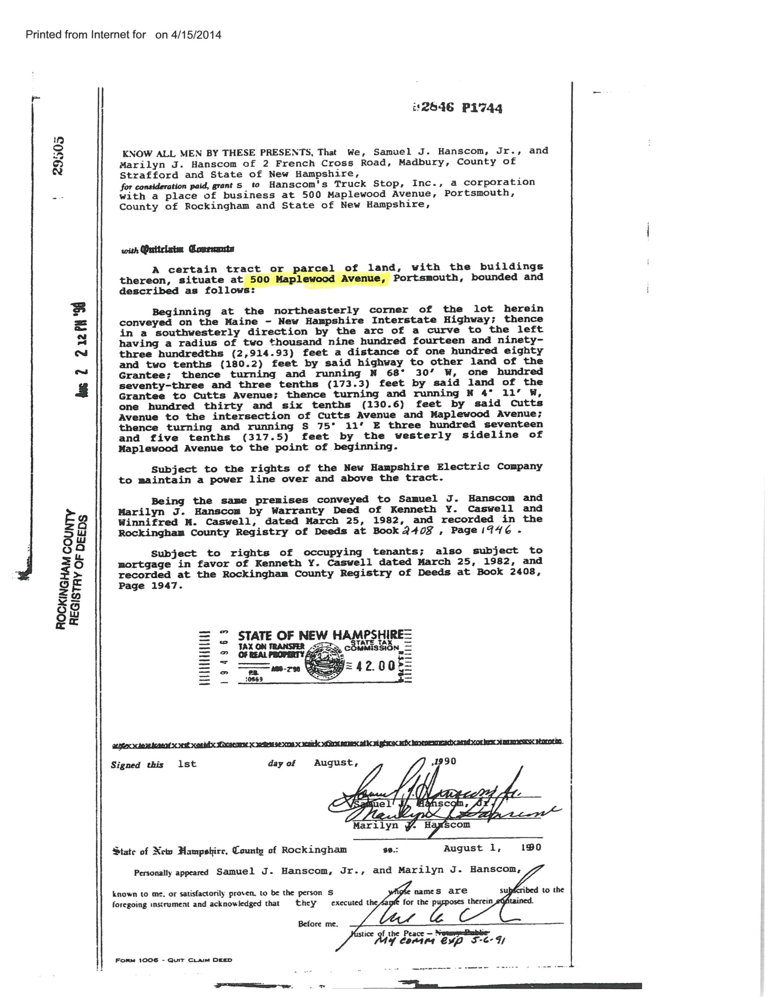
SALE 1
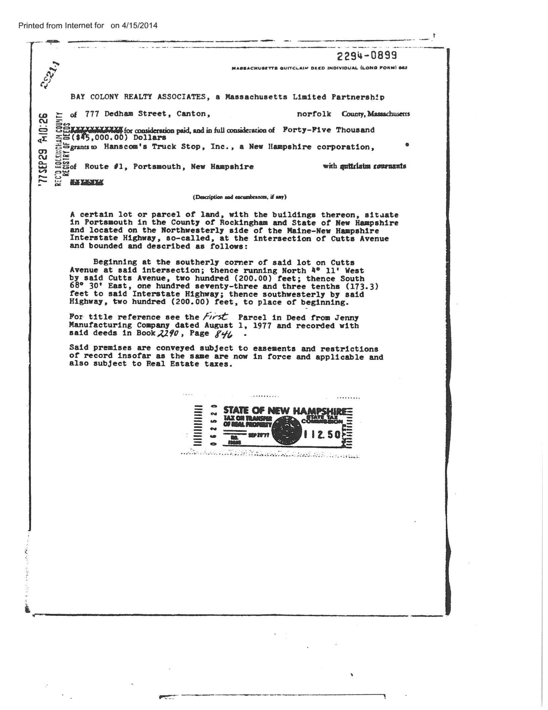
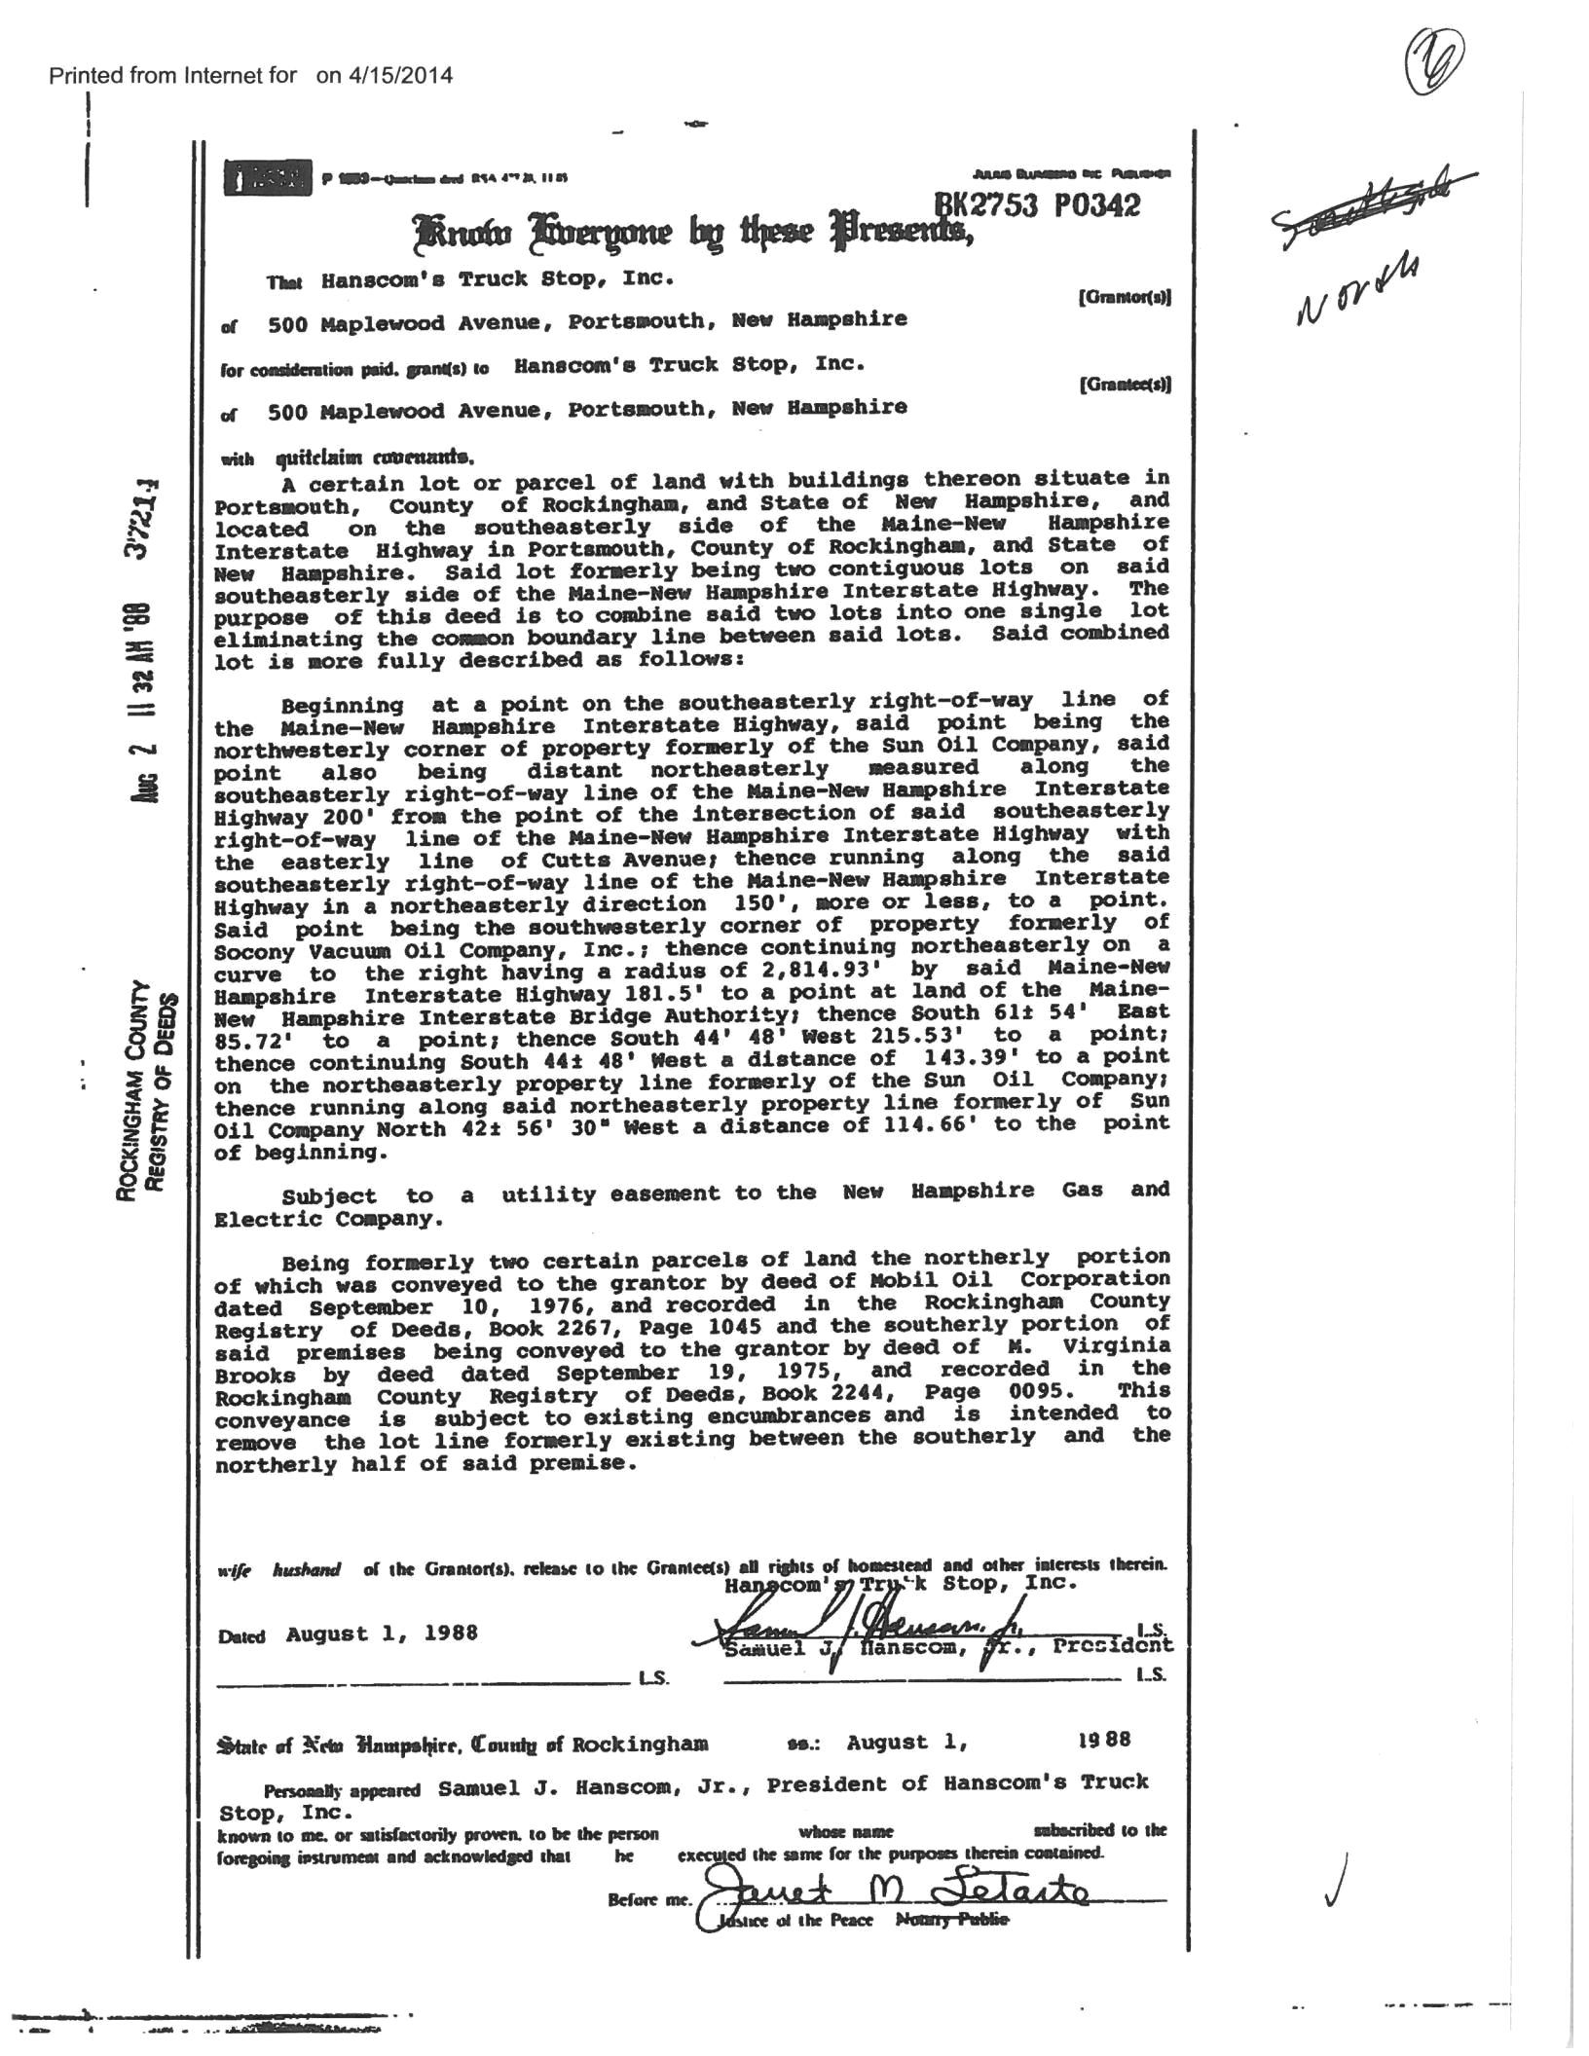
SALE 2
Schedule 1.1(b)

PERSONAL PROPERTY

Will be provided when list becomes available.

#24597639_V1

23

Schedule 1.1(g)

REAL ESTATE LEASE CONTRACTS

None.

#24597639_V1

24

