

Five Whys


Objective

To understand the cause and effect relationships underlying a particular problem.

Repeatedly ask the question ‘Why?’ in order to peel back the layers.

You can repeat the method to understand different root causes to the problem at hand.

This tool helps you to identify and tackle the source of a problem not just the symptoms.

Five Whys has its roots in the Toyota Production System (TPS) and is now one of the most common tools used when undertaking a root cause analysis.

https://www.amazon.com/Organic-Red-Onion-One-Large/dp/B000P6J1FE

2


Method

- Write down the problem you are trying to address

- Ask ‘why’ the problem occurs and write your answer down

- Repeat steps 1-2 and continue until you have identified what you believe to be the root cause of the problem

- You have reached the root cause when asking “why” produces no more useful responses

Note: You may not need 5 ‘whys’ to answer the problem, you may manage it in less…or need more!

3

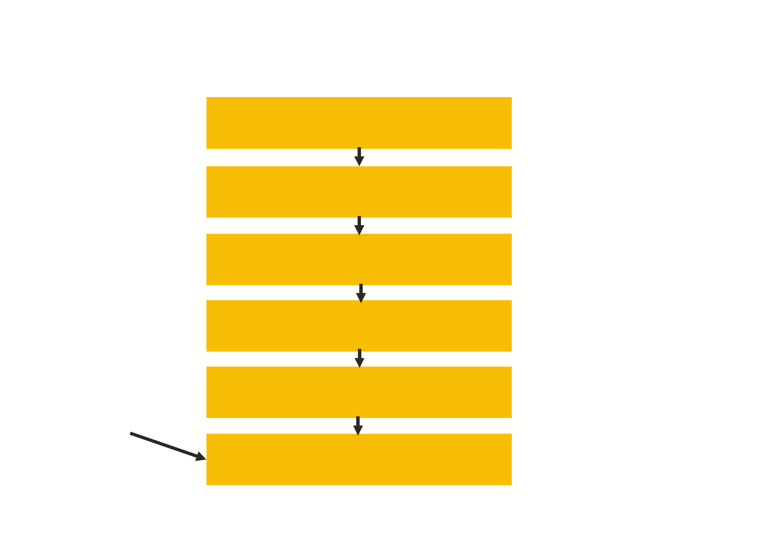
Example

Problem: The cake was burnt

Why: The oven was too hot

Why: The temperature gauge isn’t
working

Why: Because it has broken

Why: Because it had reached the
end of it’s useful life
Root cause
Why: Because the oven had not
been replaced when it was due

4

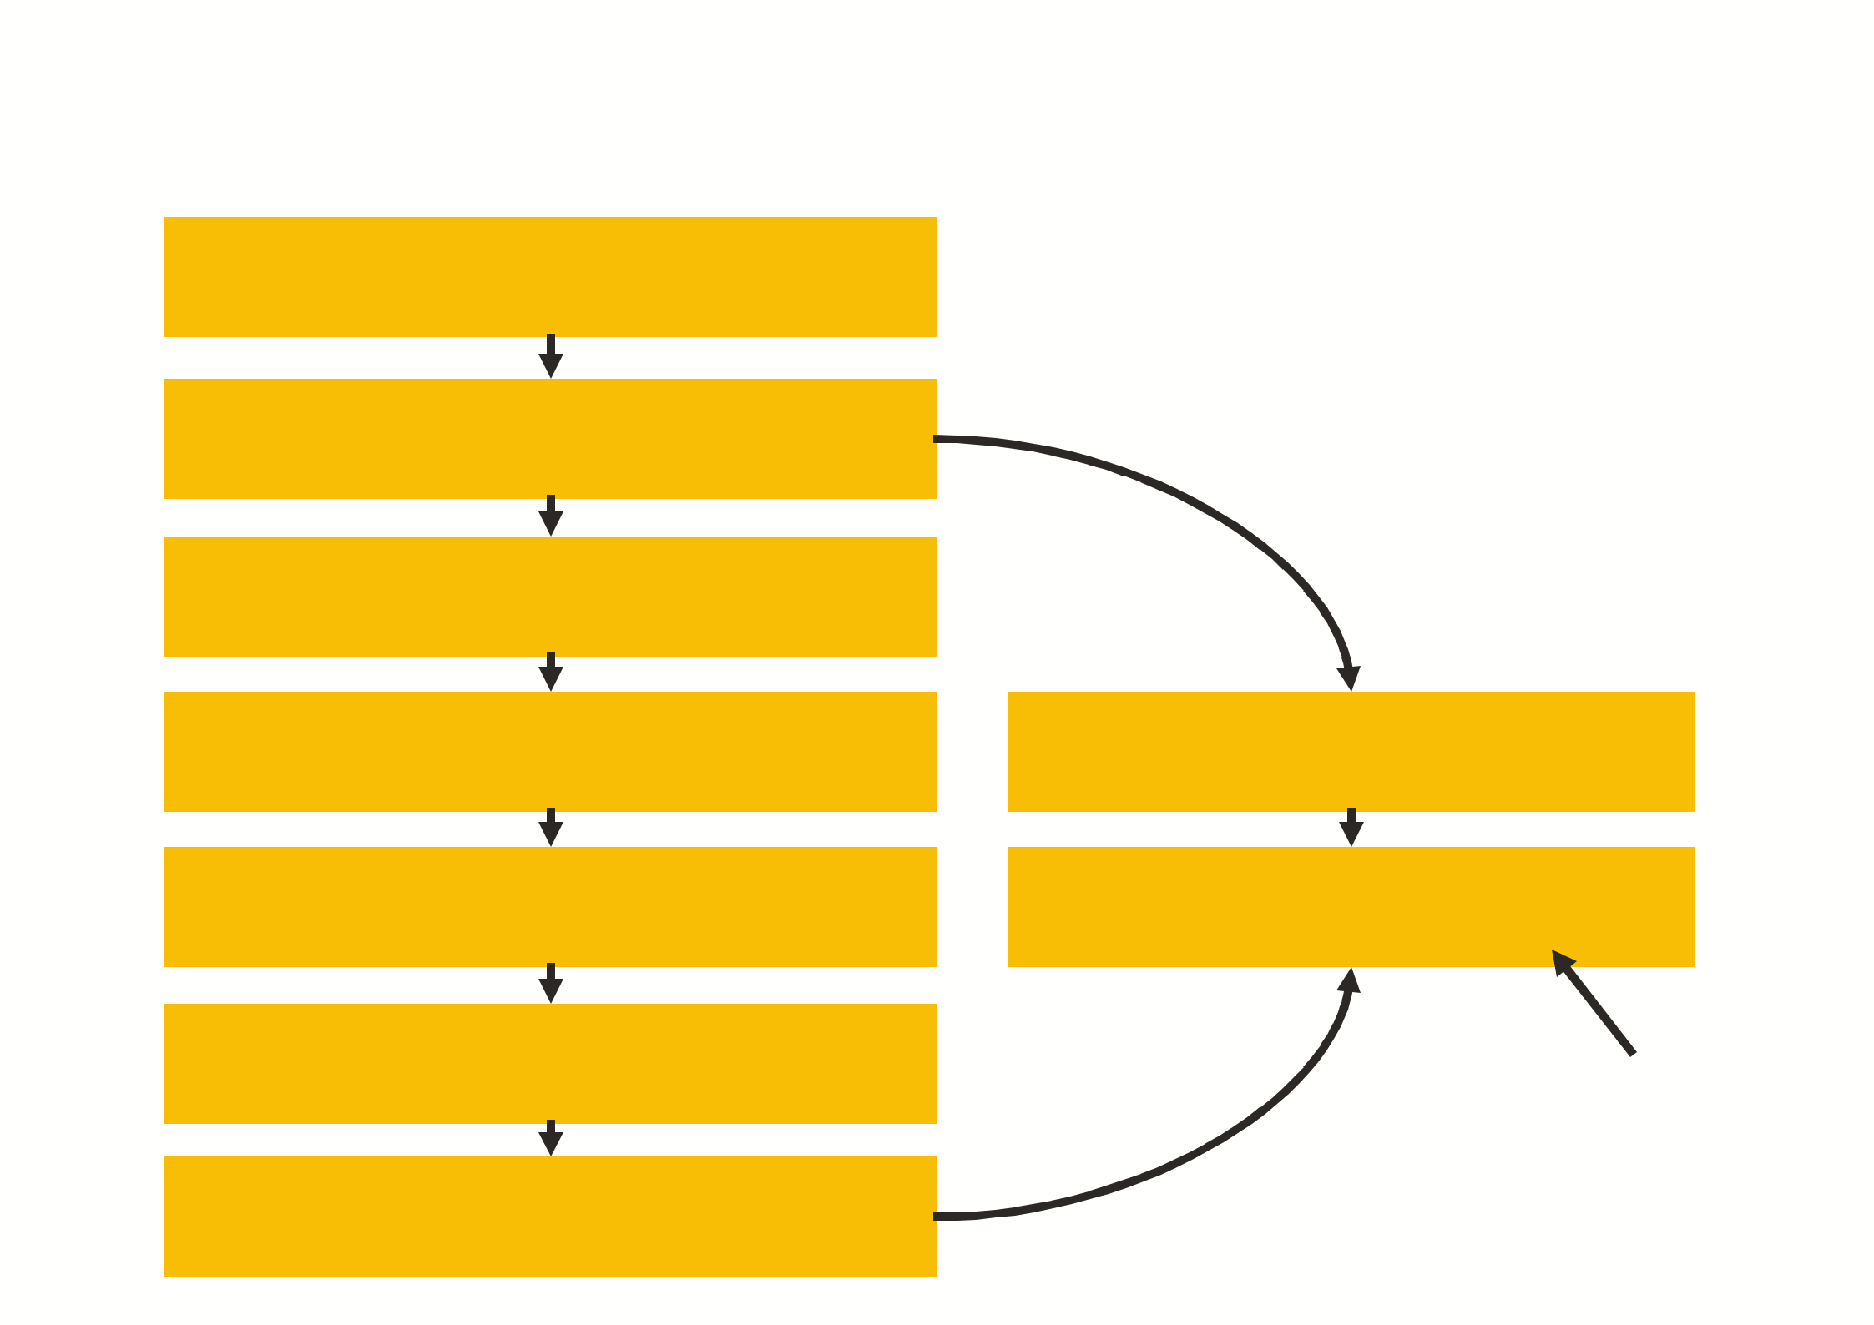
Example 2

Problem: The patient underwent an
unnecessary radiological examination

Why: The patient had two appointments for
the same test

Why: Because two different clinicians
requested the test

Why: Because the patient did not know that the tests were the same and that they had already had it

Why: Because English was not their first language and there was no interpreter at their appointment

Why: Because an interpreter had not been booked for the appointment by the administrative staff

Why: Because the need for an interpreter had
not been communicated to them

Why: Because the clinician did not check
the results system

Why: Because they were a temporary member of staff and had not been told how

Root cause

5
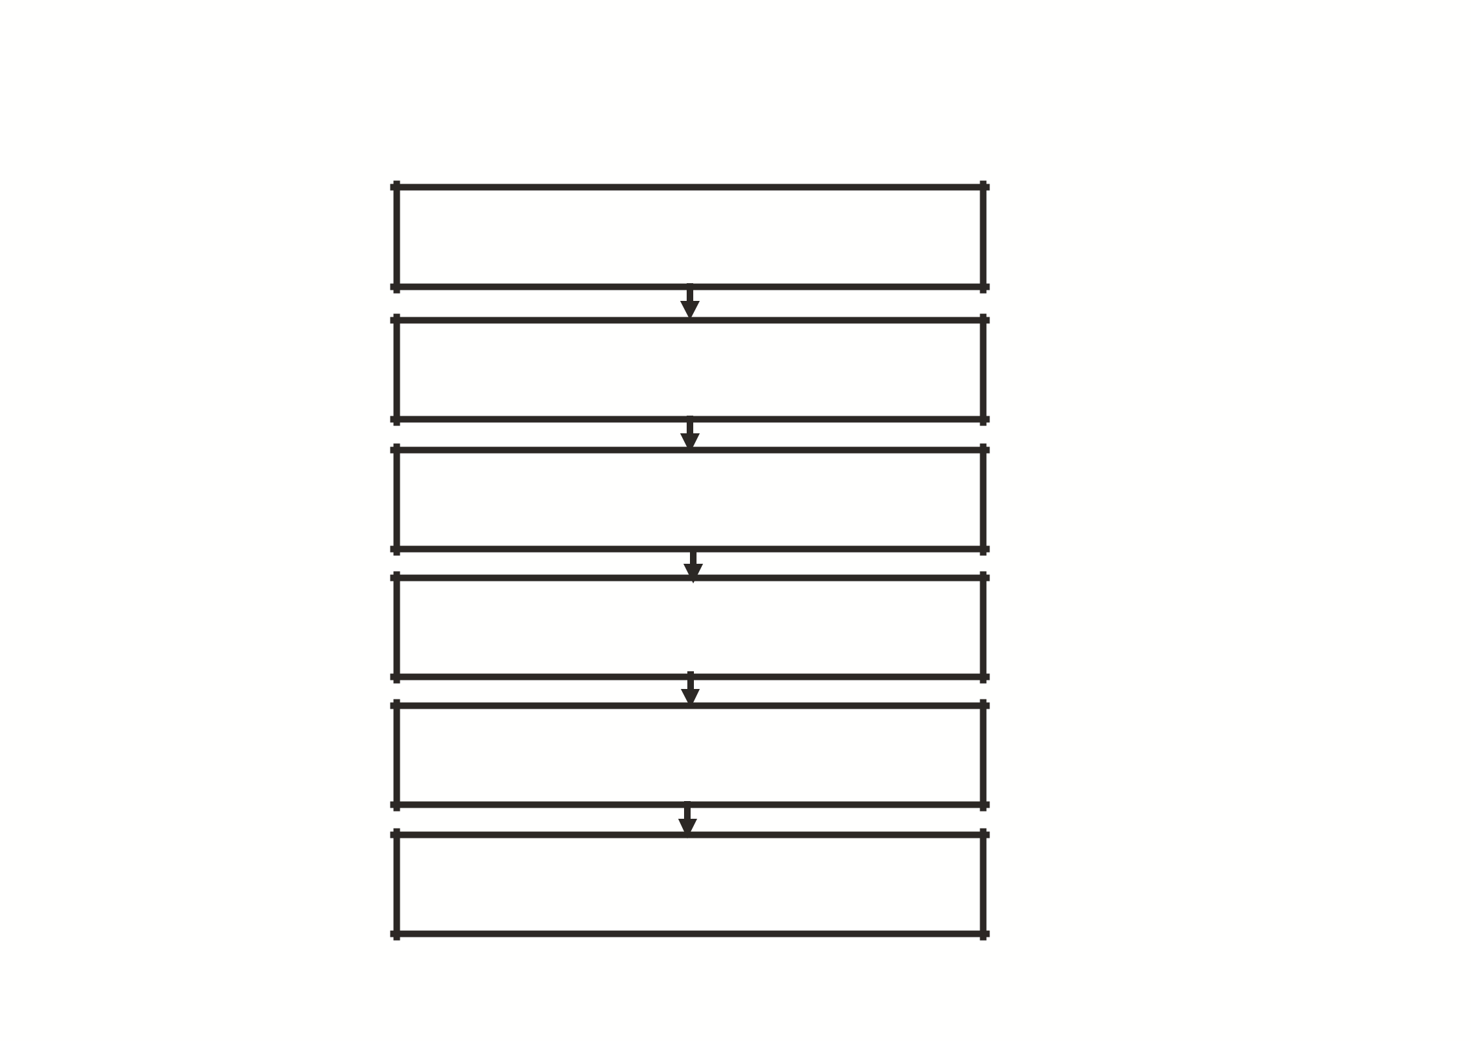
Template

Problem:

Why:

Why:

Why:

Why:

Why:

6

