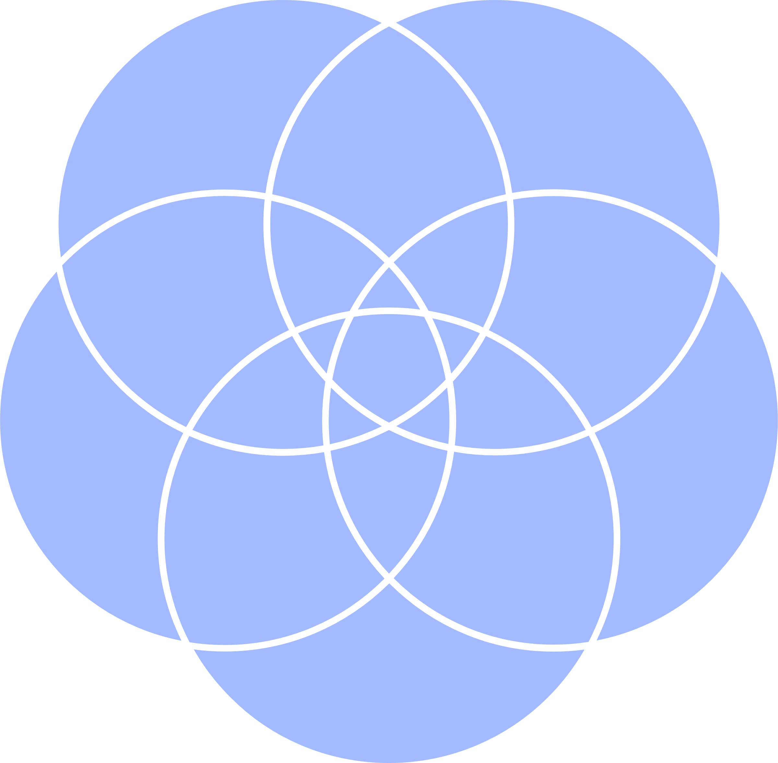

Symmetry

Pattern

Texture

Depth

Lines

5 CIRCLE VENN

DIAGRAM TEMPLATE

