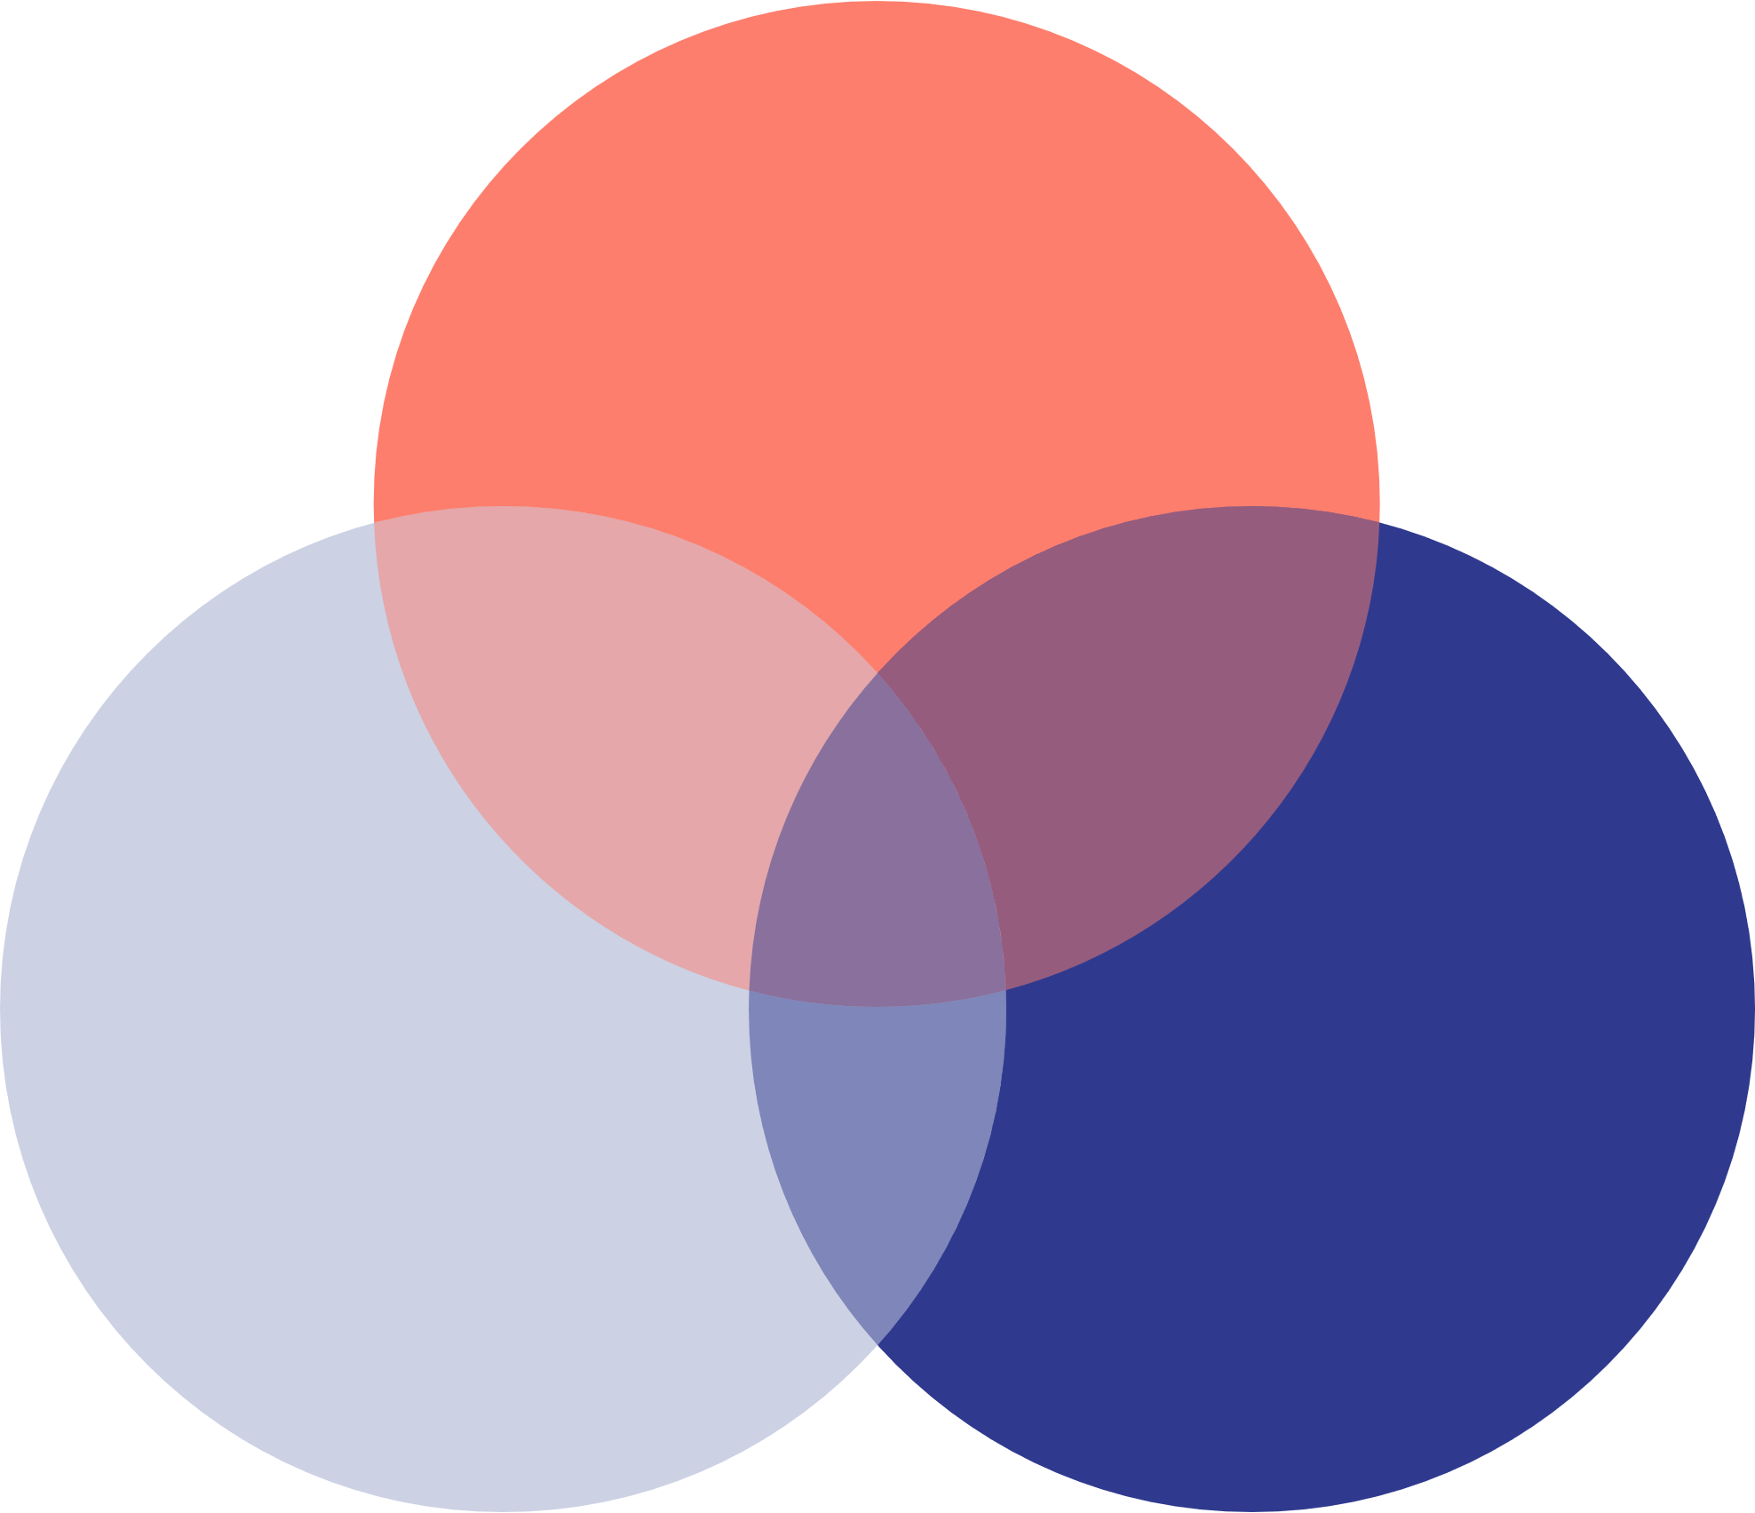

**WHAT**

**YOU**

**NEED**

**WHAT**

**YOU**

**GET**

**WHAT**

**YOU**

**LOVE**

**3 CIRCLE VENN**

**DIAGRAM TEMPLATE**



A brief description of the diagram, no more than two-three lines should be in this are so as not to overflow outside of the graphics.