Certificate of Appreciation

This is to recognize

for his immense contribution to the community's visual arts program. Thank you for your wonderful support.

Olivia Wilson

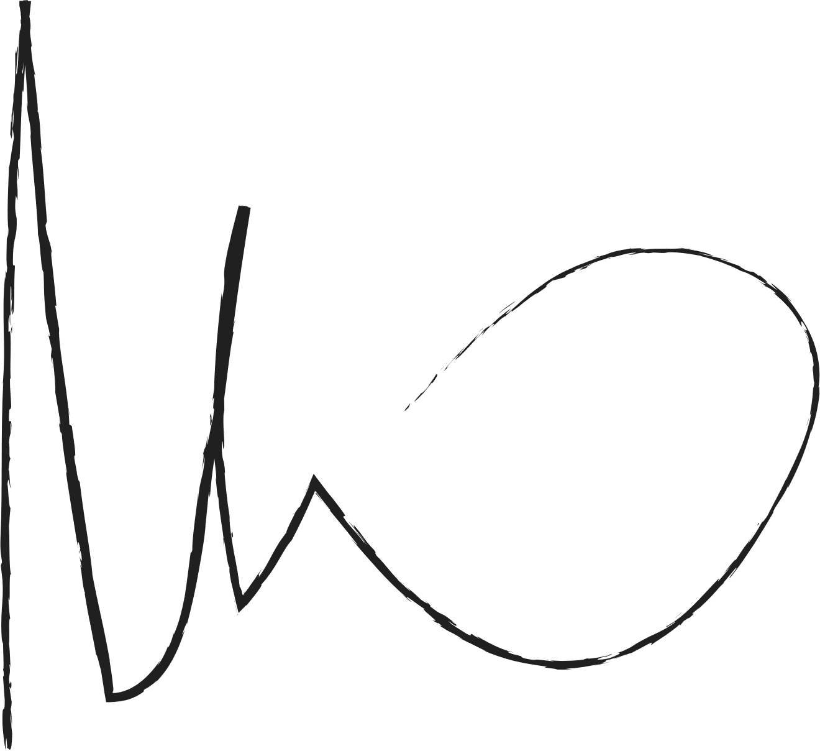

BENJAMIN SHAH

Head Community

