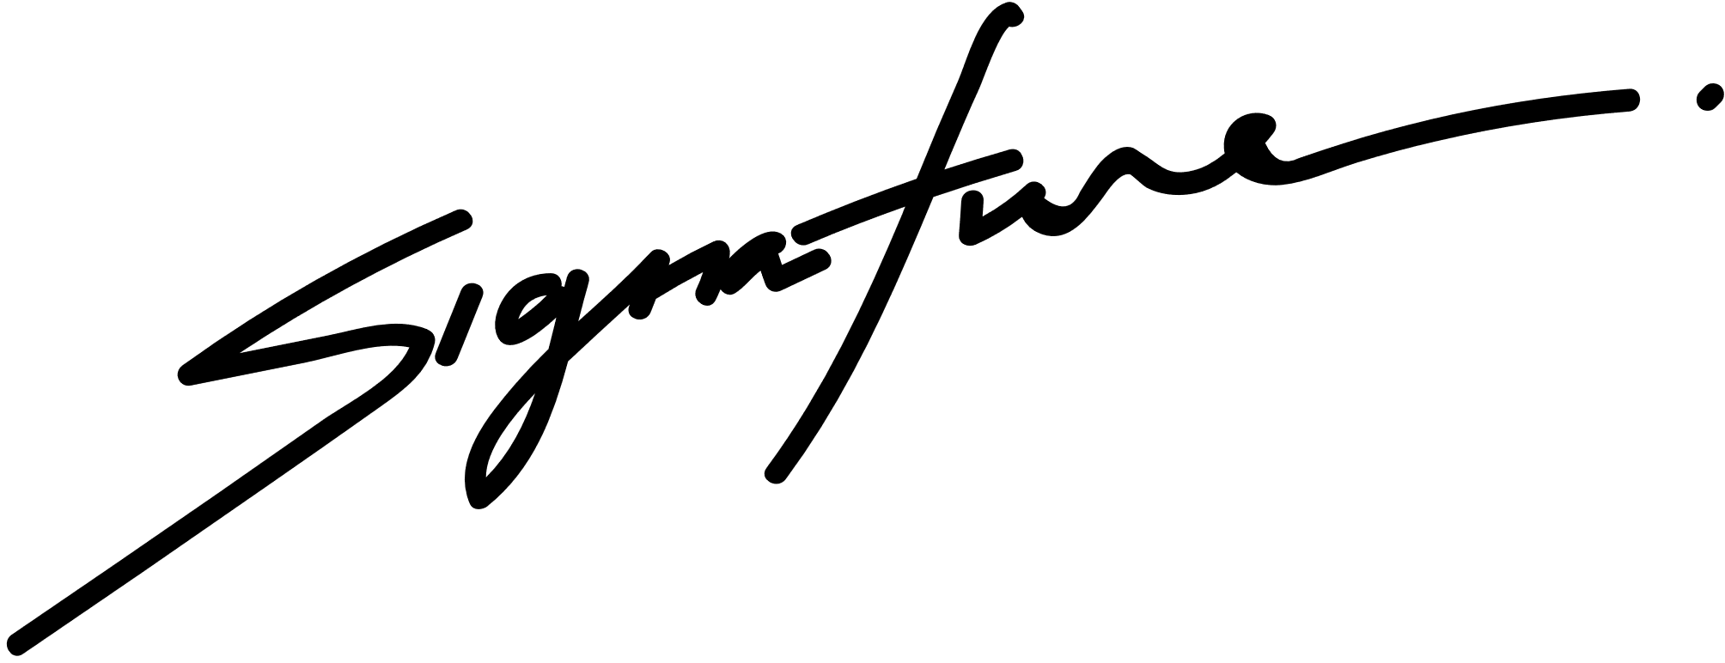

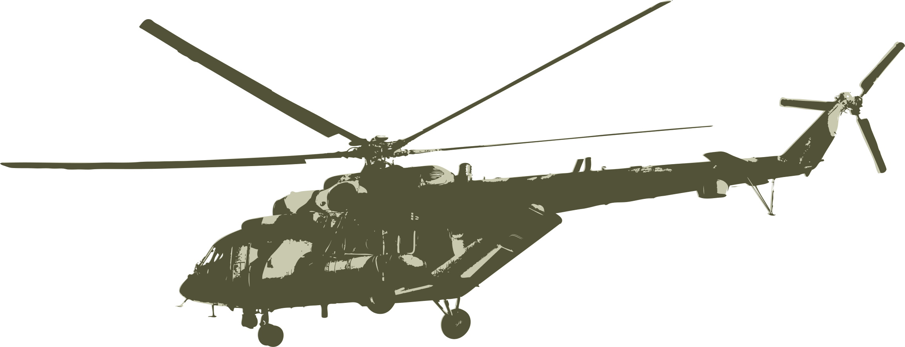

21.07.2027

DATE

SIGNATURE

DEPARTMENT OF THE ARMY

CERTIFICATE OF APPRECIATION

AWARDED TO

Sacha Dubois

for your outstanding support of the US Army Ordnance School at Fort Lee, Virginia. We greatly appreciate your excepotional service and product quality.